Massachusetts Department of

Elementary and Secondary Education

75 Pleasant Street, Malden, Massachusetts 02148-4906 Telephone: (781) 338-3000

TTY: N.E.T. Relay 1-800-439-2370

Mitchell D. Chester, Ed.D.
Commissioner

MEMORANDUM

To: | Members of the Board of Elementary and Secondary Education
From: | Mitchell D. Chester, Ed.D., Commissioner
Date: | January 18, 2013
Subject: | Charter Schools – Requests for Major Amendments for Berkshire Arts and Technology Charter School, Christa McAuliffe Regional Charter School, Foxborough Regional Charter School, and Rising Tide Charter Public School

Pursuant to the Charter School Regulations, 603 CMR 1.11(1), the Board of Elementary and Secondary Education (Board) must approve major changes in the material terms of a school’s charter. I am going to bring forward major amendments this month and in February. This year, the Department received requests from eighteen existing schools to increase their maximum enrollment, districts served, and grades served. A majority, but not all, of the requests to be presented in February require that the school meet “proven provider” status. Many of these requests come from charter schools seeking to expand in Boston. This year, applicants and existing schools requested 1,671 new seats in Boston. There are 881 seats requested via amendments with an additional 790 seats requested for new schools. The number of available seats under the eighteen percent cap is 1,379.

This month, I am recommending approval of requests from four Commonwealth charter schools. I am recommending the approval of a request from Berkshire Arts and Technology Charter School for an expansion and the addition of another district to its region. I am recommending approval of the expansion requests from Christa McAuliffe Regional Charter School and Foxborough Regional Charter School. Finally, I am recommending the approval of Rising Tide Charter Public School’s request to become a regional school. These requests are described in detail below, in preparation for a discussion and vote at the Board’s January meeting.

Section 1.11 of 603 CMR contains several criteria that the Commissioner and the Board may consider in reaching a determination regarding a school’s request to amend its charter. First, “the Commissioner and the Board may consider a charter school’s compliance with applicable state, federal, and local law.” Second, the Commissioner and the Board may consider the evidence regarding the success of the school’s academic program, the viability of the school as an organization, and the faithfulness of the school to the terms of its charter. Third, a board of trustees seeking an expansion in some districts must qualify as a “proven provider” based on the existing school and meet the performance criteria described in 603 CMR 1.05(2). Fourth, schools applying to amend their maximum enrollment and grades served must address additional criteria as outlined in the technical advisory on amendments.

The Commonwealth’s new system for District and School Accountability and Assistance was introduced in the fall of 2012. Over the past five years, charter schools have been evaluated against the Common School Performance Criteria and their Accountability Plans. Going forward, we will integrate the new state accountability system with the current charter school accountability system.

As required for requests that seek an increase in maximum enrollment, grades served, or districts served, comment was solicited from the superintendents in the school districts within each charter school’s district or region, as well as from superintendents in districts from which the charter school draws a substantial number of students. As noted below, we received a letter from the superintendent, mayor, and school committee chair in Pittsfield. The letters are attached.

Berkshire Arts and Technology Charter School

The board of trustees of Berkshire Arts and Technology Charter School (BART) has submitted an expansion request to increase maximum enrollment from 308 to 363 students, an increase of 55 students; and to add Pittsfield to the school’s region. With an increase in enrollment, the school indicates that it can meet the increased demand to attend BART, especially for the high school. The request to add Pittsfield to its region complies with G.L. c. 71, § 89(n), requiring a charter school to add a town to its region if more than 20% of its student body are from school districts not included in its original charter for two consecutive years. BART has enrolled more than 20% of its student body from Pittsfield for the past four years.

Demographic Data

The following table compares demographic data of the charter school to the state and to the districts form which it draws most of its students, Adams, Cheshire, Clarksburg, Florida, Hancock, Lanesborough, New Ashford, North Adams, Pittsfield, Savoy, and Williamstown. The comparison includes 15 schools in the region with grade levels that overlap with the charter school.

Org Code | Race/Ethnicity (%) | African American | Asian | Hispanic | White | Native American | Native Hawaiian, Pacific Islander | Multi-Race, Non-Hispanic
 | Berkshire Arts and Technology Charter Public School | 6.5% | 0.7% | 3.6% | 87.0% | 1.1% | 0.0% | 1.1%
(15 Schools) | Comparison Minimum | 0.0% | 0.0% | 0.0% | 70.0% | 0.0% | 0.0% | 0.0%
 | Comparison Median | 2.6% | 0.8% | 3.7% | 87.1% | 0.1% | 0.0% | 3.2%
 | Comparison Maximum | 11.6% | 3.8% | 10.9% | 97.8% | 0.5% | 1.1% | 9.8%
 | Comparison Total | 5.6% | 1.1% | 5.0% | 83.9% | 0.2% | 0.2% | 4.0%
State | State | 8.3% | 5.7% | 16.1% | 67.0% | 0.2% | 0.1% | 2.5%
Org Code | Other Demographics (%) | Males | Females | First Language Not English | Limited English Proficient | Special Education | Low-Income
 | Berkshire Arts and Technology Charter Public School | 46.4% | 53.6% | 1.4% | 0.0% | 19.9% | 59.8%
(15 Schools) | Comparison Minimum | 41.3% | 44.0% | 0.0% | 0.0% | 4.3% | 0.0%
 | Comparison Median | 51.3% | 48.7% | 1.2% | 0.8% | 17.9% | 38.1%
 | Comparison Maximum | 56.0% | 58.7% | 7.8% | 4.5% | 28.4% | 61.4%
 | Comparison Total | 51.2% | 48.8% | 3.0% | 1.6% | 18.4% | 38.9%
State | State | 51.3% | 48.7% | 16.7% | 7.3% | 17.0% | 35.2%

Academic Performance

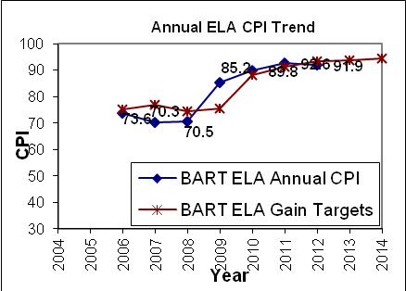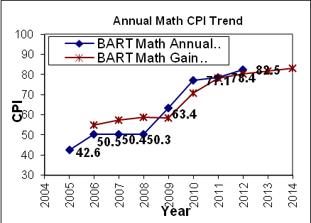

Accountability and Assistance Level:
Level 1-Percentile 43
Proficiency Gap Narrowing: | Rating:
English Language Arts | No Change
Mathematics | Above Target
Science | No Change

BART Median Student Growth Percentile
Year | 2009 | 2010 | 2011 | 2012
English Language Arts | 61.0 | 64.0 | 67.0 | 49.0
Mathematics | 61.0 | 72.0 | 67.0 | 69.5

The superintendents of the school’s sending districts were invited to submit comment on the school’s request. Comments were received from the superintendent, mayor, and school committee chair in Pittsfield opposing the addition of Pittsfield to the school’s region. The letters are attached.

Granting BART’s request to expand the region provides an enrollment preference for Pittsfield students, makes no changes to the numbers of Pittsfield students who can enroll in BART, and changes BART’s transportation obligations for Pittsfield students. Granting BART’s request provides students who live in Pittsfield with an enrollment preference equal to students who live in the other nine school districts in BART’s region. The Board may impose enrollment limits for a school district in a charter school’s designated region if it is required to enforce the statutory limits on net school spending, a scenario not present in this situation.

If the Board should deny BART’s request for an amendment, enrollment of students from Pittsfield would continue to be limited to the statutory limits on net school spending. BART, however, would have no obligation to transport Pittsfield students and would not be entitled to state transportation reimbursement if it voluntarily chose to provide transportation.

BART was chartered in 2003 and renewed with conditions in 2009. BART was successfully removed from conditions in December 2010, and submitted an application for an early renewal this year. Pursuant to my delegated authority, I renewed BART’s charter for another five-year term in 2013. Given the school’s academic success, organizational viability, and compliance with applicable state, federal, and local laws, I recommend that the Board approve the addition of Pittsfield to the school’s region and the maximum enrollment increase requested by the school. The school’s major amendment request and a motion for approval is attached for your consideration.

Christa McAuliffe Regional Charter Public School

The board of trustees of Christa McAuliffe Regional Charter Public School (CMRCPS) has submitted an expansion request to increase maximum enrollment from 306 to 396 students, an increase of 90 students. With an increase in enrollment, the school indicates that it will dedicate instructional teams to specific grades, rather than the multi-grade assignments currently used, and that it can more effectively implement the Expeditionary Learning model.

Demographic Data

The following table compares demographic data of the charter school to the districts from which it draws most of its students and to the state. The comparison includes 12 schools in the district with grade levels that overlap with the charter school.

`` | Race/Ethnicity (%) | African American | Asian | Hispanic | White | Native American | Native Hawaiian, Pacific Islander | Multi-Race, Non-Hispanic
 | Christa McAuliffe Regional Charter Public School | 5.2% | 5.6% | 11.2% | 76.2% | 0.0% | 0.0% | 1.9%
(12 Schools) | Comparison Minimum | 0.9% | 1.4% | 1.7% | 59.0% | 0.0% | 0.0% | 0.3%
 | Comparison Median | 2.6% | 5.0% | 3.8% | 84.4% | 0.0% | 0.0% | 2.1%
 | Comparison Maximum | 8.5% | 9.4% | 31.4% | 92.3% | 0.5% | 0.2% | 3.4%
 | Comparison Total | 3.1% | 5.0% | 10.6% | 79.2% | 0.1% | 0.0% | 2.1%
State | State | 8.3% | 5.7% | 16.1% | 67.0% | 0.2% | 0.1% | 2.5%
Org Code | Other Demographics (%) | Males | Females | First Language Not English | Limited English Proficient | Special Education | Low-Income
 | Christa McAuliffe Regional Charter Public School | 58.0% | 42.0% | 2.2% | 1.9% | 28.3% | 15.6%
(12 Schools) | Comparison Minimum | 47.9% | 45.6% | 1.5% | 0.0% | 12.4% | 3.1%
 | Comparison Median | 50.0% | 50.0% | 5.6% | 1.1% | 16.3% | 10.8%
 | Comparison Maximum | 54.4% | 52.1% | 42.6% | 16.8% | 28.5% | 47.5%
 | Comparison Total | 50.5% | 49.5% | 13.2% | 2.6% | 17.5% | 18.4%
State | State | 51.3% | 48.7% | 16.7% | 7.3% | 17.0% | 35.2%

Academic Performance

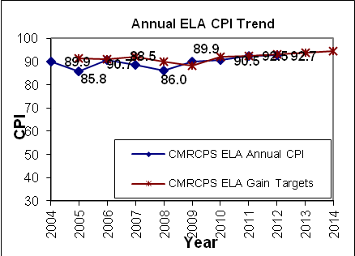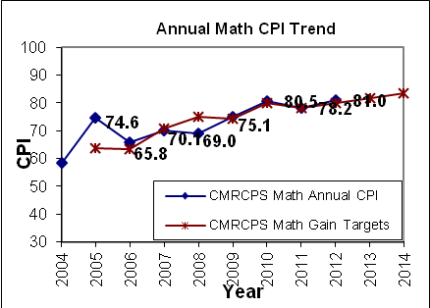

Accountability and Assistance Level:
Level 1-Percentile 57
Proficiency Gap Narrowing: | Rating:
English Language Arts | On Target
Mathematics | On Target
Science | On Target

CMRCPS Median Student Growth Percentile
Year | 2009 | 2010 | 2011 | 2012
English Language Arts | 40.0 | 45.0 | 57.0 | 51.0
Mathematics | 50.0 | 57.5 | 48.5 | 51.0

The superintendents of the school’s sending districts, Ashland, Framingham, Holliston, Hopkinton, Marlborough, Natick, Southborough, and Sudbury, were invited to submit comment on the school’s request. No comments were received.

CMRCPS was chartered in 2002 and renewed without conditions in 2007 and 2012. Given the school’s history of solid academic success, organizational viability, and compliance with applicable state, federal, and local law, I recommend that the Board approve the maximum enrollment increase requested by the school. The school's major amendment request and a motion for approval are attached for your consideration.

Foxborough Regional Charter School

The Board of Trustees of Foxborough Regional Charter School (FRCS) has submitted an expansion request to increase maximum enrollment from 1,200 to 1,300 (100 seats). With an increase in enrollment numbers, the school indicates that it will be able to meet the continued high demand for the school, especially in the high school. FRCS is currently overenrolled by # of students. The high school population has nearly doubled since the 2007 school year.

Demographic Data

The following table compares demographic data of the charter school to the districts from which it draws most of its students and to the state. The comparison includes 110 schools in the district with grade levels that overlap with the charter school.

Org Code | Race/Ethnicity (%) | African American | Asian | Hispanic | White | Native American | Native Hawaiian, Pacific Islander | Multi-Race, Non-Hispanic
 | Foxborough Regional Charter School | 21.0% | 8.9% | 5.7% | 60.5% | 0.0% | 0.1% | 3.8%
(110 Schools) | Comparison Minimum | 0.0% | 0.0% | 0.5% | 11.7% | 0.0% | 0.0% | 0.0%
 | Comparison Median | 4.6% | 3.4% | 4.3% | 79.3% | 0.1% | 0.0% | 2.3%
 | Comparison Maximum | 70.6% | 26.4% | 43.3% | 96.1% | 2.2% | 1.1% | 7.8%
 | Comparison Total | 16.7% | 4.3% | 6.8% | 69.4% | 0.2% | 0.1% | 2.4%
State | State | 8.3% | 5.7% | 16.1% | 67.0% | 0.2% | 0.1% | 2.5%
Org Code | Other Demographics (%) | Males | Females | First Language Not English | Limited English Proficient | Special Education | Low-Income
 | Foxborough Regional Charter School | 45.7% | 54.3% | 10.6% | 3.2% | 10.2% | 15.3%
(110 Schools) | Comparison Minimum | 45.8% | 26.4% | 0.0% | 0.0% | 4.6% | 2.4%
 | Comparison Median | 51.5% | 48.5% | 6.0% | 1.6% | 14.2% | 18.0%
 | Comparison Maximum | 73.6% | 54.2% | 53.9% | 38.9% | 95.3% | 92.3%
 | Comparison Total | 51.2% | 48.8% | 13.4% | 6.7% | 14.2% | 30.2%
State | State | 51.3% | 48.7% | 16.7% | 7.3% | 17.0% | 35.2%

Academic Performance

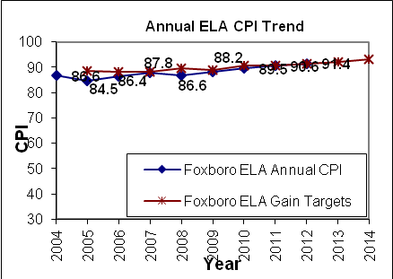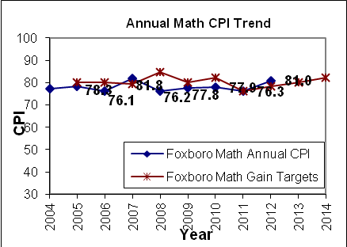

Accountability and Assistance Level:
Level 2-Percentile 47
Proficiency Gap Narrowing: | Rating:
English Language Arts | On Target
Mathematics | Above Target
Science | On Target

FRCS Median Student Growth Percentile
Year | 2009 | 2010 | 2011 | 2012
English Language Arts | 51.0 | 51.5 | 47.0 | 50.0
Mathematics | 50.0 | 45.0 | 38.0 | 54.0

FRCS was chartered in 1998 and renewed without conditions in 2003 and 2008. Pursuant to my delegated authority, I renewed FRCS’s charter for another five-year term in 2013. Given the school’s academic success, organizational viability, and compliance with applicable state, federal, and local laws, I recommend that the Board approve the maximum enrollment increase requested by the school. The school’s major amendment request and a motion for approval are attached for your consideration.

Rising Tide Charter Public School

The Board of Trustees of Rising Tide Charter Public School (RTCPS) has submitted a request to become a regional school, serving an additional 15 towns throughout the south shore and Cape Cod. Currently, only applicants from Plymouth have an enrollment preference at the school. The school has experienced increased demand from other towns but has not been able to admit these applicants.

Demographic Data

The following table compares demographic data of the charter school to the Plymouth School District and to the state. The comparison includes eleven schools in the district with grade levels that overlap with the charter school.

 | Race/Ethnicity (%) | African American | Asian | Hispanic | White | Native American | Native Hawaiian, Pacific Islander | Multi-Race, Non-Hispanic
 | Rising Tide Charter Public School | 1.0% | 1.3% | 2.1% | 90.4% | 0.3% | 0.3% | 4.7%
(11 Schools) | Comparison Minimum | 0.1% | 0.6% | 0.7% | 75.6% | 0.0% | 0.0% | 2.2%
 | Comparison Median | 1.7% | 1.3% | 1.8% | 91.5% | 0.2% | 0.0% | 3.4%
 | Comparison Maximum | 5.1% | 2.2% | 10.2% | 95.4% | 0.9% | 0.5% | 8.1%
 | Comparison Total | 2.3% | 1.3% | 2.2% | 90.7% | 0.3% | 0.1% | 3.1%
State | State | 8.3% | 5.7% | 16.1% | 67.0% | 0.2% | 0.1% | 2.5%
Org Code | Other Demographics (%) | Males | Females | First Language Not English | Limited English Proficient | Special Education | Low-Income
 | Rising Tide Charter Public School | 50.1% | 49.9% | 1.8% | 0.0% | 14.0% | 9.9%
(11 Schools) | Comparison Minimum | 44.7% | 41.5% | 0.0% | 0.0% | 11.7% | 18.4%
 | Comparison Median | 52.2% | 47.8% | 1.0% | 0.5% | 18.7% | 25.2%
 | Comparison Maximum | 58.5% | 55.3% | 6.6% | 4.6% | 22.2% | 39.6%
 | Comparison Total | 51.9% | 48.1% | 1.0% | 0.7% | 18.4% | 25.3%
State | State | 51.3% | 48.7% | 16.7% | 7.3% | 17.0% | 35.2%

Academic Performance

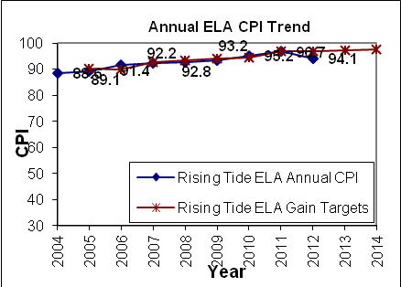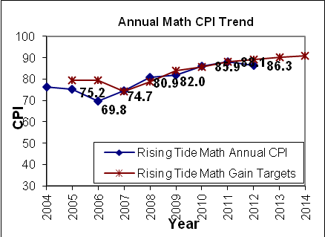

Accountability and Assistance Level:
Level 2-Percentile 84
Proficiency Gap Narrowing: | Rating:
English Language Arts | Declined
Mathematics | No Change
Science | On Target

RTCPS Median Student Growth Percentile
Year | 2009 | 2010 | 2011 | 2012
English Language Arts | 51.0 | 58.0 | 54.0 | 48.0
Mathematics | 46.0 | 49.5 | 51.5 | 40.0

RTCPS was chartered in 1998 and renewed without conditions in 2003 and 2008. Pursuant to my delegated authority, I renewed RTCPS’s charter for another five-year charter in 2013. Given the school’s academic success, organizational viability, and compliance with applicable state, federal, and local laws, I recommend that the Board approve the request by the school to become a regional charter school. The school’s major amendment request and a motion for approval are attached for your consideration.

******************************

If you have any questions regarding this amendment or require additional information, please contact Cliff Chuang, Associate Commissioner (781-338-3222); Jeff Wulfson, Deputy Commissioner (781-338-6500); or me.

Attachments: Correspondence from Christa McAuliffe Regional Charter Public School
Motion for Christa McAuliffe Regional Charter Public School

Correspondence from Berkshire Arts and Technology Charter Public School
Pittsfield comments (superintendent, mayor, school committee chair)
Motion for Berkshire Arts and Technology Charter Public School

Correspondence from Foxborough Regional Charter School
Motion for Foxborough Regional Charter School

Correspondence from Rising Tide Charter Public School
Motion for Rising Tide Charter Public School

