“Despite so many obstacles – immigrating alone at sixteen, raising a child, and navigating a new language – nothing is going to stop me from going to college.”
– Maira Murillo, Phoenix Charter Academy Chelsea Class of 2012
Our Mission
Phoenix Charter Academy Springfield’s (Phoenix Springfield) mission is to challenge teenagers in Springfield, Holyoke, and Chicopee with an academically rigorous and individually tailored curriculum. At Phoenix Springfield, talented students, some who have not succeeded in other schools, have the support, resources and training needed to succeed academically in high school and college, and become economically secure in their future. Named after a mythological figure of strength, healing and renewal, we believe in the capacity of our students to regain control of their academic future and recast themselves as strong, independent and self-sufficient adults.

Our Challenge
Across America, students are dropping out of high school at an alarming rate. According to Education Week’s 2012 Diplomas Count, “Nearly 1.2 million students from 2008’s high school class (the most recent year for which data was available) failed to graduate with a diploma. That amounts to 6,400 students lost each day of the year, or one student every 27 seconds” (23). Among students of color, this problem is particularly prevalent: only 57% of Latino students and 57.6% of African American students from the class of 2008 successfully finished high school, compared to 78.4% of white students (Diplomas Count 2012, 23).

Dropping out of high school has severe economic and social consequences. The unemployment rate of high school dropouts is four times that of college graduates, and high school dropouts are disproportionately likely to be incarcerated, homeless, or recipients of government services (Kazis 2002, 4). On average, each dropout costs the United States nearly $300,000 in lost earnings over the course of his/her lifetime (Rennie Center 2011, 1).

Phoenix Charter Academy Springfield’s target communities face the reality of the dropout crisis on a daily basis. In the 2012-13 school year, Springfield, Chicopee, and Holyoke had five-year graduation rates of 56.1%, 71.2%, and 56.1%, respectively, all significantly lower than the statewide four-year rate of 84.7%. As in the nation at large, the costs of dropping out of high school reverberate through the Massachusetts economy: the average high school dropout in Massachusetts makes $10,000 less annually than a high school graduate and $34,000 less annually than a college graduate (The Boston Foundation, 2010).

Our Strategy
Phoenix Springfield will be the third school in the Phoenix Network of high-accountability alternative schools for at-risk students. The Phoenix model, developed at Phoenix Charter Academy in Chelsea over the past six years, partners challenging academic work with comprehensive socio-emotional supports to enable all students to gain the skills necessary to succeed in college. Phoenix schools target students who turn to alternative education when traditional school systems fail, often including students who have dropped out of school, have struggled with truancy and chronic absenteeism in the past, are involved with the Department of Youth Services or the Department of Children and Families, are pregnant or parenting children of their own, and/or are recent immigrants to the country.

To help these students excel academically – including passing the MCAS, graduating from high school, and succeeding in college – Phoenix provides students with a rigorous curriculum that prepares them for college-level work. We expect our students to achieve at high levels: students attend school from 9 a.m. to 5 p.m. for 190 days each year, must earn a C- or better to earn class credit, must demonstrate mastery of upper-level math, science, and humanities classes in order to graduate, and are required to receive a college acceptance letter prior to graduation. Our College Services Department, Phoenix Through College, works with every student to help him/her map his/her course through high school and college.

While holding our students to high academic expectations, Phoenix schools also provide students with the socio-emotional supports they need to overcome obstacles they are facing outside of school. Our comprehensive student support services include a student support center that serves as a resource for students who need coaching to model the characteristics of a scholar, on-site social workers who connect students to collateral supports in the community, an on-site childcare center that offers services to teen parents, and outreach workers who tirelessly endeavor to keep students connected to and engaged in school. These non-traditional supports, necessary for a non-traditional population of young people, help students manage external struggles so that they can focus on academic growth in the classroom.

Our Results
Over the lifetime of Phoenix Chelsea, we have seen the impact of our instructional and student support programs, and believe we have developed a powerful model for reaching and retaining high-risk youth. In 2012, 86% of students scored advanced or proficient on the English Language Arts MCAS exam, as did 72% on the math exam, beating all but one of the school’s sending districts. Additionally, 77 students have now graduated from Phoenix, and 100% of those students have been accepted to college. The following chart details our students’ proficiency rates on the MCAS exam over the past five years:

Phoenix Charter Academy Chelsea MCAS Proficiency Rates, 2008-2012
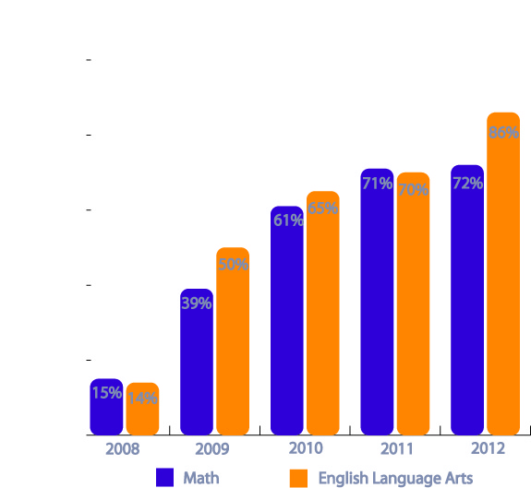

Our Vision for the Future
As mentioned briefly above, Phoenix Springfield will be the third school in the Phoenix Network, following Phoenix Chelsea (chartered in 2005; opened in 2006) and Phoenix Lawrence (an in-district school operated using the Phoenix model, opened in August, 2012). The Board of Trustees of Phoenix Charter Academy, galvanized by the success of Phoenix in Chelsea, is eager to bring our model of high accountability and wraparound support services to Springfield and surrounding communities. With the opening of Phoenix Springfield, the Phoenix Network will be serving nearly 500 students, many of whom would not have finished high school, let alone gone on to college, without Phoenix. Our strategic five-year plan, described in more detail later in this application, lays out a comprehensive strategy for developing the capacity of the organization to support the opening of schools across the Commonwealth. We are not satisfied with the educational options currently available to young people who have struggled academically, and believe our work can serve as an example of what high-risk youth can achieve when provided with high expectations and relentless support.

