Proposed School Name: |  | Phoenix Charter Academy Springfield
Proposed Proven Provider: |  | Phoenix Charter Academy Board of Trustees
General School Information: |  | Phoenix Charter Academy School, Chelsea, MA
Grades Served: | 9-12 | Current Max Enrollment: | 225
Year Opened: | 2006 | Renewed: | 2011

Selected Populations - School Years 2007-2012

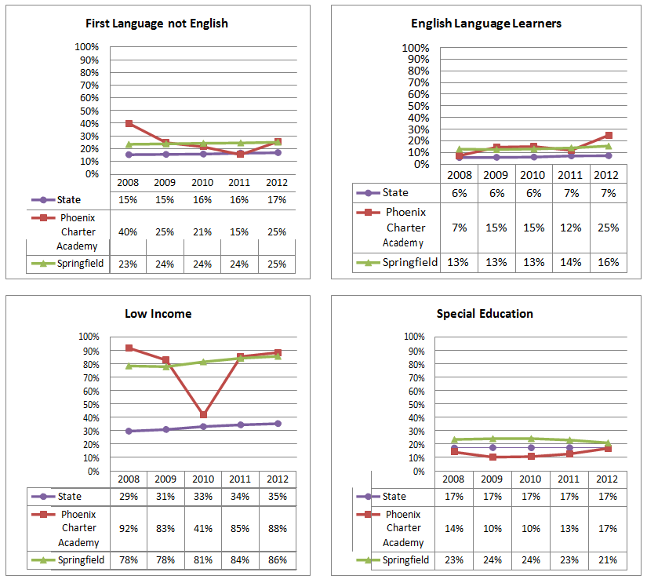

Proposed School Name: |  | Phoenix Charter Academy Springfield
Proposed Proven Provider: |  | Phoenix Charter Academy Board of Trustees
General School Information: |  | Phoenix Charter Academy School, Chelsea, MA
Grades Served: | 9-12 | Current Max Enrollment: | 225
Year Opened: | 2006 | Renewed: | 2011

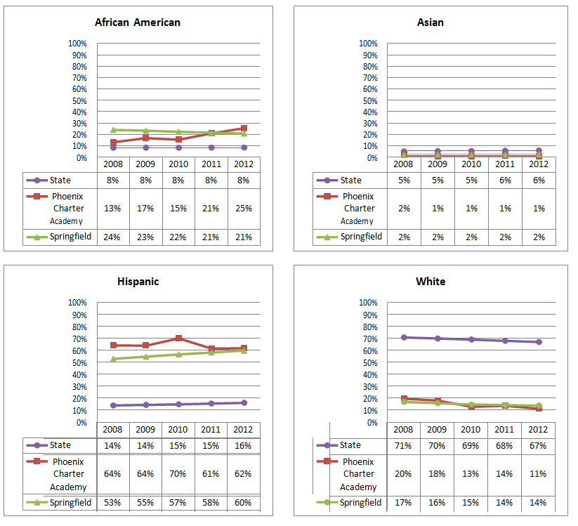
Enrollment by Race/Ethnicity - School Years 2007-2012

