Proposed School Name: |  | Pioneer Charter School of Science II
Proposed Proven Provider: |  | Pioneer Charter School of Science Board of Trustees
General School Information: |  | Pioneer Charter School of Science, Everett, MA
Grades Served: | 7-12 | Current Max Enrollment: | 360
Year Opened: | 2007 | Renewed: | 2012

Selected Populations - School Years 2007-2012

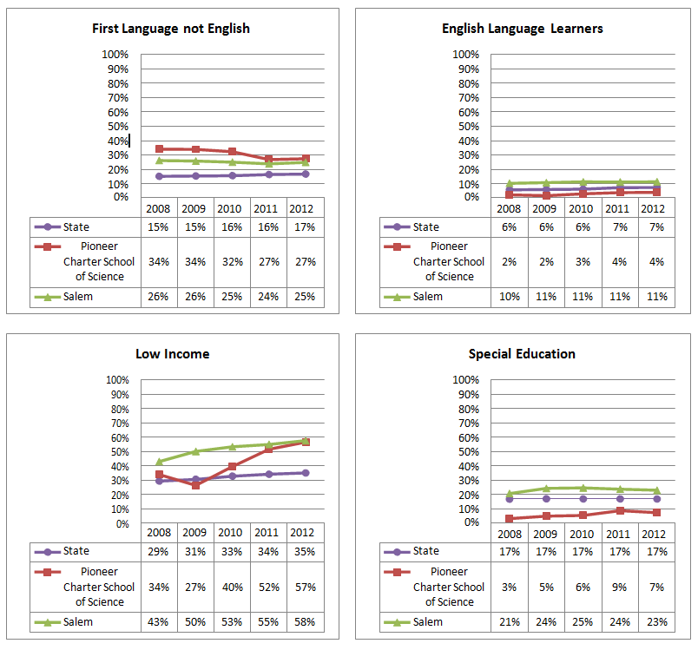

Proposed School Name: |  | Pioneer Charter School of Science II
Proposed Proven Provider: |  | Pioneer Charter School of Science Board of Trustees
General School Information: |  | Pioneer Charter School of Science, Everett, MA
Grades Served: | 7-12 | Current Max Enrollment: | 360
Year Opened: | 2007 | Renewed: | 2012

Enrollment by Race/Ethnicity - School Years 2007-2012

