AMENDMENT REQUEST – FEBRUARY 2013
School Name: | Community Day Charter Public School-Prospect
Amendment Request: | Additional seats- 69
Implementation: | 2013-2014
Year Charter/Opened: | Opened 1995; Renewed 2000, 2005, and 2010
Grades Served: | K1-8
Current Maximum Enrollment: | 331 | Wait List as of March 2012: 2,206
School Location: | Lawrence
Proven Provider Status Required? | Yes
Mission Statement:
“The mission of CDCPS is to provide a kindergarten through grade eight school that will draw upon our
considerable experience in working together as a community to develop and implement a curriculum that discovers and supports the special characteristics and unique learning styles of each student. We will engage that student in meaningful learning experiences for the purposes of clearly stated goals in the areas of understandings, knowledge, skills, habits, and social competencies. The School will reinforce the positive aspects of our city: its culture, art and economy, its working class history and strong work ethic. Our educational philosophy, curriculum and teaching methods are informed by an understanding that learning takes place in the context of family and that family must be supported in ways that make learning for the child possible.”
Nature of the Request:
The school is seeking an additional 69 seats for two primary reasons. The first is a response to demand for
its educational program, as evidenced by the sizable waitlist. Secondly, the school is seeking to align the maximum enrollment of all the schools in its network. The additional 69 seats would bring the flagship school's maximum enrollment to 400.

Strengths and Weaknesses related to Amendment Request: Strengths:
- The amendment request and recent accountability documentation contains information that indicates overall that the school’s academic program is a success, that the school is a viable
organization, and that it has been faithful to the terms of its charter.
- The school seeks to align the maximum enrollment number of all schools within its network, thereby increasing enrollment opportunities for students in Lawrence.
- The school has demonstrated sufficient demand for its educational program and maintains a waitlist in excess of 1,200 students.
- The Department’s framework for district accountability and assistance designates the school as Level 1 and in the 94th percentile.
- Independent financial audits have been conducted and the school has the financial resources to implement this request.

Weaknesses:
No weaknesses were identified.

Community Day Charter Public School-Prospect Page 1

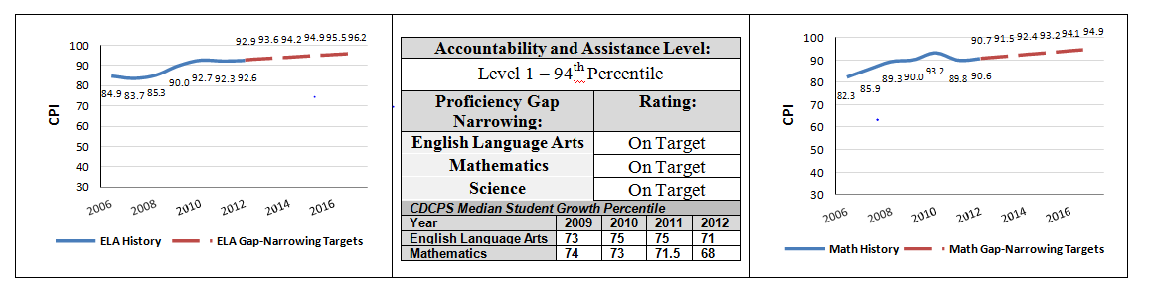

 | 2011-2012  Demographics (%) | African American | Asian | Hispanic | White | Multi- Race, Non- Hispanic | First Language Not English | Limited English Proficient | Special Education | Low- Income
 | Community Day  Charter Public School - Prospect | 1.8% | 1.2% | 89.4% | 7.6% | 0.0% | 82.2% | 35.6% | 13.9% | 74.9%
(21  Schools) | Comparison Minimum | 0.0% | 0.0% | 78.4% | 1.9% | 0.0% | 38.4% | 7.0% | 4.7% | 73.9%
 | Comparison Median | 1.5% | 0.6% | 92.3% | 4.2% | 0.2% | 70.3% | 24.9% | 18.1% | 87.3%
 | Comparison  Maximum | 4.9% | 5.9% | 96.9% | 15.9% | 1.6% | 92.8% | 48.8% | 93.1% | 98.1%
 | Comparison Total | 1.6% | 2.0% | 89.9% | 6.2% | 0.3% | 71.6% | 25.7% | 19.2% | 87.7%
 | State | 8.3% | 5.7% | 16.1% | 67.0% | 2.5% | 16.7% | 7.3% | 17.0% | 35.2%

