AMENDMENT REQUEST – FEBRUARY 2013
School Name: | Four Rivers Charter Public School
Amendment Request: | Additional seats-8
Implementation: | Effective upon approval
Year Charter/Opened: | Chartered 2002; Opened 2003; Renewed 2008
Grades Served: | 7-12
Current Maximum Enrollment: | 212 | Wait List as of March 2012: 66
School Location: | Greenfield
Regional? | Yes- Frontier Regional, Gill-Montague Regional, Greenfield,  Mohawk Trail Regional, Pioneer Regional, and Ralph C. Mahar Regional
Proven Provider Status Required? | No
Mission Statement:
“Four Rivers Charter Public School is dedicated to educating young people for lives of learning and
service. The school offers a rigorous academic program aligned with the Massachusetts curriculum frameworks and an emphasis on character development for moral and social responsibility. Three central themes - nature, technology, and community - pervade teaching and learning at the school, engaging students and teachers in a fundamental question of our times: how do we find the healthy, fruitful interrelationship of the natural world, technology in its many forms, and the human community? The school works closely with parents and seeks both to serve and to learn from the many resources of Franklin County.”
Nature of the Request:
The school requests 8 additional seats to reflect the school's present enrollment pattern and to allow the
school to support the enrollment of 36 students in each grade level.

Strengths and Weaknesses related to Amendment Request: Strengths:

The additional seats are to be added in the upper grades to allow the school to offer the maximum number of 36 seats per grade.
- The Department's framework for district accountability and assistance designates the school as level 2 and in the 72nd percentile.
- Through its renewal application, the school evidenced that its instructional approach has led to improved student performance.
- The school has previously successfully implemented a maximum enrollment increase of 20 during its most recent charter term.
- The current school facility is accessible and can accommodate the enrollment increase.

Weaknesses:
None identified.

Four Rivers Charter Public School Amendment P age 1

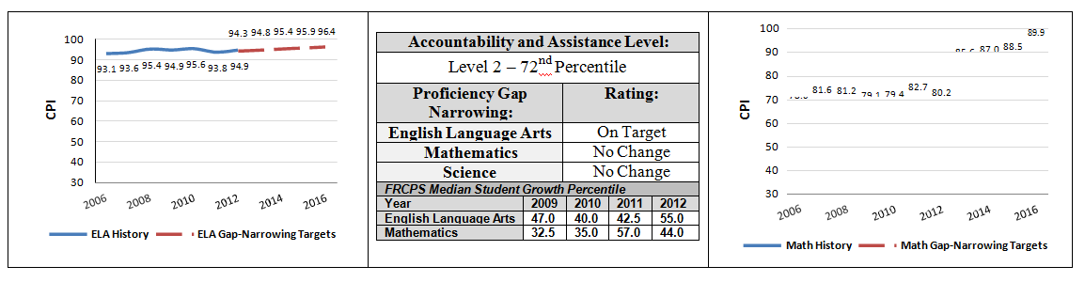

 | 2011-2012  Demographics (%) | African American | Asian | Hispanic | White | Multi- Race, Non- Hispanic | First Language Not English | Limited English Proficient | Special Education | Low- Income
 | Four Rivers Charter Public School | 1.0% | 2.4% | 4.8% | 89.4% | 1.9% | 1.9% | 0.5% | 15.9% | 22.1%
(11  Schools) | Comparison Minimum | 0.8% | 0.4% | 1.8% | 67.8% | 0.0% | 0.0% | 0.0% | 0.0% | 0.0%
 | Comparison Median | 1.9% | 1.7% | 5.7% | 88.4% | 3.0% | 3.4% | 0.9% | 18.1% | 33.4%
 | Comparison Maximum | 10.2% | 5.1% | 14.3% | 95.3% | 5.0% | 14.9% | 3.4% | 21.8% | 59.7%
 | Comparison Total | 2.5% | 1.7% | 6.4% | 85.9% | 3.0% | 3.9% | 1.2% | 15.8% | 35.9%
 | State | 8.3% | 5.7% | 16.1% | 67.0% | 2.5% | 16.7% | 7.3% | 17.0% | 35.2%

