AMENDMENT REQUEST – FEBRUARY 2013
School Name: | Pioneer Valley Chinese Immersion Charter School
Amendment Request: | Grade span- 9-12  Additional seats - 240 High School; 144 Lower School
Implementation: | 2013-2014
Year Charter/Opened: | Opened 2007; Renewed 2012
Grades Served: | K-8
Current Maximum Enrollment: | 300 | Wait List as of March 2012: 107
School Location: | Hadley
Regional? | Yes – Agawam, Amherst, Amherst-Pelham, Belchertown,  Chesterfield-Goshen, Chicopee, Conway, Deerfield, East Longmeadow, Easthampton, Frontier, Gill-Montague, Granby, Granville, Greenfield, Hadley, Hampden-Wilbraham, Hampshire, Hatfield, Hawlemont, Holyoke, Leverett, Longmeadow, Ludlow, Mohawk Trail, Northampton, Pelham, Pioneer Valley, Shutesbury, South Hadley, Southampton, Springfield, Sunderland, West Springfield, Westfield, Westhampton, Whately, Williamsburg, Southwick-Tolland.
Proven Provider Status Required? | Yes (Holyoke, Springfield)
Mission Statement:
“The Pioneer Valley Chinese Immersion Charter School (PVCICS) is a K-8th grade educational program that produces academically strong students highly proficient in Chinese and English. The program goals are: to develop proficiency in Mandarin Chinese; to maintain and extend students’ proficiency in English; to develop high levels of academic attainment, meeting or exceeding national and state standards, through rigorous study and instruction aligned with the Massachusetts Curriculum Frameworks; to develop students’ understanding of other cultures and the ability to interact successfully with others whose
language and/or culture differs from their own. PVCICS will serve the Pioneer Valley region and will offer a diverse group of students an innovative educational opportunity unavailable in Massachusetts. PVCICS will work to disseminate the school’s experiences and serve as a resource for schools trying to develop similar programs.”
Nature of the Request:
Pioneer Valley Chinese Immersion Charter School has a total of three (3) amendment requests. First, the
school is proposing to add an additional 144 seats to its lower school citing backfilling requirements as the main reason. Currently, students are admitted in grades kindergarten and 6 however, backfilling of vacancies in the lower grades could force the school to eliminate the grade 6 entry point and/or reduce kindergarten enrollment. The additional 144 seats would support backfilling, an entering student population of 44 kindergarten students, and an additional 20 students entering in grade 6.

The second and third requests are the addition of the grades 9-12 with an additional 240 high school seats. The school cited increased waitlists, parental demand, the opportunity for current students to remain enrolled, and the potential absence of seats by FY14 as the reasons for the additional requests.
Strengths and Weaknesses related to Amendment Request:
Strengths:
- The school was renewed with conditions in 2012 related to governance and oversight of the PVCICS board of trustees. The conditions have been substantially met and the school is working to
comply with the all elements of its action plan. The conditions are anticipated to be removed.

- The school offers a unique opportunity for a Chinese Immersion program in Massachusetts that is nationally and internationally recognized.
- The school has created an enrollment bubble with its present enrollment pattern and had to turn away a cohort of sixth grade students in the fall of 2012.
- The school plans to model the high school curriculum after the International Baccalaureate (IB) curriculum model, and currently employs staff with experience in implementing an IB curriculum.
- The school has had stable academic success.
- The school has worked to disseminate best practices locally and nationally.
- This plan would allow current students to continue with their education at PVCICS.

Weaknesses:
- The school has not been fully enrolled at its maximum enrollment of 300 students.
- PVCICS requires space for separate Chinese and English classrooms in its immersion model. The school will need more space if expansion is granted and may need to transport students between the current location and temporary facilities. School leaders reported that the school has struggled to
secure financing due to its conditions.
- The school did not provide a staffing plan for the request, although noted that the principal would oversee implementation.
- The school has not demonstrated sufficient demand for a high school other than informal anecdotes of parental interest.
- The school was unable to provide a realistic growth projection for a fully enrolled high school.
- Maintaining an enrollment entry point at 9th grade would create three different Chinese Immersion tracks among students that may pose implementation challenges.

Academic Performance and Demographic Data

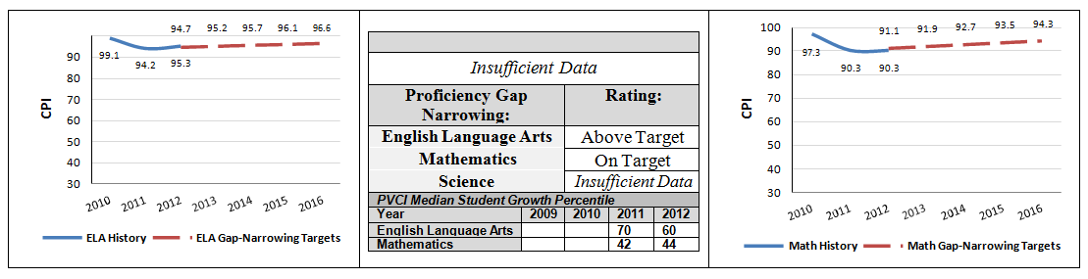

 | 2011-2012  Demographics (%) | African American | Asian | Hispanic | White | Multi- Race, Non- Hispanic | First Language Not English | Limited English Proficient | Special Education | Low- Income
 | Pioneer Valley  Chinese Immersion Charter School | 2.5% | 18.3% | 4.1% | 58.5% | 16.6% | 9.5% | 2.1% | 4.6% | 14.1%
(195  Schools) | Comparison  Minimum | 0.0% | 0.0% | 0.0% | 2.0% | 0.0% | 0.0% | 0.0% | 0.2% | 0.0%
 | Comparison  Median | 2.7% | 1.6% | 12.8% | 77.6% | 2.2% | 7.9% | 2.4% | 16.8% | 40.2%
 | Comparison  Maximum | 33.6% | 13.3% | 96.6% | 100.0% | 12.8% | 73.8% | 50.0% | 100.0% | 98.6%
 | Comparison  Total | 7.6% | 2.6% | 28.6% | 58.5% | 2.4% | 15.6% | 8.0% | 17.9% | 49.8%
 | State | 8.3% | 5.7% | 16.1% | 67.0% | 2.5% | 16.7% | 7.3% | 17.0% | 35.2%

Pioneer Valley Chinese Immersion Charter School

Demographic Data: Selected Populations
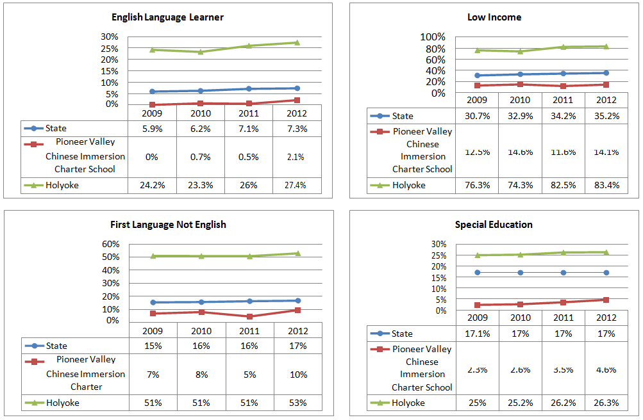
Note: Holyoke residents represent 6.5% of the present student population.

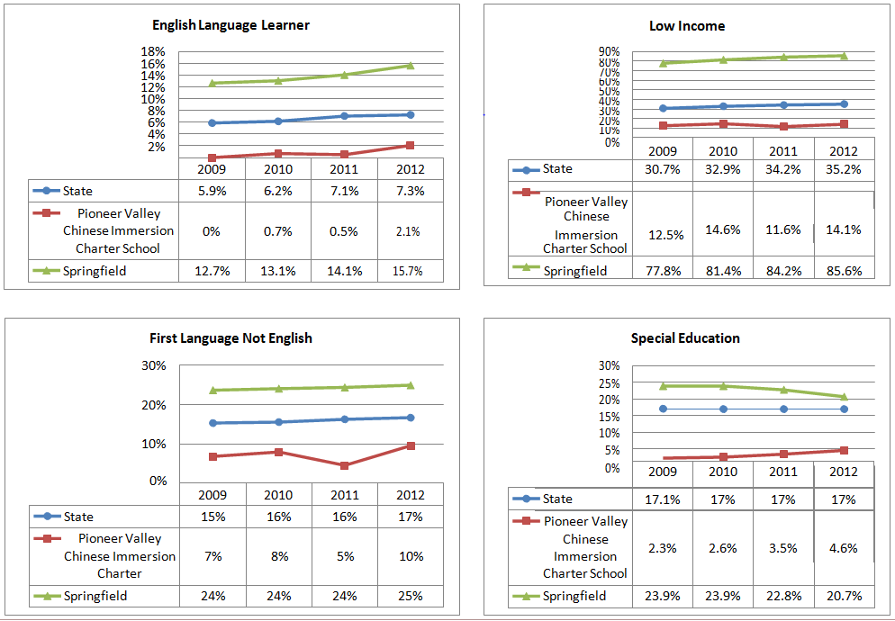

Pioneer Valley Chinese Immersion Charter School
Demographic Data: Selected Populations
Note: Springfield residents represent 5.1% of the present student population.

