Proposed School Name: |  | Argosy Collegiate Charter School (proposed grades 5-12)
Proposed Proven Provider: |  | Building Excellent Schools
General School Information: |  | Boston Preparatory Charter Public School
Grades Served: | 6-12 | Current Max Enrollment: | 400
Year Opened: | 1998 | Renewed: | 2003, 2008

Selected Populations - School Years 2007-2012
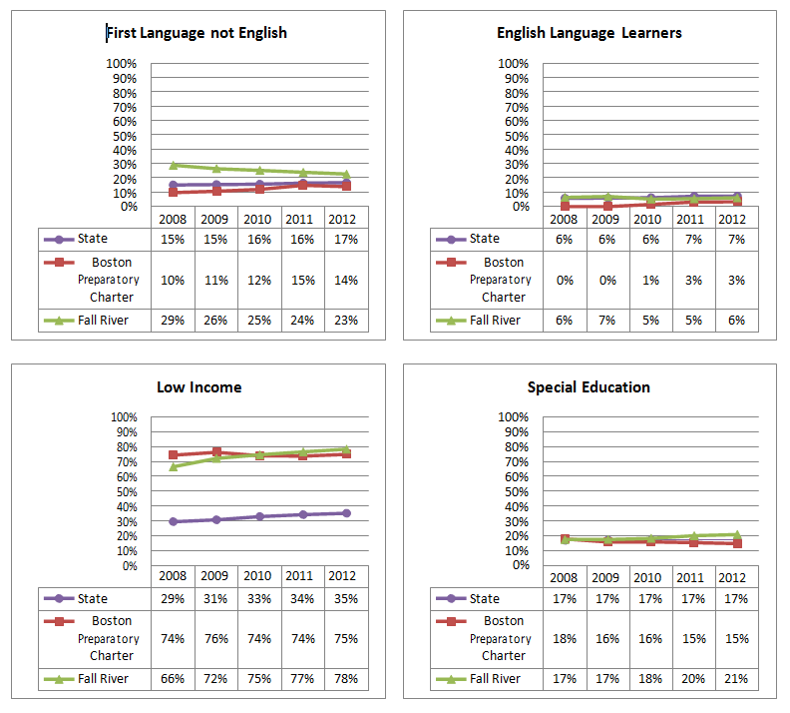
Proposed School Name: |  | Argosy Collegiate Charter School (proposed grades 5-12)
Proposed Proven Provider: |  | Building Excellent Schools
General School Information: |  | Boston Preparatory Charter Public School
Grades Served: | 6-12 | Current Max Enrollment: | 400
Year Opened: | 1998 | Renewed: | 2003, 2008

Enrollment by Race/Ethnicity - School Years 2007-2012
