Proposed School Name: |  | Argosy Collegiate Charter School (proposed grades 5-12)
Proposed Proven Provider: |  | Building Excellent Schools
General School Information: |  | Excel Academy Charter School, Boston, MA
Grades Served: | 5-8 | Current Max Enrollment: | 300
Year Opened: | 2003 | Renewed: | 2008

Selected Populations - School Years 2007-2012

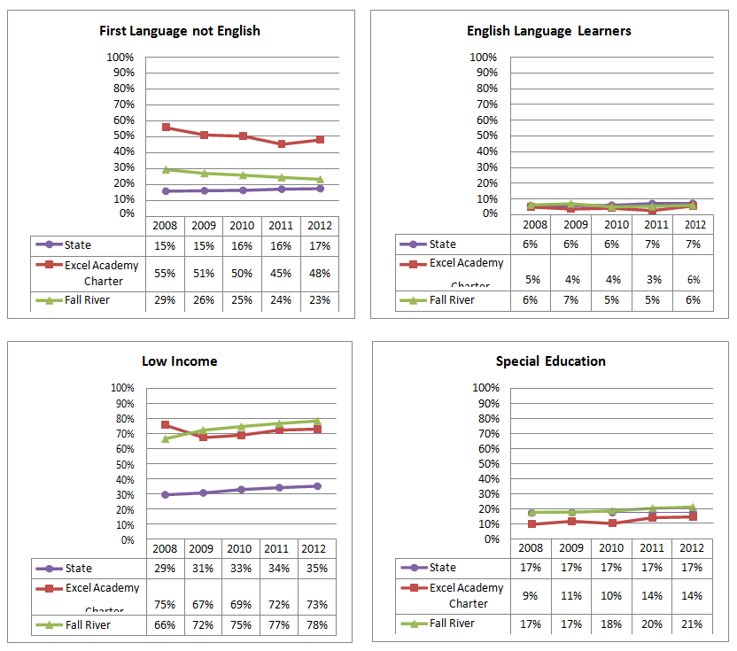

Proposed School Name: |  | Argosy Collegiate Charter School (proposed grades 5-12)
Proposed Proven Provider: |  | Building Excellent Schools
General School Information: |  | Excel Academy Charter School, Boston, MA
Grades Served: | 5-8 | Current Max Enrollment: | 300
Year Opened: | 2003 | Renewed: | 2008

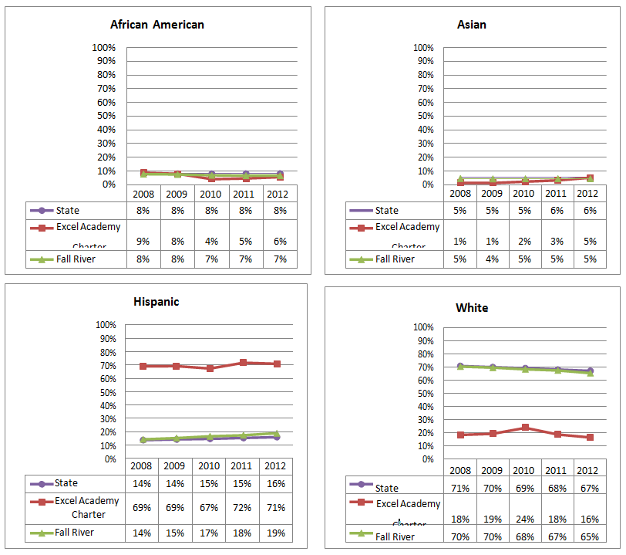
Enrollment by Race/Ethnicity - School Years 2007-2012

