Proposed School Name: |  | YouthBuild Charter Academy (proposed grades 9-12)
Proposed Proven Provider: |  | Lawrence Family Development Education Fund
General School Information: |  | Lawrence Family Development Charter School, Lawrence, MA
Grades Served: | K-8 | Current Max Enrollment: | 800
Year Opened: | 1995 | Renewed: | 2000, 2005, 2010

Selected Populations - School Years 2007-2012

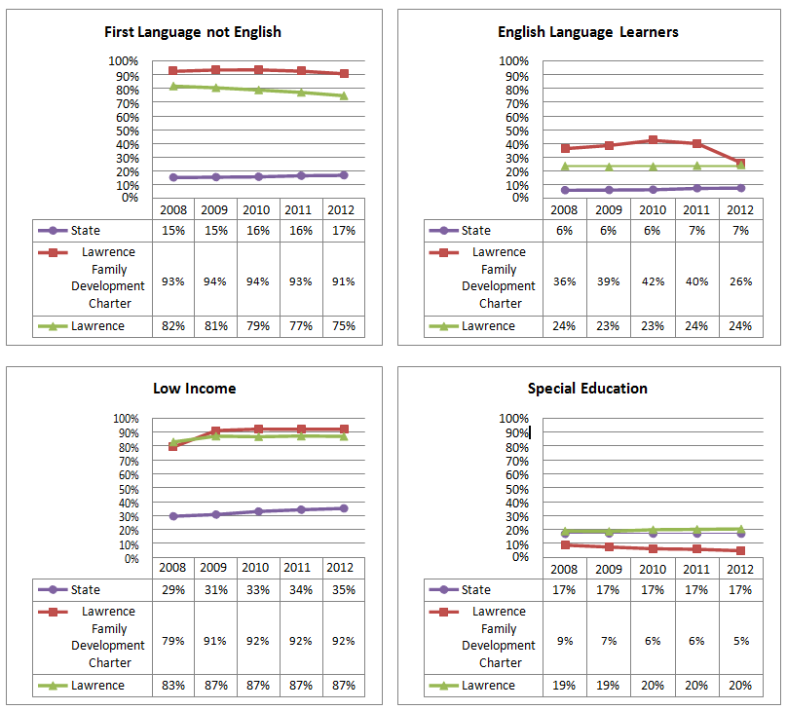

Proposed School Name: |  | YouthBuild Charter Academy (proposed grades 9-12)
Proposed Proven Provider: |  | Lawrence Family Development Education Fund
General School Information: |  | Lawrence Family Development Charter School, Lawrence, MA
Grades Served: | K-8 | Current Max Enrollment: | 800
Year Opened: | 1995 | Renewed: | 2000, 2005, 2010

Enrollment by Race/Ethnicity - School Years 2007-2012

