Massachusetts Department of

Elementary and Secondary Education

75 Pleasant Street, Malden, Massachusetts 02148-4906 Telephone: (781) 338-3000

TTY: N.E.T. Relay 1-800-439-2370

Mitchell D. Chester, Ed.D.
Commissioner

MEMORANDUM

To: | Members of the Board of Elementary and Secondary Education
From: | Mitchell D. Chester, Ed.D., Commissioner
Date: | February 15, 2013
Subject: | Charter Schools – Report on Conditions for Boston Renaissance Charter Public School and Recommendation for Probation

This memorandum provides a report on conditions for Boston Renaissance Charter Public School (BRCPS). I am recommending that the Board of Elementary and Secondary Education (Board) remove the enrollment condition placed on the charter of BRCPS, but that the Board place the school on probation with new academic conditions.

Boston Renaissance Charter Public School

Mission statement

“The Boston Renaissance Charter Public School is an urban K-6 school committed to providing a vibrant educational experience for Boston children. We strive to nurture and develop children academically, socially, and emotionally, in a stimulating supportive environment.”

Type of Charter | Commonwealth | Location | Boston
Regional/Non-Regional | Non-Regional | Districts in Region | N/A
Year Opened | 1995 | Year(s) Renewed | 2000, 2005, 2010
Maximum Enrollment | 944 | Current Enrollment | 952
Students on Waitlist | 1,391 | Chartered Grade Span | K-6

In 2005, the Board renewed the charter of BRCPS with conditions regarding academic achievement and requiring a reduction in grade span from pre-kindergarten through grade twelve to pre-kindergarten through grade six. In February 2007, the Board placed the school on probation for failing to meet the academic achievement conditions of renewal. The Board imposed additional conditions on the school’s charter requiring the school to relocate to a facility more conducive to a school program and further reduce enrollment from 1,240 to 880 students by September 2009.

In November 2008, the Board granted the school’s request to extend the deadline for relocation of the school and reduction of enrollment to September 2011. The Board also extended the school’s probation until the school’s renewal decision during the 2009-10 school year. In August 2009, BRCPS requested a second extension of the timeframe for reducing enrollment to 880 students until September 2012. In December 2009, the Board voted to renew BRCPS, to continue the school’s probation, and retained the requirement that the school reduce its enrollment. In December 2010, the Board voted to remove BRCPS from probation because the school had demonstrated progress in meeting the probationary conditions, but voted to continue the conditions on the school’s charter requiring a reduction in enrollment. In August 2011 the school asked for the removal of the enrollment condition. The Board gave the school additional time to reduce enrollment, until 2013.

In August 2012, BRCPS requested the enrollment condition be removed and its maximum enrollment be increased to 1,000. BRCPS’s amendment request noted that 58 positions have been cut over the past two years and essential programming eliminated due to the financial hardship brought about by the reduction in enrollment.

Condition

The following condition was imposed in December 2011:

Boston Renaissance Charter Public School will reduce its enrollment to 880 students by September 2013, in accordance with enrollment of no more than:
- 944 students in September 2012 and
- 880 students in September 2013.

Report on Condition

According to data submitted to the Student Information Management System (SIMS) on or about October 1, 2012, BRCPS currently enrolls 952 students from Boston in kindergarten through grade six. While the 2012 enrollment is 8 students over the 944 limit that the Board set, the school has made progress on meeting this condition.

Academic Performance
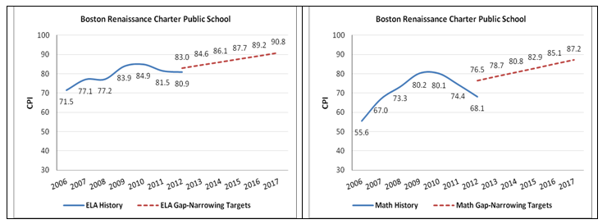

BRCPS Median Student Growth Percentile
Year | 2009 | 2010 | 2011 | 2012
English Language Arts | 35.0 | 33.0 | 29.0 | 34.0
Mathematics | 45.5 | 34.0 | 31.0 | 32.0

Recommendation

As shown in the graphs above, student performance at BRCPS is very troubling. Particularly in mathematics, BRCPS has not demonstrated adequate growth or strong overall achievement. Median student growth percentiles have been below the state median in ELA and mathematics for the past four years.

As noted above, the school reports that the financial burden of reduced enrollment has limited staffing, supports, and programming provided to students. Given that the school has substantially met the enrollment requirement for 2012 and given that a further reduction in enrollment would only negatively impact the school’s program, I am recommending the removal of the enrollment condition and the establishment of 944 as the school’s maximum enrollment.

The academic performance of BRCPS, however, is certainly not what is expected from a mature charter school. I recommend that the Board place BRCPS on probation with the imposition of academic conditions. The school is scheduled to apply for renewal of its charter in the summer of 2014. I expect that we will see substantial improvement in BRCPS’s academic outcomes prior to a renewal decision.

Academic Conditions:

- No later than April 30, 2013, the school shall submit to the Charter School Office a comprehensive evaluation of the school’s mathematics and English language arts programs conducted by an external consultant.

- No later than June 15, 2013, the school shall submit to, and receive approval from, the Charter School Office for an action plan that specifies strategies to improve mathematics and English language arts performance. The action plan must address implementation of a proven curriculum and instruction program for mathematics. The action plan must include a timetable for the implementation of actions, must set deadlines for the completion of key tasks, and must set clear and specific implementation benchmarks to allow the school’s board of trustees and the Charter School Office to monitor implementation.

- The school must demonstrate that it is an academic success by December of 2014 by providing evidence that the school has met or is making substantial progress toward meeting benchmarks in its approved Accountability Plan and, in particular, has demonstrated significant and sustained academic improvement in mathematics and English language arts.

**********************

If you have any questions regarding this recommendation or require additional information, please contact Cliff Chuang, Associate Commissioner (781-338-3222); Jeff Wulfson, Deputy Commissioner (781-338-6500); or me.

Attachment: Motion

