Proposed School Name: |  | City on a Hill Charter Public School II
Proposed Proven Provider: |  | City on a Hill Charter School Board of Trustees
General School Information: |  | City on a Hill Charter Public School, Boston, MA
Grades Served: | 9-12 | Current Max Enrollment: | 280
Year Opened: | 1995 | Renewed: | 2000, 2005, 2010

Selected Populations - School Years 2007-2012
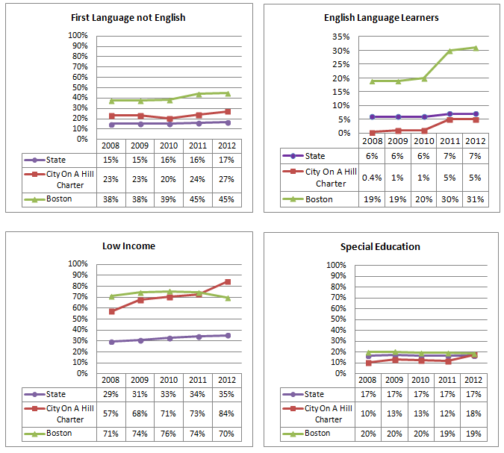

Proposed School Name: |  | City on a Hill Charter Public School II
Proposed Proven Provider: |  | City on a Hill Charter School Board of Trustees
General School Information: |  | City on a Hill Charter Public School, Boston, MA
Grades Served: | 9-12 | Current Max Enrollment: | 280
Year Opened: | 1995 | Renewed: | 2000, 2005, 2010

Enrollment by Race/Ethnicity - School Years 2007-2012
