Amendment Request – February 2013
School Name: | Academy of the Pacific Rim Charter School
Amendment Request: | Additional seats- 45
Implementation: | 2013-2014
Year Charter/Opened: | Chartered 1995; Opened 1997; Renewed 2002, 2007, and 2012
Grades Served: | 5-12
Current Maximum Enrollment: | 500 | Wait List as of March 2012: 989
School Location: | Boston
Proven Provider Status Required? | Yes
Mission Statement:

“Our mission is to empower urban students of all racial and ethnic backgrounds to achieve their full intellectual and social potential by combining the best of the East – high standards, discipline, and character education, with the best of the West – a commitment to individualism, creativity, and diversity.”
Nature of the Request:
The school has experienced a decrease in attrition in the middle school grades and the transition to ninth grade. With a new enrollment pattern that reflects both increased student retention and the backfilling requirements for grades 5 - 8, the school is experiencing larger classes in grades 7 and 8 and a greater number of students matriculating into the high school grades. The increase in maximum enrollment will allow the school to support the new enrollment pattern.

Strengths and Weaknesses related to Amendment Request:
Strengths:
- The amendment request and recent accountability documentation contains information that indicates overall that the school’s academic program is a success, that the school is a viable organization, and that it has been faithful to the terms of its charter.
- The addition of 45 additional seats will not interrupt the school's mission and educational program.
- In March 2012, the school was renewed with a condition related to the implementation of its special education program. The condition has been met and is expected to be removed.
- The school has demonstrated sufficient demand for its educational program with an excess of 1,000 applications in 2012.
- The Department's framework for district accountability and assistance designates the school as Level 1 and in the 70th percentile.
- The school has a staffing plan to address the increased high school enrollment. An additional 9th grade teacher was hired in 2011-2012 and an additional 10th grade teacher will subsequently be hired. Additional staff will be hired in FY2014.
- Plans are in place to renovate the existing mezzanine to provide for additional high school classroom space.
- The school is financially viable and able to invest in capital projects.

Weaknesses:
None identified.

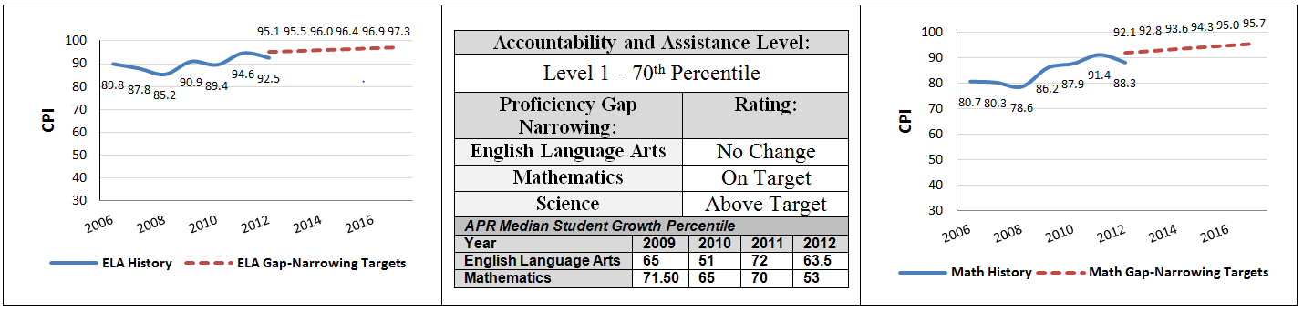
Academy of the Pacific Rim Charter School
Academic Performance and Demographic Data

Org Code | 2011-2012  Demographics (%) | African American | Asian | Hispanic | White | Multi-Race, Non-Hispanic | First Language Not English | Limited English Proficient | Special Education | Low-Income
 | Academy Of the Pacific Rim Charter Public School | 56.8% | 2.6% | 17.4% | 19.8% | 3.4% | 9.6% | 0.6% | 18.8% | 50.2%
(110 Schools) | Comparison Minimum | 1.5% | 0.0% | 9.4% | 0.0% | 0.0% | 0.0% | 0.0% | 1.2% | 28.7%
 | Comparison Median | 35.2% | 2.4% | 43.1% | 7.7% | 1.7% | 42.0% | 28.0% | 18.5% | 74.1%
 | Comparison Maximum | 75.8% | 56.6% | 90.8% | 62.3% | 6.6% | 100.0% | 94.7% | 98.4% | 92.1%
 | Comparison Total | 33.9% | 8.4% | 43.0% | 12.5% | 1.8% | 44.8% | 30.3% | 18.3% | 69.6%
State | State | 8.3% | 5.7% | 16.1% | 67.0% | 2.5% | 16.7% | 7.3% | 17.0% | 35.2%

Academy of the Pacific Rim Charter School
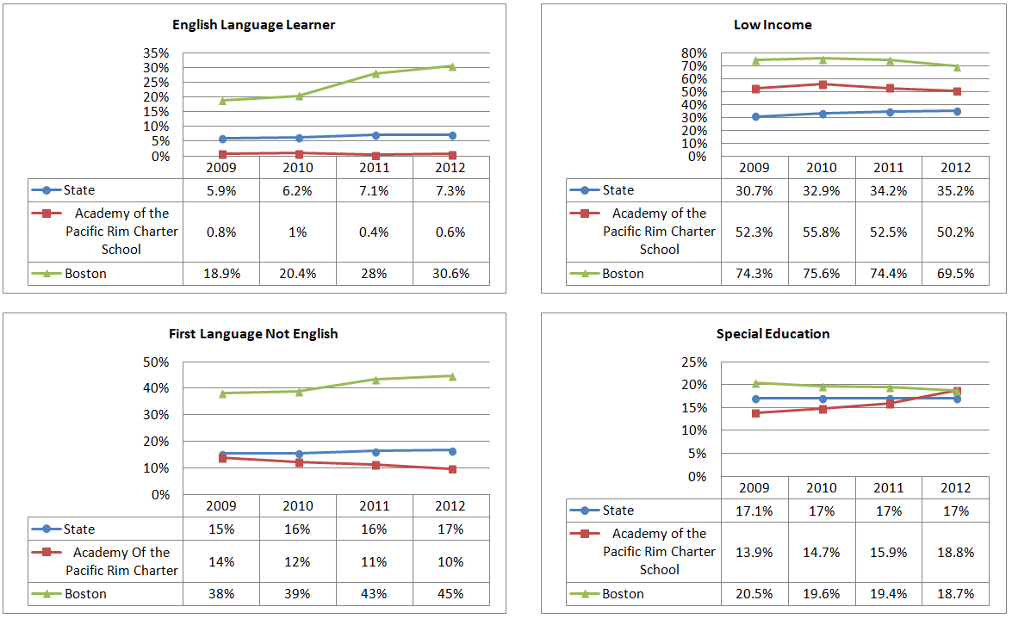
Demographic Data: Selected Populations

