Amendment Request – February 2013
School Name: | Codman Academy Charter Public School (Codman Academy)
Amendment Request: | Additional seats - 200 and Grade served - K1-8
Implementation: | 2013-2014
Year Charter/Opened: | Opened 2001; Renewed 2006, and 2011
Grades Served: | 9-12
Current Maximum Enrollment: | 145 | Wait List as of March 2012: 574
School Location: | Hyde Park
Proven Provider Status Required? | Yes
Mission Statement:
“ To prepare students for full participation in the intellectual, economic, and civic life of society, by ensuring their preparation for and access to further education, the skills and vision to undertake a rewarding career, and the motivation and character needed to engage deeply and productively in community life. We view parents and community members as integral partners in this endeavor.”
Nature of the Request:
The school seeks to expand into a K1-12 school with a maximum enrollment of 345 students. The addition of 200 seats will be used to establish grades K1-8, each consisting of 20 students per grade. The school proposes a gradual growth plan by implementing grades K1, K2, and 1 for the 2013-2014 school year. Grades will be added as the student cohorts proceed through the program. Since the original amendment request was submitted, school leaders report that they would not implement the 6th grade during the first year.

Strengths and Weaknesses related to Amendment Request:
Strengths:
- The amendment request and recent accountability documentation contains information that indicates overall that the school’s academic program is a success, that the school is a viable organization, and that it has been faithful to the terms of its charter.
- Codman Academy was renewed without conditions in 2011.
- The school leader and current principal both have elementary education experience.
- The school is deeply committed to serving the Codman Square area.
- The school will implement Expeditionary Learning (EL) Curriculum in the lower grades, has access to a national database of curriculum resources, and has identified Conservatory Lab as its local EL partner.
- The school will implement Responsive Classroom for the lower grades.
- The school makes a compelling argument for the need for a K-8 school in the area it serves.
- The school plans to continue to maintain an enrollment point at 9th grade to allow opportunities for more students (15-20 seats on average for 9th grade entry).
- The school has a strong commitment to dissemination. It is currently one of 17 EL Mentor Schools and has worked with the Margarita Muniz Academy Innovation School.
- The school leader currently serves on the Boston Public Schools committee.

Weaknesses:
Codman Academy has had a historically low graduation rate. The 2012 four year graduation rate is 62.5%.

Codman Academy Charter Public School
Academic Performance and Demographic Data

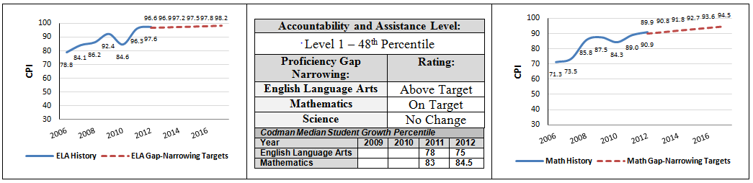

20202011-2012  Org Code | 2011-2012  Demographics (%) | African American | Asian | Hispanic | White | Multi-Race, Non-Hispanic | First Language Not English | Limited English Proficient | Special Education | Low-Income
 | Codman Academy Charter Public School | 84.6% | 1.3% | 11.4% | 2.0% | 0.0% | 22.1% | 2.0% | 22.8% | 69.1%
(31 Schools) | Comparison Minimum | 11.6% | 0.0% | 9.4% | 0.0% | 0.0% | 18.9% | 0.6% | 1.2% | 28.7%
 | Comparison Median | 40.4% | 3.2% | 38.6% | 6.6% | 1.4% | 40.0% | 18.9% | 20.7% | 75.6%
 | Comparison Maximum | 66.8% | 51.9% | 65.5% | 48.0% | 5.3% | 100.0% | 94.7% | 98.4% | 88.0%
 | Comparison Total | 36.8% | 11.5% | 35.7% | 14.0% | 1.5% | 42.0% | 19.4% | 17.9% | 66.7%
State | State | 8.3% | 5.7% | 16.1% | 67.0% | 2.5% | 16.7% | 7.3% | 17.0% | 35.2%

Codman Academy Charter Public School
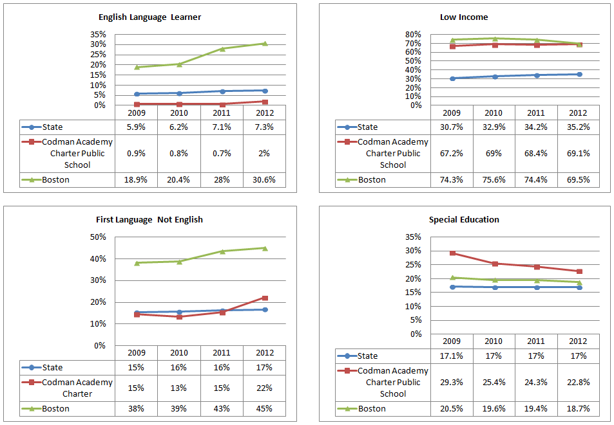
Demographic Data: Selected Populations

