Amendment Request – February 2013
School Name: | Conservatory Lab Charter School (Conservatory Lab)
Amendment Request: | Additional seats-275 and Grades served-7, 8
Implementation: | 2013-2014
Year Charter/Opened: | Opened 1999; Renewed 2004, and 2009
Grades Served: | K1-6
Current Maximum Enrollment: | 169 | Wait List as of March 2012: 883
School Location: | Brighton
Proven Provider Status Required? | Yes
Mission Statement:
“The CLCS will engage all children by using the Learning Through Music Curriculum model to ensure every child’s academic, creative, and social success, as validated by qualitative and quantitative measures.”
Nature of the Request:
With limited options for Conservatory Lab students to continue their studies in a music-based academic program, the school seeks to expand to a K1-8 model with an additional 275 seats. The grade expansion will proceed with the addition of grade 7 in 2013-2014 and grade 8 in 2014-2015. The increase in enrollment will be distributed over specific grades during a four year period with 142 students added the first year. The school expects to be fully expanded in the 2016-2017 school year.

Strengths and Weaknesses related to Amendment Request:
Strengths:
- The amendment request and recent accountability documentation contains information that indicates overall that the school’s academic program is a success, that the school is a viable organization, and that it has been faithful to the terms of its charter.
- The school has demonstrated high demand for its seats.
- The school offers a unique music program to Boston area students.
- The conditions placed on the school during its 2009 renewal were met and subsequently removed by the Board of Elementary and Secondary Education in February 2011. The three conditions were related to implementation of its Learning Through Music program and ensuring a programmatically accessible facility.
- The school is identified as Level 1 in the Department's framework for district accountability and assistance.
- The addition of a 7th and 8th grade will address attrition issues for students who had previously left in 6th grade for other middle school options.
- The school plans to expand its Expeditionary Learning (EL) model to the 7th and 8th grades.
- The school is working with a real estate broker to find and purchase its own facility. It has options for temporary space if required.
- The school has a strong teacher pipeline based on its partnerships with Simmons College and Wheelock College.

Weaknesses:
- Despite the school’s Level 1 status, it is in the 34th percentile relative to other elementary schools.
- The school plans to grow quickly by adding nearly double the student population in one year (142).
- The school has not yet developed curriculum for the new grades, although they do have content experts on staff and access to resources through an EL School Designer and the EL school network.

Conservatory Lab Charter School
Academic Performance and Demographic Data
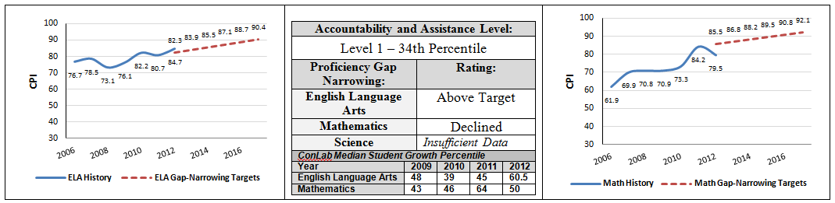

Org Code | 2011-2012  Demographics (%) | African American | Asian | Hispanic | White | Multi-Race, Non-Hispanic | First Language Not English | Limited English Proficient | Special Education | Low-Income
 | Conservatory Lab Charter School | 37.4% | 7.6% | 26.3% | 24.6% | 4.1% | 33.9% | 21.1% | 9.4% | 63.2%
(92 Schools) | Comparison Minimum | 1.5% | 0.0% | 17.2% | 0.3% | 0.0% | 0.0% | 0.0% | 7.4% | 32.7%
 | Comparison Median | 31.2% | 2.4% | 42.5% | 8.3% | 2.0% | 42.9% | 30.2% | 18.4% | 74.6%
 | Comparison Maximum | 75.8% | 56.6% | 90.8% | 62.3% | 6.6% | 86.5% | 71.4% | 98.4% | 92.1%
 | Comparison Total | 33.1% | 7.1% | 45.8% | 11.5% | 2.1% | 45.9% | 35.6% | 19.8% | 71.8%
State | State | 8.3% | 5.7% | 16.1% | 67.0% | 2.5% | 16.7% | 7.3% | 17.0% | 35.2%

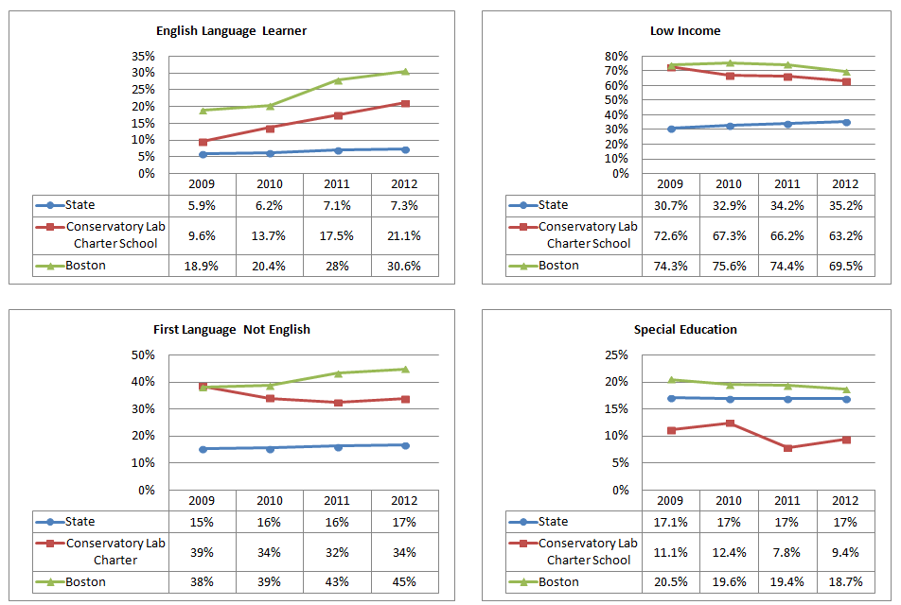
Conservatory Lab Charter School
Demographic Data: Selected Populations

