Proposed School Name: |  | ‘Brooke 4’ Charter School
Proposed Proven Provider: |  | Edward W. Brooke Charter School Board of Trustees
General School Information: |  | Edward W. Brooke, Boston, MA
Grades Served: | K-8 | Current Max Enrollment: | 475
Year Opened: | 2002 | Renewed: | 2007, 2012

Selected Populations - School Years 2007-2012
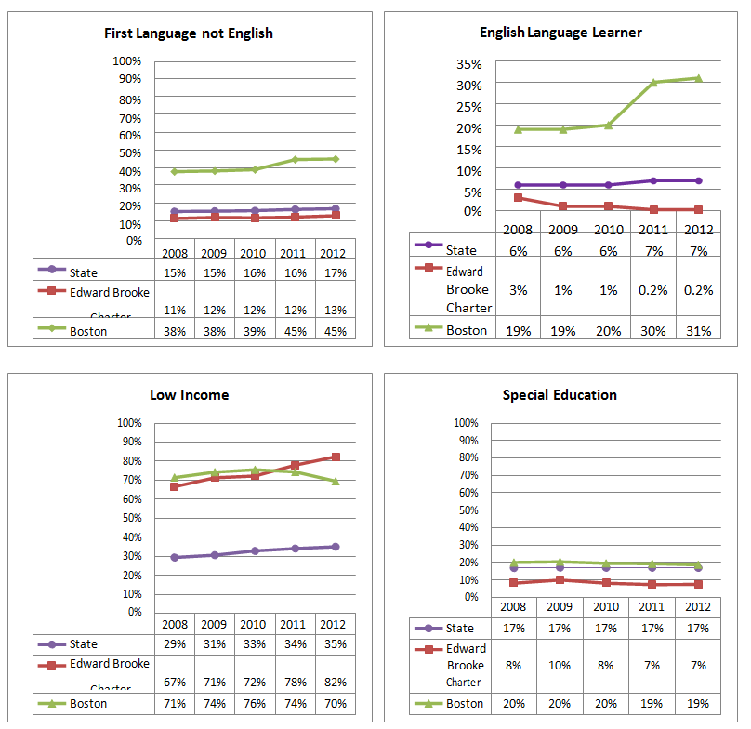

Proposed School Name: |  | ‘Brooke 4’ Charter School
Proposed Proven Provider: |  | Edward W. Brooke Charter School Board of Trustees
General School Information: |  | Edward W. Brooke, Boston, MA
Grades Served: | K-8 | Current Max Enrollment: | 475
Year Opened: | 2002 | Renewed: | 2007, 2012

Enrollment by Race/Ethnicity - School Years 2007-2012
