Amendment Request – FebRUARY 2013
School Name: | Excel Academy Charter School (Excel)
Amendment Request: | Consolidate 3 charters (maintain 9-12)  Additional seats-136 (Boston); 236 (Chelsea)
Implementation: | Fall 2015
Year Charter/Opened: | Chartered 2003; Renewed 2008
Grades Served: | 5-8
Current Maximum Enrollment: | 300 | Wait List as of March 2012: 636  (across the three Excel schools-987)
School Location: | East Boston
Regional? | Yes – Boston, and Chelsea
Proven Provider Status Required? | Yes
Mission Statement:
“Excel Academy Charter School’s mission is to prepare middle school students to succeed in high school and college, apply their learning to solve relevant problems, and engage productively in their communities.”
Nature of the Request:
The school requests to consolidate 3 charters, increase the maximum enrollment to 1,344, and create a single 5-12 grade span for all of the school's seats.

The school seeks to transfer to the flagship school 228 seats from Excel-Chelsea, 448 seats from Excel-Boston II, and the 9-12 grade span of Excel-Boston II. In addition, the school would like to add 236 Chelsea seats and 136 Boston seats for the 9-12 grades. Under this proposal, Excel Academy would become a 5-12 school with a maximum enrollment of 1,344 students; 560 seats for Chelsea and 784 seats for Boston. The middle and high school programs would enroll 672 students each.

Strengths and Weaknesses related to Amendment Request:
Strengths:
- The board of trustees (board) presently operates two 5-8 schools and one 5-12 school. The original flagship school is in its second charter term; has had continued success with its educational program; and is identified as a Level 1 school under the Department's framework for district accountability and assistance. The recently added network schools are in their second and first year of operation.
- The amendment request indicates that the board desires to guarantee a high school seat to all Excel eighth graders. Presently, a high school program will be available only to students enrolled at Excel-Boston II, opened in 2012. The board believes the requested additional seats and consolidation are the only avenue that will allow Excel students at all three schools to have access to the planned high school.

Weaknesses:
- The school was unable to provide a realistic growth projection for a fully enrolled high school. There was no planning for attrition at the high school grades to support the 672 enrollment. School leadership anticipates the attrition rate would average 5-10%.
- Without a method to ensure preferential enrollment to Excel eighth graders to the high schools, the additional seats would not guarantee access to those students.

Excel Academy Charter School
Academic Performance and Demographic Data

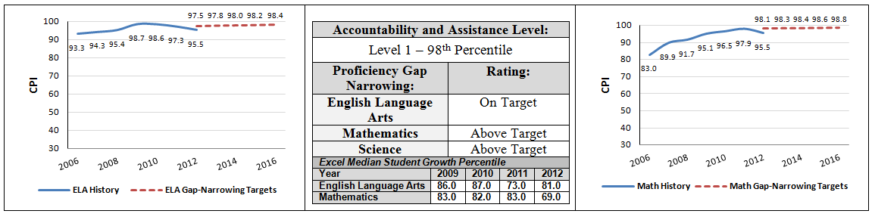

Org Code | 2011-2012  Demographics (%) | African American | Asian | Hispanic | White | Multi-Race, Non-Hispanic | First Language Not English | Limited English Proficient | Special Education | Low-Income
 | Excel Academy Charter School | 5.7% | 5.2% | 71.0% | 16.2% | 1.4% | 47.6% | 5.7% | 14.3% | 72.9%
(91 Schools) | Comparison Minimum | 1.5% | 0.0% | 9.4% | 0.3% | 0.0% | 0.0% | 0.0% | 1.2% | 28.7%
 | Comparison Median | 29.5% | 2.3% | 42.2% | 8.3% | 1.8% | 43.6% | 29.4% | 18.3% | 74.7%
 | Comparison Maximum | 75.8% | 56.6% | 90.8% | 62.3% | 6.6% | 86.5% | 71.1% | 98.4% | 92.1%
 | Comparison Total | 31.1% | 9.1% | 43.6% | 13.9% | 1.9% | 45.5% | 30.5% | 17.5% | 69.1%
 | State | 8.3% | 5.7% | 16.1% | 67.0% | 2.5% | 16.7% | 7.3% | 17.0% | 35.2%

Excel Academy Charter School
Demographic Data: Selected Populations
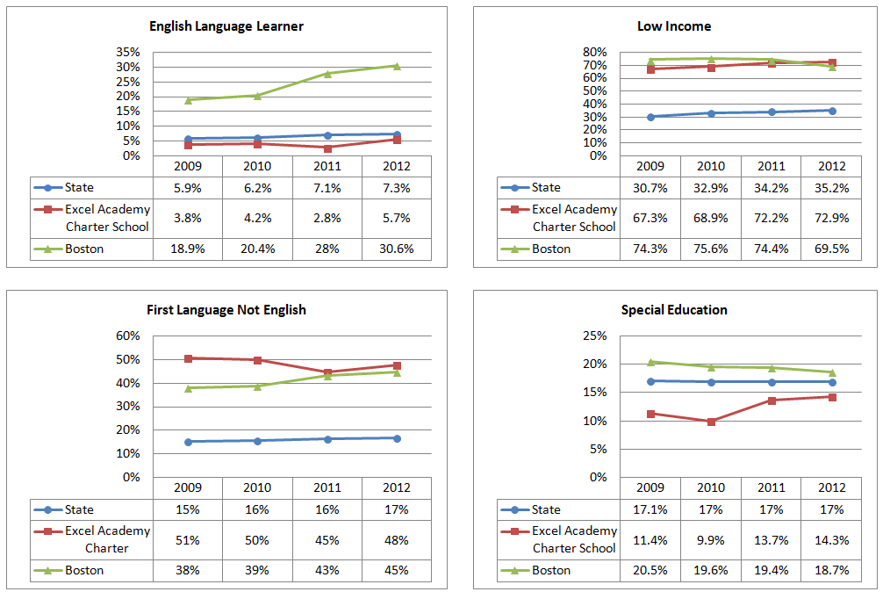
Excel Academy Charter School
Demographic Data: Selected Populations
