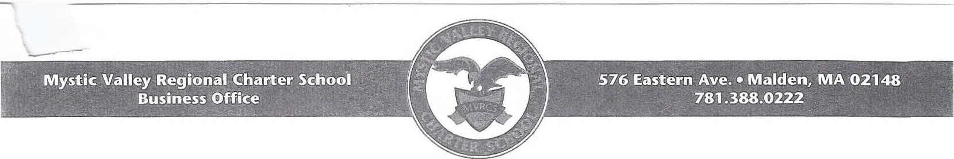

July 30, 2012

Dr. Mitchell D. Chester
Commissioner of Elementary and Secondary Education Massachusetts Department of Elementary and Secondary Education 75 Pleasant Street
Malden, MA 02148

Dear Commissioner Chester,

On behalf of the Mystic Valley Regional Charter School (MVRCS) Board of Trustees, I respectfully request your approval to amend our charter allowing for an increase to our maximum enrollment. In response to the needs of our current families and the overwhelming interest in our school, it is our desire to increase our enrollment cap gradually from its present 1,500 students to 1,900 students over a 12-year period. This change to our charter will be effective upon the approval of the Commissioner or the Board of Elementary and Secondary Education and would be implemented in the FY 13 school year with the addition of 47 students. The school, located in Malden, MA, was originally chartered in 1998 and has completed two successful renewals. It is currently chartered through June 30, 2013.

The Board of Trustees is submitting its request to make this change for three primary reasons:
- With our full Kindergarten enrollments and our current retention rates, we have nearly reached our cap of 1,500 students. Although siblings are permitted to bypass the lottery, we would not be able to enroll them without waivers for years to come.
- For the second year in a row, two of our sending districts, Malden and Everett, have increased their cap, currently at 14 percent.
- As indicated in Section A, we have a wait list that exceeds 2,500 within our regional sending district. Enclosed in Exhibit 1 is our current enrollment, by community, as of June 27, 2012. I am enclosing Exhibit 2, which is a projection of our future enrollment based on a progressive expansion plan. Our charter indicates that we do not accept new students to the school beyond the 5th grade (except for sibling preference). We intend to continue this model.

The MVRCS Board of Trustees voted to approve this request on June 25, 2012 at a meeting held in compliance with Massachusetts Open Meeting Law G.L. c. 30A, s. llA l/2. At that meeting, the Board of Trustees authorized me to submit this request on its behalf.

We believe that we have a strategic plan to handle this increased enrollment that will allow us to remain true to our charter and continue to be a viable financial school district In November, 2011, we completed construction of a new school facility at 576 Eastern Avenue and moved our Kindergarten students from 770 Salem Street to our new facility. Earlier this month, we were informed by the Malden Redevelopment Authority that we are the recommended responder to purchase the Emerson School Building at 230 Highland Avenue. This building is strategically
located two blocks from our high school building . We expect to close on that property in September, 2012.

-----

The Mystic Valley Regional Charter School is an academic success, a viable organization, and it is faithful to the terms of its charter, as you will see in the enclosed response to evaluation criteria for increasing student enrollment. The school has just completed its 13m year and considers itself to be financially and academically viable.

The Mystic Valley Regional Charter School Board of Trustees requests that the Board of Elementary and Secondary Education or the Commissioner approve this request as soon as it can. Enclosed, please find responses to the Evaluation Criteria for Requested Changes in Maximum Enrollment.

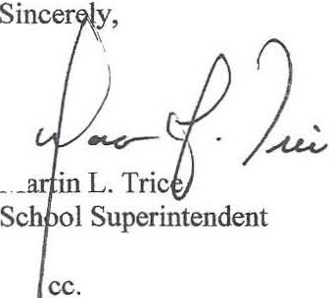
Please contact Martin Trice, mtrice@rnvrcs.org or 781-388-0222, ext. 2103 if you have any questions about this request.

M

Mystic Valley Regional Charter School Board of Trustees
Mr. Barry Barnett, Acting Director - Charter School Office Enclosures

