AMENDMENT REQUEST – FEBRUARY 2013
School Name: | Mystic Valley Regional Charter School
Amendment Request: | Additional seats- 400
Implementation: | 2013-2014
Year Charter/Opened: | Chartered 1998; Renewed 2003, and 2008
Grades Served: | K-12
Current Maximum Enrollment: | 1,500 | Wait List as of March 2012: 2,448
School Location: | Malden
Regional? | Yes – Everett, Malden, Medford, Melrose, Stoneham, and  Wakefield
Proven Provider Status Required? | Yes (Everett)
Mission Statement:
“The mission of the Mystic Valley Regional Charter School is to provide the opportunity of a world class
education characterized by a well mannered, disciplined and structured academic climate. Central to Mystic Valley’s academic environment is the incorporation of selected core virtues and the fundamental ideals of our American Culture, which are embodied in the Declaration of Independence and the United States Constitution.”
Nature of the Request:
The school is requesting an additional 400 seats over 12 years; increasing its maximum enrollment from
1,500 to 1,900 students. The enrollment increase will begin in 2013-2014 with an additional 47 seats offered and an average of 27 seats added each year over time. The school indicates that full kindergarten enrollment and current retention rates bring the school close to reaching its enrollment cap of 1,500 students; the school states that siblings experience difficulty entering from the school's waitlist. The school has a waitlist in excess of 2,500 and its sending districts, with the exception of Malden, have seats available under the net school spending cap to meet the continuing demand.

Strengths and Weaknesses related to Amendment Request: Strengths:
- The school has demonstrated sufficient demand for its educational program and maintains a waitlist in excess of 2,000 students.
- The Department's framework for district accountability and assistance designates the school as Level 1 and in the 64th percentile.
- The school completed construction of a new facility in November 2011.
- The school's implementation plan includes incorporating one additional classroom (including teacher and assistant) per year starting in 2013-2014 until fully expanded.
- The school’s academic design is centered on research-based curricular models. The school incorporates Direct Instruction, Core Knowledge, Saxon Math, and International Baccalaureate as the primary components of the general K-12 curriculum structure.

Weaknesses:
- Specific concerns have been raised repeatedly surrounding board governance and adherence to open meeting law requirements.
- Deficiencies were noted in the school’s FY2011 and FY2012 financial audits.

Mystic Valley Regional Charter School Amendment Page 1

Academic Performance and Demographic Data

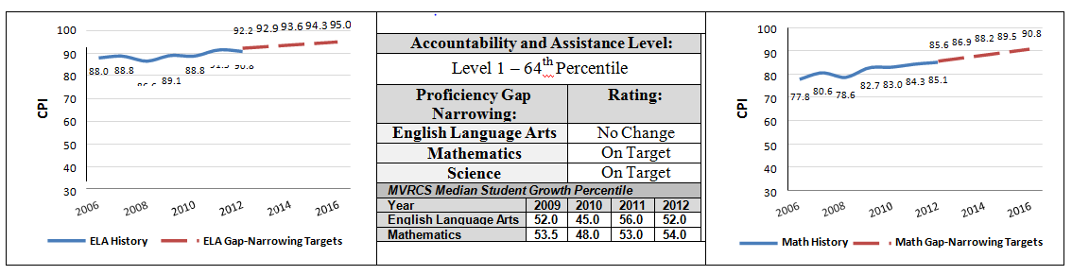

 | 2011-2012  Demographics (%) | African American | Asian | Hispanic | White | Multi- Race, Non- Hispanic | First Language Not English | Limited English Proficient | Special Education | Low- Income
 | Mystic Valley Regional Charter School | 16.5% | 13.8% | 5.0% | 61.1% | 3.3% | 16.1% | 0.0% | 11.2% | 22.0%
(42  Schools) | Comparison  Minimum | 0.0% | 0.0% | 0.8% | 26.1% | 0.0% | 0.0% | 0.0% | 5.5% | 4.7%
 | Comparison Median | 12.0% | 4.7% | 7.3% | 71.6% | 2.6% | 12.8% | 3.5% | 15.0% | 31.9%
 | Comparison  Maximum | 27.9% | 32.8% | 52.0% | 93.9% | 6.8% | 64.1% | 28.9% | 100.0% | 89.8%
 | Comparison Total | 13.3% | 9.1% | 16.3% | 58.2% | 2.6% | 27.6% | 8.6% | 14.7% | 44.0%
 | State | 8.3% | 5.7% | 16.1% | 67.0% | 2.5% | 16.7% | 7.3% | 17.0% | 35.2%

Demographic Data: Selected Populations
Note: Everett residents represent 12.7% of the present student population.
