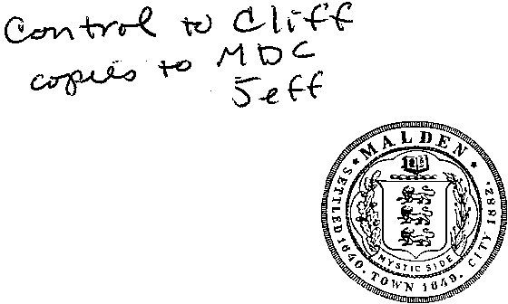
Malden Government Center Two Hundred Pleasant Street
Malden, Massachusetts 02148 City of Malden

COUNCIL OFFICE ROOM609
(781) 397-7130
FAX: (781) 397-7004
citycouncil@cityofmalden.org
Massachusetts

April l0,2013

Mitchell D. Chester, Commissioner
Massachusetts Department of Elementary and Secondary Education 75 Pleasant Street
Malden, MA 02148

Dear Commissioner Chester:

We are writing in regards to your decision to deny Mystic Valley Regional Charter School's request to increase student enrollment and are appealing to you based upon MVRCS' outstanding record of academic success and how your denial will adversely impact the entire Malden Public School system.

As you are aware, MVRCS is a Level I school district and has consistently ranked among the very best schools in Massachusetts. In 2012 MVRCS ranked second best in Massachusetts according to Newsweek Magazine and in 2011 Newsweek ranked MVRCS fourth. Further, U.S. News & World Report Magazine has recognized MVRCS three times as one of the top high schools in the country and recently placed
them as the gth best public high school in the Commonwealth.

Clearly, well-respected and independent publications agree with us that MVRCS is among the best schools in our state and the nation. We believe that this type of success should support an increase in MVRCS enrollment. There are approximately 2,700 students on the MVRCS "Waiting List" and our hope is that you will allow MVRCS to add a modest 35 students a year for the next 12 years. This will allow these students to pursue the top-notch educational opportunities that MVRCS has to offer.

Additionally, your denial may lead to the loss of approximately $1.5 million in Capital Improvements for other Malden Public Schools. This is because the City was planning to dedicate the proceeds from the sale of surplus property, the Emerson School, which MVRCS was going to purchase and rehabilitate. However, now, because of your denial, MVRCS has no reason to proceed with this purchase and, as a result, the City may now have to abandon plans for new roofs, security enhancements and other school maintenance projects.

As we have seen with other MVRCS projects across Malden, the prospect of them redeveloping the Emerson School is very advantageous for the City. We are asking that you allow their enrollment increase, with hopes that the sale of the Emerson School can be back on, allowing the City to utilize this much needed revenue to improve and maintain our school buildings.

Sincerely,

David D'Arcangelo Councillor-at-Large
Neal Anderson Council President
Craig Spadafora Councillor-at-Large
John Matheson Councillor- Ward Three

