Massachusetts Department of

Elementary and Secondary Education

75 Pleasant Street, Malden, Massachusetts 02148-4906 Telephone: (781) 338-3000

TTY: N.E.T. Relay 1-800-439-2370

Mitchell D. Chester, Ed.D.
Commissioner

MEMORANDUM

To: | Members of the Board of Elementary and Secondary Education
From: | Mitchell D. Chester, Ed.D., Commissioner
Date: | January 17, 2014
Subject: | Charter Schools – Report on Conditions and Recommendation for Probation for Global Learning Charter Public School

This memorandum provides a report on conditions for Global Learning Charter Public School (GLCPS). Based upon the evidence presented below, GLCPS has not fully met the conditions that were imposed on its charter when it was renewed in 2012. Additionally, the school’s academic performance has worsened since its 2012 renewal. I recommend that the Board of Elementary and Secondary Education (Board) place GLCPS on probation and impose new conditions on the school’s charter. Further, at this time, I am not considering the school’s renewed request for a major amendment to its charter to increase its maximum enrollment by 100 students.

Global Learning Charter Public School
Type of Charter | Commonwealth | Location | New Bedford
Regional/Non-Regional | Non-Regional | Districts in Region | N/A
Year Opened | 2007 | Year(s) Renewed | 2012
Maximum Enrollment | 500 | Current Enrollment | 501
Students on Waitlist | 211 | Grade Span in Charter | 5-12
Mission statement
The mission of Global Learning Charter Public School is to ensure that all students achieve academic excellence, are ready for the rigors of higher education, and master essential skills that prepare them for the economic, social, and civic challenges of a 21st century, global society. Our central mission is to teach and inspire the mind, body, and spirit of our students so that they can succeed in any cultural or academic setting.

Report on Conditions

In January 2012, under my delegated authority, I renewed the charter of GLCPS and placed two conditions on the school’s charter. Below is a summary of the school’s progress toward meeting the two conditions. GLCPS met one of the conditions, after the due date, and has not met the other. See the attached Year Seven Site Visit Report and Year Six Site Visit Report for additional information.

Condition 1: By December 31, 2013, Global Learning Charter Public School must demonstrate academic success in mathematics and English language arts (ELA) by:
- meeting academic growth targets in mathematics and ELA, as established by the Department of Elementary and Secondary Education,
- demonstrating improvement in absolute CPI scores, and
- meeting academic goals and objectives established in the school’s accountability plan.

Status: Not Met
The MCAS scores of students at GLCPS in 2012 and 2013 place the school in Level 3 in both years. In 2012, GLCPS was in the 15th percentile when compared to other schools of its type statewide; currently, its 2013 scores place GLCPS in the 13th percentile. Additionally, in order to meet academic growth targets established by the Department, a school must have a median student growth percentile (SGP) of 51 or greater. The school’s 2012 and 2013 median SGPs for mathematics and English language arts (ELA) were well below the state median of 51.

GLCPS Median SGP
Year | 2011 | 2012 | 2013
ELA (all grades) | 44.0 | 44.0 | 41.0
Mathematics (all grades) | 44.0 | 46.0 | 37.0

Since the renewal of the school with academic conditions, GLCPS has not demonstrated improvement in absolute Composite Performance Index (CPI) scores. Additionally, the school is not meeting its gap-narrowing targets. See the graphs below; the solid line displays the school’s CPI scores, the dashed line displays the school’s CPI targets.

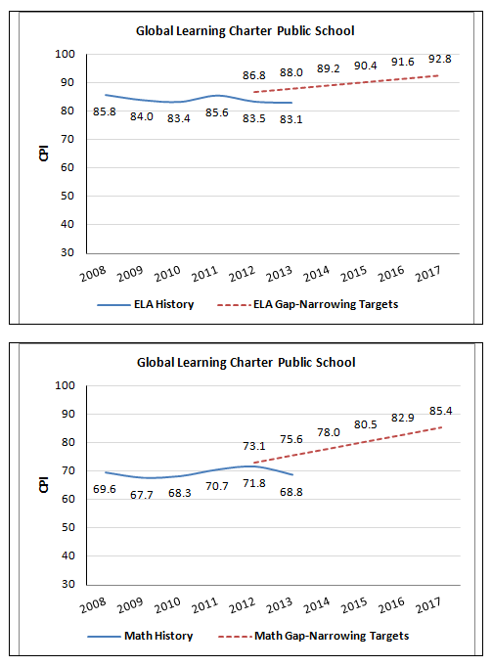

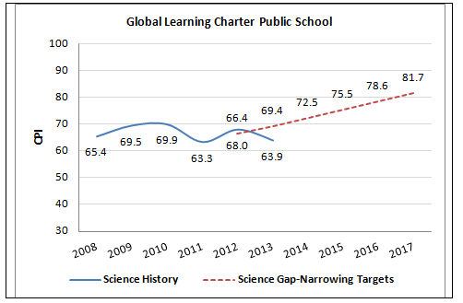

In 2012-13, GLCPS met a majority of its accountability plan goals. See the attached Year Seven Site Visit Report for further details.

Condition 2: By December 31, 2012, Global Learning Charter Public School must establish and operate a program of English language learner education in a manner consistent with the requirements of Massachusetts General Laws chapter 71A and all other applicable federal and state laws and regulations.

Status: Met after deadline
Following the charter renewal, the Department conducted site visits in November 2012 and June 2013 to review the school’s progress in establishing an ELL program. During these visits, the site visit team determined that the school had not yet established an ELL program that met applicable requirements. The school did not maintain complete ELL records for students; the school did not use appropriately licensed teachers to deliver ESL instruction; and English language instruction was not being sheltered for ELL students. The program also lacked policies and procedures and a program self-evaluation.

In a site visit on December 9, 2013, the Department determined that the school had addressed these issues. The school is now appropriately identifying and assessing students; students receive English as a second language instruction from appropriately licensed teachers; and students receive in-class language support. The ELL program now has written policies and procedures; required documentation is in student records; and the school has conducted a data-based self-evaluation of the program. An ESL curriculum is under development, and an approved trainer will provide additional teacher training in Sheltering English Instructional content beginning this month.

Recommendation

GLCPS is currently in its seventh year of operation as a Commonwealth charter school. Because the school has not met the academic condition imposed, I recommend placing the school on probation. The school must demonstrate sustained academic improvement by the end of its eighth year of operation in order to be removed from probation. If the school does not improve its academic results, I will consider revocation of the school’s charter at that time.

In order to fulfill the terms of probation, GLCPS must meet the following conditions:

- No later than April 30, 2014, the school shall submit to the Office of Charter Schools and School Redesign a comprehensive evaluation of the school’s mathematics and English language arts programs conducted by an external consultant, accepted and approved in advance by the Department.
- No later than June 15, 2014, the school shall submit to Department, and receive approval from the Department for, an action plan that specifies strategies to improve mathematics and English language arts performance. The action plan must include a timetable for the implementation of actions, must set deadlines for the completion of key tasks, and must set clear and specific implementation benchmarks to allow the school’s board of trustees and the Office of Charter Schools and School Redesign to monitor implementation.
- The school must demonstrate that it is an academic success by September 30, 2015, by providing evidence that the school has met or is making substantial progress toward meeting benchmarks in its approved Accountability Plan and, in particular, has demonstrated significant and sustained academic improvement in mathematics and English language arts.
**********************

If you have any questions regarding this recommendation or require additional information, please contact Cliff Chuang, Associate Commissioner (781-338-3222); Jeff Wulfson, Deputy Commissioner (781-338-6500); or me.

Attachment: Year 6 Site Visit Report for Global Learning Charter Public School
Year 7 Targeted Site Visit Report for Global Learning Charter Public School

