ESE

Within this report, there are six pages of graphs that provide longitudinal demographic comparison information for Excel Academy Charter School, Excel Academy Charter School – Chelsea, and Excel Academy Charter School – Boston II. On each of these pages, the graphs display the charter school of interest, and comparison schools that include all of the district public schools in the charter school’s region that serve at least one grade level of students which overlaps with the grade levels served by the charter school. All data displayed in these graphs are taken from publicly available information on ESE District and School Profiles (http://profiles.doe.mass.edu/). In school years where Excel Academy Charter School – Chelsea, and Excel Academy Charter School – Boston II were not yet in operation, the absence of student data was indicated with a dash within each table, or a graph was not included.

The first four pages of graphs provide comparison enrollment percentages for each school for four student subgroups: English language learners, first language not English, low-income, and students with disabilities. If available, data listed is displayed longitudinally across multiple years in line graph form, with:
- a bold black solid line (or a bold black dot) for the charter school of interest;
- a green dashed line for the statewide average;
- a blue solid line for the district in which the charter school is located;
- an orange dashed line for the median; and
- gray solid lines for each comparison school.

The subsequent two pages of graphs detail attrition rates in the aggregate and for the high needs student subgroup, for both Excel Academy Charter School and Excel Academy Charter School – Chelsea. Excel Academy Charter School – Boston II began school operations in 2012 and does not yet have attrition data. A student is high needs if he or she is designated as low income, an English language learner, former English language learner, or a student with disabilities. A former English language learner is a student not currently an English language learner, but had been at some point in the two previous academic years. Please note that the attrition graphs do not include district percentages (since attrition at the district-level cannot be reasonably compared to attrition at the school-level). If available, data listed is displayed longitudinally across multiple years in line graph form, with:
- a bold black solid line (or a bold black dot) for the charter school of interest;
- a green dashed line for the statewide average; and
- gray solid lines for each comparison school.

Following the six pages of demographic graphs, there are two pages of tables providing additional information regarding each school’s academic performance and additional student enrollment data, and a final three pages containing each school’s five year financial summary.

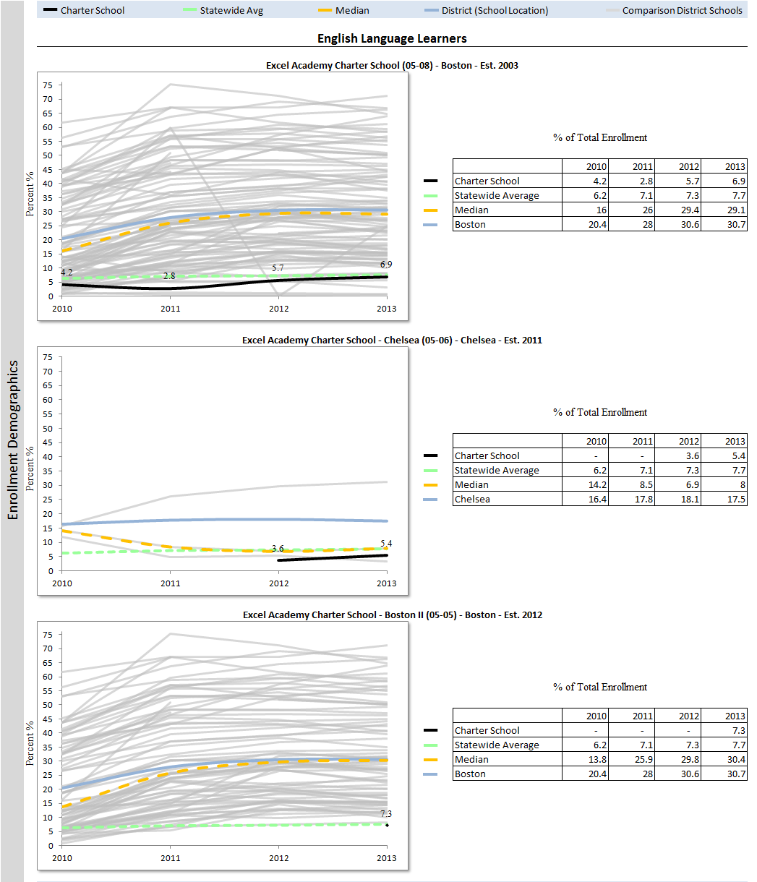
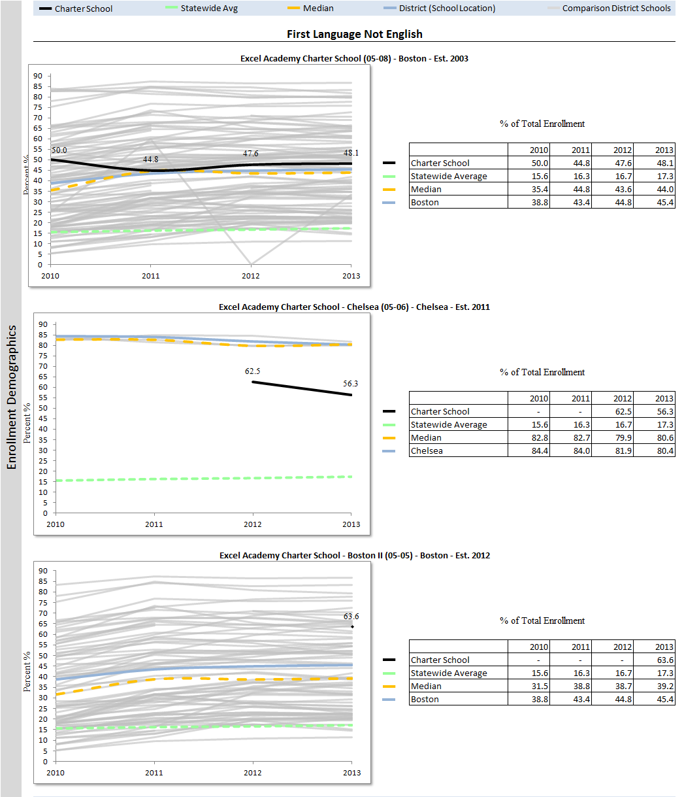

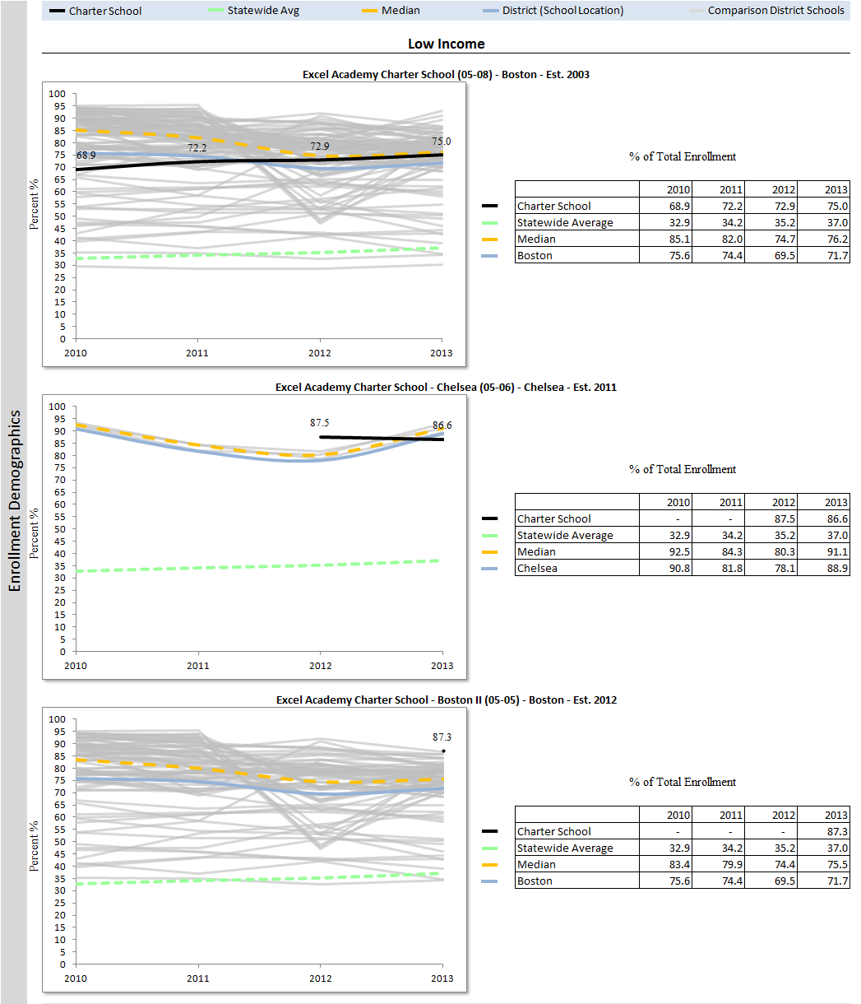
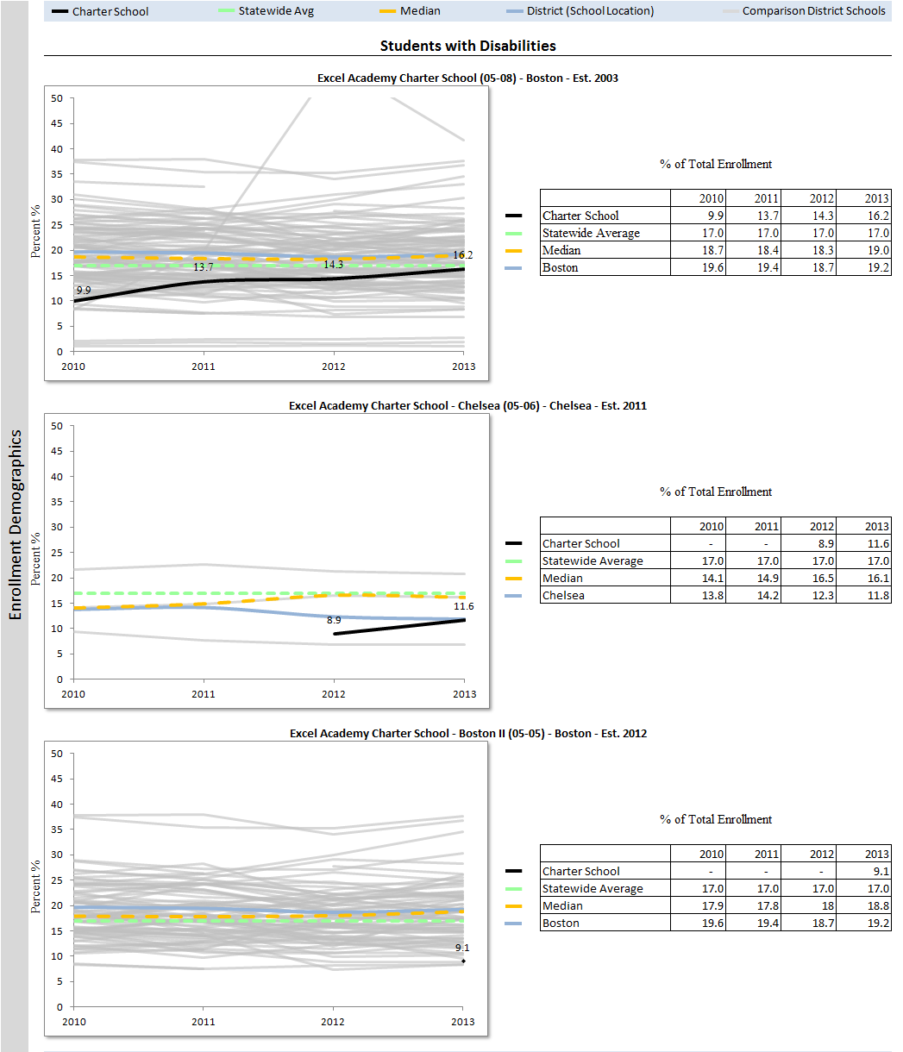
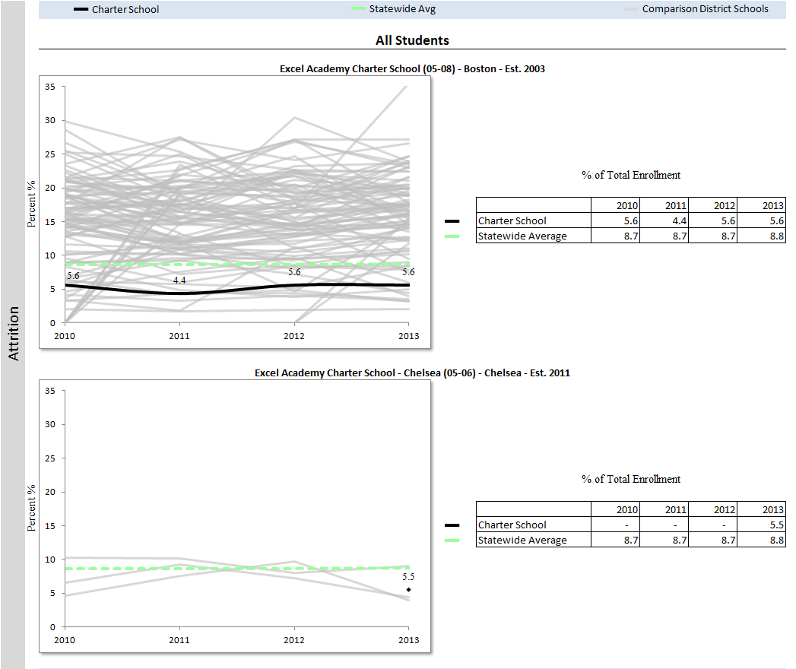
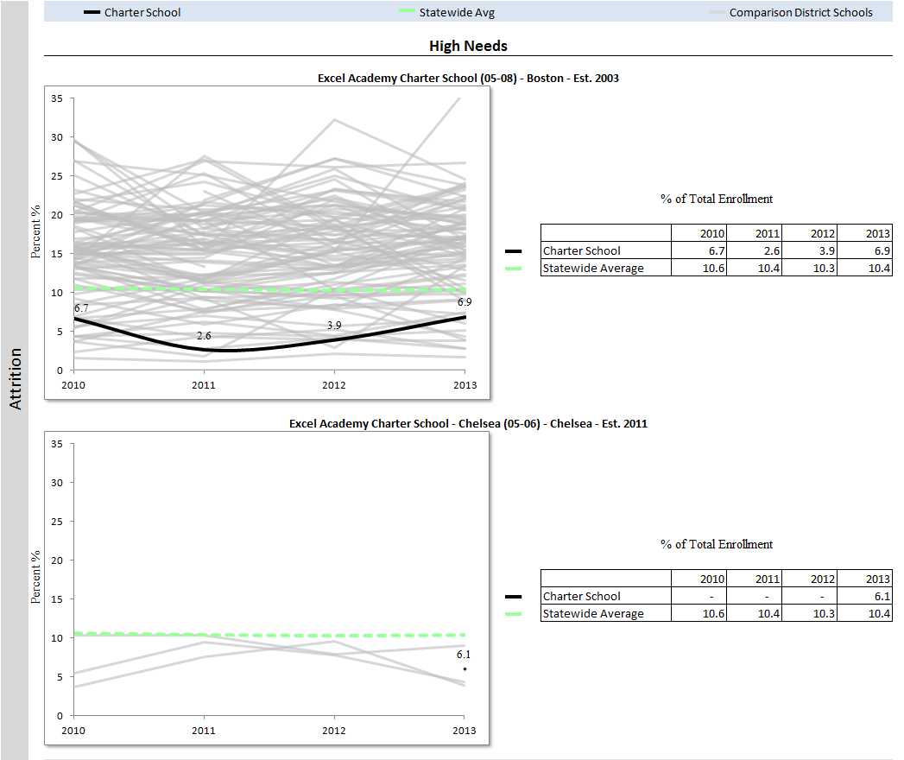

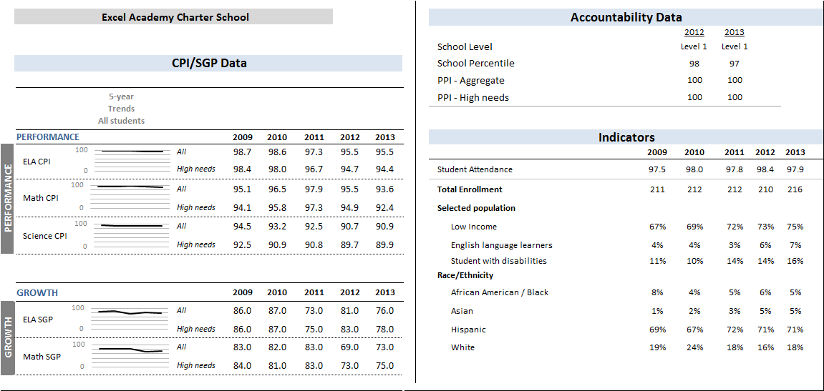
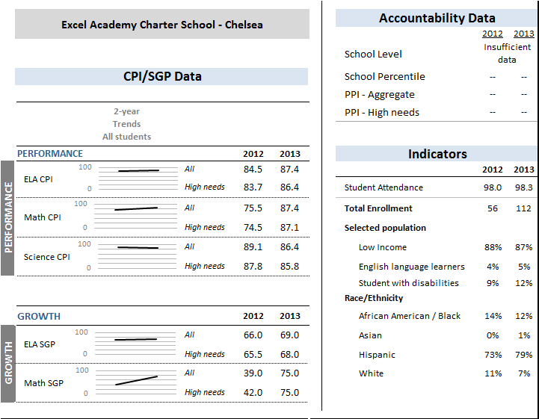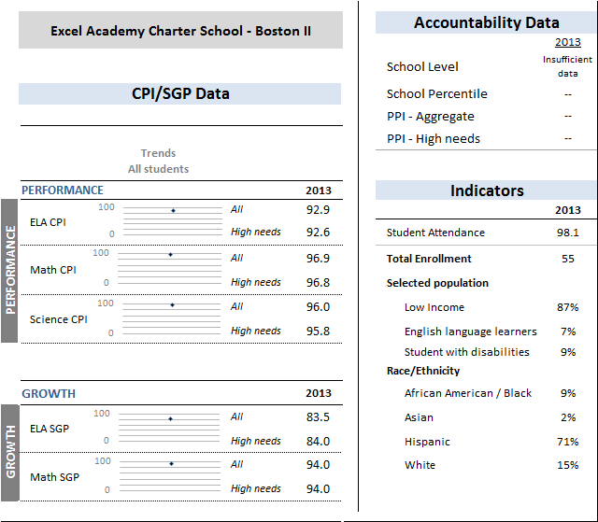
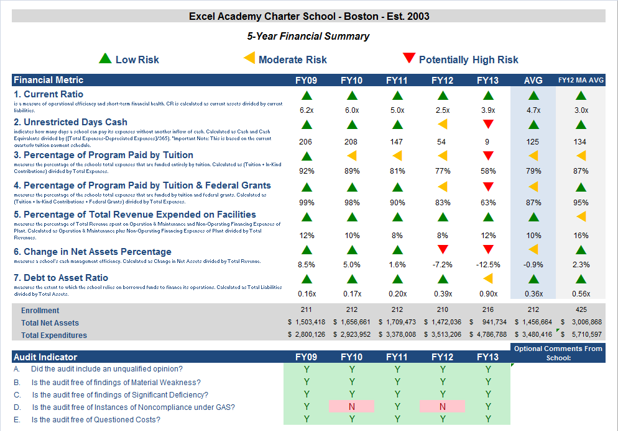
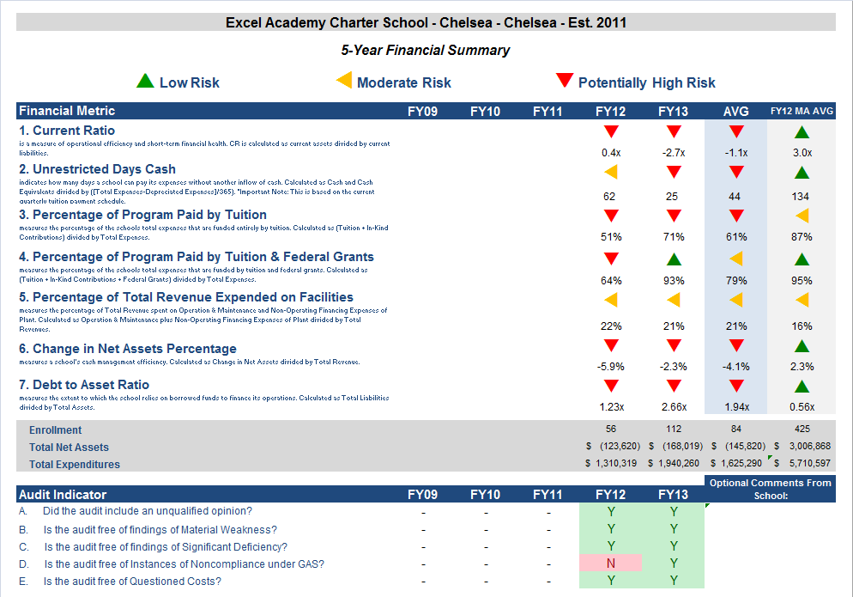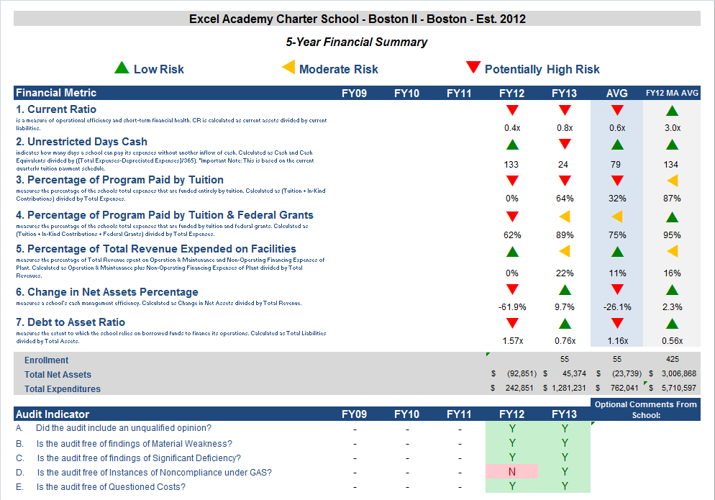
Financial Metric Definitions |  | Low Risk | Moderate Risk | Potentially High Risk
1. Current Ratio | Current Ratio is a measure of operational efficiency and short-term financial health. CR is calculated as current assets divided by current liabilities. | >= 1.5 | Between 1.0 (inclusive) and 1.5 | < 1.0
2. Unrestricted Days Cash | The unrestricted days cash on hand ratio indicates how many days a school can pay its expenses without another inflow of cash. Calculated as Cash and Cash Equivalents divided by (Total Expenses/365). | >= 90 days | Between 60 (inclusive) and 90 days | < 60 days
3. Percentage of Program Paid by Tuition | This measures the percentage of the schools total expenses that are funded entirely by tuition. Calculated as (Tuition + In-Kind Contributions) divided by Total Expenses (expressed as a percentage). Note: In-Kind Contribution are added to the numerator in this ratio to balance out In-Kind Expenditures which will be captured in the Total Expenses in the denominator. | >= 90% | Between 75% (inclusive) and 90% | < 75%
4. Percentage of Program Paid by Tuition & Federal Grant | This measures the percentage of the schools total expenses that are funded entirely by tuition. Calculated as (Tuition + In-Kind Contributions + Federal Grants) divided by Total Expenses (expressed as a percentage). Note: In-Kind Contribution are added to the numerator in this ratio to balance out In-Kind Expenditures which will be captured in the Total Expenses in the denominator. | >= 90% | Between 75% (inclusive) and 90% | < 75%
5. Percentage of Total Revenue Expended on Facilities | This measures the percentage of Total Revenue that is spent on Operation & Maintenance and Non-Operating Financing Expenses of Plant. Calculated as Operation & Maintenance plus Non-Operating Financing Expenses of Plant divided by Total Revenues (expressed as a percentage). | <= 15% | Between 15% and 30% (inclusive) | > 30%
6. Change in Net Assets Percentage | This measures a school's cash management efficiency. Calculated as Change in Net Assets divided by Total Revenue (Expressed as a percentage). | Positive % | Between -2% (inclusive) and 0% | < -2%
7. Debt to Asset Ratio | Measures the extent to which the school relies on borrowed funds to finance its operations. Calculated as Total Liabilities divided by Total Assets. | <= .9 | Between .9 and 1 (inclusive) | > 1
FY12 MA AVG Column | All financial indicated in this column are a results of each ratio calculated using statewide totals. For Enrollment, Total Net Assets and Total Expenditures rows, these numbers are averages using statewide totals of charter schools’ data.

