Massachusetts Department of

Elementary and Secondary Education

75 Pleasant Street, Malden, Massachusetts 02148-4906 Telephone: (781) 338-3000

TTY: N.E.T. Relay 1-800-439-2370

Mitchell D. Chester, Ed.D.
Commissioner

MEMORANDUM

To: | Members of the Board of Elementary and Secondary Education
From: | Mitchell D. Chester, Ed.D., Commissioner
Date: | February 14, 2014
Subject: | Charter Renewal with Probation and Charter Amendment Request – Dorchester Collegiate Academy Charter School

This month, the Board of Elementary and Secondary Education (Board) will discuss and vote on the charter renewal application for Dorchester Collegiate Academy Charter School (DCACS). I recommend that the Board place the school on probation and renew the charter with the conditions described below.

Additionally, the school submitted a major amendment in May 2013, to remain a grade 4-8 school and to not expand to grades 9-12, as originally requested in its charter. I recommend that the Board approve this amendment request.

Dorchester Collegiate Academy Charter School (DCACS)
Type of Charter  (Commonwealth or Horace Mann) | Commonwealth | Location | Boston
Regional or Non-Regional? | Non-Regional | Districts in Region  (if applicable) | N/A
Year Opened | 2009 | Year(s) Renewed  (if applicable) | N/A
Maximum Enrollment | 238 | Current Enrollment | 192
Chartered Grade Span | 4-12 | Current Grade Span | 4-8
Students on Waitlist | 912 | Current Age of School | 5 years
Mission: “Dorchester Collegiate Academy Charter School will be a rigorous middle and high school whose mission is to prepare for college those students who exhibit the primary indicators that portend poor achievement and eventually dropping out of school – chronic absenteeism, consistent disciplinary issues, and unsatisfactory academic performance. DCACS students will pursue an intellectual and ethical education in a learning community, combining high expectations with personalized academic and non-academic support systems. DCACS success will be measured by students’ high school and college graduation rates, as well as their ability to consistently think and act, using ethical foundations.”

Basis of Recommendations Regarding the Renewal of Charters

The charter school regulations state that “[t]he decision by the Board to renew a charter shall be based upon the presentation of affirmative evidence regarding the success of the school’s academic program; the viability of the school as an organization, including the extent to which the school has followed its recruitment and retention plan; and the faithfulness of the school to the terms of its charter” 603 CMR 1.12. Consistent with the regulations, recommendations regarding renewal are based upon the Department of Elementary and Secondary Education’s (Department) evaluation of the school’s performance in these areas as outlined in the Charter School Performance Criteria and my memorandum dated October 7, 2013 regarding Considerations for Charter School Renewal. In its review, the Department has considered the school’s absolute performance at the time of the application for renewal and the progress the school has made during the past four years of its charter. The accountability process for charter schools recognizes that in exchange for increased freedom, a school must demonstrate results within the term of its five-year charter or risk non-renewal.

The superintendent of the Boston Public Schools was invited to submit written comment to the Department regarding the renewal of DCACS’s charter and its major amendment request. No comments have been received.

Recommendation for Board Action

Based upon the evidence described in the attached Summary of Review and further summarized below, DCACS has had limited academic success during its first charter term. DCACS’s response to the Summary of Review is attached. I recommend that the Board place the school on probation and renew the charter with conditions requiring major improvements in the areas of faithfulness to its charter; academic program and performance; and governance and financial oversight. I am not recommending non-renewal at this time, because the school is already making efforts to address these deficiencies.

Massachusetts Charter School Performance Criteria |  |  | Rating | Summary of Review Findings
Faithfuln | - Mission and Key Design Elements |  | ● Falls Far Below | - Over the charter term, the school has not provided an academic program that is faithful to its mission. Key design elements of the charter are not fully embedded in the school’s program. The school has been providing students with social-emotional supports as envisioned in its charter  - DCACS did not meet a majority of the measures in its accountability plan.
 | - Access and Equity |  | ● Meets | - The availability of programs and services for students with disabilities and English language learners is provided in the school’s recruitment activities, but is not available on the website.  - The school’s recruitment and retention plan was received and approved following revisions.
 | - Compliance |  | ● Meets | - The school is presently working with the Department as part of the Coordinated Program Review process. In other areas, the school has compiled a record of compliance.
 | - Dissemination |  | ● Partially   Meets | - Over the course of the charter term, the school has not provided innovative models for replication and best practices to other schools, district, or organizations. In the current year DCACS is partnering with a Boston Public School to share practices.
Academic Program Success | - Student Performance |  | ● Partially   Meets | - DCACS does not consistently meet state student performance standards for academic growth, proficiency, and college and career readiness.
 | - Program  Delivery | Curriculum | ● Partially   Meets | - The school is developing curricular materials aligned to the 2011 Massachusetts Frameworks and Common Core State Standards. This work is not yet completed. Curriculum documents are not consistently accommodated to support opportunities for all students to master skills and concepts.
 |  | Instruction | ● Partially   Meets | - DCACS’s school staff share a common understanding of elements of high quality instruction, however, observed instructional practices have not been consistently aligned to this understanding.  - Over the charter term, DCACS classrooms have become more orderly. A majority of classrooms are conducive to learning.  - Over the charter term, site visitors have only observed limited evidence that instruction is differentiated to meet the needs of all learners.
 |  | Assessment/Program Evaluation | ● Partially   Meets | - The school is developing a balanced system of assessments; however, school leaders do not consistently use data to evaluate the school’s programming.
 |  | Supports for Diverse Learners | ● Meets | - The school has experienced a significant increase in both its special education and ELL populations, and staffing levels have been increased accordingly. General education academic support mechanisms are in place, but in some cases lack clear procedures.
 | - Culture and Family Engagement |  | ● Meets | - The school provides a safe learning environment and has increased staffing to provide social-emotional supports for students.  - The school has developed systems to promote strong, two-way communication in order to build relationships with families.
 | - Capacity |  | ● Partially   Meets | - Over the charter term, the board has engaged in ongoing, informal communication with the school leader. The board has not regularly or systematically assessed his performance.  - Over the charter term, DCACS has improved its practice of providing frequent feedback to teachers. In the current school year, DCACS has a professional climate providing collaboration time, instructional coaching, and frequent observation.  - The school has developed clear and well-understood systems for decision making, collaboration, and communication.
 | - Governance |  | ● Falls Far Below | - Throughout the charter term, the board of trustees has not provided adequate oversight of the school. The board has not implemented governance systems to ensure the success and sustainability of the school.
 | - Finance |  | ● Partially   Meets | - DCA maintains a sound and stable financial condition.  - DCA operates in a somewhat financially sound and publicly accountable manner, with some concerns noted.

Further Evidence

- As shown in the CPI graph below, over the past two years, student MCAS performance has declined in ELA and mathematics.
- DCACS is in the 23rd percentile relative to other schools in the same school type.
- DCACS’s median student growth percentiles (SGP) have varied throughout the charter term. See the table below.
- The percentage of students scoring Warning/Failing on standard MCAS in English Language Arts and mathematics increased in the aggregate from 2012 to 2013.
- Please see additional demographic, academic, and financial data included in the attached Summary of Review.

DCACS Growth |  | 2010 | 2011 | 2012 | 2013
ELA SGP | All | 30.5 | 60.0 | 63.5 | 40.0
 | High needs | 26.0 | 62.0 | 63.5 | 38.0
Math SGP | All | 14.5 | 76.0 | 65.0 | 39.5
 | High needs | 13.0 | 76.0 | 66.0 | 37.0

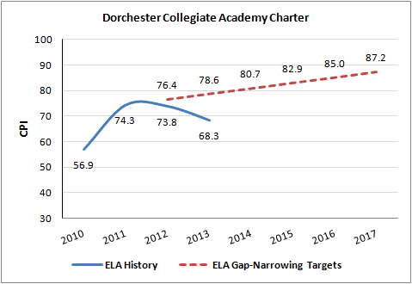

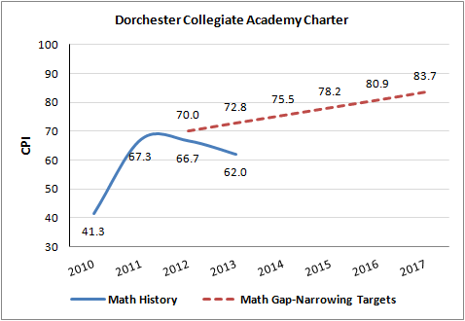

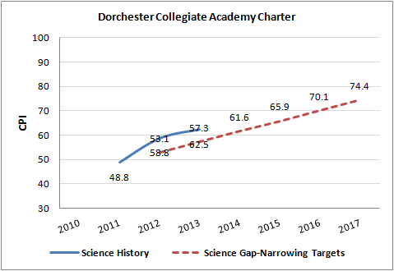

Conditions Imposed with Probation and Charter Renewal

I recommend that the Board vote to place DCACS on probation and impose the conditions that follow on the school’s charter.

- Beginning in March 2014 and until further notice, DCACS must submit to the Department of Elementary and Secondary Education (Department), at charterschools@doe.mass.edu or 75 Pleasant St., Malden, MA, 02148, board meeting agendas, materials, and minutes prior to each board meeting at the same time that these items are sent to the school’s board members. Additionally, if board materials do not already include this information, the school must also submit monthly financial statements.
- By June 30, 2014, DCACS must submit a comprehensive evaluation of the school’s mathematics and English language arts programs, including how such programs meet the needs of special education students and English language learners, conducted by an external consultant(s). Such consultant(s) must be acceptable to and approved in advance by the Department.
- By July 31, 2014, DCACS must submit an action plan to the Department for approval. Such action plan must specify strategies to improve mathematics and English language arts performance, including the performance of special education students and English language learners. The action plan must address implementation of a proven curriculum and instruction program for mathematics and English language arts. The action plan must set clear and specific implementation benchmarks, with a clear timetable and deadlines for completion of key tasks, to allow the school’s board of trustees and the Department to monitor implementation.
- By July 31, 2014, DCACS must implement all key elements of its educational program model in alignment with its charter or request an amendment to its charter to accurately reflect the school’s educational program.
- By July 31, 2014, the school’s board of trustees must have completed a comprehensive self-evaluation of its own capacity and must have recruited additional board members with needed expertise, as identified by the board of trustees and the Department.
- By August 31, 2014, the school’s board of trustees must engage in training conducted by an external consultant, acceptable to and approved in advance by the Department, on the roles and responsibilities of a board of trustees for a charter school.
- By September 30, 2014, the school’s board of trustees must develop and implement a formal system of evaluation for the executive director.
- By September 30, 2015, DCACS must demonstrate that it is an academic success by providing evidence that the school has met or is making substantial progress toward meeting benchmarks in its approved Accountability Plan and, in particular, has demonstrated significant and sustained academic improvement in mathematics and English language arts.
- By September 30, 2015, DCACS must provide written evidence of consistent implementation of its educational program in alignment with its charter, including any approved amendment(s). The Department must be able to corroborate such evidence through the site visit process.
In addition to meeting the terms of probation, DCACS, like all charter schools, must also comply with the terms of its charter. I will review and report to the Board on DCACS’s success or lack of success in meeting the terms of probation. Based upon this review, I will recommend that the Board take action as appropriate with respect to the school’s charter including, but not limited to, removal of probation, continuation of conditions, or revocation. Failure of DCACS to meet the conditions placed on renewal of its charter within the timelines specified may result in summary revocation by the Board.

Major Amendment Request

As noted above, DCACS has requested an amendment to the grade span granted to the school in its original charter. At present, DCACS’s charter permits it to serve grades 4-12. Currently the school serves grades 4-8. On May 7, 2013, DCACS submitted a major amendment request to continue to serve only grades 4-8. Given the reasons articulated in the attached request and the evidence contained in the attached summary of review, I believe it is in the best interest of the school’s students for the school to continue as a grade 4-8 school and to not expand to high school. I recommend that the Board approve the amendment request.

***************

If you have any questions or require additional information, please contact Cliff Chuang, Associate Commissioner, at 781-338-3222; Jeff Wulfson, Deputy Commissioner, at 781-338-6500; or me.

Enclosures: Summary of Review for DCACS (with DCACS’s Response)
Motion

