Massachusetts Department of

Elementary and Secondary Education

75 Pleasant Street, Malden, Massachusetts 02148-4906 Telephone: (781) 338-3000

TTY: N.E.T. Relay 1-800-439-2370

Mitchell D. Chester, Ed.D.
Commissioner

MEMORANDUM

To: | Members of the Board of Elementary and Secondary Education
From: | Mitchell D. Chester, Ed.D., Commissioner
Date: | January 16, 2015
Subject: | Charter Schools – Renewal Recommendation and Report on Probation for Boston Renaissance Charter Public School

This month, I bring two recommendations to you regarding Boston Renaissance Charter Public School (BRCPS). The Board of Elementary and Secondary Education (Board) placed BRCPS on probation in February 2013 and imposed conditions designed to improve the school’s academic program and results. BRCPS is also in the fifth year of its current charter and is coming to the Board for renewal of its charter. I recommend that the Board remove BRCPS from probation and renew the school’s charter with one condition that is designed to ensure that BRCPS continues to achieve academic success.

Boston Renaissance Charter Public School
Type of Charter  (Commonwealth or Horace Mann) | Commonwealth | Location | Boston
Regional or Non-Regional? | Non-Regional | Districts in Region  (if applicable) | NA
Year Opened | 1995 | Year(s) Renewed  (if applicable) | 2000, 2005, 2010
Maximum Enrollment | 944 | Current Enrollment | 944
Chartered Grade Span | K1-6 | Current Grade Span | K1-6
Students on Waitlist | 1,113 | Current Age of School | 20 years
Mission Statement
The mission of the Boston Renaissance Charter Public School is to nurture and develop academic, social, and emotional competence while building confidence, character, and citizenship among its students.

BRCPS was originally founded as a PK-12 school in 1995. Since 2005, the Board has taken a number of actions with respect to this school’s charter. These are summarized in the bullets that follow.

- In 2005, the Board renewed the charter of BRCPS with conditions requiring academic improvement and a reduction in grade span to PK-6.
- In February 2007, the Board placed the school on probation for failing to meet the academic achievement conditions of renewal. The Board imposed additional conditions on the school’s charter requiring the school to relocate to a facility more conducive to a school program and further reduce enrollment from 1,240 to 880 students by September 2009.
- In November 2008, the Board granted the school’s request to extend the deadline for relocation of the school and for the reduction of enrollment until September 2011. The Board also extended the school’s probation until the Board made a decision on the school’s charter during the 2009-10 school year.
- In August 2009, BRCPS requested a second extension, until September 2012, to reduce its enrollment to 880 students.
- In December 2009, the Board voted to renew the charter of BRCPS, to continue the school’s probation, and require the school to reduce its enrollment.
- In December 2010, the Board voted to remove BRCPS from probation because the school had demonstrated progress in meeting the probationary conditions, including moving to a new facility in Hyde Park, but voted to continue the conditions on the school’s charter requiring a reduction in enrollment.
- In August 2011, the school asked for the removal of the enrollment condition. The Board gave the school additional time to reduce enrollment, until 2013, six years after this condition was originally imposed.
- In August 2012, BRCPS again requested the enrollment condition be removed and its maximum enrollment be increased to 1,000.
- In February 2013, the Board removed the enrollment condition and established the maximum enrollment at 944. Additionally, based on academic data, the Board placed the school on probation and imposed a set of three conditions, all requiring BRCPS to improve its academic program and results.

Removal of Probation

This section lists the conditions imposed in 2013 and outlines BRCPS’s progress towards meeting the conditions. As summarized below, BRCPS has met the conditions imposed by the Board in connection with placing the school on probation in February 2013. The school performed an extensive school evaluation, implemented an action plan, made structural changes to its program, and met academic measures established by the Department of Elementary and Secondary Education (Department). The conditions required BRCPS to demonstrate significant and sustained academic progress by December 2014. As shown in the data charts below, BRCPS’s achievement and growth scores have improved since 2012, and I commend the school for its progress. In keeping with past accountability decisions, I recommend that the school be removed from probation but operate under a further academic condition in order to ensure sustained academic progress.

Condition 1: No later than May 31, 2013, the school shall submit to the Charter School Office a comprehensive evaluation of the school’s mathematics and English language arts programs conducted by an external consultant.

Status: Met.
In April 2013, BRCPS contracted with WestEd’s Learning Innovations regional program to conduct a comprehensive evaluation of the school’s mathematics and English language arts (ELA) programs. This culminated in a 70-page report containing findings and recommendations. The report was submitted to the Department on May 31, 2013.

Condition 2: No later than June 28, 2013, the school shall submit to, and receive approval from, the Charter School Office for an action plan that specifies strategies to improve mathematics and English language arts performance. The action plan must address implementation of a proven curriculum and instruction program for mathematics and English language arts. The action plan must include a timetable for the implementation of actions, must set deadlines for the completion of key tasks, and must set clear and specific implementation benchmarks to allow the school’s board of trustees and the Charter School Office to monitor implementation.

Status: Met.
In May 2013, BRCPS contracted with Creative Coaching to develop an action plan to improve mathematics and ELA performance. A team from the school worked with the consultant in the development of the Accelerated Improvement Action Plan (plan) that contained a timetable, deadlines, and benchmarks. The plan incorporated the recommendations resulting from WestEd’s report and the self-assessment of the school’s team based upon the Conditions for School Effectiveness. The plan included the adoption of a new mathematics program, aligned to the Common Core Standards, and a goal to better align the school’s ELA program to the Common Core Standards. The plan was submitted to the Department on June 25, 2013. At the request of the Department, the plan was slightly revised and resubmitted on July 15, 2013.

Condition 3: The school must demonstrate that it is an academic success by December of 2014 by providing evidence that the school has met or is making substantial progress toward meeting benchmarks in its approved Accountability Plan and, in particular, has demonstrated significant and sustained academic improvement in mathematics and English language arts.

Status: Met
In 2012 and 2013, BRCPS’s MCAS scores placed the school in Level 3. In 2014, BRCPS’s performance improved to place it in Level 1. In 2014, the school is in the 28th percentile when compared to other elementary schools statewide. The school met a majority of its gap narrowing targets in 2014. The school’s 2014 median student growth percentiles (SGP) are 53 for ELA and 59 for mathematics, above the state median of 50.

The school’s Composite Performance Index (CPI) for 2014 is 83.8 in ELA, 79.7 in mathematics, and 77.7 in science and technology. In 2014, 60 percent of BRCPS students scored in the Proficient and Advanced category in the ELA assessment. In mathematics, 55 percent scored Proficient and Advanced. Please see the data charts below to see historical trends in SGP and CPI. See the school’s full 2014 Accountability Data report here: http://profiles.doe.mass.edu/mcas/achievement_level.aspx?linkid=32&orgcode=04810550&fycode=2014&orgtypecode=6&

Student Growth Percentile
 |  | 2011 | 2012 | 2013 | 2014
ELA SGP | All | 29.0 | 34.0 | 57.0 | 53.0
 | High needs | 30.0 | 33.0 | 57.0 | 52.0
Math SGP | All | 31.0 | 32.0 | 63.0 | 59.0
 | High needs | 33.0 | 32.0 | 62.0 | 59.0

ELA CPI Chart
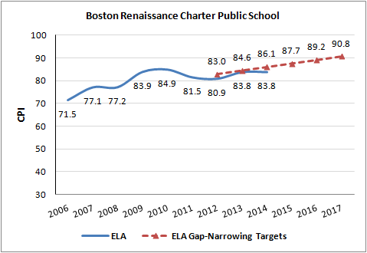

Mathematics CPI Chart

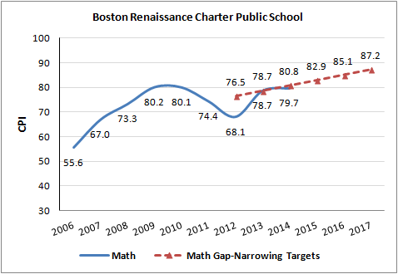

Science CPI Chart

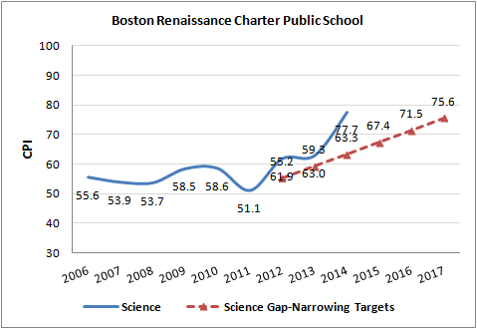

Renewal of Charter

Additionally, the school’s charter is currently under consideration for renewal. The school’s Summary of Review (attached) illustrates a school with very strong elements, such as its full service model and mission driven program. In Year 20, after recent shifts in the school’s academic program, qualitative evidence collected by the renewal inspection team indicates that BRCPS is focused on improving its academic program and results. I am recommending that the charter of BRCPS is renewed with conditions.

As shown above and in the attached Summary of Review, BRCPS has demonstrated improvement in academic outcomes during the charter term. Additionally, the school is faithful to the terms of its charter and is organizationally viable. The school has participated in dissemination efforts to share its best practices, implemented a Recruitment and Retention plan, and met a majority of the measures contained in its accountability plan. The school’s ratings from the Summary of Review follow.

Boston Renaissance Charter Public School
Massachusetts Charter School Performance Criteria |  |  | Rating
Faithfulness to Charter | - Mission and Key Design Elements: The school is faithful to its mission, implements the key design elements outlined in its charter, and substantially meets its accountability plan goals. |  | ● Meets
 | - Access and Equity: The school ensures program access and equity for all students eligible to attend the school. |  | ● Meets
 | - Compliance: The school compiles a record of compliance with the terms of its charter and applicable state and federal laws and regulations. |  | ● Partially Meets
 | - Dissemination: The school provides innovative models for replication and best practices to other public schools in the district where the charter school is located. |  | ● Meets
Academic Program Success | - Student Performance: The school consistently meets state student performance standards for academic growth, proficiency, and college and career readiness. |  | ● Meets
 | - Program Delivery: The school delivers an academic program that provides improved academic outcomes and educational success for all students. | Curriculum | ● Meets
 |  | Instruction | ● Partially Meets
 |  | Assessment and Program Evaluation | ● Meets
 |  | Supports for Diverse Learners | ● Meets
 | - Culture and Family Engagement: The school supports students’ social and emotional health in a safe and respectful learning environment that engages families. | Social, Emotional and Health Needs | ● Exceeds
 |  | Family Engagement | ● Meets
Organizational Viability | - Capacity: The school sustains a well-functioning organizational structure and creates a professional working climate for all staff. | School Leadership | ● Meets
 |  | Professional Climate | ● Meets
 |  | Contractual Relationships (If applicable) | N/A
 | - Governance: Members of the board of trustees act as public agents authorized by the state and provide competent and appropriate governance to ensure the success and sustainability of the school. |  | ● Meets
 | - Finance: The school maintains a sound and stable financial condition and operates in a financially sound and publicly accountable manner. |  | ● Partially Meets

The superintendent of Boston Public Schools was invited to submit written comment (see: http://www.doe.mass.edu/news/news.aspx?id=13496) regarding the charter renewals. No comment was received.

Recommendation

Given this evidence, further detailed in the attached Summary of Review, I recommend that the Board remove the school from probation and renew the school’s charter with one academic condition. In order to meet this condition, BRCPS must demonstrate continuous and sustained academic progress by 2016. I recommend the following condition:

Boston Renaissance Charter Public School must demonstrate that it is an academic success by September 2016 by providing evidence that the school has met or is making substantial progress toward meeting the benchmarks in its approved Accountability Plan and, in particular, is demonstrating continuous and sustained academic improvement.

**********************

If you have any questions regarding this recommendation or require additional information, please contact Cliff Chuang, Associate Commissioner (781-338-3222); Jeff Wulfson, Deputy Commissioner (781-338-6500); or me.

Attachments: Motion
Summary of Review

