Dorchester Collegiate Academy Charter School
Year Six Site Visit Report

Dorchester, MA
May 28, 2015

Massachusetts Department of Elementary and Secondary Education
75 Pleasant Street
Malden, MA 02148
Phone: (781) 338-3227
Fax: (781) 338-3220

This document was prepared by the
Massachusetts Department of Elementary and Secondary Education
Mitchell D. Chester, Ed.D.
Commissioner

The Massachusetts Department of Elementary and Secondary Education, an affirmative action employer, is committed to ensuring that all of its programs and facilities are accessible to all members of the public.
We do not discriminate on the basis of age, color, disability, national origin, race, religion, sex, gender identity, or sexual orientation.
Inquiries regarding the Department’s compliance with Title IX and other civil rights laws may be directed to the
Human Resources Director, 75 Pleasant St., Malden, MA 02148-4906. Phone: 781-338-6105.

© 2015 Massachusetts Department of Elementary and Secondary Education
Permission is hereby granted to copy any or all parts of this document for non-commercial educational purposes. Please credit the “Massachusetts Department of Elementary and Secondary Education.”

This document printed on recycled paper

Massachusetts Department of Elementary and Secondary Education
75 Pleasant Street, Malden, MA 02148-4906
Phone 781-338-3000 TTY: N.E.T. Relay 800-439-2370
www.doe.mass.edu

Table of Contents

Charter School Performance Criteria 1
Introduction 2
Findings: Charter School Performance Criteria 7
Faithfulness to Charter 7
Mission and Key Design Elements 7
Access and Equity 9
Academic Program Success 10
Program Delivery 11
Curriculum 11
Instruction 12
Organizational Viability 15
Governance 15
Appendix A 17
Accountability Plan Performance 17
Appendix B 19
Criterion 2: Access and Equity 19
Appendix C 24
Criterion 5: Student Performance 24
Appendix D 28
Criterion 10: Finance 28

Charter School Performance Criteria
Dorchester Collegiate Academy Charter School

● Exceeds | ● Meets | ● Partially Meets | ● Falls Far Below

Massachusetts Charter School Performance Criteria |  |  | Rating
Faithfulness to Charter | - Mission and Key Design Elements: The school is faithful to its mission, implements the key design elements outlined in its charter, and substantially meets its accountability plan goals. |  | ● Meets
 | - Access and Equity: The school ensures program access and equity for all students eligible to attend the school. |  | ● Partially Meets
Academic Program Success | - Student Performance: The school consistently meets state student performance standards for academic growth, proficiency, and college and career readiness. |  | ● Falls Far Below
 | - Program Delivery: The school delivers an academic program that provides improved academic outcomes and educational success for all students. | Curriculum | ● Meets
 |  | Instruction | ● Meets
 |  | Assessment and Program Evaluation | ● Meets
 |  | Supports for Diverse Learners | ● Meets
 | - Governance: Members of the board of trustees act as public agents authorized by the state and provide competent and appropriate governance to ensure the success and sustainability of the school. |  | ● Meets

Introduction

School Profile

Dorchester Collegiate Academy Charter School
Type of Charter  (Commonwealth or Horace Mann) | Commonwealth | Location | Dorchester
Regional or Non-Regional? | Non-Regional | Districts in Region  (if applicable) | N/A
Year Opened | 2009 | Year(s) Renewed  (if applicable) | 2014
Maximum Enrollment | 238 | Current Enrollment | 176
Chartered Grade Span | 4-8 | Current Grade Span | 4-8
Students on Waitlist | 449 | Current Age of School | 6 years old
Mission Statement
Dorchester Collegiate Academy Charter School will be a rigorous middle and high school whose mission is to prepare for college those students who exhibit the primary indicators that portend poor achievement and eventually dropping out of school – chronic absenteeism, consistent disciplinary issues, and unsatisfactory academic performance. DCACS students will pursue an intellectual and ethical education in a learning community, combining high expectations with personalized academic and non-academic support systems. DCACS success will be measured by students’ high school and college graduation rates, as well as their ability to consistently think and act, using ethical foundations.

School Setting
Originally chartered to serve grades 4-12, the school requested and was granted an amendment to serve only its existing grades (4-8) in 2014 and beyond. In February 2014, the Board of Elementary and Secondary Education (Board) renewed the school’s charter and placed DCACS on probation, directing DCACS to meet nine conditions by September 2015.

Demographics (2014-15)
The school reports the following racial and ethnic composition and percentages of selected populations of the student body as of the date of the site visit:
 | Number of Students | Percentage of Student Body
African American | 132 | 71%
Asian | 1 | 0%
Hispanic | 44 | 24%
Native American | 0 | 0%
White | 3 | 2%
Native Hawaiian, Pacific Islander | 5 | 3%
Multi-race, non-Hispanic | 1 | 0%
Special education | 37 | 21%
Limited English proficient | 31 | 17%
Low income | 167 | 95%
The following participants conducted the site visit on May 28th, 2015:
- Alison Bagg, Department of Elementary and Secondary Education (DESE), Office of Charter Schools and School Redesign (OCSSR)
- Puja Garg, DESE, OCSSR
- Melissa Gordon DESE, OCSSR
- Kristin Harrison, Christa McAuliffe Charter School
- Sara Schnitzer, DESE, OCSSR
Before the visit, the site visit team reviewed the school’s 2013-14 annual report, Year Five Summary of Review, the school’s accountability plan, board materials and minutes, and recent internal and external assessment data. On site, the team reviewed curricular documents and other information provided by the school. The team conducted approximately 30 classroom observations and interviewed trustees (6), administrators (5), special education/ELL administrators (2), general education teachers (5) and special education/ELL teachers (3).

The Charter School Performance Criteria (Criteria) are presented in the three guiding areas of charter school accountability defined in the current regulations, 603 CMR 1.00: academic program success, organizational viability, and faithfulness to charter. The purpose of this visit was to:
- corroborate and augment the information contained in the school’s annual report,
- assess the school’s progress relative to its accountability plan goals,
- collect information that will help the Commissioner and Board of Elementary and Secondary Education make a renewal recommendation for the school’s charter, and
- gather evidence and create findings that represent the school’s performance in relation to the Criteria; and
- review the progress that the school has made in meeting the conditions imposed.

This report contains evidence relating to a sub-set of the Criteria; Criterion 1 (Mission and Key Design Elements), Criterion 2 (Access and Equity), Criterion 5 (Student Performance), Criterion 6 (Program Delivery) and Criterion 9 (Governance). Ratings that encapsulate a school’s performance in terms of these criteria are found on the first page this report. Evidence related to Criteria 2, 5, and 10 is appended to this report. Evidence for all other criteria is contained below in the narrative site visit report. The report on probationary conditions begins on the next page.

Review of Progress Made Towards Meeting the Conditions Imposed

As noted above, DCACS is currently on probation and must meet nine conditions. This section of the report lists the conditions and DCACS’s progress towards meeting the conditions.

Condition 1: Beginning in March 2014 and until further notice, DCACS must submit to the DESE at charterschools@doe.mass.edu, board meeting agendas, materials, and minutes prior to each board meeting at the same time that these items are sent to the school's board members. Additionally, if board materials do not already include this information, the school must also submit monthly financial statements.

Status: Ongoing
DCACS has submitted board packages beginning in March 2014 on a monthly basis. In October 2014, the school also began submitting board committee notes along with the monthly package.

Condition 2: By June 30, 2014, DCACS must submit a comprehensive evaluation of the school's mathematics and English language arts programs, including how such programs the needs of special education students and English language learners, conducted by an external consultant(s). Such consultant(s) must be acceptable and approved in advance by the Department.

Status: Met
On June 30, 2014 DCACS submitted an evaluation of its mathematics and English language arts program conducted by the external consultant group Class Measures. The Department had approved the selection of Class Measures. Administrators and board members reported that the evaluation report was used to create an action plan (described below). Additionally, the school contracted with Class Measures to conduct two follow-up reviews of the school’s program in November 2014 and February 2015. These reviews assessed the quality and consistency of instruction.

Condition 3: By July 31, 2014, DCACS must submit an action plan to the Department for approval. Such action plan must specify strategies to improve mathematics and English language arts performance, including the performance of special education students and English language learners. The action plan must address implementation of a proven curriculum and instruction program for mathematics and English language arts. The action plan must set clear and specific implementation benchmarks, with a clear timetable and deadlines for completion of key tasks, to allow the school’s board of trustees and the Department to monitor implementation.

Status: Met
On July 31, 2014, DCACS submitted an action plan to the Department. The Department reviewed and provided feedback on the plan. The finalized action plan was submitted to the Department on October 7, 2014. Throughout the 2014-15 school year, the school’s headmaster has reported on the school’s progress on the action plan to the academic excellence committee of the board. Board minutes document the provision of general updates regarding the action plan to the full board.

Condition 4: By July 31, 2014, DCACS must implement all key elements of its educational program model in alignment with its charter or request an amendment to its charter to accurately reflect the school's educational program.

Status: Met
DCACS submitted an amendment to alter its educational program on August 1, 2014. The school proposed to maintain the same structure of the educational options, but to make an interdisciplinary approach, inquiry-based projects, an Aristotelian approach, and cooperative learning optional elements, rather than mandatory. The school’s request states that the school will continue to provide the following elements as central to its academic program: a standards-based curriculum, differentiated instruction, a focus on literacy, and an assessment of genuine understanding. The request was reasonable and consistent with Department guidelines, statute, and regulations and was approved on September 16, 2014.

Condition 5: By July 31, 2014, the school’s board of trustees must have completed a comprehensive self-evaluation of its own capacity and must have recruited additional board members with needed expertise, as identified by the board of trustees and the Department.

Status: Met
In May 2014, the school’s board of trustees completed two surveys. Each board member assessed the effectiveness of the board as a whole in one survey and completed a self-evaluation of their individual contributions as trustees in the second survey. During the 2014-15 school year, the board has increased its membership to 12 and at the time of the visit was in the process of adding a thirteenth member. The board has been able to recruit new members with needed expertise and has four fully functioning committees. Please see additional evidence provided in Governance, below.

Condition 6: By August 31, 2014, the school’s board of trustees must engage in training conducted by an external consultant, acceptable to and approved in advance by the Department, on the roles and responsibilities of a board of trustees for a charter school.

Status: Met
On July 21, 2014 the school’s board of trustees participated in a training conducted by an external consultant, who had been approved in advance by the Department. Board members reported that the training was helpful and helped them clarify the separation of governance and management.

Condition 7: By September 30, 2014, the school’s board of trustees must develop and implement a formal system of evaluation for the executive director.

Status: Met
The school’s board of trustees developed and implemented a formal system of evaluation of the school’s headmaster (executive director) by the time specified. By September 29, 2014, DCACS submitted the following items documenting the formal evaluation process for the school’s headmaster: the headmaster’s self-evaluation on his 12 goals for the 2013-14 school year; staff and board surveys concerning the headmaster’s performance; and the headmaster’s self-assessment using the Massachusetts Model System of Educator Evaluation headmaster rubric. These documents were used by the board to write up a summative evaluation. During the board’s August retreat, the summative evaluation was discussed and presented to the headmaster. This year, board members and the headmaster reported that his evaluation system will be further formalized by using the Board OnTrack tool to gather survey data and generate an evaluative form.

Condition 8: By September 30, 2015, DCACS must demonstrate that it is an academic success by providing evidence that the school has met or is making substantial progress toward meeting benchmarks in its approved Accountability Plan and, in particular, has demonstrated significant and sustained academic improvement in mathematics and English language arts.

Status: Ongoing
In 2013, the first year the school had sufficient data, DCACS was classified as Level 2, in the 23rd percentile. In 2014, the school is in Level 3. DCACS’s performance declined in mathematics and improved below targets in English language arts. In 2014, DCACS is in the 20th percentile when compared to other elementary-middle schools statewide. The school’s median student growth percentiles (SGP) were above the state median for English language arts, but below for mathematics. See the school’s full 2014 Accountability Data report here: http://profiles.doe.mass.edu/accountability/report/school.aspx?linkid=31&orgcode=04750505&orgtypecode=6&

DCACS Median SGP
Year | 2011 | 2012 | 2013 | 2014
ELA (all grades) | 60.0 | 63.5 | 40.0 | 57.0
Mathematics (all grades) | 76.0 | 65.0 | 39.5 | 42.0

In terms of the school’s Accountability Plan performance, DCACS’s new accountability plan was approved in April 2015. The school will report on its progress in terms of those measures in its 2014-15 Annual Report.

Condition 9: By September 30, 2015, DCACS must provide written evidence of consistent implementation of its educational program in alignment with its charter, including any approved amendment(s). The Department must be able to corroborate such evidence through the site visit process.

Status: Ongoing
One of the main purposes of the May 2015 site visit was to assess the implementation of the school’s educational program in alignment with its approved 2014 amendment. Please see Mission and Key Design Elements, below, for further information. The site visit team did observe implementation of a majority of the school’s educational program. The school will submit further written evidence of implementation of its educational program via its 2014-15 Annual Report. The school’s performance in terms of this condition will be assessed after the Annual Report is received.

Findings: Charter School Performance Criteria

Faithfulness to Charter

Criterion 1 | Rating
Mission and Key Design Elements  The school is faithful to its mission, implements the key design elements outlined in its charter, and substantially meets its accountability plan goals. | ● Meets

Finding: While all stakeholders did not consistently describe the school’s mission, the board of trustees is currently working with school leaders to revise the DCACS mission statement. In year six, the school is implementing the majority of the school’s educational program in alignment with its 2014 amendment.

The school continues to solidify a consistent understanding of the mission. In year six, the board of trustees’ academic committee is currently revising the school’s mission statement. At the time of the site visit, stakeholder groups’ understandings of the school’s mission varied. The board of trustees and school leadership reported the school’s mission is to serve an at-risk population and to provide them with strong social emotional supports at school. Teachers and special education/ELL administrators described the mission as a three prong approach: rigorous academics, social/emotional support, and the inclusion of families. DCACS stakeholders reported that the school is serving a population as defined in their mission. Please see information provided below, in Access and Equity, about the degree to which the school’s population is comparable with that of other Boston Public Schools. Further, the school’s approved mission statement (found above in School Profile) is different from the one supplied on the school’s website. It was clear to site visitors that all stakeholders share a common short term goal of meeting the probationary conditions.

Noted above, two of the conditions currently imposed upon the school’s charter relate to the alignment of the school’s educational program with its chartered educational program. In the fall of 2014, the school received approval for an amendment to its educational program. The purpose of the May 2015 site visit was partly to assess if DCACS was consistently implementing its educational program in alignment with the amended educational program. The 2014 amendement identified the provision of: a standards-based curriculum, differentiated instruction, a focus on literacy, and assessment of genuine understanding as the main elements of its school’s educational program. Site visitors observed evidence of these elements during the site visit as detailed below.

Standards-based curriculum: As noted in its 2014 amendment, the school expects goals for student achievement will be clearly set and communicated to students. During the site visit, every classroom listed standards on the lesson plans provided to site visitors and the majority were well aligned with Massachusetts Curriculum Frameworks (MCF) and Common Core (CC). In the majority of site visitor observations, classrooms had a learning objective or goal posted and students were aware of the goal.

True to the amendment, in grades 4 and 5, school leadership reported and site visitors observed students building foundational math and English language arts (ELA) skills. Additionally, the amendment noted that in grades 6-8, students will master basic skills and apply their foundational knowledge to solve new challenges, which site visitors observed in approximately two-thirds of grade 6-8 classrooms.
Differentiated instruction: In the amendment, DCACS defines differentiated instruction as providing a variety of approaches in the areas of content, product, process, or learning environment. The school has created systems and structures to support this goal. The weekly lesson plan template has a specified section to document differentiation strategies and all lesson plans viewed or collected included this section. The school has defined differentiation to include a variety of strategies, such as the use of: pictures, modeling, turn and talks, graphic organizers, behavior plans, separate curricula, repetition of directions, student choice in content of work and how to solve equations, group configurations, text summaries and use of manipulatives. Site visitors observed the use of one or more of the above strategies in the majority of classrooms.

This year, DCACS has implemented enrichment blocks during the day to provide tiered instruction and targeted academic supports. Students participate in tiered ELA instruction three days a week and tiered math instruction twice a week. Students are flexibly grouped using assessment data, mainly from AIMSweb and Math-U-See, into tier 1 (enrichment), tier 2 (grade level) or tier 3 (intervention) classrooms. Site visitors observed a range of effective implementation of instructional techniques and a range of student engagement during these sessions. The school utilizes separate curricula, like Wilson Reading and Math-U-See, both in the classroom and in pull out sessions for students needing interventions, as needed.

Focus on literacy: In the 2014 amendment, the school reaffirmed its commitment to a focus on teaching reading and writing. Based on the current school schedule, students receive 3 more hours a week in ELA instruction than math instruction. The school’s daily schedule includes a 35 minute silent sustained reading (SSR) block, 45 minutes of reading instruction, 45 minutes of writing instruction and a 60 minute ELA enrichment block three times a week. In comparison, students are scheduled for 90 minutes blocks of math instruction three times a week and for 150 minutes twice a week. In classroom observations, site visitors saw students engaging in text-based activities, such as: the use of primary sources, citing evidence for claims from the text, identifying themes, annotating articles, and reading aloud. Stakeholders reported that DCACS has a common understanding around open response writing expectations and has developed a common rubric to assess students. Site visitors observed use of common strategies across classrooms to develop writing skills, such as: stop and jots and note taking.

Assessment of genuine understanding (AGU): The school defines AGU as “the ability to demonstrate mastery of concepts, principles, facts, and skills to such a degree that students are able to successfully apply their knowledge to tackle new challenges.” Teachers and school leadership reported AGUs are given as end of unit assessments where students are required to perform real world tasks to show their understanding. For example, after reading the book Dragonwings, students researched gentrification in Boston’s Chinatown and wrote news articles. Additionally, students wrote cover letters for job applications during a personal essay unit. Teachers reported they were encouraged to do one AGU per unit. Some of the documentation submitted by the school did not reflect assessments that measured “mastery of concepts, principles, facts, and skills to such a degree that students are able to successfully apply their knowledge to tackle new challenges.” Additionally, AGUs are not included in the school’s Instructional Playbook, rather the section on assessment focuses on the use of in-class, formative assessments.

The school has put many systems, structures and administrative supports in place to assist with the delivery of a program aligned to its educational program as amended in 2014. This year, DCACS has two administrators (instructional coaches) dedicated to providing instructional leadership to all teachers. DCACS has written an Instructional Playbook that provides guidance on common instructional strategies. DCACS has also created a teacher observation form that articulates and assess teachers on the implementation of common instructional strategies: pacing, differentiation, rigor, student accountability, use of assessment, and student engagement. Teachers are observed approximately twice a month via the common form. The school has created systems to ensure further consistency in implementing the educational program. An instructional leadership team, consisting of the headmaster, dean of students, academic coach(es), special education director, ELL teacher, and department chairs, meets weekly to look at data collected from classroom observations. The school is providing professional development aligned with common instructional expectations and that responds to the observational data. The two instructional coaches provide one-on-one coaching and feedback based on observed instruction and curriculum documentation.

Additionally, stakeholders reported and the site visit team observed that DCACS is implementing other key design elements that relate to its charter, which include character development, great leaders and teachers, involving families and social/emotional supports, but the focus of the visit did not include collecting this evidence.

Finding: The DCACS accountability plan was approved in April 2015 and therefore the school has not yet reported on these measures.

DCACS received Department approval of a new accountability plan for its current charter term (2014-2019) in April 2015. DCACS’s approved accountability plan includes 6 objectives and 13 measures. The school has not yet reported on this plan, however, site visitors found that the school has systems and structures in place to meet and gather evidence on their measures. More information about the school’s progress in meeting the objectives and measures contained in its accountability plan can be found below in Appendix A, Accountability Plan Performance, of this report.

The school will report the progress it has made on its newly approved accountability plan in its 2014-15 Annual Report.

Criterion 2 | Rating
Access and Equity  The school ensures program access and equity for all students eligible to attend the school. | ● Partially Meets

Finding: The school ensures program access and equity for all students eligible to attend the school.

The school’s website can be translated into multiple languages and also contains general information on both special education and English language learner (ELL) programming. The school’s Recruitment and Retention plan states advertisements and admission materials are available in multiple languages and the school will use bilingual staff and parents to speak with prospective families in their home language over the phone. This was not a focus of the site visit and visitors did not collect evidence to confirm whether these practices are in place.

Finding: The school is working to recruit and retain a comparable student population to the sending district. Attrition rates are high for all students and for subgroups; attrition has increased over the past two years.

Enrollment trends for the past five years have been below that of comparison schools for students with disabilities and ELLs. During the 2014-15 school year, data shows that the school currently has a more comparable population of both groups. In terms of low income and high needs populations, trends have been variable, but with more comparable rates during the 2014-15 school year. The school has received Department approval for their recruitment and retention plan for the current school year, which included enhanced strategies.

Attrition for all students and all subgroups is high and shows an overall upwards trend. Attrition rates for the 2013-14 and 2014-15 school years were 32.6 percent and 30.2 percent respectively. School administrators noted that many rising grade six students choose to attend other 6-12 schools. However, a grade by grade analysis of student attrition shows that a number of grade levels (4-6) show high rates of attrition during the past two years (see: http://profiles.doe.mass.edu/attrition/default.aspx?orgcode=04750505&fycode=2015&orgtypecode=6&). Attrition rates for all students and all student subgroups (students with disabilities, ELLs and high needs) are higher than almost all comparison schools in Boston.

Criterion 3 | Rating
Compliance  The school compiles a record of compliance with the terms of its charter and applicable state and federal laws and regulations | N/A

Finding: The school is out of compliance with state regulations regarding teacher licensure and qualification.

Per state regulations (603 CMR 1.06 (4)), all teachers beyond their first year of employment must take and pass the Massachusetts Test for Educator Licensure (MTEL). As of the site visit, five teachers out of twenty beyond year one of employment had not passed the required MTELs.

Academic Program Success

Criterion 5 | Rating
Student Performance  The school consistently meets state student performance standards for academic growth, proficiency, and college and career readiness | ● Falls Far Below

Finding: In 2014, the DCACS’s MCAS scores did not meet state student performance standards for academic growth and proficiency.

In 2014, DCACS’s MCAS results placed it in Level 3; DCACS is in the 20th percentile relative to other schools statewide. The school’s CPI for 2014 was 75.7 in ELA, 58.4 in mathematics, and 47.5 in science and technology. In 2014, 51 percent of DCACS students scored in the Proficient and Advanced categories on the ELA assessment, below the state average. In mathematics, 22 percent scored Proficient and Advanced, below the state average. The school’s SGP for 2014 was 57.0 in ELA, above the state median of 50, and 42.0 in mathematics, below the state median of 50. Please refer to Appendix C for detailed student academic performance data over the charter term.

Criteria 6

Program Delivery
The school delivers an academic program that provides improved academic outcomes and educational success for all students.

Key Indicators | Rating
Curriculum  The school’s documented curriculum is aligned to state curriculum frameworks and expectations; is aligned vertically between grades and horizontally across classrooms at the same grade level; is fully implemented in classrooms; and supports opportunities for all students to master these skills and concepts. The curriculum is regularly reviewed and revised. | ● Meets

Finding: DCACS has a documented curriculum that is aligned vertically and horizontally and to the Massachusetts Curriculum Frameworks (MCF) and Common Core standards. Visitors observed the curriculum being implemented in classrooms. Over the past year, the school has devoted resources and time to examining and revising its curriculum; review and revision is teacher-driven and ongoing.

DCACS has a teacher-developed, documented curriculum that consists of annual, unit and weekly lesson plans. Based on a document review, visitors determined that the current documented curriculum is vertically aligned and aligned with the 2011 MCF and Common Core. Due to one teacher per grade level and content area, horizontal alignment is ensured. Annual ELA plans include standards, major assignments, assessments and a timeline and math annual plans are based on the Achievement Network’s (ANet) schedule of assessed standards (SAS). ELA unit plans include Common Core standards for reading and writing, language standards, assessments, texts, writing assignments, power skill focus, and extensions. Teachers use a variety of resources for math curriculum, which range from exclusively using the Engage New York curriculum to all teacher-created resources. Math unit plans include the common core standards, standards for math practice, essential questions, objectives and assessments and mirror the ANet SAS schedule. This year, the school developed school-wide open response expectations across grade levels and next year plans to incorporate cross-curricular planning into the curriculum. DCACS uses a school-wide template for weekly lesson plans that prompts teachers to post learning goals, exemplars, and criteria for success in the classroom. The template also require the use of a do now, exit ticket, mini lesson, checks for understanding, differentiated strategies, homework, and teacher reflection section. Site visitors viewed lesson plans that followed the template and noted that weekly lesson plans are aligned to the unit plans. Site visitors collected lesson plans from multiple grade levels and subject areas, which contained Common Core standards.

Visitors observed the curriculum being implemented with fidelity across classrooms, and noted weekly units and daily lesson plans aligned to standards consistently in classrooms. In the majority of classes, lesson plans were implemented as written and a majority of the activities were aligned to objective. In the minority of classes, the learning activity did not match the posted standard/learning objective.

The school has systems and structures to review and revise curriculum. Curriculum materials are examined at biweekly department meetings with content coaches. All teachers submit weekly lesson plans, which are reviewed by content coaches and receive feedback. Additionally, during the June department meetings, staff members review curriculum and revise unit and annual plans for the following school year.

Accommodations for diverse learners were documented in unit and weekly lesson plans. Language objectives and scaffolded assignments were documented in ELA unit plans and differentiation strategies are documented in weekly lesson plans. The school uses the Math-U-See curriculum during tiered intervention blocks. Site visitors saw evidence of differentiation in classrooms observations through differentiated worksheets, curricula, instructional groupings and multi-modal supports. The school purchased both the Reach and Insight National Geographic ESL curriculum for upper elementary and middle school ELL students.

Instruction  The school staff has a common understanding of high quality instruction. Instructional practices are aligned to this common understanding and are based on high expectations for all students. Instruction fosters student engagement. Classroom environments are conducive to learning. | ● Meets

Finding: The school staff has a common understanding of high quality instructional strategies. Visitors observed the school working towards consistent implementation of these strategies in classrooms. The majority of students were engaged in their learning.

All stakeholders reported, and teacher observation forms and the Instructional Playbook confirmed, a common understanding of instructional practices at the school. The six main instructional practices included: pacing, student engagement, academic rigor, differentiation, student accountability, and assessments. Visitors saw all of the described practices in the majority of observed classrooms, as described in further detail below.

Pacing: Site visitors observed pacing strategies in all classrooms. These strategies included: allotting time for activities in lesson plans, use of classroom timers, announcing time intervals left to work, checking student’s work pacing, and having students monitor time.

Student engagement: Some teachers listed student engagement strategies into lesson plans. Site visitors observed engagement enhancing strategies, which included: turn and talk, non-verbal hand signals, accountability talk stems (“I agree with….” Or “I disagree with…”), student-led discussions, quick writes, think-pair-share, table talk, hands on activities, and roles for students during group work. Site visitors observed these strategies in all classrooms, but they were used with varied effectiveness. In the majority of classrooms, students were engaged with the lesson, but in approximately one third of classrooms, site visitors observed off-task conversations, students’ heads on desks, students attempting to complete off-task work (for another class/subject area), and no teacher attempt to reengage students.

Academic rigor: All lesson plans collected and the majority of classroom instruction observed aligned with either the Common Core standards or Massachusetts Curriculum Frameworks. Site visitors observed academic rigor in the majority of classrooms. Some examples included students: having authentic dialogue about integers, grappling with underlying concepts, completing leveled work, answering open ended questioning to explain thinking, having to justify their answers, using vocabulary, and making inferences. In a minority of grade 6-8 classrooms, site visitors did not observe rigorous instruction and some classrooms used skill-based instruction without engaging students in higher order thinking skills or grappling with content. In these classrooms, teacher interactions with students focused on redirections back to learning or clarifying directions rather than increasing the rigor of student learning. In one classroom, the goal of the class was ambitious but the disjointed execution of the activities hampered students’ abilities to meet the lesson’s learning targets. In another classroom, the teacher was doing the majority of the talking and thinking for the students.

Differentiation: The school identifies this as a main component of its educational program and the majority of teachers utilized differentiation strategies, as defined by the school, in their classrooms. In addition, teachers and administrators reported a similar understanding of differentiation through content, process, product and learning environment. For more details, see Mission and Key Design Elements above.

Student accountability: A minority of classrooms utilized strategies to hold students accountable for their learning. In these few classrooms, site visitors observed the use of: no-opt out, right is right, wait time, 3 before me, stop and jots, and accountable talk. Out of the few classrooms utilizing these strategies, site visitors saw variable success in implementation.

Assessments: The school identified assessments as a common instructional practice at the school and site visitors observed and focus groups reported using assessments to guide instruction. Site visitors observed teacher circulation to monitor student learning and behavior. Teachers use strategies such as cold calling, name sticks, exit tickets, whiteboard checks, dipstick questioning and hand signals to collect both qualitative and quantitative data in a little over half of classroom observations. For more details, see Assessments and Program Evaluation below.

Assessment and Program Evaluation  The school uses a balanced system of formative and benchmark assessments. The school uses qualitative and quantitative data to improve student outcomes as well as to evaluate the quality and effectiveness of the program in serving all students and modifies the program accordingly. | ● Meets

Finding: DCACS uses a balanced set of data to assess student performance and overall program quality. This data is used to adjust classroom instruction and to make changes to the overall academic program.

Balanced data sources: According to the 2014 amendment, the ILT reviews MCAS, ANet, Fountas and Pinnell, AIMSweb, aggregated and disaggregated teacher observations, and Class Measures report data to assess the effectiveness of their educational program. Focus group reports confirm the use and analysis of the expected data sources. DCACS administers the following assessments; the Achievement Network (ANet) for math and ELA, the MCAS, AIMSweb for math and ELA, ACCESS testing, Fountas and Pinnell, Wilson Reading, Engage NY and teacher created tests, quizzes and AGUs. In addition, school leadership gathers both qualitative and quantitative data from classroom observations, Insight surveys, and two reports regarding the quality of instruction created by an external consultant.

Use of data to improve classroom instruction: School leadership reported the school has moved towards a data-driven culture and assessment is expected as a common instructional practice. After each assessment cycle (AIMsWeb for ELA, ANet and Math U See for math), teachers have data meetings to create flexible, tiered groupings for students during enrichment blocks. Teachers reported using assessments to monitor the effectiveness of their intervention strategies. The instructional coaches use classroom observation data to give teachers feedback on their instructional practices. In addition, the board’s academic excellence committee meets monthly to review ANet data. DCACS also contracted with an external consultant, Class Measures, to provide assessments of the implementation of expected instructional strategies.

Use of data to improve overall program: Prior to the start of the current school year, based on teacher surveys, school leadership provided teachers with more observations and quality feedback by hiring two full-time instructional coaches and by hiring an assistant dean of students to support teachers with classroom management. Throughout the year, the instructional leadership team (ILT) has used the newly developed classroom observation form to monitor instructional practices. Administrators reported that the ILT meets weekly to look at the data from classroom observations. Trends in the observational data are used to plan professional development or amend DCACS’ Instructional Playbook throughout the year. Additionally, after reviewing performance data for students with disabilities and ELLs, school leadership plans to add additional special education and ELL teachers next school year to increase academic achievement.

Supports for Diverse Learners  The school provides supports to meet the academic needs for all students, including but not limited to students with disabilities and English language learners. | ● Meets

Finding: DCACS has a screening process for students as well as in class supports and interventions for struggling students. The school collaborates with community partners to support students both in and out of school.

DCACS has developed a referral system for students with academic and/or social-emotional concerns. If staff has concerns, grade level teachers brainstorm intervention strategies to try with students weekly. If interventions have not resulted in progress, the student is referred to the child study team to determine the next stages of interventions, which may include family outreach or counseling and may result in a referral for special education testing. The school also includes a home language survey with each application to screen for students who may be in need of ESL services.

The dean of students reported the majority of students received some form of support services from the school, such as counseling. Last year the school offered a tutoring program but replaced it this year with a daily tiered instructional block. During this block, students are grouped into one of three tiers; tier 1 is enrichment, tier 2 helps students practice grade level content, and tier 3 is intervention. Students are put into small groups using AIMsweb, ANet and Math-U-See data and groupings changed based on student assessments. Students have ELA enrichment three times a week and math interventions twice a week. In addition, teachers stay after school to support students academically and there is a homework club four days a week.

The school employs two special education teachers, who focus on either math or ELA across all grade levels, a speech and language pathologist who also does reading support, and contracts out for related services. Next year, the school plans to add three full-time special education teachers and another part time ELL teacher to the staff as well as formal collaboration time for special education and ELL teachers.

In addition, the school utilizes separate curricula in ELA and math to support students needing academic interventions. The Wilson Reading program is used during pullout sessions and the Math-U-See curriculum is used both during the tier 3 enrichment block and in the general education classrooms as needed.

Organizational Viability

Criterion 9 | Rating
Governance  Members of the board of trustees act as public agents authorized by the state and provide competent and appropriate governance to ensure the success and sustainability of the school. | ● Meets

Finding: This year, the board’s focus has been on its probationary conditions. After a recent board training, DCACS’s board of trustees has improved its understanding of its roles and responsibilities. The board is building its capacity, reviewing student academic data, developing a formal evaluation for its school leader and monitoring the school’s fidelity to its mission.

Membership composition: Over the past year, the focus of the DCACS board has been on board recruitment, training new members, and improving governance processes. The board reported that the governance training reminded them of the responsibilities and time commitment required for the role, as well as the role of committees, importance of the school leader evaluation, and how to build overall structures for success. The board reported replacing all but one board member over the past two years. The board reported recruiting new board members through their own networks and through BoardNet. When recruiting, they looked at the areas of expertise needed in their committees. Once a need is determined, members look at resumes, evaluate perspective members, who meet with the school leader, visit the school and attend a board meeting to determine fit. DCACS’s board of trustees currently has 12 members, which increased from 6 board members last year. The board has academic excellence, finance, development and governance committees, which meet at least once a month. Since last year, the board has brought on new board members with varying expertise, including education, finance, program development, law, real estate, and leadership development. Currently, the board is interviewing candidates with development and long term planning experience and looking to attract members from the local community.

Understanding of role: Board members reported that much of the work of the board is done via committees. The academic committee looks at ANet data and aggregated teacher observation data. The board analyzes the data discussions programmatic implications with the headmaster. As noted above, in Progress Made Toward Meeting the Conditions, trustees reported a more formal process to evaluate the school leader for the 2013-14 school year. Trustees also reported that the headmaster evaluation process will become more formalized and standardized this year as they use The Board on Track platform to organize direct report, general staff, and board survey data as well as the school leader’s self-evaluation. This year, the majority of the headmaster’s goals relate to the school’s probationary status and action plan. Board minutes reflect that board practices do not always comply with the Open Meeting Law, specifically regarding noting absent members and the use of executive session.

Probationary conditions: The board reported that the probationary conditions and the action plan are monitored at each board meeting. The board reported the conditions encouraged the board to hold itself and the school accountable for improvements. Board minutes reviewed by the site visit team, however, contained evidence that the probationary conditions were reviewed at the majority of meetings, but that the action plan was inconsistently reviewed. Board members and administrators reported that the action plan is also reviewed at a more in-depth level by the academic excellence committee.

Process for ensuring success and sustainability: The board meets monthly and twice a year off-site. During the off site meetings, or retreats, the board discusses school strategy and how to support the school in meeting goals. Based on student needs, this year, the board collaborated with the school leader to revise the staffing model to include more direct student support services and leadership support and considered effects of the revised budget on the school. The board’s academic committee frequently reviews academic data to ensure its practices are reflecting positive changes in student achievement to meet the school’s mission. The school would like to develop a strategic plan, but has been focused on short term goals over the last two years. Their current goal is to come off of probation before they can return to their long-term planning goals. The board began conducting a self-evaluation last year for individual trustees and a reflective evaluation of the full board. This year, they plan on using Board on Track to assist in their evaluation.

Appendix A

Accountability Plan Performance

Faithfulness to Charter
 | 2014 Performance  (Met/Not Met) | Evidence
Objective: DCACS will support teachers with developing highly effective, standards-based lesson plans.
Measure: 90% of teachers will receive a summative evaluation rating of Meets Expectations or Exceeds Expectations from their supervisor in the area of “Well-Structured Lessons”. | The DCACS accountability plan was approved in April 2015 and therefore the school has not yet reported on these measures. | School administrators reported that DCACS has a formal evaluation system in place for teachers.
Measure: 100% teachers will be trained in meeting lesson plan expectations during Summer Orientation and/or during coaching sessions with the Instructional Coach. |  | School administrators reported that teachers were provided with summer orientation. The school employed two instructional coaches during the 2014-15 school year.
Measure: 100% teachers will submit weekly lesson plans to the Instructional Coaches. |  | Teachers and school administrators reported that this process is in place for the 2014-15 school year.
Objective: DCACS will develop a high quality and individualized school-wide literacy program.
Measure: 80% of students will a score 2 or higher on the summative Open Response test. | The DCACS accountability plan was approved in April 2015 and therefore the school has not yet reported on these measures. | The team did not collect evidence on this measure.
Measure: 80% of students will move up at least 1 grade level in reading according to Lexile Level--determined by the summative AIMsweb reading assessment. |  | The team observed evidence of AIMsweb implementation.
Objective: DCACS will support students’ character development through an Advisory Program that prepares students to be productive community members.
Measure: 90% of students will score an average of 85% or higher on all end unit Advisory assessments. | The DCACS accountability plan was approved in April 2015 and therefore the school has not yet reported on these measures. | DCACS implements an advisory program.
Measure: 90% of students will participate in at least 3 community service events annually. |  | The team did not collect evidence on this measure.
Measure: 90% of students will score an 80% or higher on an annual Community Standards assessment. |  | The team did not collect evidence on this measure.
Objective: DCACS will support teachers’ professional growth through a learning community that continually expands their expertise.
Measure: 90% of teachers will receive a summative evaluation rating of Meets Expectations or Exceeds Expectations in the areas of “Curriculum, Planning, and Assessment” and “Teaching All Students”. | The DCACS accountability plan was approved in April 2015 and therefore the school has not yet reported on these measures. | School administrators reported that DCACS has a formal evaluation system in place for teachers.
Measure: 100% of teachers will received regular observations and coaching sessions that are tailored to their specific areas of growth. |  | School administrators reported that DCACS has a formal evaluation system in place for teachers. The school employs two instructional coaches.

Dissemination
 | 2014 Performance  (Met/Not Met) | Evidence
Objective: Dorchester Collegiate Academy will share its Advisory Program with other schools in Massachusetts over the course of the charter term.
Measure: DCACS will conduct at least 8 workshops on its Advisory Program to schools in Massachusetts. | The DCACS accountability plan was approved in April 2015 and therefore the school has not yet reported on these measures. | The team did not collect evidence on this measure.

Reach Objectives and Measures related to Mission and Key Design Elements
 | 2014 Performance  (Met/Not Met) | Evidence
Objective: DCACS will establish a school-wide culture that promotes teacher retention for high quality teachers.
Measure: Teachers who earn a “Meets Expectations” or higher will remain at DCACS for at least 4 years. | The DCACS accountability plan was approved in April 2015 and therefore the school has not yet reported on these measures. | School administrators reported that DCACS has a formal evaluation system in place for teachers.
Measure: Based on the Insight Survey, the Instructional Culture Index will receive a rating of 8.0 or higher. |  | School administrators and board members reported that the school administers the Insight Survey to teachers (in the 13-14 and 14-15 school years)

Appendix B

Criterion 2: Access and Equity
All data displayed in these graphs are derived from ESE District and School Profiles (http://profiles.doe.mass.edu/).
The longitudinal demographic comparison data presented in the graphs of student enrollment is intended to provide context for the charter school’s recruitment and retention efforts. The set of displayed comparison schools includes the charter school of interest, and all of the public schools in the charter school’s region that serve at least one grade level of students which overlaps with the grade levels served by the charter school. The graphs provide comparison enrollment percentages for four different subgroups of students: low income, students with disabilities, English language learners, and first language not English. Each line on the graph represents the percentage of total school enrollment for a given school or set of schools during the most recent five years. If available, data listed is displayed longitudinally across multiple years in line graph form, with:
- a solid bold black line representing subgroup enrollment in the charter school of interest;
- a solid green line for the statewide average;
- a solid blue line for the comparison district average;
- a dotted orange line for the median enrollment percentage of all comparison schools;
- a dotted dark orange line for the first quartile enrollment percentage of all comparison schools;
- a dotted red line for the comparison index;
- a dotted pink line for the Gap Narrowing Target (GNT); and
- solid gray lines for enrollment percentage in each individual comparison school (darker gray for charter schools, and lighter gray for district schools).
Student attrition rates are provided for all students and for the high needs subgroup. Please note that district percentages are not included since attrition at the district-level cannot be reasonably compared to attrition at the school-level.
Important Notes:
New statutory provisions related to Criterion 2 were established in 2010. Though comparisons of subgroup enrollment data in a charter school to that of other public schools in a geographic area can provide some information regarding comparability of student populations, it is presented for reference only and primarily to determine trends within the charter school itself and to guide further inquiry. The subgroup composition of a charter school is not required to be a mirror image of the schools in its sending districts and region. The Department urges extreme caution in drawing any conclusions regarding comparability of subgroup populations between districts and schools based on aggregate statistics alone. Students choose to enroll or are assigned to the schools in a geographic region due to a variety of reasons and factors, including: the random lottery admissions requirement for charter schools, district assignment and programmatic placement decisions, parent choice, uneven distribution of families within a geographic region due to housing or wealth distribution patterns, and natural population variation, among many others. In specific caution should be used for special education enrollment data, as new research by Dr. Thomas Hehir (Harvard Graduate School of Education) and Associates (Review of Special Education in the Commonwealth of Massachusetts: A Synthesis Report (August 2014) found that low-income students were identified as eligible for special education services at substantially higher rates than non-low-income students and that across districts with similar demographic characteristics, district behavior differed for special education identification, placement, and performance. Finally, it is also important to note that it may take time for a charter school’s recruitment and retention efforts to be reflected in the aggregate demographic percentages given sibling preference for admission and a limited number of entry grades.
Charter schools are required to receive Department approval for a recruitment and retention plan to be reported on and updated annually. When deciding on charter renewal, the Commissioner and the Board must consider the extent to which the school has followed its recruitment and retention plan by using deliberate, specific strategies towards recruit and retain students in targeted subgroups, whether the school has enhanced its plan as necessary, and the annual attrition of students. As specified in regulation, charter schools were first required to implement recruitment and retention plans in 2011-2012. One of the Department’s key priorities with respect to charter schools is to continue to utilize new tools and processes for robustly assessing this criterion, and to support schools in meeting this criterion.

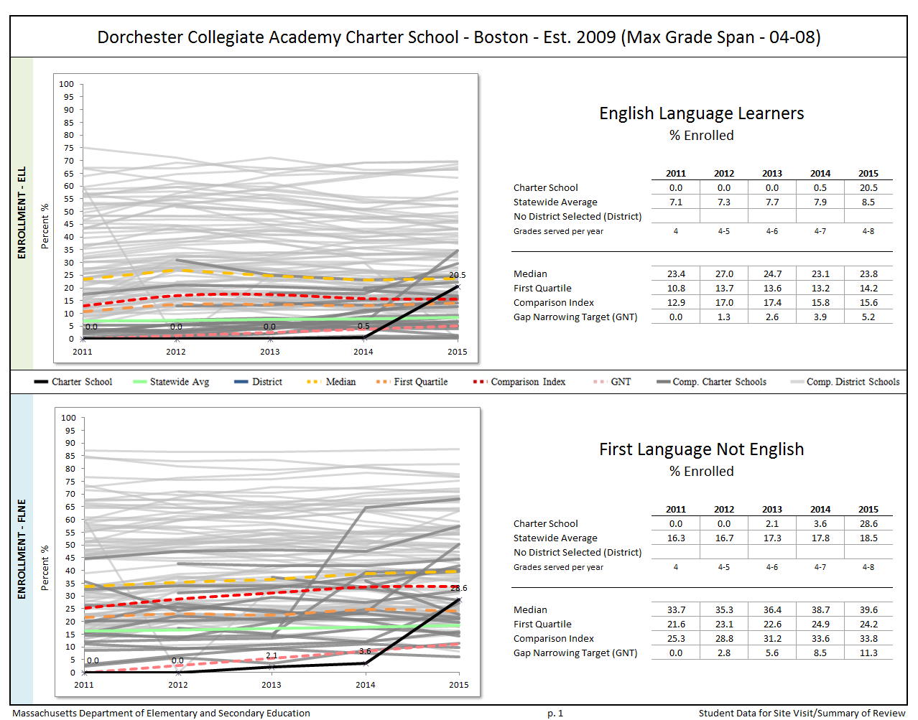
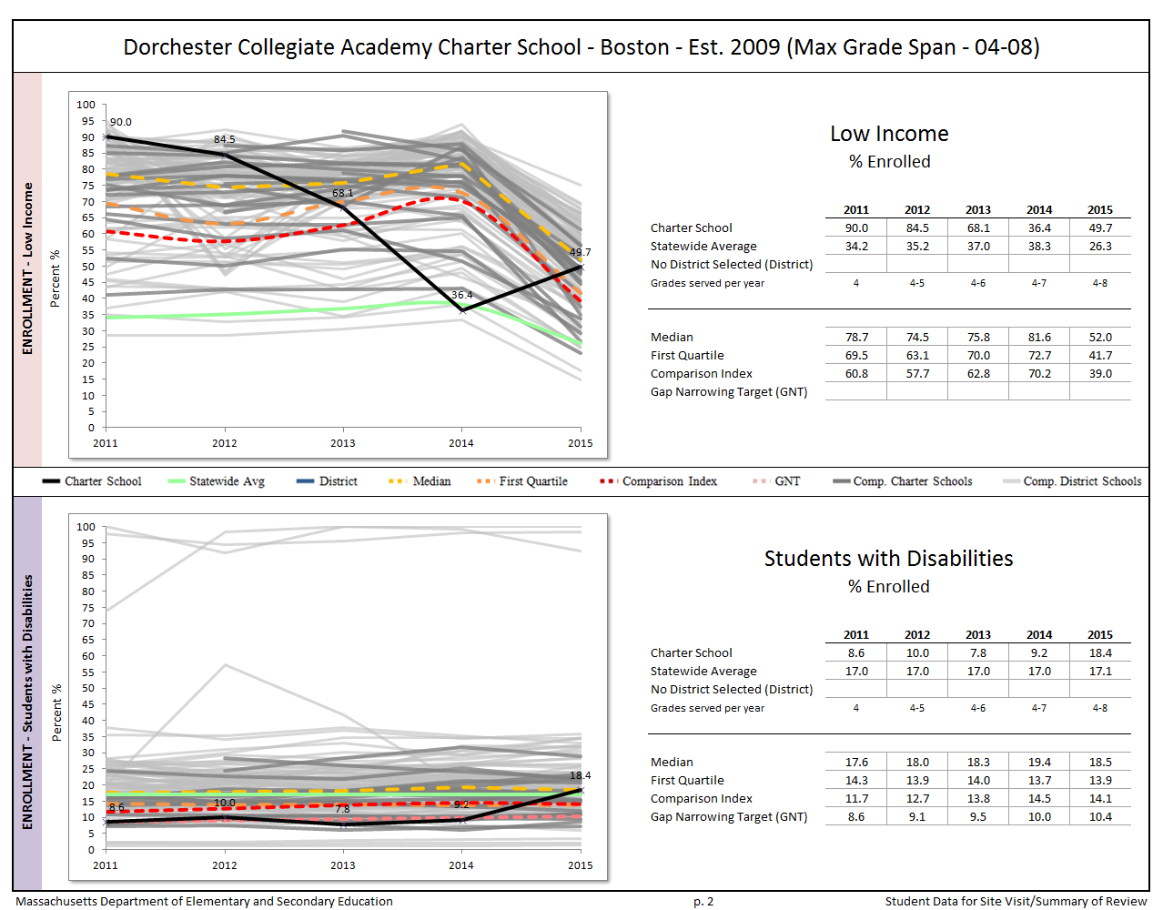
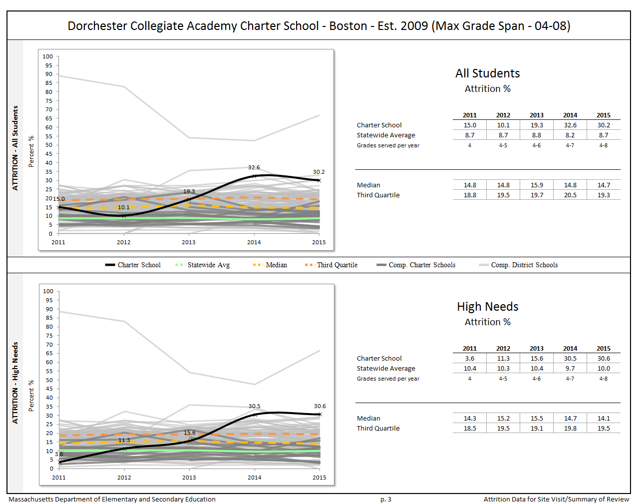

Appendix C

Criterion 5: Student Performance

The charter accountability table (below) provides several sets of data relative to charter school MCAS performance as well as student indicators. The percent of students scoring proficient or advanced (P/A), the composite performance index (CPI), the percent of students scoring warning or failing (W/F), and the student growth percentile (SGP) are all displayed in the aggregate over the term of the charter. The school’s accountability level, percentile, English Language Arts (ELA) and math percentiles for the aggregate and targeted subgroups, and cumulative progress and performance index (PPI) for the aggregate and targeted subgroups are shown if available (this depends on the size and the age of the school). When applicable, the 4-year and 5-year graduation rates as well as the annual dropout rate are also provided for the available years of the charter term. For detailed definitions of accountability terms, please visit this URL: http://profiles.doe.mass.edu/accountability/report/aboutdata.aspx#AccountabilityInformation.
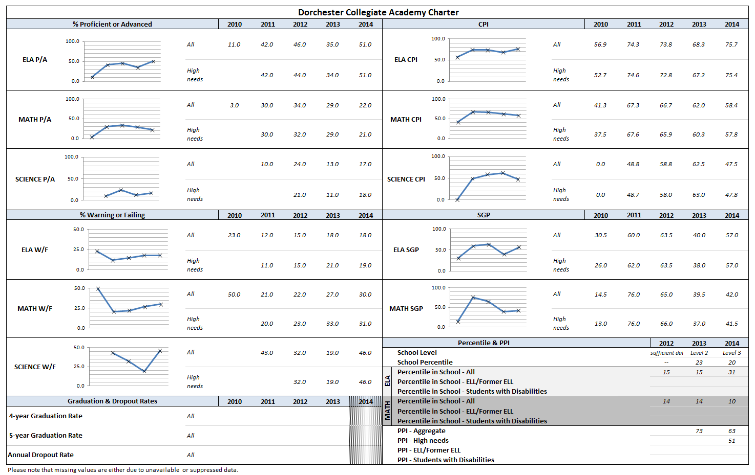
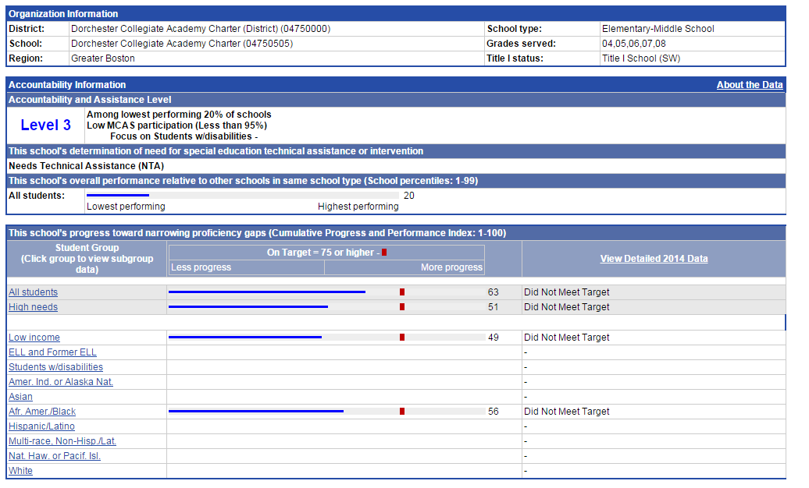

For All Students
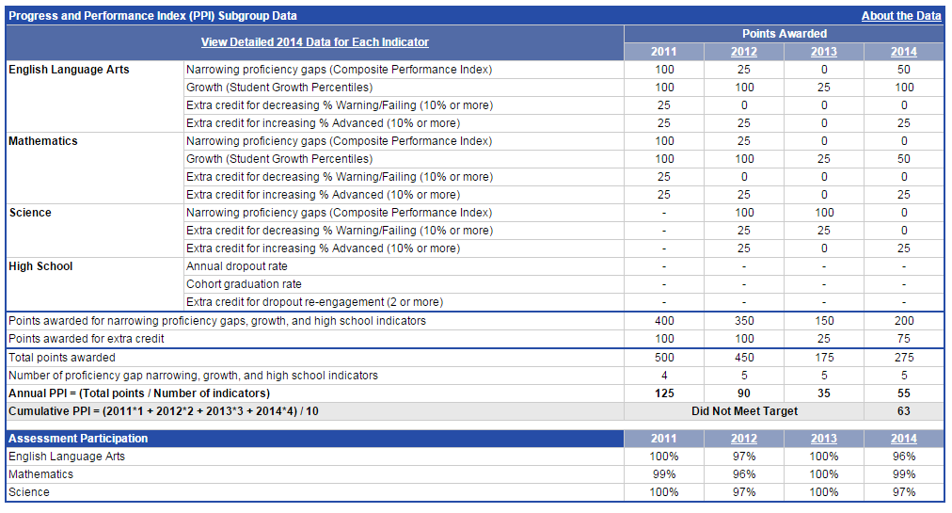
For High Needs Subgroup 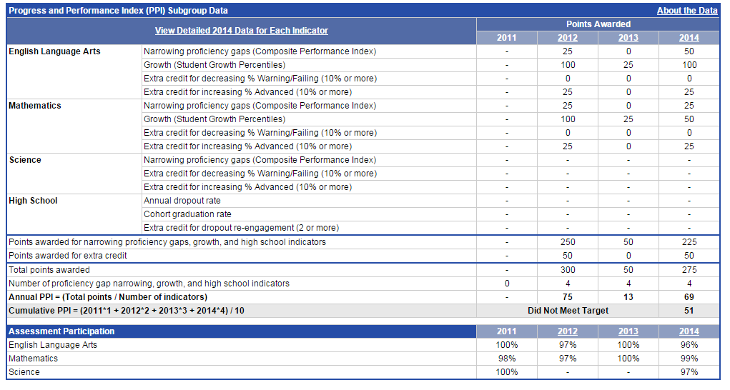

Appendix D

Criterion 10: Finance
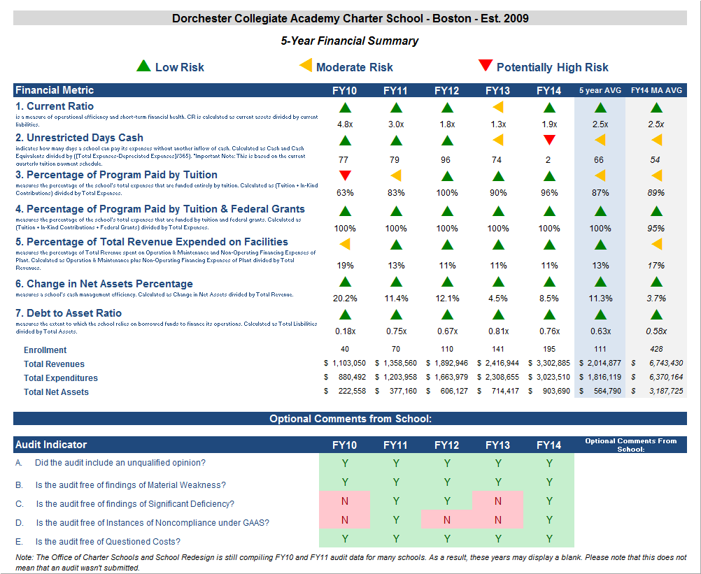

Financial Metric Definitions |  | Low Risk | Moderate Risk | Potentially High Risk
1. Current Ratio | Current Ratio is a measure of operational efficiency and short-term financial health. CR is calculated as current assets divided by current liabilities. | >= 1.5 | Between 1.0 (inclusive) and 1.5 | < 1.0
2. Unrestricted Days Cash (Prior to FY14)  Applies to 5-year average | The unrestricted days cash on hand ratio indicates how many days a school can pay its expenses without another inflow of cash. Calculated as Cash and Cash Equivalents divided by ([Total Expenses-Depreciated Expenses])/365).  Note: This is based on quarterly tuition payment schedule. | >= 75 days | Between 45 (inclusive) and 75 days | < 45 days
2. Unrestricted Days Cash (FY14 forward) | 4th quarterly tuition payments to Commonwealth charter schools in FY14 were made after June 30, 2014, which resulted in lower-than-typical cash at fiscal year end, affecting the risk levels for the current ratio and unrestricted days cash indicators for FY14 on a one-time basis. Payments for FY15 and after are made on a monthly basis, and parameters for risk have been adjusted accordingly. | >= 60 days | Between 30 (inclusive) and 60 days | < 30 days
3. Percentage of Program Paid by Tuition | This measures the percentage of the schools total expenses that are funded entirely by tuition. Calculated as (Tuition + In-Kind Contributions) divided by Total Expenses (expressed as a percentage). Note: In-Kind Contribution are added to the numerator in this ratio to balance out In-Kind Expenditures which will be captured in the Total Expenses in the denominator, and ratios over 100% are set to 100%. | >= 90% | Between 75% (inclusive) and 90% | < 75%
4. Percentage of Program Paid by Tuition & Federal Grants | This measures the percentage of the schools total expenses that are funded by tuition and federal grants. Calculated as (Tuition + In-Kind Contributions + Federal Grants) divided by Total Expenses (expressed as a percentage). Note: In-Kind Contribution are added to the numerator in this ratio to balance out In-Kind Expenditures which will be captured in the Total Expenses in the denominator, and ratios over 100% are set to 100%. | >= 90% | Between 75% (inclusive) and 90% | < 75%
5. Percentage of Total Revenue Expended on Facilities | This measures the percentage of Total Revenue that is spent on Operation & Maintenance and Non-Operating Financing Expenses of Plant. Calculated as Operation & Maintenance plus Non-Operating Financing Expenses of Plant divided by Total Revenues (expressed as a percentage). | <= 15% | Between 15% and 30% (inclusive) | > 30%
6. Change in Net Assets Percentage | This measures a school's cash management efficiency. Calculated as Change in Net Assets divided by Total Revenue (Expressed as a percentage). | Positive % | Between -2% (inclusive) and 0% | < -2%
7. Debt to Asset Ratio | Measures the extent to which the school relies on borrowed funds to finance its operations. Calculated as Total Liabilities divided by Total Assets. | <= .9 | Between .9 and 1 (inclusive) | > 1
FY12 MA AVG Column | All financial metrics indicated in this column are a result of each ratio calculated using statewide totals. For Enrollment, Total Net Assets and Total Expenditures rows, these numbers are averages calculated using the statewide totals of all charter schools’ data.

The Charter School Performance Criteria v. 3.1 is found at: http://www.doe.mass.edu/charter/acct.html?section=criteria
The attrition rate for the 2013-14 school year captures the number of students who left the school during the summer of 2013. The attrition rate for the 2014-15 school year captures the number of students who left the school during the summer of 2014.
1 The names of each of these schools and additional subgroup detail can be found in the Charter Analysis and Review Tool (CHART), http://www.doe.mass.edu/charter/chart/.
The midpoint value of all comparison schools. This is derived using Microsoft Excel's MEDIAN function.
The first quartile is the middle number between the smallest number and the median of all comparison schools. This is derived using Microsoft Excel's QUARTILE function.
The comparison index provides a comparison figure derived from data of students who reside within the charter school’s sending district(s). The comparison index is a statistically calculated value designed to produce a fairer and more realistic comparison measure that takes into account the charter school’s size and the actual prevalence of student subgroups within only those grade levels in common with the charter school.
The Gap Narrowing Target (GNT) refers to the halfway point between the school’s baseline rate (which is the rate in the 2010-11 school year, or the first year enrollment data is collected if after 2010-11,) and the current Comparison Index (the “target”). The object is to meet this halfway point by the 2016-17 school year (or in a later year if baseline is after 2010-11), giving the school six years to do so. For a school to be on schedule to meet its GNT, an incremental increase must be met annually. To determine this increment, the following equation is used: [(Comparison Index – Baseline) / 2] / 6 years = Annual GNT.
The percentage of attrition, or rate at which enrolled students leave the school between the end of one school year and the beginning of the next.
A student is high needs if he or she is designated as either low income, or ELL, or former ELL, or a student with disabilities. A former ELL student is a student not currently an ELL, but had been at some point in the two previous academic years.

