MCAS – CPI, English Language Arts, All Students

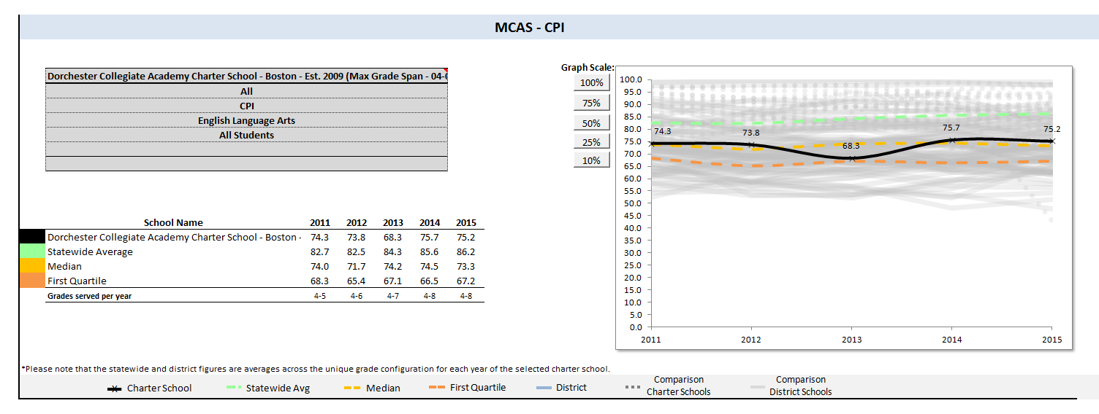

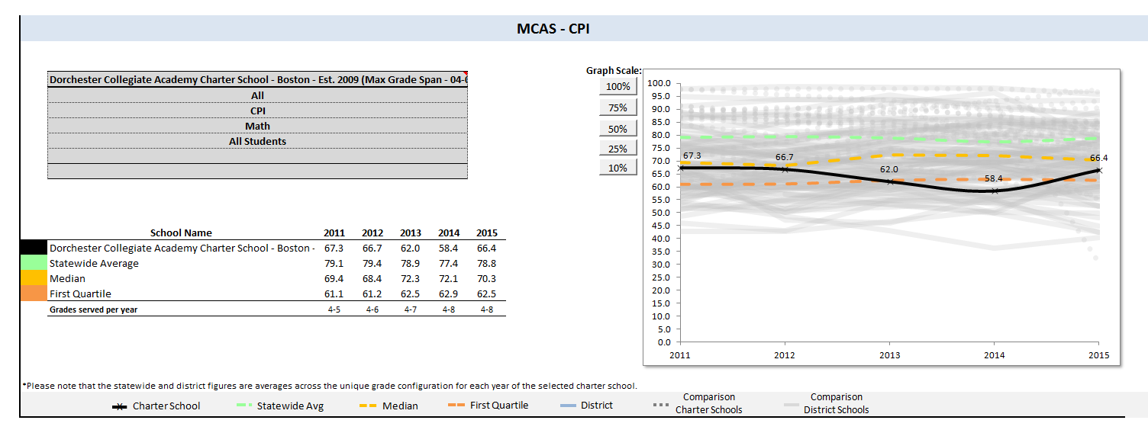
MCAS – CPI, Math, All Students

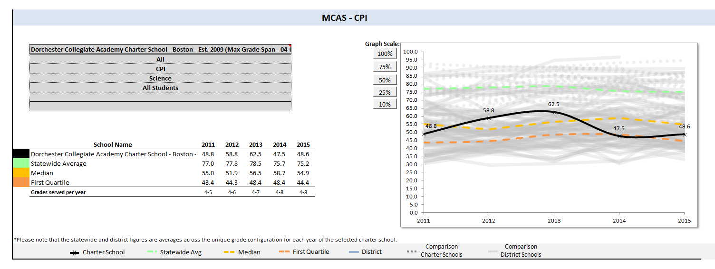
MCAS – CPI, Science, All Students

School Percentile Rank within same School Type (Elementary-Middle School)
All Boston Schools (Gray indicates Charter Schools)
SCHOOL | School Percentile (1-99)
Brooke Charter School Roslindale - Brooke Charter School Roslindale | 97
Brooke Charter School Mattapan - Brooke Charter School Mattapan | 93
Neighborhood House Charter - Neighborhood House Charter School | 78
Boston - Lyon K-8 | 76
Boston - Warren-Prescott | 69
Boston - Eliot Elementary | 68
Boston - Richard J Murphy | 64
Conservatory Lab Charter (District) - Conservatory Lab Charter School | 62
Boston - Joyce Kilmer | 62
Boston - Rafael Hernandez | 51
Boston - Joseph J Hurley | 48
Boston - Franklin D Roosevelt | 45
Boston - Joseph Lee | 42
Boston - Lyndon | 40
Boston - William H Ohrenberger | 28
Boston - Curley K-8 School | 26
Boston - Orchard Gardens | 25
Boston - Dennis C Haley | 24
Dorchester Collegiate Academy Charter - Dorchester Collegiate Academy Charter | 23
Boston - Oliver Hazard Perry | 22
Boston - Edison K-8 | 21
Boston - Boston Teachers Union School | 20
Boston - Gardner Pilot Academy | 19
Boston - Young Achievers | 17
Boston - Jackson Mann | 17
Boston - Mario Umana Academy | 16
Boston - Mildred Avenue K-8 | 14
Boston - Donald Mckay | 13
Boston - Higginson/Lewis K-8 | 11
Boston - Sarah Greenwood | 9
Boston - Mission Hill School | 5
Boston - King K-8 | 4
Boston - Maurice J Tobin | 3

PPI – All Students Rank within same School Type (Elementary-Middle School)
All Boston Schools (Gray indicates Charter Schools)
 | Cumulative Progress and Performance Index
SCHOOL | All Students | High Needs Students
Brooke Charter School Roslindale - Brooke Charter School Roslindale | 100 | 100
Brooke Charter School Mattapan - Brooke Charter School Mattapan | 100 | 100
Boston - Mildred Avenue K-8 | 83 | 83
Neighborhood House Charter - Neighborhood House Charter School | 76 | 69
Boston - Joseph J Hurley | 75 | 87
Boston - Joseph Lee | 71 | 84
Boston - Richard J Murphy | 71 | 71
Boston - Lyon K-8 | 69 | 73
Boston - Oliver Hazard Perry | 68 | 59
Boston - Dennis C Haley | 67 | 75
Boston - Higginson/Lewis K-8 | 67 | 68
Boston - Young Achievers | 66 | 75
Dorchester Collegiate Academy Charter - Dorchester Collegiate Academy Charter | 63 | 58
Boston - Rafael Hernandez | 61 | 56
Boston - Franklin D Roosevelt | 61 | 53
Boston - Warren-Prescott | 60 | 73
Boston - Curley K-8 School | 60 | 52
Boston - Edison K-8 | 59 | 52
Boston - Donald Mckay | 54 | 72
Conservatory Lab Charter (District) - Conservatory Lab Charter School | 54 | 53
Boston - Gardner Pilot Academy | 53 | 56
Boston - Orchard Gardens | 52 | 60
Boston - Mario Umana Academy | 51 | 83
Boston - Maurice J Tobin | 51 | 50
Boston - Boston Teachers Union School | 48 | 76
Boston - Lyndon | 48 | 69
Boston - Jackson Mann | 45 | 69
Boston - Joyce Kilmer | 44 | 36
Boston - Sarah Greenwood | 41 | 58
Boston - William H Ohrenberger | 41 | 52
Boston - King K-8 | 39 | 60
Boston - Eliot Elementary | 37 | 100
Boston - Mission Hill School | 33 | 38

PPI – High Needs Rank within same School Type (Elementary-Middle School)
 | Cumulative Progress and Performance Index
SCHOOL | All Students | High Needs Students
Brooke Charter School Roslindale - Brooke Charter School Roslindale | 100 | 100
Brooke Charter School Mattapan - Brooke Charter School Mattapan | 100 | 100
Boston - Eliot Elementary | 37 | 100
Boston - Joseph J Hurley | 75 | 87
Boston - Joseph Lee | 71 | 84
Boston - Mildred Avenue K-8 | 83 | 83
Boston - Mario Umana Academy | 51 | 83
Boston - Boston Teachers Union School | 48 | 76
Boston - Dennis C Haley | 67 | 75
Boston - Young Achievers | 66 | 75
Boston - Lyon K-8 | 69 | 73
Boston - Warren-Prescott | 60 | 73
Boston - Donald Mckay | 54 | 72
Boston - Richard J Murphy | 71 | 71
Neighborhood House Charter - Neighborhood House Charter School | 76 | 69
Boston - Lyndon | 48 | 69
Boston - Jackson Mann | 45 | 69
Boston - Higginson/Lewis K-8 | 67 | 68
Boston - Orchard Gardens | 52 | 60
Boston - King K-8 | 39 | 60
Boston - Oliver Hazard Perry | 68 | 59
Dorchester Collegiate Academy Charter - Dorchester Collegiate Academy Charter | 63 | 58
Boston - Sarah Greenwood | 41 | 58
Boston - Rafael Hernandez | 61 | 56
Boston - Gardner Pilot Academy | 53 | 56
Boston - Franklin D Roosevelt | 61 | 53
Conservatory Lab Charter (District) - Conservatory Lab Charter School | 54 | 53
Boston - Curley K-8 School | 60 | 52
Boston - Edison K-8 | 59 | 52
Boston - William H Ohrenberger | 41 | 52
Boston - Maurice J Tobin | 51 | 50
Boston - Mission Hill School | 33 | 38
Boston - Joyce Kilmer | 44 | 36
All Boston Schools (Gray indicates Charter Schools)

