Attachment H

Special Education Level Of Need Calculation
 |  | FY2013 | FY2014 | FY2015 | FY2016 | FY2013 | FY2014 | FY2015 | FY2016
 |  | Grades 4-­‐7 | Grades 4-­‐8 | Grades 4-­‐8 | Grades 4-­‐8 | Grades 4-­‐7 | Grades 4-­‐8 | Grades 4-­‐8 | Grades 4-­‐8
Low: less than 2 hrs per week | SIMS A; B | Rptd: 8;22 New Calculation: 3 | Rptd:17;30 New Calculation: 8 | Rptd:37;41 New Calculation: 3 | Rptd: 4 New Calcuation Dec= 4 | 2% of total pop 12.5% of SPED pop | 4.1% of total pop 22% of SPED pop | 1.6% of total pop 10% of SPED pop | 2% of total pop 7.1% of SPED pop
Low: 2-­‐5 hrs per week | SIMS A; B | Rptd 3;2 New Calculation: 15 | Rptd:1;7 New Calculation: 15 | Rptd:1;1 New Calculation: 16 | Rptd: 35 New Calculation: Dec= 28 | 11% of total pop 62.5% of SPED pop | 8% of total pop 42% of SPED pop | 9% of total pop 52% of SPED pop | 14% of total pop 50% of SPED pop
Moderate: 5+ hrs per week* (*for 2013 Mod=  6+perwk) | SIMS A; B | Rptd:0;0 New Calcuation: 6 | Rptd:0;0 New Calculation: 10 | Rptd 0;0 New Calculation: 9 | Rptd: 17 New Calculation: Dec= 21 | 4% of total pop 25% of SPED pop | 5.1% of total pop 28% of SPED pop | 5% of total pop 29% of SPED pop | 8% of total pop 38% of SPED pop
High: 14+ hrs per week; incl. those w/paras | SIMS A; B | Rptd: 0 New Caculation: 0 | Rptd: 0 New Calculation: 3 | Rptd 0 New Calculation: 3 | Rptd: 0 New Calculation: Dec= 5 | 0 | 1.5% of total pop 8% of SPED pop | 1.6% of total pop 10% of SPED pop | 2% of total pop 9% of SPED pop

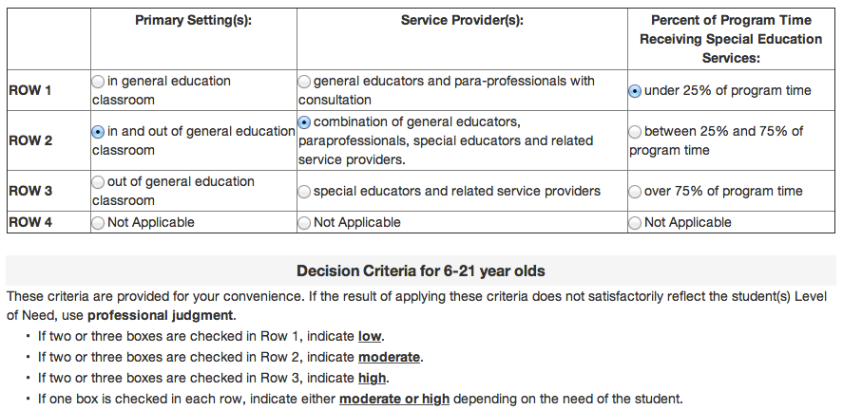
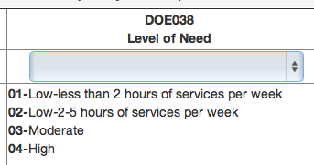

Level of need was determined based on number of hours in SPED, with consideration to PL3 chart, and through use of professional judgment; (PL3 chart frequently indicated a false positive for ‘Moderate’ when children received less than two hours of services, yet met two criteria in Row 2.) -­‐-­‐>

