Martin Luther King Jr. Charter School of Excellence
Summary of Review
Springfield, MA
February 2016
Massachusetts Department of Elementary and Secondary Education
Office of Charter Schools and School Redesign
75 Pleasant Street
Malden, MA 02148
Phone: (781) 338-3227
Fax: (781) 338-3220

This document was prepared by the
Massachusetts Department of Elementary and Secondary Education
Mitchell D. Chester, Ed.D.
Commissioner

The Massachusetts Department of Elementary and Secondary Education, an affirmative action employer, is committed to ensuring that all of its programs and facilities are accessible to all members of the public.
We do not discriminate on the basis of age, color, disability, national origin, race, religion, sex, gender identity, or sexual orientation.
Inquiries regarding the Department’s compliance with Title IX and other civil rights laws may be directed to the
Human Resources Director, 75 Pleasant St., Malden, MA 02148-4906. Phone: 781-338-6105.

© 2016 Massachusetts Department of Elementary and Secondary Education
Permission is hereby granted to copy any or all parts of this document for non-commercial educational purposes. Please credit the “Massachusetts Department of Elementary and Secondary Education.”

This document printed on recycled paper

Massachusetts Department of Elementary and Secondary Education
75 Pleasant Street, Malden, MA 02148-4906
Phone 781-338-3000 TTY: N.E.T. Relay 800-439-2370
www.doe.mass.edu

Table of Contents

I. Introduction 1
II. Executive Summary of Charter School Performance 1
III. School Setting 3
IV. Areas of Accountability 4
A. Faithfulness to Charter 4
B. Academic Program 7
C. Organizational Viability 16
Appendix A: Accountability Plan Objectives and Measures (Criterion 1: Mission and Key Design Elements) 19
Appendix B: CHART (Criterion 2: Access and Equity) 22
Appendix C: Academic Data (Criterion 5: Student Performance) 27
Appendix D: Financial Dashboard (Criterion 10: Finance) 31
Appendix E: School’s Response to the 2016 Summary of Review 33

I. Introduction
The charter school regulations state that “the decision by the Board [of Elementary and Secondary Education] to renew a charter shall be based upon the presentation of affirmative evidence regarding the faithfulness of the school to the terms of its charter, including the extent to which the school has followed its recruitment and retention plan and has disseminated best practices in accordance with M.G.L. c. 71, § 89(dd); the success of the school's academic program; and the viability of the school as an organization” 603 CMR 1.11(2). Consistent with the regulations, recommendations regarding renewal are based upon the Department of Elementary and Secondary Education’s (Department) evaluation of the school’s performance in these areas. In its review, the Department has considered both the school’s absolute performance at the time of the application for renewal and the progress the school has made during the first four years of its charter. Performance is evaluated against both the Massachusetts Charter School Performance Criteria and the school’s accountability plan. The evaluation of the school has included a review of various sources of evidence.
The following sections present a high-level summary from various sources regarding the school’s progress and success in fulfilling the terms of its charter, raising student achievement, and establishing a viable organization over the past charter term . Specific details about each criterion have been well-documented in the sources listed below.

II. Executive Summary of Charter School Performance

Martin Luther King Jr. Charter School of Excellence
Type of Charter  (Commonwealth or Horace Mann) | Commonwealth | Location | Springfield
Regional or Non-Regional | Non-regional | Districts in Region  (if applicable) | N/A
Year Opened | 2006 | Year(s) Renewed  (if applicable) | 2011
Maximum Enrollment | 360 | Current Enrollment | 366
Chartered Grade Span | K-5 | Current Grade Span | K-5
Students on Waitlist | 264 | Current Age of School | 10 years
Mission Statement
Martin Luther King, Jr. Charter School of Excellence prepares kindergarten through 5th grade students of Springfield for academic success and engaged citizenship through insistence on rigorous, challenging work. The school incorporates Dr. King’s commitment to the highest standards in scholarship, civic participation and the ideal of the beloved community.

Martin Luther King Jr. Charter School of Excellence
● Exceeds |  | The school fully and consistently meets the criterion and is a potential exemplar in this area.
● Meets |  | The school generally meets the criterion and/or minor concern(s) are noted.
● Partially Meets |  | The school meets some aspects of the criterion but not others and/or moderate concern(s) are noted.
● Falls Far Below |  | The school falls far below the criterion and/or significant concern(s) are noted.
Massachusetts Charter School Performance Criteria |  |  |  | Rating
Faithfulness to Charter | - Mission and Key Design Elements: The school is faithful to its mission, implements the key design elements outlined in its charter, and substantially meets its accountability plan goals. |  |  | ● Partially Meets
 | - Access and Equity: The school ensures program access and equity for all students eligible to attend the school. |  |  | ● Meets
 | - Compliance: The school compiles a record of compliance with the terms of its charter and applicable state and federal laws and regulations. |  |  | ● Partially Meets
 | - Dissemination: The school provides innovative models for replication and best practices to other public schools in the district where the charter school is located. |  |  | ● Partially Meets
Academic Program Success | - Student Performance: The school consistently meets state student performance standards for academic growth, proficiency, and college and career readiness. |  |  | ● Falls Far Below
 | - Program Delivery: The school delivers an academic program that provides improved academic outcomes and educational success for all students. |  | Curriculum | ● Meets
 |  |  | Instruction | ● Partially Meets
 |  |  | Assessment and Program Evaluation | ● Meets
 |  |  | Supports for Diverse Learners | ● Meets
 | - Culture and Family Engagement: The school supports students’ social and emotional health in a safe and respectful learning environment that engages families. |  | Social, Emotional and Health Needs | ● Meets
 |  |  | Family Engagement | ● Meets
Organizational Viability | - Capacity: The school sustains a well-functioning organizational structure and creates a professional working climate for all staff. |  | School Leadership | ● Partially Meets
 |  |  | Professional Climate | ● Meets
 | - Governance: Members of the board of trustees act as public agents authorized by the state and provide competent and appropriate governance to ensure the success and sustainability of the school. |  |  | ● Meets
 | - Finance: The school maintains a sound and stable financial condition and operates in a financially sound and publicly accountable manner. |  |  | ● Meets

III. School Setting

School Setting

Martin Luther King, Jr. Charter School of Excellence (MLK) opened in 2006 and is currently in its tenth year of operation. The school received its charter in 2005 and opened its first location in rented church space at 649 State Street, Springfield. The school moved to its new location at 285 Dorset Street in 2010 and has operated there for six years. When the school first opened, it served students in kindergarten through grade 2. Grade 3 was added in 2007, grade 4 in 2008, and grade 5 in 2009.

Since the school opened, several amendments to the school’s charter have been approved by the Board of Elementary and Secondary Education (BESE) regarding both the school’s schedule and educational philosophy. In 2009 the school was granted a temporary increase for two years in enrollment from 360 to 380, and the maximum authorized enrollment was reduced back to 360 in 2012. The school has been persistently overenrolled during this charter term, even during the temporary enrollment increase, more than the number allowed by its charter.

In January 2011 the BESE granted the school a probationary renewal with three conditions related to program delivery and academic performance. In January 2013, the BESE determined that MLK had “sufficiently met conditions related to academic growth, establishing a fully documented curriculum, and evaluating and staffing its leadership structure to remove MLK from probation.” The BESE imposed further academic conditions to demonstrate significant and sustained academic improvement by December of 2014.

In January 2015, the BESE placed the school on probation again following a continued decline in student achievement and set three conditions of probation related to academic improvement and sustainability.

While the executive director has remained the same since the school’s founding, instructional leadership has been inconsistent during the first and current charter terms. During this current charter term the school has employed three different individuals as the principal. Please see Key Indicator: School Leadership for more details. The school hired a new principal who began work in June 2015.

IV. Areas of Accountability

A. Faithfulness to Charter
Criterion 1: Mission and Key Design Elements
The school is faithful to its mission, implements the key design elements outlined in its charter, and substantially meets its accountability plan goals.
(Please refer to Appendix A for the school’s accountability plan.)
Finding: Over the course of the charter term, stakeholders at the school have shared a common and consistent understanding of the school’s mission. The school has not yet realized its mission to prepare students for academic success, but has implemented other aspects of its mission.  The three aspects of the MLK mission include: preparing students for academic success, developing engaged citizens, and achieving the ideal of a beloved community. In Year 6, stakeholders reported a commitment to improving academic performance and character development. In Year 10, stakeholders reported that the mission included academic excellence, developing engaged citizens, and Reverend Martin Luther King, Jr.’s ideal of the beloved community. The school has developed its implementation of these areas as it worked to address its probationary status and conditions this charter term. In addition, the school has implemented several key design elements related to the mission. These include: an extended learning day, community service, and character development. These key design elements will be discussed under the relevant areas of the mission below.  Academic Excellence  The school has made many changes in curriculum, programming, and instructional leadership to address low student achievement this charter term and to address the conditions placed on the charter this charter term. In 2013, the school contracted with a consultant to conduct a comprehensive evaluation of its school’s English Language Art’s (ELA) program. The school also developed an action plan to improve its performance in ELA. More detail about the changes to the program as a result of this evaluation and plan will be provided in Key Indicators Curriculum, Instruction and School Leadership below. Despite these efforts, the school remains in Level 3 in 2015. Please see Criterion 5: Student Performance for more information in this area. However, in Year 10, the renewal inspection team noted that this summer and fall the school has made more significant changes to the academic program under the leadership of a new principal.  The school has also implemented an extended school day as one of its key design elements over the course of the charter term. Currently, the school operates daily from 8:15am to 4:00pm except for Tuesdays when students are dismissed at 2:00pm for staff professional development. Finally, the school has developed a partnership with Uncommon Schools this charter term and has been paired with Troy Preparatory Charter School (Troy Prep) in New York as a partner school for support.  Engaged Citizenship  During the renewal inspection, stakeholders reported that each teacher prepares one community service project each year in order to foster engaged citizenship. Examples include beautification projects, writing letters to soldiers in Korea, and collecting food for a food pantry. The school also provides students with opportunities for in school community service such as preparing for school assemblies and delivering school supplies to classrooms. The school has measures related to this area of the mission in its accountability plan.  Beloved Community  The school has several systems in place to support the ideal of the beloved community. Visitors in Year 10 found that the MLK values are posted throughout the school: respect, cooperation, responsibility, learning, social justice, service, perseverance, honesty and beloved community. The school’s character education program has changed over the course of the charter term. In Year 6, visitors found that the school had partially implemented the character development program and had not yet instituted regular activities for the program. Currently, the character development program includes monthly grade level community meetings led by the principal and student services staff to learn how to live and work according to the MLK values. Different values are highlighted each month. The school provides readings focused on the monthly values in the school library.  Since 2010, the school’s approach to discipline has emphasized clear expectations and incentives to meet those expectations and is known as the MLK Way. As part of its partnership with Troy Prep, in 2014, the school added to the MLK way by implementing the MLK “100% Vision” based on Troy Prep’s “100% Vision” which outlines precise expectations for student behavior in a variety of contexts. The school has a “role model” program in place where students are recognized as role models based on their adherence to the MLK Way. Staff and parents in Years 6 and 10 stated that the school community is meeting this aspect of its mission.  Finding: MLK met a majority of the measures in its accountability plan.  MLK’s approved accountability plan includes 8 objectives and 14 related measures. MLK met 12 out of 14 measures. The two measures that were not met are related to academic achievement data. Please see Appendix A for full details. | Rating: Partially Meets
Sources:
- Renewal Inspection Report (2015)
- Renewal Application (2015)
- Year 6 Site Visit Report (2012)
- 2012-15 Annual Reports

Criterion 2: Access and Equity
The school ensures program access and equity for all students eligible to attend the school.
(Please refer to Appendix B for demographic and attrition data.)
Finding: The school made progress in recruiting and retaining a comparable student population to the sending district in two subgroups and has a low attrition rate for all students and high needs students.  Enrollment of English Language Learners (ELLs) saw improvement between 2011 and 2014, but then dipped in 2015. Enrollment of ELLs is currently below comparison schools. Enrollment of low income/economically disadvantaged students has been above the comparison index this charter term. Enrollment of students with disabilities has increased this charter term and is above comparison schools. Attrition for all students, including the high needs subgroup, is below comparison schools. The school has received Department approval for their recruitment and retention plan for the current school year. | Rating:  Meets
Sources:
- ESE Charter Analysis Review Tool (CHART)
- 2012-15 Annual Reports and Recruitment and Retention Plans

Criterion 3: Compliance
The school compiles a record of compliance with the terms of its charter and applicable state and federal laws and regulations.

Finding: The school is out of compliance with state and federal regulations regarding teacher licensure.  Per state regulations (603 CMR 1.06(4)), all teachers beyond their first year of employment must have taken and passed the Massachusetts Test for Educator Licensure (MTEL). As of the renewal inspection, seven teachers beyond their first year of employment have not passed the required MTELs. One of the school’s two ESL teachers was not appropriately licensed until Year 10 of this charter term.  Finding: The school is in compliance with program requirements as measured by the Coordinated Program Review (CPR).  The school last received a CPR visit from the Program Quality Assurance division of the Department of Elementary and Secondary Education in April 2014. MLK completed all elements of an approved Corrective Action Plan (CAP). The most recent progress report submission was submitted in April and September of 2015. The school’s next scheduled CPR activity will be the mid-cycle CPR in 2016-17.  Finding: The school has been overenrolled this charter term.  MLK has been consistently overenrolled this charter term which is more than what is allowed by the school’s charter. The charter’s maximum enrollment is 360 students. The school has enrolled the following numbers of students each year.  Year Enrollment number  2011-12 388*  2012-13 369  2013-14 373  2014-15 367  2015-16 366  * In 2009 the school was granted a temporary increase in enrollment for two years from 360 to 380, and the maximum authorized enrollment was reduced back to 360 in 2012. | Rating: Partially Meets
Sources:
- 2014-15 MLK Teacher Roster
- 2013-14 CPR
- Year 9 Targeted Site Visit Report (2014)
- Year 8 Targeted Site Visit Report (2014)
- Year 6 Site Visit Report (2012)

Criterion 4: Dissemination
The school provides innovative models for replication and best practices to other public schools in the district where the charter school is located.
Finding: The school has engaged in limited dissemination activities this charter term.  This charter term, the school has engaged in limited dissemination activities due to its probationary status and conditions. The school has partnered with Mt. Holyoke College to develop the Philosophy for Children program. The college has published books using MLK as a case study. This program has been widely shared and was featured in a documentary. The executive director visited Springfield’s Indian Orchard Elementary to discuss this program. In addition, the executive director met with the school leaders of two new charter schools in Springfield to discuss the administration of a new charter school. The school has hosted visits from other schools regarding school culture, including a principal from Oakland, CA.  The school has been a leader in organizing a regional Pioneer Valley parent advisory special education council with five other schools. The first meeting was held at MLK and the second is also scheduled at the school. As part of this group, the school has shared best practices in involving special education parents at the school. | Rating: Partially Meets
Sources:
- Interview with executive director (2015)
- Renewal Application (2015)
- 2012-15 Annual Reports

B. Academic Program

Criterion 5: Student Performance
The school consistently meets state student performance standards for academic growth, proficiency, and college and career readiness.
(Please refer to Appendix C for academic data.)
Over the charter term, MLK’s MCAS scores have not consistently met state student performance standards for academic growth and proficiency.  Since 2012, MLK has been in Level 3. In 2012, MLK was in the 12th percentile, in 2013 the 11th percentile, and in 2014 the 9th percentile. In 2015, MLK remains in Level 3 in the 16th percentile relative to other schools statewide. In 2015, the school has a cumulative PPI of 77 for all students and 76 for the high needs subgroup (both meeting gap narrowing targets). In 2015, MLK improved below its gap narrowing targets for ELA and mathematics, but was above its gap narrowing targets for science.  The school’s CPI for 2015 was 66.7 in ELA, 73.9 in mathematics, and 77.5 in science and technology/engineering. In 2015, 33 percent of MLK students scored in the Proficient and Advanced categories on the ELA assessment, below the state average of 63 percent. In mathematics, 49 percent scored Proficient and Advanced, below the state average of 63 percent. In science and technology/engineering, 46 percent scored Proficient and Advanced, below the state average of 53 percent. The school’s SGP for 2015 was 49.5 in ELA (on target growth) and 64.0 in mathematics (above target growth).. Please refer to Appendix C for detailed student academic performance data. | Rating:  Falls Far Below
Sources:
- ESE Website
- 2012-15 Annual Reports

Student Growth Percentile
 |  | 2012 | 2013 | 2014 | 2015
ELA SGP | All | 50.5 | 42 | 35.5 | 49.5
 | High needs | 50.5 | 42 | 36 | 41
Math SGP | All | 73 | 59 | 44 | 64
 | High needs | 74 | 55.5 | 44.5 | 66

ELA CPI
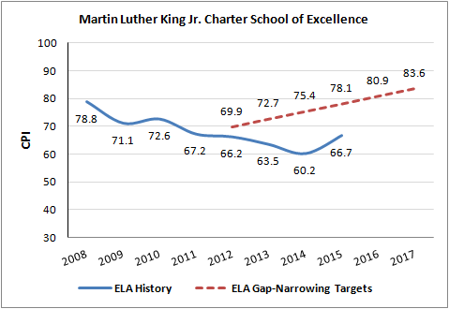

Mathematics CPI
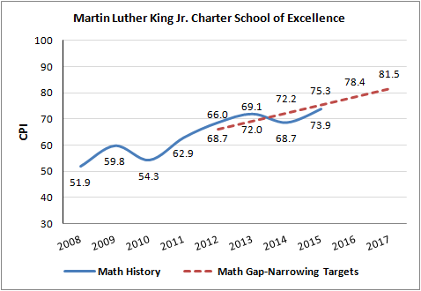

Science CPI
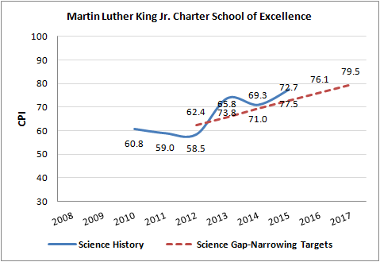

Criterion 6: Program Delivery
The school delivers an academic program that provides improved academic outcomes and educational success for all students.
Key Indicator: Curriculum
Finding: The school has made substantial changes to its curriculum this charter term. In Year 10, the school has curriculum that is aligned to the Common Core State Standards (CCSS) and the ANet assessment program. The school has instituted an ongoing system for the review and revision of the curriculum based on data.  Visitors to MLK have documented a number of curricular shifts over the course of the charter term. Following the school’s renewal in 2011, the school was required to provide evidence of a fully documented curriculum aligned to the Massachusetts Curriculum Frameworks (MCF). In Year 6, visitors found that MLK created overarching curriculum maps for all of the core academic programs that were aligned to the CCSS and MCF. Teachers used these curriculum maps to create unit plans from a common template. At the time of the visit in April of Year 6, the school was still in the process of developing unit plans. Teachers were also expected to develop daily lesson plans, however the lesson plan formats varied from teacher to teacher.  In Year 8, in an effort to better vertically align its curriculum and to meet the conditions placed on the school in 2013, MLK contracted a consultant to review the school’s ELA curriculum and developed an action plan. As a result, MLK purchased the Journeys reading curriculum from Houghton Mifflin Harcourt which was aligned to the CCSS. The school also purchased Math Expressions by Houghton Mifflin Harcourt which was aligned to the CCSS. The school had begun to require teachers to use a common lesson plan template. The new purchased curriculum, as implemented, was not aligned to the ANet assessment system nor was it well implemented in classrooms.  In Year 9, visitors found that the school was using Journeys and Math Expressions as resources, but had changed the sequencing to better align to the ANet assessments, called the schedule of assessed standards (SAS). The SAS became the operating scope and sequence for grades 2-5. Teachers had also been required to develop more rigorous ELA lessons based on Journeys. The school continued to work to better align the curriculum through new processes but inconsistencies remained. Year 9 site visitors found that lesson plans did not consistently reflect an implementation of CCSS standards or rigor.  During the renewal inspection in Year 10, visitors found that the school had made substantial changes to the ELA and mathematics curricula based on work with external consultants. Visitors found that the curriculum was aligned to the CCSS and MCF, vertically and horizontally aligned, and aligned to the school’s ANet assessment program. The current curriculum consists of a scope and sequence for every grade level, the CCSS and MCF standards, big ideas, essential questions, texts and tasks. The documented curriculum also supported opportunities for all students including diverse learners to access skills and concepts and addressed interventions, required pre-skills, information targeted for special education and ELL students, language objectives and tiered vocabulary.  The school has appointed two staff members responsible for curriculum development, monitoring, and coaching in ELA and mathematics: a literacy coordinator and a director of math curriculum/instructional coach. The school also employs an outside consultant to review the ELA curriculum units to ensure alignment and rigor. The ELA curriculum is a blend of several programs including the Lucy Calkins Writing Workshop, the Read Aloud curriculum, Engage NY units, and Journeys as supplemental materials, among other things. The mathematics curriculum was developed based on Pearson’s enVisionMath 2.0. The team found that lesson plans were consistent, rigorous, detailed and aligned to standards.  The school has also instituted an ongoing process for review and revision of the curriculum. Teachers review the curriculum with the literacy coordinator or a coach and the director of math curriculum at weekly grade level meetings and in weekly after school professional development sessions using data from MCAS, ANet, unit tests, and other assessments. Each grade level continues to have a content area lesson planner who works further with the literacy coach and director of math curriculum to refine and modify the curriculum. Additional review and revision takes place mid-year and at the end of the year.  Visitors in Year 10 observed faithful implementation of the curriculum in classrooms. The principal monitors the curriculum during classroom observations using a tracker that is linked to the curriculum standards. | Rating:  Meets
Sources:
- Renewal Inspection Report (2015)
- Renewal Application (2015)
- Year 9 Targeted Site Visit Report (2014)
- Year 8 Targeted Site Visit Report (2014)
- Year 6 Site Visit Report (2012)

Key Indicator: Instruction
Finding: Over the charter term, the school has refined its instructional practices and increased the expectations of students. Visitors in Year 10 found that school stakeholders shared a common understanding of high-quality instruction.  The school has worked to codify and enhance its instructional practices this charter term. In Year 6, visitors saw partial implementation of the school’s described model. Visitors also noted that a range of effective instruction was observed.  In Year 8, visitors found that stakeholders shared a basic understanding of the school’s instructional practices, but found that the implementation of these practices was only somewhat aligned to the described model and not always well implemented. In Year 9, stakeholders reported that the school had developed a document called the Instructor’s Manual that provided teachers with guidance on instructional delivery. While the majority of administrators and teachers shared an understanding of instructional practices, the observed practices were not consistently implemented or effective.  In Year 10, the renewal inspection team found that all teachers shared a common understanding of high quality instructional practices based on the Instructor’s Manual. These practices included posted objectives, the use of Teach Like a Champion strategies, a gradual release model, the use of higher-order thinking questions, guided reading, and a focus on procedural fluency in mathematics classes, many of which had been included in the school’s common practices throughout the charter term. The team observed instruction aligned to this description in the majority of observations. In particular, the team noted that teachers at every grade using higher-order thinking questions and strategies, although these varied with respect to the levels of complexity and teacher skill.  Finding: Student engagement and classroom environments have varied throughout the charter term as the school has made changes to the MLK Way and incorporated the MLK “100% Vision”.  In Year 6, visitors found that the school had consistently implemented the newly instituted MLK Way and classroom environments were supportive of student learning. In addition, a majority of classrooms elicited consistently high levels of student engagement. In Year 8, visitors observed that classroom environments were inconsistent in terms of student engagement and maximized learning time. Visitors also noted that checks for understanding were limited. In Year 9, the school had incorporated the newly created the “100% Vision” into the MLK Way as described in Criterion 1: Mission and Key Design Elements. Visitors again observed inconsistencies in terms of classroom environments and a range of student engagement. In Year 10, visitors found that the classroom climates were characterized by respectful relationships, behaviors, tones, and discourse. Teachers all expected students to follow the “MLK 100% Vision” of the MLK Way. Instruction fostered student engagement in two thirds of classrooms. | Rating: Partially Meets
Sources:
- Renewal Inspection Report (2015)
- Renewal Application (2015)
- Year 9 Targeted Site Visit Report (2014)
- Year 8 Targeted Site Visit Report (2014)
- Year 6 Site Visit Report (2012)

Key Indicator: Assessment and Program Evaluation
Finding: The school’s use of data has become more robust this charter term. In Year 10, the school administers a balanced system of formative and benchmark assessments. The school has developed a formalized data review process and put resources in place to support the use of data this charter term.  The school has developed its system of assessment this charter term. Throughout the charter term, the school has maintained its partnership with ANet and administered the ANet assessments in ELA and mathematics. As noted above in Key Indicator: Curriculum, in Year 8 the school’s curriculum did not align to the ANet assessment system, making it difficult to effectively monitor the academic program. These assessments were realigned in Years 9 and 10. The school has also administered the Fountas and Pinnell assessments throughout the charter term. In Years 8, 9 and 10, visitors found that the school was also administering unit assessments based on the curriculum from year to year.  The school has used data to re-teach standards and support individual students throughout the charter term. Visitors in Years 8, 9 and 10 reported that they follow the ANet data cycle to identify standards where students had fallen short and form a plan to reteach. Data processes became more formalized in Year 9 after the school worked with consultants to assess their program, and hired a curriculum and instruction coordinator in part to work with student data. The cycle is a five-step collaborative cycle of inquiry that teachers use during grade-level and content area meetings. The cycle includes the following steps: plan from standards; teach, assess; analyze data and student work; adapt teaching and reassess; reflect and begin the cycle again. Teachers also review data during professional development. The school now employs an academic data specialist focused on the school’s data system.  Data analysis has led to changes this charter term, including changes to the curriculum, changes in staffing, the recent change to an inclusion model, and changes to the behavioral system. | Rating:  Meets
Sources:
- Renewal Inspection Report (2015)
- Renewal Application (2015)
- Year 9 Targeted Site Visit Report (2014)
- Year 8 Targeted Site Visit Report (2014)
- Year 6 Site Visit Report (2012)

Key Indicator: Supports for Diverse Learners
Finding: The school has made changes to its systems, structures and resources to support diverse learners, including special education and ELL students, this charter term.  In Year 10, visitors found that the school has a process in place to identify and support struggling students and ELLs. The school uses a child study team (CST) and the Response to Intervention (RTI) model to identify students who may be in need of services. The school also uses the home language survey to identify students in need of ELL services, and then uses the WIDA Model as needed.  The school has increased its supports and resources to students over the course of the charter term. In Years 8 and 9, visitors observed some supports to meet the academic needs for all students in general education classrooms, but they were not consistently of high quality with lower quality pull-out instruction observed in Year 9. Visitors in Year 10 found that the school has for the most part moved away from pullouts, particularly in ELA. In Year 10, visitors observed differentiated activities, materials, or strategies to support all learners in the majority of classrooms. For example, visitors saw multiple adults in classrooms, leveled reading books, small group work, preferential seating, graphic organizers, manipulatives and the use of breaks.  The school has increased staffing to support diverse learners, particularly for ELL students. There are currently two ESL instructors for grades K-5, and 24 classroom teachers or coaches are SEI-endorsed. The school has also had an ESL curriculum since Year 8. The school has a school adjustment counselor, a speech and language therapist, and a school psychologist. The school works with a local organizations to provide students with counseling, occupational, and physical therapy services. The school employs three literacy specialists for grades K-5, two literacy coaches, and a writing coach.  The school has developed a tiered intervention system this charter term. In Year 9, visitors noted that the structures and systems for interventions for struggling students were in development and not fully understood by all stakeholders. In Year 10, the renewal inspection team found that the school had interventions in place based on the RTI model that were largely classroom based set by grade level teams. Additional interventions include tutoring and intervention blocks. In addition, the school implements a substantially separate pullout program that began in 2014-15, the Incremental Success Program where students who struggle with behaviors that prevent them from participating fully in the regular classroom are served. | Rating:  Meets
Sources:
- Renewal Inspection Report (2015)
- Renewal Application (2015)
- Year 9 Targeted Site Visit Report (2014)
- Year 8 Targeted Site Visit Report (2014)
- Year 6 Site Visit Report (2012)

Criterion 7: Culture and Family Engagement
The school supports students’ social and emotional health in a safe and respectful learning environment that engages families.
Key Indicator: Social, Emotional and Health Needs
Finding: MLK has a safe school environment and supports the social, emotional, and health needs of its students.  In years 6 and 10, visitors found that MLK has a safe school environment that is supportive of students. As noted in Criterion 1: Mission and Key Design Elements, staff and parents have reported that the school community is meeting this beloved community aspect of its mission. The school’s beloved community and MLK Way are discussed in detail in Criterion 1: Mission and Key Design Elements.  Visitors in Year 10 found that the new principal had instituted a number of changes to improve school culture, including morning greetings, a change in hallway and cafeteria behavior requirements, and dismissal procedures.  In addition to the support staff described in Key Indicator: Supports for Diverse Learners, the school has a dean of students, a classroom management coach, a social worker intern, a student support partner, a mentor for students, and a school nurse who are all members of the student support team. The student support team meets weekly. | Rating:  Meets
Sources:
- Renewal Inspection Report (2015)
- Renewal Application (2015)
- Year 6 Site Visit Report (2012)

Key Indicator: Family Engagement
Finding: The school has developed strong working relationships with families and guardians and provides regular communication to them. MLK parents and guardians have expressed satisfaction with the school over the course of the charter term.  Parents and guardians throughout the charter term have expressed satisfaction with the school. In Year 10, parents told visitors that the school had communicated with them about the school’s probationary status and the need to improve student learning and performance on the MCAS tests. Parents told the team that school leaders and teachers were accessible to them by telephone, text, or in-person meetings and that they received report cards three times a year. The school also has a monthly newsletter. Some parents reported receiving more frequent communication.  The school holds several evening events for parents, including ELA and mathematics curriculum nights. Some teachers told the renewal inspection team that they had conducted home visits. Parents said that the school provided staff who could translate for them and translated materials for them. As noted in Criterion 4: Dissemination, the school has established a regional special education parent council that had already met once at the time of the renewal inspection site visit. The school also has a parent survey which reflects that in 2015, more than 90 percent of parents were satisfied with the school. | Rating:  Meets
Sources:
- Renewal Inspection Report (2015)
- Renewal Application (2015)
- Year 6 Site Visit Report (2012)

C. Organizational Viability

Criterion 8: Capacity
The school sustains a well-functioning organizational structure and creates a professional working climate for all staff
Key Indicator: School Leadership
Finding: The school has lacked consistent instructional leadership this charter term. In its tenth year, the renewal inspection team found that the new principal has implemented clear structures, roles, and communication.  The current leadership team includes the executive director, the principal, an academic data specialist, the literacy coordinator, the instructional coach and director of math curriculum, dean of students, director of student services and special education coordinator, a contracted special education administrator, an ELL coordinator, and several other support roles.  In 2011, the school was renewed with probation. One of the probationary conditions was for the school to evaluate its leadership structure, develop an organizational chart with accompanying job descriptions, and create a plan to fully staff the administrative structure. The school met this condition according to the Year 6 Site Visit Report. The school hired a new principal in June of 2011 to act as the instructional leader. The principal subsequently departed the school in June of 2014 after three years. At that time, the executive director became the acting principal and worked with consultants until a new principal was hired in December of 2014. The second principal of the charter term departed in June of 2015 due to personal issues, at which point the third and current principal of the charter term was hired. The school has also reconfigured other leadership roles, including the director of student services position and the director of curriculum and instruction which subsequently moved into the academic data specialist position. The team has also increased its instructional coach positions.  In Year 10, the renewal inspection team found that the new principal has created effective structures, clear roles for leaders, and well-understood systems for communications while maintaining a commitment to the school’s existing mission, goals, and academic and behavioral systems. | Rating: Partially Meets
Sources:
- Renewal Inspection Report (2015)
- Renewal Application (2015)
- Year 9 Targeted Site Visit Report (2014)
- Year 6 Site Visit Report (2012)
Key Indicator: Professional Climate
Finding: MLK has structures in place for regular teacher collaboration. The school has increased professional development offerings and evaluates its educators.  Teachers have regular structures in place for collaboration. As reported in Year 10, teachers meet weekly in grade-level meetings to develop lesson plans, analyze data and prepare differentiated and reteaching activities, and to develop action plans for individual students. Special education and ELL staff, and other support staff participate in these meetings. The school also has regular content area meetings.  The renewal inspection team found that in Year 10, the new principal has taken steps to increase professional development offerings. The school offers two weeks of professional development in the summer and weekly opportunities throughout the school year. Morning meetings also include professional development components. The coaches meet with teachers in grade-level and professional development meetings to help them interpret data, and to train them in instructional and behavioral strategies. The school has also used a number of consultants to provide professional development. Professional development topics have included ANet analysis, Teach Like a Champion strategies, the use of data, and behavioral expectations.  As noted in Key Indicator: Capacity above, the school has experienced shifts in its instructional leadership. The school uses the Department’s Model Educator Evaluation Framework for teacher evaluation. In Year 10, the new principal has prioritized observation, and has conducted 10-15 per week this school year. She uses an observation tracker to track the student learning and professional practice goals for each teacher to use in their evaluations. | Rating:  Meets
Sources:
- Renewal Inspection Report (2015)
- Renewal Application (2015)
- Year 9 Targeted Site Visit Report (2014)
- Year 6 Site Visit Report (2012)

Criterion 9: Governance
Members of the board of trustees act as public agents authorized by the state and provide competent and appropriate governance to ensure the success and sustainability of the school.
Finding: The board of MLK has developed its oversight of the school this charter term, particularly in the area of academic achievement.  The board currently consists of 14 members. The board committees include: executive, governance, finance, human resources, strategic goal-setting, communication and academic excellence. In Year 6, visitors found that board minutes did not reflect the use of the committees. The use of the committee structure in Year 10 was found to be more robust by the visiting team; the academic committee met seven times in 2014 and eleven times in 2015 providing reports to the board that included academic data analysis. Meeting reports were provided for most other committees as well; however, minutes were not included from the governance and executive committees. The board also provides financial oversight of the school and routinely reviews the budgets and audits, a capital plan, employee compensation and professional development consultants.  The board has engaged in planning to improve in response to the probationary conditions on the school. The board developed a 2013-16 strategic plan that includes objectives to attain Level 1 status, support positive character development, and recruit an exceptional and diverse instructional staff. In 2014, the board developed an action plan to address the conditions and increase its review of academic data.  The board evaluates the executive director and conducts an annual board self-evaluation. The board has recruited new members based on needs identified through the self-evaluation. | Rating:  Meets
Sources:
- Renewal Inspection Report (2015)
- Renewal Application (2015)
- Year 6 Site Visit Report (2012)

Criterion 10: Finance
The school maintains a sound and stable financial condition and operates in a financially sound and publicly accountable manner.
(Please refer to Appendix D for a financial data.)
Finding: MLK operates in a financially sound and publicly accountable manner. The school has maintained a sound and stable financial condition over the charter term.  MLK has had unqualified audits and no findings for all years of the current charter term. The large majority of the indicators on the financial dashboard are low-risk. The board provides appropriate fiscal oversight of the school. The school is leasing its facility from the Foundation created to support the school. Per the probationary conditions on the school, MLK established an escrow account to pay for any potential expenses related to closing, should that occur. | Rating:  Meets
Sources:
- ESE Financial Dashboard
- 2012-15 Audits and End of Year Reports

Appendix A: Accountability Plan Objectives and Measures (Criterion 1: Mission and Key Design Elements)

Faithfulness to Charter
 | Charter Term Performance  (Met/Not Met) |  |  |  | Evidence
 | Year 1 | Year 2 | Year 3 | Year 4
Objective: The school is faithful to the mission, vision, and educational philosophy defined in the charter application and any subsequent approved amendment.
Measure: All students participate in at least one community service learning activity each year, as documented by project write up forms. | M | M | M | M | In the 2015 Renewal Application, and the 2012-15 Annual Reports, the school reported that it has consistently met this measure. Please see evidence regarding this in Criterion 1: Mission and Key Design Elements above. The executive director reported that these projects can be done at the class, grade or school level. For example, third grade students made blankets for the Shriner’s Hospital in Springfield, and students wrote letters to veterans for Veteran’s Day.
Measure: Annually, all students reflect on community service learning in an age-appropriate manner, are assessed by their teachers, and adequately meet grade-level expectations. | M | M | M | M | In the 2015 Renewal Application, and the 2012-15 Annual Reports, the school reported that it has consistently met this measure. The executive director reported that community service learning reflections are age dependent. For example, kindergarten students might draw pictures of their community service activities while older students will write essays about their experience.
Measure: Annually, all teachers report in their post-community-service teacher-reflection forms that community service supports academic achievement. | M | M | M | M | In the 2015 Renewal Application, and the 2012-15 Annual Reports, the school reported that it has consistently met this measure. The executive director reported that teachers complete a reflection form where they explain how the community service learning supported core education. These forms are then reviewed by administrators.

Academic Program Success
 | Charter Term Performance  (Met/Not Met) |  |  |  | Evidence
 | Year 1 | Year 2 | Year 3 | Year 4
Objective: The school achieves and maintains a median student growth percentile (SGP of 40 or higher in the aggregate and for all statistically significant sub-groups in all subject areas for accountability purposes.
Measure: The school will achieve and maintain SGP of 40 or higher in ELA in the aggregate. | M | M | NM | M | MLK has met this measure this charter term in all but one year according to data on the ESE website, the 2015 Renewal Application and the 2012-15 Annual Reports.
Measure: The school will achieve and maintain SGP of 40 or higher in math in the aggregate. | M | M | M | M | MLK has met this measure this charter term according to data on the ESE website, the 2015 Renewal Application and the 2012-15 Annual Reports.
Measure: Each year the school will achieve a higher CPI score than Springfield Public Schools, the district that our students would otherwise attend. | NM | NM | NM | NM | The school has not met this measure this charter term according to data on the ESE website, the 2015 Renewal Application and the 2012-15 Annual Reports.
Objective: The school makes Adequate Yearly Progress in the aggregate and for all statistically significant subgroups in ELA and math.
Measure: By December 2012, the school will demonstrate academic success by meeting academic growth standards as established by the Department or by making AYP. | NM | NM | NM | NM | The school has not met this measure this charter term. In 2012, the school was in corrective action for ELA and improved below target in mathematics. 2012 was the first time schools received levels. In 2013, 2014, and 2015, the school was designated a Level 3 school based on academic achievement data on the MCAS exam.
Objective: The school’s curriculum is documented, articulates the skills and concepts that all students must know and be able to do to meet state standards, is aligned horizontally and vertically, and supports opportunities for all students to master these skills and concepts.
Measure: By December 2011, school will provide evidence of a fully documented curriculum aligned to Common Core. | M | M | M | M | As documented in Key Indicator: Curriculum above, the school has met this measure this charter term, despite changes to the documented curriculum. Please see Key Indicator: Curriculum for more details.

Organizational Viability
 | Charter Term Performance  (Met/Not Met) |  |  |  | Evidence
 | Year 1 | Year 2 | Year 3 | Year 4
Objective: The school develops an annual budget that can be sustained by enrollment and is in support of student achievement.
Measure: The school’s annual budget is sustained by its enrollment. | M | M | M | M | Based on the Department’s financial dashboard, school audits and the 2012-15 Annual Reports, the school has met this measure this charter term.
Objective: The school demonstrates a history of positive net assets, adequate cash flow to sustain operations and support the academic program, and consistently operates within budget.
Measure: Each year, the school demonstrates a history of positive net assets, adequate cash flow to sustain operations and support the academic program, and consistently operates within budget. | M | M | M | M | Based on the Department’s financial dashboard, school audits and the 2012-15 Annual Reports, the school has met this measure this charter term.
Objective: The school’s annual independent audit is free of material or repeated findings.
Measure: There is an absence of material or repeated audit findings in annual audits by a qualified independent auditor. | M | M | M | M | Based on the Department’s financial dashboard, school audits and the 2012-15 Annual Reports, the school has met this measure this charter term.
Objective: The school involved parents/guardians as partners in the education of their children. Families are satisfied with the school’s program.
Measure: Incoming parents of enrolled students sign a School-Student-Parent/Guardian Partnership agreement that explains the roles of school staff, parents/guardians, and students in students’ education. | M | M | M | M | According to the 2012-15 Annual Reports, the school has met this measure.
Measure: 50% of parents will respond to an annual survey. | NM | M | M | M | According to the 2012-15 Annual Reports, the school has met this measure in three of the four years. In Year 10, the renewal inspection team found that the school administers a parent survey.
Measure: 90% of parents/guardians responding to survey will express overall satisfaction with the school. | M | M | M | M | According to the 2012-15 Annual Reports, the school has met this measure. In Year 10, the renewal inspection team found that the school administers a parent survey.

Appendix B: CHART (Criterion 2: Access and Equity)

All data displayed in these graphs are derived from ESE District and School Profiles (http://profiles.doe.mass.edu/).
The longitudinal demographic comparison data presented in the graphs of student enrollment is intended to provide context for the charter school’s recruitment and retention efforts. The set of displayed comparison schools includes the charter school of interest, and all of the public schools in the charter school’s region that serve at least one grade level of students which overlaps with the grade levels served by the charter school. The graphs provide comparison enrollment percentages for four different subgroups of students: low income /economically disadvantaged*, students with disabilities, English language learners, and first language not English. Each line on the graph represents the percentage of total school enrollment for a given school or set of schools during the most recent five years. If available, data listed is displayed longitudinally across multiple years in line graph form, with:
- a solid bold black line representing subgroup enrollment in the charter school of interest;
- a solid green line for the statewide average;
- a solid blue line for the comparison district average;
- a dotted orange line for the median enrollment percentage of all comparison schools;
- a dotted dark orange line for the first quartile enrollment percentage of all comparison schools;
- a dotted red line for the comparison index;
- a dotted pink line for the Gap Narrowing Target (GNT); and
- solid gray lines for enrollment percentage in each individual comparison school (darker gray for charter schools, and lighter gray for district schools).
Student attrition rates are provided for all students and for the high needs subgroup. Please note that district percentages are not included since attrition at the district-level cannot be reasonably compared to attrition at the school-level.
Note: New statutory provisions related to Criterion 2 were established in 2010, and as specified in regulation, charter schools were first required to implement recruitment and retention plans in 2011-2012. Charter schools are required to receive Department approval for a recruitment and retention plan to be reported on and updated annually. When deciding on charter renewal, the Commissioner and the Board must consider the extent to which the school has followed its recruitment and retention plan by using deliberate, specific strategies to recruit and retain students in targeted subgroups, whether the school has enhanced its plan as necessary, and the annual attrition of students.

Though comparisons of subgroup enrollment data in a charter school to that of other public schools in a geographic area as provided in Appendix B can provide some information regarding comparability of student populations, it is presented for reference only and primarily to determine trends within the charter school itself and to guide further inquiry. The subgroup composition of a charter school is not required to be a mirror image of the schools in its sending districts and region. The Department urges caution in drawing any conclusions regarding comparability of subgroup populations between schools and districts based on aggregate statistics alone. Enrollment of students in traditional public schools differs significantly from enrollment of students in charter schools. In particular, charter schools are required by law to use a lottery process when admitting students; traditional public schools must accept all students that live within the municipality or region that they serve. Specific caution should be used for special education enrollment data, as research by Dr. Thomas Hehir (Harvard Graduate School of Education) and Associates (Review of Special Education in the Commonwealth of Massachusetts: A Synthesis Report (August 2014) found that low-income students were identified as eligible for special education services at substantially higher rates than non-low-income students. Further, across districts with similar demographic characteristics, district behavior differed for special education identification, placement, and performance. Finally, it is important to note that student demographics for a charter school, particularly in the aggregate, will not immediately reflect recruitment and retention efforts; charter school must give preference in enrollment to siblings of currently attending students and are permitted to limit the grades in which students may enter the school.

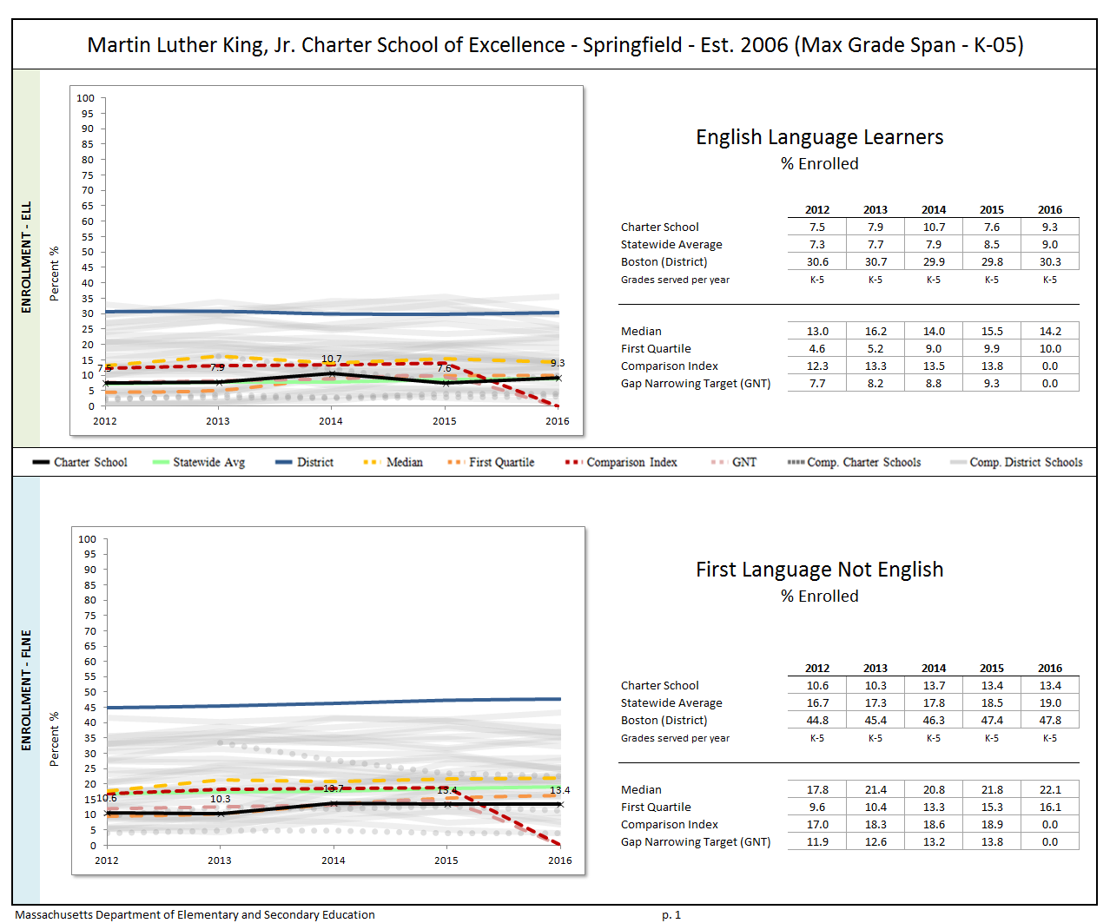
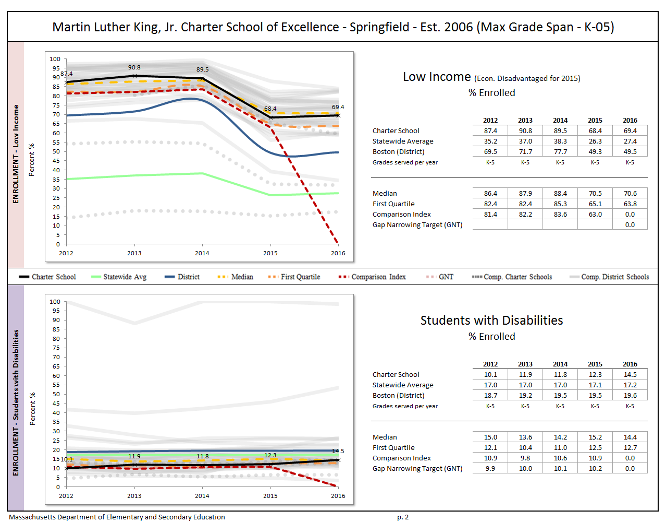
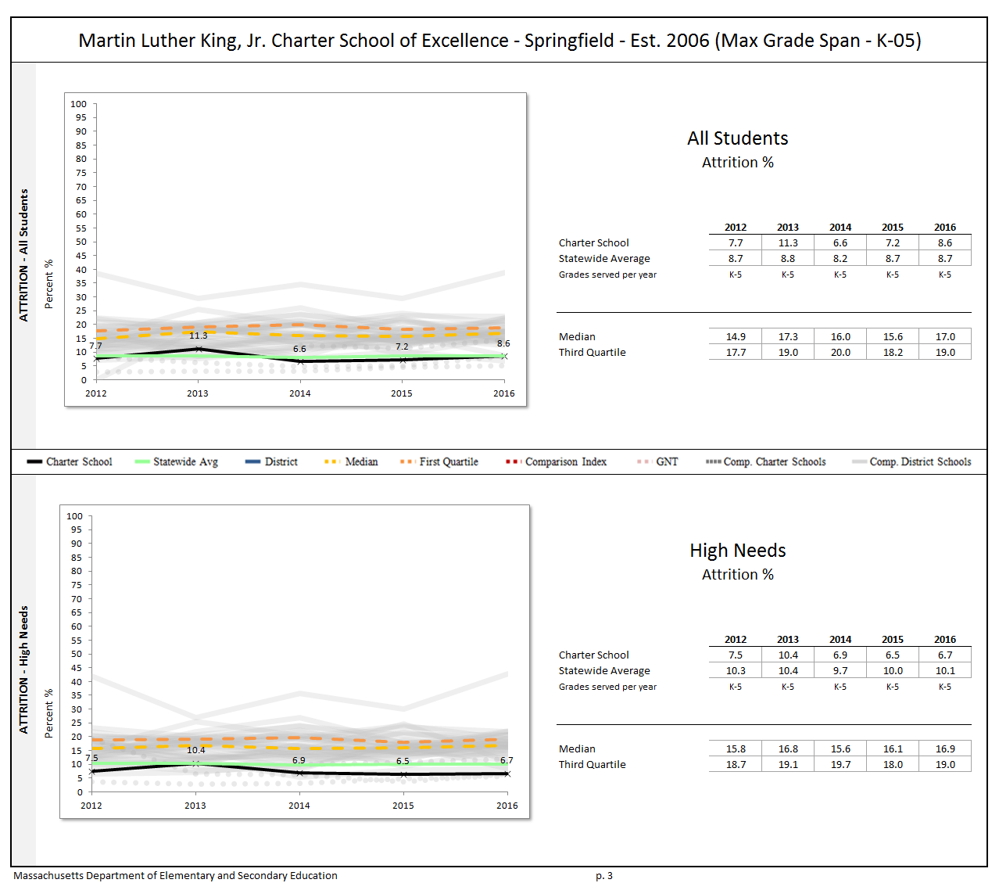

Appendix C: Academic Data (Criterion 5: Student Performance)

The charter accountability table (below) provides several sets of data relative to charter school performance on statewide assessments as well as student indicators. The percent of students scoring proficient or advanced (P/A), the composite performance index (CPI), the percent of students scoring warning or failing (W/F), and the student growth percentile (SGP) are all displayed in the aggregate over the term of the charter. For schools participating in PARCC in 2015, the percent of students who met or exceeded expectations (Level 4 and 5) and those who did not meet expectations (Level 1) are displayed. Because these are not exact equivalents to MCAS proficient/advanced or warning/failing, these figures are not included in the graph. A Transitional Composite Performance Index (Trans. CPI) and Transitional Student Growth Percentile (Trans. SGP) generated using current PARCC and prior MCAS scores are displayed as equivalents to MCAS CPI and SGP. These figures are included in the graphs. The school’s accountability level, percentile, English Language Arts (ELA) and math percentiles for the aggregate and targeted subgroups, and cumulative progress and performance index (PPI) for the aggregate and targeted subgroups are shown if available (this depends on the size and the age of the school). When applicable, the 4-year and 5-year graduation rates as well as the annual dropout rate are also provided for the available years of the charter term. For detailed definitions of accountability terms, please visit this URL: http://profiles.doe.mass.edu/accountability/report/aboutdata.aspx#AccountabilityInformation.
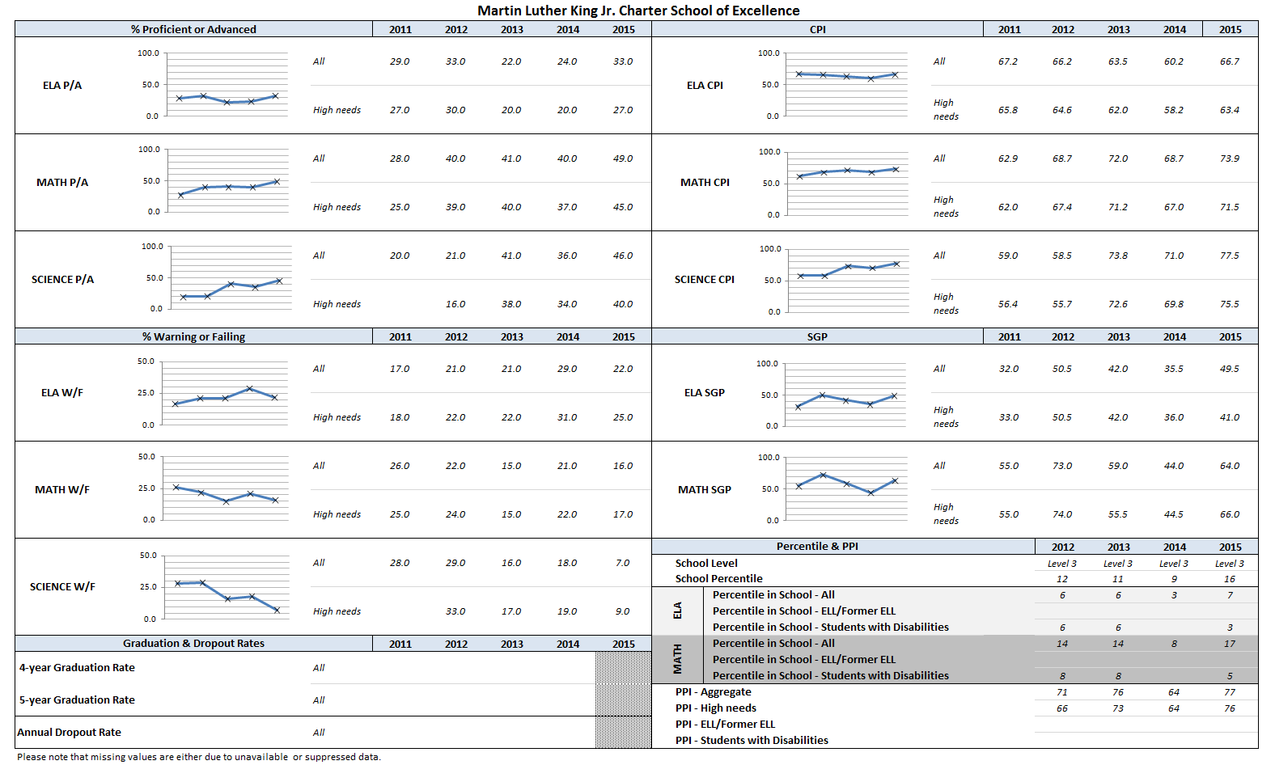
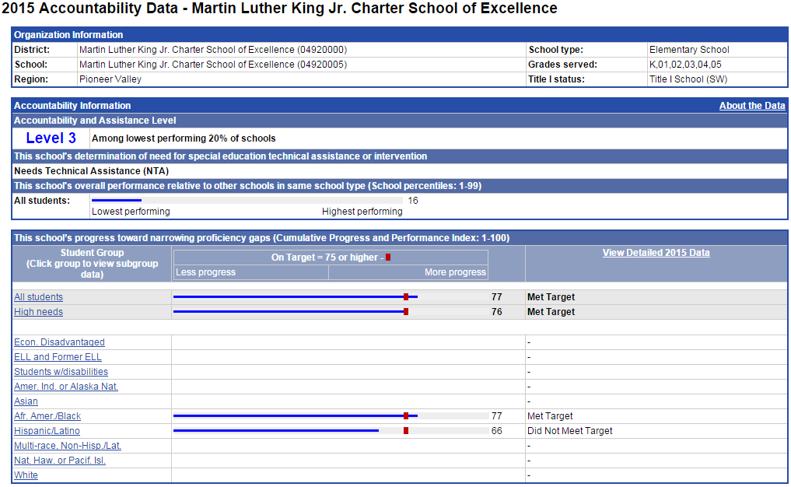

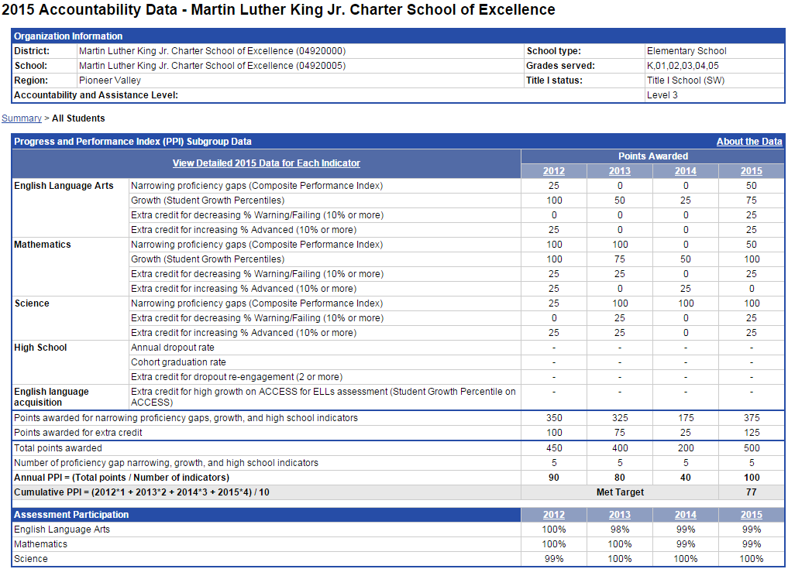
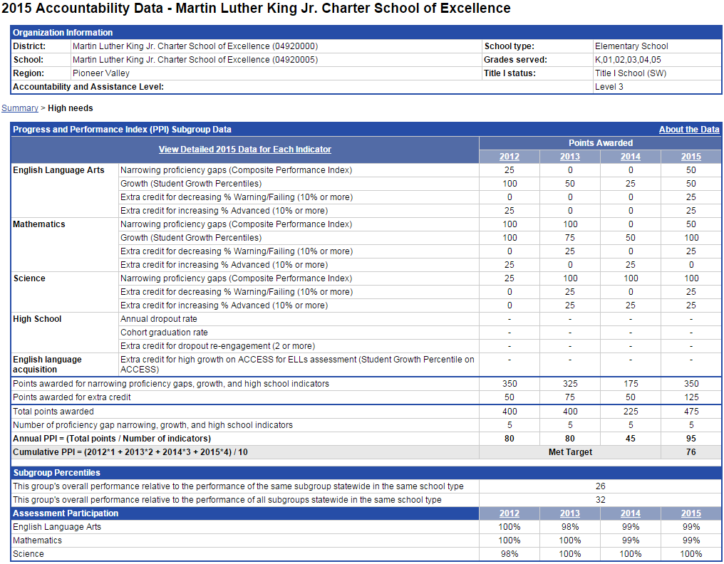

Appendix D: Financial Dashboard (Criterion 10: Finance)
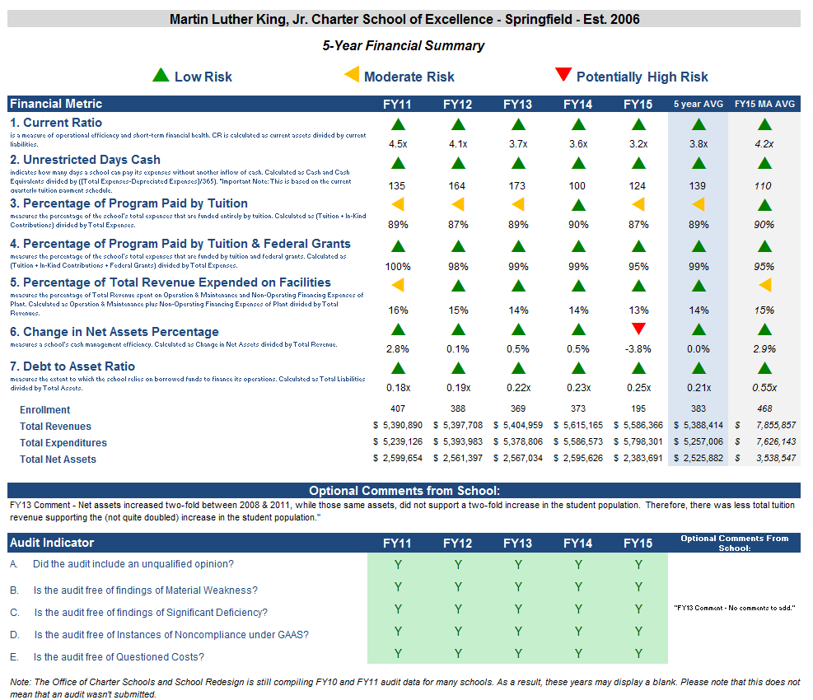

Financial Metric Definitions |  | Low Risk | Moderate Risk | Potentially High Risk
1. Current Ratio | Current Ratio is a measure of operational efficiency and short-term financial health. CR is calculated as current assets divided by current liabilities. | >= 1.5 | Between 1.0 (inclusive) and 1.5 | < 1.0
2. Unrestricted Days Cash (Prior to FY14)  Applies to 5-year average | The unrestricted days cash on hand ratio indicates how many days a school can pay its expenses without another inflow of cash. Calculated as Cash and Cash Equivalents divided by ([Total Expenses-Depreciated Expenses])/365).  Note: This is based on quarterly tuition payment schedule. | >= 75 days | Between 45 (inclusive) and 75 days | < 45 days
2. Unrestricted Days Cash (FY14 forward) | 4th quarterly tuition payments to Commonwealth charter schools in FY14 were made after June 30, 2014, which resulted in lower-than-typical cash at fiscal year end, affecting the risk levels for the current ratio and unrestricted days cash indicators for FY14 on a one-time basis. Payments for FY15 and after are made on a monthly basis, and parameters for risk have been adjusted accordingly. | >= 60 days | Between 30 (inclusive) and 60 days | < 30 days
3. Percentage of Program Paid by Tuition | This measures the percentage of the schools total expenses that are funded entirely by tuition. Calculated as (Tuition + In-Kind Contributions) divided by Total Expenses (expressed as a percentage). Note: In-Kind Contribution are added to the numerator in this ratio to balance out In-Kind Expenditures which will be captured in the Total Expenses in the denominator, and ratios over 100% are set to 100%. | >= 90% | Between 75% (inclusive) and 90% | < 75%
4. Percentage of Program Paid by Tuition & Federal Grants | This measures the percentage of the schools total expenses that are funded by tuition and federal grants. Calculated as (Tuition + In-Kind Contributions + Federal Grants) divided by Total Expenses (expressed as a percentage). Note: In-Kind Contribution are added to the numerator in this ratio to balance out In-Kind Expenditures which will be captured in the Total Expenses in the denominator, and ratios over 100% are set to 100%. | >= 90% | Between 75% (inclusive) and 90% | < 75%
5. Percentage of Total Revenue Expended on Facilities | This measures the percentage of Total Revenue that is spent on Operation & Maintenance and Non-Operating Financing Expenses of Plant. Calculated as Operation & Maintenance plus Non-Operating Financing Expenses of Plant divided by Total Revenues (expressed as a percentage). | <= 15% | Between 15% and 30% (inclusive) | > 30%
6. Change in Net Assets Percentage | This measures a school's cash management efficiency. Calculated as Change in Net Assets divided by Total Revenue (Expressed as a percentage). | Positive % | Between -2% (inclusive) and 0% | < -2%
7. Debt to Asset Ratio | Measures the extent to which the school relies on borrowed funds to finance its operations. Calculated as Total Liabilities divided by Total Assets. | <= .9 | Between .9 and 1 (inclusive) | > 1
FY12 MA AVG Column | All financial metrics indicated in this column are a result of each ratio calculated using statewide totals. For Enrollment, Total Net Assets and Total Expenditures rows, these numbers are averages calculated using the statewide totals of all charter schools’ data.

Appendix E: School’s Response to the 2016 Summary of Review

January 11, 2016

Cliff Chuang, Associate Commissioner
Alison Bagg, Coordinator of Accountability
Massachusetts Department of Elementary and Secondary Education
75 Pleasant St.
Malden, MA 02148

Dear Mr. Chuang and Ms. Bagg:

In January 2015 when recommending that MLK Charter School be placed on probation, Commissioner Chester wrote: “. . . short of clear evidence of academic improvement by the end of this year, MLK faces the prospect that I will recommend non-renewal in February 2016.”

MLK Charter School is pleased to report that we achieved significant academic improvement on the 2015 MCAS. (See grid below) This academic achievement shows every sign of continuing to improve during the 2015-2016 school year. We have a new, dynamic principal; we have committed an afternoon a week, every week, to professional development; and we reinforce the professional development through a cycle of observation in the classroom followed by debriefing by the principal and coaching by reading, writing, and math academic coaches. Much of this professional development is based on the methodology of the highly successful Uncommon Schools with its emphasis on academic rigor. An Uncommon Schools principal and a former Massachusetts charter school principal experienced in successful turn-around coach our principal. We are committed to working relentlessly to accomplish the academic excellence aspect of the MLK Charter School mission.

MLK Charter School achieved significant improvement on 2015 MCAS in all three subjects – English language arts, math, and science. The following chart shows the improvement as measured by DESE metrics.

COMPARISON OF MLK’S 2015 MCAS PERFORMANCE WITH 2014 PERFORMANCE

 | CHANGE FROM 2014
ELA CPI (composite performance index) | +6.5
Math CPI | +5.2
Science CPI | +6.5
ELA SGP (student growth percentile) | +14
Math SGP | +20
ELA % advanced and proficient | + 9 %
Math % advanced and proficient | + 9 %
Science % advanced and proficient | +10 %
School rank percentile | +7
PPI for all students (progress and performance index) | +60
PPI for high needs students | +50

MLK’s academic program delivery improved in 2014-2015. Commissioner Chester wrote in January 2015 that: “. . . site visitors did note improvement from 2013 to 2014 and found that some changes to the academic program were in effect by October 2014.” The Commissioner noted improvement in curriculum, instruction, and the assessment system. These are three of the four key indicators for program delivery. The improvements in the program delivery contributed greatly to the improved 2015 MCAS performance noted above.

Charter renewal site visit: Charter renewal site visitors in November 2015 found further improvement in all four key indicators of program delivery: curriculum, instruction, assessment and program evaluation, and supports for diverse learners. Curriculum and supports for diverse learners now meet expectations, improved from last year’s partially meeting expectations. We are confident that this continuing improved program delivery will result in further improved student performance.

The Summary of Review reports that MLK Charter School meets expectations for curriculum, assessment and program evaluation, and supports for diverse learners. Although site visitors and the school administration believed that instruction in November only partially met expectations in classrooms taught by some of our newer teachers, our systematic improvement of the academic program has already generated progress since the site visit.

Level 1: In order to be a Level 1 school, a school must satisfy three requirements: (1) percentile ranking of at least 21st percentile, (2) PPI for all students of at least 75, and (3) PPI for high needs students of at least 75. MLK satisfies the second and third requirements, but not the first.

In 2015, MLK’s percentile ranking increased by 7 percentile to the 16th percentile. To leave Level 3 and be eligible for Level 1, MLK needs a 5-percentile increase. MLK already meets the other two requirements for Level 1. We are aiming to achieve Level 1 this spring. For the first two Achievement Network (ANet) assessments of the current school year (October and December), at grades 3, 4, and 5 MLK outscored the ANet network of schools in ELA (9%, 2%, and 6%) and math (19%, 10%, and 21%).

Eleven Springfield Public Schools (SPS) that serve elementary school students have a percentile ranking higher than 16. Eighteen SPS that serve elementary school students have a percentile ranking lower than 16.

Five SPS that serve elementary school students have a PPI for both all students and high needs students of at least 75. Twenty-six SPS that serve elementary school students do not meet both these requirements.

2015 student academic performance that we are proud of: Some of MLK’s 2015 student performance highlights are:
- #1 among Massachusetts 5th grades – math SGP for African-Americans/blacks
- #2 among Massachusetts elementary schools – math SGP for African-Americans/blacks
- 7% warning/failing vs. 13% for state in 5th grade science
- 4th grade SGP exceeded Springfield in ELA and math by 11-34 points for economically disadvantaged, African-American/black, Hispanic/Latino, and all students
- #1 among Springfield elementary schools, 4th grades, and 5th grades – math SGP (growth) for economically disadvantaged students
- #2 among Springfield elementary schools – math SGP for Hispanics/Latinos
- #3 among Springfield 5th grades – science CPI for African-Americans/blacks
- 52% proficient/advanced vs. 43% for state in 5th grade math for African-Americans/blacks

A few reasons that MLK Charter School is special: The MLK Charter School community is organized around our shared vision of Dr. King’s ideal “beloved community.” The school grew out of the mission of aspiring to Dr. King’s ideal of beloved community. The charter renewal site visit report and the Summary of Review both write about beloved community at MLK Charter School. Unusual features of MLK Charter School that enrich our young scholars’ lives and help achieve our mission of academic excellence, character development, and aspiring to Dr. King’s ideal of beloved community include:
- The founders of MLK Charter School set out to serve a very high needs population and we accomplished that.
- Our founders set out to have a diverse adult community at MLK Charter School. We are named “Martin Luther King, Jr.” because Dr. King’s values set a high standard for us. We accomplish that, not by tokenism, but by having more than 50% people-of-color among our adults – the teachers, school leaders, trustees, and staff. This is important for the scholars and their parents.
- With our roots in the Martin Luther King, Jr. Community Center (now MLK Family Services) in Springfield, the founders of MLK Charter School set out to provide a wide range of services to meet the scholars’ needs. MLK has a large student support staff; the daily presence of our psychologist, adjustment counselor, speech language therapist, and nurse; graduate social work interns; the counseling, occupational therapy, and physical therapy services provided by partner agencies; and an after-school program operated by MLK Family Services. We accomplish the goal of providing extensive services.
- Our founders wanted a school with strong roots in the Springfield area community. We accomplish that with our community-based board of trustees, local ties, partner organizations, and by being a good neighbor. Both Springfield Mayor Sarno and City Council President Fenton wrote letters to Commissioner Chester in support of renewing the charter of MLK Charter School.
- We provide our scholars with a facility and grounds that differ from their neighborhoods. The Friends of Martin Luther King, Jr. Charter School of Excellence, Inc. owns our spacious, inviting school and the nine-plus acre site. Outdoors the scholars have a playground, paved play-area, playing field, and woods with nature trails. The scholars feel safe at MLK Charter School indoors and outdoors.
- One day each month the principal leads character development activities for all scholars at each grade level focusing on that month’s Dr. King Value.
- Many of the parents have a very strong, positive connection to MLK Charter School. 100-250 people attend each of our events such as Family Math Night and Family Literacy Night. Parents feel comfortable at the school. The school is always fully enrolled with a waiting list. Attrition is low – 7.2% for all students and 6.5% for high needs students. On the annual parent satisfaction survey, at least 95% of the respondents state that they are overall satisfied with MLK Charter School.

The trustees, faculty, and staff of MLK Charter School feel a tremendous sense of responsibility to the scholars whom we serve. We greatly appreciate the opportunity to educate them given to us by the Board and Department of Elementary and Secondary Education and the parents and guardians. We look forward to continuing to serve our scholars and their families and to striving even harder to accomplish our mission.

Sincerely,

Alan M. Katz
Executive Director

P.S. According to our records and the October 1, 2015 SIMS report, the percentage of ELL students at MLK Charter School in 2015-2016 is greater than 9.0%.
285 Dorset Street Springfield, MA 01108
Tel. (413) 214-7806 Fax (413) 214-7838
info@mlkcs.org
285 Dorset Street Springfield, MA 01108
Tel. (413) 214-7806 Fax (413) 214-7838
info@mlkcs.org
285 Dorset Street Springfield, MA 01108
Tel. (413) 214-7806 Fax (413) 214-7838
info@mlkcs.org

1 The names of each of these schools and additional subgroup detail can be found in the Charter Analysis and Review Tool (CHART), http://www.doe.mass.edu/charter/chart/.
The midpoint value of all comparison schools. This is derived using Microsoft Excel's MEDIAN function.
The first quartile is the middle number between the smallest number and the median of all comparison schools. This is derived using Microsoft Excel's QUARTILE function.
The comparison index provides a comparison figure derived from data of students who reside within the charter school’s sending district(s). The comparison index is a statistically calculated value designed to produce a fairer and more realistic comparison measure that takes into account the charter school’s size and the actual prevalence of student subgroups within only those grade levels in common with the charter school.
The Gap Narrowing Target (GNT) refers to the halfway point between the school’s baseline rate (which is the rate in the 2010-11 school year, or the first year enrollment data is collected if after 2010-11,) and the current Comparison Index (the “target”). The object is to meet this halfway point by the 2016-17 school year (or in a later year if baseline is after 2010-11), giving the school six years to do so. For a school to be on schedule to meet its GNT, an incremental increase must be met annually. To determine this increment, the following equation is used: [(Comparison Index – Baseline) / 2] / 6 years = Annual GNT.
The percentage of attrition, or rate at which enrolled students leave the school between the end of one school year and the beginning of the next.
A student is high needs if he or she is designated as either low income, or ELL, or former ELL, or a student with disabilities. A former ELL student is a student not currently an ELL, but had been at some point in the two previous academic years. * 2014-2015 is the first year for which the category “Economically Disadvantaged” is being reported, replacing the “Low-income,” “Free Lunch” and “Reduced Lunch” categories used in 2013-2014 and earlier. It is important for users of this data to understand that enrollment percentages and achievement data for "economically disadvantaged" students cannot be directly compared to "Low-income" data in prior years. Please see http://www.doe.mass.edu/infoservices/data/ed.html for important information about the new “Economically Disadvantaged” category.

