Massachusetts Department of

Elementary and Secondary Education

75 Pleasant Street, Malden, Massachusetts 02148-4906 Telephone: (781) 338-3000

TTY: N.E.T. Relay 1-800-439-2370

Mitchell D. Chester, Ed.D.
Commissioner

MEMORANDUM

To: | Members of the Board of Elementary and Secondary Education
From: | Mitchell D. Chester, Ed.D., Commissioner
Date: | February 12, 2016
Subject: | Charter Schools – Renewal Recommendation and Report on Probation for Martin Luther King, Jr. Charter School of Excellence

The Board of Elementary and Secondary Education (Board) placed Martin Luther King, Jr. Charter School of Excellence (MLK) on probation in January 2015 and imposed three conditions related to academic improvement and sustainability. In its tenth year of operation, MLK is also at the end of its second charter term and is coming to the Board for renewal of its charter. I recommend that the Board renew the charter of MLK but extend probation to require that the school demonstrate significant and sustained academic improvement. While the school’s academic performance does not meet state standards, I am not recommending non-renewal at this time because the school has met the three conditions that were imposed in January 2015. Further, as noted in the attached Summary of Review (SOR), MLK’s new academic leadership has made significant alterations to the school’s academic program to address academic underperformance.

Martin Luther King Jr. Charter School of Excellence
Type of Charter  (Commonwealth or Horace Mann) | Commonwealth | Location | Springfield
Regional or Non-Regional? | Non-Regional | Districts in Region  (if applicable) | N/A
Year Opened | 2006 | Year(s) Renewed  (if applicable) | 2011
Maximum Enrollment | 360 | Current Enrollment | 366
Grade Span in Charter | K-5 | Current Grade Span | K-5
Students on Waitlist | 264 | Current Age of School | 10 years
Mission Statement
Martin Luther King, Jr. Charter School of Excellence prepares kindergarten through 5th grade students of Springfield for academic success and engaged citizenship through insistence on rigorous, challenging work. The school incorporates Dr. King’s commitment to the highest standards in scholarship, civic participation and the ideal of the beloved community.
MLK opened in 2006 and is currently in its tenth year of operation. The school opened with grades K-2 and subsequently added a grade each year until it reached K-5 in 2009. The Board has taken a number of actions with respect to this school’s charter:

- In 2009, the school was granted a temporary increase in maximum enrollment from 360 to 380, and the maximum authorized enrollment was reduced back to 360 in 2012. During this charter term the school has been persistently overenrolled beyond the maximum allowed by its charter, even during the temporary enrollment increase.

- In January 2011, the Board granted the school a probationary renewal with three conditions related to program delivery, academic performance, and organizational viability.

- In January 2013, the Board determined that MLK had sufficiently met conditions to remove MLK from probation. The school had met conditions related to academic growth, had established a fully documented curriculum, and had evaluated and fully staffed its leadership structure. The Board imposed further academic conditions that required the demonstration of significant and sustained academic improvement by December 2014.

- In January 2015, following a decline in student achievement, the Board again placed the school on probation. The Board established three conditions of probation related to sustained academic improvement.

While the executive director has remained the same since the school’s founding, instructional leadership has been inconsistent during the first and current charter terms. During the current charter term the school has employed three different individuals as the principal. The school hired a new principal who began work in June 2015.

Under the new principal’s leadership, in Year 10, MLK has made substantial changes to its curriculum, instructional practices, professional development, supports for diverse learners, and use of data. The renewal inspection team found the school’s new principal has instituted numerous changes to improve academic outcomes. Please see the pages 8-9, below, or the attached SOR for additional details about MLK’s programmatic changes.

Due to the probation and conditions imposed during this charter term, MLK was visited by the Department three times: in 2012, 2013, and 2014. Additionally, the school received a renewal inspection visit in November 2015 conducted by an external vendor. The SOR for the charter term is attached to this memorandum; relevant information from the SOR is excerpted below to provide context about the school’s current charter term.

Progress Towards Meeting Conditions

This section lists the conditions imposed by the Board in 2015 and outlines MLK’s progress towards meeting the conditions. As summarized below, MLK has met the conditions imposed by the Board in connection with placing the school on probation in January 2015. The school has submitted board materials in a timely fashion, established an escrow account for potential closing costs, and has demonstrated improvement in its academic performance. While the school has demonstrated improvement in its MCAS scores, as detailed below, its overall performance and persistence as a Level 3 school does not meet the performance standards set for a charter school.

Condition 1: Beginning in February of 2015 and until further notice, MLK must submit to the Department, at charterschools@doe.mass.edu, board meeting agendas, materials, and minutes prior to each board meeting at the same time that these items are sent to the school's board members. Additionally, if board materials do not already include this information, the school must also submit monthly financial statements.

Status: Met/Ongoing
MLK has submitted board packages during the months of board meetings. Board packages contain board committee minutes, reports on academic data, financial updates and projections, budget documents, policy documents, and compliance documents.

Condition 2: By March 31, 2015, the school must establish an escrow account in an amount determined by the Department in consultation with the school to pay for any potential closing, legal, and audit expenses associated with closure, should that occur.

Status: Met
The school opened an escrow account at the Berkshire Bank by March 25, 2015. The account currently holds approximately $17,500 set aside for potential closing costs, should that occur.

Condition 3: By December 31, 2015, the school must demonstrate clear academic progress through evidence of significant academic improvement in mathematics, English language arts, and science.

Status: Met
While MLK’s overall performance has not met state standards, the school demonstrated significant academic improvement in 2015. Please see the data charts below as well as full academic results in the attached SOR.

In 2012, 2013, 2014, and 2015 MLK’s MCAS scores placed the school in Level 3. The school’s percentile, when compared to other elementary schools statewide, improved in 2015. In 2012, MLK was in the 12th percentile; in 2013, the 11th percentile; and in 2014, the 9th percentile. In 2015, the school is in the 16th percentile.

In 2015, the school has a cumulative Progress and Performance Index (PPI) of 77 for all students and of 76 for the high needs subgroup. Both PPIs meet gap narrowing targets.

Composite Performance Index (CPI) scores for the school all improved in 2015 to their highest levels of the charter term. The 2015 CPI was 66.7 in English language arts (ELA), 73.9 in mathematics, and 77.5 in science and technology/engineering. In 2015, proficiency rates reached their highest scores as well. In 2015, 33 percent of MLK students scored in the Proficient and Advanced categories on the ELA assessment, below the state average of 63 percent. In mathematics, 49 percent scored Proficient and Advanced, below the state average of 63 percent. In science and technology/engineering, 46 percent scored Proficient and Advanced, below the state average of 53 percent.

Student Growth Percentiles (SGP) have varied over the charter term but improved in 2015 and were on target for ELA and above target in mathematics. The school’s SGP for all students in 2015 was 49.5 in ELA (on target growth) and 64.0 in mathematics (above target growth).

Student Growth Percentile
 |  | 2012 | 2013 | 2014 | 2015
ELA SGP | All | 50.5 | 42 | 35.5 | 49.5
 | High needs | 50.5 | 42 | 36 | 41
Math SGP | All | 73 | 59 | 44 | 64
 | High needs | 74 | 55.5 | 44.5 | 66

ELA CPI Chart

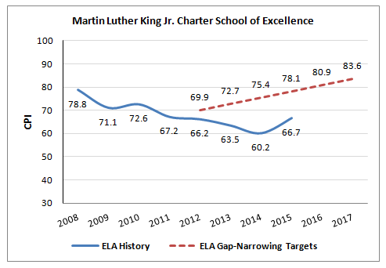
Mathematics CPI Chart

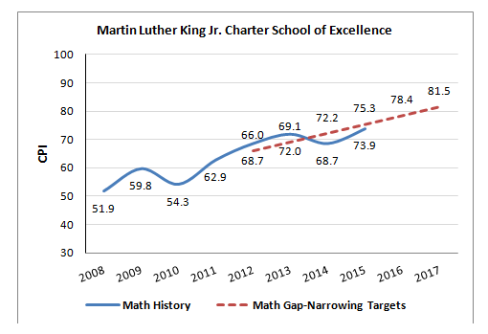

Science CPI Chart
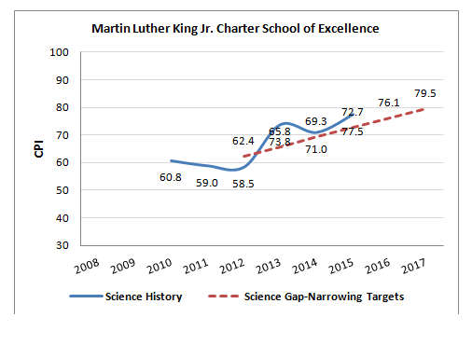

While charter school academic performance compared to its sending district is not a typical standard to assess charter school success, MLK included such comparative data in its response to the SOR. In 2015, MLK’s academic performance is better than or comparable to the performance of comparison schools in Springfield for nearly every metric. In 2015, the school’s CPI and SGP are above the medians for other elementary schools in Springfield; rates of MLK’s proficiency on the mathematics assessment nearly meet the median of comparison schools. MLK’s rates of science proficiency and CPI scores have been above the median for comparison Springfield schools for the past three years. In terms of ELA performance, MLK’s CPI and advanced/proficient scores are near the median in 2015; its SGP scores are above the median for other elementary schools in Springfield. Additionally, MLK’s 2015 PPI for all students is the 6th highest of the 32 elementary schools in Springfield.

Renewal of Charter

MLK’s charter is currently under consideration for renewal. The school’s ratings from the SOR follow. Evidence from the attached SOR is also provided below, as context.

Martin Luther King Jr. Charter School of Excellence
● Exceeds |  | The school fully and consistently meets the criterion and is a potential exemplar in this area.
● Meets |  | The school generally meets the criterion and/or minor concern(s) are noted.
● Partially Meets |  | The school meets some aspects of the criterion but not others and/or moderate concern(s) are noted.
● Falls Far Below |  | The school falls far below the criterion and/or significant concern(s) are noted.
Massachusetts Charter School Performance Criteria |  |  |  | Rating
Faithfulness to Charter | - Mission and Key Design Elements: The school is faithful to its mission, implements the key design elements outlined in its charter, and substantially meets its accountability plan goals. |  |  | ● Partially Meets
 | - Access and Equity: The school ensures program access and equity for all students eligible to attend the school. |  |  | ● Meets
 | - Compliance: The school compiles a record of compliance with the terms of its charter and applicable state and federal laws and regulations. |  |  | ● Partially Meets
 | - Dissemination: The school provides innovative models for replication and best practices to other public schools in the district where the charter school is located. |  |  | ● Partially Meets
Academic Program Success | - Student Performance: The school consistently meets state student performance standards for academic growth, proficiency, and college and career readiness. |  |  | ● Falls Far Below
 | - Program Delivery: The school delivers an academic program that provides improved academic outcomes and educational success for all students. |  | Curriculum | ● Meets
 |  |  | Instruction | ● Partially Meets
 |  |  | Assessment and Program Evaluation | ● Meets
 |  |  | Supports for Diverse Learners | ● Meets
 | - Culture and Family Engagement: The school supports students’ social and emotional health in a safe and respectful learning environment that engages families. |  | Social, Emotional and Health Needs | ● Meets
 |  |  | Family Engagement | ● Meets
Organizational Viability | - Capacity: The school sustains a well-functioning organizational structure and creates a professional working climate for all staff. |  | School Leadership | ● Partially Meets
 |  |  | Professional Climate | ● Meets
 | - Governance: Members of the board of trustees act as public agents authorized by the state and provide competent and appropriate governance to ensure the success and sustainability of the school. |  |  | ● Meets
 | - Finance: The school maintains a sound and stable financial condition and operates in a financially sound and publicly accountable manner. |  |  | ● Meets

Faithfulness to Charter (Criteria 1-4 above)

- Over the course of the charter term, stakeholders at the school share a common and consistent understanding of the school’s mission. The school has not yet realized its mission to prepare students for academic success but has implemented other aspects of its mission by emphasizing engaged citizenship of its students and the creation of a “beloved” community. Further, the school has met a majority of the measures in its accountability plan this charter term.
- The school made progress in recruiting and retaining a comparable student population to its sending district. MLK has a low attrition rate for all students, ranging from 6.6-11.3 percent during FY12-FY15, and high needs students, 6.5-10.4 percent, relative to its comparison schools in Springfield. In comparison, median rates of attrition for comparison schools in Springfield have ranged from 14.9-17.3 percent and from 15.6-16.8 percent for high needs students during the same time period. The school implements a Recruitment and Retention plan.
- In terms of compliance, as of the renewal inspection, seven teachers beyond their first year of employment have not passed the required MTELs, as required by state law. One of the school’s two ESL teachers was not appropriately licensed until this year.
- The school has engaged in limited dissemination this charter term due to its probationary status and conditions.

Academic Program Success (Criteria 5-7 above)

The school’s SOR (attached) shows that the school has recently made significant changes to its academic program to address low student achievement. A new instructional leader, who started in June 2015, has implemented a numerous changes aimed at improving academic performance.
- In Year 10, the school has made substantial changes to its ELA and mathematics curricula based on work with external consultants. The curriculum is now aligned to the Massachusetts Curriculum Frameworks, is vertically and horizontally aligned, and is aligned to the school’s assessment program. There are dedicated staff members who oversee curriculum review and revision.
- In Year 10, school stakeholders share a common understanding of high-quality instruction, and these practices were observed in a majority of classrooms. Classrooms were conducive to learning, and two-thirds of classrooms displayed engaged students.
- The school’s use of data has become more robust this charter term. In Year 10, the school administers a balanced system of formative and benchmark assessments. The school has developed a formalized data review process and put resources in place to support the use of data this charter term.
- The school has made changes to its systems and structures to support diverse learners, including special education and ELL students, this charter term. The school has increased staffing to support diverse learners, particularly ELL students.
- MLK has maintained a safe school environment throughout the charter term and supports the social, emotional, and health needs of its students.
- The school has developed strong working relationships with families and guardians and provides regular communication to them. MLK parents and guardians have expressed satisfaction with the school over the course of the charter term.

Organizational Viability (Criteria 8-10 above)

- The school has lacked consistent instructional leadership this charter term. In its tenth year, the new principal has implemented clear structures, roles, and communication.
- MLK has structures in place for regular teacher collaboration. The school has recently increased its professional development offerings and consistently evaluates educators.
- The board of MLK has developed its oversight of the school this charter term, particularly in the area of academic achievement.
- MLK operates in a financially sound and publicly accountable manner. The school has maintained a sound and stable financial condition over the charter term.

The superintendent of Springfield Public Schools was invited to submit written comment (see: http://www.doe.mass.edu/news/news.aspx?id=21205) regarding the charter renewal. No comment from the superintendent was received. The Department, however, did receive letters of support for the renewal of MLK’s charter from the Mayor of Springfield and the Springfield City Council President.

Recommendation

Charter schools are held to high standards of operation and expected to deliver an effective academic program. MLK is in its tenth year of operation and should be providing its students a robust program with strong academic outcomes. While the school has demonstrated significant academic improvement over the past year, I am still very concerned about MLK’s overall track record. Given this evidence, further detailed in the attached SOR, I recommend that the Board renew the school’s charter with continued probation, requiring significant and sustained academic improvement on the 2016 and 2017 state assessments. If academic results do not demonstrate continued improvement in ELA, mathematics, or science on 2016 assessments, however, I will recommend revocation of the school’s charter effective June 30, 2017. I also recommend that two existing conditions be extended as part of the school’s probation and charter renewal. The school has provided a sub-par program for too long. The school’s recent improvement is encouraging – and it must continue improving in order to continue operating. I also recommend that existing conditions be extended as part of the school’s probation and charter renewal.

- Until further notice, Martin Luther King, Jr. Charter School of Excellence must submit to the Department, at charterschools@doe.mass.edu, board meeting agendas, materials, and minutes prior to each board meeting at the same time that these items are sent to the school's board members. Additionally, if board materials do not already include this information, the school must also submit monthly financial statements.

- The school must maintain the established escrow account to pay for any potential closing, legal, and audit expenses associated with closure, should that occur.

- By December 31, 2016, the school must demonstrate significant and sustained academic improvement in mathematics, English language arts, and science. Should the school fail to do so, the Commissioner and the Board of Elementary and Secondary Education will consider revoking the school’s charter based on failure to meet this condition, rather than wait to see improvement by December 31, 2017.

- By December 31, 2017, the school must demonstrate continued significant and sustained academic improvement in mathematics, English language arts, and science. Should the school fail to do so, the Commissioner and the Board of Elementary and Secondary Education will consider revoking the school’s charter based on failure to meet this condition.

**********************
If you have any questions regarding this recommendation or require additional information, please contact Cliff Chuang, Associate Commissioner (781-338-3222); Jeff Wulfson, Deputy Commissioner (781-338-6500); or me.

Attachment: MLK Summary of Review with the school’s response
Motion

The degree to which the school has been overenrolled has ranged from 5 to 27 students during the charter term. The school only receives tuition for the number of students allowed by its chartered maximum enrollment.

