Boston Green Academy Horace Mann Charter School
Summary of Review
Boston, MA
February 2016
Massachusetts Department of Elementary and Secondary Education
Office of Charter Schools and School Redesign
75 Pleasant Street
Malden, MA 02148
Phone: (781) 338-3227
Fax: (781) 338-3220

This document was prepared by the
Massachusetts Department of Elementary and Secondary Education
Mitchell D. Chester, Ed.D.
Commissioner

The Massachusetts Department of Elementary and Secondary Education, an affirmative action employer, is committed to ensuring that all of its programs and facilities are accessible to all members of the public.
We do not discriminate on the basis of age, color, disability, national origin, race, religion, sex, gender identity, or sexual orientation.
Inquiries regarding the Department’s compliance with Title IX and other civil rights laws may be directed to the
Human Resources Director, 75 Pleasant St., Malden, MA 02148-4906. Phone: 781-338-6105.

© 2016 Massachusetts Department of Elementary and Secondary Education
Permission is hereby granted to copy any or all parts of this document for non-commercial educational purposes. Please credit the “Massachusetts Department of Elementary and Secondary Education.”

This document printed on recycled paper

Massachusetts Department of Elementary and Secondary Education
75 Pleasant Street, Malden, MA 02148-4906
Phone 781-338-3000 TTY: N.E.T. Relay 800-439-2370
www.doe.mass.edu

Table of Contents

I. Introduction 1
II. Executive Summary of Charter School Performance 1
III. School Setting 4
IV. Areas of Accountability 5
A. Faithfulness to Charter 5
B. Academic Program 8
C. Organizational Viability 15
Appendix A: Accountability Plan Objectives and Measures (Criterion 1: Mission and Key Design Elements) 20
Appendix B: CHART (Criterion 2: Access and Equity) 23
Appendix C: Academic Data (Criterion 5: Student Performance) 28
Appendix D: Financial Dashboard (Criterion 10: Finance) 34
Appendix E: School’s Response to the 2016 Summary of Review 36

I. Introduction
The charter school regulations state that “the decision by the Board [of Elementary and Secondary Education] to renew a charter shall be based upon the presentation of affirmative evidence regarding the faithfulness of the school to the terms of its charter, including the extent to which the school has followed its recruitment and retention plan and has disseminated best practices in accordance with M.G.L. c. 71, § 89(dd); the success of the school's academic program; and the viability of the school as an organization” 603 CMR 1.11(2). Consistent with the regulations, recommendations regarding renewal are based upon the Department of Elementary and Secondary Education’s (Department) evaluation of the school’s performance in these areas. In its review, the Department has considered both the school’s absolute performance at the time of the application for renewal and the progress the school has made during the first four years of its charter. Performance is evaluated against both the Massachusetts Charter School Performance Criteria and the school’s accountability plan. The evaluation of the school has included a review of various sources of evidence.
The following sections present a high-level summary from various sources regarding the school’s progress and success in fulfilling the terms of its charter, raising student achievement, and establishing a viable organization over the past charter term . Specific details about each criterion have been well-documented in the sources listed below.

II. Executive Summary of Charter School Performance

Boston Green Academy Horace Mann Charter School
Type of Charter  (Commonwealth or Horace Mann) | Horace Mann III | Location | Boston, MA
Regional or Non-Regional | Non-Regional | Districts in Region  (if applicable) | NA
Year Opened | 2011 | Year(s) Renewed  (if applicable) | NA
Maximum Enrollment | 595 | Current Enrollment | 439
Chartered Grade Span | 6-12 | Current Grade Span | 6,7, 9-12
Students on Waitlist | 496 | Current Age of School | 5 years
Mission Statement
Boston Green Academy welcomes diverse students of all abilities, educates and empowers them to succeed in college and career, and prepares them to lead in the sustainability of our community and world.

Boston Green Academy Horace Mann Charter School
● Exceeds |  | The school fully and consistently meets the criterion and is a potential exemplar in this area.
● Meets |  | The school generally meets the criterion and/or minor concern(s) are noted.
● Partially Meets |  | The school meets some aspects of the criterion but not others and/or moderate concern(s) are noted.
● Falls Far Below |  | The school falls far below the criterion and/or significant concern(s) are noted.
Massachusetts Charter School Performance Criteria |  |  |  | Rating
Faithfulness to Charter | - Mission and Key Design Elements: The school is faithful to its mission, implements the key design elements outlined in its charter, and substantially meets its accountability plan goals. |  |  | ● Partially Meets
 | - Access and Equity: The school ensures program access and equity for all students eligible to attend the school. |  |  | ● Meets
 | - Compliance: The school compiles a record of compliance with the terms of its charter and applicable state and federal laws and regulations. |  |  | ● Partially Meets
 | - Dissemination: The school provides innovative models for replication and best practices to other public schools in the district where the charter school is located. |  |  | ● Meets
Academic Program Success | - Student Performance: The school consistently meets state student performance standards for academic growth, proficiency, and college and career readiness. |  |  | ● Falls Far Below
 | - Program Delivery: The school delivers an academic program that provides improved academic outcomes and educational success for all students. |  | Curriculum | ● Meets
 |  |  | Instruction | ● Partially Meets
 |  |  | Assessment and Program Evaluation | ● Partially Meets
 |  |  | Supports for Diverse Learners | ● Meets
 | - Culture and Family Engagement: The school supports students’ social and emotional health in a safe and respectful learning environment that engages families. |  | Social, Emotional and Health Needs | ● Meets
 |  |  | Family Engagement | ● Meets
Organizational Viability | - Capacity: The school sustains a well-functioning organizational structure and creates a professional working climate for all staff. |  | School Leadership | ● Meets
 |  |  | Professional Climate | ● Meets
 |  |  | Contractual Relationships (If applicable) | ● Partially Meets
 | - Governance: Members of the board of trustees act as public agents authorized by the state and provide competent and appropriate governance to ensure the success and sustainability of the school. |  |  | ● Partially Meets
 | - Finance: The school maintains a sound and stable financial condition and operates in a financially sound and publicly accountable manner. |  |  | ● Partially Meets

III. School Setting

School Setting

Boston Green Academy Horace Mann Charter School (BGA) is a Horace Mann III charter school in the Boston Public School (BPS) district. In its application submitted in 2010 to become a Horace Mann III charter school, BGA promised to serve students from a Boston high school that was recommended for closure. In its subsequent memorandum of understanding (MOU) with Boston Public Schools (BPS), BGA agreed to open in 2011 with students in grades 9-12, to absorb the student population from Odyssey High School (Odyssey), and to occupy Odyssey’s facility in South Boston. Originally proposed as a 6-12 school, the MOU altered the founding group’s original growth plan and delayed the offering of middle school grades. From 2011 until the end of the 2013-14 school year, BGA served grades 9-12 in the South Boston facility. In the fall of 2014, the school moved to a new location in Brighton and began to serve the 6th grade. The Brighton facility is co-located with Another Course to College, a BPS school. In the fall of 2015, the school began to serve the 7th grade.

In the summer of 2015, the school requested an amendment to its mission statement because the school’s stakeholders felt that the original mission was not clear enough. This amendment was approved in September of 2015. The school is also planning to further amend its charter to reflect changes made to its program during the past four years.

Due to persistent concerns, the school received five visits from the Department in its first four years of operation. These visits documented concerns about the school’s faithfulness to its charter, the quality of the academic program, low academic results, the quality and amount of support for diverse learners, the school’s lack of compliance with Department regulatory requirements, and lack of attention to sub-regulatory guidance. In addition, there were concerns regarding the fiscal year 2013 audit. As a result of these concerns, in October 2014, the Board of Elementary and Secondary Education (Board) voted to put BGA on probation with eight conditions for concerns related to finance, governance, and academics. The school’s progress in terms of the conditions will be addressed in a separate memorandum to the Board.

IV. Areas of Accountability

A. Faithfulness to Charter
Criterion 1: Mission and Key Design Elements
The school is faithful to its mission, implements the key design elements outlined in its charter, and substantially meets its accountability plan goals.
(Please refer to Appendix A for the school’s accountability plan.)
Finding: BGA has developed the implementation of its mission over the course of the school’s first charter term. The school has focused on the implementation of a subset of its key design elements this charter term, and is in the process of amending others.  As noted above in the Setting section, BGA amended its mission statement in the fall of 2015. The new, streamlined mission statement focuses on three key components of the school: serving diverse students, a focus on college and career, and leadership in the sustainability, or green, sector. Similarly, stakeholders at the school have refined their understanding of the mission of the school throughout the charter term. In Years 2 and 3, stakeholders did not share a common understanding of the school’s approved mission. However, during the renewal inspection, stakeholders reported a common understanding of the three aspects of BGA’s new mission statement outlined above. During the renewal inspection, administrators reported that each aspect of the mission represents a key design element of the school.  The school has several programs in place that support each of the aspects of the mission. To serve diverse students, the school has a number of external partnerships, runs a support group for boys of color (Men Organized, Respectful and Educated, or MORE), and has a large student support team in place. Further, as noted below in Criterion 2: Access and Equity, BGA enrolls a population of students that is comparable to its sending district, and in some cases enrolls a greater percentage of certain subgroups. For college and career preparation, the school provides three courses dedicated to post-secondary life, provides an advisory program where students work on resumes and practice job searches, and students develop career portfolios. However, as noted in Criterion 5: Student Performance, the school has yet to realize the academic results to support this aspect of the mission. For the green sector, students participate in a number of programs and external partnerships, the school employs a full time director of green programming, and students engage in interdisciplinary projects known as Green Talks, among other examples.  The school continues to hone its key design elements. Stakeholders reported to the renewal inspection team that they plan to submit an amendment to refine the key design elements in their original charter. For example, the school plans to redefine its approach to trauma sensitivity and replicating the design of Fenway High School, although the school has elements of these former key design elements in place. Design consciousness is no longer a key design element.  Finding: BGA met a majority of the measures in its accountability plan.  BGA’s approved accountability plan includes 3 objectives and 7 related measures. BGA met 4 out of 7 measures. The school did not have an approved accountability plan until October of 2014 and therefore was unable to report on the 2011-12 and 2012-13 implementation of several of its measures. Please see Appendix A for full details. | Rating:  Partially Meets
Sources:
- Renewal Inspection Report (2015)
- Renewal Application (2015)
- Year 3 Site Visit Report (2014)
- Year 2 Site Visit Report (2013)
- Year 1 Site Visit Report (2012)
- 2012-15 Annual Reports

Criterion 2: Access and Equity
The school ensures program access and equity for all students eligible to attend the school.
(Please refer to Appendix B for demographic and attrition data.)
Finding: The school recruits and retains a comparable student population to comparison schools. The attrition rate has dropped over the charter term.  Enrollment of students with disabilities, English language learners (ELLs), and low income/economically disadvantaged students is above comparison schools. The school’s attrition rate has dropped from 15.2 percent in 2013 to 10.0 percent in 2015, below the median of 12.3 percent. The school has received Department approval for its recruitment and retention plan for the current school year. | Rating:  Meets
Sources:
- ESE Charter Analysis and Review Tool (CHART)
- 2014-15 Annual Report and Recruitment and Retention Plan

Criterion 3: Compliance
The school compiles a record of compliance with the terms of its charter and applicable state and federal laws and regulations.

Finding: The school is in compliance with program requirements as measured by the Coordinated Program Review (CPR).  The school last received a CPR visit from the Program Quality Assurance division of the Department in 2013-14. BGA completed all elements of an approved corrective action plan (CAP). The school is scheduled to undergo a Mid Cycle Review during 2016-17.  Finding: On several occasions throughout the charter term, BGA has been out of compliance with state law, regulations, and department guidelines. The school has improved its compliance efforts in many areas; however, full compliance with Open Meeting Law has not been realized.  During the charter term, BGA has been out of compliance in several ways. The school was placed on probation in part for concerns regarding compliance issues, including the failure to submit critical documents on time such as a list of proposed board members for approval and appointment, the end-of-year financial report for 2012, and the school’s financial audit for fiscal year 2013. The school has improved its compliance following its probationary status and has worked to meet its probationary conditions. However, during the renewal inspection visit, the team found that the board of trustees was not keeping meeting minutes for committee meetings as required by Open Meeting Law. The school’s finance committee has begun taking minutes in November 2015. | Rating: Partially Meets
Sources:
- 2014-15 BGA Teacher Roster
- Year 4 Targeted Site Visit Report (2015)
- BGA Probationary Memo (2014)
- 2013-14 CPR
- 2012-15 Audits and End of Year Reports
- 2012-15 Annual Reports

Criterion 4: Dissemination
The school provides innovative models for replication and best practices to other public schools in the district where the charter school is located.
Finding: The school has engaged in dissemination activities this charter term highlighting the unique aspects of its mission, including supporting diverse students and sustainability/green programming. The majority of the school’s dissemination activities involve participating in existing groups.  Over the charter term, BGA has worked to develop best practices and systems to disseminate them. Administrators, the charter term’s annual reports and the charter renewal application confirm that BGA has completed dissemination activities this charter term. Dissemination activities throughout the charter term include:  Supporting diverse students  - The Charles Hayden Foundation Boston Working Group. BGA has received a grant to work with other Boston charter, private and public schools to share best practices regarding serving at-risk students.  - The school is part of the Facing History Innovative Schools Network which held its annual conference at BGA in the fall of 2015. During this conference 25 educators visited BGA’s classrooms. The school shared its approach to using essential questions and real world problems in classrooms.  - Partnering with Fenway High School (FHS) and the Boston Public Schools High School Network. While FHS was originally disseminating to BGA, BPS asked FHS to expand and BGA supported their expansion, particularly around the support of ELLs, SPED scheduling, inclusion, and support staffing. BGA has also shared similar practices with other schools in the Boston Public Schools High School Network.  Sustainability/Green Programming  - The school is in the process of becoming the first municipal Leadership in Energy and Environmental Design (LEED) Existing Building (EB) building in the city of Boston. The director of green programming has presented to other schools and stakeholders within the BPS to share their process.  - The director of green programming participates in a number of green school initiatives to share best practices, including the Center for Green Schools, Project Green Schools, and National Green Schools. Some examples of best practices shared include developing interdisciplinary curricula for green programming and how to manage partnerships.  Other best practices  - BGA meets at least once monthly with the Autonomous Schools Network, where the school shares best practices regarding accountability requirements specific to being a Horace Mann Charter School.  - BGA has attended and presented at conferences for the Coalition of Essential Schools. | Rating:  Meets
Sources:
- Interview with head of school (2015)
- Renewal Application (2015)
- 2012-15 Annual Reports

B. Academic Program

Criterion 5: Student Performance
The school consistently meets state student performance standards for academic growth, proficiency, and college and career readiness.
(Please refer to Appendix C for academic data.)
Finding: Over the charter term, BGA’s MCAS scores did not meet state student performance standards for academic growth and proficiency. In 2015, BGA administered the PARCC examination as well as the MCAS. PARCC scores did not meet state student performance standards.  In 2014, BGA was designated a Level 3 school for being among the lowest 20 percent of schools and subgroups, and for low MCAS participation. The school was in the 6th percentile when compared to other schools statewide. In 2015, BGA administered the PARCC assessment in grades 6, 9 and 11 and MCAS in grade 10. In alignment with state guidance, schools that participated in the PARCC assessment are to be held harmless in the 2015-16 school year. Prior to the PARCC, BGA was a Level 3. In 2015, BGA remains in Level 3 and is in the 11th percentile. While the school's level was held harmless in 2015, the school had very low assessment participation (less than 90 percent) in 2015.  In 2015, the school has a cumulative PPI of 65 or all students and 70 for the high needs subgroup. In 2015, BGA did not meet its gap narrowing targets for ELA or mathematics, but was on target for science. The school has not met state accountability targets of 80 percent and 85 percent for 4-year and 5-year graduation rates, respectively; the 4-year graduation rate for the 2014 cohort was 75 percent, and the 5-year graduation rate was 77.6 percent for the 2013 cohort. BGA’s 2014 dropout rate was 3.2 percent, which was better than its annual target of 6.3 and better than its six year goal of 4.7 percent.  MCAS Results (Grade 10)  The school’s CPI for 2015 was 90.5 in ELA, 78.0 in mathematics, and 65.7 in science and technology/engineering. In 2015, 74 percent of BGA’s grade 10 students scored in the Proficient and Advanced categories on the ELA assessment, below the state average of 91 percent. In mathematics, 57 percent scored Proficient and Advanced, below the state average of 79 percent. In science and technology/engineering, 22 percent of students scored Proficient and Advanced, well below the state average of 72 percent. The school’s MCAS SGP for 2015 was 43.5 in ELA, below the state median of 50, and 36.5 in mathematics, below the state median of 50.  PARCC Results (Grades 6, 9 and 11)  PARCC scores are designated by Levels, with Levels 4 and 5 meeting and exceeding expectations respectively. In 2015, 29 percent of 6th graders, 17 percent of 9th graders, and 12 percent of 11th graders received a Level 4 or 5 in ELA, well below the state averages of 60, 39, and 39 percent in those grades. In mathematics, 17 percent of 6th graders, and 10 percent of 9th graders and 0 percent of 11th graders received a Level 4 or 5, again well below the state averages of 53, 22 and 13 in those grades. The transitional CPI was generated using linked PARCC and MCAS scores; the school’s transitional CPI for 2015 was 70.7 for 6th grade in ELA, and 55.0 for mathematics. The transitional SGP was generated using current PARCC and prior MCAS scores; the school’s transitional SGP for 6th grade for 2015 was 35.0 in ELA and 25.0 in mathematics. The transitional CPI and SGP were not available for the high school grades. | Rating: Falls Far Below
Sources:
- ESE Website
- 2012-15 Annual Reports

Criterion 6: Program Delivery
The school delivers an academic program that provides improved academic outcomes and educational success for all students.
Key Indicator: Curriculum
Finding: In its first charter term, BGA has developed a curriculum that is vertically and horizontally aligned and aligned to the Common Core State Standards (CCSS). In Year 5, the renewal inspection team found the curriculum to be implemented with fidelity. The school has improved its process of curricular review and revision over the course of the charter term.  As of the end of its first charter term, BGA has developed a documented curriculum that is aligned to state frameworks and implemented with fidelity during instruction. Teachers are required to create curriculum maps using a common template for each course that align to the Common Core State Standards (CCSS). These maps include a course description, length of each unit, essential questions, content objectives, skill objectives, materials, and learning standards. Teachers are also required to create weekly learning calendars which include learning standards, objectives, agendas, assessments and homework. Visitors in Year 4 and 5 saw these weekly learning calendars present in the majority of classrooms. During the renewal inspection, visitors found that the majority of observed lessons were aligned to objectives and written lesson plans.  The school has processes in place to review and revise the curriculum and to ensure horizontal and vertical alignment. Teachers ensure horizontal alignment in their grade level team meetings described further in Key Indicator: Professional Climate. Content-area teachers have weekly meetings and participate in summer retreats to ensure vertical alignment. Administrators review curriculum maps and weekly calendars during observations of teachers. | Rating:  Meets
Sources:
- Renewal Inspection Report (2015)
- Renewal Application (2015)
- Year 4 Targeted Site Visit Report (2015)
- Year 3 Site Visit Report (2014)
- Year 2 Site Visit Report (2013)
- Year 1 Site Visit Report (2012)
- 2012-15 Annual Reports
Key Indicator: Instruction
Finding: In response to the evolving needs of BGA’s students, the instructional practices of the school have changed each year of the charter term. By Year 5, BGA developed a common understanding of instructional practices; however the implementation of these practices has not consistently reflected high expectations for student learning. Student engagement and classroom environments have improved over the course of the charter term but remain a work in progress for the school.  Over the course of the charter term, the staff of the school developed a shared understanding of instructional practices. The described instructional practices changed year to year, informed by the needs of the student population and the leadership of the school. The instructional practices, as observed in Years 2 and 3 were more aligned to the original charter, whereas in Years 4 and 5, the practices shifted somewhat to reflect the needs of students. In Years 2 and 3, visitors saw inconsistent implementation of the described instructional practices. In Years 4 and 5, visitors saw the majority of the described practices across classrooms. In Year 5, common instructional practices included greeting students as they arrived, posted learning objectives, varied groupings, the use of a common weekly lesson plan template which includes daily Do Nows, agendas, homework assignments, and Exit Tickets. Further, the school implements practices specific to the middle school which include the use of call and response, silent transitions, alphabetical line ups, and the use of a “green square,” a safe space for teachers and students to have discussions. Per the Year 5 renewal inspection report and other communications with the Department, the school plans to amend its charter with respect to its educational program which will capture the changes made over the charter term.  Implementation of the described practices did not consistently reflect high expectations for students this charter term. While visitors saw improvement from prior visits in Year 4, in Year 5, visitors found that the majority of the classrooms did not fully meet expectations for high quality instruction and did not fully engage students in higher order thinking tasks.  The school has worked to increase student engagement this charter term and to improve its classroom environments. In Years 1-3, site visitors noted a lack of student engagement in the majority of classrooms, including disruptive, off-task and non-compliant behavior. In Year 4, visitors noted an increase in student engagement and that the majority of students were engaged in the observed classrooms. Visitors found the majority of students to be attentive or compliant and that there was a marked increase in respectful behavior from the prior years’ visits. In Year 5, visitors noted that variations in student engagement and classroom environments remained. The renewal inspection team found that just over half of classrooms did not meet expectations for student engagement or for classroom environments. However, slightly less than half of observed classrooms did create environments conducive to learning with high student engagement observed by the team. | Rating: Partially Meets
Sources:
- Renewal Inspection Report (2015)
- Renewal Application (2015)
- Year 4 Targeted Site Visit Report (2015)
- Year 3 Site Visit Report (2014)
- Year 2 Site Visit Report (2013)
- Year 1 Site Visit Report (2012)
- 2012-15 Annual Reports
Key Indicator: Assessment and Program Evaluation
Finding: BGA has established a comprehensive system of assessments this charter term. The school continues to work to formalize the data review process, but it has used data to make a number of programmatic changes in the past five years.  Over the course of this charter term, the school has begun to administer a variety of assessments to monitor student progress. The school moved from using district assessments in Year 2 to internally developed assessments in Year 4, although the implementation of these assessments was not robust. By Year 5, the renewal inspection team found that the assessment system was fully realized, and included internally developed standards-based assessments that are administered quarterly. Middle school students also take the online based Achieve3000 assessments for literacy and use the TenMarks mathematics program. The high school has administered the Gates-McGinitie Reading Test this charter term, and measures math using the TenMarks program. High school students also undergo a mock Massachusetts Comprehensive Assessment System (MCAS) exam two months prior to the official testing. In addition to the MCAS and the PARCC administered in 2015, students take AP tests, the SAT, and the ACT. In addition to these benchmark and summative assessments, the school uses formative assessments such as exit tickets and teacher check-ins. The school has also collected and reviewed qualitative data such as attendance, tardiness and discipline data since its inception. The school administers student and staff surveys.  In Year 3 stakeholders did not discuss how the school uses assessment data to inform instruction. In Years 4 and 5, visitors found that the school uses data to guide instruction, however data review processes are still reportedly informal. The staff reviews data in content area teams to make adjustments to instruction, and teachers use data to inform re-teaching and reassessing. In Year 5, administrators reported that the use of data is a work in progress at BGA, and that they plan to formalize some of the data analysis practices used by specific teams or individual teachers in the coming years. Several teachers were granted stipends over the summer of 2015 to develop data inquiry cycles.  The school has made programmatic decisions based on data. For example, in Year 3, the school changed the advisory schedule from the end of the day to during the day based on attendance data which reflected the students were leaving school early. In Year 4, special education administrators reported that they modified the inclusion program based on data. The school also developed a tutoring program, a homework program, an MCAS boot camp, April vacation school and Friday afternoon MCAS tutoring in response to MCAS data. In Year 5, the school created POWER enrichment blocks (a tiered intervention block) for the middle school in response to assessment data. | Rating: Partially Meets
Sources:
- Renewal Inspection Report (2015)
- Renewal Application (2015)
- Year 4 Targeted Site Visit Report (2015)
- Year 3 Site Visit Report (2014)
- Year 2 Site Visit Report (2013)
- Year 1 Site Visit Report (2012)
- 2012-15 Annual Reports
Key Indicator: Supports for Diverse Learners
Finding: BGA offers a range of supports and interventions to meet the needs of students with diverse learning needs.  In Years 1 and 2, visitors documented concerns related to the delivery of special education and English language learner (ELL) programs at the school, and the schools supports for diverse learners. These concerns included staffing, facilities, a lack of a referral process for special education, and proper documentation. These issues have largely been addressed this charter term, and were captured in the school’s 2013-14 CPR and subsequent approved CAP. Please refer back to Criterion 3: Compliance for this information.  Visitors in Years 3, 4, and 5 found that the school had systems and structures in place to support students with diverse learning needs, including special education and ELLs. BGA has a process in place to identify and support struggling students. In Year 4, visitors described the system of screening for academic and social emotional student needs, as well as identification of students needing ELL services as robust. The universal screening system includes the use of a home language survey for all incoming students, a student support team (further described in Key Indicator: Social, Emotional and Health Needs), and regular referrals to three levels of tiered support from the student’s advisor, grade level teams, teachers or guidance counselors.  The school offers a number of supports and resources to meet the needs of students, including students enrolled in special education and ELLs. Instructional practices to support diverse learning needs include visual aids, explicit vocabulary instruction, and modeling. The school also has inclusion general education classrooms, sub-separate classrooms, and a Learning for Independence (LFI) program for students with multiple and severe disabilities. The school has the student support team mentioned above, and also employs a special education coordinator and eight special education teachers. In addition, two BGA administrators and four teachers have dual-certification in special education and their content areas. The school has also increased its ELL staffing this term, moving from one teacher in Year 2 to two ELL coordinators and an ELL administrator in Year 5.  The school offers interventions to students; these interventions have become more robust over the charter term. In Year 5 interventions include supplemental instruction in mathematics and ELA twice a week for middle school students and the POWER enrichment blocks during which students are grouped into three differentiated cohorts based on a pre-assessment. High school students participate in daily enrichment blocks that are used to deliver additional support. The school has also offered a Foundations of Literacy course focused on literacy skills since Year 2. Students are also required to attend office hours once a week. The school also offers weekly math tutoring and MCAS preparation. | Rating:  Meets
Sources:
- Renewal Inspection Report (2015)
- Renewal Application (2015)
- Year 4 Targeted Site Visit Report (2015)
- Year 3 Site Visit Report (2014)
- Year 2 Site Visit Report (2013)
- Year 1 Site Visit Report (2012)
- 2012-15 Annual Reports

Criterion 7: Culture and Family Engagement
The school supports students’ social and emotional health in a safe and respectful learning environment that engages families.
Key Indicator: Social, Emotional and Health Needs
Finding: BGA has worked to improve the culture and safety of its school environment this charter term. The school now has effective systems and supports in place to address the physical, social, and emotional health needs of students.  In Year 1, visitors to BGA noted a lack of adequate student supervision in the hallways, disruptive behavior in classrooms, and disrespectful interactions between students and teachers. In Year 2, visitors noticed that many similar issues remained, but that the school environment was safer than in the prior year. In Years 3 and 4, visitors noticed and stakeholders reported a significant improvement in the classroom culture and safety of the school. The school also noted improvements in the rates of truancy, tardiness, and absenteeism. In Year 5, the renewal inspection team found that the school provides a safe environment that promotes warm, respectful interactions between students and staff. Daily attendance has increased and tardiness has decreased. However, the renewal inspection team found that over half of classroom environments were not fully conducive to learning. BGA has developed a broad set of safety guidelines for staff to follow, but does not have a consistent system of consequences. Over the course of the charter term, teachers have been encouraged to handle classroom management issues on a case by case basis.  The school has put resources and structures in place to support the social and emotional needs of students. As noted in Criterion 1: Mission and Key Design Elements, the school has developed a robust student support team that includes a dean of students, a community coordinator, an enrollment outreach coordinator, a community field coordinator, a director of student support, social workers, and several social work interns. BGA also has a school nurse. The school operates an advisory program. In visits in Years 2 and 3, visitors found that the school had a limited curriculum for advisory, however, the school has developed the program over time. | Rating:  Meets
Sources:
- Renewal Inspection Report (2015)
- Renewal Application (2015)
- Year 3 Site Visit Report (2014)
- Year 2 Site Visit Report (2013)
- Year 1 Site Visit Report (2012)
- 2012-15 Annual Reports
Key Indicator: Family Engagement
Finding: The school has improved communication with families this charter term.  Early in the charter term, families reported a lack of communication from the school. By Year 3, parents reported that communication from the school varied by teacher, with some teachers providing more active communication about student progress than others. However, parents noted that the school was proactive about communication regarding disciplinary issues. At the Year 5 renewal inspection, parents reported consistent communication from teachers. Middle school teachers keep a call log for parent contact. Advisors serve as the point people for parent communication. The school issues mid-quarter progress reports and quarterly report cards. In addition, parents stated that they were provided an option to be automatically notified if any of their child’s grades fell below a specific level. Parent teacher conferences occur for students with significant struggles. Parents receive regular automated phone calls regarding school information.  The school also offers multiple school events to engage families including open houses, exhibitions of student learning, senior parent night, information sessions about college and career searches, and an annual potluck dinner. The school has worked to change the time and location of some events to occur in the communities where students live. BGA has a family council that meets monthly. | Rating:  Meets
Sources:
- Renewal Inspection Report (2015)
- Renewal Application (2015)
- Year 3 Site Visit Report (2014)
- Year 2 Site Visit Report (2013)
- Year 1 Site Visit Report (2012)
- 2012-15 Annual Reports

C. Organizational Viability

Criterion 8: Capacity
The school sustains a well-functioning organizational structure and creates a professional working climate for all staff
Key Indicator: School Leadership
Finding: The school has had significant leadership shifts this charter term, both in terms of the structure of the leadership team, and personnel changes. By Year 5, visitors found that the school’s administrative team has clear roles, responsibilities and communication structures.  In the summer of 2013, the founding principal of the school resigned. The board subsequently appointed two co-headmasters to lead the school, the assistant headmaster, and the director of special education. One of the two co-headmasters departed the school at the end of the 2013-14 school year. The board reverted to a single headmaster role at the end of the 2013-14 school year; this headmaster remains the school’s current leader. In addition, the school has seen several shifts in personnel in the roles of assistant headmaster and the director/coordinator of special education.  While visitors in Year 2 found that teachers reported dissatisfaction with the administration, during Years 3, 4 and 5, stakeholders reported that the administrative team has clearly-defined roles and collaborative decision making processes. In addition to the roles mentioned above, the school also has a director of green programming, a director of technology, a dean of students, a director of student support, and a director of development.  Currently, the school has a leadership team that meets weekly and consists of the headmaster, two assistant headmasters, director of green programming, librarian, and a teacher representative from each content area. The leadership team focuses on issues of school policy such as reallocation of space, changes to programming and the school’s schedule.  The school also has a teaching and learning committee that includes both school leaders and instructional staff. Membership is open to all staff members and the committee meets weekly to plan professional development.  In Year 5, visitors found that the school has systems in place to promote communication including weekly staff emails from the headmaster, weekly staff meetings, through the staff representatives on the leadership team, and through the attendance of the assistant headmasters at grade and content level team meetings. | Rating:  Meets
Sources:
- Renewal Inspection Report (2015)
- Renewal Application (2015)
- Year 3 Site Visit Report (2014)
- Year 2 Site Visit Report (2013)
- Year 1 Site Visit Report (2012)
- 2012-15 Annual Reports
Key Indicator: Professional Climate
Finding: Over the course of the charter term, BGA has increased both teacher collaboration and professional development opportunities. The school has a system in place to evaluate teachers.  Over the course of the charter term, BGA has increased the number of collaborative opportunities for teachers. In Year 5, visitors found that collaborative opportunities included the leadership team and teaching and learning committee mentioned above, grade-level team meetings (weekly in the high school and twice weekly in the middle school), weekly content area team meetings, summer meetings, twice weekly middle school staff meetings, and biweekly high school staff meetings.  The school provides teachers with opportunities for professional development, driven by the teaching and learning committee as described above. The professional development calendar works on a five to six week cycle that focuses on various topics. Some topics covered this charter term include trauma sensitivity, Universal Design for Learning (UDL), assessment and data analysis and school cultures. Teachers are also encouraged to engage in off-site professional development activities. Teachers have opportunities to assume leadership roles, and can serve as grade-level and content area representatives to the leadership team. Two staff representatives serve on the board of the school. In addition, more experienced teachers serve as mentors to new staff members.  The school uses the Massachusetts Model System for Educator Evaluation as adopted by the Boston Public Schools. Teachers are observed as part of this formal evaluation process by the headmaster and assistant headmasters and are also informally observed with the frequency varying depending on their experience level. Newer teachers are observed more frequently. The school employs a part-time teacher support associate who conducts non-evaluative observations of instruction and supports specific teachers as needed. | Rating:  Meets
Sources:
- Renewal Inspection Report (2015)
- Renewal Application (2015)
- Year 3 Site Visit Report (2014)
- Year 2 Site Visit Report (2013)
- Year 1 Site Visit Report (2012)
- 2012-15 Annual Reports
Key Indicator: Contractual Relationships
Finding: Over the course of the charter term, stakeholders have reported an improved relationship with the Boston Public Schools; however, the school district has not consistently honored their MOU with the school.  In Years 1 and 2, stakeholders reported that the relationship with BPS was a challenge. However, the relationship improved over the course of the charter term and at the Year 5 renewal inspection, school stakeholders reported that the school and district have a positive working relationship. BPS provides the school with a facility and a variety of services, including transportation, security, technology support, labor and media relations, food delivery and distribution, and custodial/maintenance support. BPS also provides professional development to the headmaster. A principal leader from BPS is assigned to BGA who has visited the school approximately five times in the current school year and works with the headmaster on instructional issues, such as creating an instructional leadership team.  Although the school and district have established a positive working relationship, several challenges have hindered that relationship during the charter term. As described above, the school adjusted its growth plan to fit BPS needs. Throughout the charter term, stakeholders reported that starting BGA as a high school serving 9th-to-12th grade students (despite being designed to serve only 6th and 9th grade students in its inaugural year) was a significant struggle. In addition, BGA has struggled, at times, to collaborate with the district to secure a facility that meets its needs. For example, the school is currently co-located with Another Course to College, a BPS school, despite requiring the space of the full facility to meet its growth plan. During the Year 5 renewal inspection, administrators and board members cited several other challenges in the areas of enrollment, communication, timeliness, and transportation. | Rating: Partially Meets
Sources:
- Renewal Inspection Report (2015)
- Renewal Application (2015)
- Year 3 Site Visit Report (2014)
- Year 2 Site Visit Report (2013)
- Year 1 Site Visit Report (2012)
- 2012-15 Annual Reports

Criterion 9: Governance
Members of the board of trustees act as public agents authorized by the state and provide competent and appropriate governance to ensure the success and sustainability of the school.
Finding: The board has increased its oversight and support of the school over the course of the charter term. The board has worked to address the probationary conditions placed on the school; however the board is not yet in full compliance with Open Meeting Law.  As of the renewal inspection visit in Year 5, the board had 14 members, within the number established by the school’s bylaws. The board has reported that it has different number of committees this charter term. In Year 2, the school had six committees (development, finance, governance, the green committee, headmaster support and evaluation, and space); in Year 4, the school had three active committees (development, finance, and headmaster support and evaluation); but in Year 5, the visiting team found that the board had four committees (development, finance, governance and headmaster support). The board meets monthly.  Over the course of the charter term, the board of BGA has expressed understanding of its role in overseeing the school. Board members throughout the charter term expressed that their areas of oversight included finance, academic outcomes, school leadership, facility management, maintaining the mission, and managing the school’s probation. The board has had a process in place to evaluate the headmaster this charter term. The board currently uses the principal tool from the Massachusetts Model System for Educator Evaluation to evaluate the headmaster. The board has also put a self-evaluation process in place and developed a new board member orientation process.  The board has worked to increase its ability to ensure the success and sustainability of BGA this charter term. As noted in the Setting section, BGA was placed on probation in October 2014 in part due to issues with the governance of the school. Concerns included the failure of the board to submit proposed board members to the Commissioner for approval, a failure of the board to vote on participating board members, a failure to meet quorum in several meetings, and the improper use of executive session. In addition, the school’s audits showed a need for increased fiscal oversight on the part of the board.  As a result of the probationary conditions, the board completed a self-evaluation of its own capacity and worked to recruit additional board members, engaged in training conducted by an external consultant, and completed a series of six trainings regarding Open Meeting Law. The board has also increased its oversight of the finances of the school due to the school’s probationary status, including reviewing monthly financial statements, and monthly meetings between the headmaster and the chair of the finance committee. Due to the probationary conditions related to academics the board has also increased its review of data this charter term. Visitors in Years 4 and 5 found that the board reviewed quantitative and qualitative data, including data regarding MCAS and attendance rates.  As noted under Criterion 3: Compliance, the renewal inspection team found that the board has not kept committee meeting minutes per Open Meeting Law. | Rating: Partially Meets
Sources:
- Renewal Inspection Report (2015)
- Renewal Application (2015)
- Year 4 Targeted Site Visit Report (2015)
- Year 3 Site Visit Report (2014)
- Year 2 Site Visit Report (2013)
- Year 1 Site Visit Report (2012)
- 2012-15 Annual Reports

Criterion 10: Finance
The school maintains a sound and stable financial condition and operates in a financially sound and publicly accountable manner.
(Please refer to Appendix D for a financial data.)
Finding: BGA’s FY12, FY13 and FY14 audits revealed significant deficiencies regarding its financial controls. The school has addressed these issues and the FY15 audit is free of findings.  The school has had significant issues regarding its financial controls this charter term. The FY12 and FY13 audits were submitted to the Department significantly past their due dates. The FY12 audit included significant deficiencies including problems with financial reporting and instances of non-compliance and late Massachusetts Teacher Retirement System (MTRS) payments. The FY13 audit included material weaknesses on internal control over finances and major grant programs as well as over $100,000 of questioned costs. BGA returned the questioned funds to the Department and properly closed out the grants with the Department’s Business Office. When the FY13 audit was submitted (near the end of FY14), management had already hired a new business manager and started the process of addressing the audit findings. The FY14 audit included a qualified opinion on the financial statements. The FY15 audit for the school has been submitted and is free of any findings and issues. All past issues have been properly addressed.  The majority of indicators on the school’s financial dashboard are low-risk. Although the school has had high and moderate cash risk levels the school has maintained this condition over the course of the charter term and has had positive net assets and positive changes in net assets.  The school’s facility is provided by BPS.  The board of trustees was not providing sound financial oversight at the beginning of the charter term but has changed their practices appropriately to monitor and oversee the school’s finances. | Rating: Partially Meets
Sources:
- ESE Financial Dashboard
- 2012-15 Audits and End of Year Reports

Appendix A: Accountability Plan Objectives and Measures (Criterion 1: Mission and Key Design Elements)

Faithfulness to Charter
 | Charter Term Performance  (Met/Not Met) |  |  |  | Evidence
 | Year 1 | Year 2 | Year 3 | Year 4
Objective: The school is faithful to its mission, vision and educational philosophy defined in the charter application and any subsequently approved amendments.
Measure: By the end of the 2013-2014 school year and every subsequent year, 90% of all Boston Green Academy students will report, via a student survey designed and administered by the school’s administration and responded to by at least 75% of the student body, that they are known well by at least one adult within the school community. | NA | NA | NM | NM | BGA has not met this measure this charter term. The school has not designed its own survey. Instead, the school reported that they are using the Boston Public Schools Student School Climate Survey which was delivered late by the district. The school has consistently had student survey participation rates below the desired 75%. Further, the ratings of whether students are known well by at least one adult within the school community were below the goal of 90%, as follows:  2011-12: NA  2012-13: 75%  2013-14: 73%  2014-15: 80%
Measure: By June 2015, 90% of twelfth grade students who entered the school in ninth grade in 2011 and who were identified as being at “high risk” of dropping out of high school will graduate from BGA and enroll in a post-secondary institution for the following fall. | NA | NA | NA | NM | BGA has not met this measure this charter term. In 2014-15, 85% of 12th graders who started at BGA in 2011 enrolled in a post-secondary institution.
Measure: By June 2013, all students will annually have at least one off-campus education experience in environmental stewardship and/or another sector of the green economy. By June 2014 these experiences will be tracked by students and the Director of Green Programming. | NA | NM | NM | M | The school reported that they did not implement this program by 2012-13. In 2013-14, this program was only available to 9th and 10th graders. The school fully implemented this program for this first time in 2014-15 and the application for renewal describes the various off-campus experiences each grade participated in.
Measure: By June 2015, each graduating senior will be able to accurately describe and discuss three Green Careers and what skills and abilities are needed in these careers. The evidence of this will be in their digital Green Portfolio. | NA | NA | NA | M | The school has met this measure. As part of the school’s required Green Internship program, all seniors in 2014-15 completed an evaluation of green service opportunities that included information about the green careers. Seniors presented this information in June of 2015.
Objective: Student performance is strong and demonstrates improvement due to strong classroom practice through data inquiry cycles.
Measure: As tracked by classroom observations of all teaching staff conducted by supervising administrators at least five times per year, all teachers observed will explicitly address at least 80% of the five BGA Habits of Mind as described in our school’s charter in their each of their classes by the end of the 2013-14 school year and each subsequent year. | NA | NA | NM | M | According to the school’s application for renewal, the school met this measure in 2014-15. As a Horace Mann in the Boston Public School system, the school is implementing the Massachusetts Model System for Educator Evaluation. In using that rubric, 97% of teachers at the school exhibited proficiency or above on Standard II: Instruction, Indicator IIA which includes the Habits of Mind. However, the school is revising the Habits of Mind per the application for renewal.
Measure: In each of the four performance assessment content areas, the number of students performing at “Proficient” or “Advanced” levels will increase by 5% points per year until 80% of students achieve at the “Proficiency” or “Advanced” performance levels. | NA | NA | NM | M | According to the school’s application for renewal, the school met this measure for the first time in 2014-15. The school held 7 exhibitions in four content areas: world languages, humanities, mathematics and science. Based on aggregate data from the evaluations of these exhibitions, greater than 80% of students passed with at least a proficient grade.
Objective: Increase student attendance in order to support improved student achievement.
Measure: Boston Green Academy students will reach an average daily attendance rate of 90%. | NM | NM | NM | NM | The school has not met this measure this charter term. According to the ESE website, the school’s attendance rates have been as follows:  2011-12: 88.3%  2012-13: 87.9%  2013-14: 86.5%  2014-15: 89.2%  The school missed the 90% rate in 2014-15 by 0.8%.

Appendix B: CHART (Criterion 2: Access and Equity)

All data displayed in these graphs are derived from ESE District and School Profiles (http://profiles.doe.mass.edu/).
The longitudinal demographic comparison data presented in the graphs of student enrollment is intended to provide context for the charter school’s recruitment and retention efforts. The set of displayed comparison schools includes the charter school of interest, and all of the public schools in the charter school’s region that serve at least one grade level of students which overlaps with the grade levels served by the charter school. The graphs provide comparison enrollment percentages for four different subgroups of students: low income /economically disadvantaged*, students with disabilities, English language learners, and first language not English. Each line on the graph represents the percentage of total school enrollment for a given school or set of schools during the most recent five years. If available, data listed is displayed longitudinally across multiple years in line graph form, with:
- a solid bold black line representing subgroup enrollment in the charter school of interest;
- a solid green line for the statewide average;
- a solid blue line for the comparison district average;
- a dotted orange line for the median enrollment percentage of all comparison schools;
- a dotted dark orange line for the first quartile enrollment percentage of all comparison schools;
- a dotted red line for the comparison index;
- a dotted pink line for the Gap Narrowing Target (GNT); and
- solid gray lines for enrollment percentage in each individual comparison school (darker gray for charter schools, and lighter gray for district schools).
Student attrition rates are provided for all students and for the high needs subgroup. Please note that district percentages are not included since attrition at the district-level cannot be reasonably compared to attrition at the school-level.
Note: New statutory provisions related to Criterion 2 were established in 2010, and as specified in regulation, charter schools were first required to implement recruitment and retention plans in 2011-2012. Charter schools are required to receive Department approval for a recruitment and retention plan to be reported on and updated annually. When deciding on charter renewal, the Commissioner and the Board must consider the extent to which the school has followed its recruitment and retention plan by using deliberate, specific strategies to recruit and retain students in targeted subgroups, whether the school has enhanced its plan as necessary, and the annual attrition of students.

Though comparisons of subgroup enrollment data in a charter school to that of other public schools in a geographic area as provided in Appendix B can provide some information regarding comparability of student populations, it is presented for reference only and primarily to determine trends within the charter school itself and to guide further inquiry. The subgroup composition of a charter school is not required to be a mirror image of the schools in its sending districts and region. The Department urges caution in drawing any conclusions regarding comparability of subgroup populations between schools and districts based on aggregate statistics alone. Enrollment of students in traditional public schools differs significantly from enrollment of students in charter schools. In particular, charter schools are required by law to use a lottery process when admitting students; traditional public schools must accept all students that live within the municipality or region that they serve. Specific caution should be used for special education enrollment data, as research by Dr. Thomas Hehir (Harvard Graduate School of Education) and Associates (Review of Special Education in the Commonwealth of Massachusetts: A Synthesis Report (August 2014) found that low-income students were identified as eligible for special education services at substantially higher rates than non-low-income students. Further, across districts with similar demographic characteristics, district behavior differed for special education identification, placement, and performance. Finally, it is important to note that student demographics for a charter school, particularly in the aggregate, will not immediately reflect recruitment and retention efforts; charter school must give preference in enrollment to siblings of currently attending students and are permitted to limit the grades in which students may enter the school.

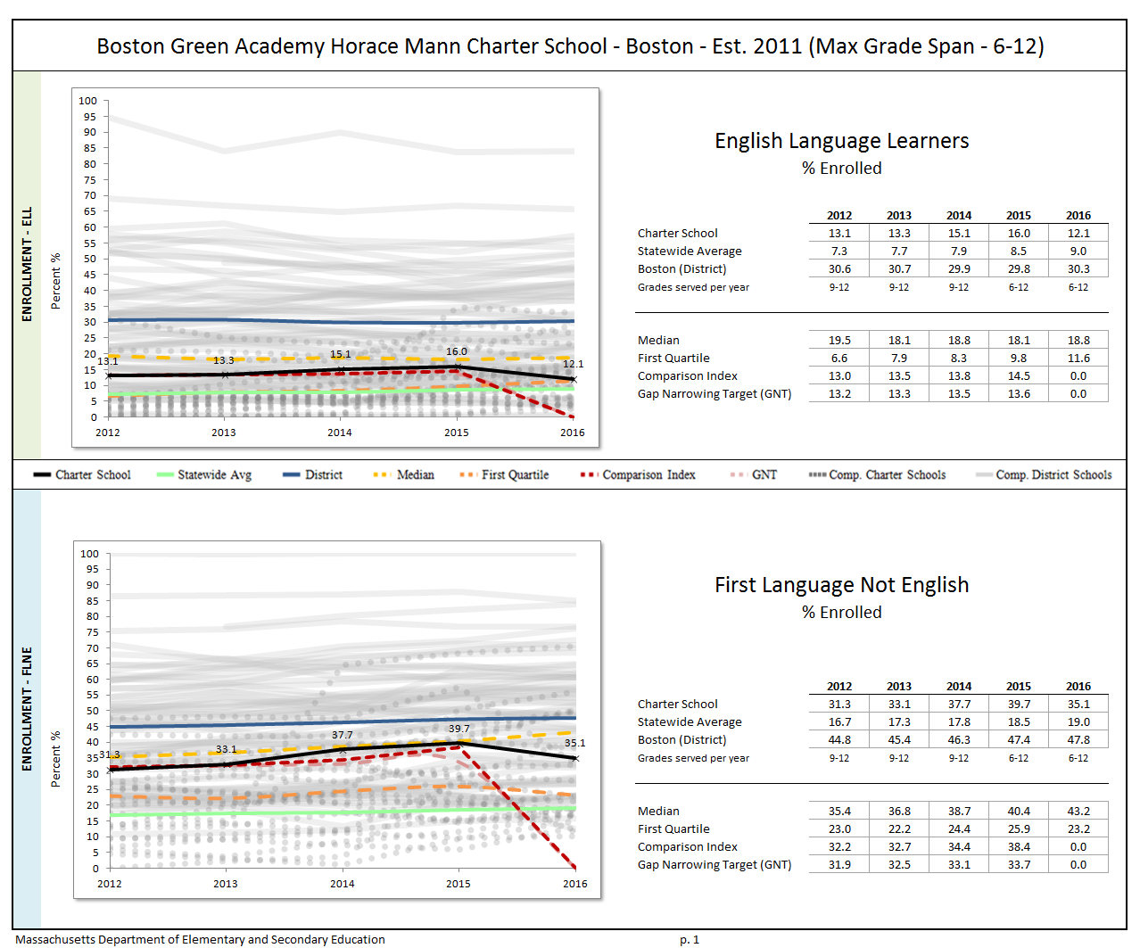
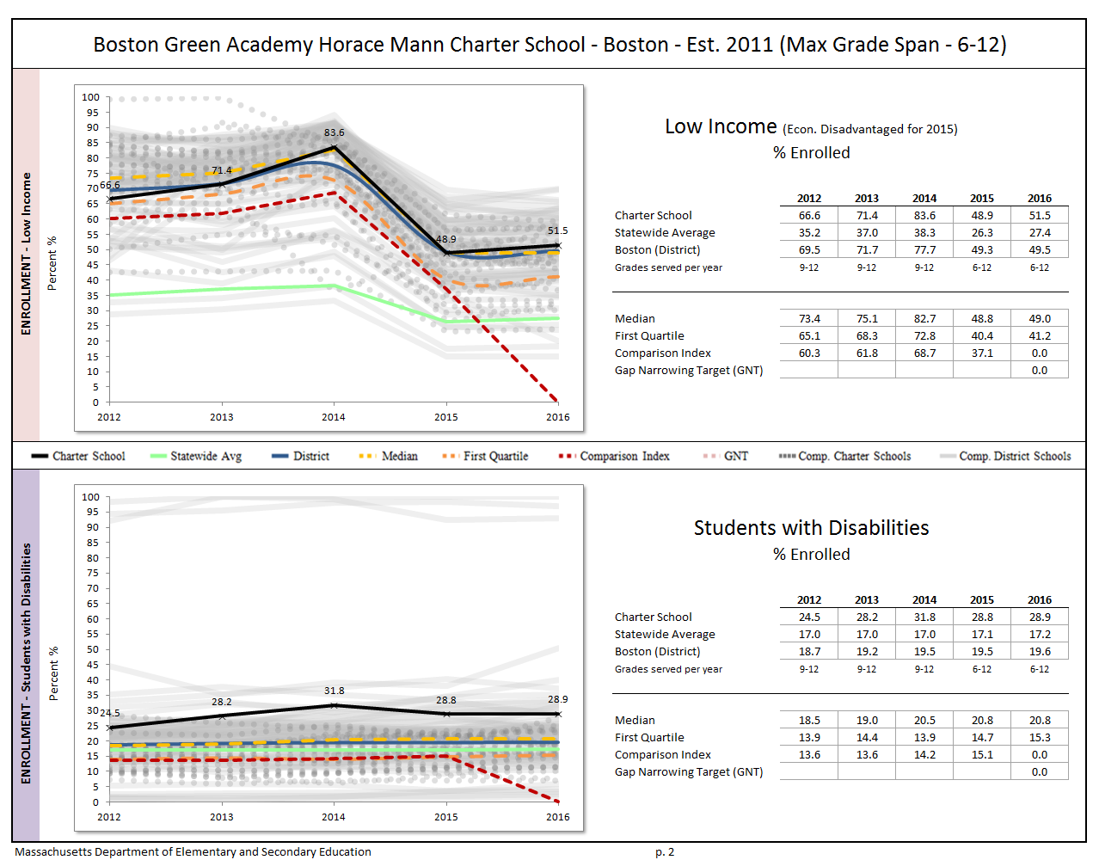
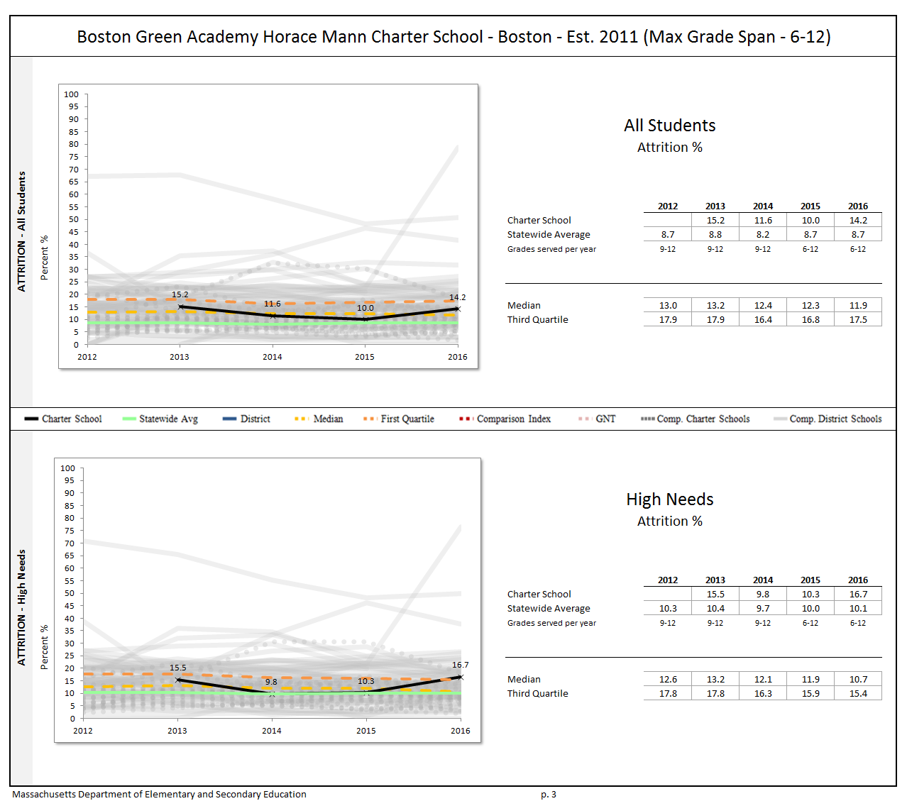

Appendix C: Academic Data (Criterion 5: Student Performance)
The charter accountability table (below) provides several sets of data relative to charter school performance on statewide assessments as well as student indicators. The percent of students scoring proficient or advanced (P/A), the composite performance index (CPI), the percent of students scoring warning or failing (W/F), and the student growth percentile (SGP) are all displayed in the aggregate over the term of the charter. For schools participating in PARCC in 2015, the percent of students who met or exceeded expectations (Level 4 and 5) and those who did not meet expectations (Level 1) are displayed. Because these are not exact equivalents to MCAS proficient/advanced or warning/failing, these figures are not included in the graph. A Transitional Composite Performance Index (Trans. CPI) and Transitional Student Growth Percentile (Trans. SGP) generated using current PARCC and prior MCAS scores are displayed as equivalents to MCAS CPI and SGP. These figures are included in the graphs. The school’s accountability level, percentile, English Language Arts (ELA) and math percentiles for the aggregate and targeted subgroups, and cumulative progress and performance index (PPI) for the aggregate and targeted subgroups are shown if available (this depends on the size and the age of the school). When applicable, the 4-year and 5-year graduation rates as well as the annual dropout rate are also provided for the available years of the charter term. For detailed definitions of accountability terms, please visit this URL: http://profiles.doe.mass.edu/accountability/report/aboutdata.aspx#AccountabilityInformation.
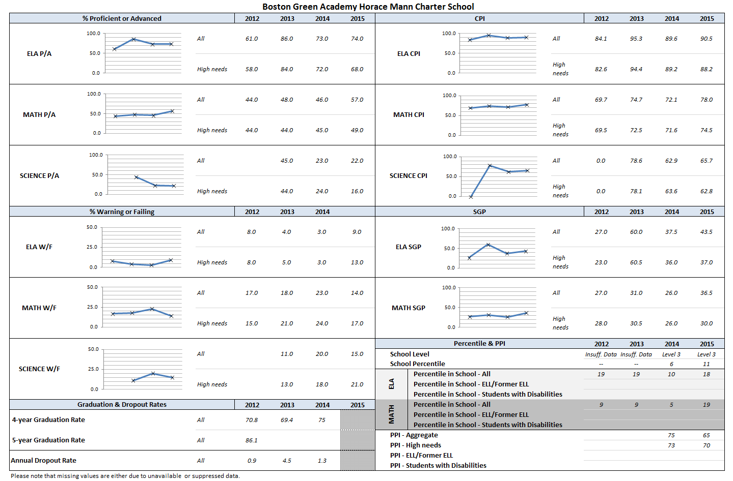

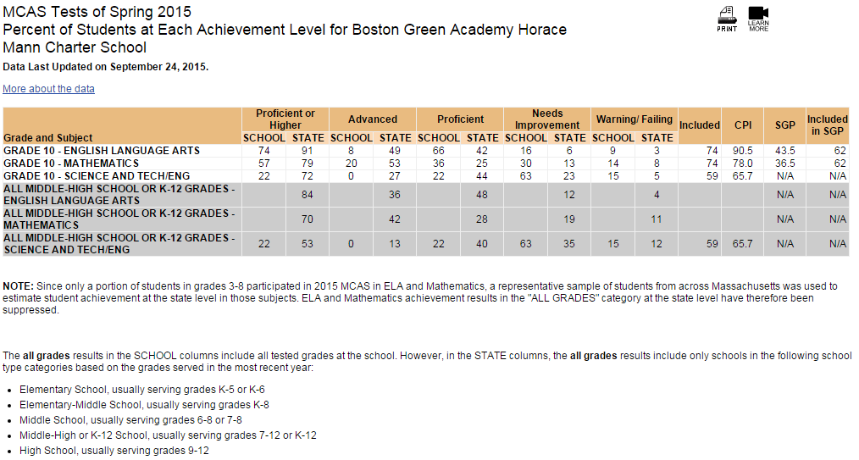
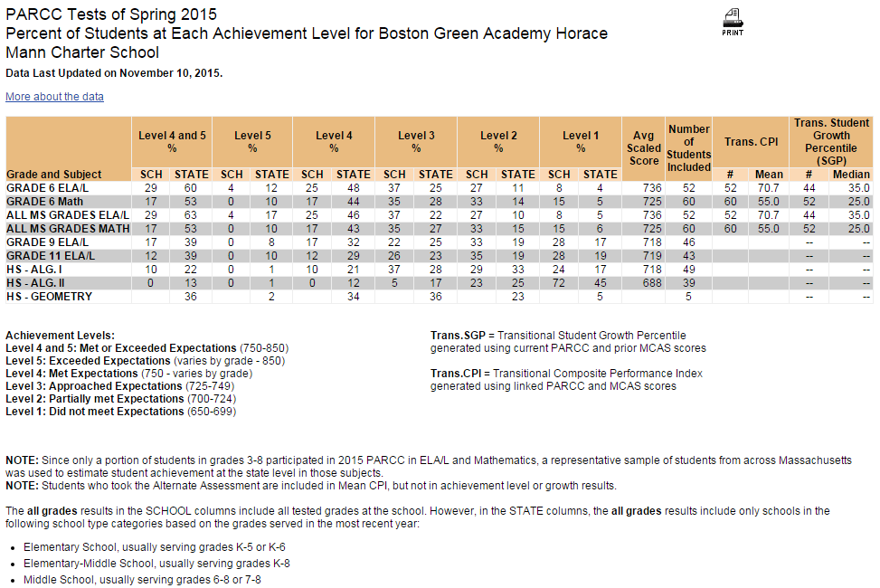

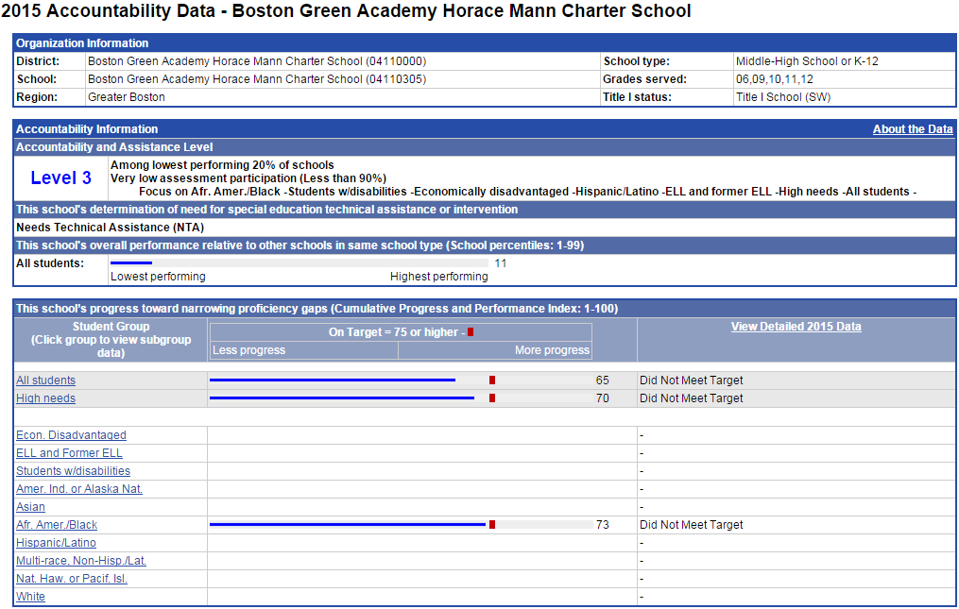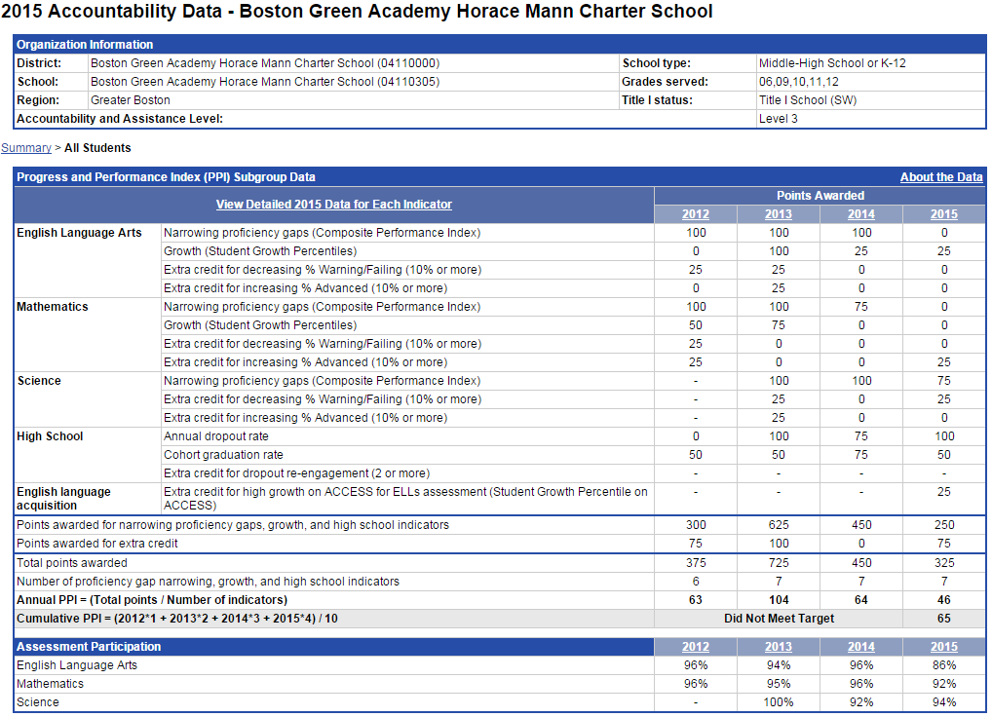
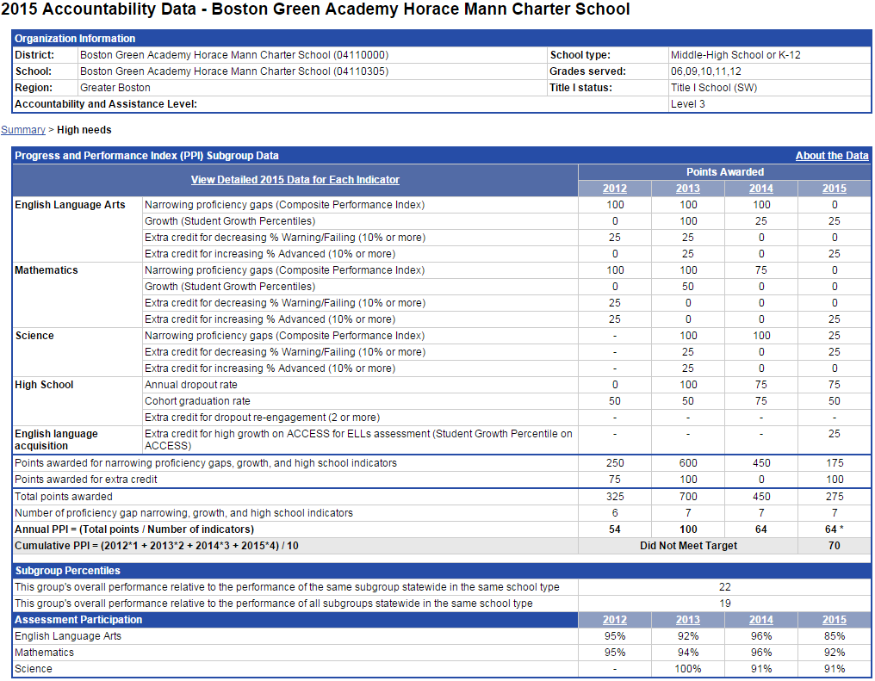

Appendix D: Financial Dashboard (Criterion 10: Finance)
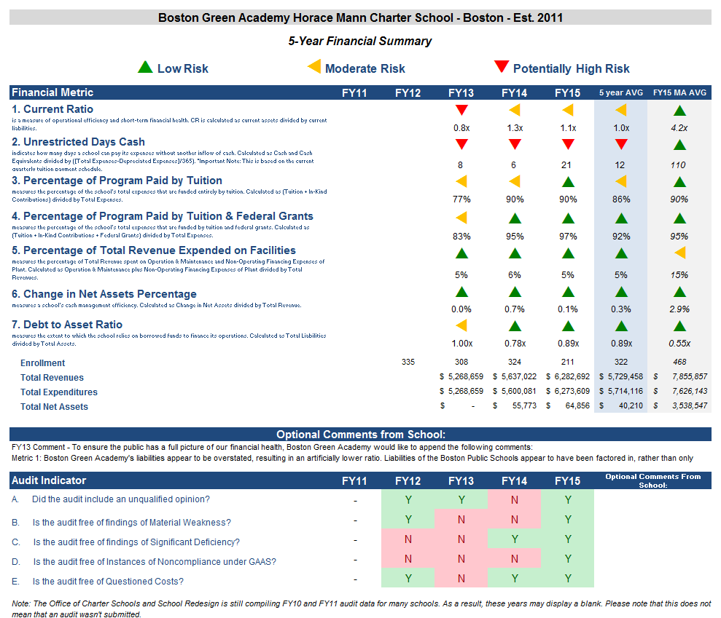

Financial Metric Definitions |  | Low Risk | Moderate Risk | Potentially High Risk
1. Current Ratio | Current Ratio is a measure of operational efficiency and short-term financial health. CR is calculated as current assets divided by current liabilities. | >= 1.5 | Between 1.0 (inclusive) and 1.5 | < 1.0
2. Unrestricted Days Cash (Prior to FY14)  Applies to 5-year average | The unrestricted days cash on hand ratio indicates how many days a school can pay its expenses without another inflow of cash. Calculated as Cash and Cash Equivalents divided by ([Total Expenses-Depreciated Expenses])/365).  Note: This is based on quarterly tuition payment schedule. | >= 75 days | Between 45 (inclusive) and 75 days | < 45 days
2. Unrestricted Days Cash (FY14 forward) | 4th quarterly tuition payments to Commonwealth charter schools in FY14 were made after June 30, 2014, which resulted in lower-than-typical cash at fiscal year end, affecting the risk levels for the current ratio and unrestricted days cash indicators for FY14 on a one-time basis. Payments for FY15 and after are made on a monthly basis, and parameters for risk have been adjusted accordingly. | >= 60 days | Between 30 (inclusive) and 60 days | < 30 days
3. Percentage of Program Paid by Tuition | This measures the percentage of the schools total expenses that are funded entirely by tuition. Calculated as (Tuition + In-Kind Contributions) divided by Total Expenses (expressed as a percentage). Note: In-Kind Contribution are added to the numerator in this ratio to balance out In-Kind Expenditures which will be captured in the Total Expenses in the denominator, and ratios over 100% are set to 100%. | >= 90% | Between 75% (inclusive) and 90% | < 75%
4. Percentage of Program Paid by Tuition & Federal Grants | This measures the percentage of the schools total expenses that are funded by tuition and federal grants. Calculated as (Tuition + In-Kind Contributions + Federal Grants) divided by Total Expenses (expressed as a percentage). Note: In-Kind Contribution are added to the numerator in this ratio to balance out In-Kind Expenditures which will be captured in the Total Expenses in the denominator, and ratios over 100% are set to 100%. | >= 90% | Between 75% (inclusive) and 90% | < 75%
5. Percentage of Total Revenue Expended on Facilities | This measures the percentage of Total Revenue that is spent on Operation & Maintenance and Non-Operating Financing Expenses of Plant. Calculated as Operation & Maintenance plus Non-Operating Financing Expenses of Plant divided by Total Revenues (expressed as a percentage). | <= 15% | Between 15% and 30% (inclusive) | > 30%
6. Change in Net Assets Percentage | This measures a school's cash management efficiency. Calculated as Change in Net Assets divided by Total Revenue (Expressed as a percentage). | Positive % | Between -2% (inclusive) and 0% | < -2%
7. Debt to Asset Ratio | Measures the extent to which the school relies on borrowed funds to finance its operations. Calculated as Total Liabilities divided by Total Assets. | <= .9 | Between .9 and 1 (inclusive) | > 1
FY12 MA AVG Column | All financial metrics indicated in this column are a result of each ratio calculated using statewide totals. For Enrollment, Total Net Assets and Total Expenditures rows, these numbers are averages calculated using the statewide totals of all charter schools’ data.

Appendix E: School’s Response to the 2016 Summary of Review

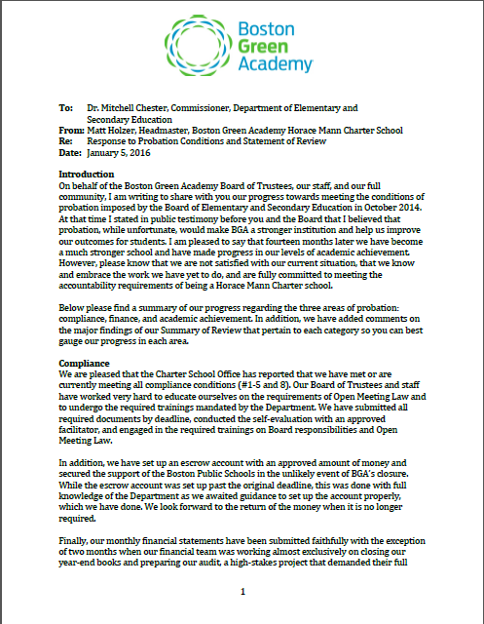
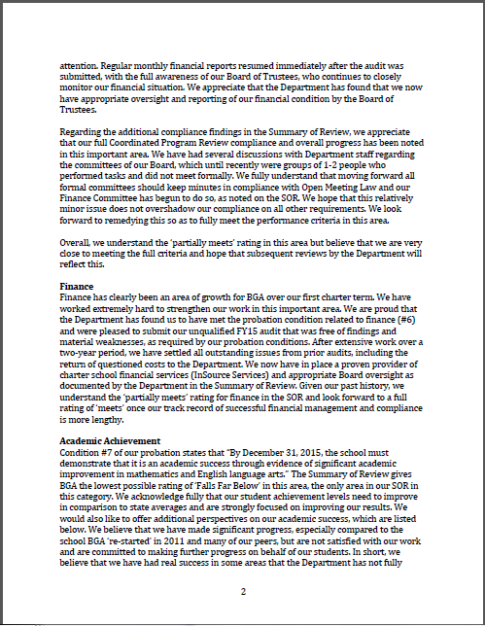
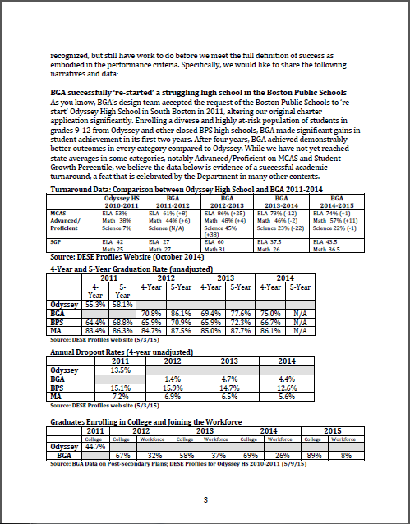
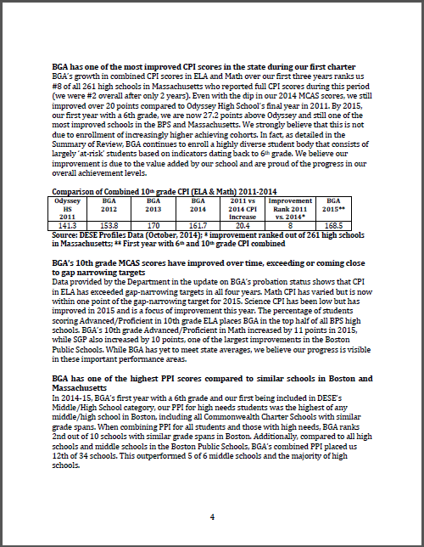
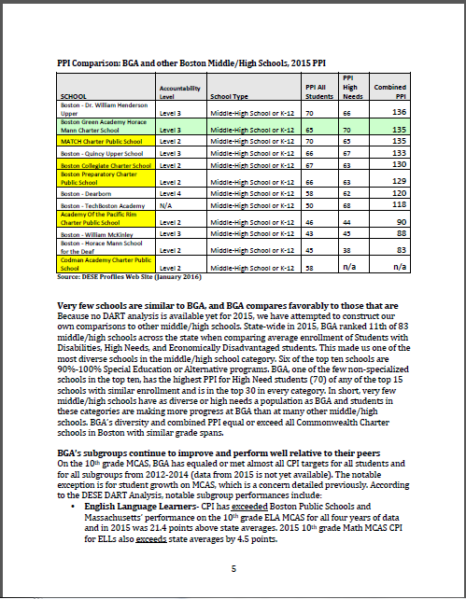
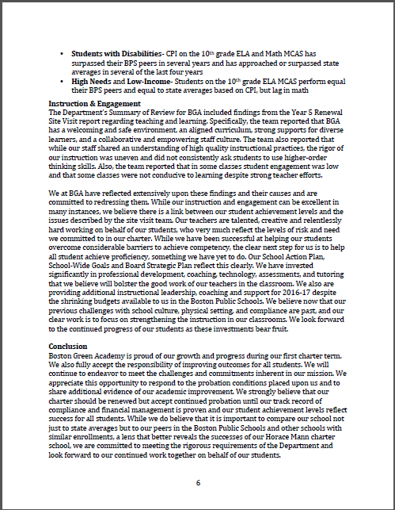

BGA has appealed to the Department regarding the very low participation designation as the school believes its participation rates are higher than those recorded by the Department. The appeal is pending.
1 The names of each of these schools and additional subgroup detail can be found in the Charter Analysis and Review Tool (CHART), http://www.doe.mass.edu/charter/chart/.
The midpoint value of all comparison schools. This is derived using Microsoft Excel's MEDIAN function.
The first quartile is the middle number between the smallest number and the median of all comparison schools. This is derived using Microsoft Excel's QUARTILE function.
The comparison index provides a comparison figure derived from data of students who reside within the charter school’s sending district(s). The comparison index is a statistically calculated value designed to produce a fairer and more realistic comparison measure that takes into account the charter school’s size and the actual prevalence of student subgroups within only those grade levels in common with the charter school.
The Gap Narrowing Target (GNT) refers to the halfway point between the school’s baseline rate (which is the rate in the 2010-11 school year, or the first year enrollment data is collected if after 2010-11,) and the current Comparison Index (the “target”). The object is to meet this halfway point by the 2016-17 school year (or in a later year if baseline is after 2010-11), giving the school six years to do so. For a school to be on schedule to meet its GNT, an incremental increase must be met annually. To determine this increment, the following equation is used: [(Comparison Index – Baseline) / 2] / 6 years = Annual GNT.
The percentage of attrition, or rate at which enrolled students leave the school between the end of one school year and the beginning of the next.
A student is high needs if he or she is designated as either low income, or ELL, or former ELL, or a student with disabilities. A former ELL student is a student not currently an ELL, but had been at some point in the two previous academic years. * 2014-2015 is the first year for which the category “Economically Disadvantaged” is being reported, replacing the “Low-income,” “Free Lunch” and “Reduced Lunch” categories used in 2013-2014 and earlier. It is important for users of this data to understand that enrollment percentages and achievement data for "economically disadvantaged" students cannot be directly compared to "Low-income" data in prior years. Please see http://www.doe.mass.edu/infoservices/data/ed.html for important information about the new “Economically Disadvantaged” category.

