Massachusetts Department of

Elementary and Secondary Education

75 Pleasant Street, Malden, Massachusetts 02148-4906 Telephone: (781) 338-3000

TTY: N.E.T. Relay 1-800-439-2370

Mitchell D. Chester, Ed.D.
Commissioner

MEMORANDUM

To: | Members of the Board of Elementary and Secondary Education
From: | Mitchell D. Chester, Ed.D., Commissioner
Date: | February 12, 2016
Subject: | Charter Schools – Renewal Recommendation and Report on Probation for Boston Green Academy Horace Mann Charter School

The Board of Elementary and Secondary Education (Board) placed Boston Green Academy Horace Mann Charter School (BGA) on probation in October 2014 and imposed eight conditions related to finance, governance, and academics. In its fifth year of operation, BGA is also at the end of its first charter term and is coming to the Board for renewal of its charter. Based upon the progress described below, I recommend that the Board renew the charter of BGA but extend probation and require that the school demonstrate significant and sustained academic improvement.

Boston Green Academy Horace Mann Charter School
Type of Charter  (Commonwealth or Horace Mann) | Horace Mann | Location | Boston
Regional or Non-Regional? | Non-Regional | Districts in Region  (if applicable) | NA
Year Opened | 2011 | Year(s) Renewed  (if applicable) | NA
Maximum Enrollment | 595 | Current Enrollment | 439
Chartered Grade Span | 6-12 | Current Grade Span | 6,7, 9-12
Students on Waitlist | 496 | Current Age of School | 5 years
Mission Statement
Boston Green Academy welcomes diverse students of all abilities, educates and empowers them to succeed in college and career, and prepares them to lead in the sustainability of our community and world.

BGA is a Horace Mann III charter school in the Boston Public School (BPS) district. In its application to become a Horace Mann III charter school, BGA promised to serve students from a Boston high school that was recommended for closure. In its subsequent memorandum of understanding (MOU) with BPS, BGA agreed to open in 2011 with students in grades 9-12, to absorb the student population from Odyssey High School (Odyssey), and to occupy Odyssey’s facility in South Boston. The fact that BGA has functioned as a turnaround effort presented the school with the greater challenge of transforming an existing culture of low academic and behavioral expectations as opposed to establishing a culture in a new school. While BGA was originally proposed as a 6-12 school, the MOU altered the founding group’s original growth plan and delayed the offering of middle school grades.

From 2011 until the end of the 2013-14 school year, BGA served grades 9-12 in the South Boston facility. In the fall of 2014, the school moved to a new location in Brighton and began to serve the 6th grade. The Brighton facility is co-located with Another Course to College, a BPS school. In the fall of 2015, BGA began to serve the 7th grade.

In the summer of 2015, the school requested an amendment to its mission statement because the school’s stakeholders felt that the original mission was not clear. The Commissioner approved the amendment in September 2015. The school is planning to request approval for further amendments to its charter to reflect changes made to its program during the past four years.

Due to persistent concerns, the school received five visits from the Department of Elementary and Secondary Education (Department) in the school’s first four years of operation. These visits documented concerns about the school’s faithfulness to its charter, the quality of the academic program, the school’s poor academic results, the quality and amount of support for diverse learners, and the school’s lack of compliance with regulatory requirements. In addition, the school’s audit for fiscal year 2013 identified material weaknesses. As a result, in October 2014, the Board voted to put BGA on probation with eight conditions related to finance, governance, and academics. The school’s progress in meeting these conditions is addressed below.

Progress Towards Meeting Conditions

This section lists the conditions imposed in 2014 and outlines BGA’s progress towards meeting the conditions. As summarized below, BGA has met the conditions imposed by the Board in connection with placing the school on probation in October 2014; one condition related to academic improvement was partially met. The school’s board conducted a self-evaluation, conducted a training with a Department-approved external consultant, established an escrow account, remedied all issues identified in the FY13 audit, and the school met academic measures established by the Department. BGA, however, did not meet the condition requiring the school to demonstrate significant academic progress by December 2015. As shown in the data charts below, BGA’s achievement and growth scores have improved since 2012 but do not yet demonstrate significant improvement.

Condition 1: Beginning in October of 2014 and until further notice, BGA must submit to the Department, at charterschools@doe.mass.edu, board meeting agendas, materials, and minutes prior to each board meeting at the same time that these items are sent to the school's board members. Additionally, if board materials do not already include this information, the school must also submit monthly financial statements.

Status: Ongoing/Met
The school has submitted its meeting minutes, agendas, and other materials to the Department in a timely manner since October 2014. The school has also submitted timely monthly financial statements with the exception of September and October 2015, which were submitted in November 2015.

Condition 2: By December 31, 2014, the school's board of trustees must have completed a comprehensive self-evaluation of its own capacity and must have recruited additional board members with needed expertise, as identified by the board of trustees and the Department.

Status: Met
The board conducted a self-assessment in December 2014 and subsequently analyzed the results during its training in January 2015 with an external consultant. As a result of the self-assessment, the board worked to improve its process for orienting new members. Prior to the due date of the condition, the board recruited one additional external member, the former education advisor to the mayor of Boston, and one staff member by December 31, 2014. The board has since recruited new members and currently has 14 members.

Condition 3: By December 31, 2014, the school must establish an escrow account in an amount determined by the Department in consultation with the school to pay for any potential closing, legal, and audit expenses associated with closure, should that occur.

Status: Met
After ongoing communication, consultation, and guidance from the Department, the school met this condition after the deadline on August 12, 2015. The school worked with the Department and Boston Public Schools to establish the amount held in escrow. The board of the school established an escrow account of $15,000, an amount approved by the Department. The school also obtained a letter of support from the Boston Public Schools concerning any potential additional costs.

Condition 4: By February 28, 2015, the school's board of trustees must engage in training conducted by an external consultant, acceptable to and approved in advance by the Department, on the roles and responsibilities of a board of trustees for a charter school.

Status: Met
On January 7, 2015, board members engaged in a training provided by an external consultant approved by the Department. During the Year 4 site visit, board members reported that they found the training helpful and have a better understanding of their role and responsibilities as a result.

Condition 5: By February 28, 2015, all members of the board of trustees of BGA will complete the series of six trainings offered online by the Office of the Attorney General regarding the Open Meeting Law. All board members will sign the required certificate stating that they have received, read, and viewed the following materials: the Open Meeting Law, G.L. c. 30A, §§ 18-25; regulations promulgated by the Attorney General under G.L. c. 30A, § 25; and educational materials available from the Attorney General explaining the Open Meeting Law and its application.

Status: Met
This condition was met by the deadline. Required certificates were submitted to the Department on February 27, 2015.

Condition 6: By November 1, 2015, as documented by the school’s FY15 independent financial audit, the school must remedy all material weaknesses and deficiencies identified in the FY13 financial audit and any subsequent findings in the school’s audit for FY14. The school must have an unqualified opinion on its FY15 audit without any identified material weaknesses.

Status: Met
When the FY13 audit was submitted near the end of FY14, management had already hired a new business manager and started the process of addressing the audit findings. Some findings remained in FY14, and the FY14 audit included a qualified opinion on the financial statements. The school had an unqualified opinion on its FY15 audit and did not have any identified material weaknesses. According to the audit, all past issues have been properly addressed.

Condition 7: By December 31, 2015, the school must demonstrate that it is an academic success through evidence of significant academic improvement in mathematics and English language arts.

Status: Partially Met
BGA’s overall performance has not yet met state standards. The school, however, demonstrated some academic improvement in its 2015 grade 10 results. Please see the data charts below as well as full academic results in the attached SOR.

The school’s Composite Performance Index (CPI) for grade 10 improved for all subjects in 2015. The CPI was 90.5 in English language arts (ELA), 78.0 in mathematics, and 65.7 in science and technology/engineering, all showing improvement from the 2014 scores. In 2015, proficiency rates increased in ELA and mathematics. In 2015, 74 percent of grade 10 students at BGA scored in the Proficient and Advanced categories on the ELA assessment, compared to 73 percent in 2014. In 2015, 57 percent of students scored Proficient and Advanced on the mathematics assessment, compared to 46 percent in 2014.

Student Growth Percentiles (SGP) have been below target for most of the charter term but improved in 2015.

BGA Median Student Growth Percentile
Year | 2012 | 2013 | 2014 | 2015
English Language Arts | 27.0 | 60.0 | 37.5 | 43.5
Mathematics | 27.0 | 31.0 | 26.0 | 36.5

BGA has greatly improved its graduation rates when compared to the graduation rates of former Odyssey High School, which were 55.3 percent at 4 years and 58.1 percent at 5 years. The school has not met state accountability targets of 80 percent and 85 percent for 4-year and 5-year graduation rates, respectively; the 4-year graduation rate for the 2014 cohort was 75 percent, and the 5-year graduation rate was 77.6 percent for the 2013 cohort. BGA’s dropout rate in 2014 was 3.2 percent, which was better than its annual target of 6.3 and better than its six-year goal of 4.7 percent. Odyssey High School’s drop-out rate was 13.5 percent in 2011, the year before the school was taken over by BGA.

When compared to other middle-high, non-exam schools in Boston, BGA has the highest Progress and Performance Index (PPI) in 2015 for the high needs subgroup. Additionally, when compared to the academic results of the Odyssey High School, BGA has greatly increased the percent of students reaching proficiency. In 2011, 53 percent of Odyssey’s students reached proficiency in ELA, and 38 percent were proficient in mathematics. By 2015, 74 percent of BGA students reached proficiency in ELA, and 57 percent were proficient in mathematics. The school provides other comparative data in its response to the SOR (attached).

ELA CPI Chart

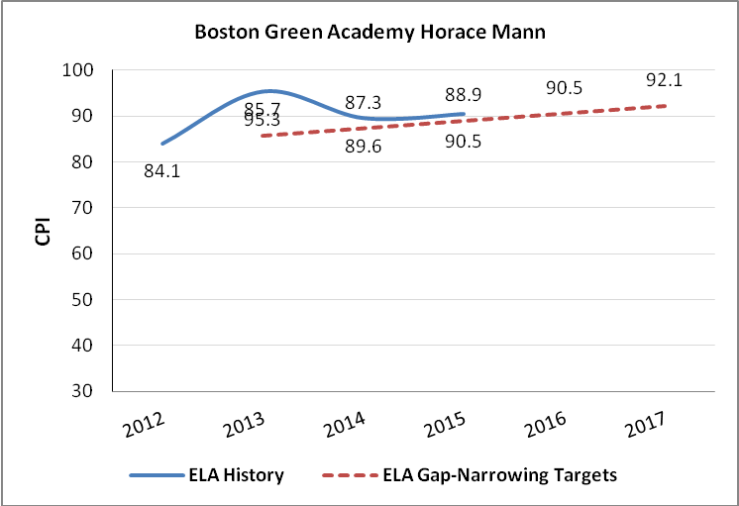

Mathematics CPI Chart

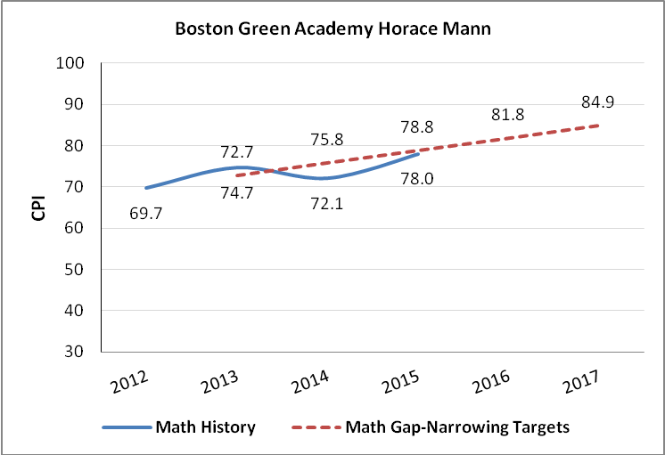

Science CPI Chart

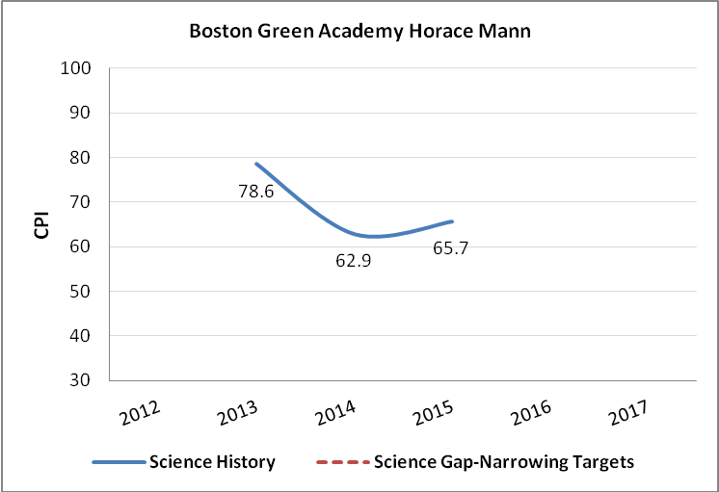

Condition 8: The school will submit all documentation required by the Department in accordance with deadlines established by the Department for the remainder of the school’s charter term including, but not limited to, documents for approval and appointment of new board members; financial disclosures of board members; the school’s annual financial audit; the school’s application to renew its charter, if desired; the school’s annual report and end of year financial report; and all required and accompanying documentation.

Status: Met
Systems are now in place to ensure that deadlines are met in a timely manner. At this time, the Department is in receipt of board approval documentation for all current and pending members. The Department received the school’s 2014-15 Annual Report and the Application for Renewal of its charter on time. In addition, the school submitted the FY14 and FY 15 audits and end of year financial reports on time.

Renewal of Charter

BGA’s charter is currently under consideration for renewal. The school’s ratings from the Summary of Review (SOR) follow. Evidence from the attached SOR is also provided below, as context.

Boston Green Academy Horace Mann Charter School
● Exceeds |  | The school fully and consistently meets the criterion and is a potential exemplar in this area.
● Meets |  | The school generally meets the criterion and/or minor concern(s) are noted.
● Partially Meets |  | The school meets some aspects of the criterion but not others and/or moderate concern(s) are noted.
● Falls Far Below |  | The school falls far below the criterion and/or significant concern(s) are noted.
Massachusetts Charter School Performance Criteria |  |  |  | Rating
Faithfulness to Charter | - Mission and Key Design Elements: The school is faithful to its mission, implements the key design elements outlined in its charter, and substantially meets its accountability plan goals. |  |  | ● Partially Meets
 | - Access and Equity: The school ensures program access and equity for all students eligible to attend the school. |  |  | ● Meets
 | - Compliance: The school compiles a record of compliance with the terms of its charter and applicable state and federal laws and regulations. |  |  | ● Partially Meets
 | - Dissemination: The school provides innovative models for replication and best practices to other public schools in the district where the charter school is located. |  |  | ● Meets
Academic Program Success | - Student Performance: The school consistently meets state student performance standards for academic growth, proficiency, and college and career readiness. |  |  | ● Falls Far Below
 | - Program Delivery: The school delivers an academic program that provides improved academic outcomes and educational success for all students. |  | Curriculum | ● Meets
 |  |  | Instruction | ● Partially Meets
 |  |  | Assessment and Program Evaluation | ● Partially Meets
 |  |  | Supports for Diverse Learners | ● Meets
 | - Culture and Family Engagement: The school supports students’ social and emotional health in a safe and respectful learning environment that engages families. |  | Social, Emotional and Health Needs | ● Meets
 |  |  | Family Engagement | ● Meets
Organizational Viability | - Capacity: The school sustains a well-functioning organizational structure and creates a professional working climate for all staff. |  | School Leadership | ● Meets
 |  |  | Professional Climate | ● Meets
 |  |  | Contractual Relationships (If applicable) | ● Partially Meets
 | - Governance: Members of the board of trustees act as public agents authorized by the state and provide competent and appropriate governance to ensure the success and sustainability of the school. |  |  | ● Partially Meets
 | - Finance: The school maintains a sound and stable financial condition and operates in a financially sound and publicly accountable manner. |  |  | ● Partially Meets

Faithfulness to Charter (Criteria 1-4 above)

- As noted above, the school recently amended its mission statement and is in the process of identifying possible amendments to its original charter. The school is meeting the aspects of its mission of serving a diverse population and developing green programming. While the school has structures and systems in place to support college and career preparation, the school has yet to realize the academic results to support this aspect of the mission. The school met a majority of its accountability plan measures.
- BGA enrolls a higher percentage of English language learners, students who are low income or economically disadvantaged, and students with disabilities than the median of its comparison schools in Boston. See CHART in Appendix B of the SOR for comparative demographics.
- The school’s attrition rate has dropped from 15.2 percent in 2013 to 10.0 percent in 2015, below the median for comparison schools in Boston. The school implements a Recruitment and Retention plan.
- On several occasions throughout the charter term, BGA has been out of compliance with educator licensure regulations and other requirements. The school has remedied the areas and has improved its record of compliance.
- The school has disseminated best practices this charter term.

Academic Program Success (Criteria 5-7 above)

- As shown above and in the attached SOR, BGA has demonstrated improvement in academic outcomes during the charter term.
- In its first charter term, BGA has developed a curriculum that is vertically and horizontally aligned and aligned to the Massachusetts curriculum frameworks. In Year 5, the renewal inspection team found the curriculum implemented with fidelity. The school has improved its process of curricular review and revision over the course of the charter term.
- In response to the evolving needs of BGA’s students, the instructional practices of the school have changed each year of the charter term. By Year 5, BGA staff developed a common understanding of instructional practices; implementation of these practices, however, has not consistently reflected high expectations for student learning. Student engagement and classroom environments have improved over the course of the charter term but remain a work in progress for the school.
- BGA has established a comprehensive system of assessments this charter term. The school continues to work to formalize the data review process, but it has used data to make a number of programmatic changes in the past five years.
- BGA offers a range of supports and interventions to meet the needs of students with diverse learning needs. The school provides extensive supports for its high percentage of students with disabilities, 29 percent in 2016. The school has inclusion general education classrooms, sub-separate classrooms, and a Learning for Independence program for students with multiple and severe disabilities.
- BGA has worked to improve the culture and safety of its school environment this charter term. The school now has effective systems and supports in place to address the physical, social, and emotional health needs of students.
- The school has improved communication with families this charter term.

Organizational Viability (Criteria 8-10 above)

While the school has had challenges in the areas of organizational viability throughout the charter term, many of the issues have been resolved by Year 5, particularly in Governance and Finance.

- By Year 5, visitors found that the school’s administrative team has clear roles, responsibilities, and communication structures.
- BGA has increased both teacher collaboration and professional development opportunities. The school has a system in place to evaluate teachers.
- Over the course of the charter term, stakeholders reported an improved relationship with the Boston Public Schools; BPS, however, has not consistently honored its MOU with the school.
- The board has increased its oversight and support of the school over the course of the charter term. The board has worked to address the probationary conditions placed on the school; the board, however, is still working to operate in full compliance with Open Meeting Law.
- BGA’s audits for FY12, FY13, and FY14 revealed significant deficiencies regarding its financial controls. The school has addressed these issues, and its audit for FY15 was free of findings.

Recommendation

Charter schools are held to high standards of operation and expected to deliver an effective academic program. Based upon the evidence described in the attached SOR and further summarized below, BGA had limited academic success during its first charter term, but has demonstrated improvement between 2014 and 2015. The school, however, has faced and remedied multiple challenges in its first five years of operation. Not least of these is that the school, in many ways, has functioned as a turnaround effort in light of essentially having restarted the low-performing Odyssey High School. As shown in the school’s response to the SOR, BGA has substantially better academic outcomes than the former Odyssey school – the school that BGA’s founding group agreed to operate as a Horace Mann III charter school. The school has met all of the conditions placed on its charter as part of probation in 2014, except for partially meeting the conditions related to academic improvement. While academic performance is not yet acceptable in the aggregate, the school did demonstrate some improvement from 2014 to 2015.

Given this evidence, further detailed in the attached SOR, as well as the school’s response to the SOR, I recommend that the Board renew the school’s charter with continued probation, requiring significant and sustained academic improvement on the 2016 and 2017 state assessments. If academic results do not demonstrate continued improvement in ELA, mathematics, or science on 2016 assessments, however, I will recommend revocation of the school’s charter effective June 30, 2017. I also recommend that two existing conditions be extended as part of the school’s probation and charter renewal.

- Until further notice, Boston Green Academy Horace Mann Charter School must submit to the Department, at charterschools@doe.mass.edu, board meeting agendas, materials, and minutes prior to each board meeting at the same time that these items are sent to the school's board members. Additionally, if board materials do not already include this information, the school must also submit monthly financial statements.

- The school must maintain the established escrow account to pay for any potential closing, legal, and audit expenses associated with closure, should that occur.

- By December 31, 2016, the school must demonstrate significant and sustained academic improvement in mathematics, English language arts, and science. Should the school fail to do so, the Commissioner and the Board of Elementary and Secondary Education will consider revoking the school’s charter based on failure to meet this condition, rather than wait to see improvement by December 31, 2017.

- By December 31, 2017, the school must demonstrate continued significant and sustained academic improvement in mathematics, English language arts, and science. Should the school fail to do so, the Commissioner and the Board of Elementary and Secondary Education will consider revoking the school’s charter based on failure to meet this condition.

**********************

If you have any questions regarding this recommendation or require additional information, please contact Cliff Chuang, Associate Commissioner (781-338-3222); Jeff Wulfson, Deputy Commissioner (781-338-6500); or me.

Attachments: Motion
BGA’s Summary of Review with the school’s response

BGA’s lack of compliance included: lack of appropriate licensure for two special education staff; failure to request approval of board members for Commissioner approval prior to service, and failure to submit the 2012 end-of-year financial report or the 2013 financial audit in a timely manner.
In 2014, BGA served grades 9-12 and was compared to other high schools statewide for its Level and Percentile. In 2015, BGA served grades 6 and 9-12 and was classified as a middle-high school. Due to the change to BGA’s school type, it is difficult to determine the actual change in BGA’s percentile from 2014 to 2015. In 2014 and 2015, BGA’s MCAS scores placed the school in Level 3. In 2014, BGA was in the 6th percentile when compared to other high schools statewide. In 2015, due to the addition of 6th grade in the 2014-2015 school year, the school is in the 11th percentile when compared to other middle-high schools statewide.
BGA’s lack of compliance included: lack of appropriate licensure for two special education staff; failure to request approval of board members for Commissioner approval prior to service, and failure to submit the 2012 end-of-year financial report or the 2013 financial audit in a timely manner. These issues have been resolved.

