Boston Green Academy

Horace Mann Charter School
Year 6 Targeted Site Visit Report

Boston, MA
November 1, 2016

Massachusetts Department of Elementary and Secondary Education
75 Pleasant Street
Malden, MA 02138
Phone: (781) 338-3227
Fax: (781) 338-3220

This document was prepared by the
Massachusetts Department of Elementary and Secondary Education
Mitchell D. Chester, Ed.D.
Commissioner

The Massachusetts Department of Elementary and Secondary Education, an affirmative action employer, is committed to ensuring that all of its programs and facilities are accessible to all members of the public.
We do not discriminate on the basis of age, color, disability, national origin, race, religion, sex, gender identity, or sexual orientation.
Inquiries regarding the Department’s compliance with Title IX and other civil rights laws may be directed to the
Human Resources Director, 75 Pleasant St., Malden, MA 02148-4906. Phone: 781-338-6105.

© 2016 Massachusetts Department of Elementary and Secondary Education
Permission is hereby granted to copy any or all parts of this document for non-commercial educational purposes. Please credit the “Massachusetts Department of Elementary and Secondary Education.”

This document printed on recycled paper

Massachusetts Department of Elementary and Secondary Education
75 Pleasant Street, Malden, MA 02148-4906
Phone 781-338-3000 TTY: N.E.T. Relay 800-439-2370
www.doe.mass.edu

Table of Contents
Charter School Performance Criteria and Ratings 1
Introduction 2
School Profile 2
School Setting 2
Demographics 3
Methodology 3
Review of Progress Made Towards Meeting the Conditions Imposed 4
Ratings, Findings, and Evidence 5
Faithfulness to Charter 5
Criterion 1: Mission and Key Design Elements 5
Academic Program Success 8
Criterion 5: Student Performance 8
Criterion 6: Program Delivery 10
Organizational Viability 15
Criterion 8: Capacity 15
Criterion 9: Governance 16
Appendix A: Access and equity 19
Appendix B: Student Performance 24
Appendix C: Finance 29

Charter School Performance Criteria and Ratings
Massachusetts Charter School Performance Criteria |  |  | Rating
Faithfulness to Charter | Criterion 1: Mission and Key Design Elements  The school is faithful to its mission, implements the key design elements outlined in its charter, and substantially meets its accountability plan goals. |  | ● Meets
Academic Program Success | Criterion 5: Student Performance  The school provides consistently meets state student performance standards for academic growth, proficiency, and college and career readiness. |  | Level: 3  Percentile: 10th
 | Criterion 6: Program Delivery  The school delivers a high quality academic program that meets the academic needs of all students. | 2. Instruction | ● Partially Meets
 |  | 3. Assessment and Program Evaluation | ● Partially Meets
 |  | 4. Supports for Diverse Learners | ● Meets
Organizational Viability | Criterion 8: Capacity  The school sustains a well-functioning organizational structure and creates a professional working climate for staff. | 1. School Leadership | ● Meets
 | Criterion 9: Governance  Members of the board of trustees act as public agents authorized by the state and provide competent and appropriate governance to ensure the success and sustainability of the school. |  | ● Partially Meets

Rating Key
● Exceeds | The school fully and consistently meets the criterion and is a potential exemplar in this area.
● Meets | The school generally meets the criterion and/or minor concern(s) are noted.
● Partially Meets | The school meets some aspects of the criterion but not others and/or moderate concern(s) are noted.
● Falls Far Below | The school falls far below the criterion and/or significant concerns are noted.

Introduction

School Profile
Boston Green Academy Horace Mann Charter School (BGA)
Type of Charter | Horace Mann III | Location | Boston
Regional or Non-Regional | Non-Regional | Districts in Region | NA
Year Opened | 2011 | Year(s) Renewed | 2016
Maximum Enrollment | 595 | Current Enrollment | 510
Chartered Grade Span | 6-12 | Current Grade Span | 6-12
Students on Waitlist | 513 | Current Age of school | 6 years
Mission Statement:
Boston Green Academy welcomes diverse students of all abilities, educates and empowers them to succeed in college and career, and prepares them to lead in the sustainability of our community and world.

School Setting
Boston Green Academy Horace Mann Charter School (BGA) is a Horace Mann III charter school in the Boston Public School (BPS) district. In its application submitted in 2010 to become a Horace Mann III charter school, BGA promised to serve students from a Boston high school that was recommended for closure. In its subsequent memorandum of understanding (MOU) with BPS, BGA agreed to open in 2011 with students in grades 9-12, to absorb the student population from Odyssey High School (Odyssey), and to occupy Odyssey’s facility in South Boston. Originally proposed as a 6-12 school, the MOU altered the founding group’s original growth plan and delayed the offering of middle school grades. From 2011 until the end of the 2013-14 school year, BGA served grades 9-12 in the South Boston facility. In the fall of 2014, the school moved to a new location in Brighton and began to serve the 6th grade. For two years, the Brighton facility was co-located with Another Course to College, a BPS school for two years. Currently, the school occupies the entire Brighton facility and serves grades 6-12.
In the summer of 2015, the school requested an amendment to its mission statement because the school’s stakeholders felt that the original mission was not clear enough. This amendment was approved in September of 2015.
Due to persistent concerns, the school received five visits from the Department in its first four years of operation. These visits documented concerns about the school’s faithfulness to its charter, the quality of the academic program, low academic results, the quality and amount of support for diverse learners, the school’s lack of compliance with Department regulatory requirements, and lack of attention to sub-regulatory guidance. In addition, there were concerns regarding the fiscal year 2013 audit. As a result of these concerns, in October 2014, the Board of Elementary and Secondary Education (Board) voted to put BGA on probation with eight conditions for concerns related to finance, governance, and academics.
In 2016, BGA was granted a renewal of its charter with continued probation. The school had met the conditions related to compliance, but conditions related to academic achievement and governance were extended. The school’s progress against those conditions will be discussed in detail below.
This school year is the first year that the school is serving its full grade span of 6 through 12. However, the school is currently under-enrolled by 85 students due to the school’s historical facilities issues. The school is increasing its enrollment to approach its maximum enrollment now that it is in an appropriate facility.

Demographics
The table below represents student enrollment by race/ethnicity and for selected populations.
Enrollment by Race/Ethnicity
 | Number of Students | Percentage of Student Body
African-American | 273 | 54
Asian | 11 | 2
Hispanic | 168 | 33
Native American | 4 | .8
White | 37 | 7
Native Hawaiian, Pacific Islander | 0 | 0
Multi-Race, Non Hispanic | 15 | 3

Selected Populations
 | Number of Students | Percentage of Student Body
English Language Learner | 56 | 11
Students with Disabilities | 153 | 30
Economically Disadvantaged | 263 | 51.5

Methodology
The Charter School Performance Criteria (Criteria) define expected performance in the three guiding areas of charter school accountability defined in the current regulations, 603 CMR 1.00: faithfulness to charter, academic program success, and organizational viability. The purpose of this targeted visit was to gather evidence regarding the school’s performance on its probationary conditions and on a sub-set of the Criteria related to those conditions.
This report contains evidence related to a sub-set of the Criteria: Criterion 1: Mission and Key Design Elements, Criterion 5: Student Performance, Key Indicator 6.2: Instruction, Key Indicator 6.3: Assessment and Program Evaluation, Key Indicator 6.4: Supports for Diverse Learners, Key Indicator 8.1: School Leadership, and Criterion 9: Governance. Ratings that encapsulate a school’s performance in terms of these criteria are found on the first page of this report. Evidence and findings that support the ratings are presented below. Additional evidence related to Criteria 2, 5, and 10 is appended to this report.
The following participants conducted the site visit on November 1, 2016:
- Alison Bagg , Department of Elementary and Secondary Education (DESE), Office of Charter Schools and School Redesign (OCSSR)
- Patrick Buckwalter, DESE, OCSSR
- Melissa Gordon, DESE, OCSSR
- Kristin Harrison, Christa McAuliffe Charter School
- Ellie Rounds Bloom, DESE, OCSSR
- Claire Smithney, DESE, OCSSR
Before the visit, the site visit team reviewed the school’s 2015-16 Annual Report, Year 5 Summary of Review, board materials and minutes, and recent internal and external assessment data. On site, the team reviewed an update on BGA’s academic progress, professional development documents, staff and student handbooks and other information provided by the school. The team conducted 39 classroom observations and interviewed trustees (6), administrators (7), special education and EL administrators (5), teachers including special education teachers (11), and students (10).

Review of Progress Made Towards Meeting the Conditions Imposed
As noted above, BGA is currently on probation and must meet three conditions. This section of the report lists the conditions and BGA’s progress towards meeting the conditions.
Condition 1: Until further notice, Boston Green Academy Horace Mann Charter School must submit to the Department, at charterschools@doe.mass.edu, board meeting agendas, materials, and minutes prior to each board meeting at the same time that these items are sent to the school's board members. Additionally, if board materials do not already include this information, the school must also submit monthly financial statements.
Status: Ongoing
Since the school’s probation was extended in February of 2016, the school has regularly submitted the school’s board minutes and related documents, including board agendas and regular headmaster reports, along with the financial statements shared with the board. Submitted board minutes have been compliant with Open Meeting Law with the exception of the August 30, 2016 meeting where the board voted to go into executive session without a quorum.
Condition 2: The school must maintain the established escrow account to pay for any potential closing, legal, and audit expenses associated with closure, should that occur.
Status: Met
The school worked with the Department and Boston Public Schools to set up this account on August 12, 2015. The board of the school established an escrow account of $15,000; an amount approved by the Department. The school also obtained a letter of support from the Boston Public Schools concerning the escrow account. The school has maintained this account.
Condition 3: By December 31, 2016, the school must demonstrate significant and sustained academic improvement in mathematics, English language arts, and science. Should the school fail to do so, the Commissioner and the Board of Elementary and Secondary Education will consider revoking the school’s charter based on failure to meet this condition, rather than wait to see improvement by December 31, 2017.
Status: To Be Determined
In 2016, BGA is in Level 3 for being among the lowest performing 20 percent of schools. BGA is currently in the 10th percentile, down from the 11th percentile in 2015, relative to other middle-high schools statewide. In 2016, BGA administered the PARCC assessment in grades 6 and 7, and the MCAS for grade 10. The school has been in Level 3 since it first received a level in 2014. Please see Criterion 5: Student Performance for more information.
Condition 4: By December 31, 2017, the school must demonstrate continued significant and sustained academic improvement in mathematics, English language arts, and science. Should the school fail to do so, the Commissioner and the Board of Elementary and Secondary Education will consider revoking the school’s charter based on failure to meet this condition.
Status: Not Yet Applicable

Ratings, Findings, and Evidence

Faithfulness to Charter

Criterion 1: Mission and Key Design Elements
The school is faithful to its mission, implements the key design elements outlined in its charter, and substantially meets its accountability plan goals. | ● Meets
Finding: Stakeholders share a consistent understanding of two of the three aspects of the mission: serving a diverse student population and a focus on sustainability. Two focus groups did not report on the college and career aspect of the mission. In year six, the school is meeting its mission to enroll a diverse population and has structures and programming in place that are faithful to the mission and key design elements outlined in the mission and accountability plan.
As noted in the Setting section above, the school amended its mission statement in September of 2015 to provide more clarity around the mission of the charter. The revised mission emphasizes enrolling a diverse student population, educating and empowering them to succeed in college and career, and preparing them to lead in the sustainability of their community and world, an aspect of the mission related to the green economy. Stakeholders consistently reported that the mission of the school was to enroll a diverse student population and to prepare students to lead in the sustainability sector. Board members and special education and ESL administrators did not report on preparing students to be ready for college and career as part of the school’s mission.
Each aspect of the school’s mission is considered a key design element of the school, in addition to a fourth key design element, providing a trauma sensitive school environment. The school has systems and structures in place to implement each aspect of its mission and key design elements. These are further described below:
Enrolling a diverse student population
According to BGA’s DESE demographic profile, the school’s population of high needs students in 2015-16 was 72.9 percent of the school, almost double that of the state’s (42.5 percent) and slightly above Boston, its sending district (72.4). The Charter Analysis and Review Tool (CHART) shows that BGA has consistently enrolled students with disabilities above the comparison rates of Boston. In 2016 28.9 percent of BGA students were students with disabilities, versus 19.6 percent in the BPS system. The school has a full continuum of placements for special education services. The school also enrolls economically disadvantaged students at a greater rate comparable to the district (51.5 versus 49.5). The school, however, is below the comparison index for English Learners (ELs) in 2016 (12.1 versus 30.3) and did not meets its gap narrowing target of 14.0. In the documentation provided for the visit, the school reported that, for the 2016-2017 school year, its most recent subgroup enrollment numbers were 30 percent for students with disabilities, 11 percent for ELs, and 51.5 percent for economically disadvantaged students. The school has an approved recruitment and retention plan in place and provided enhanced strategies for ELs in the most recent plan. The school also provided visitors with recruitment documents that were translated into Spanish and Haitian Creole, with applications available in the additional languages of Cape Verdean, Portuguese, Vietnamese, and Somali. All stakeholders reported that it is important to the school that they welcomes and serves students of all abilities and that they aggressively recruit at-risk students. The headmaster described the school’s strong relationship with the Department of Children and Families, which has recommended students to apply to the school. In addition to the subgroups discussed above, stakeholders reported that the school also serves a large population of trauma-impacted students, which will be discussed further below.
The school has high rates of attrition. In 2015-16, the school’s rate of attrition was 14.2 for all students and 16.7 for high needs students. In 2015-16, 29.1 percent of students were chronically absent, or absent for more than 10 percent of the school year. The school also has a low stability rate at 61.7 percent, compared with the BPS rate of 86.6 percent.
College and career preparation
In year six, the school has developed structures to support students to prepare for college and career. The school has instituted a number of ways to develop college going awareness in students. Students reported that they go on college visits and that colleges come to the school to recruit. During the site visit, site visitors heard an announcement that representatives from a college were at BGA for the day to meet with students. The school has developed junior and senior seminars for students to work on more independent projects. As of 2015-16, according to the school’s most recent annual report and teacher reports, the school also requires graduating students to complete a six-week green internship opportunity. Students reported that they are given support to apply to college from a number of staff: and the school has a director of college and career counseling, a college advisor, and a career specialist/internship teacher. The school offers AP courses in English Language/Composition, English Literature/Composition, Environmental Science and Physics 1. In 2015-16, the school had thirty-eight BGA students who took the SAT. The average scores were 367 in reading, 336 in writing and 357 in math, below the state and BPS averages.
The school’s 2015 four-year cohort graduation rate is 77.3, above the BPS graduation rate of 70.7 percent, but below the state rate of 87.3. The school’s five-year graduation rate is 85.3, above the BPS five-year rate of 73.1 percent and below the state rate of 88.5. In 2015, 62 percent of students had plans to attend a four-year college and 14 percent had plans to attend a two-year college, above the respective BPS rates of 54 percent and 12 percent.
Leadership in the sustainability sector
The headmaster reported that the school thinks of its approach to sustainability as more than operating a recycling program. Further, he reported that the school is working to instill a set of skills in students that will allow them to grapple with complex problems using Norman Webb’s Depth of Knowledge Levels. More about problem solving is described in Key Indicator: Instruction. Before commencing classroom observations, visitors were told that not every lesson would have a “green theme” as the school has learned that such a heavy emphasis repels students, which was confirmed in the student focus group. Instead, the headmaster reported that the theme is about giving students access to open-ended problem solving and discussing social justice. The school has a director of green programming who organizes sustainability opportunities for students in this area. As such, the school has a 40 hour community service requirement for graduation. Visitors heard and observed aspects of the school that supported the theme of sustainability, including a sustainability poster displayed throughout the school, a new school garden, an urban ecology course, and several lessons with a social justice theme. Teachers and students reported that students have access to internships that often have a green theme, and the school has developed partnerships with organizations like Outward Bound and the Appalachian Mountain Club. The school also has interdisciplinary exhibitions (grades 6, 9, and 10) which often have a green focus and formed part of the grades for advisories.
Trauma-sensitive school environment
Stakeholders consistently reported that the fourth key design element of the school is to provide a trauma sensitive environment. The school employs an extensive student support team (SST) of 13 staff, including a director of student support services, a school psychologist, a dean of students, four community field coordinators, a director of college and career counseling, a PIC career specialist, a college advisor, two social workers, and a nurse. Visitors observed students asking to go to the SST office during the visit. Visitors were also told that they would see certain practices in classrooms that would reflect trauma sensitivity such as preferred seating, restorative conferencing, calm down spaces, and nonstandard expectations for students. Visitors observed many of these practices in classrooms. Students reported that they feel well-known and supported at the school. The school also offers an advisory program four days a week which is meant to provide socio-emotional support and to ensure that students are known well. Administrators reported that past case files and knowing students well are the methods used that to track trauma-impacted students, but that they do not necessarily have a specific trauma metric.
In 2015, when the school submitted an amendment for their mission statement, a draft amendment was also submitted to alter some of the key design elements in the original charter. The school was advised to wait until after the renewal process to submit the final amendment. When asked about the status of the amendment, the board reported that it has not been the school’s main focus but that they still intend to submit an amendment. This sentiment was echoed by administrators.

Academic Program Success

Criterion 5: Student Performance
The school consistently meets state student performance standards for academic growth, proficiency, and college and career readiness. | Level: 3  Percentile: 10th
Finding: As described under Condition 3 above, in 2016 the school did not meet state student performance standards for academic growth and proficiency.
In 2016, BGA is in Level 3 for being among the lowest performing 20 percent of schools. BGA is currently in the 10th percentile, down from the 11th percentile in 2015, relative to other middle-high schools statewide. In 2015 and 2016, BGA administered the PARCC assessment in grades 6 and 7, and the MCAS for grade 10. Since 2014, when the school first received a level designation, the school has been in Level 3.
In 2016, the school did not meet its gap narrowing targets for its progress toward narrowing proficiency gaps for all students or for high needs students. The school’s Composite Performance Index (CPI) for all students declined in both ELA and mathematics between 2015 and 2016, but increased for science and technology/engineering.
Aggregate CPI scores are shown in the three displays below. In the charts below, in 2012 through 2014 only grade 10 MCAS scores are represented. For 2015, grade 6 PARCC and 10th grade MCAS are represented, and for 2016 grades 6 and 7 PARCC and 10th grade MCAS are represented.
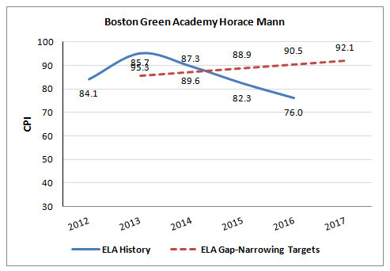
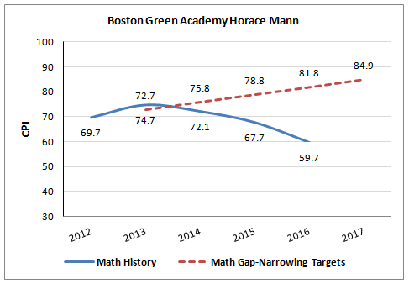
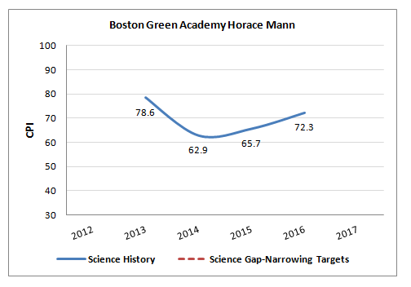

MCAS Results (Grade 10: ELA, mathematics and science and technology/engineering):
The school’s grade 10 CPIs for 2016 were 92.2 for ELA, 83.2 for mathematics and 72.3 for science and technology/engineering. The grade 10 CPIs increased from 2015, with a 1.7 point increase in ELA, a 5.2 point increase in mathematics, and a 6.6 point increase in science and technology/engineering. In 2016, 80 percent of BGA grade 10 students scored in the Proficient and Advanced categories on the ELA assessment. In mathematics, 58 percent scored Proficient and Advanced. In science and technology/engineering, 36 percent scored Proficient and Advanced. The school’s grade 10 MCAS SGPs for 2016 were 37.0 in ELA and 27.5 in mathematics, both below the state median of 50.0.
The school’s historical SGP data for the 10th grade MCAS is below.
BGA Median Student Growth Percentile for 10th graders
Year | 2012 | 2013 | 2014 | 2015 | 2016
English Language Arts | 27.0 | 60.0 | 37.5 | 43.5 | 37.0
Mathematics | 27.0 | 31.0 | 26.0 | 36.5 | 27.5

PARCC Results (Grades 6 and 7, ELA and mathematics):
PARCC scores are designated by Levels, with Levels 4 and 5 meeting and exceeding expectations respectively. In 2016, 31 percent of grades 6 and 7 BGA students received a Level 4 or 5 in ELA. Fourteen percent of grades 6 and 7 students received a Level 4 or 5 in mathematics. The transitional CPI was generated using linked PARCC and MCAS scores; the school’s transitional CPI for 2016 was 68.4 in ELA and 48.4 in mathematics. The transitional SGP was generated using current PARCC and prior MCAS scores; the school’s transitional SGP for 2016 was 34.0 in ELA and 24.0 in mathematics. In 2015, for grade 6, the school’s transitional SGP was 35.0 in ELA and 25.0 in mathematics.

Criterion 6: Program Delivery
The school delivers a high quality academic program that meets the academic needs of all students.

Key Indicator 6.2: Instruction
The school staff has a common understanding of high-quality instruction. Instructional practices are aligned to this common understanding. Instructional practices are based on high expectations for all students. Instruction fosters student engagement. Classroom environments are conducive to learning. | ● Partially Meets
Finding: School staff reported a common understanding of classroom routines and pedagogy, with an instructional focus on depth of knowledge and evidence based argumentation. Visitors observed these common practices in a majority of classrooms. However, the instructional practices as implemented did not reflect high expectations for students in half of the classrooms observed. Visitors observed inconsistency in student engagement and classroom environments.
School staff share a common understanding of the instructional expectations at the school. The headmaster and teachers reported that the focus of this school year is on increasing rigor and incorporating more student-centered work through promoting more higher order thinking work (strategic thinking or extended thinking) through Levels 3 and 4 in Norman Webb’s Depth of Knowledge (DOK). Similarly, the school is continuing in its third year of the use of Evidence-Based Argumentation (EBA), an instructional tool developed by the Boston Debate League with Boston Public Schools to focus on claims, evidence, and reasoning. In addition to these pedagogical practices, the headmaster described a number of common classroom routines such as both welcoming students and having exit tickets or other assessments at the end of class, a common blackboard configuration, weekly learning calendars, checks for understanding, middle school specific routines, and specific cultural norms such as no hats or cell phones. Teachers echoed this description of instructional practices at the school. Visitors observed these practices, or evidence that teachers were working to implement these practices in the majority of classrooms (28 of 39).

Classroom Routines

Welcomes and Exit Tickets - Visitors observed teachers welcoming students or administering exit tickets in 9 of the 16 classes where the beginning or end of the lesson was observed. Visitors noted that there was evidence that welcome or exit was planned through collected lesson plans in the majority of other classrooms.

Common Blackboard Configuration - Visitors observed a common blackboard configuration in 37 of the 39 observed classrooms. The blackboard configuration consisted of the objective for the lesson, a do now, an agenda and homework assignments. These elements were echoed in the collected lesson plans.

Weekly Learning Calendars - Visitors were provided with weekly learning calendars in 28 of the 39 classrooms, but noted that earlier visitors might have taken copies from some of the classrooms. The weekly learning calendars consist of the objectives, do nows, agendas, and homework assignments for the week, along with the standards addressed in each day’s lesson plan.

Checks for Understanding - The headmaster reported that visitors should see a variety of checks for understanding and that the school does not require a standard check for understanding. He described the implementation of this practice as a work in progress. Visitors observed checks for understanding in 25 of the 39 classrooms. Visitors observed that the most common check for understanding was teachers circulating, but also observed exit tickets, and instances of cold calling and conferencing.

Middle School Specific Routines - The headmaster reported that these are largely routines related to the trauma-sensitivity aspect of the mission and to classroom management. These include a “Green” square for student breaks, “Green” tickets for positive behavior, a time out zone, the use of SLANT (sit up, lean forward, ask and answer questions, nod your head, track the speaker). Visitors observed examples of the use of these techniques in 5 of the 15 middle school classrooms observed, although noted evidence of structures in place to implement these routines in other classrooms (such as designated break zones).

Curriculum and Pedagogy
Webb’s Depth of Knowledge (DOK) - Visitors found evidence of activities or questions reflecting the DOK on all of the collected lesson plans and noted posters of the DOK on classroom walls around the school. Visitors observed teachers implementing or attempting to implement the DOK aspects of the lesson in 26 of 39 classes. Examples of DOK tasks seen in lesson plans and in classrooms included a graphing activity requiring students to generate and use evidence to generalize a conjecture and to critique mathematical arguments, students using their knowledge of macromolecules to construct a scientific argument; students developing a logical argument for the best set of laws for a country, and students making comparisons within and across data sets.

Evidence-Based Argumentation – Visitors observed EBA techniques in 17 of 39 classrooms, aligning to the head of school’s description that this is not a daily expectation for each classroom. During lessons where EBA was observed, visitors saw students being asked to make claims or counter claims and draw from evidence to support their answers. For example, one lesson required students to make a claim about the environmental impact of coal based on evidence, and another required students to make claims about molecules based on a previously conducted experiment.

High Expectations

Instructional practices reflected high expectations for students in half of the classrooms observed (19 of 39). In rooms where the instructional practices reflected high expectations for students, teachers were communicating specific standards for student work such as requiring full sentence answers, comprehensive products, or the use of academic language. Teachers modeled and reinforced ways for students to approach the material and responded to student inquiries. In these rooms, the teachers adhered to the DOK aspects of the lesson and required students to use EBA to support their answers to the DOK questions or to make their claims about the DOK tasks. In the other half of classrooms, visitors observed: teachers accepting one word answers, answering their own questions, not requiring academic language in student products, accepting short student products, providing unclear or multi-step directions, or noted students not being redirected after not starting or continuing a task.

Student Engagement

Visitors observed that instruction fostered student engagement in over half of classrooms (22 of 39): In 4 classrooms, less than 25 percent of students were observed to be on task; in 7 classrooms 25 to 50 percent of students were observed to be on task; in 6 classrooms 50 to 75 percent of students were observed to be on task; and in 22 classrooms 75 to 100 percent of students were observed to be on task. Observed techniques observed that fostered engagement included: group work, multi-modal projects, problem solving, stations, the incorporation of real life experiences, experimentation, personal connections and jokes to draw in students. In classrooms where student engagement was low, visitors observed students who were slow to start tasks or not working, students having side conversations, students not following teachers’ directions, and teachers not reinforcing expectations.

Classroom Environments

Visitors found that classroom environments were conducive to learning in 25 of 39 observations. In those classroom environments that were conducive to learning, visitors observed respectful interactions between students and teachers, well-organized classrooms and safe classroom environments and posted BGA safety guidelines and expectations. In other classrooms, visitors observed a casual environment where students were off-task, swearing was unaddressed, students were play fighting, or where teachers attempted routines but students did not follow them. Visitors noted that learning time was maximized for students in only 12 of the 39 observations with do nows taking over 15 minutes, slow transitions, students being off task, and a lack of a sense of urgency on the part of teachers.

Key Indicator 6.3: Assessment and Program Evaluation
The school uses qualitative and quantitative data to improve student outcomes as well as to evaluate the quality and effectiveness of the program in serving all students and modifies the program accordingly. | ● Partially Meets
Finding: The school collects quantitative and qualitative data and is in the beginning phases of implementing a new data cycle following trainings provided by the new director of teaching and learning. The school uses data to organize students for interventions and provided some examples of programmatic changes made based on data. The school has not conducted self-evaluations for its special education or English language programming.
The school collects quantitative and qualitative data. In addition to PARCC and MCAS data, the school administers mock MCAS assessments as formative assessments in ELA and mathematics in all relevant grades. A description of the data cycle provided in the staff handbook stated that these formative assessments are given four times per year. This year the school began administering the STAR 360 in grades 6 and 9 in reading and mathematics in place of the Gates-MacGinitie assessment. As of the visit, the school had administered the assessment for the first time, but had not yet analyzed the resulting data. Administrators reported that the STAR 360 would be administered three to four times per year. The school also uses Achieve 3000 for reading and writing. The school reviews student exhibitions using rubrics and teachers reported that rubrics are used for other student work as well. Teachers reported that they also collect data through do nows, exit tickets, and other in class assessments. The school collects grades through the new Jupiter online platform, and attendance and behavior data through ASPEN. The school also administers annual staff and parent surveys.

The headmaster reported that data analysis has been an area of growth for the school in the past. Administrators reported that the new director of teaching and learning is working to formalize the use of data and has provided training on data cycles. The staff handbook notes that teachers are expected to review the results of the mock MCAS and make adjustments to their instruction based on the data which will be available online and discussed in content teams, grade level team, and at the instructional leadership team (ILT); however teachers did not report on the mock MCAS. Administrators and teachers reported that they plan to use the STAR data to provide interventions to students. Currently, the school is using student assessment data from last year, including Achieve 3000 and teacher’s observations of students to form intervention groups. The middle school has a daily intervention block in mathematics and ELA and power learning blocks.

Administrators reported that the school developed an action plan based on data following renewal in 2016 and hired the new director of teaching and learning to emphasize instructional oversight. Administrators reported that data reflected that students did not have the stamina to work on the open ended portions of the MCAS and as a result the school did a data deep dive this summer about students not finishing the test. To foster reading stamina, the school has instituted a “strive for 25” program where students read 25 books a year in order to increase their reading ability. Administrators and teachers reported that the push to use Webb’s Depth of Knowledge (see Key Indicator: Instruction) was based on the results of student achievement data and past site visit reports. The school also brought in the tutoring program Tutors for All and a math coach based on math data.

The school does not use the results of a data-based program of self-evaluation to inform the special education and English learner programs to improve instructional strategies and ensure that the needs of students are met. Administrators reported that for special education students they review how many students are graduating and meeting their goals, but did not report that the school had conducted formal program self-evaluations. Similarly, for the EL program, administrators reported that they review ACCESS data, teacher created assessments and MCAS data, and will use STAR 360 data in middle school, but did not describe a formal program self-evaluation process.

Key Indicator 6.4: Supports for Diverse Learners
The school has systems to identify students in need of support, and provides supports, interventions, and resources to meet the academic needs for all students, including but not limited students with disabilities and English language learners. | ● Meets 
Finding: The school has a system in place to identify students in need of support. The school provides interventions, supports and resources to diverse learners.
The school has a screening process in place for students in need of additional support. The special education administrator reported that there is a protocol for teachers to follow in order to refer students for support. He reported that he will discuss struggling students with their teachers to see if a student has a suspected disability. A student might then be referred to be discussed at grade level team meetings if there are academic concerns, or referred to the SST if there are social emotional concerns. For academic concerns at the grade level team meetings, teachers will develop strategies that they then employ for four to six weeks before reevaluating. Teachers were unable to corroborate this process due to early departures from the focus group. A student who has not been making progress may be referred for special education testing. The screening process for EL students is conducted by the Boston Public Schools.

The school provides a continuum of services and allows students to change placements as needed. Special education administrators, other administrators and teachers reported, and a review of documentation confirmed, that the school offers full inclusion programming, partial inclusion programming and sub-separate programming, including Learning For Independence (LFI) classrooms. Administrators described the school’s inclusion program as “maximum” inclusion and noted that the push to inclusion was a big change for the school. Administrators reported, and the staff roster reflected, that the school has been pushing to have teachers dual licensed in their content area and special education.

The school provides interventions to meet the academic needs of diverse learners. As noted in Key Indicator: Assessment and Program Evaluation, the school plans to use the STAR data to provide weekly interventions to students but is currently using Achieve 3000 data from the prior school year and teacher’s observations. The school schedule reflected and administrators and teachers reported that the middle school has a daily intervention block in mathematics and ELA and power learning blocks. The school employs online intervention programs during these blocks. The school also enhanced its school wide tutoring program and partners with Tutors for All specifically for math tutoring.

BGA provides school wide supports to students. These include teacher office hours, after school writing workshops, and twice weekly homework club for middle school students. Teachers also offer targeted support once a week during advisory. ELs also have a study hall during the day when they receive extra support. Visitors saw evidence of supports for diverse learners in just over half of the observed classrooms (20 of 39). Observed supports included graphic organizers, visuals, guided notes, group work, laptops and iPads, manipulatives and rubrics. Visitors noted that students were largely working on the same materials. The headmaster reported that the school provides differentiation in procedural ways, for example through the use of extended time, reading to students, or breaks. Visitors did not observe the use of language objectives in classrooms or on lesson plans.

The school provides resources to support diverse learners. According to the staff roster, the school employs 10 paraprofessionals. The school also has a large SST team as described in Criterion 1: Mission and Key Design Elements. There are also interns working at the school in counseling and other areas. The school provides laptops and iPads to students as needed. The school has two ESL teachers, and 11 teachers with dual licensure in ESL and another area, with two more teachers with pending licenses. The school has ten special education teachers and eleven dually licensed teachers with nine more pending.

Organizational Viability

Criterion 8: Capacity
The school sustains a well-functioning organizational structure and creates a professional working climate for all staff.

Key Indicator 8.1: School Leadership
The school has an effective school leadership team that implements a clearly defined mission and set of goals. The school defines and delineates clear roles and responsibilities among leaders, staff, management, and board members. The school has clear and well-understood systems for decision-making and communication processes among all members of the school community. | ● Meets
Finding: School stakeholders reported that they have clear roles and responsibilities, and processes for decision-making and communication appeared to be clear within the school community. The school is increasing its focus on instructional support and supervision this year as a result of student achievement data.
The administrative team currently consists of a headmaster, an assistant headmaster, a director of students support services, a dean of students, a director of green programming, a director of strategic advancement, a coordinator of special education, and a new part-time director of teaching and learning. The organizational chart provided by the school outlines the responsibilities associated with each role and mirrored the responsibilities reported in the administrator focus group. A new part-time director of teaching and learning was hired at the start of the 2016-17 school year to provide instructional support and trainings to bolster the school in this area. Board members reported that while staff had been tasked with providing instructional support in the past, these school leaders found it challenging to provide the instructional support because of other issues that came up on a daily basis.

The school has a number of different structures in place for decision-making and communication according to a document provided to the team, “BGA PD and Meeting Plan 2016-17,” that was referenced in the administrator focus group. Special education and EL administrators described the school as having a shared leadership model. The school’s administrative team meets weekly. The meeting plan reflects that these meetings consist of all of the administrators listed above and focuses on day to day management for the school and continuous improvements. The leadership team, which includes all grade level facilitators, the headmaster, assistant headmasters, the director of student support and others as identified, meets weekly to make policy decisions about the community, discuss operations, and to advise the headmaster. The meeting plan also states that grade level teams meet twice per week with the goal to discuss individual students’ progress and grade level cultural meetings where advisory, exhibitions and activities are discussed. Grade level facilitators lead these meetings and are able to disseminate information from the leadership team. The school has an instructional leadership team that meets weekly and is led by the director of teaching and learning with the purpose of supporting staff development and instructional improvement. The instructional leadership team includes content team facilitators, administrators, and other teachers as identified. The school has content team meetings weekly to focus on strengthening teaching and learning which are lead by the content team facilitators. In addition to these meetings, the document reflected that the school offered summer professional development, and weekly professional development. The grade level team and content team structures and professional development opportunities were confirmed by teachers.

Additionally, the school has a supervision and evaluation team lead by the director of teaching and learning that meets weekly to discuss and improve the supervision and evaluation process. Currently there are four supervisors that evaluate teachers: the headmaster, assistant headmaster, director of teaching and learning and the coordinator of special education. The “Update on BGA Progress for DESE” document states that the group has a goal to increase classroom visits and to provide timely feedback. Administrators reported that they are observing teachers at least once a month, although the site visit team was unable to have teachers corroborate the frequency of observations.

Administrators and teachers reported, and documentation reflected, that the leadership team communicated the two goals for this year are to expand and sustain a strong school culture and to improve student outcomes in ELA, mathematics, and science. Following the visit, the team was provided with an action plan that outlines objectives, deliverables, and key performance indicators for each of these goals. The action plan also indicates the lead or leads for each indicator. The action plan was written in reaction to the most recent student achievement scores.

During the summer, the instructional leadership team developed the school’s instructional focus on Webb’s Depth of Knowledge and EBA and communicated those areas to the school community. As noted above, the new director of teaching and learning position was developed as a result of a desire for more focus on instructional support and professional development at the school. The school also hired a math coach to provide further support.

Criterion 9: Governance
Members of the board of trustees act as public agents authorized by the state and provide competent and appropriate governance to ensure the success and sustainability of the school. | ● Partially Meets
Finding: Board documentation and the board focus group reflected that the board continues to have issues with its adherence to Open Meeting Law and has recently had attendance issues with over a third of its members. The board understands its role and provides oversight in the areas of finance and governance, but continues to have limited engagement with student assessment data despite the probationary academic condition on the school’s charter. The board has engaged in some planning to ensure the success and sustainability of the school.
The board reported that they currently have fourteen members, with two currently pending Departmental approval. Board minutes reflected that the board has recently struggled with board attendance, with five of the board’s fourteen members missing five to six of the meetings between February and August of 2016. Board minutes from August of 2016 reflect a discussion of how to reengage board members and board members reported that the board chair has had targeted conversations with the inactive members and that they are in the process of recruiting new members. The board focus group consisted of five board members and one former member who had recently stepped off the board. An additional member noted that she is stepping down from the board due to her recent inability to attend meetings. The board noted that one of the pending members is a parent as they do not currently have a parent on the board per their bylaws.

Because compliance issues, in part, led the school to be placed on probationary status in 2014, the board has received training on Open Meeting Law and has worked to ensure that it is following the law, including adding a board member with legal experience to provide oversight in this area. However, board minutes from August of 2016 reflect that the board voted to go into executive session without a quorum. Subsequent discussions with the headmaster indicated that the executive session was held to discuss the then embargoed state assessment data. The school was referred to the Massachusetts’ Attorney General’s office to seek future guidance in this area.

Board members reported that they currently have four committees: finance, headmaster support and evaluation, the advancement council which focuses on fundraising and development, and governance. The headmaster support and evaluation committee was described as an ad- hoc committee. As noted in the 2016 Summary of Review, the school board had not been recording committee meeting minutes. For the Year 6 visit, the visiting team was provided with committee minutes for the governance and finance committees; however, as noted in the BGA Governance minutes from December 20th, 2015, the “governance committee of the BGA is not a committee per se, rather an individual tasked with updating and monitoring the Board requirements, as set by the Massachusetts Department of Elementary and Secondary Education.” As such, the governance committee minutes provided were a record of governance activities over the span of several months, not recorded minutes with dates and times noted. Finance committee minutes, though brief, were more traditional, but reflected that most meetings are attended by the headmaster and the board treasurer and there does not otherwise appear to be consistent committee membership. The team did not receive committee minutes for the headmaster support and evaluation committee.

The board receives updates via reports from the headmaster at every board meeting. The board has also received updates and presentations from faculty, and has a teacher representative as a member. Despite the school’s probationary status and low student achievement scores, board members reported and board minutes reflected limited discussions about academic data. The headmaster reports at times reflected data updates, but board minutes did not reflect any related discussion around them. As noted above, the board discussed MCAS and PARCC data during an executive session outside of Open Meeting Law. The board reported that members were presented with the school’s action plan to improve student achievement as a result of the data. Board members reported, and minutes reflect that they discussed qualitative data such as student discipline, enrollment, attendance, and survey data. Board minutes do reflect the board providing oversight in other areas such as finance, including a discussion of the school’s audit, and policy. The board reported that they focus on the governance of the school and trust the school leadership with the day-to-day management.

The board evaluates the headmaster through the headmaster support and evaluation committee. The board reported that the evaluation process is the same one used by BPS for principals. The board works to set goals with the headmaster, including goals around student growth, and then has observed the headmaster, reviewed headmaster reports, and this year administered faculty and family surveys. Board minutes reflect, and board members reported, that they planned to give the headmaster an overall rating of “exceeds” in 2015-16, but the headmaster declined due to the probationary status of the school and student achievement data. As a result, the board gave the headmaster a “proficient” rating.

The board engages in some strategic planning related to the school’s mission. As noted in Criterion 1: Mission and Key Design Elements, the board did not report on the aspect of the school’s mission related to college and career preparatory focus. The board referenced a strategic plan, but noted that they have to review it to see what parts of the plan they want to focus on. The board reported that they are still moving away from operating from a reactive state based on the early performance of the school. The board holds an annual retreat and has conducted board self-evaluations, leading to recruitment of new board members in the areas of legal expertise and the sustainability sector. The board acknowledged that it has not yet done succession planning as it has been focusing on stabilizing the school leadership over the past several years and the desire to maintain the current school leader.

Appendix A: Access and equity
All data displayed in these graphs are derived from ESE District and School Profiles (http://profiles.doe.mass.edu/).
The longitudinal demographic comparison data presented in the graphs of student enrollment is intended to provide context for the charter school’s recruitment and retention efforts. The set of displayed comparison schools includes the charter school of interest, and all of the public schools in the charter school’s region that serve at least one grade level of students which overlaps with the grade levels served by the charter school. The graphs provide comparison enrollment percentages for four different subgroups of students: low income /economically disadvantaged*, students with disabilities, English language learners, and first language not English. Each line on the graph represents the percentage of total school enrollment for a given school or set of schools during the most recent five years. If available, data listed is displayed longitudinally across multiple years in line graph form, with:
- a solid bold black line representing subgroup enrollment in the charter school of interest;
- a solid green line for the statewide average;
- a solid blue line for the comparison district average;
- a dotted orange line for the median enrollment percentage of all comparison schools;
- a dotted dark orange line for the first quartile enrollment percentage of all comparison schools;
- a dotted red line for the comparison index;
- a dotted pink line for the Gap Narrowing Target (GNT); and
- solid gray lines for enrollment percentage in each individual comparison school (darker gray for charter schools, and lighter gray for district schools).
Student attrition rates are provided for all students and for the high needs subgroup. Please note that district percentages are not included since attrition at the district-level cannot be reasonably compared to attrition at the school-level.

Note: New statutory provisions related to Criterion 2 were established in 2010, and as specified in regulation, charter schools were first required to implement recruitment and retention plans in 2011-2012. Charter schools are required to receive Department approval for a recruitment and retention plan to be reported on and updated annually. When deciding on charter renewal, the Commissioner and the Board must consider the extent to which the school has followed its recruitment and retention plan by using deliberate, specific strategies to recruit and retain students in targeted subgroups, whether the school has enhanced its plan as necessary, and the annual attrition of students.

Though comparisons of subgroup enrollment data in a charter school to that of other public schools in a geographic area as provided in Appendix B can provide some information regarding comparability of student populations, it is presented for reference only and primarily to determine trends within the charter school itself and to guide further inquiry. The subgroup composition of a charter school is not required to be a mirror image of the schools in its sending districts and region. The Department urges caution in drawing any conclusions regarding comparability of subgroup populations between schools and districts based on aggregate statistics alone. Enrollment of students in traditional public schools differs significantly from enrollment of students in charter schools. In particular, charter schools are required by law to use a lottery process when admitting students; traditional public schools must accept all students that live within the municipality or region that they serve. Specific caution should be used for special education enrollment data, as research by Dr. Thomas Hehir (Harvard Graduate School of Education) and Associates (Review of Special Education in the Commonwealth of Massachusetts: A Synthesis Report (August 2014) found that low-income students were identified as eligible for special education services at substantially higher rates than non-low-income students. Further, across districts with similar demographic characteristics, district behavior differed for special education identification, placement, and performance. Finally, it is important to note that student demographics for a charter school, particularly in the aggregate, will not immediately reflect recruitment and retention efforts; charter school must give preference in enrollment to siblings of currently attending students and are permitted to limit the grades in which students may enter the school.
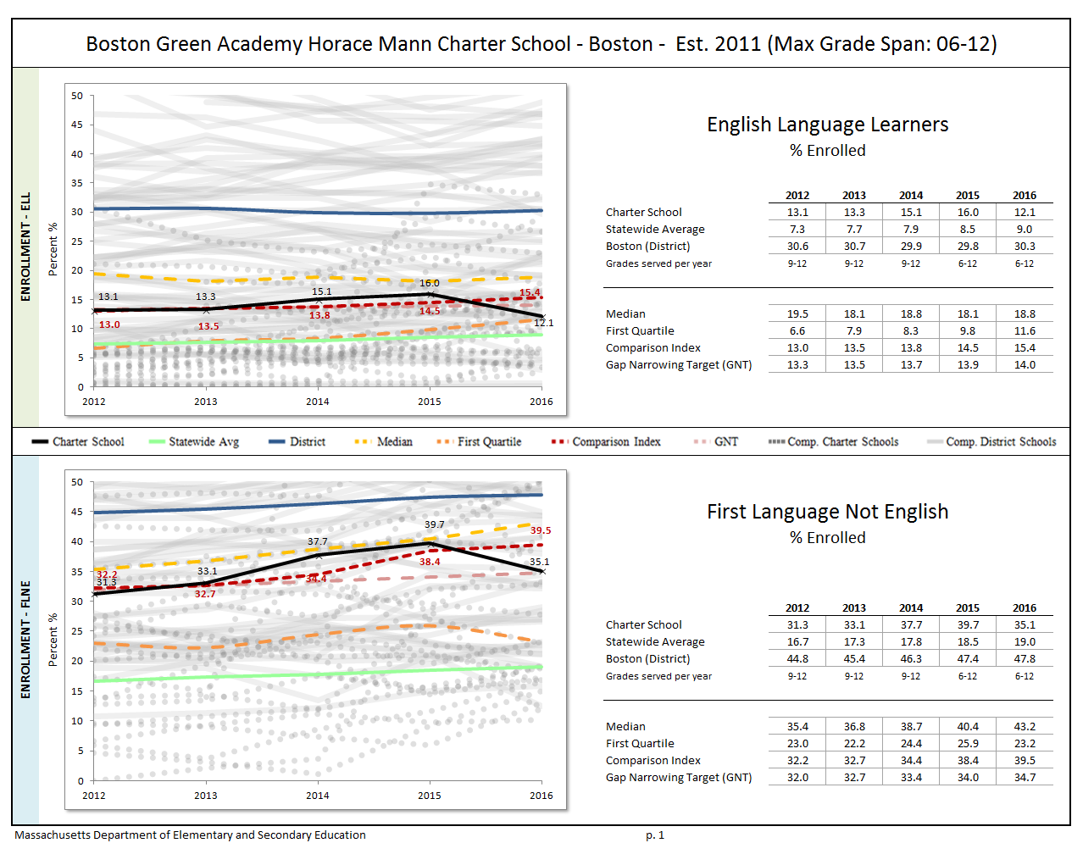
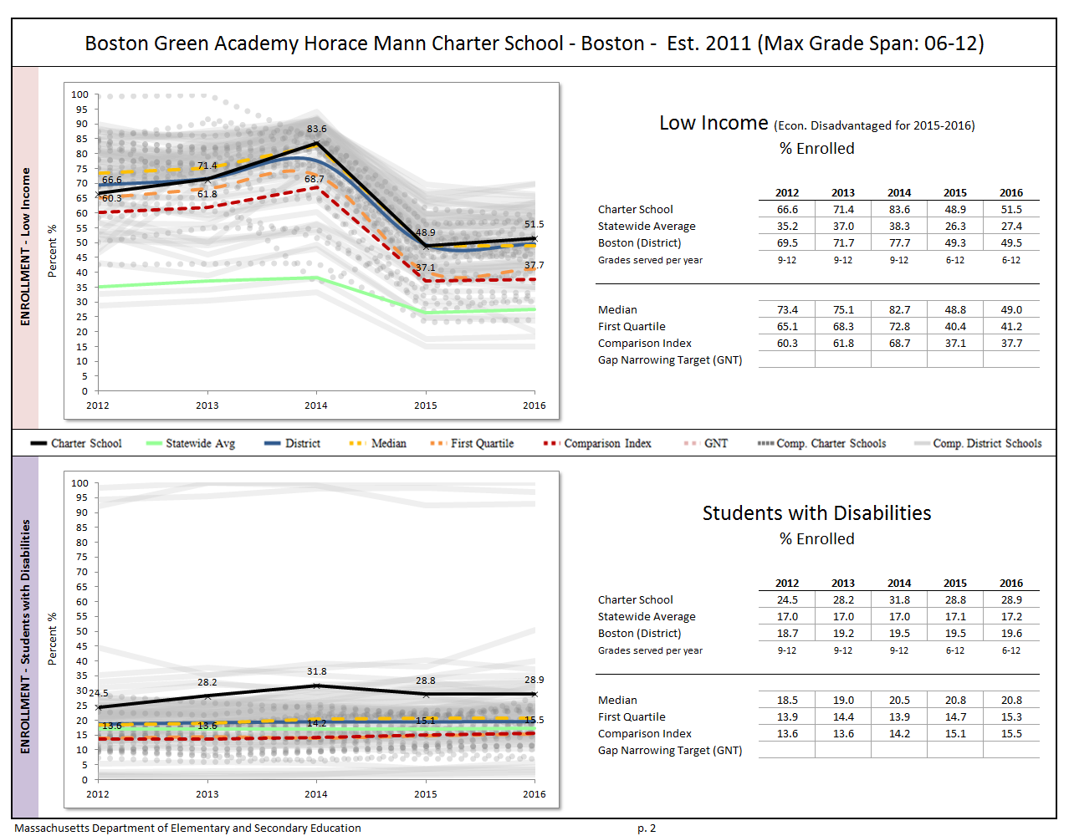
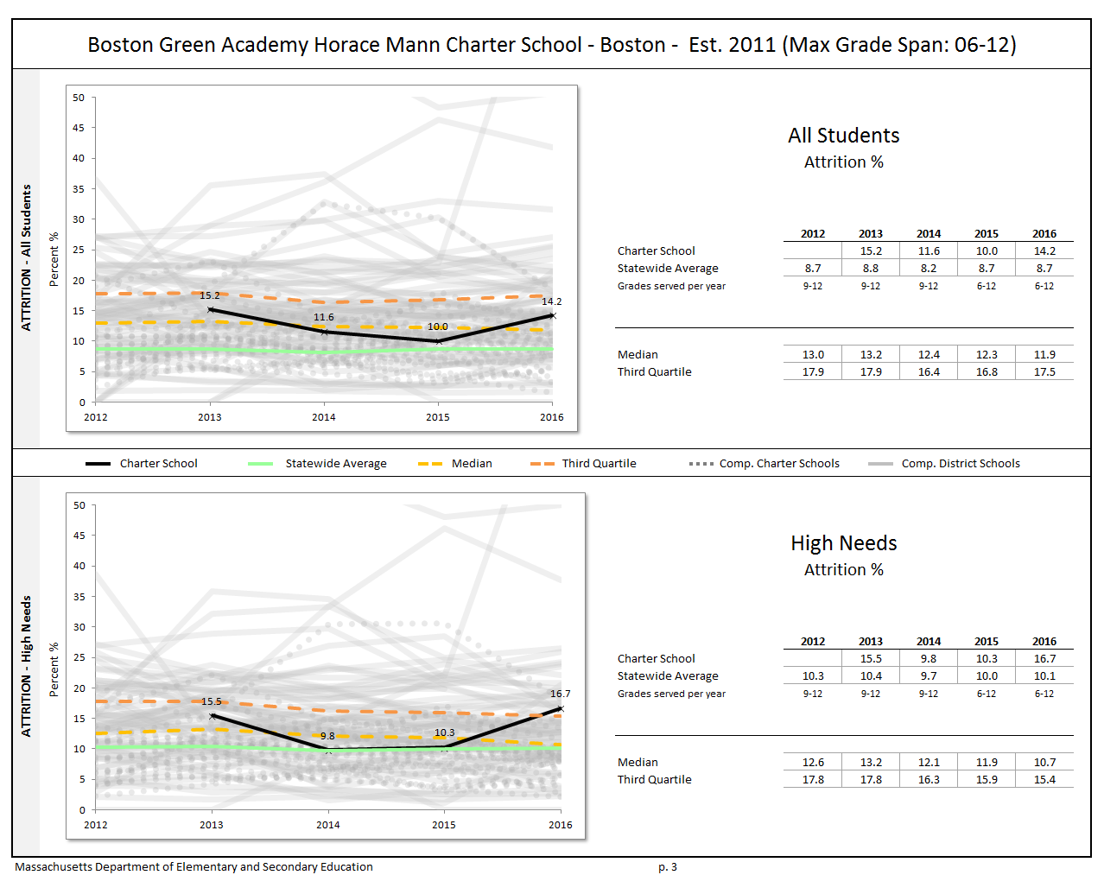

Appendix B: Student Performance

The charter accountability table (below) provides several sets of data relative to charter school performance on statewide assessments as well as student indicators. The percent of students scoring proficient or advanced (P/A), the composite performance index (CPI), the percent of students scoring warning or failing (W/F), and the student growth percentile (SGP) are all displayed in the aggregate over the term of the charter. For schools participating in PARCC in 2015, the percent of students who met or exceeded expectations (Level 4 and 5) and those who did not meet expectations (Level 1) are displayed. Because these are not exact equivalents to MCAS proficient/advanced or warning/failing, these figures are not included in the graph. A Transitional Composite Performance Index (Trans. CPI) and Transitional Student Growth Percentile (Trans. SGP) generated using current PARCC and prior MCAS scores are displayed as equivalents to MCAS CPI and SGP. These figures are included in the graphs. The school’s accountability level, percentile, English Language Arts (ELA) and math percentiles for the aggregate and targeted subgroups, and cumulative progress and performance index (PPI) for the aggregate and targeted subgroups are shown if available (this depends on the size and the age of the school). When applicable, the 4-year and 5-year graduation rates as well as the annual dropout rate are also provided for the available years of the charter term. For detailed definitions of accountability terms, please visit this URL: http://profiles.doe.mass.edu/accountability/report/aboutdata.aspx#AccountabilityInformation.

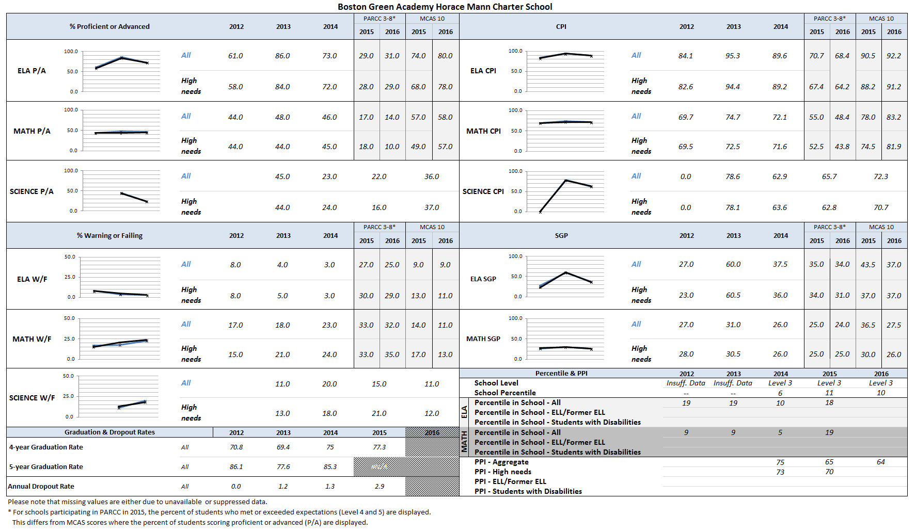
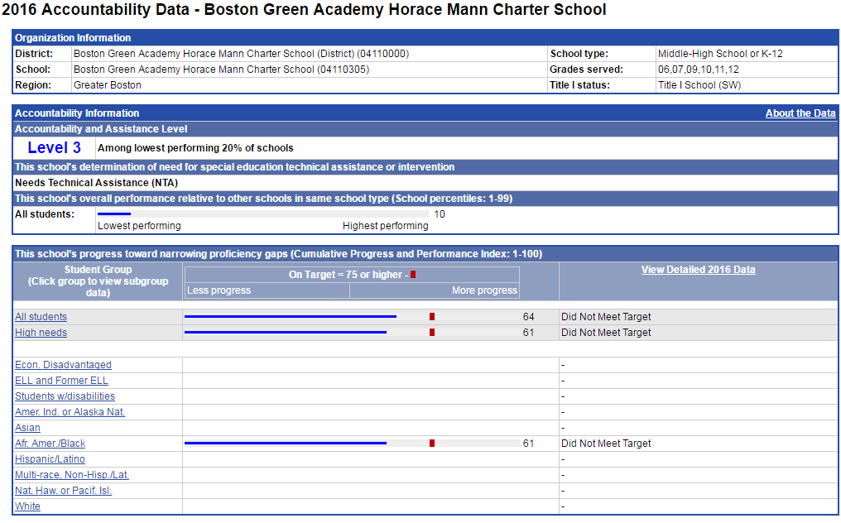
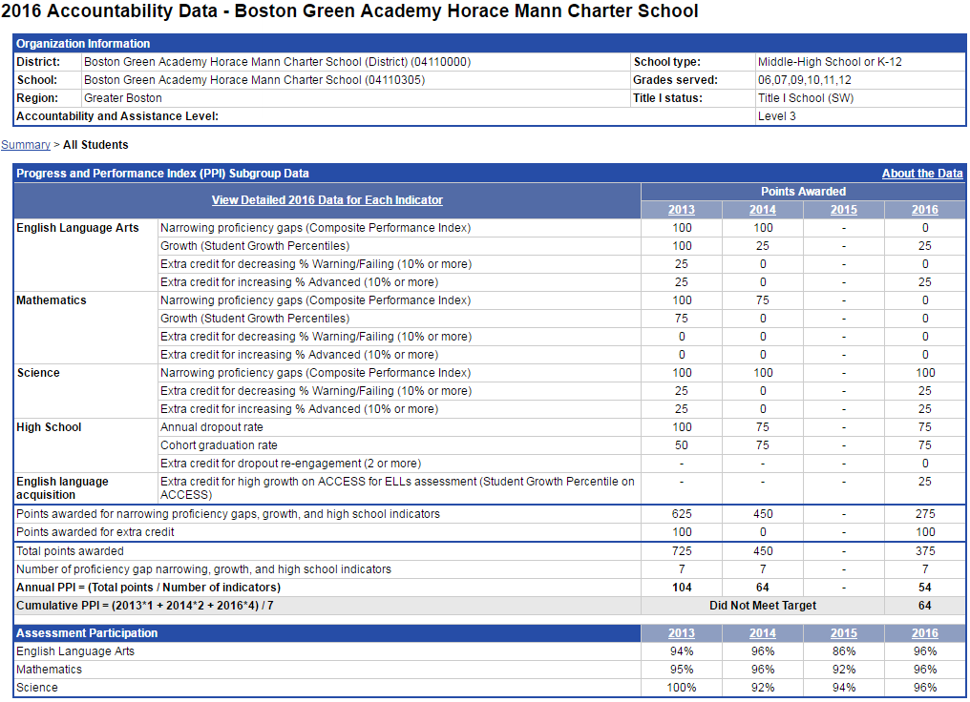
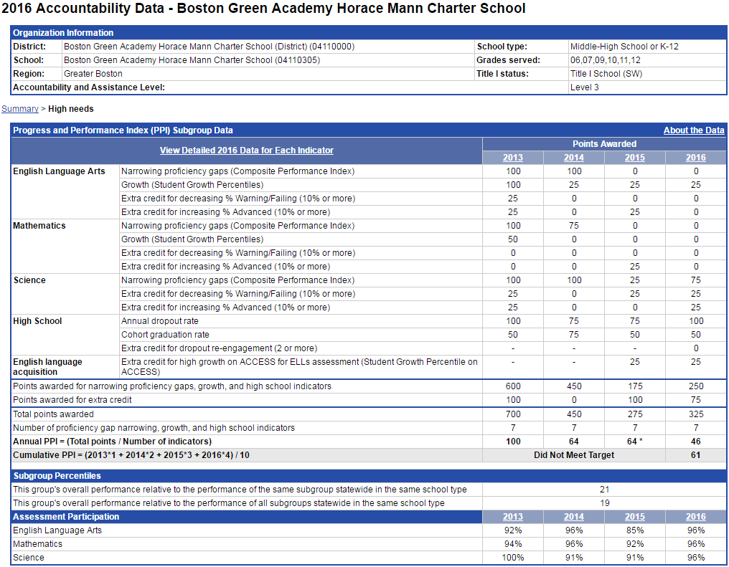

Appendix C: Finance
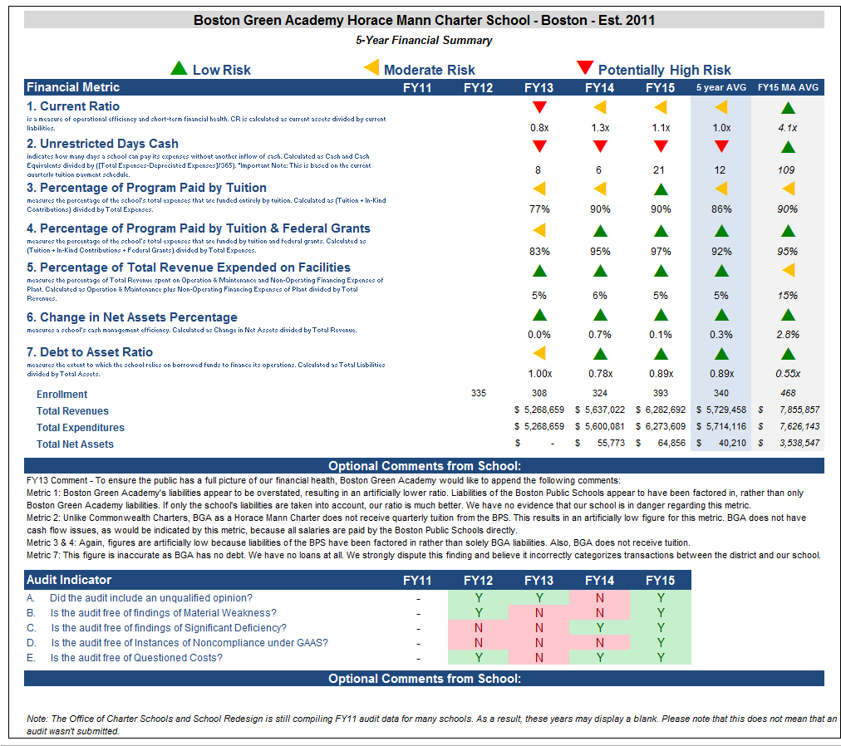

Financial Metric Definitions |  | Low Risk | Moderate Risk | Potentially High Risk
1. Current Ratio | Current Ratio is a measure of operational efficiency and short-term financial health. CR is calculated as current assets divided by current liabilities. | >= 1.5 | Between 1.0 (inclusive) and 1.5 | < 1.0
2. Unrestricted Days Cash (Prior to FY14)  Applies to 5-year average | The unrestricted days cash on hand ratio indicates how many days a school can pay its expenses without another inflow of cash. Calculated as Cash and Cash Equivalents divided by ([Total Expenses-Depreciated Expenses])/365).  Note: This is based on quarterly tuition payment schedule. | >= 75 days | Between 45 (inclusive) and 75 days | < 45 days
2. Unrestricted Days Cash (FY14 forward) | 4th quarterly tuition payments to Commonwealth charter schools in FY14 were made after June 30, 2014, which resulted in lower-than-typical cash at fiscal year end, affecting the risk levels for the current ratio and unrestricted days cash indicators for FY14 on a one-time basis. Payments for FY15 and after are made on a monthly basis, and parameters for risk have been adjusted accordingly. | >= 60 days | Between 30 (inclusive) and 60 days | < 30 days
3. Percentage of Program Paid by Tuition | This measures the percentage of the schools total expenses that are funded entirely by tuition. Calculated as (Tuition + In-Kind Contributions) divided by Total Expenses (expressed as a percentage). Note: In-Kind Contribution are added to the numerator in this ratio to balance out In-Kind Expenditures which will be captured in the Total Expenses in the denominator, and ratios over 100% are set to 100%. | >= 90% | Between 75% (inclusive) and 90% | < 75%
4. Percentage of Program Paid by Tuition & Federal Grants | This measures the percentage of the schools total expenses that are funded by tuition and federal grants. Calculated as (Tuition + In-Kind Contributions + Federal Grants) divided by Total Expenses (expressed as a percentage). Note: In-Kind Contribution are added to the numerator in this ratio to balance out In-Kind Expenditures which will be captured in the Total Expenses in the denominator, and ratios over 100% are set to 100%. | >= 90% | Between 75% (inclusive) and 90% | < 75%
5. Percentage of Total Revenue Expended on Facilities | This measures the percentage of Total Revenue that is spent on Operation & Maintenance and Non-Operating Financing Expenses of Plant. Calculated as Operation & Maintenance plus Non-Operating Financing Expenses of Plant divided by Total Revenues (expressed as a percentage). | <= 15% | Between 15% and 30% (inclusive) | > 30%
6. Change in Net Assets Percentage | This measures a school's cash management efficiency. Calculated as Change in Net Assets divided by Total Revenue (Expressed as a percentage). | Positive % | Between -2% (inclusive) and 0% | < -2%
7. Debt to Asset Ratio | Measures the extent to which the school relies on borrowed funds to finance its operations. Calculated as Total Liabilities divided by Total Assets. | <= .9 | Between .9 and 1 (inclusive) | > 1
FY15 MA AVG Column | All financial metrics indicated in this column are a result of each ratio calculated using statewide totals. For Enrollment, Total Net Assets and Total Expenditures rows, these numbers are averages calculated using the statewide totals of all charter schools’ data.

To: Dr. Mitchell Chester, Commissioner, Department of Elementary and
Secondary Education
From: Matt Holzer, Headmaster, Boston Green Academy Horace Mann Charter School
Re: Response to DESE Year Six Targeted Site Visit Report (November 2016)
Date: December 20, 2016

Introduction
On behalf of the Boston Green Academy Board of Trustees, our staff, and our full community, I am writing to share with you our response to the Year Six Targeted Site Visit Report by the Department from November 2016. I would also like to share our progress towards meeting the conditions of probation originally imposed by the Board of Elementary and Secondary Education in October 2014 and updated in January 2016. BGA has become a much stronger school in the last few years, in part because of the feedback from the Department. We are proud of our progress and are committed to continued improvement.

Background
As you know, Boston Green Academy was unanimously re-chartered with probation conditions by the Board of Elementary and Secondary Education in January 2016. Prior to that we also received a unanimous vote of support from the Boston School Committee in support of our re-chartering application as a Horace Mann Charter School within the Boston Public Schools. Superintendent Dr. Tommy Chang has also expressed his strong support for Boston Green Academy to you and you have been encouraging of us in your public comments about BGA. We appreciate the support and are working hard to build upon our past progress to continue strengthening our school. We are aware of the work we must do and are working hard to accomplish it.

This year’s Site Visit focused on a subset of the Charter School Performance Criteria. We are pleased that BGA was found to meet the criterion in the areas of Mission and Key Design Elements, Support for Diverse Learners, and School Leadership. We would like to provide additional perspective regarding the findings of the Report in the areas of Student Performance, Program Delivery and Governance where BGA was rated ‘partially meets’.

Student Performance
BGA’s High School program continues to improve and succeed relative to the Boston Public Schools on MCAS and has met the requirements of our probation

BGA’s high school and middle school programs are currently at different levels of performance and development. We feel it is important to disaggregate their results and understand them both in context.

BGA’s high school program is in its sixth year of operation. As we detailed in our charter renewal application, BGA successfully turned around a struggling high school (Odyssey HS) and became one of the most improved high schools in the BPS and throughout Massachusetts over the course of our first charter term. This is based on combined CPI increases in ELA and Math from 2011-2016 provided to you last January.

After overcoming most of our organizational growing pains as an organization with the support of the BPS and the Department, BGA’s graduation rate and drop out rate greatly outperform BPS averages (see charts below), and we continue to enroll one of the most diverse populations of any BPS or Charter school in Boston, including above average percentages of Students with Disabilities (29%), high needs (73%), and economically disadvantaged students (52%), all of which exceed BPS and Massachusetts averages (see Department data in the Site Visit Report). This is the population our charter and mission envisioned that we would serve, and we are proud to serve the students in our care.

BGA 4-Year Graduation Rates (Adjusted) 2011-2016
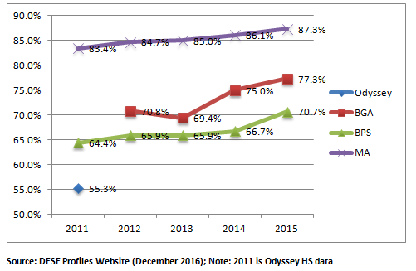

BGA 5-Year Graduation Rates (Adjusted) 2011-2016 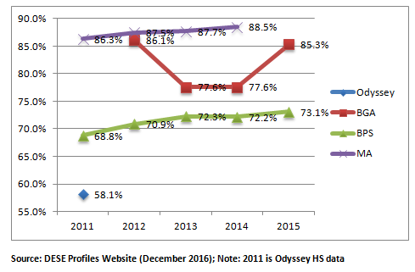

BGA’s probation required our school to demonstrate improvement in ELA, Math and Science in 2016. Our Spring 2016 MCAS scores successfully demonstrated this in all three areas based on CPI. See chart below.

BGA 10th Grade ELA and Math CPI 2012-2016 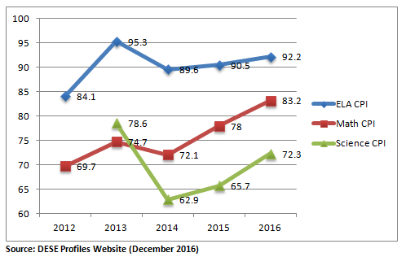
Based on 2016 CPI, BGA’s 10th grade now outperforms the majority of BPS high schools and is among the top performing non-selective admission high schools in the district.

2016 10th Grade CPI Data | ELA CPI | Math CPI | Combined Math and ELA CPI | Admissions | DESE Level
Boston Latin School | 100 | 99.9 | 199.9 | Screened | 2
Boston Latin Academy | 100 | 99.6 | 199.6 | Screened | 2
O'Bryant | 99.9 | 99.2 | 199.1 | Screened | 1
New Mission | 99.3 | 94.7 | 194 | Screened | 1
Boston Arts Academy | 99.1 | 91.1 | 190.2 | Screened | 1
Fenway | 97.4 | 91.9 | 189.3 | Screened | 1
Boston International | 96.5 | 91.5 | 188 | Open | 1
Boston Comm. Lead. Academy | 93.9 | 94 | 187.9 | Screened | 2
EMK Health Careers | 97.4 | 83.7 | 181.1 | Open | 2
Another Course to College | 98.2 | 81.3 | 179.5 | Open | 2
Snowden | 94.4 | 85 | 179.4 | Open | 2
Quincy Upper School | 93.1 | 83.8 | 176.9 | Screened | 3
Boston Green Academy | 92.2 | 83.2 | 175.4 | Open | 3
West Roxbury Academy | 91.3 | 82.2 | 173.5 | Open | 3
Charlestown | 90.2 | 82.3 | 172.5 | Open | 3
Burke | 89.9 | 82.6 | 172.5 | Open | 3
TechBoston | 92.8 | 78.5 | 171.3 | Open | 2
Mary Lyon | 95.2 | 75.8 | 171 | Open | 3
East Boston | 91 | 76.8 | 167.8 | Open | 3
Muniz | 90.8 | 76.1 | 166.9 | Open | 3
Urban Science Academy | 91.6 | 74.7 | 166.3 | Open | 3
Excel | 88.1 | 76.7 | 164.8 | Open | 4
Henderson | 90.6 | 72.7 | 163.3 | Open | 3
Dearborn | 90.7 | 67.9 | 158.6 | Open | 4
Comm. Acad. of Sci. and Health | 89 | 69.5 | 158.5 | Open | 3
Brighton | 85.2 | 67.3 | 152.5 | Open | 4
Madison Park | 86.2 | 62.3 | 148.5 | Open | 4
Source: DESE Profiles Website (December 2016)

BGA is committed to continued improvement of academic performance in ELA, Math and Science and our current achievement levels, while stronger, are not sufficient to meet our mission’s goal of preparing all students for college and career. The major academic issue for BGA’s high school is Student Growth Percentile (SGP), which has been below average in ELA and Math for several years, especially in Math. We are very aware of this issue and have made numerous changes and investments that we believe will improve SGP and CPI. These include repositioning personnel, investing in new Common Core/MCF-aligned curriculum, extended professional development for teachers to increase rigor and engagement, purchase and use of a new formative assessment system, and targeted tutoring and interventions for struggling students. We believe the conditions are right for continued improvement in our high school program and will continue with a sense of urgency to respond to the feedback from the Department, BPS, and our own internal observations about this core aspect of our school.

BGA’s Middle School program is young and developing, has struggled on the PARCC exams in its first two years, and is the focus of our efforts to improve achievement

BGA’s middle school program, established in 2014, is now in its third year of operation and has two years of student achievement data. While BGA was supposed to open with a 6th grade in 2011, our middle grades program was delayed at the request of the Boston Public Schools due to facilities issues and the need to turn around Odyssey High School first. Once the school moved to Brighton, the 6th grade opened in 2014-15, followed by the 7th grade in 2015-16. Facilities issues were present in both of those school years that challenged the program. The current school year 2016-17 is the first with all grades 6-12 and the first with a stable and adequate facility.

As envisioned by our charter, BGA’s middle school program enrolls a diverse and high needs population, mirroring the composition of our high school grades. Students entered BGA’s 6th grade from over 30 elementary schools across Boston and arrive, on average, 2-3 years below grade level in terms of ELA and Math skills. This is the demographic we seek to serve and it is consistent with our charter, mission and vision to serve students as early as possible so as to disrupt the ‘drop out pipeline’ and alter the trajectory of at-risk students.

While there has been growth and improvement in terms of student achievement and school culture, BGA students did not perform as well as we had hoped on the PARCC exams. In 2015-16, both the 6th and 7th grade performed below BPS averages on ELA and Math (state averages were not released). Student Growth Percentile (SGP) was also well below the expected median of 50. BGA is very aware of these issues and shares the concerns of the Department. We have made numerous investments, similar to our high school program, that include staffing changes, the addition of an instructional leader administrative position with middle school experience, additional social emotional supports for struggling students, formative assessments, in-depth professional development to increase rigor and engagement, and new investments in curriculum, technology and interventions. We believe these will better support our students and are working hard to yield improved results.

Overall, we firmly believe that our middle grades program will result in better-prepared high school students who can in turn graduate more prepared and at higher rates than their predecessors who entered BGA in 9th grade. We have already seen that our 8th grade students, who joined us as 6th graders three school years ago, can read, write and compute at much higher levels than our current 9th graders. As a result, we have purchased new texts throughout the high school with higher Lexile levels, plan to expand the number of sections of geometry for 9th graders (most will have passed Algebra I in 8th grade), and purchased new more rigorous science curriculum to support students with higher skills.

Being a 6-12 school is a long-term strategy for improving student achievement. Statewide, CPI is lower in middle grades than in high school, as it is at BGA. Adding middle grades, as we have done, has made our school-wide overall CPI appear to decrease. We think this is an inappropriate conclusion. In fact, our high school has greatly improved while our middle grades have been added and are developing. We understand clearly that the success of our school is directly linked to the success of our middle grades program. However, we do not feel it is appropriate to judge our middle and high school results in aggregate at this time given the differences in the state assessments (PARCC for middle school, MCAS for high school) and the different developmental levels of the two programs.

When BGA’s charter was renewed a year ago, the Board expressed a clear hesitancy to make decisions regarding probation and revocation based solely on PARCC scores, the only data that is available as of yet for our middle grades program. We believe this caution is appropriate. We do not deny or ignore what the achievement data says about what we need to do better and focus upon. We are responding to it, making swift improvements, and looking forward to building a steady track record of academic success across all levels of our school over our second charter term. We believe we have earned more time to continue this important work.

Program Delivery
BGA has responded to feedback and made strong investments in instruction. We have a shared vision but our implementation is still developing

BGA continues to respond to feedback from the Department, BPS and our own community about the level of rigor and engagement in our classrooms. We believe that both are improved from previous years but there is still work to do. Below is a summary of the changes we have made to strengthen these core areas:

- Following last year’s Renewal Site Visit Report, we reorganized our administrative team to add a dedicated Director of Teaching and Learning to strengthen our professional development, observation, feedback and assessment
- We have established a framework for rigor (Webb’s Depth of Knowledge) and identified key strategies to increase the intellectual demand of tasks in our classrooms (Evidence-Based Argumentation, BGA Common Practices, etc.). We have spent over 40 hours of PD this year already on this topic and expect to complete over 80 hours by the end of the school year.
- We revamped our observation and feedback system to provide more frequent support to teachers, as well as targeted coaching in math and for new teachers
- We purchased a new formative assessment system for ELA and Math to be used 3-4 times per year and to be reviewed by our Instructional Leadership Team, grade level teams, administrators and the Board of Trustees
- We purchased new, more rigorous materials for all Humanities/ELA classes (higher Lexile), math (common-core aligned), and science (common-core aligned), aligned the work across grades 6-12, and reviewed its linkage to the Massachusetts Curriculum Frameworks. We also purchased online academic intervention programs for math and ELA

These changes have brought a strong, common vision for teaching and learning to our staff that is in line with our mission and values. We have seen definite improvement in many of our classrooms. However, the Site Visit Team observed several classrooms that did not yet have the high engagement or high expectations that we are working towards. We acknowledge that our implementation of our vision is still developing and is uneven across the school. We appreciate the Report’s confirmation of our progress in this area, but we can also confirm that the picture it paints of our classrooms is mostly accurate. We continue to work with our teachers and students to strengthen our rigor and engagement, especially at the middle school level.

Finally, the Site Visit Report stated that two of the focus groups failed to mention preparation for college and career as part of BGA’s mission. We believe this was an oversight of something that everyone at BGA knows is core to our work, rather than a signal of a lack of belief in this part of our mission. In debriefing with the participants in those groups, they reported making a nervous oversight and wanted to express their strong commitment to all parts of our mission, including college and career preparation. In fact, BGA’s doubling of students admitted to college over the last five years is a fact that is often cited by all staff members as evidence of our progress. We do not believe its omission in the focus groups is a sign of anything more than an oversight, one that we will make sure to rectify in the future.

Governance
BGA’s Board is very aware of its obligations, understands Open Meeting Law, and is in the process of recruiting new members and increasing supervision of academics

BGA’s Board has become much stronger since probation was imposed by the Department and takes its obligations very seriously. The areas of growth for the Board highlighted by the Site Visit Report are ones that the Board has already begun to address. Members with attendance issues are slowly removing themselves from the Board and are being replaced by new and committed recruits who bring new strengths to the group. The Chair of the Board of Trustees has worked hard with members over the last six months to recruit and add new Board members, including three new community members, two teachers and one parent, all of whom replace valued but departing members. This process of transition takes some time, but will ultimately yield a fully committed board for the next charter term. The Board appreciates DESE’s feedback and believes the issues posed by transition will be remedied shortly.

The Board also takes BGA’s probationary status very seriously, has moved forward to increase its supervision of the academic program, and will analyze school data more rigorously and regularly beyond state assessment data. As mentioned in the Site Visit Report, BGA has planned this year to roll out a more robust data platform to gauge student and school-level progress. This work was shared with the Board for its December meeting and will be updated and refined every four 4-6 weeks throughout the rest of the school year. The Board will review this at every meeting as part of the Headmaster Report. The Board has also moved to formed a permanent Academics Committee that will work with the Headmaster, the Instructional Leadership Team, and staff to monitor and support the academic program and review all formative assessment data throughout the rest of the year. This is an important step—one that has been planned for some time and can address immediately the feedback from the Department. We will share evidence of this work through our mandated monthly communication with the Department regarding Board documents.

Finally, regarding the incident described in the Site Visit Report of the Board going into executive session without a quorum, we wish to add important information. As communicated to the Department by the Headmaster when asked about this incident following the meeting, the Board was well aware of the requirements of the Open Meeting Law at the time of the August 30th, 2016 meeting. In fact, because Board members felt so strongly that they needed to discuss embargoed MCAS scores in light of our probationary status, the Board sought counsel prior to the meeting to determine the proper way to do so. Counsel advised the Board that the use of executive session was permissible to discuss embargoed results. The Board then followed the counsel it was given. The Department later suggested that the absence of a quorum made the executive session improper, and that this was a violation of the Open Meeting Law. While we will make sure not to repeat this incident, we strongly believe that it reflects a good faith effort to comply with the law rather than a lack of understanding of its requirements. Given the probationary conditions regarding compliance, the Board has been very focused on all ensuring BGA is current on all aspects of compliance (a fact confirmed by our FY15 and FY16 audits). This incident, we believe, was a complicated outlier, not a pattern or cause for concern. We will continue to monitor our meeting protocols and decisions and will seek counsel and Department guidance as needed.

Conclusion

Boston Green Academy is proud of our growth and progress. We also fully accept the responsibility of improving outcomes for all students. We will continue to endeavor to meet the challenges and commitments inherent in our mission. We appreciate this opportunity to respond to the probation conditions placed upon us and to share additional evidence of our academic improvement. We believe that our school has earned the opportunity to continue our work. If you have any questions, please contact us and we appreciate your continued support.

As of March 15, 2016.
Source: [BGA, October 2016]
The Charter School Performance Criteria v. 3.2 is found at: http://www.doe.mass.edu/charter/acct.html?section=criteria
http://profiles.doe.mass.edu/profiles/student.aspx?orgcode=04110000&orgtypecode=5&
1 The names of each of these schools and additional subgroup detail can be found in the Charter Analysis and Review Tool (CHART), http://www.doe.mass.edu/charter/finance/chart/.
The midpoint value of all comparison schools. This is derived using Microsoft Excel's MEDIAN function.
The first quartile is the middle number between the smallest number and the median of all comparison schools. This is derived using Microsoft Excel's QUARTILE function.
The comparison index provides a comparison figure derived from data of students who reside within the charter school’s sending district(s). The comparison index is a statistically calculated value designed to produce a fairer and more realistic comparison measure that takes into account the charter school’s size and the actual prevalence of student subgroups within only those grade levels in common with the charter school.
The Gap Narrowing Target (GNT) refers to the halfway point between the school’s baseline rate (which is the rate in the 2010-11 school year, or the first year enrollment data is collected if after 2010-11,) and the current Comparison Index (the “target”). The object is to meet this halfway point by the 2016-17 school year (or in a later year if baseline is after 2010-11), giving the school six years to do so. For a school to be on schedule to meet its GNT, an incremental increase must be met annually. To determine this increment, the following equation is used: [(Comparison Index – Baseline) / 2] / 6 years = Annual GNT.
The percentage of attrition, or rate at which enrolled students leave the school between the end of one school year and the beginning of the next.
A student is high needs if he or she is designated as either low income, or ELL, or former ELL, or a student with disabilities. A former ELL student is a student not currently an ELL, but had been at some point in the two previous academic years. * 2014-2015 is the first year for which the category “Economically Disadvantaged” is being reported, replacing the “Low-income,” “Free Lunch” and “Reduced Lunch” categories used in 2013-2014 and earlier. It is important for users of this data to understand that enrollment percentages and achievement data for "economically disadvantaged" students cannot be directly compared to "Low-income" data in prior years. Please see http://www.doe.mass.edu/infoservices/data/ed.html for important information about the new “Economically Disadvantaged” category.

