Massachusetts Department of Elementary and Secondary Education
75 Pleasant Street, Malden, MA 02148-4906
Phone 781-338-3000 TTY: N.E.T. Relay 800-439-2370
www.doe.mass.edu
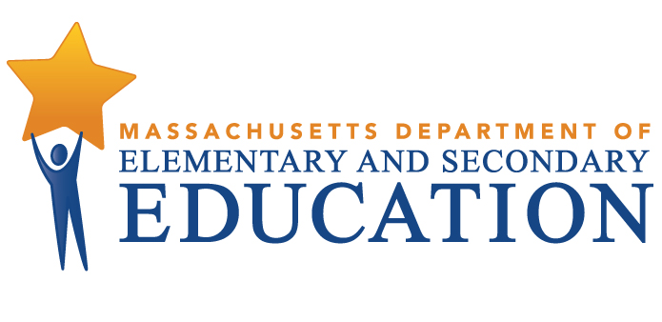

ESE Strategic Plan

Civic Learning and Engagement

Strategic Plan

Center for Instructional Support
March 2017

EXECUTIVE SUMMARY

In 2016, the Massachusetts Department of Elementary and Secondary Education engaged a group of educators, researchers and representatives from non-profit organizations with expertise in civic learning and engagement to make recommendations for a statewide plan to promote education in this area. The strategies outlined in the Department’s Civic Learning and Engagement Strategic Plan are based on the final recommendations determined to be of particular priority by the Civic Learning and Engagement Task Force (Task Force).

The Task Force identified the following areas to improve civic learning and engagement:
- Create policy and broad-based, consistent support
- Create relevant resources
- Align existing resources for civic learning
- Provide professional development for educators
- Develop data and accountability measures to elevate the importance of civic learning and engagement among educators and the general public

The Task Force recommends the following strategies to address the challenges:

Develop a communications strategy about the importance of civic learning and engagement in students’ success

Increase visibility of civic learning and engagement offerings and highlight best practices using data

Strengthen the teaching and learning of civics

In the United States we assume that civic engagement and an understanding of history and the social sciences are as “unalienable” as the rights championed in the Declaration of Independence—life, liberty and the pursuit of happiness. Unfortunately, results from the National Assessment of Educational Progress (NAEP) and research findings, both nationally and in Massachusetts, demonstrate that the foundation of our democracy is in jeopardy.

Substantial numbers of our young people do not hold a fundamental grasp of history and civics. The most recent results from NAEP, last administered in 2014, indicate that a mere 23% of students in the U.S. are proficient or better in their understanding of civics. Similarly, substantial numbers do not fully participate in the civic life of our nation. A high percentage do not vote or engage in such activities as volunteering or working with others to address a community problem. Only about half of the eligible young people—about 24 million youth, ages 18-29, voted in the 2016 general election. National data indicate that only roughly 19% of young adults engage in volunteer activities in their communities.

These findings are even more dramatic among youth from disadvantaged populations. In school, African-American and Hispanic students are twice as likely as their white counterparts to score below proficient on the NAEP civics assessment. A similar civic knowledge gap exists between America’s wealthiest and poorest students. In the community, national survey data show that a majority of non-college youth are disengaged from traditional civic life, with only 13.5 percent of them engaged in forms of conventional civic leadership. Researchers have noted that the “civic empowerment gap” between demographic groups, both in terms of civic learning in school and civic engagement in the community, parallels longstanding gaps in other areas of academic achievement.

Over the past two decades, Massachusetts has established itself as a national and global leader in many areas of education, with students performing at or near the top on both national and international assessments such as NAEP and the Program for International Assessment (PISA). As home to the first public school in the nation, the Commonwealth has a long tradition of providing high quality public education. The Massachusetts Department of Elementary and Secondary Education’s (the Department’s) goal is to ensure that all students have the requisite knowledge, skills, and experiences to effectively participate in a 21st century economy. Yet some policymakers, educators and citizens note that, in addition to the focus on mathematics, English/language arts, and STEM fields (science, technology, engineering and math), it is critically important to focus on developing a well-informed and engaged citizenry. At a time when the world is more interconnected globally, more polarized economically and more stratified politically, the need for increased civic engagement is particularly urgent.

As a leader in many areas of education, the Department believes that the Commonwealth should lead in civic education as well. The Civic Learning and Engagement Strategic Plan that follows is intended to send a powerful signal of the state’s commitment to civic learning as one step in renewing civic life and catalyzing increased civic engagement in our democracy.

In 2016, Massachusetts Commissioner of Elementary and Secondary Education Mitchell Chester established the Civic Learning and Engagement Task Force (Task Force), and charged it with drafting recommendations for a preliminary statewide strategic plan to promote civic learning. The strategic plan, presented here, is intended to describe the Task Force, chronicle its activities, and present a way forward for ensuring that all students have more opportunities to engage in high quality civics education.

The Task Force identified three core strategies:

Develop a communications strategy about the importance of civic learning and engagement in students’ success

Increase visibility of civic learning and engagement offerings and highlight best practices using data

Strengthen the teaching and learning of civics

The Department selected members for the Civic Learning and Engagement Task Force to represent a range of perspectives and backgrounds, including K-12 educators, representatives of state advisory councils, leaders of professional organizations, higher education faculty, and students from across the state. A complete list of Task Force members appears in Appendix A. The Task Force met four times over the course of 2016. See Appendix B for a summary of the main activities of the Task Force. The strategies outlined in the Department’s Civic Learning and Engagement Strategic Plan are based on the final recommendations determined to be of particular priority by the Task Force.

In response to concerns about U.S. citizens’ lagging knowledge of civics, various organizations nationally and in Massachusetts have focused their attention on increasing public schools’ focus on and engagement in civics education. Nationally, the Campaign for the Civic Mission of Schools, a coalition of over sixty organizations, scholars and researchers, published a report in 2011 that highlighted U.S. students’ lack of civic knowledge, low levels of civic engagement and, as noted above, an alarming gap in achievement between demographic groups.

The report, Guardian of Democracy: The Civic Mission of Schools, describes the benefits of civic learning as a critical component of preparing students for citizenship, college and careers, and notes that civic learning is “the tool by which individuals . . . become equipped with the knowledge, skills and dispositions to participate in the life of their nation.” Further, the report identifies six proven practices for improving civic learning and engagement, all described in the sidebar on page 5.

Closer to home, Massachusetts policymakers and education leaders responded to growing concerns about developing a well-informed and engaged citizenry by establishing several groups to focus on the issue of civic learning and engagement. In 2011, the Massachusetts Legislature enacted legislation to revive and continue the Special Commission on Civic Engagement and Learning. Under the leadership of Senator Richard Moore, the Special Commission submitted a report, Renewing the Social Compact, to the State Legislature in 2012. The report included recommendations for improving civics education from kindergarten through adulthood, as well as examples of civics in action across Massachusetts. At the elementary and secondary levels, the Special Commission recommended developing model curricula aligned to history and social science curriculum frameworks, appropriating sufficient funds to implement the MCAS history test, establishing a Commonwealth Medal for Exemplary Civic Engagement and Learning, reviving Student Government Day and establishing a working group to review the current state of student participation in the Student Advisory Council and Student Regional Councils.

Also in 2012, the Board of Higher Education (BHE) established a Study Group on Civic Learning and Engagement that was charged with formulating a definition of and goals and objectives for civic learning in public higher education, making recommendations to BHE and identifying metrics to measure progress. In 2014, the BHE Study Group on Civic Learning and Engagement produced a report titled, Preparing Citizens Report on Civic Learning and Engagement which included six recommendations (summarized below) designed to “embed civic learning as an expectation of all students.” The Study Group encouraged each institution to submit an internal assessment of its capacity to: prepare citizens for civic engagement, include civic learning and engagement as part of five-year strategic plans, include engaged scholarship as part of faculty evaluation, support the collection of complex data that captures students’ civic learning and civic engagement, commit to including civic learning and engagement as an expected learning outcome for all students, and address civic learning and engagement in college-readiness initiatives.

In 2014, informed by the work of the Legislature’s Special Commission and BHE’s Study Group on Civic Learning and Engagement, the Board of Elementary and Secondary Education (BESE) established the Working Group on Civic Learning and Engagement. The Group, chaired by then Board Vice-Chair David Roach, was charged with:

Six Proven Practices
- Classroom Instruction: Schools should provide instruction in government, history, economics, law, and democracy.
- Discussion of Current Events and Controversial Issues: Schools should incorporate discussion of current local, national, and international issues and events into the classroom, particularly those that young people view as important to their lives.
- Service-Learning: Schools should design and implement programs that provide students with the opportunity to apply what they learn through performing community service that is linked to the formal curriculum and classroom instruction.
- Extracurricular Activities: Schools should offer opportunities for young people to get involved in their schools or communities outside of the classroom.
- School Governance: Schools should encourage student participation in school governance.
- Simulations of Democratic Processes: Schools should encourage students to participate in simulations of democratic processes and procedures.

(Source: Guardian of Democracy: The Civic Mission of Schools.)
- investigating the current status of civic education and engagement in Massachusetts’ elementary and secondary schools,
- identifying promising practices and existing resources used in schools and districts to maximize opportunities for students’ civic education and engagement,
- identifying opportunities for elevating civic education and engagement within existing curricular and program initiatives, and,
- identifying opportunities for collaboration with public higher education to develop a civic education and engagement “pathway” from K-16.

In June 2015, the Working Group published a report, Preparing Citizens: Report on Civic Learning and Engagement, summarizing its findings and providing six recommendations:
- Revise the definition of college and career readiness to include readiness for civic life.
- Establish a statewide network of regional advisory councils that will provide the Board with advice and recommendations to improve and enrich civic learning in the Commonwealth.
- Convene an annual conference sponsored by the Department and planned in partnership with the many professional organizations committed to effective instructional practice in history, social studies and civics in order to share promising practices across all disciplines.
- Initiate a process to revise the 2003 History and Social Science Curriculum Framework and consider other ways to use the Framework to enhance the effectiveness of civics instruction.
- Establish state funding to support district adoption and expansion of the Guardian of Democracy report’s six proven practices (described in the sidebar above) in civic learning in the form of grants or dedicated funds.
- Develop a strategy to assess each school’s and district’s effectiveness in developing and delivering sound civics instruction, including ample opportunities for community engagement and varied practice in democratic processes to ensure every Massachusetts student graduates from high school prepared for active citizenship.

Progress to Date

Over the past 18 months, the Department has made progress on four of the six recommendations described above. In February 2016, BESE and BHE jointly approved a new definition of college and career readiness and civic preparation (excerpt from full definition included in Appendix C). In response to the second recommendation to establish a statewide network, the Department created the Task Force on Civic Learning and Engagement that made recommendations for the development of this strategic plan. In May 2016, the Department responded to the Working Group’s third recommendation by hosting the first annual statewide Civics Literacy conference. The second annual conference is scheduled for May 2017. To address the fourth recommendation, in early 2017, the Department launched a process to review the Massachusetts History and Social Science Curriculum Framework.

Timeline of Important Reports and Events

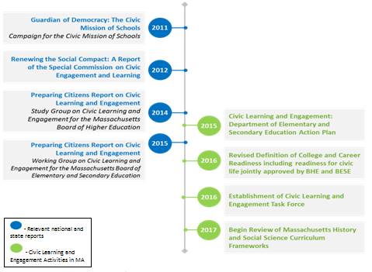

Mission
The Department’s mission is to strengthen the Commonwealth's public education system so that every student is prepared to succeed in postsecondary education, compete in the global economy, and understand the rights and responsibilities of American citizens, and in so doing, to close all proficiency gaps.

The charge of the Civic Learning and Engagement Task Force was to advise the Department on a strategic plan for improving civic learning in order to prepare the students of the Commonwealth to be informed, engaged and responsible citizens.

Vision
The Department envisions that every student at every school in the Commonwealth will learn the core knowledge and skills that are fundamental to civic life and gain the experience and practice in exercising what they have learned that will motivate them to become active citizens for life.

Challenge Statements
The strategies and objectives outlined in this plan are based on recommendations that the Task Force made to improve civic learning and engagement in the following areas:
- Create policy and broad-based, consistent support
- Create relevant resources
- Align existing resources for civic learning
- Provide professional development for educators
- Develop data and accountability measures to elevate the importance of civic learning and engagement among educators and the general public

Strategic Objectives and Initiatives
The following pages describe the three strategies that the Task Force identified to improve civic learning, along with action steps, a timeline, measures, funding and feasibility, and time and resources vs. projected impact.

Objectives
Note: **indicates that this objective will depend on additional funding.
- Promote the new definition of College and Career Readiness and Civic Preparation through communications, conferences, and professional development for educators at all levels.
- Incorporate civic learning and engagement in documents, professional development, guidance and other resources across content areas.
- **Develop a consistent, coordinated message across agencies and organizations that builds support regionally and across a range of constituent groups.
- Highlight connections between civic learning and engagement and district/school priorities, as well as other efforts to close achievement gaps, increase workforce readiness, and improve student success.
- **Recognize and reward effective practices and implementation.

Action Steps
Note: **indicates that this objective will depend on additional funding.
- Objectives 1, 2, 4 - Continue to integrate the new definition of College and Career Readiness and Civic Preparation and make explicit connections between civic learning and interdisciplinary initiatives, such as the Department’s work on social emotional learning, service learning, efforts to close achievement gaps, workforce alignment in all relevant documents and materials through explicit references to it in all state curriculum frameworks, model curriculum units, guidance documents and other resources.
- Objective 3A- - Convene periodic meetings of “Civic Education Partners” among professional education associations and civic education organizations with the goal of establishing partnerships to encourage coordination in this work and a unified, common message. Build on current collaboration with the Massachusetts Department of Higher Education (DHE) and Department of Early Education and Care (EEC) to promote coherence across agencies, understanding of the goals of the work, and a unified message PK-16.
- **Objective 3B- - Establish a communications campaign via the press and social media.
- **Objective 5 - Establish a recognition program for districts and schools similar to the Commendation Schools system; exemplary districts and schools would be selected through the review of applications submitted by districts.

Measure of Success
A widely recognized, consistent message among educators, legislators and the general public.

Funding and Feasibility
- Objectives 1 – 3A may be carried out with FY17 funding and staffing levels.
- Objective 3B - Communications campaign will depend on additional funding.
- Objective 5 – Recognition program will depend on additional funding.

Time and Resources vs. Projected Impact
High time and resources anticipated/Moderate projected impact

Objective
- Develop an inventory of program offerings and effective practices in civic learning and engagement; partner with districts to implement the inventory.
- Develop a statewide system to analyze and describe the status of civic learning and engagement.

Action Steps
- Objective 1 - Develop a self-administered district and school inventory aligned to the six proven practices (described on page 5) for comprehensive civic learning and engagement. This inventory would assist districts and schools in gaining an understanding of where they stand relative to an identified set of criteria, and serve as a benchmark of their current understanding and use of the six proven practices.
- Objective 2- Research and draft a proposal to develop a statewide system to analyze and describe the status of civic learning and engagement.

Measure of Success
- An inventory of program offerings and best practices in civic learning and engagement at the district and school level; and
- A statewide understanding of the status of civic learning and engagement.

Funding and Feasibility
- This strategy may be carried out with FY17 funding and staffing levels.
- Additional funds may be required for districts and schools to support staff time for professional development and implementation of the six proven practices.

Time and Resources vs. Projected Impact
Moderate time and resources required /High projected impact

Objectives
Note: **indicates that this objective will depend on additional funding.
- Integrate civic learning and engagement PK-12 in the revised MA History Social Science Curriculum Framework and the history-social science state assessment.
- Make explicit connections between civic learning and engagement and other disciplines across the curriculum.
- Incorporate expectations of content knowledge of civic learning and engagement in educator and administrator preparation programs.
- **Collaborate, coordinate and share information about resources available to support civic learning and engagement (e.g. curricula, software, professional development, etc.).
- **Provide districts and schools across the regions of the state access to content expertise in history-social studies/civics.
- **Pursue funding for state and district sponsored professional development to support implementation of effective curricula and practices.

Action Steps
Note: **indicates that this objective will depend on additional funding.
- Objectives 1, 2 – Continue the work of the current History-Social Science Review Panel that will include consideration of recommendations for the revision of the MA History Social Science Curriculum Framework such as the following:
  - Provide examples of the use of engaging instructional strategies (e.g., service-learning, simulations, etc.)
  - Provide guidance on integration of civic learning at the elementary level.
  - Establish a model course in civics or that includes civics to be offered prior to and to build the foundation for all secondary course pathways for history-social studies.
  - Supplement the Framework with model curricula, to include a civics capstone project at each grade span.
  - Incorporate examples and guidance to make explicit connections between civic learning and engagement and other disciplines across the curriculum.
- Objective 3 – Collaborate with ESE Offices for Licensure and Educator Preparation, the Department of Higher Education and other institutions of higher education, to update standards for Subject Matter Knowledge (SMKs) in civic education for individual professional licensure as well as the review of educator preparation programs statewide.
- **Objective 4 – Build on the convening of “Civic Education Partners”, professional education associations and civic education organizations, noted in Strategy 1, Action Step 3A, to also establish a common platform and vetting criteria to review and curate curricular materials and other resources.
- **Objective 5 – Hire new History Social Studies/Civics Specialists or Develop a Teacher Leader program to bring content expertise to the regions of the state. These Specialists or Teacher Leaders would provide strategic planning, targeted professional development and other support for districts and schools; The Teacher Leader program would build on the existing Ambassador program in another content area to train cohorts of educators with the necessary content expertise to provide similar support regionally.
- **Objective 6 – Pursue the creation of a line item in the annual state education budget to fund a grant program to support professional development and strategic follow up on implementation of the revised History-Social Science Curriculum Framework for educators statewide. This professional development would, for example, focus on:
  - Promoting the state learning standards and the Six Proven Practices (page 5) to support them for civic learning across content areas. This training would focus, in particular, on those practices that can impact all students rather than those who decide to participate in optional or extra-curricular programs. For example, professional development would address classroom instruction (on civic content and skills), simulations of the democratic process, service-learning and discussions of controversial issues.
  - Integrating civic learning and engagement across content areas in addition to history-social studies, to include, for example, engaging students in:
    - STEM - research and civic action projects related to current issues in science, technology, engineering and math (STEM);
    - Arts - the arts as a mode of communication and action on civics-based issues;
    - ELA/Digital Literacy – use of print and online media to access evidence, evaluate evidence for credibility, and use credible evidence to make an effective argument on a current or historical civic-related issue through oral and text-based multi-media presentations.

Measure of Success
Year-to-year progress in achievement on the history-social science state assessment and/or other established measures.

Funding and Feasibility
- Objectives 1, 2 and 3 may be carried out with FY17 funding and staffing levels.
- Objective 4 - Development of website or other on-line platform for resources will depend on additional funding.
- Objective 5 – Hire of new History Social Studies/Civics Specialists/Development of a Teacher Leader program will depend on additional funding.
Objective 6 - Grant program and related professional development/follow up will depend on additional funding.

Time and Resources vs. Projected Impact
High Time and resource intensive/High projected impact
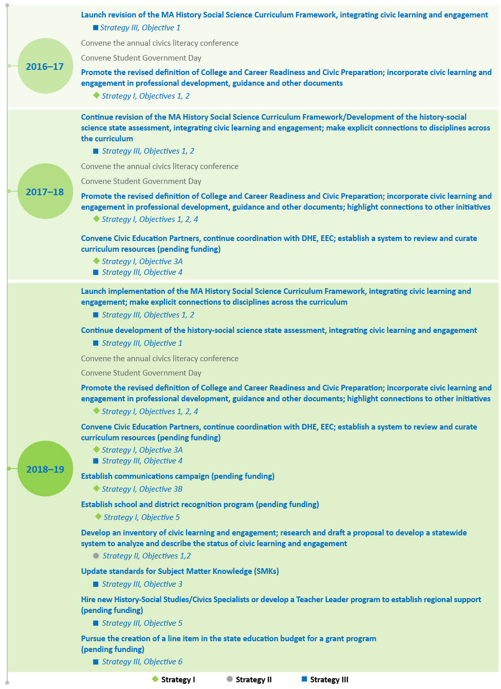
Educational Organizations/Representatives
Brian Bemiss | Principal, Huckleberry Hill Elementary School; Massachusetts Association of Elementary School Principals' Association (MESPA)
Shelley Berman | Superintendent, Andover Public Schools
Maureen Binienda | Superintendent, Worcester Public Schools, Massachusetts Association of School Superintendents (MASS), member of former Working Group on Civic Learning and Engagement
Richard Cairn | Director, Emerging America Program, Collaborative for Educational Services
Roger Desrosiers | President, Massachusetts Center for Civic Education, member of former Working Group on Civic Learning and Engagement
Nadine Ekstrom | Superintendent, Berlin/Boylston Public Schools; Massachusetts Association of School Superintendents (MASS)
Patrick Francomano | President, Massachusetts Association of School Committees (MASC)
Dan Gutekanst | Superintendent, Needham Public Schools; Massachusetts Association of School Superintendents (MASS), member of former Working Group on Civic Learning and Engagement
Patricia Hogan | History/Social Science Department Chairperson, Minnechaug Regional High School; Representing Massachusetts Council on Social Studies
Ruth Kaplan | Former Director, Boston-Haifa Connection; Global Education Advisory Committee
Rashaun Martin | District Supervisor of Social Studies & World Languages, Haverhill Public Schools
Courtney Meisberger | Content Coordinator, Social Studies, Central Berkshire Regional School District; Representing MA Council on Social Studies
Jeff Shea | 2015 Teacher-of-the-Year, Belmont Public Schools; Massachusetts Teachers Association (MTA)
Todd Wallingford | Curriculum Director, Hudson Public Schools; MA Council on Social Studies
Mark Wilson | Principal, Monomoy Regional Schools; member of former Working Group on Civic Learning and Engagement

Higher Education
Susan Lane | Senior Advisor to the Commissioner for P-16 Access & Alignment, Massachusetts Department of Higher Education (DHE)
Peter Levine | Director, Center for Information Research on Civic Learning and Engagement (CIRCLE), Tufts University
Meira Levinson | Professor of Education, Graduate School of Education, Harvard University
Patricia Marshall | Deputy Commissioner for Academic Affairs & Student Success, Massachusetts Department of Higher Education (DHE)
Alan Melchior | Deputy Director, Brandeis University, member of former Working Group on Civic Learning and Engagement
Lauren Mountain | Associate Director, United Way Youth Venture, Mount Wachusett Community College
Student Representatives
Bridget Mills | Bridgewater High School, Student Advisory Council
Owen O'Donnell | Acton High School, Student Advisory Council
Civic Organizations
Caroline Angel Burke | Vice President, Education, Visitor Experience and Collections, Edward M. Kennedy Institute for the United States Senate
Carolyn Casey | Director, Project 351
Arielle Jennings | Greater Boston Program Manager, Generation Citizen
Karen Mazza | Director, Supporting Youth Program, League of Women Voters
Edward J. O'Connell | Exhibit Interpretation Lead, Education, Visitor Experience and Collections, Edward M. Kennedy Institute for the United States Senate
Gillian Pressman | Massachusetts Executive Director, Generation Citizen
Adam Strom | Director of Scholarship and Innovation, Facing History and Ourselves

The Task Force met four times in 2016. Commissioner Chester and Department staff welcomed members of the Task Force to the first meeting on February 2, 2016. Department staff then established the Task Force’s charge, provided background and context, and facilitated a discussion among members about potential recommendations.

The Task Force met again on April 5, 2016 with discussion focused on developing a common understanding of the definition of civic learning and the Six Proven Practices from the Guardian of Democracy: the Civic Mission of Schools report (summarized in the sidebar on page 5). Members discussed existing barriers to effective civic learning and engagement and identified specific outreach that would be conducted to engage other stakeholders’ feedback on promoting civic learning.

The third Task Force meeting took place on September 22, 2016. Members reviewed outreach conducted since the last meeting (described in more detail below) that was designed to gather additional feedback from educators and partners. Task Force members engaged in a process to identify major challenges to improving civic learning and engagement and develop recommended strategies to address them.

The Task Force met again on December 12, 2016. Members reviewed the full list of strategies developed at the previous meeting and engaged in a structured discussion to prioritize the strategies. They made these determinations through consideration of feedback received during outreach, research findings such as those found in the Guardian of Democracy: the Civic Mission of Schools report, their own experiences in the field and discussion of the feasibility of the strategies in terms of such factors as Department staffing, resources available, leverage to make the strategies take hold and political will.

Task Force Outreach

Over the spring and fall of 2016, Task Force members conducted outreach to a number of stakeholders. For example, Department staff and representatives from the Task Force made presentations and organized panel discussions at the New England Regional Conference (NERC), the annual regional social studies conference, the Massachusetts Secondary School Administrators Association (MSSAA) summer conference, two Massachusetts Council for the Social Studies (MCSS) conferences, the joint Massachusetts Association of School Committees (MASC) and Association of School Superintendents (MASS) conference, as well as conducting other regional outreach in their local communities.

Public Survey

In order to gain additional input, Department staff developed a survey on civic education, which was posted on the ESE website and active from May 23, 2016 through January 3, 2017. The Department and Task Force members shared information about the form and invited responses at all outreach events and through communications via the Department’s network of professional organizations and district, school and higher education contacts.

The survey contained questions regarding respondents’ schools or districts definition of civics education, views on the current status of civics education, the models or programs that have helped achieve success in offering high-quality civic learning opportunities at each grade span, the barriers encountered in offering high-quality civic learning opportunities to all students, the supports they would like to have for students, the opportunities for integrating or linking civic learning with other educational priorities or initiatives, and ideas for measuring students’ civic competencies at the classroom, school and state levels.

An analysis of survey results found that 182 respondents viewed the online survey, while only 84 respondents submitted complete or partially complete responses (completed more than 50% of questions). Of these responses, 68 were from social studies teachers and the remaining responses were administrators and classroom teachers of subjects other than social studies. With such a small number of respondents, the survey findings do not provide a strong basis from which to draw conclusions. The themes are included here with the caution that they should be considered in the context of the low response rate.

A majority of survey respondents indicated that civic learning and engagement is currently incorporated into their district’s/school’s program of study (47 respondents) and mission statement (31 respondents). Most survey respondents indicated that Massachusetts schools and districts do not emphasize developing civic competencies today. Finally, more than three-quarters (65) of survey respondents reported that additional civic learning and engagement implementation support would be helpful (e.g., tools and resources, professional development, revised framework that incorporates civics more prominently). Approximately 32 respondents indicated that they do not believe a statewide civics assessment would be helpful.

Massachusetts Definition of College and Career Readiness and Civic Preparation

Approved by the Board of Higher Education on
January 26, 2016
Approved by the Board of Elementary and Secondary Education on February 23, 2016

Overview

Massachusetts students who are college and career ready and prepared for civic life will demonstrate the knowledge, skills and abilities that are necessary to successfully complete entry-level, credit-bearing college courses, participate in certificate or workplace training programs, enter economically viable career pathways, and engage as active and responsible citizens in our democracy. In order to meet this goal, the Commonwealth has defined a set of learning competencies, intellectual capacities and experiences essential for all students to become lifelong learners; positive contributors to their families, workplaces and communities; and successfully engaged citizens of a global 21st century.

___________________

Civic Readiness

To be college and career ready and prepared for civic life, students must also possess a deep understanding and knowledge of U.S. history and its foundational documents, along with the knowledge, intellectual skills, and applied competencies that citizens need for informed and effective participation in civic and democratic life. They must also acquire an understanding of the social values that underlie democratic structures and practices. Civic knowledge, skills, and competencies can be obtained in a variety of settings and ways, including in the classroom, across content areas, through service-learning, discussion of controversial issues, student government, and extracurricular opportunities. Key knowledge, skills, and dispositions that students should possess to be prepared to engage as active citizens include:
- Core civic content knowledge and the ability to apply that knowledge to different circumstances and settings.
- Civic intellectual skills, including the ability to identify, assess, interpret, describe, analyze and explain matters of concern in civic life.
- Civic participatory skills, including knowing how to work collaboratively in groups and organizational settings, interface with elected officials and community representatives, communicate perspectives and arguments, and plan strategically for civic change.
- Civic dispositions including interpersonal and intrapersonal values, virtues and behaviors respect for freedom of speech and thought, respect for others, commitment to equality, capacity for listening, capacity to communicate in ways accessible to others, etc.).

Qualities and Strategies

Preparation for college, career, and civic life should help students develop a wide range of quantitative and qualitative abilities that go beyond the minimum levels of competence needed for entry-level college courses and employment. In high school, students should demonstrate:

- Higher order thinking skills of analysis, synthesis, and evaluation

- The ability to think critically, coherently, and creatively

- The ability to direct and evaluate their own learning, be aware of resources available to support their learning, and have the confidence to access these resources when needed.
- Motivation, intellectual curiosity, flexibility, discipline, self-advocacy, responsibility, and reasoned beliefs
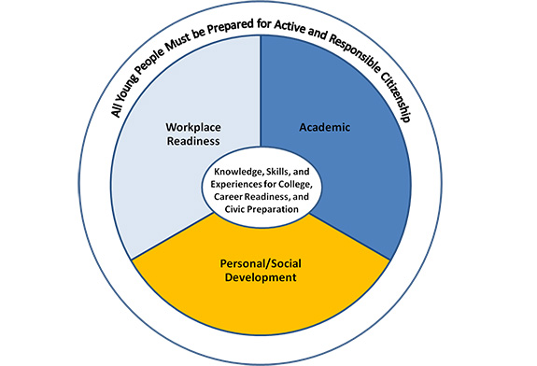

This definition adds a section on Civic Readiness (see page 3) to the joint definition of College and Career Readiness that the Board of Higher Education and Board of Elementary and Secondary Education approved in 2013. The two boards met jointly on January 26, 2016, and discussed the revised definition and possible amendments. The Board of Higher Education subsequently voted to approve the revised definition, as amended based on that discussion. This revised definition was adopted by the Board of Elementary and Secondary Education on February 23, 2016.
Note: The definition that appears here is an excerpt from the complete document. The full definition is available here: http://www.doe.mass.edu/ccr/definition.pdf.

