Massachusetts Department of

Elementary and Secondary Education

75 Pleasant Street, Malden, Massachusetts 02148-4906 Telephone: (781) 338-3000 TTY: N.E.T. Relay 1-800-439-2370

Jeffrey C. Riley
Commissioner

MEMORANDUM

To: | Members of the Board of Elementary and Secondary Education
From: | Jeffrey C. Riley, Commissioner
Date: | October 19, 2018
Subject: | Update on Chronically Underperforming Schools: FY2019 Quarter 1 Reports

This month’s memo highlights several aspects of our work with chronically underperforming schools and districts. I am presenting the first of four FY2019 quarterly progress updates to the Board of Elementary and Secondary Education (Board) on the four chronically underperforming schools’ implementation of their school turnaround plans, focusing on activities from July-September 2018. Future quarterly updates for FY2019 will be presented in January 2019 and April 2019, and a final annual review in June 2019.

FY2018 accountability data as well as comparative FY2017 and FY2018 assessment data has been included for your reference. Next quarter we will provide staffing and student demographic data.

Senior Associate Commissioner Russell Johnston will join us at the October 30 meeting to answer your questions.

Chronically Underperforming Schools

In the fall of 2013, four schools were designated as chronically underperforming schools in response to their low performance and lack of improvement while underperforming (Level 4) schools: John P. Holland Elementary School (UP Academy Holland) and Paul A. Dever Elementary School (Dever) in Boston, Morgan Full Service Community School (Morgan) in Holyoke, and John Avery Parker Elementary School (Parker) in New Bedford. This memorandum provides an update on each school.

Paul A. Dever Elementary School, Boston, MA
Prepared by Michael Contompasis, Receiver

Successes:
- Strong professional development structures: Utilizing feedback from FY18 staff, the Dever leadership team established a strong start to the school year by creating a staff professional development schedule at the beginning of the year including specific supports for new training for all staff. Returning staff bolstered their knowledge in instructing English Learners (ELs) through the BPS English Language Learner summer symposium. As the year progresses, educators in the school will have opportunities to share effective instructional practices through teacher-led professional development and coaching.
- Student support systems and structures: Another success in the first quarter of the school year is the creation of a Student Support Team (SST), dedicated to ensuring high-needs students have necessary supports early in the school year. The Student Support Team created a schedule and articulated a strong vision to support staff and students. Key stakeholders such as City Connects, sports coaches, and behavioral specialists were part of this process. Identifying student supports early will help students to receive timely and effective support.
- Data-driven instruction to target students’ needs: Throughout August and September, Dever’s instructional team diagnosed students’ strengths and weaknesses in the areas of literacy and math to create targeted supports based upon student need. All Dever students were individually tested using literacy and math diagnostic assessments. Using this data, students will be assigned to groups to receive targeted supports based upon their needs. In addition, the instructional team has worked to incorporate EL teachers within the co-teaching model so that all lessons provide English Learner supports.

Challenge:
- Implementing a consistent science curriculum: Science has been an area of weakness at the Dever. After identifying that science was a limited part of the curriculum, the Dever instructional team has searched for resources and supports to implement an effective science curriculum. This year, the school is piloting Amplify Science as the curriculum of choice, with the expectation that 4th and 5th grade students will all receive science instruction on a regular basis. As the year progresses, the Dever instructional team will monitor the progress of this goal and shift the schedule of science instruction as needed. The staff had training on science instruction on October 3, leading to recommendations for next steps in implementing the curriculum.

2018 Accountability Data: Paul A. Dever

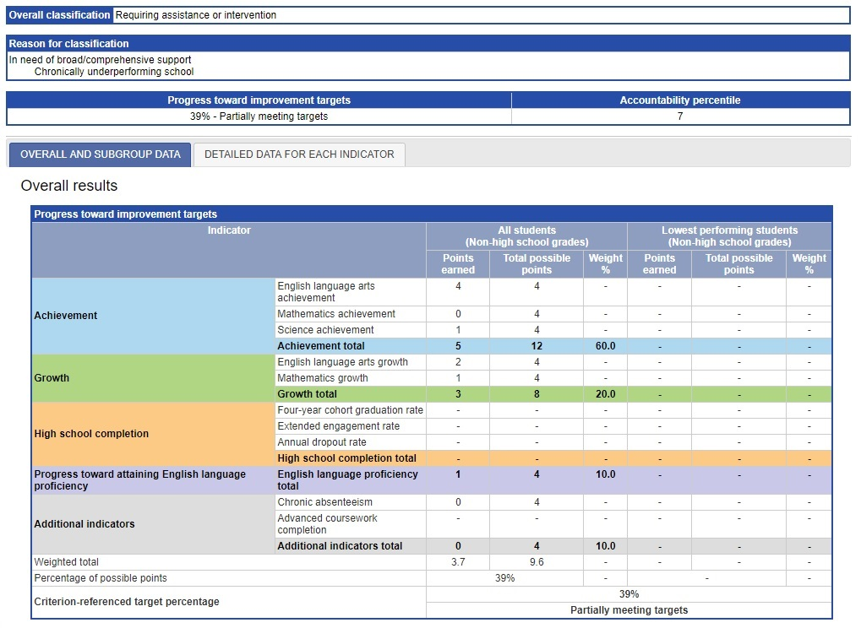
UP Academy Holland, Boston, MA
Prepared by UP Education Network, Receiver

Successes:
- Instructional Walkthroughs. The UP Academy Holland (UAH) team been more strategic and goals-oriented in the school’s approach to developing teachers this academic year. The Leadership Team began the year with daily instructional walkthroughs and frequent teacher coaching and have tracked results weekly. Leadership has been strategic about allocating resources to the most struggling teachers, and in allocating resources based on data accordingly. Now, almost 80 percent of the classrooms have clear procedures and expectations, and offer a supportive, welcoming culture. This stability allows the Leadership Team to focus on instructional coaching points for teachers instead of coaching on classroom management or classroom systems. This early coaching will help teachers to improve their instructional practice more rapidly and lead to better outcomes for students.
- Staff recruitment and retention. The Leadership Team has seen success in teacher retention, recruiting, and staffing at this point in the year. The school had 73 percent of all staff members return for the 2018-19 school year. Additionally, all lead teaching roles were fully staffed before the beginning of August orientation. This allowed the team to focus their attention during orientation on training and development. The Leadership Team has begun having individual meetings with staff members to get feedback on how they can support individuals and improve staff sustainability.
- Implementing a multi-tiered system of support. UP Academy Holland has improved their Multi-tiered System of Support (MTSS) for the 2018-19 school year. New Tier 2 processes and supports have been added, including a robust Tier 2 intervention team, mapped interventions based on data collection, and clear indicators for when a student should be referred to the Tier 2 intervention team. This will allow the team to identify students in need of intervention earlier and implement support plans on a more regular basis. The school will continuously monitor student progress with the interventions and collect feedback from staff members on the experience of the new system.

Challenge:
- Support to students with disabilities. The entire school team is focused on increasing proficiency levels of our students with disabilities. Historically, this has been a growth area for the school. As we increase the number of students in inclusion from the substantially separate program, more teachers need greater capacity to appropriately support students with disabilities while meeting the needs of the rest of the students in the class. We have increased the number of instructional staff members in the building to support our students with disabilities by adding two full-time special education teachers and one full-time paraprofessional. We have also increased the time the leadership team is observing inclusion teachers, and supporting inclusion teachers and inclusion teams in analyzing student work. We believe these additional supports will boost student success and increase proficiency levels of students with disabilities.

2018 Accountability Data: UP Academy Holland

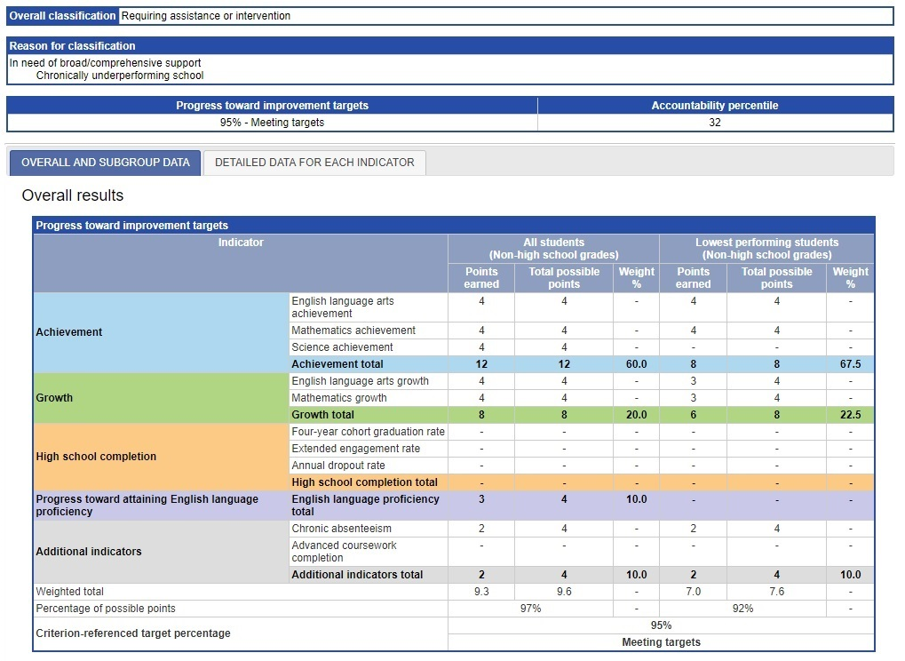
Morgan Full Service Community School, Holyoke, MA
Prepared by Superintendent Zrike, Receiver

Successes:
- Successful summer professional learning: Morgan School engaged in 4.5 days of successful and focused professional learning in August before the arrival of students. Morgan leaders had planned for these days as part of their School Improvement Planning (SIP) work in late spring and summer with an intentional focus on setting the framework for an effective instruction and data cycle, including the systems and processes to support it. While not an exclusive emphasis, this work had a significant math focus given the ongoing gaps in student achievement in math. This professional learning included best practices for structuring data analysis meetings and grade level team meetings, developing a template that is useful and creates dialogue around looking at student work, digging into and unraveling standards aligned to ANet Cycle 1, creating pre-assessments and continuous review for math, and preparing for a math instructional block to allow for high quality math core instruction and intervention.
- Consistent implementation of the instructional cycle framework: Morgan leaders are encouraged by early and consistent implementation of the instructional cycle framework. It is evident that the system, designed as a key lever that was prioritized during the August professional development, is taking hold and staff is buying in. As planned, the first cycle of this work started on September 14th, with all teachers in grades 1-4 prepared for and implementing weekly assessments for continuous review. Leaders had thought the adoption would be more incremental and are pleased with initial progress that is producing student work and outcomes to identify and address gaps in learning early on. Pre-K and Kindergarten teachers developed math center work that will provide baseline information to inform instruction.
- Strategic and thoughtful transition of leadership: Steven Moguel is the new principal of the Morgan School, starting in early July and replacing Alyson Lingsch, who was promoted to a school supervisor position at the district level. District leaders assigned Ms. Lingsch as Mr. Moguel’s school supervisor and ensured that he was present for all of the district’s professional learning for principals and their leadership teams in late June and during the summer. Ms. Lingsch also prioritized her work with Mr. Moguel at Morgan with over twenty face-to-face, formal work sessions. As a result of this collaboration, there were no breaks in planning, messaging, and momentum of the improvement work at the school. Additionally, Mr. Moguel scheduled meetings and opportunities for community and family members to meet him, providing a platform to discuss concerns. He spent two days visiting summer school to meet the Morgan students ahead of the start of school. Mr. Moguel took time in his early weeks at Morgan to meet with all of his staff individually and in teams, engaging in professional conversations and getting a sense of their needs, talents and concerns. This smooth and strategic onboarding positioned Morgan School for a strong start to the year.
Challenge:
- Staff resignations that took place in late August and September. While most of these were resolved by the start or near the start of the school year, the late hiring and replacement process was very time consuming at the time when Morgan leaders needed to be fully focused on school readiness, professional learning, and coaching. Because several of the new staff members were hired late, they missed attending the important start-of-the-year professional learning and preparation. The Morgan leaders accommodated for this and were able to get those teachers up to speed although doing so required time and focus away from other instructional priorities.

2018 Accountability Data: Morgan Full Service Community School

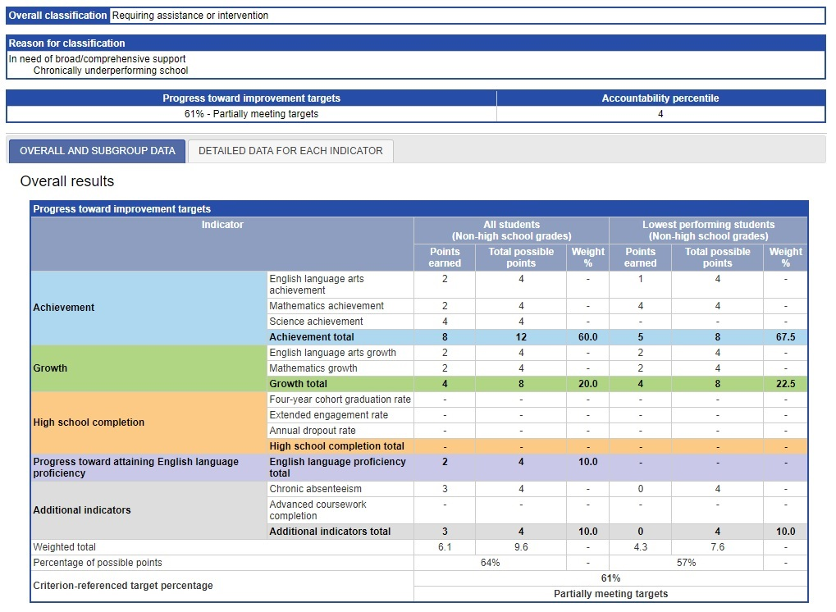
John Avery Parker Elementary School, New Bedford, MA
Prepared by School and Main Institute, Receiver

Successes:
- Focus on Mathematics instruction. Parker is excited to see that the culture and practice of math instruction has transformed since last year. This year the rollout of a new math curriculum has placed students and their curiosity at the center of instruction. School leaders observing instruction see that students are collaborating authentically and solving problems that are rich, complex and set in real-world contexts. Formative assessments are already showing that student learning is increasing and student behavior shows more engagement in the process of learning. The Parker is still working to see more student-to-student discourse as they continue to push for student centered learning.
- Enhancements of the master schedule. Another success at the Parker is the change in the master schedule to enhance the support of teachers’ planning needs and relationship building between teacher and students. New to Parker this academic year is an established double block of weekly teacher collaboration time (TCT). This allows teachers sufficient time to plan and collaborate. An instructional coach supports educators as they plan during TCT. Teachers express appreciation for the direction and support codified in the schedule. Another shift is that teachers supervise student recess , allowing them to engage and build relationships with their students. As part of the plan to create a more supportive master schedule, enrichment blocks have been instituted once per week with student choice. For example, grade 5 students can choose from courses such as drumming, cursive writing, drama, team sports, chorus, and Harry Potter character drawing.
- Improvements to culture and climate. The Parker is seeing significant success with improving the overall culture and climate of the school through implementation of Responsive Classroom. The first three weeks of school were solely dedicated to establishing rituals and routines, setting goals through students’ hopes and dreams, building relationships, and developing a sense of community. Students are responding positively; behavior in unstructured areas (recess and lunch) has improved, and transitions are quieter, calmer, and consistent. In addition, the Parker is seeing early evidence that students are building a sense of community with one another through routines such as morning meeting and restorative circles.
Challenge:
- Supporting students with emotional impairments and trauma. An area that the Parker leadership team will continue sustained focus on is support for students with Tier 3 (i.e., requiring intensive intervention) social and emotional needs. The leadership team is in the process of moving from a reactive system of behavior management to a proactive support system that builds the social and emotional skillset of the most emotionally and behaviorally fragile students. In addition to data collection, this newly designed system will include a revised template for understanding students’ social and emotional strengths and weaknesses, a list of appropriate pull-out and push-in interventions, support for classroom teachers, and a parent connection.

2018 Accountability Data: John Avery Parker
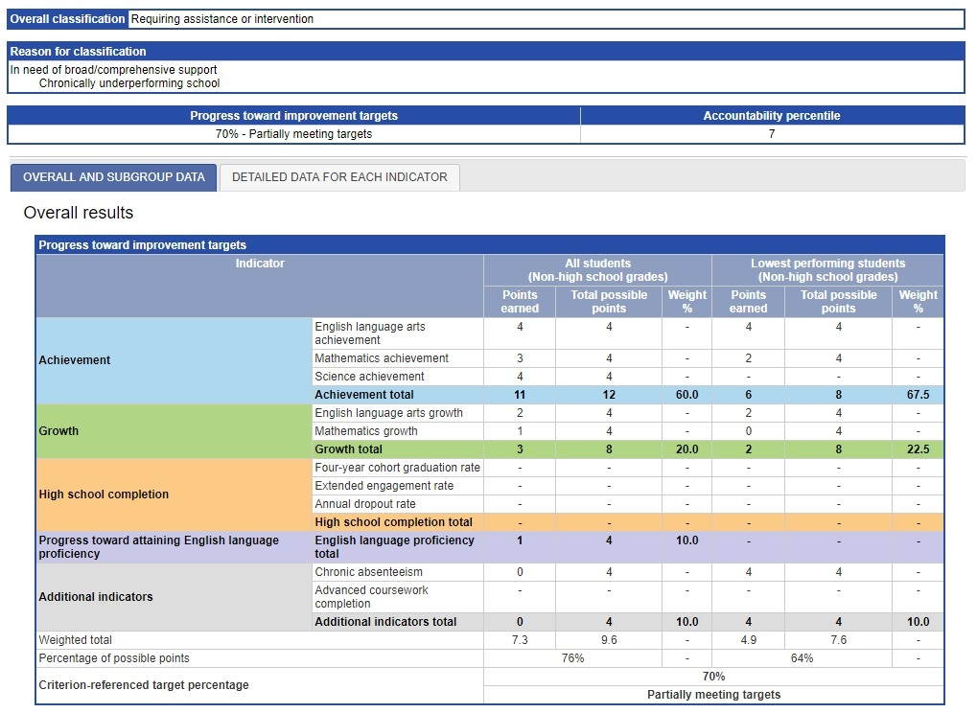

Attachment 1: Next-Generation MCAS Tests 2017 and 2018

Paul A. Dever Elementary School
For more information, please see:
http://profiles.doe.mass.edu/mcas/mcascharts2.aspx?linkid=33&orgcode=00350268&fycode=2018&orgtypecode=6&
Grade and Subject | Exceeding Expectations |  | Meeting Expectations |  | Partially Meeting Expectations |  | Not Meeting Expectations |  | Avg. Scaled Score |  | Median SGP |  | Achievement Percentile
 | 2017 | 2018 | 2017 | 2018 | 2017 | 2018 | 2017 | 2018 | 2017 | 2018 | 2017 | 2018 | 2017 | 2018
GRADE 03 - READING | 0 | 11 | 40 | 35 | 53 | 52 | 7 | 2 | 496.4 | 500.3 | N/A | N/A | 35 | 38
GRADE 03 - MATH | 12 | 13 | 54 | 39 | 26 | 46 | 7 | 2 | 506.0 | 506.5 | N/A | N/A | 73 | 69
GRADE 04 - ELA | 2 | 0 | 17 | 23 | 49 | 55 | 32 | 21 | 482.1 | 485.2 | 45.5 | 26.2 | 4 | 4
GRADE 04 - MATH | 0 | 0 | 20 | 26 | 61 | 60 | 19 | 15 | 485.1 | 487.8 | 64.0 | 20.4 | 12 | 17
GRADE 05 - ELA | 0 | 0 | 31 | 24 | 41 | 66 | 27 | 10 | 485.9 | 489.8 | 68.0 | 54.1 | 10 | 10
GRADE 05 - MATH | 2 | 0 | 45 | 18 | 29 | 73 | 24 | 10 | 492.1 | 487.4 | 84.0 | 51.7 | 24 | 15
GRADES 03 - 08 - ELA | 1 | 3 | 29 | 27 | 48 | 58 | 22 | 11 | 488.2 | 491.6 | 55.0 | 40.6 | 12 | 16
GRADES 03 - 08 - MATH | 5 | 4 | 40 | 27 | 40 | 60 | 16 | 9 | 494.4 | 493.6 | 70.0 | 36.7 | 30 | 29

Grade and Subject | Advanced |  | Proficient |  | Needs Improvement |  | Warning/ Failing |  | CPI |  | Median SGP
 | 2017 | 2018 | 2017 | 2018 | 2017 | 2018 | 2017 | 2018 | 2017 | 2018 | 2017 | 2018
GRADE 05 - SCIENCE AND TECH/ENG | 0 | 0 | 4 | 10 | 59 | 51 | 37 | 39 | 47.1 | 45.6 | N/A | N/A

UP Academy Holland
For more information, please see:
http://profiles.doe.mass.edu/mcas/mcascharts2.aspx?linkid=33&orgcode=00350167&fycode=2018&orgtypecode=6&
Grade and Subject | Exceeding Expectations |  | Meeting Expectations |  | Partially Meeting Expectations |  | Not Meeting Expectations |  | Avg. Scaled Score |  | Median SGP |  | Achievement Percentile
 | 2017 | 2018 | 2017 | 2018 | 2017 | 2018 | 2017 | 2018 | 2017 | 2018 | 2017 | 2018 | 2017 | 2018
GRADE 03 - READING | 1 | 2 | 15 | 25 | 59 | 52 | 26 | 21 | 484.3 | 489.9 | N/A | N/A | 7 | 9
GRADE 03 - MATH | 0 | 2 | 27 | 31 | 44 | 41 | 29 | 26 | 485.8 | 490.2 | N/A | N/A | 11 | 18
GRADE 04 - ELA | 2 | 1 | 21 | 22 | 44 | 52 | 33 | 26 | 483.3 | 487.0 | 35.0 | 48.2 | 5 | 6
GRADE 04 - MATH | 1 | 0 | 16 | 28 | 48 | 37 | 36 | 35 | 479.7 | 484.1 | 33.0 | 51.2 | 5 | 10
GRADE 05 - ELA | 2 | 3 | 29 | 45 | 49 | 44 | 19 | 9 | 490.2 | 499.8 | 77.0 | 73.1 | 18 | 40
GRADE 05 - MATH | 0 | 2 | 18 | 40 | 56 | 46 | 26 | 12 | 483.8 | 496.5 | 56.0 | 81.2 | 8 | 44
GRADES 03 - 08 - ELA | 1 | 2 | 21 | 30 | 51 | 49 | 26 | 19 | 485.7 | 492.0 | 55.0 | 60.5 | 8 | 16
GRADES 03 - 08 - MATH | 0 | 1 | 20 | 33 | 49 | 41 | 31 | 25 | 483.0 | 490.1 | 46.0 | 66.1 | 7 | 20

Grade and Subject | Advanced |  | Proficient |  | Needs Improvement |  | Warning/ Failing |  | CPI |  | Median SGP
 | 2017 | 2018 | 2017 | 2018 | 2017 | 2018 | 2017 | 2018 | 2017 | 2018 | 2017 | 2018
GRADE 05 - SCIENCE AND TECH/ENG | 2 | 5 | 10 | 18 | 46 | 61 | 41 | 15 | 52.0 | 67.3 | N/A | N/A

Morgan Full Service Community School
For more information, please see:
http://profiles.doe.mass.edu/mcas/mcascharts2.aspx?linkid=33&orgcode=01370025&fycode=2018&orgtypecode=6&
Grade and Subject | Exceeding Expectations |  | Meeting Expectations |  | Partially Meeting Expectations |  | Not Meeting Expectations |  | Avg. Scaled Score |  | Median SGP |  | Achievement Percentile
 | 2017 | 2018 | 2017 | 2018 | 2017 | 2018 | 2017 | 2018 | 2017 | 2018 | 2017 | 2018 | 2017 | 2018
GRADE 03 - READING | 0 | 3 | 26 | 41 | 64 | 50 | 10 | 6 | 488.6 | 492.9 | N/A | N/A | 14 | 14
GRADE 03 - MATH | 0 | 0 | 19 | 12 | 60 | 53 | 21 | 35 | 485.4 | 478.8 | N/A | N/A | 10 | 3
GRADE 04 - ELA | 0 | 0 | 8 | 21 | 68 | 52 | 25 | 26 | 479.9 | 482.5 | 18.5 | 31.6 | 2 | 3
GRADE 04 - MATH | 0 | 0 | 12 | 19 | 46 | 52 | 41 | 29 | 475.8 | 480.4 | 12.5 | 36.4 | 3 | 5
GRADE 05 - ELA | 0 | 0 | 30 | 9 | 47 | 74 | 23 | 16 | 487.3 | 484.6 | 60.0 | 43.0 | 12 | 3
GRADE 05 - MATH | 0 | 0 | 17 | 16 | 60 | 63 | 23 | 21 | 480.7 | 481.2 | 37.0 | 41.6 | 5 | 5
GRADE 06 - ELA | 0 | 0 | 3 | 20 | 53 | 54 | 45 | 26 | 470.9 | 483.0 | 29.5 | 44.7 | 1 | 8
GRADE 06 - MATH | 0 | 0 | 0 | 11 | 58 | 66 | 42 | 23 | 473.2 | 482.7 | 36.0 | 49.9 | 2 | 10
GRADE 07 - ELA | 0 | 0 | 7 | 9 | 70 | 44 | 22 | 47 | 480.6 | 472.5 | 69.5 | 55.1 | 7 | 3
GRADE 07 - MATH | 0 | 0 | 7 | 3 | 67 | 44 | 26 | 53 | 478.0 | 470.1 | 61.5 | 40.3 | 8 | 2
GRADE 08 - ELA | 0 | 0 | 12 | 15 | 58 | 48 | 30 | 36 | 479.0 | 475.7 | 67.0 | 53.8 | 6 | 5
GRADE 08 - MATH | 0 | 0 | 9 | 6 | 51 | 79 | 40 | 15 | 474.3 | 479.2 | 58.0 | 51.0 | 3 | 9
GRADES 03 - 08 - ELA | 0 | 0 | 14 | 19 | 60 | 55 | 26 | 26 | 481.1 | 482.1 | 49.0 | 44.8 | 4 | 5
GRADES 03 - 08 - MATH | 0 | 0 | 11 | 12 | 56 | 59 | 33 | 29 | 478.0 | 479.0 | 37.0 | 43.4 | 4 | 4

Grade and Subject | Advanced |  | Proficient |  | Needs Improvement |  | Warning/ Failing |  | CPI |  | Median SGP
 | 2017 | 2018 | 2017 | 2018 | 2017 | 2018 | 2017 | 2018 | 2017 | 2018 | 2017 | 2018
GRADE 05 - SCIENCE AND TECH/ENG | 0 | 7 | 21 | 12 | 52 | 53 | 28 | 28 | 56.0 | 57.6 | N/A | N/A
GRADE 08 – SCIENCE AND TECH/ENG | 0 | 0 | 0 | 0 | 40 | 39 | 60 | 61 | 34.3 | 36.4 | N/A | N/A

John Avery Parker Elementary School
For more information, please see:
http://profiles.doe.mass.edu/mcas/mcascharts2.aspx?linkid=33&orgcode=02010115&fycode=2018&orgtypecode=6&
Grade and Subject | Exceeding Expectations |  | Meeting Expectations |  | Partially Meeting Expectations |  | Not Meeting Expectations |  | Avg. Scaled Score |  | Median SGP |  | Achievement Percentile
 | 2017 | 2018 | 2017 | 2018 | 2017 | 2018 | 2017 | 2018 | 2017 | 2018 | 2017 | 2018 | 2017 | 2018
GRADE 03 - READING | 0 | 0 | 14 | 24 | 66 | 67 | 20 | 9 | 485.3 | 492.7 | N/A | N/A | 9 | 14
GRADE 03 - MATH | 0 | 0 | 17 | 24 | 57 | 61 | 26 | 15 | 485.1 | 488.1 | N/A | N/A | 10 | 13
GRADE 04 - ELA | 0 | 0 | 15 | 28 | 62 | 63 | 23 | 9 | 483.5 | 490.9 | 39.5 | 30 | 5 | 13
GRADE 04 - MATH | 0 | 0 | 8 | 19 | 56 | 52 | 36 | 29 | 475.4 | 481.0 | 24.0 | 29 | 3 | 6
GRADE 05 - ELA | 0 | 0 | 11 | 24 | 59 | 59 | 30 | 16 | 479.0 | 487.7 | 49.0 | 35 | 3 | 7
GRADE 05 - MATH | 0 | 0 | 26 | 11 | 59 | 59 | 15 | 30 | 484.7 | 478.8 | 46.0 | 35 | 9 | 3
GRADES 03 - 08 - ELA | 0 | 0 | 14 | 25 | 62 | 63 | 24 | 12 | 482.9 | 490.3 | 46.0 | 65 | 5 | 13
GRADES 03 - 08 - MATH | 0 | 0 | 16 | 18 | 57 | 57 | 27 | 25 | 481.3 | 482.5 | 31.0 | 64 | 6 | 7

Grade and Subject | Advanced |  | Proficient |  | Needs Improvement |  | Warning/ Failing |  | CPI |  | Median SGP
 | 2017 | 2018 | 2017 | 2018 | 2017 | 2018 | 2017 | 2018 | 2017 | 2018 | 2017 | 2018
GRADE 05 - SCIENCE AND TECH/ENG | 0 | 0 | 11 | 14 | 44 | 54 | 44 | 32 | 44.4 | 54.1 | N/A | N/A

State
Grade and Subject | Exceeding Expectations |  | Meeting Expectations |  | Partially Meeting Expectations |  | Not Meeting Expectations |  | Avg. Scaled Score
 | 2017 | 2018 | 2017 | 2018 | 2017 | 2018 | 2017 | 2018 | 2017 | 2018
GRADE 03 - READING | 8 | 9 | 39 | 43 | 42 | 50 | 10 | 7 | 498.8 | 502.2
GRADE 03 - MATH | 7 | 10 | 42 | 40 | 38 | 53 | 13 | 12 | 498.8 | 500.0
GRADE 04 - ELA | 7 | 10 | 41 | 43 | 42 | 52 | 10 | 9 | 499.2 | 501.8
GRADE 04 - MATH | 6 | 7 | 43 | 41 | 39 | 52 | 13 | 13 | 498.0 | 497.9
GRADE 05 - ELA | 6 | 6 | 43 | 48 | 42 | 74 | 10 | 8 | 498.9 | 501.9
GRADE 05 - MATH | 7 | 5 | 39 | 41 | 44 | 63 | 10 | 10 | 498.7 | 497.5
GRADE 06 - ELA | 7 | 10 | 43 | 40 | 39 | 54 | 10 | 12 | 499.5 | 501.0
GRADE 06 - MATH | 7 | 7 | 42 | 41 | 39 | 66 | 11 | 11 | 499.2 | 498.6
GRADE 07 - ELA | 6 | 8 | 44 | 38 | 39 | 44 | 11 | 15 | 499.1 | 497.0
GRADE 07 - MATH | 9 | 7 | 38 | 39 | 42 | 44 | 12 | 14 | 498.7 | 497.5
GRADE 08 - ELA | 8 | 10 | 41 | 41 | 39 | 48 | 11 | 15 | 498.9 | 499.1
GRADE 08 - MATH | 9 | 8 | 39 | 41 | 42 | 79 | 11 | 12 | 499.6 | 498.8
GRADES 03 - 08 - ELA | 7 | 9 | 42 | 42 | 41 | 55 | 10 | 11 | 499.1 | 500.5
GRADES 03 - 08 - MATH | 8 | 7 | 40 | 40 | 41 | 59 | 12 | 12 | 498.8 | 498.4

Grade and Subject | Advanced |  | Proficient |  | Needs Improvement |  | Warning/ Failing |  | CPI
 | 2017 | 2018 | 2017 | 2018 | 2017 | 2018 | 2017 | 2018 | 2017 | 2018
GRADE 05 - SCIENCE AND TECH/ENG | 17 | 18 | 29 | 30 | 39 | 39 | 15 | 13 | 75.3 | 76.5
GRADE 08 – SCIENCE AND TECH/ENG | 3 | 4 | 37 | 31 | 40 | 44 | 20 | 21 | 70.6 | 68.3

In the fall of 2018, the grade-span for the Morgan School changed from serving grades Pre-K–8 students to Pre-K–4 students, as two new middle school options were opened: Veritas Prep Holyoke and Holyoke STEM Academy. More information on the district’s middle school redesign efforts can be found here: https://www.hps.holyoke.ma.us/turnaround/msredesign/.

