

city on a hill charter public school, new bedford

Summary of RevieW

New Bedford, MA

January 2019

**Massachusetts Department of Elementary and Secondary Education**

75 Pleasant Street

Malden, MA 02138

Phone: (781) 338-3227

Fax: (781) 338-3220



This document was prepared by the   
Massachusetts Department of Elementary and Secondary Education

Jeffrey C. Riley

Commissioner

The Massachusetts Department of Elementary and Secondary Education, an affirmative action employer, is committed to ensuring that all of its programs and facilities are accessible to all members of the public.

We do not discriminate on the basis of age, color, disability, national origin, race, religion, sex, gender identity, or sexual orientation.

Inquiries regarding the Department’s compliance with Title IX and other civil rights laws may be directed to the

Human Resources Director, 75 Pleasant St., Malden, MA 02148-4906. Phone: 781-338-6105.

© 2019 Massachusetts Department of Elementary and Secondary Education

Permission is hereby granted to copy any or all parts of this document for non-commercial educational purposes. Please credit the “Massachusetts Department of Elementary and Secondary Education.”

This document printed on recycled paper

Massachusetts Department of Elementary and Secondary Education

75 Pleasant Street, Malden, MA 02148-4906

Phone 781-338-3000 TTY: N.E.T. Relay 800-439-2370

[www.doe.mass.edu](http://www.doe.mass.edu)



Table of Contents

About the Charter School Renewal Process 1

School Overview 2

School Profile 2

School History 2

Student Demographics 3

Executive Summary of School Performance 5

Findings 6

Faithfulness to Charter 6

Criterion 1: Mission and Key Design Elements 6

Criterion 2: Access and Equity 10

Criterion 3: Compliance 14

Criterion 4: Dissemination 15

Academic Program Success 15

Criterion 5: Student Performance 15

Criterion 6: Program Delivery 19

Criterion 7: Culture and Family Engagement 25

Organizational Viability 29

Criterion 8: Capacity 29

Criterion 9: Governance 33

Appendix A: Accountability Plan Performance 37

Appendix B: Access and Equity 48

Student Enrollment 48

Student Indicators 52

Appendix C: Student Performance 58

Overall Results 58

Results for Students in the High Needs Subgroup 59

Detailed Data for Each Indicator 60

Appendix D: Finance 63

Appendix E: Sources of Evidence 66

Appendix F: Renewal Inspection Methodology 67

City on a Hill New Bedford Renewal Inspection Schedule 69

Appendix G: School’s Response to Summary of Review 70

# About the Charter School Renewal Process

The charter school regulations state that “the decision by the Board [of Elementary and Secondary Education] to renew a charter shall be based upon the presentation of affirmative evidence regarding the faithfulness of the school to the terms of its charter, including the extent to which the school has followed its recruitment and retention plan and has disseminated best practices in accordance with M.G.L. c. 71, § 89(dd); the success of the school's academic program; and the viability of the school as an organization” 603 CMR 1.11(2). Consistent with the regulations, recommendations regarding renewal are based upon the Department of Elementary and Secondary Education’s (Department) evaluation of the school’s performance in these areas. In its review, the Department has considered both the school’s absolute performance at the time of the application for renewal and the progress the school has made during the first four years of its charter. Performance is evaluated against both the [Massachusetts Charter School Performance Criteria](http://www.doe.mass.edu/charter/acct.html?section=criteria) (Criteria) and the school’s accountability plan.

The charter renewal process begins when a charter school submits to the Department an Application for Renewal of a Public School Charter (Application for Renewal). After the Department has determined the Application for Renewal is complete, the Department works with the school to schedule a renewal inspection.

The renewal inspection provides the Department with current information about the school’s performance relative to the Criteria. The Department conducts two types of renewal inspections: full criteria renewal inspections, which address all of the Criteria, and core criteria renewal inspections, which address a sub-set of the Criteria. Both types of renewal inspection visits collect evidence that are required for a renewal determination as outlined by M.G.L. c. 71, § 89(dd). The type of renewal inspection a school receives depends on a number of factors, including the school’s age, size, whether the school is operating under conditions or probation, recent major expansions, and prior academic performance. The Department may contract with an independent organization to conduct the renewal inspection. For more details about the renewal inspection, see the [Charter School Renewal Inspection Protocol](http://www.doe.mass.edu/charter/acct.html?section=renew).

The Summary of Review (SOR) summarizes the school’s performance over the five-year charter term, reflecting evidence compiled throughout the charter term from sources such as Annual Reports, site visit reports, and state assessment results. See *Appendix F: Sources of Evidence* for more details. The SOR incorporates descriptions of evidence gathered during the renewal inspection[1]. The renewal inspection team prepares these descriptions, and they are included in the gray shaded boxes in the body of the report[2]. The SOR highlights evidence for six Criteria aligned with the statutory requirements for charter renewal outlined by M.G.L. c. 71, § 89(dd): Criterion 1: Mission and Key Design Elements; Criterion 2: Access and Equity; Criterion 3: Compliance; Criterion 4: Dissemination; Criterion 5: Student Performance; and Criterion 9: Governance. The SOR also includes evidence related to other Criteria assessed during the renewal inspection.

# School Overview

## School Profile

| **City on a Hill Charter Public School, New Bedford (CoaH NB)** | | | |
| --- | --- | --- | --- |
| **Type of Charter** | Commonwealth | **Location** | New Bedford |
| **Regional or Non-Regional** | Non-Regional | **Districts in Region** | N/A |
| **Year Opened** | 2014 | **Year(s) Renewed** | N/A |
| **Maximum Enrollment** | 280 | **Current Enrollment** | 217[3] |
| **Chartered Grade Span** | 9-12 | **Current Grade Span** | 9-12 |
| **Students on Waitlist** | 0[4] | **Current Age of School** | 5 years |
| **Mission Statement:**  City on a Hill New Bedford graduates responsible, resourceful, and respectful democratic citizens prepared for college and to advance community, culture, and commerce, and to compete in the 21st century. We do so by emphasizing academic achievement, citizenship, teacher leadership, and public accountability. | | | |

## School History

* City on a Hill Charter Public School New Bedford (CoaH NB) is part of a three-school network of charter schools. The original City on a Hill Charter Public School, now known as City on a Hill Circuit Street (CoaH CS), opened in 1995.
* In 2012, CoaH CS’s board of trustees applied to open two additional charter schools, one in Boston and one in New Bedford. The Board of Elementary and Secondary Education (Board) granted the two charters; City on a Hill Dudley Square opened in Boston in 2013, followed by City on a Hill New Bedford in 2014.
* CoaH NB opened in 2014, serving 88 students in grade 9. CoaH NB expanded one grade per year and served grades 9-12 during the 2017-18 school year.
* There were no major amendments granted to the school during the charter term.
* A single board of trustees is responsible for overseeing the three schools in the City on a Hill network and evaluating the executive director. The board hired a new executive director in 2015. That executive director left in May 2017, and in early June the board hired an interim executive director who served for the 2017-18 school year. In May 2018, the board of trustees hired a permanent chief executive officer (a new title) who began in July.
* City on a Hill New Bedford is overseen by the permanent chief executive officer, who serves as the leader across the three schools (New Bedford, Dudley Square and Circuit Street) and network office. Staff at the network office provide support to all three City on a Hill charter schools. The chief schools officer oversees the CoaH NB principal. Depending on subject matter and grade, teachers are reviewed, coached, and supported by the principal, vice principal, or network instructional content specialists. The instructional content specialist role is new in 2018-19 and is intended, among other things, to ensure that teachers have strong content specific support and coaching to better drive instruction.
* During the 2017-18 school year, teachers and non-instructional staff across the City on a Hill network engaged in discussions with the Boston Teacher’s Union, eventually voting to join the BTU. Negotiations between the board of trustees and the union are ongoing; no contracts have been signed.
* CoaH NB received site visits in Years One, Two, and Three of the charter term.

## Student Demographics

| **Enrollment by Race/Ethnicity[5]** | |
| --- | --- |
| **Race/Ethnicity** | **Percentage of Student Body** |
| African-American | 11.1 |
| Asian | 0.9 |
| Hispanic | 45.6 |
| Native American | 0.9 |
| White | 36.4 |
| Native Hawaiian, Pacific Islander | 0.0 |
| Multi-Race, Non Hispanic | 5.1 |

| **Selected Populations[6]** | |
| --- | --- |
| **Title** | **Percentage of Student Body** |
| First Language not English | 51.2 |
| English Language Learner | 21.2 |
| Students with Disabilities | 31.8 |
| High Needs | 82.0 |
| Economically Disadvantaged | 67.3 |

# Executive Summary of School Performance

| **Massachusetts Charter School Performance Criteria** | | |
| --- | --- | --- |
| **Faithfulness to Charter** | | **Rating[7]** |
| 1. **Mission and Key Design Elements:** The school is faithful to its mission, implements the key design elements outlined in its charter, and substantially meets its accountability plan goals. | | ** Falls Far Below** |
| 1. **Access and Equity:** The school ensures access and equity for all students eligible to attend the school. | | ** Partially Meets** |
| 1. **Compliance:** The school is in compliance with the terms of its charter and applicable state and federal laws and regulations. | | **Not Rated** |
| 1. **Dissemination:** The school provides innovative models for replication and best practices to other public schools in the district where the charter school is located. | | ** Partially Meets** |
| **Academic Program Success** | |  |
| 1. **Student Performance:** The school consistently meets state student performance standards as defined by the statewide accountability system. | 2018 Overall Classification: | **Requiring assistance or intervention** |
| Progress Toward Improvement Targets: | **46 percent** |
| 2018 Accountability Percentile: | **4** |
| **Organizational Viability** | |  |
| 1. **Governance:** Members of the board of board members act as public agents authorized by the state and provide competent and appropriate governance to ensure the success and sustainability of the school. | | ** Meets** |

# Findings

## Faithfulness to Charter

| Criterion 1: Mission and Key Design Elements | |
| --- | --- |
| The school is faithful to its mission, implements the key design elements outlined in its charter, and substantially meets its accountability plan goals. | ** Falls Far Below** |

*Finding: Throughout the charter term, all stakeholders had a common understanding of the school’s mission and key design elements; however, information collected during site visits and other data from the charter term reflects limited evidence of successful implementation of the school’s mission to prepare students to compete in the 21st century and of the school’s key design elements.*

* CoaH NB’s mission is to graduate responsible, resourceful, and respectful democratic citizens prepared for college and to advance community, culture, and commerce, and to compete in the 21st century.
* During visits to the school in Years One, Two, and Three, and during the renewal inspection, site visitors found mixed evidence related to the school’s mission. Evidence of programming aligned to the school’s mission and vision includes: two full-time college and career counselors who teach college seminars; dual enrollment with Bristol Community College; college visits, assistance with college applications and financial aid; local fieldtrips; and local internships. During the charter term, CoaH NB’s data related to post-secondary measures demonstrated a lack of success in preparing students for college. Evidence that does not support fidelity to the school’s mission includes: 5.6 percent of students dropped out of school during the 2016-17 school year[8] (an increase from the previous year), as compared the state rate of 1.8 percent; the retention rate for the 2017-18 school year was 12.3 percent[9], the chronic absenteeism rate for the 2017-18 school year was 34.3 percent[10] (an increase from the previous year); and suspension rates at the school were high throughout the charter term[11]. Additionally, CoaH NB did not meet key Accountability Plan measures related to college preparation.
* CoaH NB has four key design elements: academic achievement, citizenship, teacher leadership, and public accountability. During visits to the school in Years One, Two, and Three, and during the renewal inspection, site visitors found limited evidence of successful implementation of key design elements. Positive evidence of the school’s implementation of the key design elements includes: daily advisories, a grade 9 civics class, school-wide town meetings led by students, student government opportunities, senior City Projects, teacher leadership roles in each department, teacher mentoring opportunities, community service graduation requirements, and members of the public attending student juries as jurors. Evidence that the school has not successfully implemented its key design elements includes: the school is among the lowest performing 10 percent of schools across the state based on its progress towards improvement targets in 2018 and requires DESE assistance or interventions[12]; site visit teams observed limited evidence of high expectations, student engagement, and environments to conducive learning across the charter term; the school reported limited evidence of citizenship, including community service hours and internships; the school’s teacher retention rate average is 50 percent during the period 2015-2018; and teachers reported inconsistent implementation of teacher leadership opportunities. Evidence gathered and reviewed as part of the renewal inspection is described in further detail below.
* During the renewal inspection, the board reported the current network and school leadership teams will refocus the network and school on meeting the school’s mission and implementing the key design element related to academic achievement with fidelity. School and network leaders reported that based on declining academic data, the school restructured its leadership team, ended its contract with AmeriCorps, and hired interventionists for its tutorial program. Evidence gathered and reviewed as part of the renewal inspection is described in further detail below.

| *Evidence gathered and reviewed as part of the renewal inspection:*  All CoaH NB stakeholders share a common and consistent understanding of the school’s mission and the four key design elements.   * Board members, school leaders, and teachers identified their main responsibilities as providing students with skills to become leaders and productive citizens in New Bedford and to demonstrate academic achievement. * Students and parents identified citizenship and preparation for college as the key reasons why they chose to attend CoaH NB. * Board members, school leaders, and teachers identified academic achievement, citizenship, teacher leadership, and public accountability as the school’s key design elements.   CoaH NB is working towards operating in a manner that is faithful to its mission.   * Board members reported the new CoaH network chief executive officer (CEO), hired in July 2018, will refocus the CoaH network and its schools to reflect the CoaH mission and key design elements. Other network changes occurred in 2017 and 2018, including the resignation of the 23-year academic officer in June 2018 and the special education administrator in April 2018. In July 2018, the board hired a new chief executive officer and the principal and assistant principals were hired in 2017. |
| --- |

| * CoaH NB hired in 2016 its first full-time college and career counselor to meet the college preparation needs of its first group of grade 12 students. There are currently two college and career counselors who teach grades 11 and 12 college preparation seminars, provide individualized college counseling, and work with families and students in preparing college and financial aid applications. The counselors also organize visits to colleges. * The school offers dual enrollment courses with Bristol Community College. Students, and parents said that they value the dual enrollment opportunities and cited it as an important feature that attracted them to the school. * Board members, school leaders, teachers, and students spoke about advancing the community, culture, and commerce of New Bedford and preparing students for active citizenship. They cited the school’s commitment to helping students connect with, and appreciate New Bedford’s rich history. Students said that they learned about the fishing industry, and visited local areas of interest such as the historical parks and the U.S. Navy ships. All stakeholders reported the school’s central location in New Bedford provides many opportunities to learn about local businesses and issues confronting the community though local field trips, internships with local businesses, and invitations to community members to serve on project juries. * Grade 12 students participate in local opportunities most actively during their City Project course requiring 100 volunteer hours. Site visitors observed one City Project lesson where students were learning about current events in the Middle East and discussing global and local implications. All students participated in one day of community service during the 2017-18 school year. School leaders reported students will engage in four community service days during the 2018-19 school year and students reported they had already engaged in one this year.   CoaH NB is implementing of its key design elements with variable outcomes. The school is focused on strengthening areas of concern related to academic achievement and teacher leadership.  *Academic Achievement*   * As measured by two years of MCAS data (2016 and 2017), academic achievement results have declined. In 2017, the number of students scoring proficient and advanced in ELA fell from 97 percent to 66 percent; the number of students scoring proficient and advanced in math fell from 84 percent to 41 percent. * School and network leaders acknowledged that academic achievement at CoaH NB needs to improve. To accomplish this goal, the principal and the vice principal, with support from the network, have made recent organizational and program changes after completing their first year in leadership at the school. * In grades 10 through 12, the principal discontinued the contract with the AmericCorp program, which school leaders said was a factor in student discipline problems and insufficient focus on academics. School leaders replaced them with subject-specific interventionists. |
| --- |

| * The leadership model in the school includes a principal and a vice principal for instruction; in addition, the network’s reorganization now provides weekly direct curriculum and instruction support from the network for each content area: English language arts (ELA), math, science, and social studies, as well as coaching and supervision of the school’s leaders. * In 2018-19, the school initiated a partnership with Landmark School to increase the rigor of special education instruction. Landmark School, located in Prides Crossing, Massachusetts, serves students with dyslexia and other language-based learning disabilities. * An established building-based academic committee, with network and school staff including the special education and ESL coordinators, the principal or vice principal, lead teachers from each department, and the college counselor work with the school leader in improving systems, programs, and procedures.   *Citizenship*   * Students reported examples of volunteering within the community, such as cleaning up nearby Buttonwood Park and supporting homeless families through work with Gifts to Give in Acushnet. * School leaders, teachers, and students described the weekly town meeting debates as important elements in learning about citizenship. For example, according to interviewees, a recent debate topic was immigration, and other issues raised in the upcoming national election. * All seniors complete 100 internship hours as part of their City Project and all students in grade 11 travel to Washington D.C. Students participated in student government during the 2017-18 school year and elections for the current school year are in the planning stages.   *Teacher Leadership*   * Board members and school leaders described opportunities for teacher leadership, including opportunities for grade level leaders to serve on the board’s academic committee, and to serve as an instructional coach. * Board members and network leaders acknowledged that in recent years, with numerous changes in leaders and leadership styles, there have been fewer opportunities for teacher leadership and engagement in decision-making. For example, board members reported the interim executive director was hired in 2017 without teacher input; however, the current CEO was hired in July 2018 with teacher input. * Teachers reported some examples of having little voice in what was happening in CoaH NB, such as last-minute changes to schedules with minimal teacher input and being assigned heavy teaching loads. However, teachers reported some improvement in leadership opportunities under the new school leadership. * All three CoaH network schools voted to form a union and affiliate with the Boston Teachers Union in 2018. |
| --- |

| *Public Accountability*   * To enhance transparency and build trust with the community, the new CEO sent all parents a letter, and posted it on the school’s website, with the school’s MCAS performance results compared to the results of other schools. He also stated that CoaH NB had not met performance expectations and listed several steps in an action plan for improvement. During the team’s site visit, the CEO led an evening meeting with parents whom he invited to ask him about their concerns related to student performance. * Teachers, parents, and students discussed the importance of the presence of parents and community members who participated in evaluating students’ end-of-year juried presentations. * Students reported their grades and behavior reports available through Power School helped to keep them accountable because parents and staff can view their academic status. Several students said that their participation in sports and after school activities was monitored through tracker sheets indicating that students had met their class responsibilities. |
| --- |

*Finding: CoaH NB met a majority of the measures in its Accountability Plan.*

* CoaH NB’s approved Accountability Plan includes 5 objectives and 18 related measures. The school met 10 out of 18 measures. The school met 3 out of 7 measures related to college success, 3 out of 5 measures related to citizenship, both measures related to teacher leadership, 0 out of 3 measures related to engagement with parents and stakeholders, and met the one measure related to dissemination. Please see *Appendix A: Accountability Plan Performance* for full details.

| Criterion 2: Access and Equity | |
| --- | --- |
| The school ensures access and equity for all students eligible to attend the school. | ** Partially Meets** |

*Finding: CoaH NB provides information about its special education and English learner programing for prospective families, but has limited translated materials for families once students are enrolled.*

* The school received approval for its Recruitment and Retention Plan for the 2018-19 school year.
* The school provides sufficient information to the public regarding non-discriminatory enrollment practices and the availability of special education and English learner programs. The school’s website includes descriptions of the special education and English learner programs and a “right to attend” statement for students with diverse learning needs.
* The school provides a limited number of translated materials for families whose first language is not English. Spanish and Portuguese are the most prevalent languages in the school’s sending district. The school translates recruitment materials, applications and EL compliance-based documents, but provided limited evidence that it translates other materials that are sent home.

*Finding: The school has been successful in recruiting and retaining a demographically comparable[13] student population. The school has had varying rates of attrition over the charter term. The school’s stability rates were above the median for all students for the past two years, except in 2015. Please see* Appendix B: Access and Equity *and* [Profiles](http://profiles.doe.mass.edu/profiles/student.aspx?orgcode=35070000&orgtypecode=5&) *for further information.*

* During the charter term, the school enrolled a student population that contains a comparable or greater percentage of students in the students with disabilities subgroup. Percentages at or above the Comparison Index are highlighted in green; those below the Comparison Index are highlighted in red.

| **Students with Disabilities (Percent Enrolled)** | | | | |
| --- | --- | --- | --- | --- |
|  | **2015** | **2016** | **2017** | **2018** |
| **CoaH NB** | 34.1 | 32.9 | 31.6 | 29.7 |
| **Comparison Index** | 10.0 | 10.3 | 11.0 | 11.7 |

* During the charter term, the school in most years enrolled a student population that contains a comparable or greater percentage of students in the English learners subgroup. Percentages at or above the Comparison Index are highlighted in green; those below the Comparison Index are highlighted in red.

| **English Learners (Percent Enrolled)** | | | | |
| --- | --- | --- | --- | --- |
|  | **2015** | **2016** | **2017** | **2018** |
| **CoaH NB** | 9.1 | 7.1 | 11.3 | 17.4 |
| **Comparison Index** | 5.6 | 8.3 | 10.2 | 11.4 |

* During the charter term, the school enrolled a student population that contains a comparable or greater percentage of students in the economically disadvantaged subgroup. Percentages at or above the Comparison Index are highlighted in green; those below the Comparison Index are highlighted in red.

| **Economically Disadvantaged (Percent Enrolled)** | | | | |
| --- | --- | --- | --- | --- |
|  | **2015** | **2016** | **2017** | **2018** |
| **CoaH NB** | 63.6 | 56.4 | 71.2 | 68.6 |
| **Comparison Index** | 35.5 | 35.5 | 44.5 | 48.6 |

* During the charter term, attrition rates most years were below the median rate for all students and for students in the high needs subgroup. Percentages at or below the median are highlighted in green; those above the median are highlighted in red.

| **All Students (Percent Attrition)** | | | | |
| --- | --- | --- | --- | --- |
|  | **2015** | **2016** | **2017** | **2018** |
| **CoaH NB** | 14.3 | 12.2 | 21.2 | 10.5 |
| **Median** | 15.1 | 14.4 | 17.0 | 17.1 |

| **High Needs (Percent Attrition)** | | | | |
| --- | --- | --- | --- | --- |
|  | **2015** | **2016** | **2017** | **2018** |
| **CoaH NB** | N/A | 13.0 | 18.8 | 12.8 |
| **Median** | 15.4 | 15.6 | 16.2 | 15.9 |

* During the charter term, stability rates improved for all students and for students in the high needs subgroup. Percentages at or above the median are highlighted in green; those below the median are highlighted in red.

| **All Students (Stability Rate Percentage)** | | | |
| --- | --- | --- | --- |
|  | **2015** | **2016** | **2017** |
| **CoaH NB** | 71.3 | 78.3 | 83.0 |
| **Median** | 78.2 | 63.2 | 81.1 |

| **High Needs (Stability Rate Percentage)** | | | |
| --- | --- | --- | --- |
|  | **2015** | **2016** | **2017** |
| **CoaH NB** | 70.5 | 77.1 | 83.3 |
| **Median** | 77.0 | 61.0 | 79.9 |

*Finding: During the charter term, the school’s rates of both in-school and out-of-school suspension were higher than the statewide average. The highest rates of out-of-school suspension in 2017-18 were for students in the African American/Black subgroup.*

* During the charter term, the school suspended students at rates higher than the statewide average. Discipline rates at or below the statewide average are highlighted in green; those above the statewide average are highlighted in red.
* The school has participated in the Department’s [Rethinking Discipline Professional Learning Network](http://www.doe.mass.edu/news/news.aspx?id=21719) (PLN) since 2016. The PLN works to reduce the inappropriate or excessive use of long-term suspensions and expulsions, including disproportional rates of suspensions for students with disabilities and students of color.
* The school has begun to implement a restorative justice model to decrease its high suspension rates. Information regarding the school’s implementation of its restorative justice model is described in *Key Design Element 7.1: Social, Emotional, and Health Needs*.

| **In-School Suspension (Percentage)** | | | | |
| --- | --- | --- | --- | --- |
|  | **2015** | **2016** | **2017** | **2018** |
| **CoaH NB** | 8.1 | 14.4 | 6.0 | 20.7 |
| **Statewide Average** | 1.8 | 1.9 | 1.7 | 1.8 |

| **Out-of-School Suspension (Percentage)** | | | | |
| --- | --- | --- | --- | --- |
|  | **2015** | **2016** | **2017** | **2018** |
| **CoaH NB** | 35.4 | 37.9 | 14.0 | 17.0 |
| **Statewide Average** | 2.9 | 2.9 | 2.8 | 2.9 |

* Discipline rates for student subgroups higher than the discipline rates for all students are highlighted in red.

| **2017-18 Student Discipline Data Report[14]** | | | |
| --- | --- | --- | --- |
| **Student Group** | **Students Disciplined** | **Percent In-School Suspension** | **Percent Out-of-School Suspension** |
| All Students | 68 | 20.7 | 17.0 |
| ELL | 13 | 23.3 | 14.0 |
| Economically Disadvantaged | 57 | 18.1 | 16.9 |
| Students with Disabilities | 16 | 15.3 | 13.9 |
| High Needs | 56 | 19.9 | 15.9 |
| Female | 33 | 20.2 | 17.1 |
| Male | 35 | 21.6 | 17.1 |
| American Indian or Alaska Native | N/A | N/A | N/A |
| Asian | 0 | 0.0 | 0.0 |
| African American/Black | 15 | 33.3 | 30.3 |
| Hispanic/Latino | 33 | 20.5 | 18.8 |
| Multi-race, Non-Hispanic/Latino | 4 | 0.0 | 0.0 |
| Native Hawaiian or Pacific Islander | N/A | N/A | N/A |
| White | 16 | 17.3 | 8.6 |

| Criterion 3: Compliance |
| --- |
| The school is in compliance with the terms of its charter and applicable state and federal laws and regulations. |

*Finding: CoaH NB is in compliance with program requirements as determined by the Coordinated Program Review (CPR).*

The Office of Public School Monitoring conducted its most recent CPR visit to CoaH NB in [May 2017](http://www.doe.mass.edu/pqa/review/cpr/reports/). The outcome of the visit was six findings in special education and seven findings in civil rights. CoaH NB addressed the findings by implementing an approved [corrective action plan (CAP)](http://www.doe.mass.edu/pqa/review/cpr/caps/).

| Criterion 4: Dissemination | |
| --- | --- |
| The school provides innovative models for replication and best practices to other public schools in the district where the charter school is located. | ** Partially Meets** |

*Finding: During the charter term, CoaH NB engaged in limited dissemination activities.*

The school’s application for renewal and annual reports indicate that CoaH NB engaged in limited dissemination activities during the charter term. CoaH NB met its Accountability Plan measure related to dissemination.

* Annual reports from the charter term indicate that network staff were involved in a number of dissemination activities during the charter term, including: sharing best practices in the Accelerator Program through Achievement First; presenting at the Department’s 2016 Dissemination Fair, and partnering with teacher preparation programs at Boston University and Simmons College.
* Annual reports from the charter term and the school’s application for renewal do not include specific examples of staff members at CoaH NB engaging in dissemination activities.
* The school met its Accountability Plan measure related to dissemination, which was to conduct and publish a study on school culture on the school’s website. See *Appendix A: Accountability Plan Performance* for more details.

## Academic Program Success

| Criterion 5: Student Performance | | |
| --- | --- | --- |
| The school consistently meets state student performance standards as defined by the statewide accountability system. | 2018 Overall Classification: | **Requiring assistance or intervention** |
| Progress Toward  Improvement Targets: | **46 percent** |
| 2018 Accountability  Percentile: | **4** |

*Finding: During the charter term, there was insufficient data for CoaH NB to be classified into an accountability and assistance level from 2015 through 2017. In 2018, CoaH NB partially met targets for indicators included in the new statewide accountability system. The reason for CoaH NB’s 2018 classification, requiring assistance or intervention, is that the school is among the lowest performing 10 percent of schools in the state.*

The purpose of the statewide accountability system is to provide clear, actionable information about school performance. The accountability indicators used for each school depend on the grades served and the assessments administered. Following is summary information for CoaH NB over the course of the charter term, with any areas of significant concern described in further detail. A copy of the school’s overall results for 2018 along with detailed data for each indicator is included in *Appendix C: Student Performance*. More detailed information related to student performance across the charter term is included in [Profiles](http://profiles.doe.mass.edu/general/general.aspx?topNavID=1&leftNavId=100&orgcode=35070000&orgtypecode=5). Please note that in general, caution is required when making comparisons across years when there were changes to the state accountability system. As a result of significant changes to the state’s accountability system in 2018, comparisons between 2018 accountability results and historical accountability data should not be made.

*Accountability and Assistance Level/Overall Classification*

Prior to 2018, all Massachusetts schools and districts with sufficient data were classified into one of five accountability and assistance levels (1-5), with the highest performing in Level 1 and lowest performing in Level 5. Beginning in 2018, all Massachusetts districts and schools with sufficient data were classified into one of two accountability categories: districts and schools requiring assistance or intervention, and districts and schools without required assistance or intervention. The reason for CoaH NB’s 2018 classification, requiring assistance or intervention, is that the school is among the lowest performing 10 percent of schools in the state.

| **Accountability and Assistance Level** | | | **Overall Classification** |
| --- | --- | --- | --- |
| **2015** | **2016** | **2017** | **2018** |
| **No Level**:  Insufficient data | **No Level**:  Insufficient data | **No Level**:  Insufficient data | **Requiring assistance or intervention**: Partially meeting targets  **Progress Toward Improvement Targets**:46 percent |

*School Percentile/Accountability Percentile*

Prior to 2017, a school percentile between 1 and 99 was reported for schools with at least four years of data. This number is an indication of the school's overall performance relative to other schools that serve the same or similar grades. CoaH NB did not have at least four years of data in 2015-2017.

| **School Percentile** | | |
| --- | --- | --- |
| **2015** | **2016** | **2017** |
| -- | -- | -- |

Beginning in 2018, an accountability percentile between 1 and 99 is reported for most schools. This number is an indication of the school's overall performance relative to other schools that serve similar grades, and is calculated using data for all accountability indicators. The 2018 accountability percentile should not be compared to school percentiles calculated in 2015-2017 because they represent different calculations.

| **Accountability Percentile** |
| --- |
| **2018** |
| 4 |

*Composite Performance Index*

The Composite Performance Index is a 100-point index that serves as a measure of the extent to which all students are progressing toward proficiency. When all students score Proficient or Advanced on the legacy MCAS assessment, the CPI will be 100.

Please note that the school added grades during the charter term. The table below does not include data for the school for 2015 because the school did not enroll students in grade 10 in that year.

CoaH NB’s CPI for grade 10 ELA was higher than state averages in 2016 and 2018 and below state averages in 2017. The school’s CPI for grade 10 mathematics was lower than state averages in 2016 and decreased significantly below state averages in 2017 and 2018. The school’s CPI for grade 10 science has been below state averages from 2016-2018 and is on a decreasing trend.

| **Composite Performance Index (CPI)** | | | | | | | | |
| --- | --- | --- | --- | --- | --- | --- | --- | --- |
| **Grade and Subject** | **2015** | | **2016** | | **2017** | | **2018** | |
| **School** | **State** | **School** | **State** | **School** | **State** | **School** | **State** |
| **Grade 10 English Language Arts (ELA)** | -- | 96.7 | 98.4 | 96.7 | 81.4 | 96.5 | 90.7 | 96.2 |
| **Grade 10 Mathematics** | -- | 89.9 | 93.0 | 89.7 | 66.5 | 89.9 | 68.8 | 89.5 |
| **Grade 10 Science** | -- | 88.2 | 80.2 | 89.0 | 78.5 | 89.4 | 74.0 | 89.3 |

*Student Growth Percentile*

The Department uses Student Growth Percentiles (SGPs) to demonstrate progress in student achievement each year. SGPs are generated based on student performance on statewide assessments, including MCAS and/or PARCC in 2015 and 2016 and the Next-Generation MCAS in 2017 and 2018. For schools that took PARCC, transitional SGPs were calculated based on PARCC and prior MCAS scores. In 2018, DESE began including average SGP in all assessment and accountability reports instead of median SGP. In general, SGPs in the range of 1-39 are associated with lower growth, SGPs in the range of 40-60 are associated with moderate growth, and SGPs in the range of 61-99 are associated with higher growth.

Please note that the school added grades during the charter term. The table below does not include data for the school for 2015 because the school did not enroll students in grade 10 in that year.

| **Student Growth Percentile** | | | | |
| --- | --- | --- | --- | --- |
| **Grade and Subject** | **MCAS** | | | |
| **Median SGP** | | | **Average SGP** |
| **2015** | **2016** | **2017** | **2018** |
| **Grade 10 English Language Arts (ELA)** | -- | 45.0 | 35.5 | 43.4 |
| **Grade 10 Mathematics** | -- | 66.0 | 38.0 | 41.3 |

*Graduation and Dropout Rates*

The 4-year graduation rate is the percentage of students in an annual cohort who graduate with a regular high school diploma within 4 years. The table below does not include data for the school because the first cohort of students graduated from CoaH NB in 2018.

| **4-Year Graduation Rate (Percent Graduated)** | | | |
| --- | --- | --- | --- |
|  | **2015 cohort** | **2016 cohort** | **2017 cohort** |
| **CoaH NB** | -- | -- | -- |
| **Statewide** | 87.3 | 87.5 | 88.3 |

The 5-year graduation rate is the percentage of students in an annual cohort who graduate with a regular high school diploma within 5 years. Data for the 2016 cohort is the most recent available because it includes students in that cohort who graduated as late as 2017. The table below does not include data for the school because the first cohort of students graduated from CoaH NB in 2018.

| **5-Year Graduation Rate (Percent Graduated)** | | |
| --- | --- | --- |
|  | **2015 cohort** | **2016 cohort** |
| **CoaH NB** | -- | -- |
| **Statewide** | 89.4 | 89.8 |

Dropout rates are reported for high school students who drop out of high school.

| **Dropout Rate (Percent Dropout)** | | | |
| --- | --- | --- | --- |
|  | **2015** | **2016** | **2017** |
| **CoaH NB** | 0 | 5.0 | 5.6 |
| **Statewide** | 1.9 | 1.9 | 1.8 |

| Criterion 6: Program Delivery |
| --- |
| The school delivers a high quality academic program that meets the academic needs of all students. |

| Key Indicator 6.2: Instruction |
| --- |
| The school staff has a common understanding of high-quality instruction. Instructional practices are aligned to this common understanding. Instructional practices are based on high expectations for all students. Instruction fosters student engagement. Classroom environments are conducive to learning. |

| *Evidence gathered and reviewed as part of the renewal inspection:*  Site visitors observed components of the expected instructional practices inconsistently across observed classrooms.   * Prior to the site visit, school leaders provided the team with a list of two common instructional practices: use of an activator and Gradual Release Model of Instruction. * Site visitors observed the use of a do now activator in 20 of the 26 classes observed. Teachers used a range of tasks, including asking provocative questions for students to respond to in writing (“What do you fear the most, and why?”), a review of vocabulary in a science lesson, and review of math skills learned in a prior class. * Site visitors observed the Gradual Release Model in 10 of 26 classes. When this was observed, teachers mixed direct instruction with strategies such as think-pair-share, and independent work. However, in the other 16 classes the team observed teachers engaged in direct teaching for an extended time with limited opportunities for whole class practice or independent work. |
| --- |

| The majority of observed classes at CoaH NB did not reflect high expectations for all students.   * The team observed 10 classes that reflected high expectations for all students and 16 that did not. * In classrooms that reflected high expectations for students, site visitors observed: teachers providing learning objectives and performance criteria; use of a do now, setting the tone and direction for the lesson, and exit tickets for application of skills; use of content-specific language with checks for understanding; use of wait time and cueing to encourage critical thinking combined with a crisp pace; teacher pursuit of more detailed answers, requesting evidence, analysis, and prediction; and teacher and student or student group analyzing errors and retrying a problem. * In classrooms that did not reflect high expectations for students, site visitors observed: recall-level thinking in the do now activity, in teacher questions, and on exit tickets; few checks for understanding; worksheet-based tasks; and no observed connection to essential questions.   In the majority of classrooms, instruction did not foster student engagement.   * The team observed that students were fully engaged in 11 of the 26 classes observed, whereas they were only partially engaged in the other 15 classes. * In classes in which the team observed instruction that fostered student engagement, the team observed the following practices: activities establishing prior knowledge, sparking interest in the topic, and drawing on student experience; partner work leading to individual presentations; "sharing out" after group discussion; students making links to objectives or essential questions; and humor connected to the task at hand. * In classes in which the team observed partial engagement, the team observed: few or no checks for understanding; little evidence of strategies for ensuring participation by all; and limited evidence of teachers supporting students make connections to concepts in the lesson.   The team observed that approximately half of the classroom environments were conducive to learning.   * Prior to the site visit, school leaders provided the team with three common classroom practices related to behavior: rules posted and consistently enforced, use of deans by teachers to support maintenance of an effective learning environment, and students consistently in uniform. * Classroom rules were posted and consistently enforced in 14 of the 26 classes observed by the team. In three classes, rules were posted but partially or inconsistently enforced and site visitors observed off-task behavior, social conversations, or cell phone use. The team did not observe rules posted in seven classrooms. |
| --- |

| * The team observed teachers or paraprofessionals conferencing with individual students to solve problems or redirect behavior. * Use of the deans to support an effective learning environment was observed in three classes on an as-needed basis. The team observed that deans were present in the hallways for ready access to students and teachers. Site visitors observed deans intervening to help with disruptive behavior in classrooms with varying effectiveness. * The team observed consistent uniform use in 20 of the 26 classes observed. * In classes in which the environment was conducive to learning, the team observed practices including: orderly rooms with accessible materials and routines well-established and followed; timer used to help maximize time on task; momentum and pacing appropriate to the tasks and the students; respectful interactions among teachers and students; teachers giving students positive praise; cell phones in holders or put away; and off-task or disruptive behavior addressed quickly and effectively. * In classes in which the environment was not conducive to learning, the team observed practices including: the phone rule inconsistently enforced; off-task or discourteous behavior and conversation that disrupted learning; learning time not maximized or significant time spent on classroom management; and limited and ineffective strategies for gaining student attention. |
| --- |

| Key Indicator 6.3: Assessment and Program Evaluation |
| --- |
| The school uses qualitative and quantitative data to improve student outcomes as well as to evaluate the quality and effectiveness of the program in serving all students and modifies the program accordingly. |

| *Evidence gathered and reviewed as part of the renewal inspection:*  CoaH NB uses various tools to gather and review qualitative and quantitative data.   * CoaH NB administers the following assessments: quarterly and annual network-wide baseline assessments in all content areas; quizzes, test, and projects; juries as part of final exams; grades from college-level work through dual enrollment with Bristol Community College; STAR in ELA and math for students in grades 9 and 10; ACT as a measure of college readiness; MCAS tests; ACCESS, World Class Design and Assessment (WIDA) Access Placement Test (W-APT) used for English Language Development (ELD) classes, and writing class data; Dean's List software for disciplinary referral tracking; Response to Intervention (RTI) data used by the school’s student support team; and Early Warning Indicator System (EWIS) data around attendance and behavior |
| --- |

| CoaH NB uses assessment data to identify and respond to areas of strength and weakness in order to improve student learning outcomes.   * In the last year, in response to unsatisfactory student achievement data, CoaH NB initiated additional assessments to track student academic and behavioral progress. These supplemented the content-based assessments provided by the network, which provide comparisons to student performance in the two other CoaH schools. * The main initiative in using data to improve student learning was the introduction of   Star baseline testing for all students in ELA and math. It provides information used in decisions about placement for interventions, curriculum, and instruction. Teachers reported that analysis of the baseline assessment data informs their teaching practices and weekly department meeting agendas.   * Quarterly tests, including two interim tests, a midterm test, and a final test, provide information about student progress in relation to network-wide standards. The results become part of professional conversations among the network chief academic officer, network content specialists, on-site lead teachers, and content teachers. The network leadership team and the board of trustees also review academic data, including interim assessment data. Network specialists are on site weekly to observe classes and meet with content teachers; content area teachers also meet weekly with their lead teachers. Teachers reported that these meetings provide a consistent structure for conversations about data and areas of student weakness and strength, and about strategies to meet students’ learning needs that have emerged from the data analysis. * The school is piloting an instruction model, Evidence Based Teaching and Learning (EBTL) in grade 9, which provides ongoing information about student progress and links teaching and learning to the data. School leaders said that three of the four grade 9 teachers were participating in the pilot and viewed it positively. * MCAS results and other data are part of the school’s academic dashboard and are reviewed periodically by the board. For example, November 2017 board minutes referenced the discussion of the 2016-17 school year performance results for all CoaH students, including CoaH NB; these minutes included a report from staff on interim assessments and “instruction revisions” that were being made to improve student performance. At a February 2018 board meeting, college counselors from all three schools reported data on college persistence, dual enrollment, and advanced placement. * Board members and the CEO reported that a more detailed data report is planned using the newly acquired Board on Track program. * Teachers reported they use GradeCam software for analysis of interim assessments relative to network standards. |
| --- |

| The school is reviewing and shifting its systems and structures to use data more effectively in order to evaluate the quality/effectiveness of the programs in serving all students.   * School leaders who are in their second year of leadership said that during their first year the lack of sufficient data made it difficult to make some decisions about program effectiveness; they instituted the use of the STAR assessment program to better track student progress and program effectiveness. Further, according to the school’s leaders, assessment data indicated that Saturday school and tutorials were not producing results and have been eliminated. * School leaders also reviewed data on student achievement and student behavior relative to support programs and did not to renew its contract with the AmeriCorps program. * School leaders, deans, and the counselor reported they track individual and school-wide behavior through newly implemented Dean's List software, an online referral that also notifies the deans of classroom issues requiring immediate attention. Initiation of the Dean's List resulted from the school’s analysis of out-of-school suspension data and one of the school’s new efforts to provide proactive disciplinary responses. * The director of data and compliance and the CoaH NB school-based staff also examine EWIS data to ensure students receive supports and interventions based on this data. * Using supporting data, the school’s academic committee realized that writing in grades 9 and 10 was an area of weakness in the school, and a writing class was added for students in grades 9 and 10. * School leaders reported the school has a new contract with Landmark School to review the school’s special education programming. Landmark also provides one-on-one coaching to special education teachers and professional development for all teachers on best education practices to support students with special needs as well as all learners. |
| --- |

| Key Indicator 6.4: Supports for Diverse Learners |
| --- |
| The school has systems to identify students in need of support, and provides supports, interventions, and resources to meet the academic needs of all students, including but not limited to students with disabilities and English learners. |

| *Evidence gathered and reviewed as part of the renewal inspection:*  CoaH NB uses a universal screening system to assess academic and behavioral strengths and challenges of all learners and to identify those in need of additional support.   * Based on the results of the STAR assessments, students in need of support may receive instruction from the ELA and math instructional interventionists. * Indications that a student is struggling academically or behaviorally may result in referral to the Response to Intervention (RTI) or student assistance team, which creates action plans and tracks the students using academic and behavioral data. Teachers and school leaders said that classroom interventions may also result from grade level teacher discussions. * Teachers and student support staff reported on systems to discuss students, which include conferencing with grade level colleagues at grade level meetings, using data to assess the effectiveness of Tier 1 classroom interventions, referral to the RTI team for consideration of Tier 2 interventions and more specialized support, or, following a period of monitoring, a move to Tier 3 interventions with specialized staff. The mental health counselor coordinates the student assistance team; members include the counselor, a classroom teacher, the building permanent substitute teacher, the college counselor, and the school nurse if needed. * At the time of the visit, the support staff reported that the RTI team had not yet met because there had been no teacher referrals. * English learner (EL) staff reported that after receiving home language surveys, a determination of need is made following analysis of the WIDA screener, ACCESS scores, and additional data if needed. Staff described program options for ELs, including participation in ELD class in grades 9-11, direct support by an EL paraprofessional, and participation in ESL writing classes twice each week.   The CoaH NB intervention system has a number of support components that include a responsive continuum of services, allowing students to change placements according to need.   * For students with behavioral concerns, the network has provided teachers with a classroom management chart that provides a flow chart indicating the level of support a student might need and how to access these. * Acquired in 2018, new Dean's List software allows the school to track disciplinary referrals and interventions so that appropriate responses can be made.   Newly hired interventionists in ELA and math offer support to students as needed; student assignments to interventionists are based on the results of STAR assessments in reading and math and intervention services change as students demonstrate progress. |
| --- |

| * The team observed some evidence of SEI classroom instruction such as the availability of visual notes, the use of partner and small group learning, access to devices for translations, and the use of visuals to support instruction. * The team confirmed through interviews and sample curriculum document reviews that an ELD curriculum in core content areas is in place for grades 9 through 11. The curriculum includes scope and sequence as well as objectives; team members also reviewed a sample lesson plan and sample materials. According to teachers and school leaders, the ELD curriculum is both WIDA aligned and aligned with the general education curriculum, but also is flexible enough to be tailored for individual student needs. Additionally, the school offers an ELD writing class two times per week and an academic English class for help with homework and class assignments. Ellevation software provides lists of appropriate accommodations for classroom teachers. * According to school leaders and teachers, one goal of the grade 9 academy this year was to consolidate interventions and supports for students at this grade level and facilitate student movement between their classes and support services. * In an effort to reduce discipline referrals and out-of-school suspensions, CoaH NB has begun to implement a restorative justice model. The team did not observe this model in practice in classes, although school leaders and documents indicated the program was in place. Some staff have participated in training sessions with the Center for Restorative Practices at Suffolk University. * Students reported that teachers have after-school and during-school help times. There is also an after-school homework club available four days per week. * The team observed teachers use a variety of approaches to meet the needs of diverse learners before accessing support services. Among these were: visual reinforcement during instruction (videos, pictures etc.), posted or written class notes, small group instruction, learning objectives and language objectives, the use of graphic organizers, and paired learning.   In its program self-evaluation document, the school uses the results of MCAS data to inform some changes in its special education programs to ensure that that the needs of students are met. It has not done a similar review of data to make improvements in its English learner programs.   * In network documents provided by the school, the next planned formal evaluation for programming for English learners will take place in November 2019. * The CoaH NB special education program evaluation for the 2017-18 school year, aligned to DESE guidance on program evaluation, includes MCAS data analysis as well as a list of three programmatic changes for the 2018-19 school year: a changed course sequence so that physics is taught in the freshman year, the hiring of two interventionists, and the use of the Renaissance Learning platform in grades 9 and 10 to track student progress. * School leaders have engaged an outside consultant to evaluate special education programming and services, establishing a new partnership and contract between CoaH NB and Landmark School. According to school leaders, consulting services will help evaluate the school’s needs for instructional and programming support for all students, including those on IEPs. |
| --- |

| Criterion 7: Culture and Family Engagement |
| --- |
| The school supports students’ social and emotional health in a safe and respectful learning environment that engages families. |

| Key Indicator 7.1: Social, Emotional, and Health Needs |
| --- |
| The school creates a safe school environment and addresses the physical, social, emotional, and health needs of its students. |

| *Evidence gathered and reviewed as part of the renewal inspection:*  The CoaH NB has made changes to improve the learning environment so that it is more physically and emotionally safe for students.   * According to its 2017-18 Annual Report, CoaH NB is continuing to analyze suspension and expulsion data with a goal to bring the out-of-school suspension (OSS) rate to 16 percent or less; one result is that the school has continued to move from a reactive to proactive approach to discipline and has begun implementing a restorative justice program. The 2017-18 OSS rate was 17 percent. * According to school leaders and teachers, this year the school implemented clearer school and classroom behavioral expectations and established a more organized system of supports for teachers and students. School leaders said that their first year at the school was one of assessing current practices with few changes; at the start of the current year (2018-19) they were able to implement changes such as creating the grade 9 academy, using deans as resources rather than disciplinarians, and using a new data collection system (Dean’s List) to monitor and analyze teacher calls for help. * Teachers and students reported that they feel safer; they noted that over time there have been improvements in the school and classroom environments. The school leaders described the previous school environment as inconsistent in some areas. * All doors, windows, hallways, classrooms, and offices at CoaH NB are wired into a main alarm system with security cameras. Leaders and staff have fobs for entry into the buildings and keys to enter locked classrooms. Grade 9 students travel to the main building one block away only for sports and other after-school activities. Students sign in and out of the building. The team observed that deans monitor all hallways and are generally visible while classes were in session. * CoaH NB has four deans of citizenship; one dean has a dual role as the mental health counselor. The deans reinforce school-wide behavior in and out of the classroom. The team observed teachers and deans in the hallways when students entered the building and passed from class to class. Site visitors observed safe transitions throughout the hallways. * In the current school year, CoaH NB has a full-time nurse, which was previously a half-time position according to the school’s Application for Renewal. The nurse participates in student assistance team meetings when appropriate. |
| --- |

| * Students reported they feel safe in school. They reported they are supervised and that the teachers and the deans hold them accountable for their actions. For example, the school tracks behavior data, and if a student has detentions or dean referrals, the coach will not allow the student to participate in a sport. Parents interviewed by the team also reported that the school is safe. * The team reviewed CoaH NB’s Student and Family Handbook 2018-2019, which contains numerous policies related to safety and discipline, such as policies governing discipline, harassment, threats, and bullying prevention and intervention. The handbook also lists student discipline, responsibilities, and consequences for level 1, 2, and 3 offenses. The team observed classroom practices that aligned with the handbook and with the guide to behavioral interventions provided to teachers, which is described below. * School leaders, staff, parents, and students reported classroom management is an area that needs improvement. CoaH NB network and school staff provided training to teachers on how to implement positive behavioral supports and participated in training sessions given by the Center for Restorative Justice at Suffolk University. * The team viewed a flowchart provided to teachers with suggestions on “positive behavior interventions.” Examples on the chart included pre-correction before entering a room and conferencing privately with the student. The flowchart also listed examples of classroom-managed behaviors versus dean-managed behaviors. * School leaders and student support staff reported, and document reviews confirm, that these were made in order to promote more positive outcomes for students and to use the deans as resources beyond maintaining discipline. For example, the deans are responsible for organizing rewards and celebrations for students who demonstrate school citizenship. The team observed a grade 9 academy list of students scheduled for “pizza with the dean.” * Site visitors observed behavioral rules posted in most classrooms, but observed that teachers were inconsistent implementing these rules. As noted earlier, teachers enter data into Dean’s List software, and several staff monitor the origin, number, and types of behavioral referrals.   Site visitors observed respectful classroom environments in about half of observed classrooms.   * Following their initial year at CoaH, school leaders made changes in September 2018 to address discipline issues. The grade 9 academy, which is located in a separate building on Williams Street, houses all grade 9 students while students in grades 10, 11, and 12 attend classes at the building on Acushnet Avenue. According to school leaders, this change has eliminated many discipline issues that arose from students moving between buildings throughout the day. Teachers reported that this change has made students at both sites safer. * After school leaders observed discipline issues with the Americorps student tutorial program in the Acushnet Street cafeteria, the program was discontinued once the contract with Americorps expired. The team observed an orderly lunch period while on site, with several adults monitoring student activity. |
| --- |

| * An advisory structure provides daily support and guidance around academic and social emotional issues. Teachers and school leaders reported expectations for advisory have been clarified this school year such as contacting parents, monitoring students’ report cards, and providing academic support when appropriate. * Depending on the grade level, the seminar focuses on core values of the school, topics for town meeting, test taking strategies, and college research and planning. The team observed one freshman seminar class where students were learning about developing their work habits. * School leaders reported that the seminars better support the academic and social emotional needs of students since clearer expectations for teachers were set and an improved curriculum was provided for the 2018-19 school year. * Each grade level has a weekly town meeting. Teachers and students reported that they select debate topics for the town meetings in seminar class. For example, the students told the team that they debated the pros and cons of holding a Spanish Heritage Day at a town meeting. Other debate subjects include current issues, student government, and law. * Students in grades 10 and 11 reported they served as mentors for incoming grade 9 students during the summer freshman academy, to acquaint students with school expectations and in some cases helped them to handle situations before teachers became involved. * During classroom observations, the team observed some teachers conferencing with individual students about their behavior, respectfully engaging with students, and encouraging persistence and effort. Some teachers quickly responded to disruptive behavior and continued with instruction. There were occasions when some students used inappropriate language or were noncompliant.   The school has recently begun its implementation of a restorative justice model.   * According to interviews with staff, the school is implementing some aspects of the program, such as shifting from a punitive to a restorative discipline culture, providing more opportunities for positive adult/student interaction, and fostering skills to resolve conflicts. Teachers and students reported that there was noticeable improvement in student behaviors and consistency in discipline in the past year and in the current school year. Student support staff reported on inconsistencies with the implementation and the effectiveness of restorative practices. * Students reported that they participate in mediation and that sometimes this involves the principal and their parents. * School leaders provide teachers with a City on a Hill Room Management Chart, a flow chart that guides the teacher when a problem occurs and indicates whether a referral to the dean is warranted or not. The chart has examples of positive behavior interventions such as verbal reminder, seat change, private conference with the student, conference with other staff members and parent contact. A dean referral may be made in instances such as harassment, threats of aggression, and directed profanity. |
| --- |

| * CoaH NB has instituted an informal system of incentives and rewards. For example, students may earn gift cards, dress-down days, or participate in “donuts with the deans” on Fridays for positive behavior. * The school uses Dean’s List software to track student referrals for inappropriate behavior and to monitor the data for patterns. For example, school leaders use the software to identify teachers struggling with managing classroom behaviors. * All CoaH NB students may participate in extracurricular programs such as basketball, step, volleyball, student government, newspaper, and other activities. Students reported that they are expected to maintain academic and behavioral expectations in order to participate in these programs, which are tracked via a daily tracker and signed by teachers. |
| --- |

| Key Indicator 7.2: Family Engagement |
| --- |
| The school develops strong working relationships with families/guardians and communicates with them in order to support students’ academic progress and social and emotional well-being. |

| *Evidence gathered and reviewed as part of the renewal inspection:*  CoaH NB works to ensure effective communication with families through formal and informal means.   * Parents and students reported multiple ways the school communicates with them, including phone calls, texts, and mailings. The school uses automated calls to communicate information such as the change in cell phone policy, school meetings, or upcoming events such as an open house. * According to school leaders, teachers, parents, and students, all families receive school flyers, a school calendar, and the school handbook. Families are invited to open houses, board meetings, parent council meetings, and school events. Parents said that the communication is available in other languages.   CoaH NB communicates with parents regarding their children’s academic and social progress.   * CoaH NB’s school leaders and staff regularly update families on their children’s academic progress. Families are mailed quarterly progress reports and report cards each semester. Parents are encouraged to pick up the report card in person. * Parents meet quarterly with their child’s advisor, who is their homeroom teacher, and may meet with the dean and the principal if there are major concerns regarding student behavior. * Parents reported teachers keep parents informed of their children’s progress by emails, texts, phone calls, and the parent portal, which allows parents to access real-time information about their children’s grades and behavior. * Students reported their parents are well aware of their academic progress and are kept informed by their teachers. Students reported that parents are able to check grades by using PowerSchool software, which provides them with access to their grades, attendance record, outstanding homework assignments, and behavior referrals. * Parents reported advisors or teachers call to discuss their children’s grades, attendance and other concerns. Parents reported if they have an issue, they can call the school and if parents need translation services, the school secretary, who is bilingual, connects parents with the appropriate staff. |
| --- |

## Organizational Viability

| Criterion 8: Capacity |
| --- |
| The school sustains a well-functioning organizational structure and creates a professional working climate for all staff. |

| Key Indicator 8.1: School Leadership |
| --- |
| The school has an effective school leadership team that implements a clearly defined mission and set of goals. The school defines and delineates clear roles and responsibilities among leaders, staff, management, and board members. The school has clear and well-understood systems for decision-making and communication processes among all members of the school community. |

| *Evidence gathered and reviewed as part of the renewal inspection:*  In the last two years of its charter term, CoaH NB modified some leadership positions in order to better define and delineate roles. There have been many staff transitions at the leadership and teacher level during the charter term.   * Currently, the chief executive officer (formerly the executive director) has direct oversight of five people and their functions: the senior director of finance, the chief of strategy and operations, the chief of staff/general counsel, the chief academic officer, and the chief of schools. The chief of schools has direct oversight of, and evaluates, the principal. * The school maintained a one principal and one vice principal leadership model for most of the charter term. During the 2017-18 school year, the school had two vice principals for the first half of the year. * According to school leaders, the shift better aligned to the needs of students with diverse learning and behavioral needs, providing better administrative oversight of the special education program. The remaining vice principal, a certified special education leader, became the vice principal for instruction and assumed the responsibilities for supervising special education programming and staff. In prior years, special education programming and staff were overseen by someone with the network. * According to staff and students, the vice principal and principal have established more consistent procedures and practices in the school. * The network has reorganized and changed some of its roles following the hiring of a new chief executive officer in July 2018. The network now provides more targeted support to CoaH NB staff, such as instructional content specialists in ELA, math, science, and history, who provide direct support to classroom teachers. The new position of chief of schools supports and evaluates the principal, tracks discipline in all of the schools, and hires and trains the deans. The new chief executive officer spends two days each week at CoaH NB. Teachers and school leaders reported the presence of network staff in the school is a substantial change from past practice. |
| --- |

| * Interviews with leaders and staff indicate that the changes have resulted in a focus on the quality of instruction and student learning and greater stability and consistency in operations. * Board members, network staff, and school leaders acknowledged that during this charter term, major transitions at the network and at CoaH NB may have had some impact on staff and students. Board members reported that issues of trust between the schools and the network as well as turnover contributed to teacher attrition. Board members and teachers reported that the hiring of the current school and network leaders has brought increased clarity about roles and responsibilities. For example, the director of data and compliance provides CoaH NB with data reports and analysis, also meeting weekly with CoaH NB staff at the school to examine student academic and discipline data; a current goal is working with deans to reduce student suspensions. In addition, the network’s chief schools officer provides direct support and supervision to the principal, including evaluating her performance and providing opportunities for co-observations of classes. She told the team that she also conducts a summer workshop for principals.   CoaH NB has a clear and well-understood process for decision-making and communication among all members of the school community.   * Teachers interviewed by the team described a schedule of weekly meetings with their department teacher leader and colleagues where they discuss issues of concern; these issues are then be brought by the teacher leaders to the building-based academic committee, described below. Weekly staff meetings occur each Friday except once a month when the meeting is reserved for professional development. * Teachers reported that the school has an open-door policy and provides opportunities for their voices to be heard. Teachers reported good communications between school leaders and staff. * The academic committee is an important component of the school’s decision-making process. The academic committee includes the ESL network coordinator, the special education coordinator, the lead teachers of each department, a teacher from special education, the college counselor, and the principal or vice principal. School leaders and teachers described the academic committee as a problem-solving task force. * Board members and network staff told the team that the principal and vice principal, two former New Bedford public school administrators, have provided strong leadership and helped to refocus the school on its mission of academic achievement. |
| --- |

| Key Indicator 8.2: Professional Climate |
| --- |
| The school staff frequently collaborate and engage in professional development to improve implementation of the curriculum and instructional practice. A system is in place for monitoring instructional practice for consistency, which includes a formal process of teacher evaluation. |

| *Evidence gathered and reviewed as part of the renewal inspection:*  CoaH NB provides teachers with opportunities for regular and frequent collaboration and professional development.   * Each academic department has weekly department meetings, led by a lead teacher. Teachers reported they discuss curriculum, scope and sequence documents, unit plans, assessments, instructional strategies, and student progress. Content specialists in reading and math attend department meetings and provide additional supports for teachers. * The weekly teacher meeting schedule also allow for collaboration time between special education and general education teachers, and between teachers of English learners and general education teachers. Teachers also reported that collaboration happens informally. * The typical teacher schedule includes two prep periods each day. Teachers use the periods to collaborate with other teachers, review student work or grades, plan lessons, or work on projects. Teachers meet with administrators to discuss classroom observations during one of the three non-teaching periods. They work with a supervisor, lead teacher, co-worker, dean, or coach for instructional or other support. * Professional development for CoaH NB teachers begins in the summer and continues throughout the school year. The following topics were among several listed in the school’s 2018-19 professional development plan: lesson planning, special education for general education teachers, SEI strategies for all teachers, evidence-based teaching and learning strategies, higher order thinking, and using STAR 360 reports to inform instruction. Teachers reported that they attend a week-long summer orientation before the start of the school year. * School leaders and teachers reported they have two additional network-wide professional development meetings, an initiative introduced by the new network CEO and designed to refocus all staff on the school’s mission. * The principal and vice principal introduced a new pilot for the 2018-19 school year. Three of four teacher volunteers in grade 9 are piloting an Evidence-Based Teaching and Learning (EBTL) initiative. School leaders and teachers reported the data shows that students in classrooms included in the pilot have had fewer discipline issues and improved test scores. School leaders are planning for greater teacher participation in evidence-based teaching and learning once data is shared with the entire staff. |
| --- |

| * Professional development is held on Friday afternoons. Teachers meet as a full team or in subgroups. On the third Friday of the month, school leaders and teachers reported that there is a scheduled student support team meeting as well as department meeting time for all staff, including English learner and special education staff.   CoaH NB monitors instructional practice for consistency and has a formal process for conducting teacher evaluations.   * Teachers reported school leaders conduct weekly learning walks and provide feedback both orally and in writing to teachers. Administrators said that they use a district template to observe teachers’ implementation of the strategies they learned in professional development and to determine further support. The principal or vice principal observes each teacher for a full period at least once a week. Beginning in the current school year, network-level instruction content specialists in math, English, history, and science observe teachers weekly and provide coaching and feedback. This change was made in response to, among other things, teacher feedback concerning the need for more content-specific coaching. * Teachers confirmed that they receive oral and written feedback that can be put to immediate use. * Teachers reported that the principal and vice principal are routinely in their classrooms, observe lessons regularly, and provide feedback, and said that this was not the practice under prior leadership. * Teachers conduct peer observations in pairs; each teacher observes the other three times. The paired teachers conduct pre-observation and post-observation conferences with each other and keep their notes in a file. * Administrators and teachers described a formal process for teacher evaluation. The principal and the vice principal supervise the teachers and other staff. Teachers meet at the start of the school year with their supervisor, set their goals, meet for a mid-year check-in, and conduct a self-evaluation due at a final meeting in May. Completed evaluations are shared with the network CEO and then returned to the teachers in June. * The director of data and compliance also compiles teacher report cards, which are then provided to the principal and vice principal for supervision and evaluation purposes. |
| --- |

| Criterion 9: Governance | |
| --- | --- |
| Members of the board of board members act as public agents authorized by the state and provide competent and appropriate governance to ensure the success and sustainability of the school. | ** Meets** |

*Finding:* *Throughout the charter term, members of the CoaH NB board have been active and involved in their roles as public agents, providing competent and appropriate governance and oversight of the school.*

* During visits in Years One, Two, and Three, and during the renewal inspection, site visitors found evidence of board members being actively engaged in fulfilling their legal responsibilities and obligations to the school. The board meets regularly and has several active committees.
* During visits in Years One, Two, and Three, and during the renewal inspection, site visitors found evidence of board members providing competent and appropriate governance and oversight of the charter school administration, financial health, and progress toward meeting academic and other school goals. During the charter term, the board oversaw hiring for three leadership transitions and the opening of CoaH NB. Board members interviewed during the renewal inspection indicated they are aware of concerns regarding student discipline and academic performance and reported that they have regular check-ins with the newly hired chief executive officer to monitor the school’s progress.

| *Evidence gathered and reviewed as part of the renewal inspection:*  Board members are active and engaged in fulfilling their legal responsibilities and obligations to CoaH NB. The board follows its bylaws.   * The team reviewed minutes from board meetings as well as committee and executive session meetings from September 2017 to October 2018. The board meets 8 to 12 times per year, including a summer retreat, meeting the minimum of five meetings during the academic year and at least quarterly as required by the bylaws. * The board has the following committees which meet when called by the chair, the CEO, or two or more trustees: governance, academic performance, finance, development, and CEO support and development. * There are currently 11 board members, which falls within the range of 7 to 25 members permitted and is an odd number, as required under the bylaws. Bylaws also permit the formation of committees as needed, and the board reported they recently restructured to form the committees mentioned above.   Following a three-year transition period, the board demonstrates appropriate oversight of the school, including the school’s leader, the school’s financial health, progress towards meeting academic goals, and alignment with the mission while remaining a governing authority. |
| --- |

| * Board members reported they have a commitment to ensuring the success of CoaH NB, as illustrated by hiring a new network CEO with knowledge of and ties to the New Bedford community and a recruiting two New Bedford residents to serve on the board. * Board members reported a three-year period of transition and reorganization during the charter term, including: the appointment of a network executive director at the time of network expansion from one to three schools, the replacement of the executive director with an interim director for one year, and hiring the current network CEO in July 2018. * Board members reported that during some of the transition time, the board needed to engage in some management tasks. Now that a new CEO has been hired, they expect to be able to resume a more strictly governance role. * The board evaluates the CEO; the CEO evaluates the chief of schools, and the chief of schools evaluates the principals at all three schools in the network, including CoaH NB. The board has not yet evaluated the CEO who began in July 2018. However, board members reported that they are working with him on his 2018-19 goals. * The Application for Renewal states, and meetings with school leaders confirmed, that the budgeting process is open and transparent; the process is published on the website, and includes collaboration between the board finance team, the network’s academic team, and the building principal. A review of board minutes revealed discussions about fund-raising and special events, and members interviewed said that there were current discussions about lease renewals in New Bedford. * Board members reported the academic achievement of CoaH NB is below expectations. The board reported they are aware that students in CoaH NB have needs that are different from students in the other two CoaH network schools and have to resource the school differently. For example, the high number of students with disabilities results in the need for additional funding for professional development around special education. * Board minutes indicated the board reviews student performance data. For example, some board meetings focused on academic performance results for all three CoaH network schools, a discussion about college acceptance rates and the factors that impact student success in college, and the CoaH NB academic committee report on student performance. In addition, the board described the Evidence Based Teaching and Learning pilot in grades 9 and 10. * The board reported knowledge of the school’s high out-of-school suspension rates and the steps taken by the school to address this issue. The board reported they have weekly check-ins with the network CEO about the school’s progress on decreasing student discipline rates. * As discussed earlier in this report, board members reported working with the new CEO and with school leaders to align the school’s programs with the school’s mission. |
| --- |

| The CoaH NB board has clear and well-understood systems for decision-making and communication.   * Board members reported and the Application for Renewal confirms that the board contracted with Board on Track in the summer of 2017 to upgrade its board governance practices. A review of September 2017 through 2018 meeting minutes showed a system of work completed in committees and then reported to the board about numerous topics, including student performance, student suspension rates, the CEO search, fund-raising needs, and succession planning. * Communication among board members and between the board and the network CEO is facilitated through Board on Track. Board members are informed about the school’s progress in areas such as attendance and compliance with legal requirements. * Board members and the network CEO reported they are developing a dashboard that will better capture the school’s progress in critical areas such as student performance on MCAS, changes in student suspension data, and enrollment. * Board members reported the Board on Track program provides a self-evaluation tool that the board has not yet used but plans to use with the new CEO; currently the board uses its retreat meeting to reflect on and discuss ways in which to improve their work as a board.   The board has engaged in strategic and continuous improvement planning.   * A review of board minutes indicated discussions about recruitment of new members to bring a broader range of skills and increased New Bedford representation. According to their Application for Renewal, the governance committee is responsible for recruitment; new members meet with the governance committee, visit schools, and attend board meetings. Members receive past site visit reports, bylaws, training on ethics laws, and the most recently approved budget. * Board members reported that they are reaching a period of stability in school and network leadership after significant changes throughout the organization. Their current goals are to focus on academic improvement, grow the board membership to increase representation from New Bedford, and support the CEO as he continues to work on the mission. * The board does not currently have a formal strategic planning document; however, the Application for Renewal discusses plans for the next five years. Future planning includes increasing the level of local partnerships, increasing the number of course offerings, and continuing with professional development to support recent initiatives. * Board members reported they have a succession plan for two key positions: the CEO and the committee chair. A review of board minutes outlined a process for hiring the current CEO and the transition of the board and committee chairs. |
| --- |

# Appendix A: Accountability Plan Performance

**Faithfulness to Charter**

|  |  |  |  |  |  |
| --- | --- | --- | --- | --- | --- |
|  | **Charter Term Performance**  M (Met)  NM (Not Met) | | | | **Evidence** |
| **Year 1** | **Year 2** | **Year 3** | **Year 4** |  |
| **Objective: City on a Hill New Bedford prepares students to succeed in college or in the post-secondary placement that is appropriate to their documented learning needs.** | | | | | |
| **Measure:** Each year, 100 percent of students promoted to the next level in each subject will demonstrate mastery of the school’s common-core aligned college prep curriculum by earning 70 percent or above on written and oral proficiencies. | N/A | M | M | M | * According to the school’s Application for Renewal and Annual Reports, the school met this measure in three out of three years during the charter term when it was applicable. The following percentage of students were promoted to the next level in each subject after demonstrating mastery of the school’s common-core aligned college prep curriculum by earning 70 percent or above on written and oral proficiencies: * 2014-15: Measure not applicable * 2015-16: 100 percent * 2016-17: 100 percent * 2017-18: 100 percent |
| **Measure:** Each year, 80 percent of students will demonstrate proficiency in grit and perseverance by the end of the school year as measured by an annual grit survey. | NM | NM | NM | NM | * According to the school’s Application for Renewal and Annual Reports, the school did not meet this measure during the four years of this charter term. The following percentage of students demonstrated proficiency in grit and perseverance by the end of the school year as measured by an annual grit survey: * 2014-15: Not referenced in 2014-15 Annual Report * 2015-16: 55 percent * 2016-17: 53 percent * 2017-18: 73 percent |
| **Measure**: By the fall of 2016, college counseling staffing, curriculum, and resources in place to support junior level college programming for the first graduating class (and each successive class). | N/A | M | M | M | * According to the school’s Application for Renewal and Annual Reports, the school met this measure in three out of three years of the charter term when it was applicable. * 2014-15: Not referenced in 2014-15 Annual Report * 2015-16: A college counselor was hired to start 8/1/16 and implement the City on a Hill junior seminar curriculum. * 2016-17 & 2017-18: A college counselor implemented the City on a Hill junior academy curriculum over the 2016-17 school year |
| **Measure**: By the fall of 2017, college counseling staffing, curriculum, and resources in place to support senior level college application and enrollment for the first graduating class. | N/A | M | M | M | * According to the school’s Application for Renewal and Annual Reports, the school met this measure in three out of three years of the charter term when it was applicable. * 2014-15: Not referenced in 2014-15 Annual Report * 2015-16: A second college counselor has been hired for 2017-18, the senior seminar curriculum has been created, and a partnership with Bristol Community College for Dual Enrollment has been established. * 2016-18: A college counselor implemented the City on a Hill senior academy curriculum over the 2017-18 school year. |
| **Measure**: Starting with the graduating class of 2018 (in 2018), each year, 100 percent of graduates earn college acceptance by graduation. | N/A | N/A | N/A | NM | * According to the school’s Application for Renewal and Annual Reports, the school did not meet this measure during the charter term. * 2017-18: 76 percent |
| **Measure**: Starting with the graduating class of 2018 (in 2018), each year, 80 percent or more of graduates earn college acceptance to four-year colleges. | N/A | N/A | N/A | NM | * According to the school’s Application for Renewal and Annual Reports, the school did not meet this measure during the charter term. * 2017-18: 60 percent of graduates earned college acceptance to four-year colleges. |
| **Measure**: Starting with the graduating class of 2018, each year, 100 percent of graduates enroll in college or their appropriate post-secondary placement by January following their senior year. | N/A | N/A | N/A | N/A | * According to the school’s Application for Renewal and Annual Reports, the school did not meet this measure during the charter term. * The information will be available in January 2019. |
| **Objective: City on a Hill New Bedford prepares students to exercise their rights and responsibilities as citizens.** | | | | | |
| **Measure:** Each year, 100 percent of students participate in at least one half day of community service. | N/A | NM | NM | NM | * According to the school’s Application for Renewal and Annual Reports, the school did not meet this measure ­­­during the four years this charter term. The following percentage of students participated in a community service: * 2014-15: Measure not stated on Annual Report * 2015-16: 88 percent * 2016-17: 97 percent * 2017-18: 85 percent |
| **Measure:** By the end of each year, 100 percent of advisory groups have prepared for and conducted a debate at town meeting. | N/A | M | M | M | * According to the school’s Application for Renewal and Annual Reports, the school met this measure in three out of three years during the charter term when it was applicable. The following percentage of advisory groups prepared for and conducted a debate at town meeting: * 2014-15: Not stated in Annual Report * 2015-16: 100 percent * 2016-17: 100 percent * 2017-18: 100 percent |
| **Measure**: Starting with the graduating class of 2018, each year, 100 percent of graduates complete their City Project course and project, earning at least a 70 percent on standardized rubrics. | N/A | N/A | N/A | M | * According to the school’s Application for Renewal and Annual Reports, the school met this measure by the target date. * 2017-18: 100 percent of graduates completed their City Project course and project, earning at least 70 percent on standardized rubrics. |
| **Measure**: Starting with the graduating class of 2018, each year, 100 percent of graduates complete a 100-hour internship at a non-profit or government agency. | N/A | N/A | N/A | NM | * According to the school’s Application for Renewal and Annual Reports, the school did not meet this measure during the last year of this charter term. * 2017-18: 80 percent of gradates completed a 100-hour internship at a non-profit or government agency. |
| **Measure**: Starting with the graduating class of 2018, each year, 100 percent of graduates identify, research, and present solutions to a problem in the city. | N/A | N/A | N/A | M | * According to the school’s Application for Renewal and Annual Reports, the school met this measure one out of four years this charter term. * 2017-18: 100 percent of graduates identified, researched and presented solutions to a problem in a city |
| **Objective: City on a Hill New Bedford’s teachers contribute to the improvement of the school.** | | | | | |
| **Measure:** Each year, the majority of teaching faculty (>65 percent) engage in leadership activities, including holding administrative roles, participating in planning communities, engaging in dissemination activities, or participating in external education reform opportunities. | NM | M | M | M | * According to the school’s Application for Renewal and Annual Reports, the school met this measure three out of four years this charter term. * 2014-15: 45 percent of teaching faculty were engaged in leadership of the school through holding administrative responsibilities or participating in planning committees. The following percentage of teaching faculty engaged in leadership activities, including holding administrative roles, participating in planning committees, engaging in dissemination activities, or participating in external education reform opportunities: * 2015-16: 76 percent * 2016-17: 68 percent * 2017-18: 100 percent |
| **Measure:** In annual survey given to all teachers, 85 percent or more will agree or strongly agree with the statement, “City on a Hill NB is a school where teachers contribute to the improvement of the school.” | N/A | NM | NM | M | * According to the school’s Application for Renewal and Annual Reports, the school met this measure in one out of three years during the charter term when it was applicable. * 2014-15: Measure not stated on Annual Report * 2015-16: 83 percent agreed, “City on a Hill NB is a school where teachers contribute to the improvement of the school.” * 2016-17: 78 percent agreed with the statement, “New leadership at the school level, including the principal and vice-principal will create new strategies to engage teachers in the improvement of the school.” * 2017-18: 85 percent of teachers agreed or strongly agreed with the statement, “City on a Hill NB is a school where teachers contribute to the improvement of the school.” |
| **Objective**: **City on a Hill New Bedford engages parents and external stakeholders to ensure that it is delivering on its promise to educate students.** | | | | | |
| **Measure**: Each year, advisors, teachers, or administrators met in person with 90 percent or more of parents/ guardians. | N/A | M | M | NM | * According to the school’s Application for Renewal and Annual Reports, the school met this measure two out of four years this charter term. * 2014-15: Not stated in 2014-15 Annual Report * 2015-16: Advisors, teachers or administrators met with 100 percent of parents/guardians * 2016-17: Advisors, teachers, or administrators met with 100 percent of parents/ guardians. * 2017-18: Advisors, teachers and administrators met with 80 percent of parents/guardians in person. |
| **Measure**: In an annual survey given to all parents, at least 50 percent respond and 85 percent or more of respondents agree or strongly agree with the statement, “City on a Hill NB offers a high quality educational program.” | M | M | NM | NM | * According to the school’s Application for Renewal and Annual Reports, the school met this measure two out of four years this charter term. * 2014-15: 62 percent of families responded to the survey and 89 percent of those families agreed with the statement “City on a Hill offers a high quality educational program for its students.” * 2015-16: At least 50 percent responded with 95 percent agreeing that City on a Hill New Bedford offers a high quality educational program. * 2016-17: 44 percent of parents responded with 94 percent agreeing that City on a Hill NB offers a high quality educational program. * 2017-18: 42 percent of parents responded, with 95 percent agreeing with the statement, “City on a Hill NB offers a high-quality educational program.” |
| **Measure**: Each year, 95 percent of eligible students in grades 9-11 have their skills and knowledge evaluated by a member of the public through juries. | N/A | NM | NM | NM | * According to the school’s Application for Renewal and Annual Reports, the school did not meet this measure during the four years this charter term. * 2014-15: Not stated in 2014-15 Annual Report * 2015-16: 88 percent of eligible students were evaluated by a community member. 97 percent of the students who were assessed in June were evaluated by a community member (the remainder will sit for a jury in summer school) * 2016-17: 92 percent of juries sessions included participants from a member of the public or the network office * 2017-18: 82 percent of eligible students in grades 9-11 had their skills and knowledge evaluated by a member of the public through juries. A plan for handling last-minute cancellations and greater community recruitment is being developed. |

**Dissemination**

|  |  |  |  |  |  |
| --- | --- | --- | --- | --- | --- |
|  | **Charter Term Performance**  M (Met)  NM (Not Met) | | | | **Evidence** |
| **Year 1** | **Year 2** | **Year 3** | **Year 4** |  |
| **Objective: City on a Hill New Bedford disseminates what it has learned, in order to contribute to the improvement of urban education.** | | | | | |
| **Measure:** By August 2018, City on a Hill New Bedford will publish its study on school culture to the internet. | N/A | N/A | N/A | M | * According to the school’s Application for Renewal and Annual Reports, the school met this measure by the target date. * 2017-18: City on a Hill New Bedford finalized and published its study on school culture to the City on a Hill website in July 2018. |

# Appendix B: Access and Equity

The longitudinal comparison data presented in the graphs of student enrollment and student indicators are intended to provide context for the charter school’s recruitment and retention efforts[15]. Information is displayed for the charter school and for comparison schools, which include all of the public schools in the charter school’s region that serve at least one grade level of students that overlaps with the grade levels served by the charter school. All data displayed in these graphs are derived from DESE District and School Profiles (<http://profiles.doe.mass.edu>).

## Student Enrollment

The graphs provide comparison enrollment percentages for four different subgroups of students: English language learners, first language not English, low income /economically disadvantaged[16], and students with disabilities. Each line on the graph represents the percentage of total school enrollment for a given school or set of schools during the most recent five years. If available, data listed are displayed longitudinally across multiple years in line graph form, with:

* a solid **bold black** line representing subgroup enrollment in the charter school;
* a solid **green** line for the statewide average;
* a solid **blue** line for the comparison district average;
* a dotted **orange** line for the median[17] enrollment percentage of all comparison schools;
* a dotted **dark orange** line for the first quartile[18] enrollment percentage of all comparison schools;
* a dotted **red** line for the Comparison Index[19];
* a dotted **pink** line for the Gap Narrowing Target (GNT)[20]; and
* solid **gray** lines for the enrollment percentage in each individual comparison school (darker gray for charter schools, and lighter gray for district schools).

Though comparisons of subgroup enrollment data in a charter school to that of other public schools in a geographic area as provided in Appendix B can provide some information regarding comparability of student populations, it is presented for reference only and primarily to determine trends within the charter school itself and to guide further inquiry. The subgroup composition of a charter school is not required to be a mirror image of the schools in its sending districts and region. The Department urges caution in drawing any conclusions regarding comparability of subgroup populations between schools and districts based on aggregate statistics alone. Enrollment of students in traditional public schools differs significantly from enrollment of students in charter schools. In particular, charter schools are required by law to use a lottery process when admitting students; traditional public schools must accept all students that live within the municipality or region that they serve. Specific caution should be used for special education enrollment data, as research by Dr. Thomas Hehir (Harvard Graduate School of Education) and Associates (Review of Special Education in the Commonwealth of Massachusetts: A Synthesis Report (August 2014) found that low-income students were identified as eligible for special education services at substantially higher rates than non-low-income students. Further, across districts with similar demographic characteristics, district behavior differed for special education identification, placement, and performance. Finally, it is important to note that student demographics for a charter school, particularly in the aggregate, will not immediately reflect recruitment and retention efforts; charter school must give preference in enrollment to siblings of currently attending students and are permitted to limit the grades in which students may enter the school.

English Language Learner and First Language Not English dataEEconomically Disadvantaged and Student with Disability Data

## Student Indicators

The graphs include comparison data for the following indicators: attrition rate[21] for all students, attrition rate for students in the high needs subgroup[22], in-school suspension rate, out-of-school suspension rate, attendance, retention rate[23], four-year graduation rate (if applicable), dropout rate, stability rate[24] for all students, and stability rate for students in the high needs subgroup. Each line on the graph represents a school or set of schools during the most recent five years. If available, data listed are displayed longitudinally across multiple years in line graph form, with:

* a solid **bold black** line representing the charter school;
* a solid **green** line for the statewide average;
* a solid **blue** line for the comparison district average[25];
* a dotted **orange** line for the median[26] percentage of all comparison schools;
* a dotted **dark orange** line for the first quartile[27] percentage of all comparison schools; and
* solid **gray** lines for the percentage in each individual comparison school (darker gray for charter schools, and lighter gray for district schools).

All student and High Need attrition dataIn School Suspension and Out of School Suspension dataAttendance and Retention data4 year graduation and dropout dataAll student and High Need stability rates

# Appendix C: Student Performance

The following tables are taken from the Department’s [2018 Official Accountability Report for CoaH NB.](http://profiles.doe.mass.edu/accountability/report/school.aspx?linkid=31&orgcode=35070505&orgtypecode=6&Overall%20results)

## Overall Results

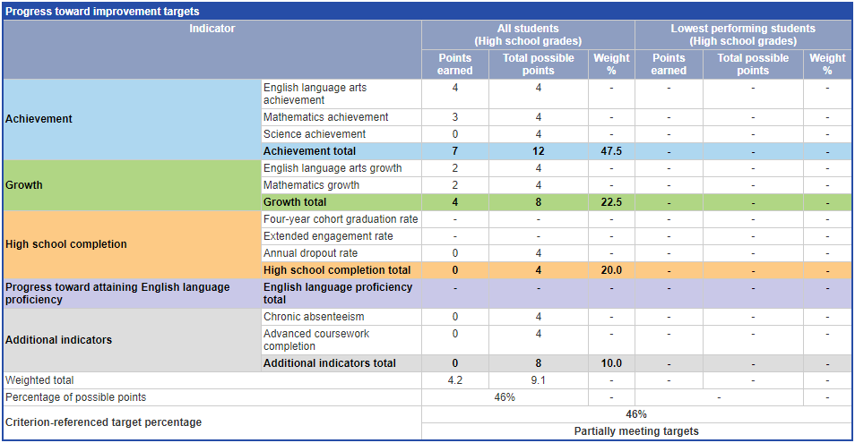

## Results for Students in the High Needs Subgroup

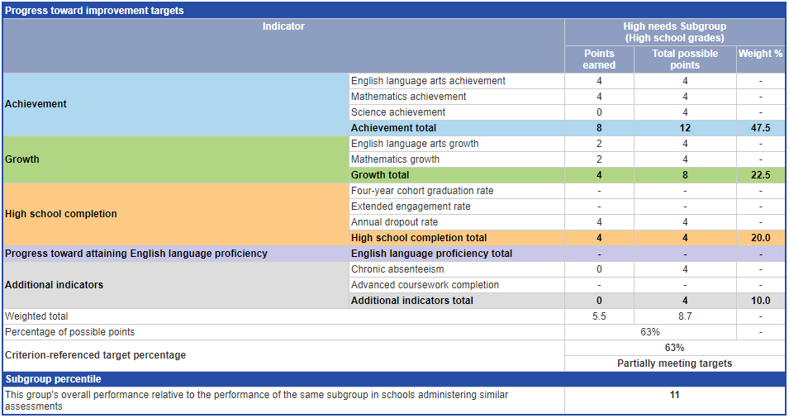

## Detailed Data for Each Indicator

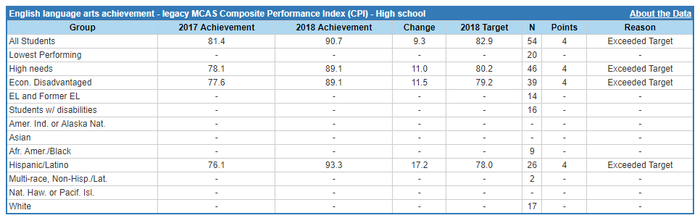

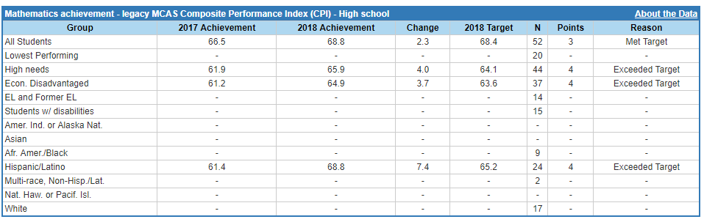

Sci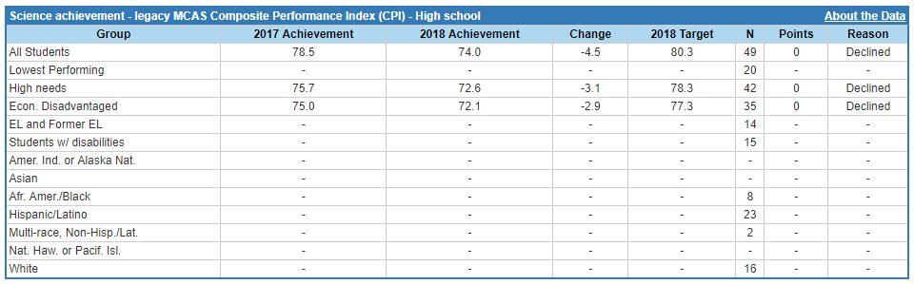

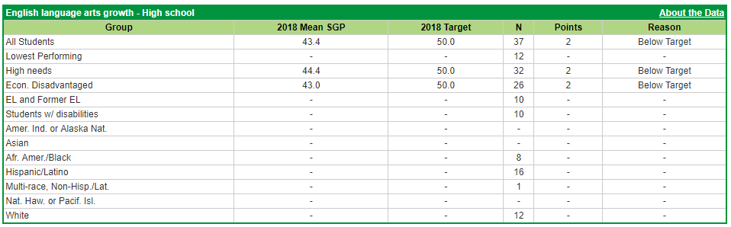

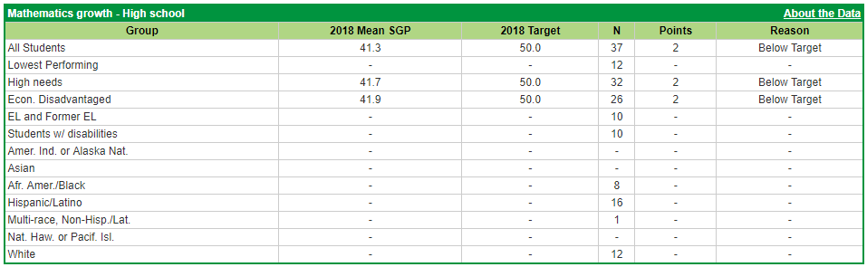

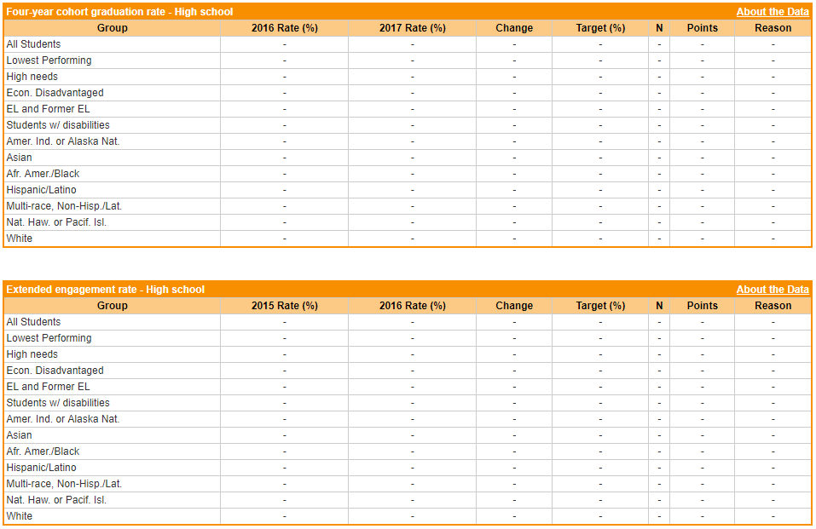

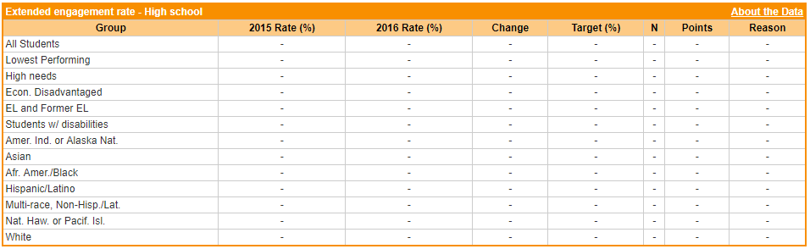

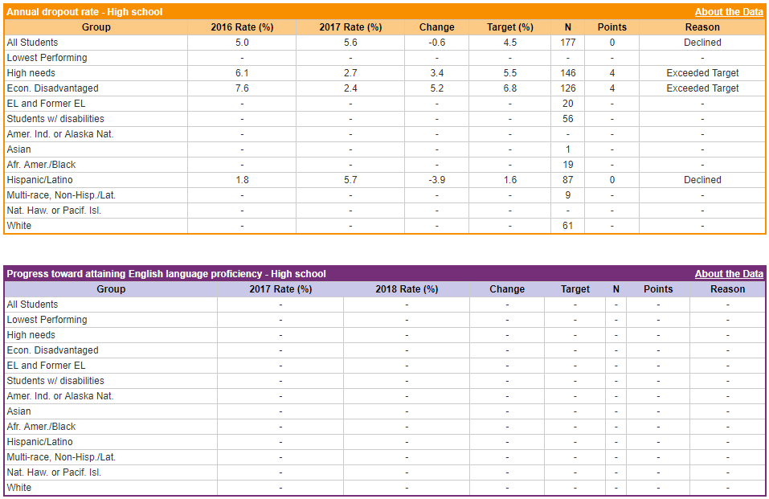

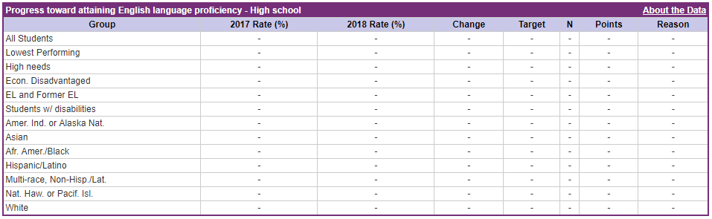

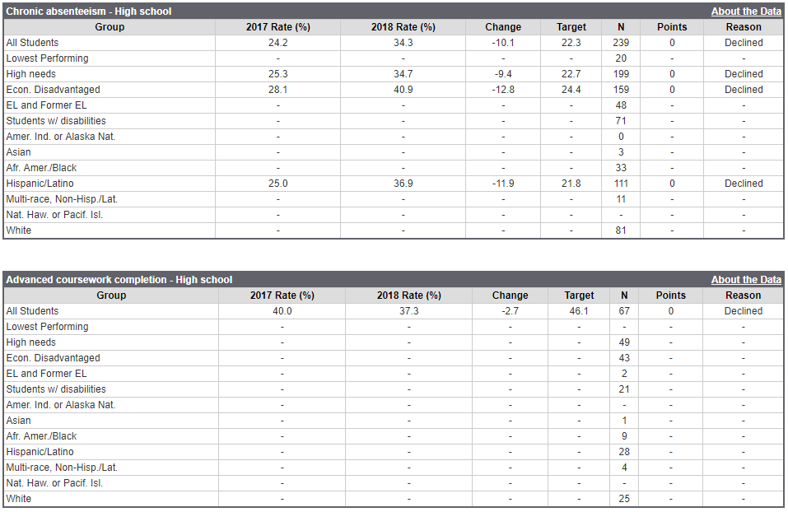

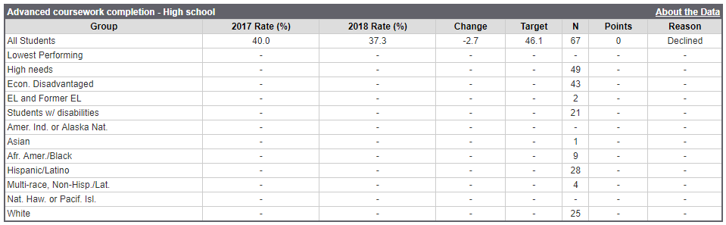

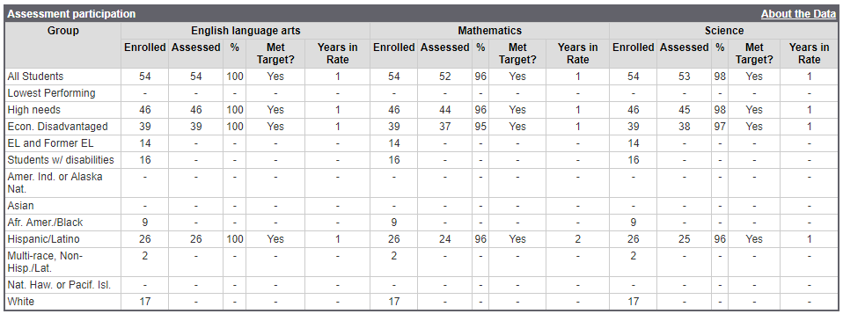

# Appendix D: Finance

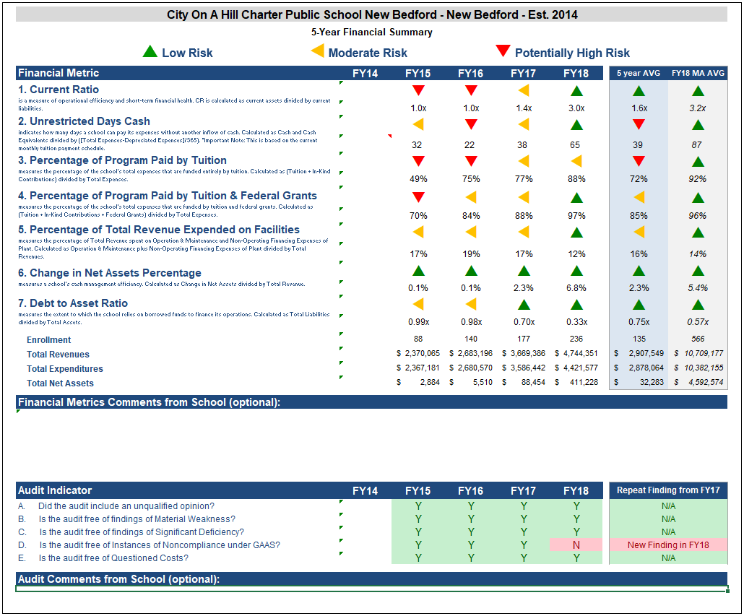

Financial summary definitions

Financial definitions page 2

# Appendix E: Sources of Evidence

* [CoaH NB Academic Performance](http://profiles.doe.mass.edu/mcas/achievement_level.aspx?linkid=32&orgcode=35070000&orgtypecode=5&)
* CoaH NB Accountability Plan performance (2015-2018)
* CoaH NB Annual Reports (2015-2018)
* CoaH NB Board Minutes [November 2017 through October 2018]
* CoaH NB Board Committee Minutes [September 2017 through September 2018]
* CoaH NB Student enrollment data and student indicator data: [DESE Charter Analysis and Review Tool](http://www.doe.mass.edu/charter/finance/chart/) (CHART)
* CoaH NB Recruitment and Retention Plans (2015-18)
* CoaH NB Renewal Application (2018)
* Renewal Inspection Evidence (2018)
* CoaH NB Bylaws
* CoaH NB Handbook
* CoaH NB Recruitment Materials
* CoaH NB Translated Documents
* CoaH NB Staff roster
* CoaH NB Staff qualifications: [Education Personnel Information Management System (EPIMS)](http://www.doe.mass.edu/infoservices/data/epims/); [Educator Licensure and Renewal (ELAR)](http://www.doe.mass.edu/licensure/elar/)
* [CoaH NB Website](https://www.cityonahill.org/our-schools/city-hill-new-bedford/)
* Site Visit Reports for Years One, Two, and Three
* CoaH NB ESL curriculum documents
* CoaH NB teacher evaluation form
* City Project description
* CoaH NB Room Management Chart

# Appendix F: Renewal Inspection Methodology

The following individuals conducted the renewal inspection:

* **Helen Apostolides** is an independent education consultant. She was a school district examiner for the Massachusetts Office of Educational Quality and Accountability (EQA) and participated in numerous school district reviews, underperforming school reviews and charter school renewal inspections. She has over 34 years of experience as a teacher, mentor, and administrator in public education. Before she retired in 2003, she was an elementary school principal for 11 years in Peabody, Massachusetts. She instituted the Skills for Life program at her school, which won national recognition. In addition, her school was the first to collaborate with the Lesley University Literacy Collaborative, restructuring the school’s reading program to the Collaborative’s standards. She also helped facilitate the development of full-day kindergarten throughout the district. She was an assistant principal for 14 years and a classroom teacher in numerous grade levels. She has a Master of Education degree in elementary education from Boston State College and a Master of Teaching degree in history on the secondary level from Salem State College. She received the Pride of Peabody award in 2003 and was a semi-finalist in Massachusetts in NASA’s Teacher in Space Program.
* **Christine Brandt** is an independent education consultant. Her recent experience includes leading school inspections in Massachusetts, New York, Michigan, Ohio, and the United Arab Emirates-Dubai. She is currently a district review coordinator for the New York Department of Education, and the Massachusetts Department of Elementary and Secondary Education. She has been an educator for over 40 years, serving as a classroom teacher, special educator, and elementary school principal. She began her career as a middle school teacher of English, French, moderate special needs, and reading. She served as elementary school principal for 18 years, first in Wellesley and then in Dover, Massachusetts. Her experience in charter schools includes serving as lower school coordinator for the Somerville Charter School. For several years she served as the federal and legislative liaison for the Massachusetts Elementary School Principals Association. She earned her undergraduate degree from Regis College and her graduate degrees from the University of Massachusetts at Lowell in Reading and Learning Disabilities and from Northeastern University in Leadership in Education.
* **Ellen Barol** has more than 30 years or educational experience, first as a teacher and then as an administrator at the secondary level.  She spent 20 years in the classroom, during which she taught classes at all levels and in several content areas.  She also created and ran dropout prevention programs for at-risk students. For the next ten years, as Administrator for Academic Programs at Falmouth High School, her responsibilities included developing and monitoring school-wide curricular, instructional, and programmatic initiatives. After retiring in 2006, she joined Class Measures. She has been a leader or team member in charter school reviews in Massachusetts and New York and is also an instructional consultant to teachers seeking initial licensure.
* **F. Daniel Ahern, Jr.** and **Pamela Bloomfield,** principals of Clarus Group, provided quality assurance and editorial advice regarding drafts of this report.

The two-day full criteria renewal inspection was conducted at CoaH NB on October 15-16, 2018. The renewal inspection team (the team) held focus group interviews, conducted classroom observations, and reviewed documents and other information listed in *Appendix E: Sources of Evidence*.

The team conducted interviews with the following stakeholder groups:

* Board of trustees: four board members, including the chair and the vice-chair.
* Administrative team: two administrators, including the principal and the vice principal of instruction.
* Teachers: eight teachers, including teachers representing grades 9, 10, 11, 12, and the following content areas: geometry and algebra I, algebra II, pre-calculus, physics, world history, City Project, and English.
* Special education and English as a second language (ESL) administrators: one special education administrator and one ESL administrator, and the vice principal of instruction (supervisor of the new special education administrator).
* Staff providing services for students with disabilities and English learners: three staff members, including two special education teachers and one ESL teacher. Staff members interviewed had worked at the school for as few as one year and as many as four years.
* Student and family support staff: three staff members, including the nurse, the dean of citizenship, and the mental health counselor.
* Parents/caregivers: six individuals representing students in grades 9, 10 and 11.
* Students: five students, including students in grades 10 and 11. Students interviewed had attended the school for as few as two years and as many as three years.

The team conducted 26 classroom observations and recorded evidence of what they saw using a classroom observation form developed by the Office of Charter Schools and School Redesign. The form is aligned with the areas of inquiry referenced in the section *Key Indicator 6.2: Instruction* of this report. Team members observed classrooms in grades 9 through 12 and in a variety of content areas, including English, chemistry, biology, marine biology, physics, math intervention and math revisit, geometry, algebra, world history, City Project, technology, and freshman seminar. Team members also observed three special education classes and three ESL classes.

The renewal inspection schedule is included on the following page.

## City on a Hill New Bedford Renewal Inspection Schedule

October 15, 2018

|  | **Team Member 1** | **Team Member 2** | **Team Member 3** |
| --- | --- | --- | --- |
| 7:30-8:00 | Team Meeting and Meeting with Head(s) of School | | |
| 8:00-9:00 | Classroom Observations and Document Review | | |
| 9:00-10:00 | Classroom Observations | Network Focus Group | |
| 10:00-11:00 | Board of Trustees Focus Group | | Classroom Observations |
| 11:00-12:00 | Classroom Observations | SPED and ELL Admin Focus Group | |
| 12:00-1:00 | Lunch | | |
| 1:00-2:00 | Student Support and Family Services Focus Group | | Classroom Observations |
| 2:00-3:00 | Classroom Observations | SPED and ELL Teachers Focus Group | |
| 3:00-4:00 | Families Focus Group | | Classroom Observations |
| 4:00-4:45 | Team Moderation | | |

October 16, 2018

|  | **Team Member 1** | **Team Member 2** | **Team Member 3** |
| --- | --- | --- | --- |
| 7:30-8:00 | Team Meeting and Meeting with Head(s) of School | | |
| 8:00-9:00 | Administrator Focus Group | | Classroom Observations |
| 9:00-10:00 | Classroom Observations and Document Review | | |
| 10:00-11:00 | Classroom Observations | Teachers Focus Group | |
| 11:00-12:00 | Student Focus Group | | Classroom Observations |
| 12:00-1:00 | Lunch | | |
| 1:00-2:00 | Classroom Observations | | |
| 2:00-4:00 | Team Moderation | | |
| 5:00 | Exit Discussion with Head(s) of School | | |

# Appendix G: School’s response to summary of review



Mr. Jeffery C. Riley, Commissioner Elementary and Secondary Education 75 Pleasant St.

Malden, MA 02148-4906

January 9, 2019

**Re: Response of City on a Hill New Bedford to the Summary of Review**

Dear Commissioner of Elementary and Secondary Education:

City on a Hill New Bedford (CoaH NB) would like to submit an additional statement in response to the Summary of Review on its Renewal Application.

At CoaH NB, we recognize that we have had challenges in our first charter term, but we believe that we have made significant changes to address these concerns. We want to be sure that these are fully considered in your decision. Given another term, we are confident we will be successful at implementing our mission with fidelity and partnering with our students and families to achieve academic success.

While our school has the benefit of the support from a Network in our sister schools in Boston, teaching and learning is an inherently local process. Although our two Roxbury campuses are mere minutes apart, New Bedford is a different community all together and we acknowledge that this required more local understanding on our part than was originally anticipated when the decision was made to expand to a different gateway city.

Just as when the original City on a Hill application was submitted in 1994, beginning a new school from the ground up is not easy work. Nevertheless, it is work in which we eagerly engage so that our students and families have more educational choices in New Bedford. Students and families who choose our school benefit from a small and collegial environment and succeed in a unique, college-bound and citizenship focused culture that is different than other high school options in “The Whaling City.”

During our first charter term in New Bedford, we have learned that the needs of our students in New Bedford are not identical to the needs of our students in Boston. We have also begun to learn how best to leverage our Network to support all three schools.

To support this work, our Board has transitioned the leadership of our New Bedford school, as well as the leadership of our Network team. Specifically, to help ensure that New Bedford has the focus it needs, we hired in July 2018 a new permanent CEO, Kevin T. Taylor, who has a background of living and pastoring in New Bedford from 2015-2017. Our goal was to ensure that we had a CEO with a firsthand understanding of the New Bedford community. In his first few months, Mr. Taylor has already made significant changes to help improve CoaH NB. This has included both continuing changes that were already in process and implementing additional

supports for New Bedford, along with establishing and re-establishing relationships with elected officials and community and civic leaders.

Further, though we understand that the charter renewal process necessarily looks back at the first four years of the charter term, we hope that you will also consider the work being done since July 2018 -- the fifth year of the charter term -- to ensure CoaH NB’s long-term success. These changes have been wide-ranging and include, but are not limited to:

* Seeking to improve academic outcomes by implementing specialist led content specific coaching for English, Math, History, and Science
* Recognizing that we have a significantly higher proportion of students with special needs than either New Bedford Public Schools or our Boston CoaH schools and partnering with Landmark Schools to consult on professional development to ensure that our teachers are best prepared to support our diverse learners
* In October 2018, hiring a new Chief Academic Officer with a demonstrated track record of successfully leading school turnaround work in charter schools to help ensure that we are making the changes necessary to see meaningful growth
* Piloting a new curriculum for our ninth grade students
* Rethinking and implementing new assessment programs and discipline data tracking systems to help ensure that both our academic instruction and social-emotional supports for students are data driven and focus on leading, rather than lagging, indicators so we can make mid-course corrections as needed to our programming

At CoaH NB, we do not shy away from making difficult decisions when we need to improve our programs. When making a decision about whether to renew our charter, we ask that you consider the improvement of our Board governance over our charter term as an example of our ability to successfully implement change and achieve success.

A little over a year ago, our Board recognized that it needed additional support and coaching. Our Board immediately considered and put in place the conditions to improve, hiring an interim Executive Director for the organization and hiring a Board governance consultant to support the improvement process. Working with the consultant and the interim Executive Director, the Board was able to improve its governance practices and successfully hire its new CEO, receiving a “meets expectations” rating in the October 2018 charter renewal inspection process. Given the opportunity, we believe that we will be able to achieve the same success on all of the charter school performance criteria.

We would like to specifically address our “Mission and Key” design element rating. We believe that this rating does not presently reflect the entirety of our mission driven work. Our mission is to graduate responsible, resourceful and respectful democratic citizens prepared for college and to advance community, culture, and commerce and to compete in the 21st century. Our key design elements are academic achievement, citizenship, teacher leadership, and public accountability. We have already acknowledged challenges related to academic achievement, but we wholeheartedly believe the balance of evidence in the Summary of Review supports successful implementation of the remaining key design elements. Examples cited in the report include: dual enrollment programs with Bristol Community College; two full-time college counselors; college visits; assistance with college applications and financial aid; local field trips; and local internships, among other aspects of our design elements.

Evidence in the report cited in support of our citizenship key design element includes daily advisories; classes in civics; school-wide town meetings led by students; student government opportunities; senior City Projects; community service graduation requirements, as well as school-wide community service days, and an annual trip to Washington, D.C. We do not believe the report sufficiently clarifies our City Project program, which is a graduation requirement. All seniors are required to design and to complete a yearlong research and community service- based project in the New Bedford community. This helps students prepare for the more independent work of college, gives our students an opportunity to live our citizenship mission element, and helps ensure public accountability for our program. Recent project examples include one project focused on health care in New Bedford and a second focused on engineering in New Bedford.

Speaking of our core values, one of the tenants of City on a Hill since our inception is that we would not engage in social promotion of students. As a practical matter, what this means to us is that if we believe a student is not ready to progress to the next grade or to graduate, we will not progress or graduate that student. Instead, we will continue working with that student to ensure the student is prepared to succeed. This is a critical part of what we mean by academic achievement and public accountability and how we see these two design elements working together.

Further evidence of teacher leadership and public accountability are also cited throughout the report and we ask you to consider those together in making your determination.

In closing, when coming to your final decision about whether to recommend a second charter term, we reiterate our request that you consider the significant changes we have made to address our challenges, our track record of making tough decisions and improving over time, and the full scope of evidence to support our school living its mission.

Given the opportunity of a second charter term, we are confident we will be successful at implementing our mission with fidelity and partnering with our students and families to achieve academic success. We ask for the opportunity to make this a reality in New Bedford.

Sincerely, Kevin Taylor

Chief Executive Officer

City on a Hill New Bedford Charter Public School

1. The renewal inspection to City on a Hill New Bedford was conducted by Class Measures on October 15-16, 2018.
2. Descriptions of evidence gathered during the renewal inspection constitute the renewal inspection report referenced in 603 CMR 1.11.
3. This is the number as of October 1, 2018. Source: [Profiles](http://profiles.doe.mass.edu/profiles/student.aspx?orgcode=35070000&orgtypecode=5&)
4. This is the number as of March 15, 2018, Source: [Massachusetts Charter School Waitlist Initial Report for FY 2019](http://www.doe.mass.edu/charter/enrollment/)
5. Source: [Profiles](http://profiles.doe.mass.edu/profiles/student.aspx?orgcode=35070000&orgtypecode=5&leftNavId=300&)
6. Source: [Profiles](http://profiles.doe.mass.edu/profiles/student.aspx?orgcode=35070000&orgtypecode=5&leftNavId=305&)
7. Rating Key:

   ** Exceeds:** The school fully and consistently meets the criterion and is a potential exemplar in this area.

   ** Meets:** The school generally meets the criterion and/or minor concern(s) are noted.

   ** Partially Meets:** The school meets some aspects of the criterion but not others and/or moderate concern(s) are noted.

   ** Falls Far Below:** The school falls far below the criterion and/or significant concerns are noted.
8. See *Appendix C: Student Performance*
9. Source: [Profiles](http://profiles.doe.mass.edu/profiles/student.aspx?orgcode=35070000&orgtypecode=5&leftNavId=16818&&fycode=2018)
10. See *Appendix C: Student Performance*
11. See *Criterion 2: Access and Equity*
12. See: *Criterion 5: Student Performance*
13. A school’s enrollment of a particular subgroup is determined to be comparable if the percentage is equal to or greater than the Comparison Index, a figure derived from data of students who reside within the charter school’s sending district(s). The Comparison Index is explained in further detail in *Appendix B: Access and Equity*.
14. Source: [Profiles](http://profiles.doe.mass.edu/ssdr/default.aspx?orgcode=35070505&orgtypecode=6&=35070505&)
15. New statutory provisions related to Criterion 2 were established in 2010, and as specified in regulation, charter schools were first required to implement recruitment and retention plans in 2011-2012. Charter schools are required to receive Department approval for a recruitment and retention plan to be reported on and updated annually. When deciding on charter renewal, the commissioner and the Board must consider the extent to which the school has followed its recruitment and retention plan by using deliberate, specific strategies to recruit and retain students in targeted subgroups, whether the school has enhanced its plan as necessary, and the annual attrition of students.
16. 2014-2015 is the first year for which the category “Economically Disadvantaged” is being reported, replacing the “Low-income,” “Free Lunch” and “Reduced Lunch” categories used in 2013-2014 and earlier. It is important for users of this data to understand that enrollment percentages and achievement data for "economically disadvantaged" students cannot be directly compared to "Low-income" data in prior years. Please see <http://www.doe.mass.edu/infoservices/data/ed.html> for important information about the “Economically Disadvantaged” category.
17. The midpoint value of all comparison schools. This is derived using Microsoft Excel's MEDIAN function.
18. The first quartile is the middle number between the smallest number and the median of all comparison schools. This is derived using Microsoft Excel's QUARTILE function.
19. The Comparison Index provides a comparison figure derived from data of students who reside within the charter school’s sending district(s). The Comparison Index is a statistically calculated value designed to produce a fairer and more realistic comparison measure that takes into account the charter school’s size and the actual prevalence of student subgroups within only those grade levels in common with the charter school.
20. The Gap Narrowing Target (GNT) refers to the halfway point between the school’s baseline rate (which is the rate in the 2010-11 school year, or the first year enrollment data is collected if after 2010-11,) and the current Comparison Index (the “target”). The object is to meet this halfway point by the 2016-17 school year (or in a later year if baseline is after 2010-11), giving the school six years to do so. For a school to be on schedule to meet its GNT, an incremental increase must be met annually. To determine this increment, the following equation is used: [(Comparison Index – Baseline) / 2] / 6 years = Annual GNT.
21. The percentage of attrition, or rate at which enrolled students leave the school between the end of one school year and the beginning of the next.
22. A student is high needs if he or she is designated as either low income, or ELL, or former ELL, or a student with disabilities. A former ELL student is a student not currently an ELL, but had been at some point in the two previous academic years.
23. The percentage of enrolled students in grades 1-2 who were repeating the grade in which they were enrolled the previous year.
24. The Stability Rate measures how many students remain in a district or school throughout the school year.
25. District percentages are not included for attrition since attrition at the district level cannot be reasonably compared to attrition at the school level.
26. The midpoint value of all comparison schools. This is derived using Microsoft Excel's MEDIAN function.
27. The first quartile is the middle number between the smallest number and the median of all comparison schools. This is derived using Microsoft Excel's QUARTILE function.