Massachusetts Department of

Elementary and Secondary Education

75 Pleasant Street, Malden, Massachusetts 02148-4906 Telephone: (781) 338-3000 TTY: N.E.T. Relay 1-800-439-2370

Jeffrey C. Riley
Commissioner

MEMORANDUM

To: | Members of the Board of Elementary and Secondary Education
From: | Jeffrey C. Riley, Commissioner
Date: | October 17, 2023
Subject: | Update on Chronically Underperforming Schools: SY2023-2024 Quarter 1 Reports

This month, I am presenting the first of four SY2023-2024 quarterly progress updates to the Board of Elementary and Secondary Education (Board) on the three chronically underperforming schools’ implementations of their school turnaround plans, focusing on activities from July to October 2023. Future quarterly updates for SY2023-2024 will be presented in January 2024 and April 2024, and a final annual review in June 2024.

SY2022-2023 accountability data has been included for your reference.

Chronically Underperforming Schools
In the fall of 2013, four schools were designated as chronically underperforming in response to their low performance and lack of improvement while in underperforming status: John P. Holland Elementary School (UP Academy Holland) and Paul A. Dever Elementary School (Dever) in Boston, Morgan Full Service Community School (Morgan) in Holyoke, and John Avery Parker Elementary School (Parker) in New Bedford.

In September 2022, I exercised my authority under 603 CMR 2.06 (10)(d) to remove the chronically underperforming status from the Morgan Full Service Community School in Holyoke on the basis of the district’s concurrent designation as chronically underperforming. With this technical change, the ongoing strategic transformation efforts at Morgan are fully aligned with and supported by Holyoke’s district turnaround plan. As a result, this update and future quarterly updates include information on the three remaining chronically underperforming schools: UP Academy Holland, Dever, and Parker.

Strategic Planning with School Empowerment Network

During the summer of 2023, the Department of Elementary and Secondary Education’s Office of Strategic Transformation (OST) and the School Empowerment Network (SEN) engaged school leaders of the three chronically underperforming schools in a robust strategic planning process to create one-year implementation plans for their schools, aligned to their turnaround plans. This process included at least four meetings with each school leader between May and September to discuss school goals, areas for growth, and specific actions intended to advance student achievement and racial equity this school year.

Throughout the year, OST will meet regularly with school leaders of the chronically underperforming schools to discuss progress on school action plans and benchmarks and provide targeted supports. Updates on the focus areas of each school’s action plan are summarized below.

Updates on the Chronically Underperforming Schools

Paul A. Dever Elementary School, Boston. The Paul A. Dever Elementary (Dever) opened school with School & Main Institute (SMI) returning as receiver for the fourth year and Margaret Reardon beginning her fourth year as principal. Principal Reardon’s leadership team in school year 2023-2024 includes three new administrators.

Dever school leaders engaged with OST and SEN in a series of strategic planning meetings between June 2023 and September 2023. This process enabled the Receiver and Principal Reardon to onboard the new administrators, clarify their roles, and calibrate on the school’s vision for instruction. The school’s overarching goal is to create transformative learning experiences for all members of the community by fostering a sense of unconditional belonging for students, families, and staff.

To create transformative learning experiences for students and staff, school leaders will continue to build teachers’ capacities to effectively enact Dever’s core curricula and culturally responsive pedagogy. Specific goals include prioritizing academic discourse in lesson planning, advancing teachers’ skills in assessing and responding to student understandings in the moment, and frequently monitoring the quality and fidelity of teachers’ curriculum implementation through classroom walkthroughs.

To promote a sense of unconditional belonging among all Dever community members, school leaders have engaged a consultant to support the instructional leadership team in centering equity in its continuous improvement efforts and to increase teacher team efficacy across the school. School leaders also have established goals for increasing family and community involvement and will be measuring progress using student attendance data and a family survey that will be administered twice during the year. To foster student belonging, the school will focus on using restorative practices, enacting social-emotional learning curricula, and strengthening students’ out-of-classroom experiences through partnerships with families and community organizations.
UP Academy Holland, Boston. Victoria Thompson is in her fifth year as principal of UP Academy Holland (UAH). UP Education Network continues to serve as the school’s receiver. OST and SEN met with Principal Thompson from June 2023 through September 2023 to create the year’s strategic plan.

Following review of data from School Quality Reviews (SQRs), classroom observations and student assessments, the UAH team centered their 2023-2024 strategic plan around the following priorities: building students’ conceptual understandings in core instruction; bolstering academic interventions to enable all students to access rigorous grade-level instruction; introducing a new social-emotional learning (SEL) curriculum, and expanding the use of restorative practices across all grade levels.

To build teachers’ capacities to teach toward conceptual understandings, school leaders have developed a research-based framework for conceptual understanding that draws resources from the school’s high-quality instructional materials. School leaders are grounding their year-round instructional professional development for teachers in this new framework. In addition, school leaders have revised the school’s lesson planning protocol to support the strategic focus on building students’ conceptual understandings throughout lessons. UAH teachers will continue to receive feedback on their implementation of schoolwide academic expectations through a robust observation and feedback system.

In addition to launching the new framework for building conceptual understandings, school leaders also provided summer professional learning sessions on the school’s new SEL curriculum, the academic intervention system, and the restorative practices expectations and procedures.

John Avery Parker Elementary School, New Bedford. The John Avery Parker Elementary (Parker) opened the 2023-2024 school year with School & Main Institute (SMI) returning for its sixth year as receiver and Amy (Bousquet) Tavares entering her third year as principal. Principal Tavares’ leadership team for the 2023-2024 school year includes a new Assistant Principal.

School leaders engaged with OST and SEN in a series of strategic planning meetings from June 2023 through September 2023. Based on a review of student achievement data and SQR results, school leaders identified three strategic priorities for SY2023-2024. The first priority is to establish a differentiated professional development system to develop and support all educators. This system will include team-based coaching cycles and peer observations to leverage the expertise of the teaching staff. As a second strategic priority, school leaders and teacher teams will refine and revise all curriculum maps to ensure they are grounded in research and promote deeper learning. The school will continue to integrate pedagogical strategies from systemic functional linguistics into instruction across all content areas. Finally, Parker leaders have prioritized building teachers’ capacities to continuously monitor and respond to student understanding throughout lessons. School leaders will facilitate professional development on strategies to confer with students and uses of formative assessment data. At the school level, the leadership team will convene bi-weekly academic review meetings to analyze student-level, classroom, and schoolwide data to plan responsive adjustments to curriculum and instruction.

MCAS and Accountability Data 2023

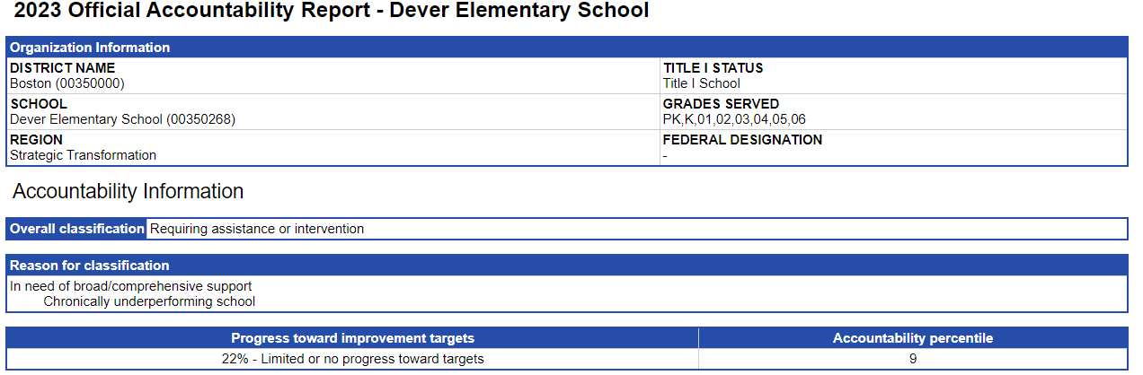
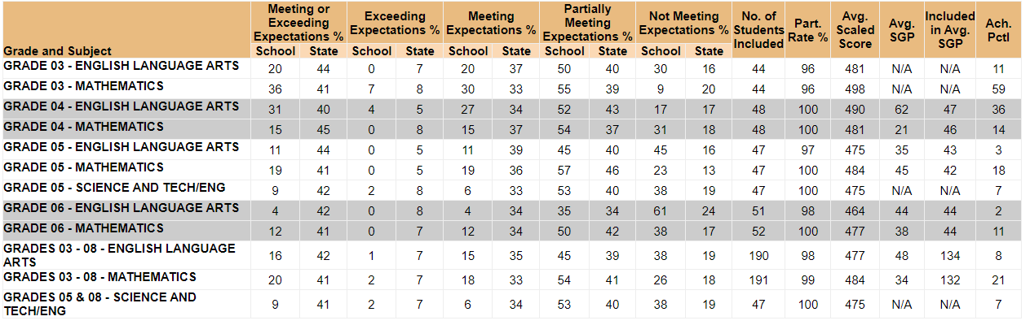

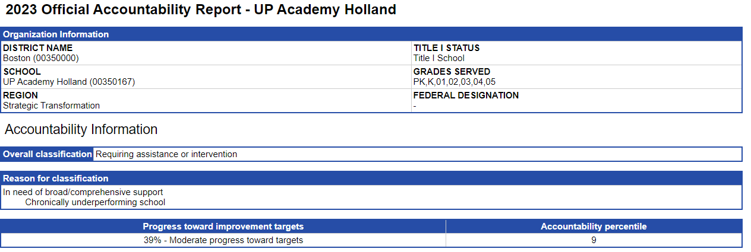

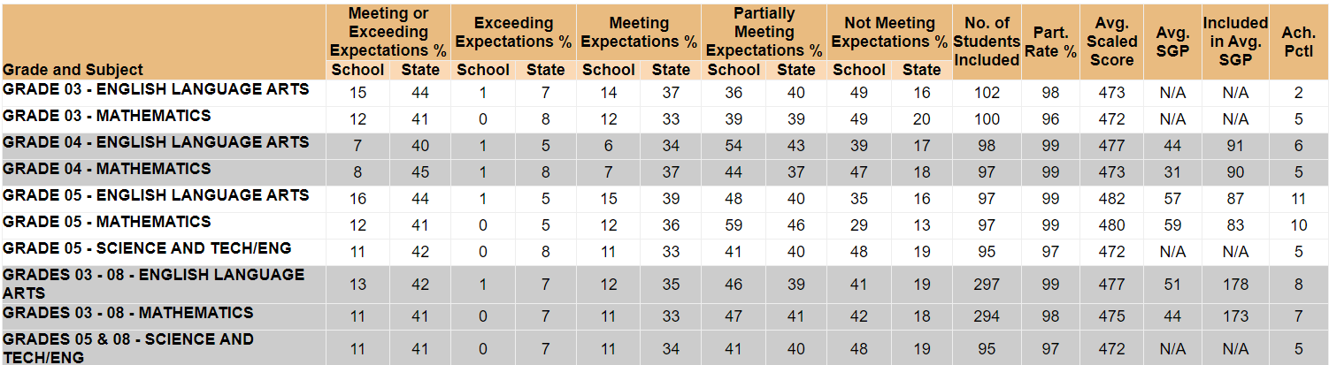

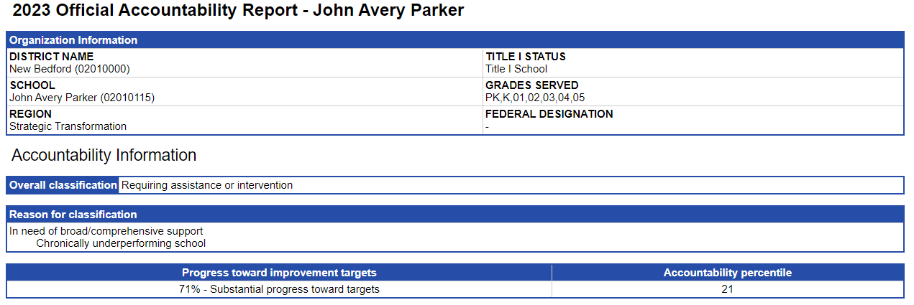

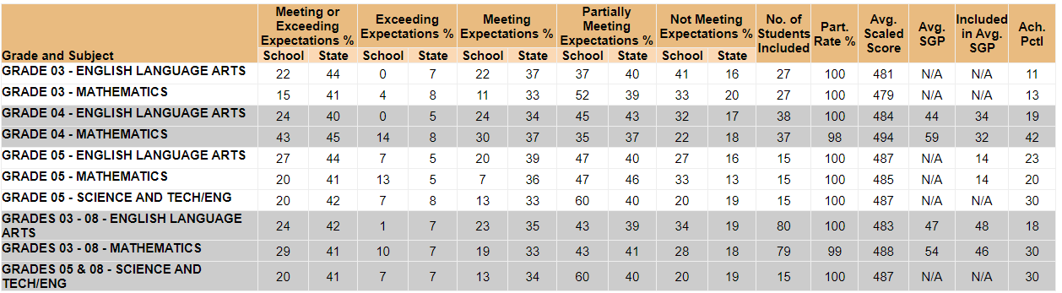

The September 26, 2022 letter announcing the change in designation for Morgan may be found here: https://www.doe.mass.edu/level5/schools/morgan.html.

