Edwin FAFSA Reports
December 2023
FAFSA reports in Edwin for current high school seniors should be available starting in January 2024.
To apply for federal and state financial student aid, such as Pell Grant grants, Work Study, and educational loans, students are required to complete the Free Application for Federal Student Aid (FAFSA®) form. Completing and submitting the FAFSA form is free and easier than ever, and it gives access to the largest source of financial aid to pay for postsecondary education.
The Massachusetts Departments of Elementary and Secondary Education and the Department of Higher Education, in partnership with the Massachusetts Executive Office of Education, have developed reports that allows schools and districts to monitor the status of student submission and completion of FAFSA. School counselors and other educators can use this alongside other college and career readiness resources to support students in the college application process.
Two FAFSA reports will be available for districts and high schools in EDWIN Analytics: FAFSA Completion Report Summary CR307and FAFSA Completion Report Detail CR607.
The reports are compiled from FAFSA data from the US Department of Education via the Massachusetts Department of Higher Education matched to data submitted by districts, such as Student Information Management System (SIMS) and other sources. The information is dynamic and updated weekly; as a result, representation may change from what was shown in an earlier reporting period. The date the FAFSA data was updated is noted on both reports. Matching techniques have been applied to current high school student records to maximize identification of students. Despite these matching techniques, there may be unmatched records; the reports may list some students as “Not Found” although they have completed a FAFSA. For school year 2023-4, the reports include demographic information to help set goals and improve equitable outcomes.

Access to Edwin Analytics
Both FAFSA reports are in Edwin. Access to Edwin is determined on the school and district level by a directory administrator. District and/or School “Administrator Role”, which allows for access to student level data, is necessary to view FAFSA Completion Report Detail and most helpful to fully use both reports.

How do I find these reports?
There are several ways to find the reports. The first is to type FAFSA into the Search in Edwin; you will find your choice of the two reports.
Another option is to click on the High School & Beyond folder, then the Postsecondary Readiness folder:
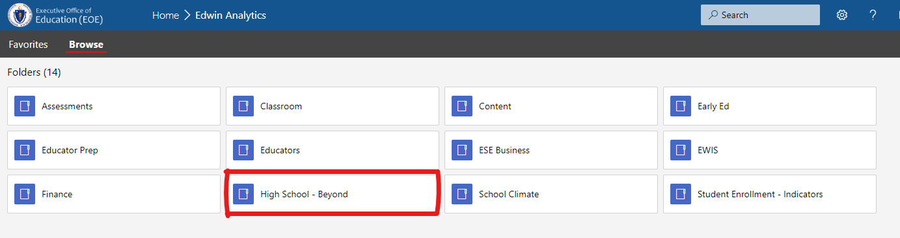
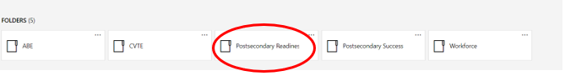
A note on the FAFSA process and the terminology in these reports:
When students submit a FAFSA, the US Department of Education marks it as ‘Complete’ or ‘Incomplete’. FAFSAs marked Incomplete may have some level of detail from US Department of Education about what, specifically, is incomplete. These reasons may include one or more of the following: No Signature, SSN and/or Name Mismatch, and Missing Information. If no FAFSA is found for a 12th grade student (or beyond grade 12 special education student) enrolled in Massachusetts public high school, it is reported as Not Found. This could mean that a student has yet to submit a FAFSA, or that no submitted FAFSA was found with the matching techniques used for this report. The user should discuss this situation with the student.

FAFSA Completion Report Summary (CR307)
Selecting the FAFSA Completion Report Summary should open with the prompts defaulting to your school/district and the most recent year.

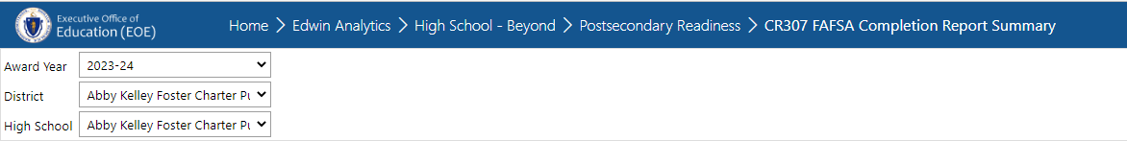

You can adjust the prompts if needed. FAFSA data will be available in January 2024 for the 2024-25 Award Year, which is the current FAFSA application cycle prospective college students are filing to attend postsecondary between July 1, 2024 and June 30, 2025. After making any changes to the prompt section, click ‘View Report’ to display the report.
The FAFSA Completion Report Summary gives an overview of FAFSA completion for the school(s) and district selected. This summary includes the number of FAFSA’s Submitted, and a breakdown of the number Completed, Not Completed and Not Found. The percentages shown are based on the number of 12th or SP student enrolled in your district according to student claiming. If you have access to student level data, the school name is a blue hyperlink; clicking on this link will bring you to the FAFSA Completion Report Detail for these students.
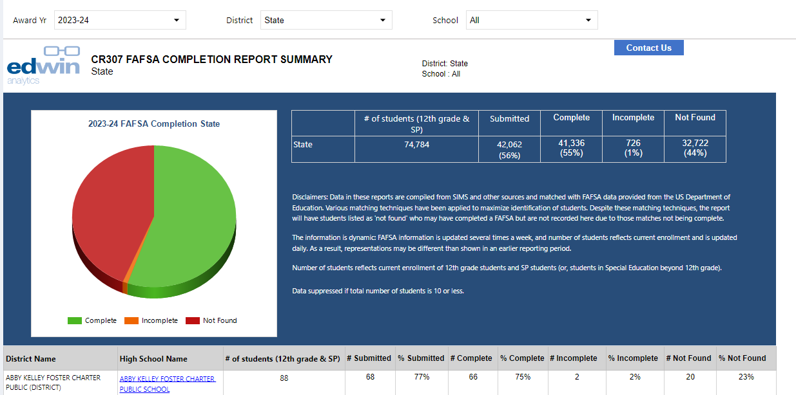

FAFSA Completion Report Detail (CR607)
The FAFSA Completion Report Detail has a prompt section interface and filter similar to the summary report, with the option to choose one or any number of high schools (for districts with multiple high schools) and select FAFSA status (e.g. only identify students with Incomplete FAFSAs). After filling out the prompt page, click ‘View Report’ for the report.
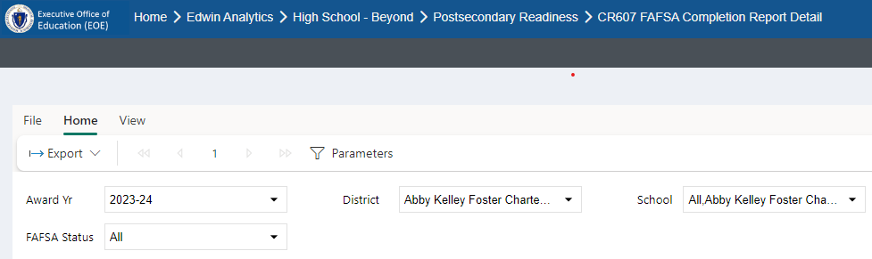

In the example below, a user can see the student name and SASID with the completion status. The report also includes subgroup information and dates of FAFSA submission and completion to better target and set goals around equity for all students.
First Name | Last Name | MI | SASID | DOB | Gender | Race | Low Income | ELL | SWD | High Needs | FAFSA Completion Date | Submitted FAFSA | Status | FAFSA Detail
 |  |  | 1111111111 | 01/0105 | F | White | Low Income | N | N | Y | 06/09/2023 | Y | Complete
 |  |  | 1111111111 | 01/0105 | F | Hispanic/Latino | Non-Low Income | N | N | N | 10/25/2022 | Y | Complete
 |  |  | 1111111111 | 01/0105 | M | Black/African American | Low Income | N | N | Y | 02/15/2023 | Y | Complete
 |  |  | 1111111111 | 01/0105 | F | Black/African American | Low Income | N | N | Y | 10/08/2022 | Y | Incomplete | missing information
 |  |  | 1111111111 | 01/0105 | M | Hispanic/Latino | Non-Low Income | N | N | N | 01/02/2023 | Y | Not Found
 |  |  | 1111111111 | 01/0105 | M | Black/African American | Non-Low Income | N | N | N | 11/13/2022 | Y | Not Found

The SASID is a blue hyperlink; clicking on this link brings a user to the PR600 Student Profile Report with details of that student’s academic history. Remember, students with status listed as ‘Not Found’ in some cases may have completed FAFSA but were not matched to other records in the matching algorithm.

Additional Non-Matched Students:
This report now includes students who submitted a FAFSA and reported your high school on their FAFSA although according to our algorithm were not matched to students currently enrolled in your high school. They appear at the end of the report in their own table. As these data are not matched to SIMS data, additional demographic information is not available.

These Additional Non-Matched Students submitted a FAFSA but the information they entered could not be matched to a SASID through our automated process (e.g., their DOB was different, variations in name spellings). The students in this table may correspond to students identified as ''not found'' in the main table of the report. They may also include former students who are not currently enrolled in your school. You may use this information for your internal tracking of FAFSA completion. If you realize that information for a current student in your Student Information System is incorrect (e.g. your Student Information System has the wrong DOB), corrections made in your system may enable the automated process to match the student in the future.
First Name | Last Name | MI | SASID | DOB | Gender | FAFSA Completion Date | Submitted FAFSA | Status
Al | Jones | Z |  | 06/24/04 | F | 04/17/2023 | Y | Complete
Jay | Rojas | J |  | 06/25/04 | M | 05/01/2023 | Y | Complete
John | Adams | M |  | 06/26/04 | M | 04/30/2023 | Y | Complete
Ann | Holt | R |  | 06/27/04 | F | 01/24/2023 | Y | Complete

Frequently Asked Questions
How are the Edwin reports aligned to or different from the federal report?
Federal reports are available at this link:
https://studentaid.gov/data-center/student/application-volume/fafsa-completion-high-school

The federal reports include an aggregate view and are based on high schools as reported by students, so a high school may have multiple entries if a student reports alternative versions of a high school’s name. Completion rates are calculated using an estimate of graduating seniors based on data from the National Center of Education Statistics data, and only schools with five or more completions are shown in the report.

The reports in Edwin include student-level and aggregate views of FAFSA completion and completion rates are based on current school enrollment. For students whose FAFSA is incomplete, the student-level report also includes details of what is incomplete. Students are included in the report if they are currently enrolled in your school, although they may have provided a different high school on their form.

The Edwin student-level report also includes students who provided your high school name on their FAFSA, although not currently enrolled in your school based on SASID. These are shown in a different table for clarity and are not counted as part of the completion rate.

How is FAFSA data matched to SIMS data?
A matching algorithm is used to pair students’ federal data to Massachusetts SIMS data for students currently enrolled in 12th grade and Special Education students beyond 12th grade. The matching includes name and date of birth (DOB), so if these differ in the two data sources, the student will be listed as ‘Not Found’. If there is incorrect information (such as name or DOB) in the Edwin reports and that is corrected locally, the match may be improved, and you will see the corrected data in the near future.

Can Edwin reports be downloaded in an Excel format?
Yes, reports can be downloaded. In the prompt bar there is an option called “export” that allows you to download the file in different formats.

What about undocumented parents of a student who has green card/or is a DACA student?
A student who has a “green card” typically means a student is considered an eligible non-citizen. If parents are undocumented, issues may arise if that student is dependent, whereby parental information would be required on FAFSA. If student is independent, parental information is not required on FAFSA. Deferred Action for Childhood Arrivals (DACA) students are not eligible for Federal financial aid, though they may file a FAFSA by virtue of having a Social Security Number. By not qualifying for Federal financial aid, a DACA student is also ineligible for the vast majority of state aid.

If a student accidently did the FAFSA for the previous year instead of this year, will they still be counted as a senior completing their FAFSA? Or because of their mistake, would they be put in the previous graduating class as completing their FAFSA and doing a renewal?
FAFSA Completion reports can be run for the 2019-2020, 2020-21, 2021-22, 2022-23 and 2023-24 award years. Reports for award year 2024-25 will be available starting in January 2024; this award year reflects the high school senior class of 2024.
The 2024-25 report will include current 12th and SP students who submitted a FAFSA for the 2024-25 award year, regardless of if it is an initial or renewal FAFSA.

Can one counselor under special circumstances access student-level data for more than one school or district?
Access to Edwin is determined at the local level. A counselor would need to work with the Edwin Analytics contacts in the schools or districts of interest to discuss access.

If I am non-district personnel, can I access these reports?
K12 education providers of additional services, such as Collaboratives, Special Education Agencies and DYS, can get access to Edwin reports (See http://www.doe.mass.edu/edwin/securityroles.docx). Other non-district staff may work with schools/districts to determine data sharing agreement and access to Edwin reports.

Additional Information
If you have any questions about using this report, please email ewis@doe.mass.edu. For other information about FAFSA or financial aid, please go to the Massachusetts Office of Student Financial Assistance.

