Instructions for School Districts in Reporting Data for Career/Vocational Technical Education

September, 2021

Massachusetts Department of Elementary and Secondary Education

Office for College, Career, and Technical Education
75 Pleasant Street, Malden, MA 02148-4906
781-338-3910 http://www.doe.mass.edu/ccte/cvte/
CCTE@mass.gov

TABLE OF CONTENTS

Instructions for School Districts in Reporting Data for CVTE 3
SECONDARY: SIMS DATA COLLECTION 4
SECONDARY: CVTE GRADUATE FOLLOW-UP 7
CHAPTER 74 VOCATIONAL TECHNICAL EDUCATION POSTSECONDARY AND POSTGRADUATE REPORT 11
Appendix 1: Sample Log for CVTE GRADUATE FOLLOW-UP 13
Appendix 2: Submitting the CHAPTER 74 VOCATIONAL TECHNICAL EDUCATION POSTSECONDARY AND POSTGRADUATE REPORT 14

Instructions for School Districts in Reporting Data for CVTE

What this Document is -
This document was developed by the Massachusetts Department of Elementary and Secondary Education (DESE) Office for College, Career, and Technical Education (CCTE) to assist school districts in submitting data for students enrolled in and completing career/vocational technical education (CVTE) programs. This document is a supplement to the SIMS Data Handbook at https://www.doe.mass.edu/ccte/cvte/data/

Why Submit?
The Strengthening Career and Technical Education in the 21st Century Act and the Massachusetts Vocational Technical Education Regulations 603 CMR 4.00 require that data on student enrollment in and completion of career/vocational technical education programs be submitted for accountability and funding purposes. These must be submitted for districts to be considered for Perkins funding. In addition, state aid is calculated based on students enrolled in Chapter 74-approved vocational technical education programs on October 1.

NOTE:
The Carl D. Perkins Career and Technical Education Improvement Act of 2006 (Public Law 109-270) commonly known as Perkins IV was reauthorized on July 26, 2018. The new law is titled Strengthening Career and Technical Education for the 21st Century Act, also known as Perkins V ("Perkins Five"). In Massachusetts, the Department of Elementary and Secondary Education (DESE) administers Perkins V. Details are covered in the Massachusetts Perkins V Manual available at http://www.doe.mass.edu/ccte/cvte/perkins-v/.

What are the consequences for failure to submit?
Failure to submit data (or corrected/revised data) by the due dates may result in the district being declared ineligible for Perkins funds, and may result in revocation of Chapter 74 program approvals and the loss of state aid for the programs.

When are these due?
With Perkins V, there are some changes to timelines, including the timing of the Graduate Follow-up. Please review the Timelines and other material on the Perkins V website for more. ( http://www.doe.mass.edu/ccte/cvte/perkins-v/)

SECONDARY: SIMS DATA COLLECTION

Student Information Management System (SIMS) is managed by DESE’s Data Collection team. The primary source for guidance regarding SIMS Data Collection is the SIMS Data Handbook (http://www.doe.mass.edu/infoservices/data/sims/). This document is not a replacement for the SIMS Data Handbook; it provides additional guidance regarding CVTE reporting.

Collaboration
It is critical for a district’s CVTE staff to collaborate with their district’s SIMS Contact to ensure that career/vocational technical education data is submitted accurately and on time. Find a districts’ SIMS Contacts on the district’s Profiles page:
- Go to Profiles (http://profiles.doe.mass.edu/).
- Search for a district and open the district’s Profiles page.
- From the General tab, on the left, click on People. A SIMS Contact is listed on the table.

Which Districts Submit CVTE data in SIMS?
A districts meeting any of the following criteria must submit career/vocational technical education data in SIMS:
- A district with secondary-level state-approved vocational technical education program(s) known as Chapter 74-approved vocational technical education program(s);
- a sending district that enrolls students in Chapter 74 vocational technical education programs through a state-approved Chapter 74 Partnership ‘After Dark’ collaboration: and/or
- a district with other secondary-level career/vocational technical education program(s) known as non-Chapter 74 career and technical education program(s). This is a CVTE program that, although not a Chapter 74-approved vocational technical education program, meets the definition of career and technical education in the Perkins Act.

Districts may use the Massachusetts Perkins V Manual and Perkins V Checklist ( http://www.doe.mass.edu/ccte/cvte/perkins-v/) to determine if programs meet this definition. (When auditing data reporting, the DESE uses this checklist to verify that programs meet the definition.)

SIMS Data Elements Specific to Career/Vocational Technical Education
There are eight SIMS data elements designed and collected to better understand career/vocational technical education. These are:
DOE031: Career/Vocational Technical Education - Competency Attainment
DOE035: Career/Vocational Technical Education – Type of Program
DOE042: Career/Vocational Technical Education - Special Populations
DOE043: Career/Vocational Technical Education - Chapter 74-Approved Vocational Technical Education Program Participation
DOE044: Career/Vocational Technical Education - Non-Chapter 74 Career and Technical Education Program Participation
DOE047 Industry Recognized Credentials
DOE048 Industry Recognized Credentials
DOE049 Industry Recognized Credentials

Notes:
- DOE031 captures completion of Chapter 74 and non-Chapter74 programs.
- Industry Recognized Credentials (IRCs) attained by students are reported in DOE047, DOE048 and DOE049. The three elements are identical and allow for up to three IRC’s to be reported per student. They are applicable to students in grades 9 through 12, and cumulative, reflecting the IRC’s attained while in school.
- For more on this, review the SIMS Data Handbook, including Appendix D.
- Several data elements (DOE035, DOE043, DOE044) are used to calculate and report on Perkins concentrators and Core Indicators, the accountability system for federally funded Perkins programs (which includes Chapter 74-approved programs).

Program Participation
Districts should report ‘CVTE Type of Program’ (DOE 035) and ‘CVTE program participation’ (DOE 043 and DOE 044) for students enrolled in CVTE programs. Districts with Chapter 74-approved programs should report students consistent with state-approved Admissions policies; districts with non-Chapter74 programs should report students consistent with program policies.
For example:
- Students enrolled in a Chapter 74-approved Culinary program are reported as enrolled in Chapter-74 Program (DOE035=04); the reported program is Culinary Arts (DOE 043=120500).
- Students enrolled in a non-Chapter 74 (Perkins) Culinary program are reported as enrolled in non-Chapter 74 Program (DOE035=14); the reported program is Culinary Arts (DOE 044=1205).
- Students participating in a state-approved ‘After Dark’ collaboration for a Chapter 74-approved vocational technical education program in Automotive Technology are reported (by the sending district) as enrolled in Chapter 74 Partnership Program (“After Dark”) (DOE35=94); the reported program is Automotive Technology (DOE043=470604).
- Districts with five or more Chapter74-approved programs offer Exploratory, where 9th grade students explore the available programs. These students are reported as enrolled in Chapter-74 Program (DOE 035=04); the reported program is Exploratory (DOE 043=990100).
- Students taking a Chapter 74 or non-Chapter 74 program course as an elective (or otherwise not enrolled in a program) are reported as not enrolled in a career/vocational technical education program. (DOE 035=00).

Establishing Enrollment for non-Chapter 74 (Perkins) Programs
The Department encourages districts to have a clear process of determining which students are enrolled in non-Chapter74 Perkins programs for the purpose of accurate data reporting.
For example
- Students know which Perkins program(s) are available, and have an intention of completing a sequence of courses in at least one Perkins program. These students may be considered enrolled in a program.
- Students may be enrolled in a Perkins program course with the intention of completing a sequence of courses in this program. These students may be considered enrolled in a program.
- Students may be enrolled in a Perkins program course with the intention of taking it as an ‘elective’ only. These students are not considered enrolled in a program.

Students might not be aware of available programs or how they may signal their intention to participate. Districts should inform students of programs available and have a method in place for identifying students wishing to participate.

Notes:
- Nonresident students enrolled in secondary-level Chapter 74-approved vocational technical education programs are reported in the receiving district’s SIMS count.
- Students enrolled in secondary-level Chapter 74-approved vocational technical education programs in the Lower Pioneer Valley Educational Collaborative Career and Technical Education Center are reported in SIMS by the sending districts.

Technical Assistance
If the district SIMS Contact has questions about SIMS reporting, they can contact the appropriate DESE Data Collection Support Specialist at 781-338-3282 or via email at data@doe.mass.edu. A list of DESE Data Collection Support Specialists can be found at http://www.doe.mass.edu/infoservices/data/fts.html.

If district staff have questions regarding career/vocational technical education, they should contact the assigned liaison in the Office for College, Career and Technical Education, found on this list. http://www.doe.mass.edu/ccte/cvte/liaisons.html

SECONDARY: CVTE GRADUATE FOLLOW-UP

Districts conduct a Career/Vocational Technical Education Graduate Follow-up of graduates. This is used to calculate and report on a Perkins V Core Indicator: Postsecondary Placement (3S1) as part of the accountability system for federally funded Perkins programs (which includes Chapter 74-approved programs). With Perkins V, there are some changes to the core indicators, including the timing of the Graduate Follow-up. Please review the material on the Perkins V Manual website for more.

Which districts submit the CVTE Graduate Follow-up results?
If a district has met one or more of the following three criteria, information on graduates who completed career/vocational technical education programs must be submitted:
- district has secondary-level or postsecondary-level Chapter 74- approved vocational technical education programs
- district sends students to a receiving district for a Chapter 74-approved vocational technical education program in through a state-approved ‘After Dark’ collaboration
- district had a Perkins allocation grant (Fund Code 400) during the graduation year
- district had a The Carl D. Perkins Career and Technical Education Improvement Act of 2006 P.L. 109-270 (Perkins IV) or The Strengthening Career and Technical Education for the 21st Century Act-Perkins V Rural District grant (previously under Fund Code 409), which requires reporting graduate follow-up data for a specific year
Notes:
- Lower Pioneer Valley Career and Technical Education Center (LPVCTE): LPVCTE conducts follow-up on graduates from sending high schools that completed career/vocational technical education programs at the LPVCTE. LPVCTE submits the career/vocational technical education graduate follow-up results to DESE.
- Collaborative for Educational Services (formerly Hampshire Perkins Secondary Consortium): Districts that are members of the Collaborative for Educational Services (Hampshire Perkins Secondary Consortium) are required to report follow-up results on graduates that completed career/vocational technical education programs. Note that members of the Hampshire Perkins Secondary Consortium may have graduates that completed career/vocational technical education programs at LPVCTE. If LPVCTE conducts follow-up on these graduates, the districts that are members of the Hampshire Perkins Secondary Consortium may want to arrange to receive the results from LPVCTE. However, the districts that are members of the Collaborative for Educational Services (Hampshire Educational Collaborative) must provide the results to DESE through the CVTE Grad Follow-up Results application located at https://gateway.edu.state.ma.us/.
- Perkins Postsecondary Consortium: Districts that are members of the Perkins Postsecondary Consortium are required to conduct follow-up on graduates that completed postsecondary-level Chapter 74-approved vocational technical education programs in their schools. The districts are required to report the follow-up results in the Chapter 74 Vocational Technical Education Postsecondary and Postgraduate Report Excel Database. Graduate follow-up tables are included in the database.

In addition, the Perkins Postsecondary Consortium is required to complete and submit the Massachusetts The Strengthening Career and Technical Education for the 21st Century Act-Perkins V Public Two-Year College/Postsecondary Career and Technical Education Data Report, which includes a graduate follow-up table.

When is the career/vocational technical education graduate follow-up conducted?
Beginning with 2020 graduates, the timeline for this metric shifts; it should reflect graduates’ postsecondary placement in the 3-6 months following graduation.

When are the career/vocational technical education graduate follow-up results due?
DESE will not be collecting graduate follow-up data for 2019 grads. Districts still may want to collect this for their purposes & learning and are not required to submit this to the state.

Beginning with 2020 graduates, DESE plans to collect this in late 2020 and into early 2021: the application will open in December, with results submitted and certified by the last Friday in March. These must include only information that has been verified through a mail, telephone, email survey, or in person. Districts shall not include unverified information.

How is the career/vocational technical education graduate follow-up conducted?
Follow-up may be conducted by mail, telephone, email, or in person. Most districts use a combination of methods to achieve the recommended 65% or better follow-up response rate.

Who manages the career/vocational technical education graduate follow-up process in each district?
Each district develops its own process for conducting the follow-up. The district’s career/vocational technical education coordinator/director, teachers from each program area, school counselors, office staff, or other staff may conduct follow-up.

What documentation should be maintained?
In addition to the follow-up results, districts should keep a log that keeps tracks of attempts to contact graduates. A sample log is included later in this document.

The district must keep copies of completed follow-up forms and a telephone log for at least five years. Files should be paper or some other permanent storage media. Technology changes rapidly, thus districts should choose electronic storage methods carefully. Districts should make every attempt to obtain at least a 65% return rate for the follow-up. DESE will conduct a review of the follow-up records. Ordinarily this will take place during CVTE Program Reviews but may occur at other times. DESE may contract with a certified public accountant to perform the review.

How does the district submit career/vocational technical education graduate follow-up results?
DESE has an online application in the Security Portal that districts use to enter and submit follow-up results. The application is called CVTE Grad Follow-up Results.

Technical Assistance: For more on the CVTE Graduate Follow-up, contact Marnie Jain at 781-338-3908 or Marnie.A.Jain@mass.gov, or Jen Appleyard at 781-338-3909 or jennifer.e.appleyard@mass.gov .

Accessing and Using the Online CVTE Grad Follow-up Results Application

The online CVTE Grad Follow-up Results application is a method for providing to DESE the data that DESE requires. In this online application, DESE collects only the information required to fulfill Massachusetts Chapter 74 and federal Perkins Act reporting requirements. (Districts may choose to collect information beyond what is required by DESE, for districts’ own purposes; it is not necessary to submit this extraneous information.)

Accessing the CVTE Grad Follow-up Results Application
Access to this application is managed locally. The district’s Directory Administrator (http://www.doe.mass.edu/infoservices/data/diradmin/list.aspx) may assign to a district staff person the security role “CVTE Grad Follow-up Results”; this district staff person can then enter and submit (certify) the data. Once a person has been assigned this security role, this person can login to the DESE Security Portal and select the “CVTE Grad Follow-up Results” application from the Vocational Education section of the Security Portal.

Organization List
When the application is opened, the Organization List is displayed. Users should select the organization for which they want to enter follow-up information and select the Continue button to display the forms. Most users will have only one organization in their Organization List.

Survey page
The Survey form page opens when the organization is selected from the Organization List. The graduates included on this page were reported in SIMS (in June or October) as graduates of career/vocational technical education programs. The district’s SIMS Contact should be contacted if the user has questions about the student information.

Use this form to enter follow-up results for each graduate listed on the page. For each graduate, select the appropriate response from the drop down boxes. Users can select the Save button at the bottom of the page at any time to save entered data. If the list of graduates includes more graduates than fit on one page, users can select a different page to display other graduates. Users can also display a graduate list by the first letter of the last name.

The Export Data to Excel link on the Survey Page allows users to create an Excel spreadsheet with the data that was entered. The spreadsheet includes codes for the information entered, not the text the user selected on the form. See “Technical Notes” in this section for a map of the codes to the follow-up responses.

Certify Page
When finished entering survey information for all graduates and the user is sure that the information is accurate, the user shall select the Certify link in the left navigation panel. On the Certify page, select the checkbox to confirm that that the CVTE Grad Follow-up Results is complete and accurate and select the Submit button. Once certified, the user will not be able to change or edit any information. This also alerts DESE that the entering of information is complete.

Notes
- In addition to using the online CVTE Grad Follow-up Results application to provide follow-up information to DESE, the district can submit the data through a file upload. Districts with a large number of graduates can prepare a text file using the same layout and codes as the Excel file created by the Export Data to Excel link on the Survey page. If users would like to upload a follow-up results file, follow the instructions in the CVTE Grad Follow-up Results application.

CHAPTER 74 VOCATIONAL TECHNICAL EDUCATION POSTSECONDARY AND POSTGRADUATE REPORT

Districts with postsecondary and postgraduate students enrolled in Chapter 74-approved vocational technical education programs submit a Chapter 74 Vocational Technical Education Postsecondary and Postgraduate Report. This Report has recently changed. Full information is available on the CVTE Reporting/Data website (http://www.doe.mass.edu/ccte/cvte/data/ ).

Which Districts Submit the Chapter 74 Vocational Technical Education Postsecondary and Postgraduate Report?
If a district has met one or both of the following two criteria, information on postsecondary and postgraduate students enrolled in Chapter 74-approved vocational technical education programs must be submitted in the Chapter 74 Vocational Technical Education Postsecondary and Postgraduate Report Excel Database:
- The district has state-approved vocational technical education programs known as postsecondary-level Chapter 74-approved vocational technical education programs.
- The district has secondary-level Chapter 74-approved vocational technical education programs with postgraduate students enrolled in them.
Notes:
- State aid is calculated based on secondary, postsecondary, and postgraduate students enrolled in Chapter 74-approved vocational technical education programs on October 1. SIMS does not collect student data beyond high school, thus the Chapter 74 Vocational Technical Education Postsecondary and Postgraduate Report is necessary.
- Postsecondary students are students enrolled in postsecondary-level Chapter 74-approved vocational technical education programs.
- Postgraduate students are adults enrolled in the ‘shop’ portion of a secondary-level Chapter 74 approved vocational technical education program.
- Programs that are approved under Chapter 74 Vocational Education law and regulations are required to employ a teacher appropriately licensed as a vocational teacher. This report captures these data for postsecondary Chapter 74-approved programs.

Instructions for Completion of the Report
Districts can download the Chapter 74 Vocational Technical Education Postsecondary and Postgraduate Report and Memo from the website at http://www.doe.mass.edu/ccte/cvte/data/.

Reporting Timelines and Submission
Follow the data guidelines established by your district. Student-identifiable information should not be sent via email. The Report should be submitted electronically using DESE’s Security Portal. See the Appendix in this document for details. The report should be submitted no later than October 30.

Technical Assistance
Please contact Jen Appleyard (781-338-3909) about this Report and its submission, or contact Lisa Sandler (781-338-3956) or Marnie Jain (781-338-3908) for other questions; all are in the Office for College, Career, and Technical Education.

Appendix 1: Sample Log for CVTE GRADUATE FOLLOW-UP

SAMPLE FOLLOW-UP LOG
Student Name & ID | Date of  Follow-up & Time * | Follow-up Status/Result/Comments  (Complete, No phone number, Letter returned, etc.) | How Contacted?  (Mail, Phone, Email)
Mail Follow-up Form  COMPLETE  No Response  Letter returned/Addressee unknown  Follow-up telephone call made  Follow-up letter sent | Telephone Follow-up  COMPLETE  Wrong telephone number  Refused to complete  No answer  Left message with family/roommate  Left message on answering machine  Disconnected telephone | Email Follow-up Form  COMPLETE  No Response  Email returned/Addressee unknown  Follow-up telephone call made  Follow-up letter sent

The time of follow-up & respondent (if not student) are needed for telephone follow-up only.

Appendix 2: Submitting the CHAPTER 74 VOCATIONAL TECHNICAL EDUCATION POSTSECONDARY AND POSTGRADUATE REPORT

From the DESE home page (http://www.doe.mass.edu/ ), click on Security Portal.

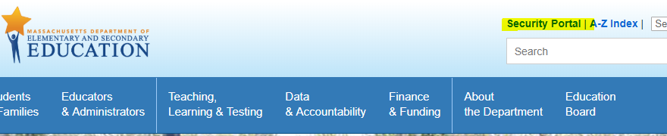

Log into the Security Portal.

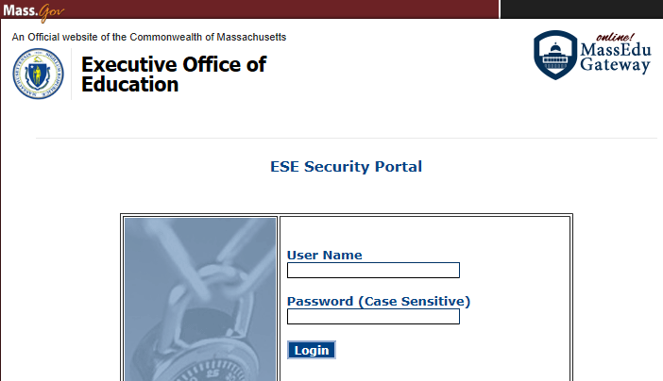

Click on Application List to see the Applications you can access. Then select DropBox Central. If you do not have DropBox Central, contact the District Directory Administrator for your district using this list (http://www.doe.mass.edu/InfoServices/data/diradmin/list.aspx).

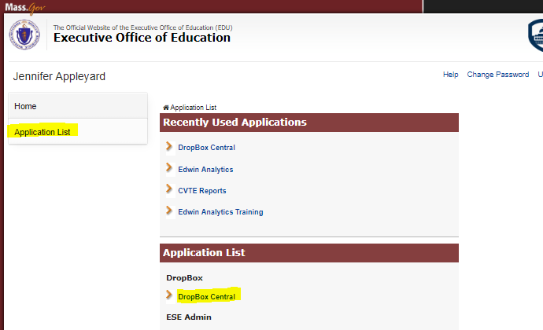

From DropBox Central, select CVTE PostSec PostGrad Data. If you do not have the CVTE PostSec PostGrad Data dropbox, contact the District Directory Administrator for your district using this list (http://www.doe.mass.edu/InfoServices/data/diradmin/list.aspx).

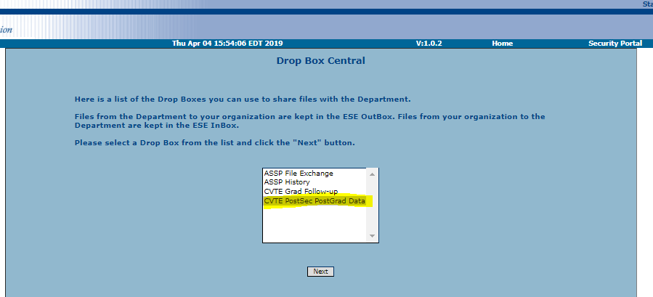

In 1. Select Organization, select Public School District (5).
In 2. Select Organization, select your district.
In 3., click Next.

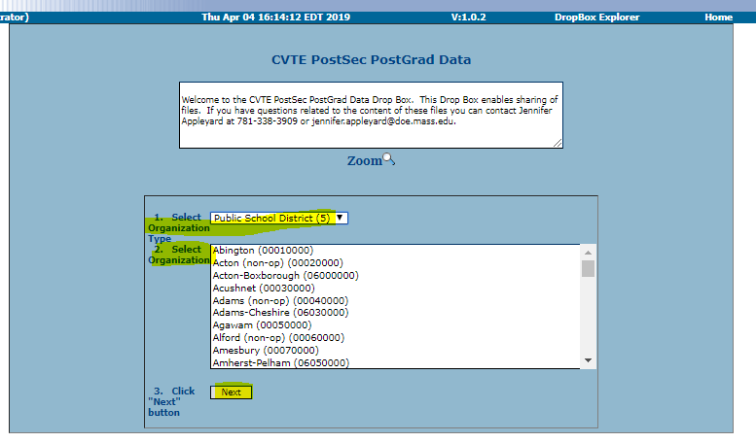

Follow the steps ‘To upload a file’.

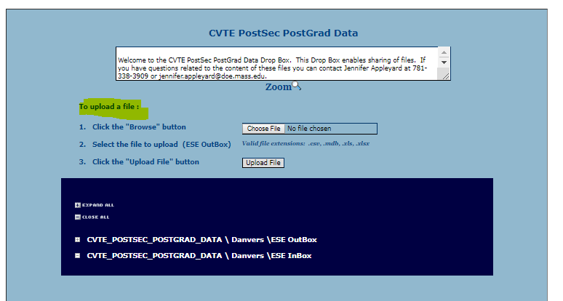

Once the file is loaded, this message will be shown.

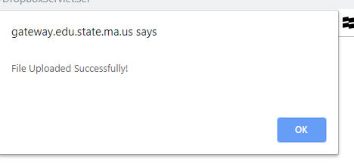

For any questions, please contact Jen Appleyard at (781)338-3909.

