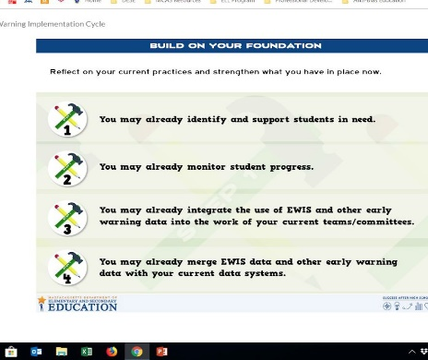
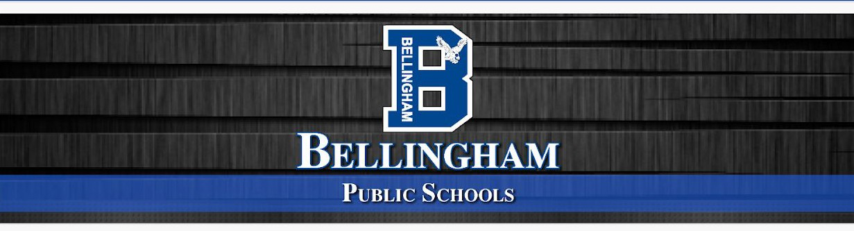

The Six-Step Early Warning Implementation Process | The Using Data Process | Overview of the Year  RBT Data Course - to train Data Coaches for each building
Step 1:Get Organized  - Educators their data use habits and establish plans for using Early Warning Risk Data during the school year.  - In your school or district, are there times where you and your colleagues review data together and decide how to act on it? | Building the Foundation  - Launch Data Teams  - Reflect on Our School  - Raise Awareness of Cultural Proficiency  - Commit to Shared Values, Standards, and Visions  Considerations moving forward:  - Tool 4 - Step 1 Early Warning Implementation Action Planning Tool will be beneficial at this phase | September - RBT Data Course Session 1  School based teams, with Admin begin the RBT course. Day 1 includes on overview of the Using Data Process, the Data Driven Dialogue protocol as they learn to make working with data an energizing and collaborative experience!  - RTI HS Begins exploring Analysis Tool, identifying risk factors, and look at state and local data sources  - RTI at BMS and elementary schools begin cycle using state and local data to identify student learning needs and interventions
Step 2: Review Data  Educators Review EWIS Data from Edwin reports to examine who is at risk and determine patterns of risk across the school and district. | Identifying the Student-Learning Problem  - Build Data Literacy  - Drill Down into Data  - Aggregate Level Analysis  - Disaggregate Level Analysis  - Strand Level Analysis  - Item Level Analysis  - Examine Student Work, | October - RBT Data Course Session 2  Participants:  - Use collaborative norms to strengthen and monitor team collaboration  - Explore the Using Data Process cycle using

RTI Teams will meet to review EWIS
Data 2019-20 Using Tool 7 – Step 2:
Exploring Early Warning data by Broad
Dimensions/Main Categories

In addition to the Verifying Causes tree,
teams can explore Tool 11 – Step 3:
Potential Underlying Causes of Risk and
Associated Data Sources Reference

 | Common Assessments and other Local Student Learning Data Sources  Considerations moving forward:  School Based Teams have varying levels of access to data sources. Decisions will need to be made moving forward about who should have additional levels - HS and BMS have had some EWIS training, but staff have changed, so this will need to be revisited. | state data to identify trends in student enrollment and teacher and community characteristics through an analysis of demographic data  - Distinguish among the five types of data used for instructional and school improvement, their purposes, and their recommended  frequency of use (data pyramid)
Step 3: Explore Causes  Educators continue their investigations to determine what is causing students’ risk, pulling in local data and context for a comprehensive picture.  Tool 11 – Step 3: Potential Underlying Causes of Risk and Associated Data Sources Reference | Verifying Causes  - Cause and Effect Analysis  - Verifying Causes Tree  Considerations moving forward: | November - January - RBT Data Course Sessions 3- 4  We are learning to:  Apply the Using Data Process, principles, and tools (Verify Causes Tree, Logic Model) for using data to strengthen equity and excellence  •Investigate and verify causes of achievement gaps, using research and and local data, including surveys, classroom observations, and interviews  •Establish a student-learning goal  Participants:  - Explore the relevance of cultural proficiency to data analysis  - Used the Cultural Proficiency Continuum to describe the range of responses to cultural diversity in their own  practice and their team's practice  HS RTI Team works to identify available interventions Considerations moving

Tool 16 – Step 4: Review Your
Inventory of Interventions and
Supports

 |  | forward: Have al RTI Teams use the tools provided by EWIS Tool 14- Step 4 (Inventory of Interventions and Supports)
Step 4: Assign Interventions  Educators compare students’ needs to the services available and assign students to interventions that will best meet their needs. | Generating Solutions  - Building Your Logic Model  - Refine Outcomes and Strategies  - Develop a Monitoring Plan  Considerations moving forward:  Regroup the Data Teams to explore these questions:  What structures do we have in place to assess the success of our interventions and how they are implemented?  How do we monitor student progress and our interventions? | April - RBT Data Course Session 5  Participants complete the work on their Verify Causes Tree and Logic Models, using the research and local data that they collected.  Participants learn how to combine Data-Driven Dialogue with Item Analysis and a template for planning data meetings.
Step 5: Monitor

Educators use monitoring indicators to assess student progress in interventions and evaluate ongoing risk throughout the year.

The monitoring indicators can also be used to improve the effectiveness of the interventions throughout the year.
Step 6: Refine Process  Educators reflect in the Early Warning Implementation Cycle and incorporate changes into the plan for the upcoming year. | Considerations moving forward:  Tool 19 - Step 5 (Monitoring Indicators by Grade Level) How can we adapt to meet our needs at ALL levels?  Tool 20 - Step 5 (Early Warning Data Exploration Summary Chart for Monir…  Create a timeline for progress monitoring  *minimally 3x year as a group | May - RBT Data Course Session 6  Participants learn two protocols for analysing data and exploring causes:  Error Analysis w Reteaching Interview Design and  Dialogue  Finalize work and prepare for Data Showcase

