Massachusetts Department of

Elementary and Secondary Education

135 Santilli Highway, Everett, Massachusetts 02149-1962 Telephone: (781) 338-3000 TTY: N.E.T. Relay 1-800-439-2370

Jeffrey C. Riley
Commissioner

MEMORANDUM

To: | Charter School Board Chairs, Leaders, and Business Managers
From: | James DiMaio, Data and Finance Specialist
Date: | January 31, 2024
Subject: | FY23 Update - Charter School End of Year Financial Report (CSEOYFR) Amendment Application

The purpose of this memorandum is to provide the collection dates and instructions for the CSEOYFR amendment application. The CSEOYFR amendment application allows all charter schools to submit corrected CSEOYFR data for the previous fiscal year via a Security Portal application. Full instructions to submit amendments are found at the bottom of this memorandum.

There are two periods during which charter schools may submit amendments. The amendment collection schedule is as follows:
For the FY23 CSEOYFR submitted on December 1, 2023:
Start of amendment collection | End of amendment collection | Please note:
12/1/2023 | 5/3/2024 | All data submitted during this collection period will be exported at the close of business on 5/3/2024. Data will be reviewed and corresponding reports will be updated.
5/4/2024 | 11/1/2024 | All data submitted during this collection period will be exported at the close of business on 11/1/24. Data will be reviewed and corresponding reports will be updated.

Many reports published on the Department of Elementary and Secondary Education’s (Department) website rely on CSEOYFR data. The Department continues to emphasize the utmost importance of submitting accurate, certified data by the CSEOYFR due date (December 1); the Department strongly discourages amendments.
The instructions for using the amendment application are below. After completing your amendment submission, please remember to upload the amended CSEOYFR Excel file into the Security Portal Dropbox. Please use the following naming convention for your amended CSEOYFR file upload: 23CSEOYFR_LEA_Amended.

Please contact James DiMaio if you have any questions or comments about the application: James.DiMaio2@mass.gov.

Instructions for using the CSEOYFR Amendment Application [including screenshots]:
- Go into the Security Portal and click on Application List in the top left corner of the page:

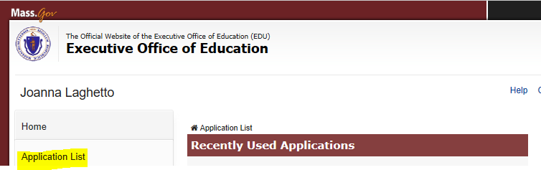
- Click on CSEOYFR Amendment Application:

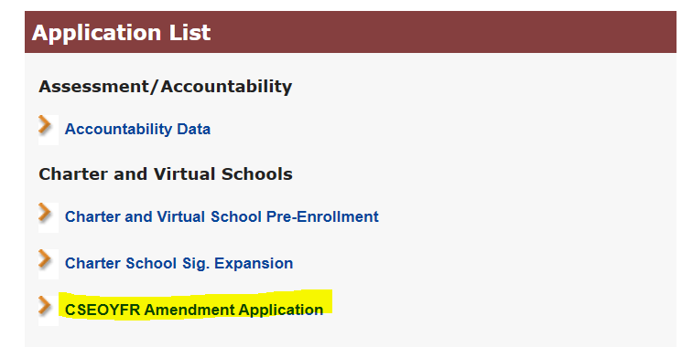

- Choose the applicable school’s name from the drop-down menu. Please note that only fiscal year 2023 is available for amendments at this time. Click NEXT.
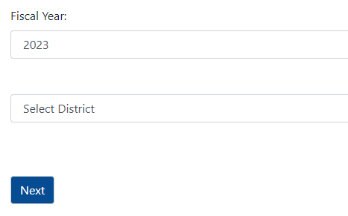
- Use the drop-down menus to make the applicable correction. You may only make one correction at a time. Click the Add button after each correction.

For example, if the Schedule of Functional Expenses line 211 column 1 (Instructional Leadership: Salaries-Professional) was recorded as $1,000,000 in the original submission, but needs to be corrected to $1,100,000, the following will be submitted:

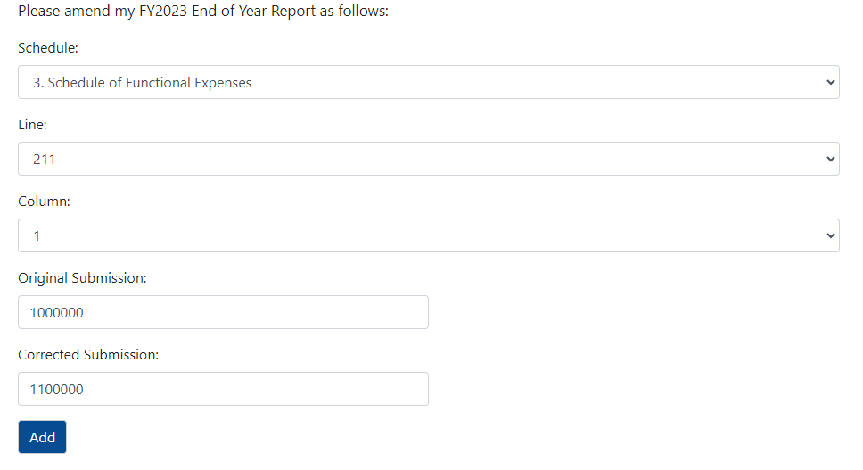

- Once all corrections have been added, you will be prompted to verify your amounts and certify the submission. You will also be prompted to upload the amended CSEOYFR Excel file into the Security Portal Dropbox. Please use the following naming convention for your amended CSEOYFR file upload: 23CSEOYFR_LEA_Amended.
Your amendment submission is not complete until you upload your amended CSEOYFR.
