Attachment A:
Limited English Proficiency Taglines Cover Page
Insert local phone numbers below where a parent who is not proficient in English and/or is hearing impaired could call to get access to program information. This should be available at the school or district level where a parent can go to get any vital information about their child’s education experience.

ATTENTION: If you speak [insert language], language assistance services, free of charge, are available to you. Call 1-xxx-xxx-xxxx (TTY: 1-xxx-xxx-xxxx).

Spanish
ATENCIÓN: si habla español, tiene a su disposición servicios gratuitos de asistencia lingüística. Llame al 1-xxx-xxx-xxxx (TTY: 1-xxx-xxx-xxxx).
Vietnamese
CHÚ Ý: Nếu bạn nói Tiếng Việt, có các dịch vụ hỗ trợ ngôn ngữ miễn phí dành cho bạn. Gọi số 1-xxxxxx-xxxx (TTY: 1-xxx-xxx-xxxx).
Mandarin Chinese
注意：如果您使用繁體中文，您可以免費獲得語言援助服務。請致電 1-xxx-xxx-xxxx (TTY：1-xxx-xxx-xxxx）。
Portuguese
ATENÇÃO: Se fala português, encontram-se disponíveis serviços linguísticos, grátis. Ligue para 1-xxx-xxx-xxxx (TTY: 1-xxx-xxx-xxxx).
Russian
ВНИМАНИЕ: Если вы говорите на русском языке, то вам доступны бесплатные услуги перевода.Звоните 1-xxx-xxx-xxxx (телетайп: 1-xxx-xxx-xxxx).
Haitian Creole
ATANSYON: Si w pale Kreyòl Ayisyen, gen sèvis èd pou lang ki disponib gratis pou ou. Rele 1-xxx-xxx-xxxx (TTY: 1-xxx-xxx-xxxx).
[Insert language, as needed]

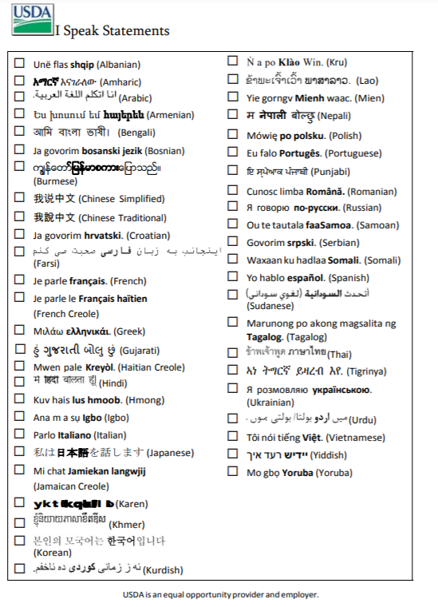
Student Name: __________________________________________
School: ________________________________________________ Grade: ___________

Meal Modification Request Form

Student Name |  | School
What Food(s) Should be Avoided: |  | Recommended Substitutions:
Brief Explanation of How Exposure to the Food(s) Effects the Child:

Are There Any Other Modifications to the Meal Needed:

Signature of Parent/Guardian | Printed Name |  | Date
Signature of Medical Authority | Printed Name |  | Date

In accordance with Federal civil rights law and U.S. Department of Agriculture (USDA) civil rights regulations and policies, the USDA, its Agencies, offices, and employees, and institutions participating in or administering USDA programs are prohibited from discriminating based on race, color, national origin, sex, disability, age, or reprisal or retaliation for prior civil rights activity in any program or activity conducted or funded by USDA.

Persons with disabilities who require alternative means of communication for program information (e.g. Braille, large print, audiotape, American Sign Language, etc.), should contact the Agency (State or local) where they applied for benefits. Individuals who are deaf, hard of hearing or have speech disabilities may contact USDA through the Federal Relay Service at (800) 877-8339. Additionally, program information may be made available in languages other than English.

To file a program complaint of discrimination, complete the USDA Program Discrimination Complaint Form , (AD-3027) found online at: How to File a Complaint, and at any USDA office, or write a letter addressed to USDA and provide in the letter all of the information requested in the form. To request a copy of the complaint form, call (866) 632-9992. Submit your completed form or letter to USDA by:

mail: U.S. Department of Agriculture
Office of the Assistant Secretary for Civil Rights
1400 Independence Avenue, SW
Washington, D.C. 20250-9410;

fax: (202) 690-7442; or

email: program.intake@usda.gov.

This institution is an equal opportunity provider.

