Sample Taglines and Instructions:
The sample taglines below are in the six most frequently spoken languages in Massachusetts (Spanish, Vietnamese, Mandarin Chinese, Portuguese, Russian, and Haitian Creole). The taglines state:
- “ATTENTION: If you speak [insert language], language assistance services, free of charge, are available to you. Call 1-xxx-xxx-xxxx (TTY: 1-xxx-xxx-xxxx).”

Instructions:
- Insert the appropriate phone numbers in the yellow highlighted sections, including the appropriate district contact person and the “TTY” phone number. (Note: “TTY” refers to Text Telephone or a special device that assists hearing impaired individuals.)
- Insert other languages in the blank sections, as needed, based on the languages spoken by LEP populations within your district or institution. For additional language tagline translations, visit the U.S. Department of Health and Human Services’ Translated Resources for Covered Entities website.
- Copy and paste the table below into a document that will be the cover page for the district’s or institution’s vital Child Nutrition Program documents.

Spanish
ATENCIÓN: si habla español, tiene a su disposición servicios gratuitos de asistencia lingüística. Llame al 1-xxx-xxx-xxxx (TTY: 1-xxx-xxx-xxxx).
Vietnamese
CHÚ Ý: Nếu bạn nói Tiếng Việt, có các dịch vụ hỗ trợ ngôn ngữ miễn phí dành cho bạn. Gọi số 1-xxxxxx-xxxx (TTY: 1-xxx-xxx-xxxx).
Mandarin Chinese
注意：如果您使用繁體中文，您可以免費獲得語言援助服務。請致電 1-xxx-xxx-xxxx (TTY：1-xxx-xxx-xxxx）。
Portuguese
ATENÇÃO: Se fala português, encontram-se disponíveis serviços linguísticos, grátis. Ligue para 1-xxx-xxx-xxxx (TTY: 1-xxx-xxx-xxxx).
Russian
ВНИМАНИЕ: Если вы говорите на русском языке, то вам доступны бесплатные услуги перевода.Звоните 1-xxx-xxx-xxxx (телетайп: 1-xxx-xxx-xxxx).
Haitian Creole
ATANSYON: Si w pale Kreyòl Ayisyen, gen sèvis èd pou lang ki disponib gratis pou ou. Rele 1-xxx-xxx-xxxx (TTY: 1-xxx-xxx-xxxx).
[Insert language, as needed]

This I Speak Document can be included along with the taglines cover page in order to capture a broader number of languages spoken. 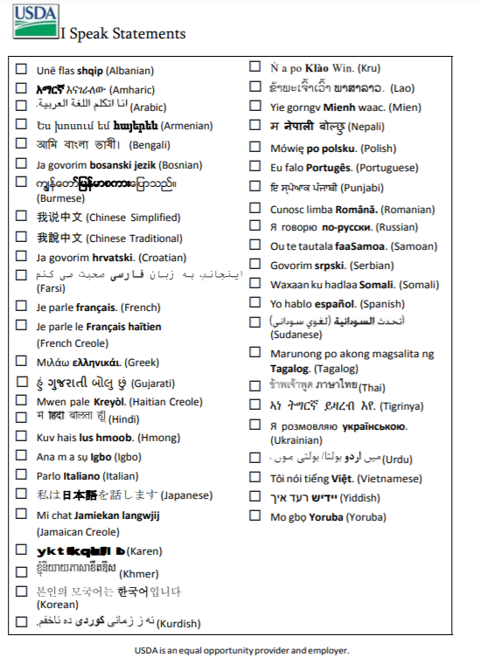
Student Name: __________________________________________
School: ________________________________________________ Grade: ___________

If you have questions about how to use taglines or providing meaningful access to Child Nutrition Programs in Massachusetts contact the DESE FNP at Nutrition@doe.mass.edu and 781-338-6480.

