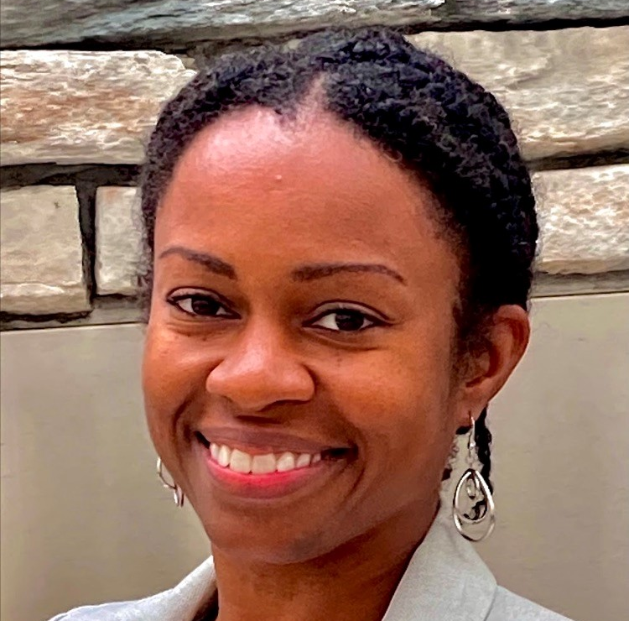
Kenya Avant-Ransome, District Data Coordinator
Somerville Public Schools

Kenya has served as the Data Coordinator at Somerville Public Schools since 2013. In this role, she supports principals and department leaders with building a culture of shared responsibility, intentional data-use, and data-informed decision-making. Kenya has over 20 years of experience as an educator at the school, district, and state levels. These roles include experience as a teacher at a charter school in Detroit, MI, from whence she hails, as an education researcher from 2009-2011, and as an education policy analyst with the Massachusetts Department of Elementary and Secondary Education. Kenya’s personal philosophy of education centers on the principles of self-actualization, equity, and self-determination. She holds a Bachelor of Arts in Sociology from Princeton University, a Master of Social Work in community organizing, and a Master of Public Policy from the University of Michigan, Ann Arbor.
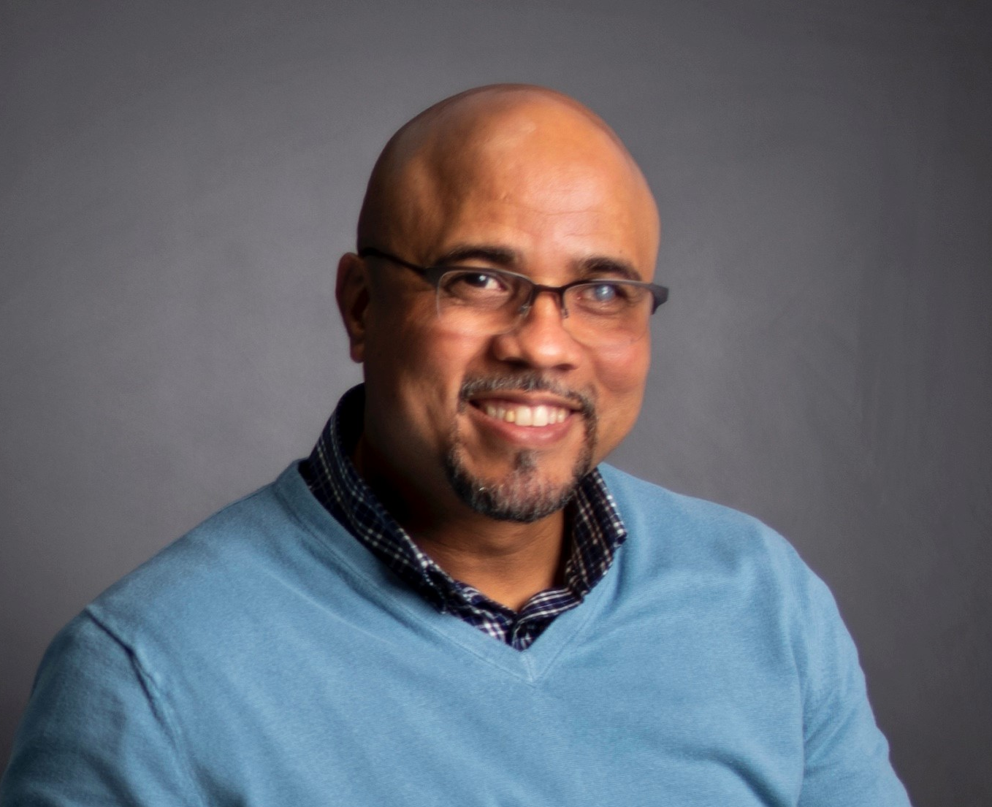
Nelson Butten, Director, Family, Student and Community Partnerships
Lawrence Public Schools
Nelson Butten emigrated to Lawrence, Massachusetts, from the Dominican Republic in 1993. He has over 20 years of experience in community development and organizing. He started his career in the non-profit sector as an AmeriCorps member and is currently the Director of Community, Family, and Student Partnerships at Lawrence Public Schools. Nelson is also a current member of the Lawrence Public Library Board of Trustees. Before working for Lawrence Public Schools, he was the Director of Community Organizing and then a Co-Executive Director at Lawrence CommunityWorks, a very active and respected community development corporation in Lawrence, MA.
Desmond Caldwell, Principal, JFK Middle School
Northampton Public Schools
Desmond Caldwell is a career educator. Born in Springfield Ma, Desmond has a B.S. and M.Ed. from Springfield College and a Ed. S. from East Carolina University. Over the past 22 years he has held the roles of Teacher Assistant, Teacher, Instructional Coach, Assistant Principal and Principal. Desmond has been a principal in Durham, NC, Hartford, CT and now Massachusetts. His schools have been named a “National School to Watch,” “Learning Laboratory School,” and “Magnet School of Excellence.” Desmond has overseen two high schools which graduated 100% of students and sent 100% to college. He has led the turn-around work at three schools boasting increases in standardized test scores and family engagement while seeing drastic reductions in suspensions and student arrests. He is currently principal of JFK Middle School in Northampton. In his short tenure there he has already made national headlines for his fight against displays of the Confederate flag and other hate symbols on campus. Desmond is committed to anti bias and anti racist equity work and purposeful recruitment of staff that reflect the culture(s) of the students and surrounding communities being served.
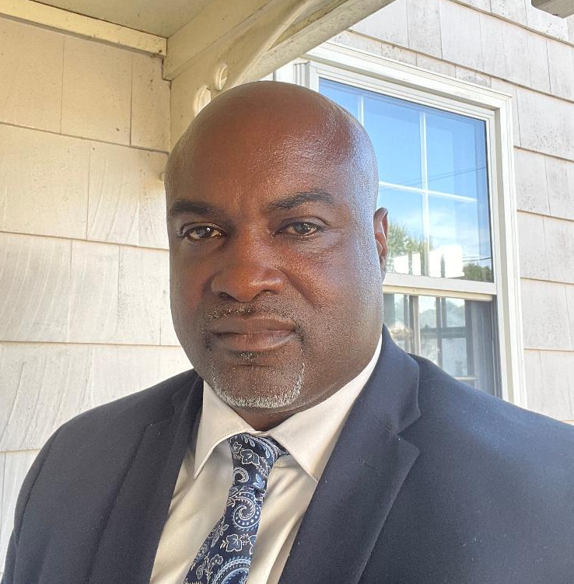
Carlton Campbell, Principal, West Middle School
Brockton Public Schools
Carlton Campbell is a stalwart of the community. He grew up in the district and knows the impact of having leaders of color as a student, a teacher, a parent, and an administrator. He knows what it feels like to never have a male teacher who looks like him. He knows what it is like to walk into an administrator's office and never see another person of color. As a successful middle school principal and high school administrator, he also knows the difference a leader of color can make to students, faculty, and staff. Among Carlton's greatest strengths is his ability to positively impact students and work constructively with families and staff. The school he leads is currently in the midst of turnaround work, and the results of his leadership have been positive. Carlton knows the difference a leader of color can have on a student, a school, a district, and a community.
Maria Campusano, Family Partnerships Manager
Lawrence Public Schools
Maria is originally from the Dominican Republic where she pursued a licensure degree in office management from the O&M University. She came to the USA during the late 1990's, MA where she continued her studies while holding a full time job and raising a family. Maria currently holds a Bachelor of Arts in Psychology, and a Masters of Education, School Guidance Counselor from Cambridge College. She has worked for the Lawrence Public Schools since 2009 in various capacities. In her current role she manages the Lawrence Family Institute for Student Success, coordinates the District Wide Tu Voz Council, serves as crisis interventionist for the schools, and supports the district, schools, and families to close the communication gap. Maria is fluent in Spanish and English.

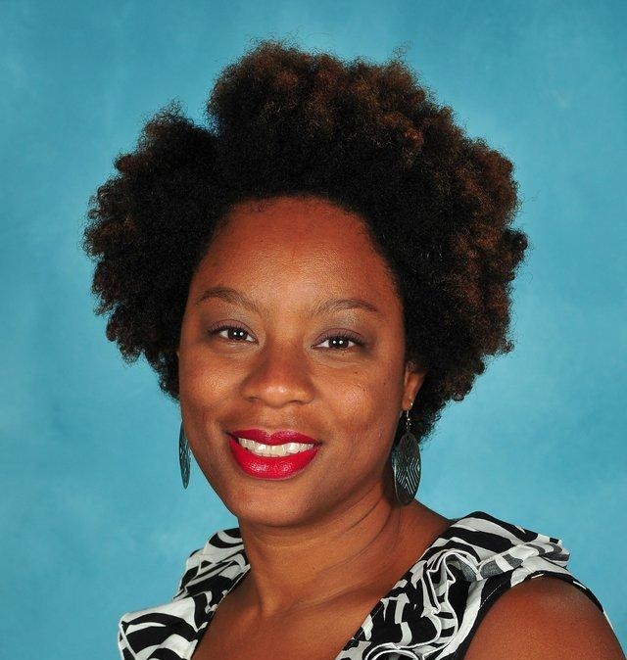
Rasheedah Clayton, Director for the Metropolitan Council for Educational Opportunities
Natick Public Schools
Rasheedah Clayton currently serves as the Director for the Metropolitan Council for Educational Opportunities (METCO) program for Natick Public Schools. Previously, she worked for Northeastern University as the Associate Director for Undergraduate Admissions working with transfer, veteran and Boston Public School students. She is passionate about assisting students to pursue their educational and career goals.

Beth Choquette, Principal, Bridge Street School
Northampton Public Schools
Beth is the principal of Bridge Street School in Northampton where she has served as principal since 2012. Prior to that Beth served as a PreK-8th grade principal in Vermont. Beth received her doctorate in educational leadership from the Lynch School of Education at Boston College. The focus of her research and dissertation was on Leadership for Inclusive Practices: Supporting Students Who Have Experienced Trauma. In addition to her current position as principal, she also teaches at Massachusetts College of Liberal Arts and is a field supervisor for aspiring principals at Boston College. Next summer Beth will be teaching for the online Masters of Education program at Boston College. As a school leader, Beth describes herself as a social justice leader whose mission is to ensure that all students, regardless of their social, personal, or cultural contexts, are successful. Working to eliminate racism and social injustices for all is at the core of who she is as a school leader.
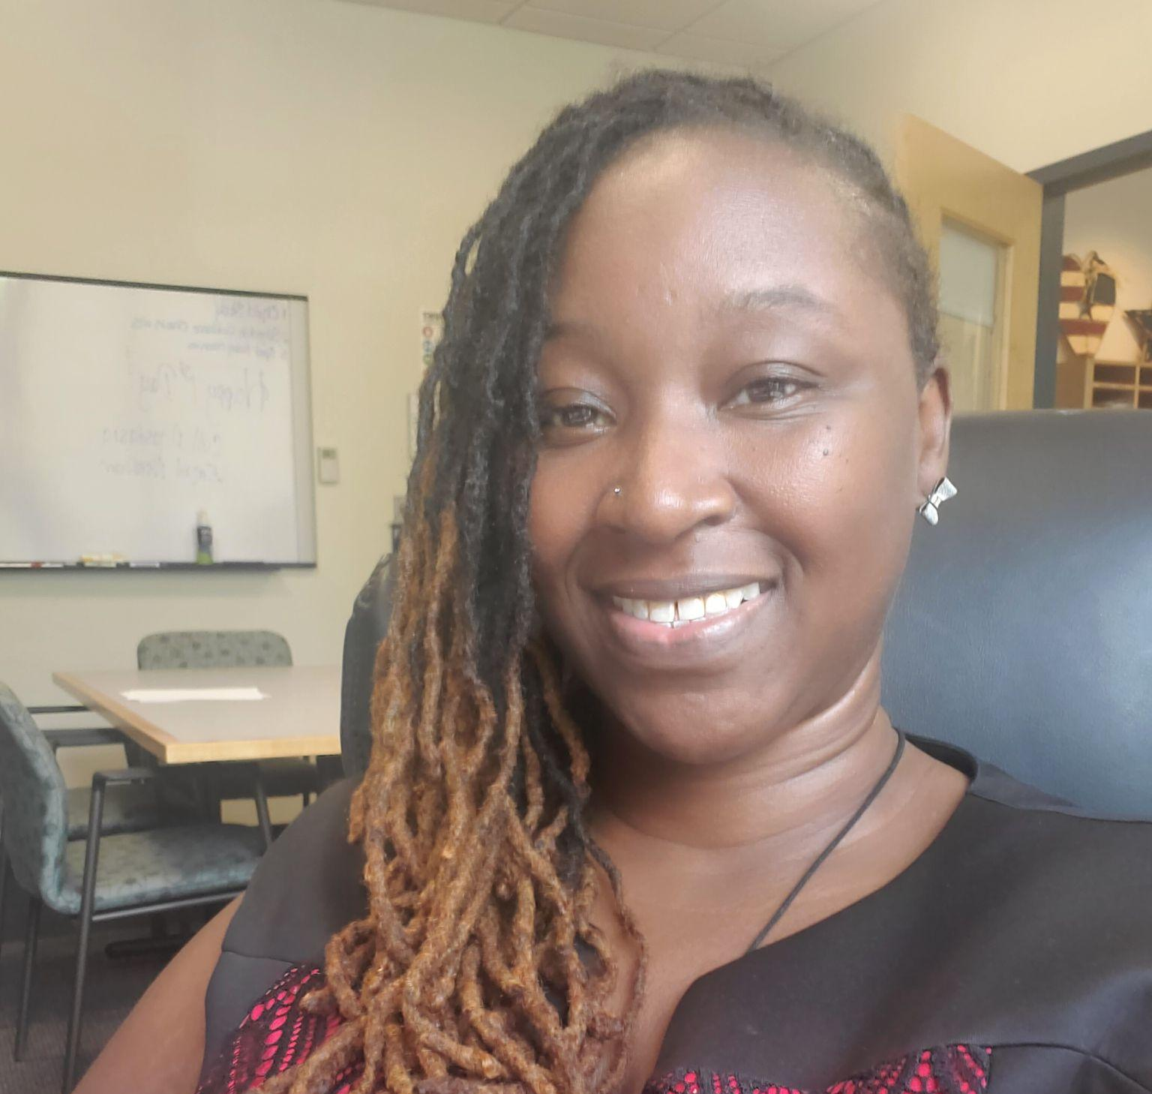
Tara Harris, Principal, Memorial Elementary School
Burlington Public Schools
Tara is a native of Boston and a graduate of Natick High School. She is overly excited to be back home and be able to support the children and families of the Burlington community. She spent the last 21 years dedicated to serving the children of New York City in various capacities (7 years in child welfare/child protection and 14 years with the Department of Education, serving as a Special Education teacher, PBIS Coordinator, a Special Education Administrator/Borough Manager for ASD Programs, Assistant Principal, and Director of Special Education). She brings a wealth of experience related, but not limited to, special education, behavior, classroom management, Autism, ED, learning disabilities, curriculum writing, and educational leadership. She believes wholeheartedly that every child deserves a stellar education. Every child has a story, and as educators, it is our job to learn that story. Once you learn that story, it should positively impact the way in which you interact with that child. Every child is capable of learning and when you raise the bar, children will rise to meet it. Tara believes that school is a safe haven for children, where they learn life lessons beyond the classroom. She believes in the importance of the home/school partnership as a team and together every student will succeed.
Joel Jocelyn, Principal, Indian Head Elementary School
Whitman-Hanson Regional School District
Dr. Joel Jocelyn is an experienced educator with over 15 years of experience as a School Principal, Director of Curriculum and Instruction, and Special Education Teacher. Joel is committed to social-emotional learning. He embraces the concept of asset-based education and dedicates himself to building district-level differentiated systems and structures to ensure that every student receives the highest quality education irrespective of their background. Joel served as a special education teacher, Principal Fellow, and Director of Curriculum and Instruction in the Boston Public Schools before transitioning as the Founding Principal of the Stone Therapeutic Day School in Fall River. Joel was a Principal in Fall River and Newton before joining the Whitman-Hanson Regional School District. Joel holds a doctorate in Educational Leadership and an MBA from Boston University, and a Masters of Education from UMass Boston.

Amy Kelly, Director of Equity and Professional Learning
Weston Public Schools
Amy is the Director of Equity and Professional Learning for the Weston Public Schools. Since she began in Weston two and a half years ago, the district has trained all K-8 and most high school teachers in various approaches to Social and Emotional Learning. Under her leadership, they are beginning to focus on Culturally Responsive Teaching and have formed a Diversity, Equity, and Inclusion Committee, including stakeholders across the district and community. When Amy started her various roles focusing on Social and Emotional Learning, she was concerned by the lack of cultural responsiveness in that field of study and is interested in continuing to learn more about culturally sustaining pedagogy and leading. Weston is an incredibly high performing district in academic achievement, but many students are marginalized in the community and beyond. Amy hopes to use what she learns from Influence 100 to create an educational environment that inspires all learners and educators to bring their whole selves to school every day.

David King, Principal, Athol High School
Athol-Royalston Public Schools
David King is the current Principal of Athol High School, a 9-12 school that serves the towns of Athol and Royalston in the North Quabbin region. David has been a lifelong resident of Athol, including a former graduate of Athol High School in 1994. Before returning to Athol, he earned his bachelor's degree from the University of Massachusetts, Amherst and master's degree from the University of New England in Biddeford, ME. David is married with three children, ages 23, 20, and 7. Before becoming an instructional leader, he held the position of Athletic Director for the Athol-Royalston Regional School District for 19 years from 1999-2018. During this time he served in numerous athletic leadership positions throughout the state including ten years on the Massachusetts Interscholastic Athletic Association (MIAA) board of directors, and president of the MIAA for two years from 2015-2017.
Jennifer Knight, Director of Family Engagement
Burlington Public Schools
Jennifer joined the Burlington School District Team in January of 2021 after relocating from Washington State. She brings significant experience to the district with over 14 years in education, teaching, training, and business management. She has successfully aligned herself with pathways for progress. She has a BA in Education(K-8) and Master's of Education, Teacher Leadership. She currently holds the following certifications: Superintendent/ Assistant Superintendent, Director/Supervisor, Principal/Assistant Principal, and teacher. Her current role in Burlington is as the Director of Family and Community Engagement, and she sees herself as positioned to be a partner for equitable change and is able to impact the greater student population by supporting families and students at all levels of education. Her constant focus is through an equity lens, seeking ways to holistically improve the district's cultural climate. As an advocate for change, she works to facilitate engagement of all families with a focus on increasing engagement and communication with minorities and underrepresented families. She collaborates daily with key stakeholders and leaders in the district working towards equity goals, identifying areas of improvement in teaching and learning, program design/implementation, and curriculum and content development. As a woman of color, she wants to use her unique perspective to impact the district in ways to provide an equitable education for all students. In a short time, she has had a significant impact. For instance, by using some of the district’s federal funding to provide transportation and staff the cafeteria, it was able to serve twice as many elementary students in the summer program than had been serviced over the history of the program. In fact, the district had more students in the building this summer than attended during the school year.

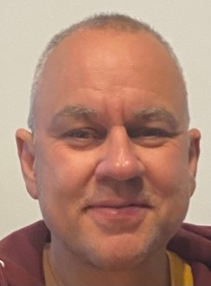
Obed Morales, Principal, East Somerville Community School
Somerville Public Schools
Obed followed a rather traditional path to school leadership by beginning his career in education as a math teacher for twelve years in middle and high school. This is his 3rd year as principal of the East Somerville Community School, Somerville, MA. Additionally, he completed nine years of experience in school administration where was assistant principal with extensive work in both operations and instruction of large schools in Florida and most recently in North Carolina. At his core, he is still the math teacher at heart that now uses data to guide instruction. On a personal level, Obed’s pride and joy is his family. He is the son of immigrants from the Dominican Republic and Puerto Rico who sacrificed all they had to ensure his five siblings and he all attained higher education and always valued hard work. Additionally, the love of his life is his wife; they have been married for thirty years. They are the proud parents of two amazing adults, Dean and Alexis, both obtained graduate degrees in recent years and are local residents in the Greater Boston Area. Dean earned a master’s in mindfulness-based transpersonal counseling. Alexis earned a Doctorate in Occupational Therapy. Family is an integral part of who he is and how he works. His belief and commitment to continuing the legacy of success established at East is by learning from teachers, staff, students, families, and community partners. Education is a partnership among and between the school and all stakeholders, and Obed is fully invested in building strong relationships with each person to make sure each child succeeds.

Raymond Porch, Diversity, Equity, & Inclusion Officer
Burlington Public Schools
Raymond’s Statement of Purpose is: “I am a student of humanity and freedom. I am a K-12 educator that's committed to co-construction of excellent learning environments, communities, and cultures; environments that support and facilitate freedom. My skills and passion flourish and add value in spaces where knowledge and awareness are a priority; where co-constructing socially, emotionally and academically equitable environments are paramount; and where curiosity, learning, and understanding are interrelated and influence all interactions.” His experience and career include: husband of 23-years; father (daughter-Raychell, 22-years old); Coach, Mentor & Educator (25+years); Basketball Coach (Middle School, High School, College & International); Youth Mentor (Young Kings Scholars 5th-8th grade boys of color); classroom teacher (Math Teacher, Adjunct college instructor); K8-School Teacher (Boston); School Leader/Administrator ( Boston); School District Leadership (Boston & Burlington). He has a BA in Sociology & English, an M.Ed in Education Administration, and is currently a Doctoral of Education Candidate. He holds the following certifications: Superintendent/ Asst Superintendent License; Principal/Assistant Principal, 5-12, Initial License; 2017-18 Harvard Leading Change (School Management & Leadership Certificate); 2017-18 Education Policy Fellow (Institute for Educational Leadership); 2017-18 Harvard Business School (Become a Better Manager Program); 2014-Boston Public Schools Male Educators of Color Executive Coaching Program.

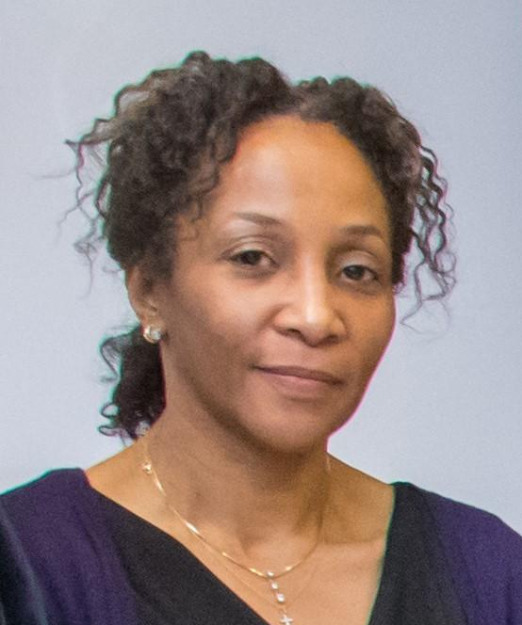
Dr. Oneida Fox Roye, Diversity, Equity, and Inclusion Officer
Dedham Public Schools
Dr. Oneida Fox Roye has been in education for over fifteen years. Dr. Fox began her career working with English language learners in the Boston Public Schools. This experience inspired Dr. Fox to pursue her master’s in language, literacy, and cultural studies at Boston University. Dr. Fox also received a certificate as a Consultant Teacher of Reading. These degrees informed her career in BPS as a literacy coach, lead literacy coach, literacy program director, and senior program director. Dr. Fox was promoted to Executive Director of English Language Arts and Literacy while pursuing her doctoral degree in literacy, language, and cultural studies. In 2016, Dr. Fox completed her doctoral degree in language and literacy from BU where she received the Lucy Wheelock Award in 2020. This award honors an alumna/alumnus who has achieved distinction through exemplary leadership by fostering excellence in their field, advocating for social justice, stimulating systemic change, and promoting diversity. Dr. Fox has supervised and supported the work of central literacy coaches, English Language Arts (ELA) program directors, and teachers. Dr. Fox’s experience includes educational leadership, supervision, curriculum development, and professional development in English, language, literacy, and reading. Additionally, Fox worked as a national trainer for Reading Apprenticeship and as a consultant providing professional learning in public schools across the United States. She is currently the Diversity, Equity, and Inclusion Officer for the Dedham Public schools.
Magaly Sanchez De Salcedo, Curriculum Data & Assessment Manager, Accelerated & Enrichment Programs
New Bedford Public Schools
Magaly Sanchez De Salcedo joined New Bedford Public Schools in December of 2020 as Curriculum Data and Assessment Manager of Magnet, Enrichment and Accelerated Programs. Ms. Sanchez De Salcedo is a strategic minded educational leader with a 20-year track record of developing visions and delivering on organizational missions and objectives throughout a career in school-based and district-wide leadership. Ms. Sanchez De Salcedo has held such positions as Director of Student Registration and Assignment, Elementary and High School Leader, Chief of Family and Community Engagement and Director of Implementation where she mentored and supported high school principals through the process of developing start up schools within an urban district. She possesses a solid understanding of state and federal school law, and demonstrated experience working with culturally diverse populations, English learners, and students of diverse capabilities within urban and suburban districts. Ms. Sanchez De Salcedo benefits from a strong ability and commitment to forge and manage relationships with interdepartmental and community-based resources, coach, lead and direct cohesive and productive teams and provide on-going assessments to ensure achievement and continuous-improvement. As an Afro-Latina and first to graduate from college in her family, Ms. Sanchez De Salcedo understands via first hand experiences the importance of equitable personalized programmatic access, experiences and outcomes for all students which is her philosophical approach to education. Ms. Sanchez De Salcedo earned a B.A. in Communications and Marketing from Providence College, a Master of Arts in Educational Leadership from University of Rhode Island, and a Master of Arts in Interdisciplinary Studies from Cambridge College.
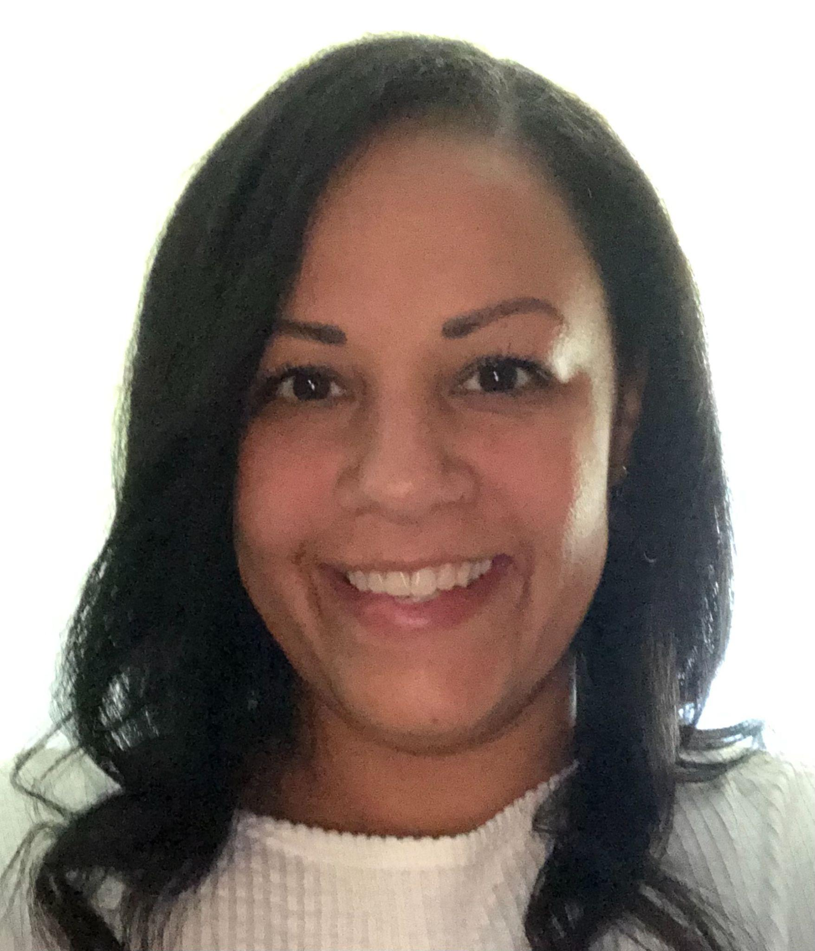
Dr. Kelly Silva, Design Leader, PROMISE High School
Brockton Public Schools
Dr. Kelly A Silva has 22 years of experience in the Brockton Public School System. She has served as a Middle School mathematics teacher, an Instructional Resource Specialist, an Associate Principal of Curriculum and Instruction and the principal of East Middle School. In 2011, East Middle School was the first level 3 middle school awarded a School Redesign Grant ($900,000) issued by the Massachusetts Department of Elementary and Secondary Education (DESE), which Dr. Silva was instrumental in writing. Under her leadership, within five years, East Middle School, an urban middle school with a diverse student population (20% Students with Disabilities, 40% English Language Learners, 89% Free and Reduced and 79% high-needs) moved from a low Level 3 designation, to a Level 1 designation. For the past 3 years, Dr. Silva has served as the Design Lead for PROMISE College and Career Academy (PCCA). Responsible for all aspects of designing a new high school, Dr. Silva has worked closely with the Barr Foundation, Springpoint Schools and various stakeholders (staff, parents, community, and students) to create a student-centered high school designed with and for students who are looking to engage and connect to learning in a non-traditional school model. Beginning in September of 2022, Dr. Silva will serve as the principal of PCCA. In addition to her professional work experience, Dr. Silva earned her Doctor of Education degree in 2011 from the University of Massachusetts at Boston and completed her dissertation "Inverse Operations: A Grade 8 Urban Mathematics Teacher's Response to the Achievement Gap.” Dr. Silva holds a professional license for Principal/Assistant Principal (PreK-6), Principal/Assistant Principal (5-12) and Superintendent/Assistant Superintendent. In addition to her Doctoral work, Dr. Silva has presented at various conferences on integrating processes to address the needs of English Language Learners, Exploring Identity, Context, and Purpose in Urban Education: A Culture of Success in an Urban Mathematics Classroom, and Using Digital Video for Professional Development and Leadership: Understanding and Initiating Teacher Learning Communities. Dr. Silva is a proven leader and fierce proponent of providing equitable educational opportunities for students of diverse backgrounds and cultures.

Hope Taylor, Associate Principal, Barnstable High School
Barnstable Public Schools
Hope is from the Bronx originally. She earned a BA in Government from St. Lawrence University, an MSED from SUNY Potsdam and a CAGS from Bridgewater State University. She started in education teaching Social Studies for 9 years, then became a Housemaster/Dean for 16 years at Barnstable High School. Hope became Associate Principal of Student Support last year and is starting her second year in this position. She has led the district in looking at diversity, equity and white privilege.
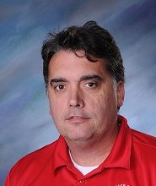
Sean McNiff, Principal, Normandin Middle School
New Bedford Public Schools
Sean started in education at the Fitchburg Alternative Evening program after graduating from New England Law School. After teaching two years in the night program, he had fallen in love with the profession and committed full time to teaching English. Over the years, Sean has had the opportunity to work in all different types of districts, and in many different roles. This has given him an amazing perspective on how different communities educate their kids. In New Bedford, he has had a chance to work at both the high school and middle school level, and has been surprised how much he has enjoyed being a Middle School principal. Sean is most interested in finding ways to have the most inclusive learning environment for all students, and to ensure that we do not place barriers that prevent kids from showing their best selves.

