Stakeholder Engagement
Stakeholders involved
- District and school leaders
- Teachers and other school personnel
- Parents
- Representatives of English Language Learners and Students with Disabilities
- Educator Preparation Programs
All root causes highlighted in the plan were identified by stakeholders, especially educators.
Examples of how stakeholder feedback affected the plan
- Educators’ capacity to serve needs of diverse learners, particularly students with behavioral issues
- Educator turnover
- Lack of tiered academic and social-emotional support systems

;
Overview of the MA Equity Plan

- Response to July 2014 USED requirement of state plans to ensure equal access to excellent educators for low income and minority students
- About increasing student experiences with excellent educators; not about redistributing teachers
- Defines “excellent educator” as a combination of characteristics, which often include student impact, experience, and highly qualified status; definition not based on a “one size fits all” metric or formula
- Promotes equitable access through diverse approaches; does not require specific additional actions from districts/schools
- ESE will continue to provide updates to and solicit feedback from stakeholders

Gaps in Student Access to Teachers, Between Schools in
Highest and Lowest Quartiles of Minority and Low Income Students
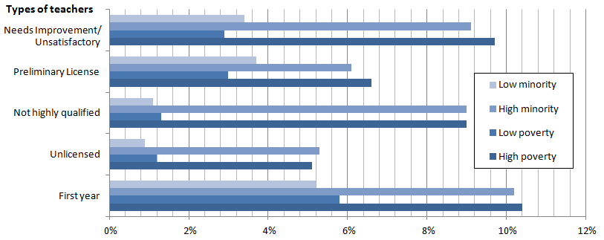

Source: Educator Personnel Information System (EPIMS) 2013-2014 Data Collection

High-poverty and high-minority schools and districts tend to suffer from adverse hiring conditions, resulting in disproportionate hiring of less-successful teachers. The high rate of turnover can perpetuate and exacerbate equity gaps.

Data analysis also showed gaps in principal access. See the full Equity Plan for more information.

Four Key Strategies Highlighted
- Educator Preparation – changes and additions to approval of EPPs and monitoring of outcomes
- Educator Evaluation System – state supports districts and schools in effective implementation
- Student Learning Experience Report – provides school and district leaders with data on proportion of students’ experiences with different categories of teachers; can sort by subgroups including race, English Language Learners and Students with Disabilities
- Educator Evaluation Guidebook for Inclusive Practices – tools for educators and evaluators to better teach diverse learners and boost inclusion of students with disabilities in general education classrooms

Root Cause Analysis
Stakeholder feedback, data analysis, and national research provided insight into causes of equity gaps. The relationships among root causes and equitable access gaps are often cyclical, and several root causes affect multiple equity gaps. The following list is not exhaustive, but represents several major root causes addressed in the Equity Plan.
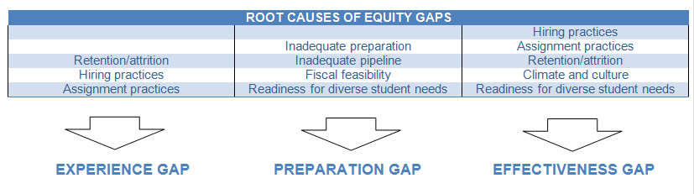
Next Steps for School Leaders
To pursue more equitable access and close gaps, school leaders can:
- Read the Equity Plan
- Use Edwin Analytics and School & District Profiles to get a picture of equitable access in your school, and how it compares to state and district data (see the Equitable Access website for links to data)
- Conduct root cause analysis for equity gaps in your school
- Identify goals, resources and strategies that address equitable access gaps and that align with your school’s current work and objectives
  - Ex: Identify a team of teachers who would benefit from an Massachusetts Tiered System of Support cousrse
- Use local educator evaluation data to inform decisions
- Consult District and School Assistance Centers/Office of District and School Turnaround for support
- Provide feedback: email educatordevelopment@doe.mass.edu

Although these steps are not required, schools can benefit:
- The plan is aligned with and supports work schools are already doing to pursue ongoing goals, such as enhancing educator quality, improving hiring practices, and meeting the needs of diverse learners.
- The plan aims to close achievement gaps.
- Access to excellent educators affects virtually all other school-level issues. We know that the quality of educators is the most important in-school factor, and it mitigates the success of other initiatives. Attempts to improve student learning are compromised without quality educators to implement them.

Next Steps for ESE
- Inform a range of stakeholders of the plan
- Create website and Annual Report to share outcomes of strategies and changes to the plan
- Communicate the strategies and resources included in the plan to DSACs and ODST, so that they are prepared to share strategies/resources and support interested schools in closing equity gaps
- Pilot use of key strategies, and share outcomes with school and district leaders
- Regularly meet with diverse stakeholder groups to provide updates and solicit feedback
- Engage stakeholder groups through focus groups, board meetings, general membership meetings, or sharing of tools

