Mentor Training Seminar: Session 2
Presenter: Melissa McMahon

Name: __________________________________

Group 1:

Group 2:

Group 3:

Course objectives
Teachers who participate in the course will:
- develop a realistic understanding of the role of a mentor and will be able to identify qualities of effective mentors
- explore the diverse thinking and communication styles that different people use to solve problems
- work collaboratively to create a “New Teacher Survival Packet,” that can be distributed to future new teachers
- learn to identify protege communication styles and determine the best way to interact with new teachers, especially when providing constructive feedback and having difficult conversations
- learn to observe and coach proteges in order to identify teacher strengths and weaknesses, with an emphasis on planning and time management
- familiarize themselves with district and school procedures and guidelines
- critically examine their practice to deepen knowledge and expand their repertoire of skills

Agenda: Session 2
Icebreaker
- As a group, we will stand in a circle.
- Each person should select in his/her mind two other people in the room. He/she should not say the names of those people or indicate in any way who they are. The people selected do not have to be standing near each other.
- When I say "Go," each person moves to try to stand between the two people selected. The exercise ends when everyone is satisfied with their position or when chaos ensues.

Discussion
- The decisions we make affect others in ways we may not initially be aware of, and our ability to carry out our own decisions is often dependent on the decisions of other people.
- When our own goals are frustrated, how do we react? Do we continue to pursue our own interests?
- Do we give up?
- Do we stand back, look at the larger picture, and try to make some order out of the chaos?
- What can we learn from this exercise about the complexity of decision-making?

Building Rapport and Trust
Activity: Having a difficult conversation with your mentee (review). (Appendix A, pg. 3)
- Get with your partner for group #1 and practice your role play together.
Activity: “Courting” your protege by creating a New Teacher Survival Packet (Appendix B, pg. 4) with group #2.

Understanding Communication Styles
Video: Five love languages
Activity: Five Love Languages worksheet
Activity: Identifying your communication style

Conference Styles
Jigsaw: Nondirective, Collaborate, and Directive Conferencing Styles (Appendix E)
Nondirective: Tigers
Collaborative: Lions
Directive: Bears

After reading, brainstorm a list of possible problems which would benefit from that particular conference style.

Appendix A: Tough Topic Conversation Worksheet
Instructions: Get in group #1 groups
- Decide who will be the Mentee and who will be the Mentor.

- Based on your group - you will participate in the following role-playing activities.

Green: The mentee has been dressing inappropriately. The principal called him/her into the office to discuss the issue. The mentee is furious and he/she thinks he/she has done nothing wrong.

Pink: The mentee is young and enthusiastic, so as a result, he/she has been asked to take on a number of additional responsibilities (student council, extra help, etc..) She/he is so overwhelmed he/she winds up in tears during a meeting.

Blue: The mentee has a number of difficult students and does not have the skills to work with them effectively. Today, he/she lost it in class, threw the students out to the office, and when class ended, started talking about leaving the teaching profession.

Orange: The mentor does a peer observation and the mentee is struggling terribly with content. It is clear to the mentor that the mentee does not understand the lesson he/she is teaching. It is the post-observation.

Purple: The mentor continues to ask the mentee to meet, but the mentee keeps saying "Everything is fine," although the students are starting to complain that he/she is boring and doesn't know what she/he is doing.

- While the mentee is explaining the problem, the mentor actively listens, but does not ask questions. After the mentee has explained the situation, the mentor will communicate with the mentee by utilizing the communication skills in the article we read during session #1. Each role play should last for a few minutes, until a decision has been reached.

- All: After each role-play, take a few minutes to discuss the questions below and write down your impressions if you wish.

Role Play Questions
Observers: What did you notice? Did you have another idea of how to approach the situation?

If you were the mentor in this situation…
- What do you need to consider BEFORE responding?
- What might be an initial possible response?
- What exactly would you say?
- What might you need to consider AFTER the conversation?

Appendix B: New Teacher Survival Kit Challenge
You and a partner (Group #2 partner) have to create the best new teacher survival kit without spending any money. The kit must include 5 creative items. At the end, make a wish list of 5 items you would include if you could make purchases. Below is a list of ideas to get you thinking... but feel free to be creative. Think about how you would package the kit as well! You may use any of the provided art materials.

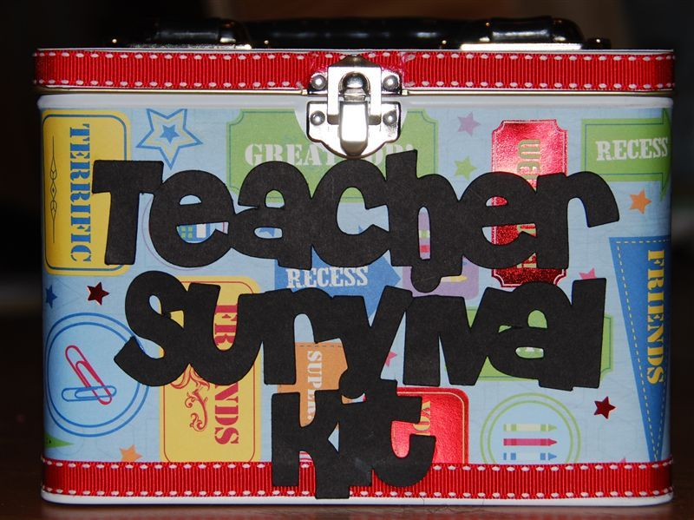

- Frequently used phone numbers
- A cool hall pass where teacher can personalize with name
- A coupon book with coupon items such as help with creating one set of papers, a cup of coffee, a walk around the block
- Personalized map of the area
- Take out menu for a place that delivers
- Thank you notes
- Advice note cards

Possible topics
- Setting up your classroom
- Routines and procedures
- Planning curriculum
Brainstorm possible ways for the new teacher to introduce a curriculum unit.
Identify strong points in lesson design.
- Encouraging student participation
- Working with families
Establish a format to follow when communicating with parents.
- Preparing for an evaluation

Appendix C: The Five Love Languages
A Quick Assessment

Within each group, rate each sentence 1-5 according to what would make you feel most appreciated and loved. The number 5 represents what you would most appreciate; number 1, in contrast is what you least appreciate in each group. You may only use each number once in any particular group.

This assessment can also be taken with a friend, child or parent in mind, simply put their name in where the line says “spouse.”

Group One
A___ Your spouse says, “You did a great job on that. I appreciate it.”
B___ Your spouse unexpectedly does something in or around the house or your room that you appreciate.
C___ Your spouse brings you a surprise treat from the store.
D___ Your spouse invites you on a leisurely walk just to chat.
E___ Your spouse makes a point to embrace and/or kiss you before leaving the house.

Group Two
A___ Your spouse tells you how much he or she appreciates you.
B___ Your spouse volunteers to do the dishes (or wash the car) for you and encourages you to relax.
C___ Your spouse brings flowers (or special food treat) for you just because he/she cares for you.
D___ Your spouse invites you to sit down and talk about your day.
E___ Your spouse enjoys receiving a hug even when you are just passing from room to room.

Group Three
A___ Your spouse during a party shares about a recent success you had.
B___ Your spouse does one of your chores.
C___ Your spouse surprises you with an unexpected gift.
D___ Your spouse surprises you with a special afternoon trip.
E___ Your spouse hold your hand as you walk through the mall or stands by your side with an arm around your shoulder at a public event.

Group Four
A___ Your spouse praises you about one of your special qualities.
B___ Your spouse brings you breakfast in bed.
C___ Your spouse surprises you with a membership to something you have always wanted.
D___ Your spouse plans a special night out for the two of you.
E___ Your spouse will personally drive you to an event instead of you having to go on the old, crowded bus with the rest of the group.

Group Five
A___ Your spouse tells you how much his/her friends appreciate you.
B___ Your spouse takes the time to fill out the long complicated applications that you had hoped to get to this evening.
C___ Your spouse sends you something special through the mail.
D___ Your spouse kidnaps you for lunch and takes you to your favorite restaurant.
E___ Your spouse gives you a massage/back scratch.

(Transfer your scores from your test questions to this score sheet.)
Group 1 A___ B___ C___ D___ E___
Group 2 A___ B___ C___ D___ E___
Group 3 A___ B___ C___ D___ E___
Group 4 A___ B___ C___ D___ E___
Group 5 A___ B___ C___ D___ E___

Totals A___ B___ C___ D___ E___

Appendix D: Communication and Interaction Styles

Communication Styles (Saphier, Freedman, & Aschheim, 2007)
Highlight your communication style below and get ready to defend:
- Some people like to generate masses of alternative solutions before beginning to weigh what should be done.
- Others want to linger over the definition of a problem and a vision of the outcomes that could result from the solution before spending time in brainstorming ideas.
- Some people think through their ideas by talking out loud without intending to signify that they have taken a position; they may sound like they're taking a position, but they're only thinking aloud.
- Other people do their thinking and sorting inside their head, and only speak when they have a position, which they want to float.

Information Processing (Rutherford, 2005, p. 29-30)
The mentoring dilemma is the need to step out of our comfort zones in order to establish cognitive empathy, to think what the other person is thinking. Use the list below to assess your own tendencies and then read through it again trying to see the world the way you think those you are mentoring do. Once you identify the potential differences, you can plan how to accommodate them. You may want to discuss these information processing variables with the new teachers with whom you are working. The information can be valuable to them and their interactions with colleagues, students, and parents.

Do you hear what I say? Do I hear what you say?
Highlight the term that best describes you.

- Introverted or extroverted: Do you prefer to respond to new information immediately doing your thinking out loud or do you prefer information in advance so you have time to think about the issues before you have to respond?

- Global or analytical: Do you tend to see the big picture and like to have the scaffolding on which to hang details or do you prefer to see the bits and pieces and put them into the whole?

- Random or sequential: Do you prefer to work through steps in sequence or are you more inclined to jump around and deal with ones that interest you in a moment?

- Concrete or abstract: Do you want to see the real thing rather than hear about the theory or the possibilities?

- Sensing or feeling: Do you prefer to deal with what you can see, hear, and touch or do you prefer to go with gut instinct?

- In the moment or in the past or in the future: Is what happened in the past, what is happening right now, or what the future will bring that matters most?

- Decisive or open-ended: Do you tend to make quick decisions and stand by them or would you prefer to continue to gather information and have several options?

- Head or heart: Do you lead primarily with your head or your heart? Do you say “I think” or “I feel?”

- Why or how: Which question is the first to come to your mind when someone presents information, “Why is that a good idea?” or “How would that look?”

- Observer or hands-on active learner: Do you learn best by observing from a distance or do you need to get into the action and mess around with new ideas and processes?

- Research or personal practice experience: Do you tend to seek out and find research or do you prefer to rely on past experience?

- Plan ahead or wait until last-minute: Do you finish projects well in advance and put them away until needed or leave them until the very end?

- Internal attribution or external attribution: Do you tend to question the effectiveness of your own efforts or attribute success or failure to the variables that are beyond your control?

- Logical or intuitive: Do you prefer to measure and quantify things or are you comfortable knowing without knowing how you know?

After you have assessed your own view of the world and made your best predictions about the person or persons with whom you're working, it is important that you not think that you have the correct view and that they have the wrong one. It is a waste of energy to try to convince them to see the world through your lens. The reality of the information or data that you want to share does not change, so there is no need to back off from doing it. The way you present the information or data is the variable that can be adjusted in order to promote acceptance, understanding, and action.

Appendix E: Nondirective, Collaborate, and Directive Conferencing Styles
adapted from: Sullivan, S. & Glanz, J. (2000). Supervision that improves teaching. Thousand Oaks, CA: Corwin Press.

Nondirective
The communication behaviors of active listening, paraphrasing, questioning, clarifying, and reflecting are used to extract the mentees'* own solutions for improving their instructional performance in nondirective conferencing. The mentor's role is to serve as a sounding board. Mentors withhold their own input, verify accuracy of the solutions, elicit information without value judgment, and encourage mentees to come to their own decisions.
The nondirective approach is best used when the mentee has many experiences and resources to draw upon. The mentor must be confident in those abilities. A large block of time is required in this approach, because its
success lies in the ability of the mentees to generate several causes of the instructional need, as well as several possible solutions.

Key Steps--Nondirective Supervision
1. Listen carefully to the mentee's initial statement.
2. Reflect back your understanding of the problem.
3. Constantly clarify and reflect until the real problem is identified.
4. Have the mentee problem solve and explore the consequences of various actions.
5. The mentee commits to a decision and firms up a plan.
6. The mentor restates the mentee's plan and schedules a follow-up meeting.

Collaborative Conferencing
The communication behaviors of problem solving, sharing, brainstorming, compromising, consensus, negotiating, teamwork, and mutual goal setting are characteristic of collaborative conferencing. The mentor's role in guiding the conference is to first actively listen to the mentees' reflections by asking how they felt about the lesson, what went well, what they did not bring that about, and what was disappointing. Next the mentors present their own position, describing it in terms of its impact on themselves. "In my own experience..." and "It is my belief..." are examples of "I" messages. This communication behavior is less likely to be perceived as a complaint or a criticism of the mentee. Once both positions have been clarified, a list of possible solutions is generated by both parties involved. The discussion is then moved to an examination of each other's ideas, looking for commonalities as well as differences. Consequences of each proposed action are discussed, narrowing the choices and negotiating a compromise for a mutually acceptable plan. The collaborative approach is best used when there really are mutually acceptable multiple alternatives to instructional needs.

Key Steps--Collaborative Supervision
1. Identify the problem from the mentee's perspective, soliciting as much clarifying information as possible.
2. Reflect back what you've heard for accuracy.
3. Begin collaborative brainstorming, asking the mentee for his/her ideas first.
4. Problem solve through a sharing and discussion of options.
5. Agree on a plan and follow-up meeting.

Directive Conferencing
The communication behaviors of presenting, clarifying, controlling, directing, standardizing, and reinforcing are characteristic of directive conferencing. The mentor's role in guiding the conference is to inform, direct, and assess the mentees' performance. This direct approach may include reinforcement or direct instruction in skills or concepts. The mentors are responsible for providing the direction and choices. They begin by reviewing the data or issue, analyzing the results and/or problem for the mentee, and concluding with a plan of action. They ask for input into the plan, listening to see if the mentee understands.
Finally, mentors clarify the details of the plan along with the rationale, setting up the expected criteria and the time frame for the plan to be implemented. Possible consequences, either positive or negative, may need to be discussed, depending upon the acceptance of the plan by the mentee. If resistance is met, the broken record of communication can be used to repeat the plan: "I understand that you do not agree, but I want you to..."
The directive approach is best used when time is short, as in emergency or crisis situation, or when the mentee really has no choice in the matter. These situations would involve legal issues or school-mandated classroom rules. The directive approach is best used when mentees are unable or unwilling to generate alternatives in a more collaborative problem-solving arena. They may be unaware of the need for improvement to be made in the classroom, or they may not have the expertise to identify or solve the instructional problem.

Key Steps--Directive Supervision
1. Identify the problem or goal and solicit clarifying information.
2. Offer solutions.
3. Summarize chosen alternatives, ask for confirmation, and request that the mentee restate final choices.
4. Set a follow-up plan and meeting.

* Note: The term [student-teacher], replaced with [mentee], for improved coherency.

