Mentor Training Seminar: Session 1
Presenter: Melissa McMahon

Name: __________________________________

Group 1:

Group 2:

Group 3:

Course objectives
Teachers who participate in the course will:
- develop a realistic understanding of the role of a mentor and will be able to identify qualities of effective mentors
- explore the diverse thinking and communication styles that different people use to solve problems
- work collaboratively to create a “New Teacher Survival Packet,” that can be distributed to future new teachers
- learn to identify protege communication styles and determine the best way to interact with new teachers, especially when providing constructive feedback and having difficult conversations
- learn to observe and coach proteges in order to identify teacher strengths and weaknesses, with an emphasis on planning and time management
- familiarize themselves with district and school procedures and guidelines
- critically examine their practice to deepen knowledge and expand their repertoire of skills

Agenda
Session 1: Roles of Mentors

Activator
What is your mentoring philosophy? Complete this sentence.

- I believe... ___________________________________________________________________________________________________________________________________________________________________________________________________________________________________________________________________________________________________

- List three words that capture your belief about mentoring new teachers.

________________________ ________________________ _______________________

- What do you see as your strengths as a teacher/counseler?

___________________________________________________________________________________________________________________________________________________________________________________________________________________________________________________________________________________________________________________________
__________________________________________________________________________________________________________________________________________________________________________________________________________________

Icebreaker
Identifying qualities of effective mentors
- Identify one person, preferably someone who is not a relative, who was a mentor for you during your education or teaching/counseling career. Think about why that person is important to you. Recall the qualities that made her or him so valued, and write down three or four of those qualities on the index card.
- As a group, we will map the qualities and identify themes.
- Discussion: Which qualities that you admire do you feel you possess? Which do you need to work on developing?

Clarifying mentor’s roles, responsibilities, and necessary skills
Activity: Jigsaw "Supporting New Teachers," by Rowley. (Appendix A, pg. 4)
Exemplar: The good mentor is committed to the role of mentoring.
Jacks: The good mentor is accepting of the beginning teacher.
Queens: The good mentor is skilled at providing instructional support.
Kings: The good mentor is effective in different interpersonal contexts.
Aces: The good mentor is a model of a continuous learner.
Jokers: The good mentor communicates hope and optimism.

The needs and phases of the beginning teacher
Powerpoint on the phases of beginning teachers (Appendix B, pg. 8)
Activity: Artistic representation jigsaw "Phases of Beginning Teachers."
Bananas: Anticipation Phase
Grapes: Survival Phase
Apples: Disillusionment phase
Oranges: Rejuvenation phase
Pineapples: Reflection phase
- Maslow's Hierarchy of Needs (Appendix C, pg. 11)
- Discussion of how roles and responsibilities are affected by the phases and needs of the first year teacher

Building rapport and trust
Read article: Building Rapport with a Mentee (Appendix D, pg. 12)
Activity: Saturday Night Live skits - barrier to communication
- Role-play tough conversations using communication skills (Appendix E, pg. 15)
- Activity: “Courting” your protege by creating a New Teacher Survival Packet
(Appendix F, pg. 16)

Appendix A: Supporting New Teachers
Rowley, J.B. (1999). Supporting new teachers. The Good Mentor, 56(8), 20-22.

Can you name a person who had a positive and enduring impact on your personal or professional life, someone worthy of being called your mentor? Had he or she been trained to serve in such a role or been formally assigned to help you? I frequently ask veteran teachers these questions. As you might guess, most teachers with 10 or more years of experience were typically not assigned a mentor, but instead found informal support from a caring colleague. Unfortunately, not all teachers found this support. In fact, many veterans remember their first year in the classroom as a difficult and lonely time during which no one came to their aid.
Much has changed in the past decade, however, because many school districts have established entry-year programs that pair beginning teachers with veteran, mentor teachers. In the majority of such cases, the matching occurs before they meet and establish a personal relationship. This prevalent aspect of school-based mentoring programs presents special challenges that are further exacerbated when mentor teachers receive no or inadequate training and only token support for their work.

Qualities of a Good Mentor
During the past decade, I have helped school districts design mentor-based, entry-year programs. In that capacity, I have learned much by carefully listening to mentor and beginning teachers and by systematically observing what seems to work, and not to work, in formal mentoring programs. As a result of these experiences, I have identified six basic but essential qualities of the good mentor and the implications the qualities have for entry-year program design and mentor teacher training.

The good mentor is committed to the role of mentoring. The good mentor is highly committed to the task of helping beginning teachers find success and gratification in their new work. Committed mentors show up for, and stay on, the job. Committed mentors understand that persistence is as important in mentoring as it is in classroom teaching. Such commitment flows naturally from a resolute belief that mentors are capable of making a significant and positive impact on the life of another. This belief is not grounded in naive conceptions of what it means to be a mentor. Rather, it is anchored in the knowledge that mentoring can be a challenging endeavor requiring significant investments of time and energy. What can be done to increase the odds that mentor teachers possess the commitment fundamental to delivering effective support?
First, good programs require formal mentor training as a prerequisite to mentoring. Veteran teachers unwilling to participate in a quality training program are often indicating their lack of dedication to the role. Second, because it is unreasonable to expect a teacher to commit to a role that has not been clearly defined, the best mentoring programs provide specific descriptions of the roles and responsibilities of mentor teachers. Third, good mentoring programs require mentors to maintain simple logs or journals that document conferences and other professional development activities involving the mentor and mentee. But such record-keeping devices should keep paperwork to a minimum and protect the confidentiality of the mentor-mentee relationship.
Finally, although the majority of mentor teachers would do this important work without compensation, we must not overlook the relationship between compensation and commitment. Programs that provide mentors with a stipend, release time from extra duties, or additional opportunities for professional growth make important statements about the value of the work and its significance in the school community.

The good mentor is accepting of the beginning teacher. At the foundation of any effective helping relationship is empathy. As Carl Rogers (1958) pointed out, empathy means accepting another person without making judgments. It means setting aside, at least temporarily, personal beliefs and values. The good mentor teacher recognizes the power of accepting the beginning teacher as a developing person and professional. Accepting mentors do not judge or reject mentees as being poorly prepared, overconfident, naive, or defensive. Rather, should new teachers exhibit such characteristics, good mentors simply view these traits as challenges to overcome in their efforts to deliver meaningful support.
How can we encourage mentor teachers to be more accepting of new teachers? A training program that engages prospective mentors in reflecting on the qualities of effective helpers is an excellent place to begin. Reading and discussing passages from the works of Rogers (1958) and Combs, Avila, and Purkey (1971), for example, can raise levels of consciousness about this important attribute. Equally important in the training protocol is helping prospective mentors understand the problems and concerns of beginning teachers (Veenman, 1984; Fuller & Bown, 1975) as well as stage and age theories of adult development (Loevinger, 1976; Sprinthall & Theis-Sprinthall, 1980). Training exercises that cause mentors to thoughtfully revisit their own first years of teaching in light of such research-based and theoretical perspectives can help engender a more accepting disposition toward beginning teachers regardless of their age or prior life experiences.

The good mentor is skilled at providing instructional support. Beginning teachers enter their careers with varying degrees of skill in instructional design and delivery. Good mentors are willing to coach beginning teachers to improve their performance wherever their skill level. Although this seems obvious, many mentor teachers stop short of providing quality instructional support. Among the factors contributing to this problem is a school culture that does not encourage teachers to observe one another in their classrooms. I often ask mentors-in-training whether they could imagine helping someone improve a tennis serve or golf swing without seeing the athlete play and with only the person's description of what he or she thought was wrong.
Lacking opportunities for shared experience, mentors often limit instructional support to workroom conversations. Although such dialogue can be helpful, discussions based on shared experience are more powerful. Such shared experiences can take different forms: mentors and mentees can engage in team teaching or team planning, mentees can observe mentors, mentors can observe mentees, or both can observe other teachers. Regardless of the nature of the experience, the purpose is to promote collegial dialogue focused on enhancing teacher performance and student learning.
What can we do to prepare mentors to provide instructional support? The quality of instructional support that mentor teachers offer is largely influenced by the degree of value an entry-year program places on such support. The mentor training program should equip mentors with the knowledge, skills, and dispositions prerequisite to effective coaching. Such training helps mentors value description over interpretation in the coaching process; develop multiple methods of classroom observation; employ research-based frameworks as the basis for reflection; and refine their conferencing and feedback skills. Finally, we need to give mentors and mentees time and opportunity to participate in the preconferences, classroom observations, and postconferences that lead to quality clinical support.

The good mentor is effective in different interpersonal contexts. All beginning teachers are not created equal, nor are all mentor teachers. This simple fact, when overlooked or ignored by a mentor teacher, often leads to relationship difficulties and diminished support for the beginning teacher. Good mentor teachers recognize that each mentoring relationship occurs in a unique, interpersonal context. Beginning teachers can display widely different attitudes toward the help offered by a mentor. One year, a mentor may work with a beginning teacher hungry for advice and the next year be assigned a beginning teacher who reacts defensively to thoughtfully offered suggestions.
Just as good teachers adjust their teaching behaviors and communications to meet the needs of individual students, good mentors adjust their mentoring communications to meet the needs of individual mentees. To make such adjustments, good mentors must possess deep understanding of their own communication styles and a willingness to objectively observe the behavior of the mentee.
How can we help mentors acquire such self-knowledge and adopt a positive disposition toward adjusting their mentoring behaviors? Mentor training programs that engage mentors in completing and reflecting on self-inventories that provide insight into their leadership or supervisory styles are particularly helpful.
The Supervisory Beliefs Inventory (Glickman, 1985) offers an excellent vehicle for introducing mentors to the challenges of interpersonal communication. In similar fashion, The Leadership Adaptability and Style Inventory (Hersey & Blanchard, 1974) can provoke mentors to reflect on the appropriateness of their mentoring behavior given the maturity and commitment of their mentees. In my own mentor training, I follow discussions of such theoretical perspectives with the analysis of videotaped conversations between mentors and mentees from the Mentoring the New Teacher series (Rowley & Hart, 1993).

The good mentor is a model of a continuous learner. Beginning teachers rarely appreciate mentors who have right answers to every question and best solutions for every problem. Good mentor teachers are transparent about their own search for better answers and more effective solutions to their own problems. They model this commitment by their openness to learn from colleagues, including beginning teachers, and by their willingness to pursue professional growth through a variety of means. They lead and attend workshops. They teach and enroll in graduate classes. They develop and experiment with new practices. They write and read articles in professional journals. Most important, they share new knowledge and perplexing questions with their beginning teachers in a collegial manner.
How can we ensure that mentors continue their own professional growth and development? Quality entry-year programs establish clear criteria for mentor selection that include a commitment to initial and ongoing mentor training. In addition, program leaders work hard to give veteran mentors frequent opportunities to participate in high-quality professional-growth experiences that can enhance their work as a mentor teacher. Some programs, for example, reward mentors by giving them additional professional development days or extra support to attend professional conferences related to their work.

The good mentor communicates hope and optimism. In "Mentors: They Simply Believe," Lasley (1996) argues that the crucial characteristic of mentors is the ability to communicate their belief that a person is capable of transcending present challenges and of accomplishing great things in the future. For mentor teachers working in school-based programs, such a quality is no less important. Good mentor teachers capitalize on opportunities to affirm the human potential of their mentees. They do so in private conversations and in public settings. Good mentors share their own struggles and frustrations and how they overcame them. And always, they do so in a genuine and caring way that engenders trust.
What can we do to ensure that beginning teachers are supported by mentors capable of communicating hope and optimism? Quality programs take the necessary precautions to avoid using veteran teachers who have lost their positive outlook. If teachers and administrators value mentoring highly and take it seriously, mentoring will attract caring and committed teachers who recognize the complex and challenging nature of classroom teaching. It will attract teachers who demonstrate their hope and optimism for the future by their willingness to help a new teacher discover the same joys and satisfactions that they have found in their own career.

References
Combs, A., Avila, D., & Purkey, W. (1971). Helping relationships: Basic concepts for the helping professions. Boston: Allyn & Bacon.
Fuller, F., & Bown, O. (1975). Concerns of teachers: A developmental conceptualization. American Educational Research Journal, 6, 207–226.
Glickman, C. (1985). Supervision of instruction: A developmental approach. Boston: Allyn & Bacon.
Hersey, P., & Blanchard, K. (1974). So you want to know your leadership style? Training and Development Journal, 28(2), 1–15.
Lasley, T. (1996). Mentors: They simply believe. Peabody Journal of Education, 71(1), 64–70.
Loevinger, J. (1976). Ego development: Conceptions and theories. San Francisco: Jossey-Bass.
Rogers, C. (1958). The characteristics of a helping relationship. Personnel and Guidance Journal, 37, 6–16.
Rowley, J., & Hart, P. (1984). Mentoring the new teacher. [Videocassettes]. Alexandria, VA: ASCD.
Sprinthall, N., & Theis-Sprinthall, L. (1980). Education for teacher growth: A cognitive developmental perspective. Theory into Practice, 19, 278–285.
Veenman, S. (1984). Perceived problems of beginning teachers. Review of Educational Research, 54(2), 143–178.

Appendix B: Phases of First-Year Teaching
by: Ellen Moir, New Teacher Center, University of California, Santa Cruz
This article was originally written for publication in the newsletter for the California New Teacher Project, published by the California Department of Education (CDE), 1990.
Top 5 Concerns of New Teachers
1. Classroom arrangement and management
2. Curriculum planning and pacing
3. Establishing a grading system that’s fair
4. Parent conferences
5. Personal sanity
It's alarming but true: studies have shown that 35% of teachers leave the profession during the first year. By the end of the fifth year, 50% of teachers have left the field! — From Teachers Helping Teachers, Springfield Public Schools, Springfield, MA

The first year of teaching is a difficult challenge. The University of California Santa Cruz New Teacher Project has worked to support the efforts of new teachers. They have identified phases through which all new teachers’ progress. The phases are very useful for mentors and new teachers as they work together the first year. Teachers move through the phases from anticipation, to survival, to disillusionment, to rejuvenation, to reflection, and then back to anticipation.

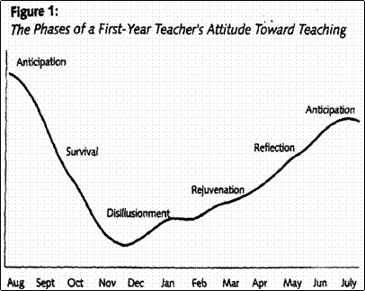

Anticipation Phase: The anticipation stage begins during the student teaching portion of preservice preparation. The closer student teachers get to completing their assignment, the more excited and anxious they become about their first teaching positions. They tend to romanticize the role of the teachers and the positions. New teachers enter with a tremendous commitment to making a difference and a somewhat idealistic view of how to accomplish their goals. This feeling of excitement carries new teachers through the first few weeks of school.

Survival Phase: The first month of school is very overwhelming for new teachers. They are learning a lot at a very rapid pace. Beginning teachers are instantly bombarded with a variety of problems and situations they had not anticipated. Despite teacher preparation programs, new teachers are caught off guard by the realities of teaching.
During the survival phase, most new teachers struggle to keep their heads above water. They become very focused and consumed with the day-to-day routine of teaching. There is little time to stop and reflect on their experiences. It is not uncommon for new teachers to spend up to seventy hours a week on schoolwork.
Particularly overwhelming is the constant need to develop curriculum. Veteran teachers routinely reuse excellent lessons and units from the past. New teachers, still uncertain of what will really work, must develop their lessons for the first time. Even depending on unfamiliar prepared curriculum such as textbooks, is enormously time consuming.

Disillusionment Phase: After six to eight weeks of nonstop work and stress, new teachers enter the disillusionment phase. The intensity and length of the phase varies among new teachers. The extensive time commitment, the realization that things are probably not going as smoothly as they want, and low morale contribute to this period of disenchantment. New teachers begin questioning both their commitment and their competence. Many new teachers get sick during this phase.
Compounding an already difficult situation is the fact that new teachers are confronted with several new events during this time frame. They are faced with back-to-school night, parent conferences, and their first formal evaluation by the site administrator. Each of these important milestones places an already vulnerable individual in a very stressful situation.
During the disillusionment phase, classroom management is a major source of distress. New teachers want to focus more time on curriculum and less on classroom management and discipline.
At this point, the accumulated stresses of the first year teachers, coupled with months of excessive time allotted to teaching, often bring complaints from family and friends. This is a very difficult and challenging phase for new entrants into the profession. They express self-doubt, have lower self-esteem, and question their profession commitment. In fact, getting through this phase may be the toughest challenge new teachers face.

Rejuvenation Phase: The rejuvenation phase is characterized by a slow rise in the new teacher’s attitude toward teaching. It generally begins in January. Having a winter break makes a tremendous difference for new teachers. It allows them to resume a more normal lifestyle, with plenty of rest, food, exercise, and time for family and friends. This vacation is the first opportunity that new teachers have for organizing materials and planning curriculum. It is a time for them to sort through materials that have accumulated and prepare new ones. This breath of fresh air gives novice teachers a broader perspective with renewed hope.
They seem ready to put past problems behind them. A better understanding of the system, an acceptance of the realities of teaching, and a sense of accomplishment help to rejuvenate new teachers.
Through their experiences in the first half of the year, beginning teachers gain new coping strategies and skills to prevent, reduce, or manage many problems they are likely to encounter during the second half of the year. Many feel a great sense of relief that they have made it through the first half of the year. During this phase, new teachers focus on curriculum development, long-term planning, and teaching strategies.

Reflection Phase: The reflection phase, beginning in May, is a particularly invigorating time for first-year teachers. Reflecting back over the year, they highlight events that were successful and those that were not. They think about the various changes that they plan to make the following year in management, curriculum, and teaching strategies. The end is almost in sight, and they have almost made it; but more importantly, a vision emerges as to what their second year will look like, which brings them to a new phase of anticipation.
It is critical that we assist new teachers and ease the transition from student teachers to full-time professionals. Recognizing the phases new teachers go through gives us a framework within which we can begin to design support programs to make the first year of teaching a more positive experience for our new colleagues.
Appendix C: Maslow's Hierarchy of Needs

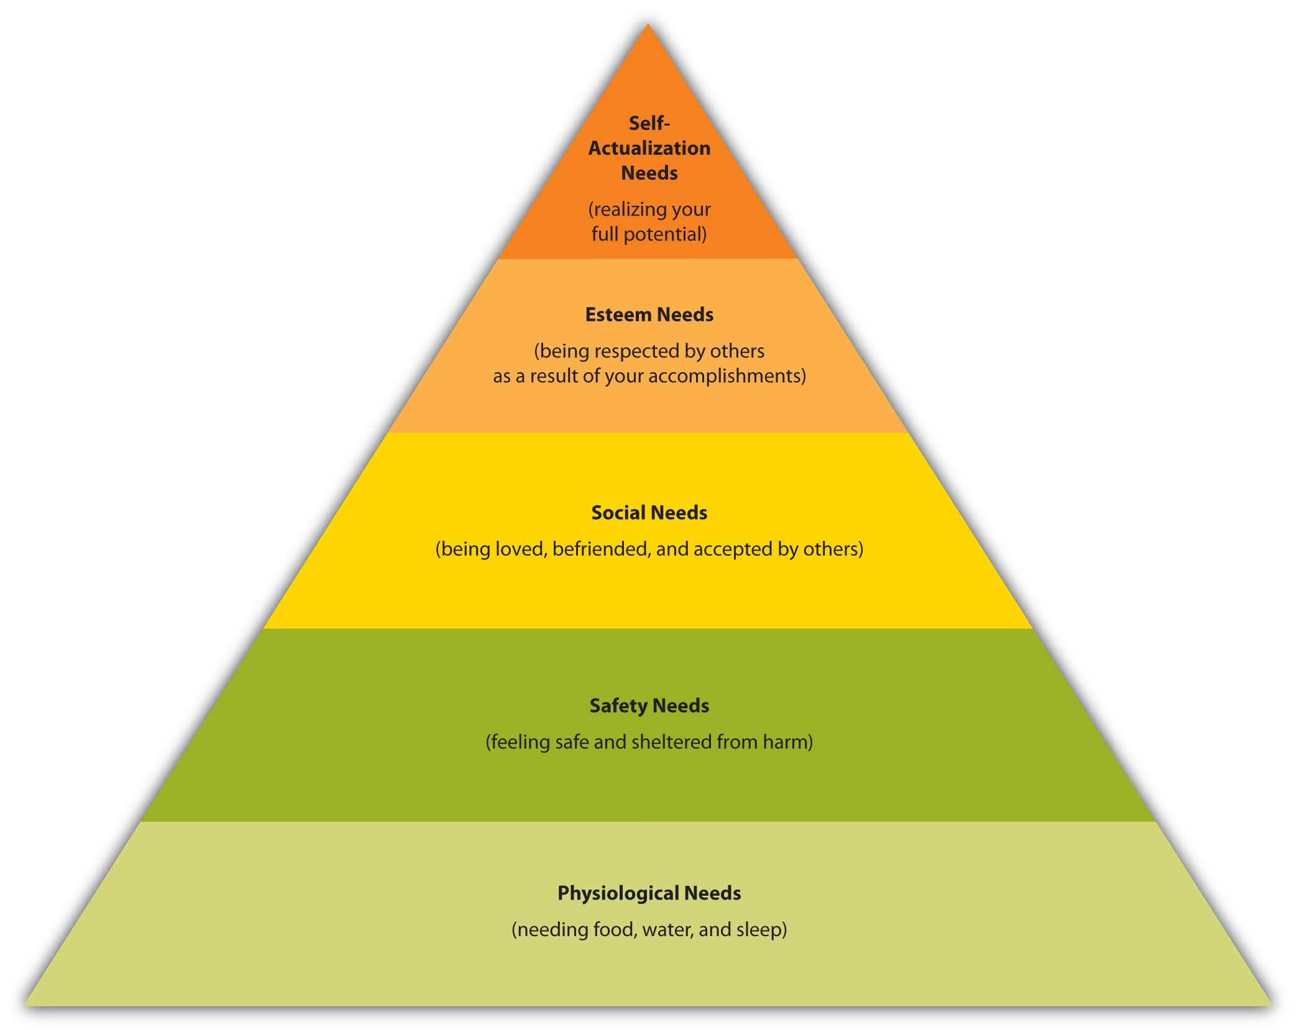
Appendix D: Building Rapport with a Mentee
adapted from ITech's Clinical Mentoring Toolkit

This document contains information and advice to help mentors build rapport and create positive relationships with mentees so that both parties can achieve the greatest benefit from the mentoring experience.

Interpersonal Communication
When mentoring, effective communication involves more than just providing information or giving advice. It requires asking questions, listening carefully, trying to understand a mentee’s concerns or needs, demonstrating a caring attitude, remaining open-minded, and helping to solve problems. There are many communication skills that mentors can utilize to effectively communicate with mentees, including the following:

- Active listening: Be sure to really listen to what a mentee is saying. Often, instead of truly listening to what the mentee is saying, the mentor is thinking about his/her response, what to say next, or something else entirely. It is important to quiet these thoughts and remain fully engaged in the task of listening.

- Attending: Listen while observing, and communicate attentiveness. This can include verbal follow-up (saying “yes,” or “I see”) or nonverbal cues (making eye contact and nodding the head).

- Reflective listening: Verbally reflect back what the mentee has just said. This helps the mentor to check whether or not he/she understands the mentee, and helps the mentee feel understood. Examples: “So it seems that you’re overwhelmed with your workload."

- Paraphrasing: Determine the basic message of the mentee’s previous statement and rephrase it in your own words to check for understanding. Examples: “It sounds like you’re concerned about what to say to this parent because she is coming off as very combative."

- Summarizing: Select main points from a conversation and bring them together in a complete statement. This helps to ensure that the message is received correctly. For example, “Let me tell you what I heard, so I can be sure that I understand you. You said that the main thing bothering you today is that George's mother keeps emailing you at night demanding an immediate response. Is that right?”

- Asking open-ended questions: Ask mentees questions that cannot be answered with a simple “yes” or “no.” Open-ended questions encourage a full, meaningful answer using the mentee’s own knowledge and feelings, whereas closed-ended questions encourage a short or single-word answer. Examples:
Closed-ended question: “You didn’t get to chapter 6 this week?"
Open-ended question: “What factors led you to your decision not to start chapter 6 this week?"

- Probing: Identify a subject or topic that needs further discussion or clarification and use open-ended questions to examine the situation in greater depth. For example, “I heard you say you are overwhelmed; please tell me more about why you are feeling so overwhelmed."

- Self-disclosure: Share appropriate personal feelings, attitudes, opinions, and experiences to increase the intimacy of communication. For example, “I can relate to your difficult situation, I have experienced something similar and recall being very frustrated. Hopefully I can assist you to figure out how to move forward.”

- Interpreting: Add to the mentee’s ideas to present alternate ways of looking at circumstances. When using this technique, it is important to check back in with the mentee and be sure you are interpreting correctly before assigning additional meaning to their words. For example, “So you are saying Michael is such a problem in your class because he's in class with Gary? That is a possibility, but have you also considered....?”

- Confrontation: Use questions or statements to encourage mentees to face difficult issues without accusing, judging, or devaluing them. This can include gently pointing out contradictions in mentees’ behavior or statements, as well as guiding mentees to face an issue that is being avoided. Example: “It’s great that you are so committed to creating these really creative assignments. However, I’m confused about the lack of standards that are tied to these projects? Having standards-based instruction is critical to student success.”

A number of attitudes and/or behaviors can serve as barriers to communication—these can be verbal or nonverbal. Verbal barriers to communication that should be avoided include the following:

- Moralizing: Making judgments about a mentees’ behavior, including calling it “right” or “wrong,” or telling them what they “should” or “should not” do.

- Arguing: Disagreeing with instead of encouraging the mentee.

- Preaching: Telling the mentee what to do in a self-righteous way.

- Storytelling: Relating long-winded personal narratives that are not relevant or helpful to the mentee.

- Talking too much: Talking so much that the mentee does not have time to express him or herself. As a mentor, it is important not to dominate the interaction.

Examples of nonverbal barriers to communication include shuffling papers, not looking directly at the mentee when he/she is speaking, and allowing interruptions or distractions. These barriers may have consequences for both the mentor and the mentee. They may lead to a lack of information shared, fewer questions being asked by the mentee, difficulty in understanding problems, uncomfortable situations, and a lack of motivation on the part of the mentee.

Building Trust
The following list provides some ideas for how the mentor can build trust with the mentee:
- Share appropriate personal experiences from a time when they were mentored.
- Acknowledge mentee strengths and accomplishments from the outset of the mentoring process.
- Encourage questions of any type, and tell the mentee that there is no such thing as a bad question.
- Acknowledge the mentee’s existing knowledge, and incorporate new knowledge into existing knowledge.
- Ask for and be open to receiving feedback from mentees; apply constructive feedback to improve mentoring skills.
- Eat a meal with the mentee to get to know him/her in a non-work setting.

Maintaining Confidentiality
Maintaining confidentiality is a critical component of the mentor-mentee relationship. In such relationships, confidentiality refers to the mentor’s duty to maintain the trust, and respect the privacy of the mentee. Without appropriate confidentiality, mentors will find that it is very difficult, if not impossible, to establish trust and build rapport with their mentees. Note that at the beginning of the mentoring relationship, it is very important for the mentor to explain to the mentee any circumstances in which confidentiality may be broken. Such circumstances include when a student is in danger, or if the mentee is engaging in illegal activity that may harm students.
To maintain confidentiality with their mentees, mentors need to be sensitive to when and where to have conversations with and provide feedback to their mentees. Some mentees may feel shame if they are corrected in front of their supervisors, peers, or students so make efforts to offer feedback in a private setting whenever possible. Additionally, the mentor should refrain from sharing details of mentor-mentee conversations at later times.

Conclusion
Using effective interpersonal communication skills, establishing trust, and maintaining confidentiality are key components of building a strong, effective relationship with mentees. Good mentors take care to utilize effective communication skills from the beginning of the mentoring experience to ensure their mentees’ comfort; they also make trust and confidentiality the foundation of their mentor-mentee relationships. By practicing these approaches, mentors will build rapport with mentees and both parties will gain from the mentoring experience.

Appendix E: Tough Topic Conversation Worksheet

Instructions
- Decide who will be the Mentee and who will be the Mentor.
- Select one of the role-play cards and read it aloud.
- Mentee: Begin the conversation with your mentor. While the mentee is explaining the problem, the mentor actively listens, but does not ask questions. After the mentee has explained the situation, the mentor will communicate with the mentee by utilizing the communication skills in the previous article. Each role play should last for a few minutes, until a decision has been reached.
- All: After each role-play, take a few minutes to discuss the questions below and write down your impressions if you wish.

Role Play Questions
Mentee: What worked well for you?
Mentor: What worked well for you?
Observers: What did you notice? Did you have another idea of how to approach the situation?
If you were the mentor in this situation…
- What do you need to consider BEFORE responding?
- What might be an initial possible response? What exactly would you say?
- What might you need to consider AFTER the conversation?
Appendix F: New Teacher Survival Kit Challenge
You and a partner have to create the best new teacher survival kit without spending any money. The kit must include 5 creative items. At the end, make a wish list of 5 items you would include if you could make purchases. Below is a list of ideas to get you thinking... but feel free to be creative. Think about how you would package the kit as well! You may use any of the provided art materials.

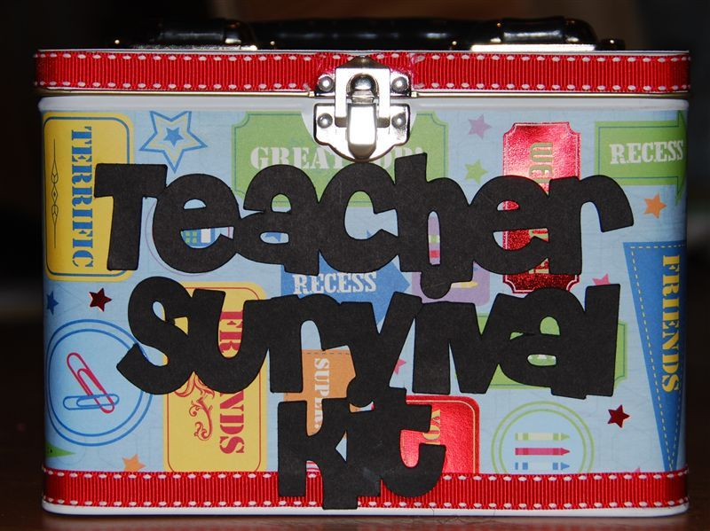

- Frequently used phone numbers
- A cool hall pass where teacher can personalize with name
- A coupon book with coupon items such as help with creating one set of papers, a cup of coffee, a walk around the block
- Personalized map of the area
- Take out menu for a place that delivers
- Thank you notes
- Advice note cards

Possible topics
- Setting up your classroom
- Routines and procedures
- Planning curriculum
Brainstorm possible ways for the new teacher to introduce a curriculum unit.
Identify strong points in lesson design.
- Encouraging student participation
- Working with families
Establish a format to follow when communicating with parents.
- Preparing for an evaluation

