What does it take
To make peer observation really work?

Before
- A particular view of the knowledge base on teaching:
Area of performance, repertoire, matching
- Commitment to certain attitudes
- Steady inflow of new ideas to try or things to look at
- Clear purpose for the visit along with specification by the teacher of what data he/she wants
- Planning conference with key components
- Use conferencing skills

During
7. Literal note taking and data gathering skills

After
8. Reflecting conference with key components and conferencing skills

Sustaining
9. Frequency
10. Clear separation from evaluation
11. Administrative recognition and reward for risk taking by making resources available for those who do peer observation
12. Confidential and non-bureaucratic

Key Attitudes
Behind
Peer Observations

We believe in each other’s positive motivations.

We respect the teacher’s position as ultimate decision maker.

We’re doing this to help each other grow:
- In our teaching repertoires.
- In our thinking.

We have something to learn from every other person.

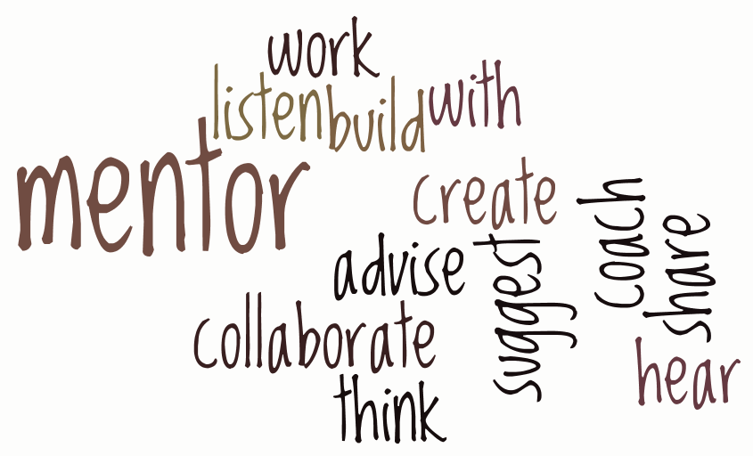
We trust that if we see something that we’re uncomfortable about or don’t understand, we will ask about it…and we will do it from the rather than judgment.

