The Cycle for Planning and Assessing

High Quality Professional Development

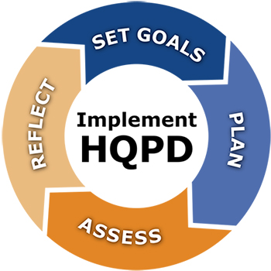

This four-step cycle is designed to help district and school PD teams design and implement high-quality professional development for educators. The process is described in four phases. The first two phases comprise a planning process and the second two phases comprise an assessment process.

PHASE I: SET PD GOALS
The PD planning process should be anchored by a set of goals. What new skills or knowledge will educators learn? How will this learning help educators improve their practice? To ensure that PD is meeting the needs of educators and students, PD teams should start the goal-setting process by conducting a needs assessment and use the results of the needs assessment to develop goals.

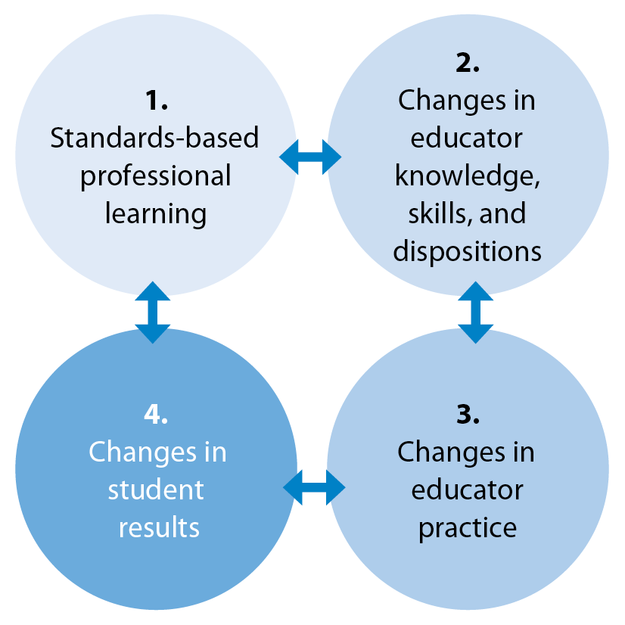
Step 1: Identify PD needs
HQPD: Desired Outcomes
- What areas of strength and need can be identified by reviewing data (e.g., educator evaluation data, student assessment data, outcome data from previous PD offerings)?

Step 2: Prioritize PD needs
- Which identified needs are best aligned to educator, school, and district goals?

Step 3: Examine potential root causes for PD needs
- What are potential causes for the identified PD needs (e.g., curriculum deficiencies, changes in student demographics, shifts in school culture)?

Step 4: Identify PD solutions to address root causes
- Which potential PD solutions do educators believe will best meet identified needs? Is there data (e.g., academic research, testimonials from colleagues in neighboring districts, educator survey data) to support one set of PD solutions over another?

Step 5: Write PD goals
- What are the specific intended student outcomes from the PD that should be reflected in PD goals?
- What changes in educator knowledge, skills, and/or practice should be reflected in PD goals?
- The Massachusetts Standards for Professional Development include the following recommendations:
  - PD goals specify intended student outcomes.
  - PD learning objectives specify changes in knowledge, skills, and/or practices necessary to achieve the intended student outcomes.
  - Learning objectives are written in SMART format.

The following school-level example is a modification of a PD goal from Easthampton High School, Easthampton, MA.
SCHOOL GOAL | PD GOAL
Student performance on complex learning tasks in grades 9-12, in all content areas, will increase by 10% over the next year. (The school will measure this goal through pre-, mid-, and post-testing on the district’s interim assessment.) | Over the next year, 90% or more of teachers will implement complex learning tasks in classroom instruction.  In addition, over the next year, the school will:  - Define complex learning tasks and increase staff exposure to complex tasks.  - Foster an understanding of what complex learning looks like and how to achieve it.  - Establish protocols for how staff will model and promote complex learning in classrooms.  - Use student data to identify challenges in teaching and student learning.  - Identify possible solutions to complex learning challenges.  Successful fulfillment of the goal will be measured by looking at learning walkthrough data. In addition, the school will examine student performance on complex tasks at the mid-year and end-of-year (post) assessment. Teachers will also use the complex learning rubric throughout the year to determine student progress.

PHASE II. DEVELOP THE PD PLAN
A PD Plan will ensure that a school or district’s PD program is comprised of a cohesive set of strategies and activities, aligned to PD goals, as opposed to a series of ad hoc, disparate activities.

Step 1: Design the PD program
- Keeping PD goals at the forefront, how should the program be designed to include a variety of learning experiences and delivery mechanisms to best meet educators’ needs?
  - For example, if building educator knowledge and skill in universal design for learning is identified as a component of a PD goal, the PD Team should consider which types of experiences will best help educators learn the content and apply it to their practice (e.g., small-group, full-day intensive, online, or blended learning).
- When designing the PD program, the PD team may find it beneficial to identify a team of “critical friends” (e.g., a different school or district leadership team) to provide a fresh perspective on the alignment between the PD goals, activities, and expected outcomes.
Step 2: Determine the resources necessary to implement the PD program
- Facilitation:
  - Which learning experiences are best led/facilitated by educators from the school or district and which are best led by outside PD providers?
  - How can the PD team use educator evaluation data to identify staff with expertise in a PD content area that would be well-suited to provide PD to colleagues?
    - Leveraging teacher leaders to provide PD to colleagues has several advantages: it can be more economical than outsourcing PD; it facilitates ongoing support and continuity of learning within the school or district; and it recognizes and motivates high performance.
  - How will the PD team support educators who lead PD in planning for and executing High Quality PD (HQPD)?

- Time:
  - How much time is needed to reach the PD goals? The team should carefully assess the time needed to implement each learning experience within the PD program.
- Funding:
  - There are many possible funding sources for PD, including: local funds, Title I and Title IIA funds, ESE grants, and other external grants. What financial resources are available to support PD? Are there existing structures (e.g., PLCs, common planning time) through which PD can be delivered without incurring additional costs?
Step 3: Plan the PD Assessment
- Assessment of learning is just as important for educators as it is for students, yet assessing the effectiveness of PD is often an omitted step. What types of assessments will the PD team put in place to determine whether the PD activities met educators’ needs and addressed the PD goals set in Phase I? Planning PD assessments as part of Phase II – the planning of the PD program – creates the inextricable link necessary to ensure that meaningful data is available to guide the continuous improvement process.
Assessing educators’ learning is as important as assessing students’ learning, but is often left out of the PD process.

- The assessment should help the PD team determine whether each PD offering
  - was based on standards,
  - increased educator knowledge and skills,
  - changed educator dispositions,
  - resulted in positive changes to educator practice,
  - and ultimately improved student outcomes.
- When planning the PD assessment, consider starting by identifying a set of questions that will help the PD team understand whether its expected outcomes were achieved (see the chart on the hierarchy of questions included in Phase III). What data sources are available (e.g., educator evaluation data) or data collection tools should be created (e.g., PD participant feedback surveys) to answer each of the PD team’s questions?

Phase III: Assess the Impact of PD
The assessment of PD can be broken down into two stages: formative and summative. This document contains a description of key steps for both stages, guiding questions for each step, and a summary of key areas for assessment.
Step 1: Create or select the assessment instruments (e.g., surveys, focus group questions, pre- and post-assessments)
- Do data collection instruments meet basic standards for validity and reliability? Are they appropriate for the content and format of the PD activity?
- Examples of evaluation instruments are surveys, focus group protocols, and observation protocols. When appropriate, are pre- and post-assessments in place? Regardless of format, are all PD assessment instruments in place?
Step 2: Collect and analyze formative PD assessment data
- Does the assessment plan have a specific protocol, schedule, and system in place to collect formative data? Are there policies in place to account for security and confidentiality of the data?
- Who will conduct the analysis of the formative assessment data?
- How will the findings from the formative assessment data analysis be used to inform refinements to the PD?
- What types of changes are suggested by formative assessment data?
Step 3: Collect and analyze final outcome data
- Will the summative assessment instruments differ from the formative assessment instruments?
- Does the PD assessment plan have a specific protocol, schedule, and system in place to collect summative data around the effectiveness of the PD? Are there policies in place to account for security and confidentiality of the data?
- Who will conduct the analysis of the summative assessment data?
- How will the findings from the summative assessment data analysis be applied to future school or district PD planning?
- What types of changes does the data suggest should be made to the school or district’s PD planning process?

FORMATIVE & SUMMATIVE STAGES

The Formative Stage
During the formative stage of the PD assessment, the PD team collects and analyzes data at a time when program changes can be made. The team seeks information about the implementation of professional development and the attainment of educator knowledge and skills. It is also during this stage that the team attempts to understand if there have been any changes in educator practice resulting from PD activities. The results of this analysis can be used to make immediate adjustments to PD and to ensure that the quality of the PD implementation is maintained throughout the execution of the PD plan.

The formative stage of the PD assessment should be on-going and iterative, driving mid-course adjustments to the PD plan.

Possible adjustments include:
- Modifications to PD content (e.g., the facilitator reorders the content)
- Changes in the overall PD design (e.g., additional workshops are added to support content knowledge)
- Changes to organizational structures and policies (e.g., the principal repurposes faculty meetings to allow more time for educators to meet in PLCs)
The formative phase of PD assessment is set in motion once the PD team begins implementing the PD activities and continues until all activities are complete. Data analysis can begin while data is being collected. Based on the results of the analysis, the PD team makes necessary mid-course corrections and documents their findings for later use in Phase IV.

The Summative Stage
The summative stage occurs at the conclusion of all professional development activities, at a point when the team has access to the necessary outcome data to analyze whether the goals of the PD were met. It is during this time that student outcomes are analyzed to determine the impact of the PD on student learning. The PD team documents whether goals were met and uses the results of the summative assessment to identify changes that must be made to the PD plan.

Results of the summative phase of the assessment yield information that help PD teams:
- Determine the degree to which the PD goals and objectives were achieved
- Inform decisions about the future of the PD program

A Summary of What to Assess
What to Assess: The Hierarchy of Questions for Evaluating PD
Formative and Summative Assessment of PD | PD Implementation  Did the professional development occur as planned? | Inputs  Were the necessary resources (supplies, technology, etc.) available?
Activities
Were the planned activities implemented?
In what ways, if any, did the implemented activities differ from what was planned (e.g., number of meeting times, length of the PD)?
Participation
Did the expected (types of) educators participate?
Did more educators participate than expected? Fewer?
 | Educator Knowledge, Skills, and Disposition  How did educator practice change as a result of the PD? | Reactions  Were educators receptive to the PD offered?  Did educators find the PD relevant and useful?  Did the PD support attainment of Educator Evaluation goals?
Knowledge, Skills, Disposition
Did educators’ knowledge of the content area increase as a result of their participation?
Are educators more skillful in the PD area?
Are educators confident in their ability to apply what they learned?
District/School Organizational Practices that Support PD
Were the proper PD supports in place to ensure changes in practice?
Are there district/school policies that should be revised to enable the successful transfer of learning into practice (e.g., changes in scheduling, changes to priorities)?
Educator Practices and Behavior
How did educator practice change as a result of participation?
SA | Student outcomes  How did student learning improve? What evidence exists of the impact of the PD on student outcomes?
_
Note: If the final outcome of the professional development focuses on educator outcomes and not on students, the educator outcomes become the focal point of the summative phase of the PD evaluation.

PHASE IV: REPORT AND REFLECT ON RESULTS
This critical phase is often overlooked under the assumption that a PD program concludes once assessment data are collected and analyzed. To the contrary, high quality professional development requires both the analysis of data and reflection on results. The true benefits of the professional development program can only be realized when planners, participants, and supporters are provided with: (1) a summary report of the outcomes; (2) adequate time for reflection; and (3) guidance on feedback expectations.
Step 1: Summary report of PD outcomes
- Who will prepare the summary report? What is its audience and how will it be shared?

Step 2: Presentation of outcomes and reflection
- Who will present the summary report to stakeholders?
- What kind of reflection activities will they participate in? Who will facilitate the reflection activities?

Step 3: Shared decision-making about future direction
- What are the decisions to be made on the basis of the summary report?
- How will the stakeholder group reflection arrive at these decisions?

In preparation for carrying out these final steps, at least one district or school administrator should meet with the PD team to determine the following:
- Purpose of the final feedback
- Final conclusions and recommendations to be included in the report
- Report recipients (audiences) and the need to tailor reporting methods
- Reporting methods
- Report release schedule
- Reflection session date and feedback deadline

Reporting Results
As a general rule of thumb, the final report is concise and guided by the following considerations:
Conclusions and recommendations are backed up with evidence/data.
The PD team should ensure that their summary of conclusions and recommendations address educator and student outcomes based on an analysis of the formative and summative results. The Summary of Conclusions and Recommendations organizer can help the team ensure that their findings are based on evidence and data.
Ideally, the report includes anecdotal feedback and testimonials from participating educators, as well as recommendations on sustainability and the need for program modifications and improvements.
Audience selection is based on interest and benefits.
The PD team should identify the stakeholder audience that has the most interest in the outcomes of the PD programs (e.g., administrators and participants). The team should also think of those who may benefit from a review of the outcomes (e.g., sharing middle school PD program results with high school teachers).
Methods and Schedule
The PD team should choose the best reporting methods for reaching the desired audience. The table below provides suggestions for reporting methods by audience. If the outcomes are especially promising, school leaders may wish to use a variety of reporting methods to not only share and celebrate outcomes but also garner future support for sustaining the PD program.
Reporting Method | Target Audience | When to Report | Feedback Option
Formal evaluation report | School committee, district and school administrators | According to school committee calendar | Feedback given to superintendent
Oral presentation (guided by slide deck of key findings) | School/district educators, union leaders, parents | Scheduled assemblies | Feedback gathered during the meeting with a means and deadline for additional feedback
Newsletter article summarizing conclusions | Educators and parents | According to school newsletter schedule | Suggestion drop box in main office
School web page with brief narrative overview, data, video clips, photos, etc. | School audience | Shortly after the conclusion of the PD program | Email address provided for feedback

Reflecting on the Results
The final step in the PD evaluation process is reflecting on the results of the PD assessment. During this step, the PD team meets with stakeholders, especially the participants. The PD team documents initial feedback while also giving time for in-depth reflection and final feedback on such areas as:
  - Impact of the PD on educators and students
  - Quality of implementation
  - The quality of the assessments used
  - Adequacy of data for credibility of the results
  - Resources allocated to the evaluation
  - Overall value of assessment results

The team might use the prompts in the Guiding Protocol for Interpreting Final Outcomes to facilitate group reflection, discussion, and feedback from stakeholders In all cases, the team provides group members with instructions and a deadline for final feedback.

Results are documented and reviewed by the PD team and district/school administrators for future PD planning and decision-making.

See the Massachusetts Standards for Professional Development for more information about HQPD: http://www.doe.mass.edu/pd/standards.pdf.
Studies show that effective PD programs require anywhere from 50 to 80 hours of instruction, practice, and coaching before teachers arrive at mastery (French, 1997; Banilower, 2002; Yoon et al., 2007). High-quality PD programs of about 50 hours over a 6-to-12 month period increased student achievement by 21 percentile points on average (Darling-Hammond, 2012).

