Massachusetts Model System for Educator Evaluation
Participant Handouts for Workshop 4:
Gathering Evidence
October 2014 (updated)
Massachusetts Department of Elementary and Secondary Education
75 Pleasant Street, Malden, MA 02148-4906
Phone 781-338-3000 TTY: N.E.T. Relay 800-439-2370
www.doe.mass.edu

Workshop 4: Gathering Evidence

Intended Outcomes
At the end of this workshop, participants will be able to:
- Explain the three types of evidence required by the regulations and identify concrete examples of each.
- Describe characteristics of high-quality sources of evidence.
- Identify artifacts of practice and measures of student learning aligned to activities outlined in their educator plans.

Agenda
- Review Objectives for Today’s Workshop (2 Minutes)
- Learning Activity 1: Three Types of Evidence (13 Minutes)
- Learning Activity 2: Identifying Sources of Evidence (20-25 Minutes)
- Learning Activity 3: Identifying Your Own Evidence (20 Minutes)
- Exit Ticket/Homework

For More Information
Participants interested in learning more about evidence gathering may wish to familiarize themselves with additional materials on the Massachusetts Department of Elementary and Secondary Education website – particularly Part II: School-Level Planning and Implementation Guide, pgs 32-39, Module 5: Gathering Evidence, and the ESE Evidence Collection Toolkit For these resources and additional information about the Massachusetts Educator Evaluation Framework, please go to www.doe.mass.edu/edeval/model and www.doe.mass.edu/edeval/modules.

Handout 1: Learning Activity 1

Three Types of Evidence
“I was evaluated today.”
This phrase may be quite familiar to you. Typically, it has meant a formal observation. Now, perhaps it means that your supervisor dropped by to observe you teaching a lesson. Not an unusual occurrence in your school these days. In fact, this was the third time this year that she slipped into your classroom for a brief visit. She stayed for about ten minutes and jotted things down from time to time as the lesson progressed. You can expect a brief chat with some suggestions related to what she observed, followed by a short written summary of her notes later in the week. Luckily you were on top of your game that day. Your students rolled out of bed on the “right” side, showed up on time, and paid attention; and the activity appeared to engage most of the students and wrapped up before the bell rang.
You feel pretty good—it wasn’t your best lesson, but it explicitly targeted one of the new literacy standards and there were no major hiccups. You would have liked your principal to see the small group work that took place prior to her arrival to illustrate how far some of your struggling students have come in engaging with their peers since her last observation but she saw the whole group discussion at the end. It would also have been nice to share the growth your ELL students demonstrated from the beginning to the end of the unit on Explanatory Writing. Hopefully that progress will show up on their ACCESS scores next year. Regardless, overall, the three observations should place you on solid ground.
The scenario above describes components of a relatively productive evaluation. The principal is in the habit of observing her teachers multiple times throughout the year and providing timely, targeted feedback after each visit. Multiple observations have given the principal the opportunity to see different aspects of this teacher’s practice at different points in the year, and she might even be able to see both changes in teacher practice as well as student learning, depending on what she observes.
Overall, these observations probably facilitated some good conversation around instruction and hopefully resulted in constructive feedback to the teacher about how to improve his/her practice in the future. That said, will the principal have enough information to provide this teacher with a comprehensive, informed analysis of his or her work over the course of the year? Maybe not. In fact, the teacher feels that the principal may not have witnessed some of his/her proudest achievements. Are observations enough?
The new evaluation framework defines short, frequent observations as a critical source of evidence in an evaluation. However, observations are not enough to give supervisors a complete picture of practice. As you know, teaching encompasses much more than the delivery of a lesson. Curriculum mapping, assessment development, analysis of student work, independent and collaborative lesson planning, one-on-one conferencing with struggling students, parent outreach, classroom set-up: all of this “behind-the-scenes” work is what makes a single lesson resonate with a single student, yet may go undetected during a classroom observation. Therefore, in the new evaluation framework, observations live alongside several other types of evidence that inform an individual educator’s evaluation.
Everyone’s evaluation will incorporate three categories of evidence: (1) products of practice (artifacts and observations); (2) multiple measures of student learning; and (3) additional sources that provide relevant information on an educator’s practice related to one or more performance standards, including student feedback.

Category 1: Products of Practice (Artifacts & Observations)
Products of practice include (1) artifacts related to educator practice, and (2) observations of practice. Both sources of evidence should yield information related to the educator’s practice within the four Standards and/or the educator’s goals. Artifacts, which are the primary responsibility of the educator, could include anything from team-developed curriculum units to lesson plans to parent/teacher communication logs. Artifacts should always be ‘products of an educator’s work that demonstrate knowledge and skills of the educator.’ In other words, artifacts should be naturally occurring products related to the day-to-day work of instruction, and never be manufactured solely for the evaluation.
Short, unannounced observations as well as longer, announced observations also fall under this category of evidence. Supervisors are primarily responsible for this type of evidence, although peer observations may also be included.

Category 2: Multiple Measures of Student Learning, Growth & Achievement
The second category of evidence—Measures of Student Learning, Growth & Achievement—informs both the Summative Performance Rating and the Student Impact Rating. With regard to the Summative Performance Rating, educators use multiple measures of student learning, growth and achievement to demonstrate practice related to one or more of the four Standards, such as “Teaching All Students,” as well as progress toward their student learning goal. These measures can and should go beyond traditional standardized, year-end assessments to include performance assessments, capstone projects, or interim and unit assessments, or even homework assignments or quizzes. It all depends on what the individual educator is seeking to measure. For example, a math teacher might include unit assessment trend data in her evidence portfolio to demonstrate student growth related to fractions, while a guidance counselor might incorporate attendance records and college application rates in his evaluation portfolio.
For the Student Impact Rating, multiple measures of student learning, growth and achievement (1) must be comparable across similarly situated educators, and (2) must include state assessment data when applicable, as well as district-determined measures.
Bottom line: YOU are in the driver’s seat. “What is the story behind the numbers?” Unlike other evaluation systems that rested heavily on observations, the incorporation of artifacts and measures of student learning provides educators with a unique opportunity to frame the nature of their evaluations—to use this evidence to tell a story of their professional growth and student learning.

Category 3: Other Evidence related to Standards of Practice (Student Feedback)
The third category of evidence includes feedback from students. Effective teaching and learning environments are the result of complex, collaborative, meaningful interactions between students and educators, and student feedback is an opportunity for students to share ideas about how to best improve instructional practices. Student feedback should therefore address instructional practices and classroom conditions that are conducive to student learning and instructional leadership. Research has demonstrated that student survey data can be a strong predictor of student learning.
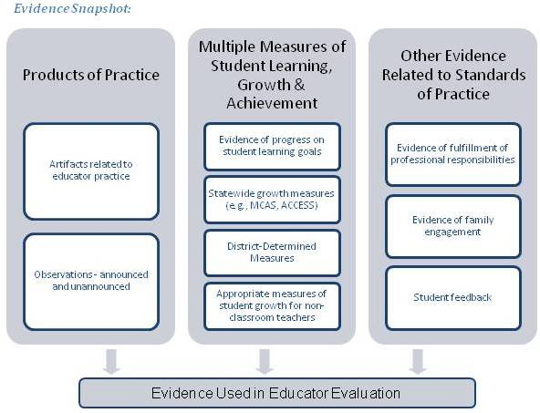

Guiding Questions
- What aspects of educator practice does each category of evidence seek to demonstrate?
- How might you use strategically selected sources of evidence to “tell the story behind the numbers?” How is this valuable to you as an educator?
- What type of information about educator practice might student feedback yield that is different from artifacts of practice or observational evidence?

This page intentionally left blank.

Handout 2: Learning Activity 2

Identifying Sources of Evidence
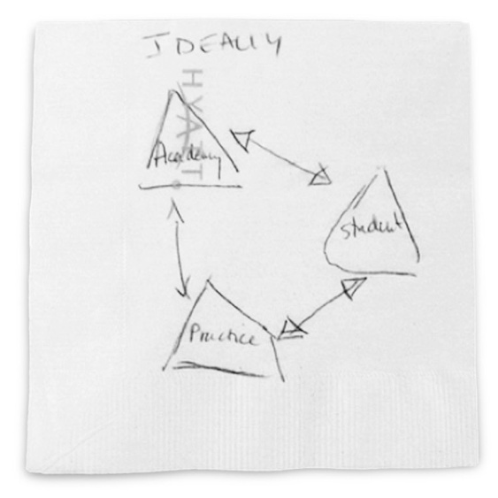 | OR | 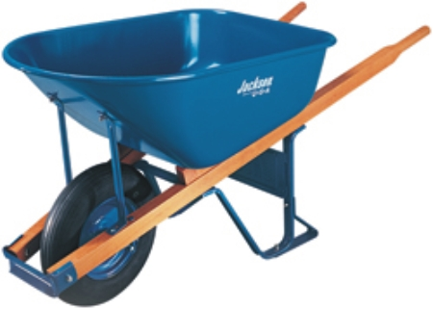
Everyone is required to collect artifacts that show evidence of practice related to (1) their goals, and (2) the Standards and Indicators of Effective Practice. This may feel like a daunting task—one for which you will need a wheelbarrow to hold all of the evidence you generate over the course of a year! Or, you may be used to simply scribbling a few notes on the back of a napkin just prior to a conversation with your supervisor. Neither approach is ideal.
This activity will give you an opportunity to think more strategically about how to avoid this “all or nothing” dilemma, and help you identify high-quality, authentic sources of evidence related to your practice.

Key Points to Consider When Thinking about Evidence:
- Artifacts and measures of student learning should be a sample that demonstrates educator performance and impact. Don’t unintentionally bury your evidence in a huge binder of artifacts; similarly, don’t shortchange yourself by not providing your supervisor with the important information they need to make a professional judgment.
- Evidence within each artifact should be clearly tied to educator goals and/or the Standards and Indicators.
- Evidence selection should be strategic. Consider how multiple sources of evidence might tell a story (e.g. a lesson plan, results from a formative assessment, student work samples, and a second lesson plan could demonstrate how you adjusted practice based on student data), or how one artifact could present evidence of practice associated with multiple Standards and Indicators.

Meet Tom Wilson
Mr. Wilson is an experienced 6th grade science teacher on a 2-year self-directed growth plan, and he is approaching his formative evaluation at the end of year 1. Throughout the year, Mr. Wilson has been gathering artifacts. As you can see on the next page, there are numerous artifacts from which he could choose. Take a minute to familiarize yourself with Mr. Wilson’s two goals, followed by the list of potential artifacts and measures of student learning he could use to demonstrate practice.

Tom Wilson: Educator Evaluation Binder
Student Learning Goal (INDIVIDUAL): Each of my Intermediate and Advanced ELL students will demonstrate mastery of science content standards across three units based on unit assessments throughout the year.
Professional Practice Goal (TEAM): In order to build mastery of science content by ELLs, the science team will work to consistently identify and teach symbols, key terms, and other domain-specific words and phrases, using at last three specific, agreed-upon pedagogical techniques and additional resources to ensure comprehension.

Possible Sources of Evidence
- lesson plans
- Student notebook excerpts
- daily “do now” activities from students
- Word Walls (weekly snap shots)
- Pre-lab reports
- Post-lab reports
- Extensions to curriculum units (when necessary to provide students with deeper knowledge of a concept
- Pre-unit assessments for Life Sciences, Earth Science, and Physical Science
- Post-unit assessments for Life Sciences, Earth Science, and Physical Science
- End-of-course writing assessments (format: persuasive essays)
- Monthly science team meeting notes (Oct—March)
- parent email correspondence
- monthly parent phone log

Guiding Questions
- Does this appear to be a representative sample of Mr. Wilson’s performance? A strategic selection of artifacts?
- Can you clearly tie each of these items to Mr. Wilson’s goals, and/or the Standards and Indicators?

This page intentionally left blank.

Handout 3: Learning Activity 2

Educator Plan Form
Educator—Name/Title: T. Wilson, sixth-grade science teacher

Primary Evaluator—Name/Title: P. Randolph, principal

Supervising Evaluator, if any—Name/Title/Role in evaluation: N/A

School(s): George Washington Middle School
Educator Plan: Self-Directed Growth Plan Directed Growth Plan
Developing Educator Plan Improvement Plan*

Plan Duration: Two-Year One-Year Less than a year

Start Date: September 19, 2011 End Date: June 15, 2013
X Educator Goal Setting form with final goals is attached to the Educator Plan.
Some activities may apply to the pursuit of multiple goals or types of goals (student learning or professional practice). Attach additional pages as necessary.
Student Learning Goal(s): Planned Activities
Describe actions the educator will take to attain the student learning goal(s).
Activities may apply to individual and/or team. Attach additional pages as needed.
SL GOAL (individual): Each of my Intermediate and Advanced ELL students will demonstrate mastery of science content standards across three units based on unit assessments throughout the year.
Action | Supports/Resources From School/District² | Timeline, Benchmarks, or Frequency
1. Identify student knowledge level at the beginning of each unit using a formative assessment. | - 2006 MA Science Curriculum Framework  - 2011 MA Revised Curriculum Framework for ELA and Literacy (Standards for Literacy in Science) | - Frequency: Prior to each unit  - Process benchmark: Development/refinement of formative assessments for each unit  - Outcome benchmark: Analysis of student knowledge level related to content standard(s) using formative assessment results prior to each unit  Evidence:
*Additional detail may be attached if needed.
Student Learning Goal(s): Planned Activities
Describe actions the educator will take to attain the student learning goal(s).
Activities may apply to individual and/or team. Attach additional pages as needed.
Action | Supports/Resources From School/District² | Timeline, Benchmarks, or Frequency
2. Use formative assessment results to plan and adjust instruction for each unit. | - Formative assessment results  - Collaboration with ELL specialist  - Weekly science team meetings | - Frequency: After each formative unit assessment  - Process benchmark: collaboration and analysis with ELL specialist, plus feedback notes  - Process benchmark: Analysis of student data after each formative assessment, with notes as to how instruction will be adjusted during the next unit  - Outcome benchmark: Lesson plans that target core content standards for each unit and reflect attention to identified student needs based on formative assessments  Evidence:
3. Disaggregate unit assessment data for Intermediate and Advanced ELL students and identify proportion that mastered content standards within each unit. | - Unit assessment results  - Collaboration with ELL specialist  - Weekly science team meetings | - Frequency: After each unit assessment  - Process benchmark: Tracking form of student mastery of core content standards within each unit  - Outcome benchmark: Completed/updated tracking form of unit assessment results, with analysis of ELL student growth data  Evidence:

Professional Practice Goal(s): Planned Activities
Describe actions the educator will take to attain the professional practice goal(s).
Activities may apply to individual and/or team. Attach additional pages as needed.
PP Goal (TEAM): In order to build mastery of science content by ELLs, the science team will work to consistently identify and teach symbols, key terms, and other domain-specific words and phrases, using at least three specific, agreed-upon pedagogical techniques and additional resources to ensure comprehension.
Action | Supports/ Resources From School/District | Timeline, Benchmarks, or Frequency
4. Research evidence-based instructional strategies that target vocabulary development and academic language with ELL students. Identify a minimum of three instructional strategies for use in my classroom. | - Weekly science team meetings  - ELL specialist | - By Oct 1, read Teaching Basic & Advanced Vocabulary by Marzano and share insights with science team  - By Oct 1, meet with ELL specialist to discuss evidence-based instructional strategies for teaching academic language and vocabulary to ELL students  - By Oct 15, identify three instructional strategies to use in my classroom  Evidence:
5. Pilot three instructional strategies related to teaching symbols, key terms, and other domain-specific works and phrases effectively with ELL students. Use weekly checks to measure student mastery of new vocabulary and/or scientific language. | - Weekly science team meetings | - Process benchmark: implement instructional strategies  - Process benchmark: Weekly analysis of “do now” activities to assess student mastery of new vocabulary and/or use of scientific language and determine effectiveness of each instructional strategy. Make adjustments if needed.  - Outcome benchmark: Implemented lesson plans that incorporate identified instructional strategies  - Outcome benchmark: Improved mastery of scientific vocabulary and discourse by Intermediate and Advanced ELL students with link to specific instructional strategy  - Outcome benchmark: “bank” of effective resources/instructional strategies to inform future ELL science instruction  Evidence:
Educator Plan is “designed to provide educators with feedback for improvement, professional growth, and leadership,” is “aligned to statewide Standards and Indicators in 603 CMR 35.00 and local Performance Standards,” and “is consistent with district and school goals.” (See 603 CMR 35.06 (3)(d) and 603 CMR 35.06(3)(f).)
Signature of Evaluator P. Randolph Date 9/23/11
Signature of Educator T. Wilson Date 9/23/11
* As the evaluator retains final authority over goals to be included in an educator’s plan (see 603 CMR 35.06(3)(c)), the signature of the educator indicates that he or she has received the Educator Goal Setting form with the “Final Goals” box checked, indicating the evaluator’s approval of the goals. The educator’s signature does not necessarily denote agreement with the goals. Regardless of agreement with the final goals, signature indicates recognition that “It is the educator’s responsibility to attain the goals in the plan and to participate in any trainings and professional development provided through the state, district, or other providers in accordance with the Educator Plan.” (See 603 CMR 35.06(4).)

Guiding Questions
- How does your selection of evidence sources for Mr. Wilson differ from the original list of possible sources? Did you add any items that he didn’t consider? Disregard others?
- This activity asked you to identify sources of evidence associated with Mr. Wilson’s goals, as represented through this educator plan. Which artifacts and student data sources might provide evidence of practice associated with one or more of the four Standards? (Curriculum, Planning & Assessment; Teaching All Students; Family & Community Engagement; Professional Culture)
- How might this evidence collection process contribute to Mr. Wilson’s reflection of his professional practice? The performance of his students?
- How will these particular artifacts contribute to making Mr. Wilson’s conversations with his evaluator about his practice more meaningful and productive?

Handout 4: Learning Activity 3

Identifying Your Own Evidence
At this point, you have already developed your goals, and you’ve either completed or are well on your way to completing your Educator Plan. This is the ideal time to start identifying evidence you will collect to demonstrate (1) progress related to your goals, and (2) practice associated with the four Standards and related Indicators. When thinking about high-quality evidence, take into account the following considerations:
- Will this particular artifact or group of artifacts show what I’m trying to demonstrate?
  - Example: a classroom roster may reveal attendance on one particular Friday, but an analysis of six rosters from the six consecutive Fridays will demonstrate a pattern of declining absentee rates.
- Will this collection of artifacts and measures of student learning help me tell a story of professional growth and development, as well as student learning and achievement?
  - Example: through the submission of an analysis of Friday lab absentee rates, lesson plans for four consecutive unit labs, and related unit assessment data from chronically absent and underperforming students, I can demonstrate correlations between changes to my instructional approach to better engage all students, improved attendance rates, and improved student learning.

Your turn…
Take out your own Educator Plan. Using the action steps and benchmarks you’ve already developed in alignment with your goals, begin identifying the appropriate artifacts and measures of student learning you expect to produce as a result of these action steps—sources of evidence that will demonstrate targeted, rich evidence of practice related to your goals and overall professional practice.
Jot down ideas for evidence in the margins next to each action step, or develop a separate document to start cataloging what you think will be effective, representative artifacts of practice and measures of student learning. **Remember: artifacts should be naturally-occurring products of practice and NOT something produced for the sake of evaluation.

This page intentionally left blank.

Handout 5: Exit Ticket/Homework

Aligning Evidence to Standards & Indicators
In this activity, you will have an opportunity to identify how and where each artifact or measure of student learning identified on your plan reflects practice associated with one or more Standard and Indicator. It’s highly likely that simply identifying evidence associated with your goals has already yielded evidence tied to several Standards and Indicators.
For example, several of Mr. Wilson’s artifacts and measures of student learning represent evidence of practice associated with several Standards and Indicators:
Evidence Source | Standard/Indicator
- Notes from meetings with the ELL specialist  - Formative assessment data results and analysis | Indicator I.B (Assessment)  Indicator I.C (Analysis)  Indicator IV.C (Collaboration)
- Select lesson plans reflecting new instructional strategies | Indicator I.A (Curriculum and Planning)  Indicator II.A (Instruction)  Indicator II.D (Expectations)

Using your annotated educator plan from Learning Activity 3 and a copy of your rubric, start noting how each of your selected artifacts or measures of student learning might yield evidence of practice associated with one or more Standards and Indicators. Eventually, this kind of alignment will help both you and your evaluator organize and analyze evidence of practice in a targeted, meaningful way.
Remember, one artifact or measure of student learning may contain evidence associated with multiple Standards or Indicators!

- Suggested ESE Model System Resources & Tools:
  - Educator Collection of Evidence Form
  - Artifact Cover Page
(available at http://www.doe.mass.edu/edeval/resources/evalforms/)

This page intentionally left blank.

Appendix A: Educator Plan Form

Educator Plan Form
Educator—Name/Title:

Primary Evaluator—Name/Title:

Supervising Evaluator, if any—Name/Title/Role in evaluation:

School(s):
Educator Plan: Self-Directed Growth Plan Directed Growth Plan
Developing Educator Plan Improvement Plan*

Plan Duration: 2-Year One-Year Less than a year

Start Date: End Date:

Goal Setting Form with final goals is attached to the Educator Plan.
Some activities may apply to the pursuit of multiple goals or types of goals (student learning or professional practice). Attach additional pages as necessary.

Student Learning Goal(s): Planned Activities
Describe actions the educator will take to attain the student learning goal(s).
Activities may apply to individual and/or team. Attach additional pages as needed.
Action | Supports/Resources from School/District¹ | Timeline or Frequency
 |  | Evidence:
*Additional detail may be attached if needed

Educator Plan Form
Educator—Name/Title:
Professional Practice Goal(s): Planned Activities
Describe actions the educator will take to attain the professional practice goal(s).
Activities may apply to individual and/or team. Attach additional pages as needed.
Action | Supports/Resources from School/District | Timeline or Frequency
 |  | Evidence:

This Educator Plan is “designed to provide educators with feedback for improvement, professional growth, and leadership,” is “aligned to statewide Standards and Indicators in 603 CMR 35.00 and local Performance Standards,” and “is consistent with district and school goals.”
(see 603 CMR 35.06 (3)(d) and 603 CMR 35.06(3)(f).)

Signature of Evaluator Date

Signature of Educator Date

* As the evaluator retains final authority over goals to be included in an educator’s plan (see 603 CMR 35.06(3)(c)), the signature of the educator indicates that he or she has received the Goal Setting Form with the “Final Goal” box checked, indicating the evaluator’s approval of the goals. The educator’s signature does not necessarily denote agreement with the goals. Regardless of agreement with the final goals, signature indicates recognition that “It is the educator’s responsibility to attain the goals in the plan and to participate in any trainings and professional development provided through the state, district, or other providers in accordance with the Educator Plan.” (see 603 CMR 35.06(4))

All districts without Level 4 schools as of January 2011 may use the 2013–14 school year to begin to pilot district-determined measures they identify by September 2013; these districts are expected to begin administering district-determined measures no later than the 2014–15 school year and begin administering Student Impact Ratings in the 2015-2016 school year.
Student feedback is a required component of educator evaluation as of the 2014–15 school year (603 CMR 35.07(1)(c)(2)). Districts have the flexibility to determine feedback instruments, as well as how student feedback informs the Summative Performance Rating.
Bill & Melinda Gates Foundation. 2012. Asking Students about Teaching: Student Perception Surveys and Their Implementation. http://www.metproject.org/downloads/Asking_Students_Practitioner_Brief.pdf. Bill & Melinda Gates Foundation. 2012. Gathering Feedback for Teaching: Combining High-Quality Observations with Student Surveys and Achievement Gains. http://www.metproject.org/downloads/MET_Gathering_Feedback_Practioner_Brief.pdf
All names are pseudonyms. Materials for “T. Wilson” are based on the goals and artifacts of a Massachusetts science teacher participating in the new educator evaluation framework in 2011-2012.
Must identify means for educator to receive feedback for improvement per 603 CMR 35.06(3)(d).
Must identify means for educator to receive feedback for improvement per 603 CMR 35.06(3)(d)

