The Massachusetts Department of Elementary and Secondary Education (ESE) conducted a survey and several focus groups to solicit feedback from various stakeholders engaged in the Candidate Assessment of Performance (CAP) Fall 2015 Pilot. The feedback will be used to inform:
- Revisions to the CAP Guidelines, and
- The ongoing development of resources to support organizations in effective implementation.
The feedback summary that follows is organized by:
- Core Principles,
- Participation,
- Training,
- Guidelines and forms,
- Resources,
- CAP content,
- Supporting candidate readiness, and
- Looking Forward.

Core Principles
As ESE collects feedback to improve CAP and prepare for full implementation, we want to maintain the purpose and goals of CAP, which include:
- To ensure teacher candidates are ready to make impact with students day one;
- To measure teacher candidates’ practice on key indicators as outlined in the Guidelines for the Professional Standards for Teachers (PSTs); and
- To support teachers in improving their practice based on targeted feedback and performance evaluations.
In support of these goals, there are several key principles that both drove the initial development of CAP and that ESE anticipates maintaining throughout future iterations in order to preserve the integrity of the assessment. These Core Principles include:
- Observations and Feedback
- Alignment to the Educator Evaluation Framework
- Calibration
- Evidence
- Focus Elements
- Expectation of Candidate Readiness
Full descriptions of each of the Core Principles can be found on our website.

Participation
Survey Responses
A total of 294 respondents answered the survey, representing 24 different Sponsoring Organizations.

Focus Group Participation
ESE conducted five focus groups across the Commonwealth with Program Supervisors, Supervising Practitioners, Sponsoring Organization representatives, and teacher candidates. In all, there were 41 focus group participants representing 16 Sponsoring Organizations and three districts.

Feedback Summary
For this summary, we examined common trends from the survey responses and the focus group discussions.

Training
We asked survey respondents and focus group participants about the type and amount of training the Sponsoring Organizations provided. Sponsoring Organization representatives and Program Supervisors reported an average of five hours of training provided to CAP pilot participants prior to the beginning of CAP. Supervising Practitioners reported experiencing approximately three hours of training, and teacher candidates reported an average of one hour.
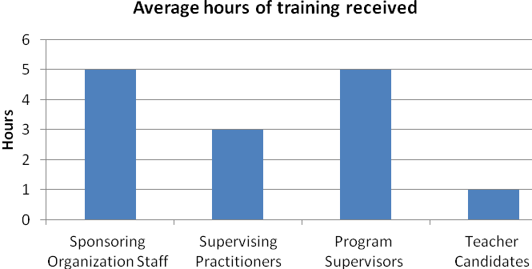
When asked to describe the nature of the training for the CAP pilot, we learned that organizations varied widely in the length and approach of the training they provided.
- One organization described an “initial 3-hour training, followed by a 2-to-3 hour training on campus each month” for all Program Supervisors.
- Another program held monthly 3-hour meetings with Program Supervisors, and one-time semester training with Supervising Practitioners.
- Another organization noted that “Program Supervisors were given the notebook and we worked together on the first day of practicum to learn the process.” One Program Supervisor commented in the survey that he/she “did not receive any formal training before I started using CAP.”

Teacher candidates reported that they had limited training prior to participating in CAP.
- Only 16 percent of teacher candidates (N=15) reported that they understood CAP going into the practicum.
- 29 percent of candidates (N=27) agreed with the statement, “I received adequate support and/or training in…engaging in the 5-Step Cycle.” Candidates commented that they are “unsure what the 5 step cycle is,” and “we did not go over the cycle…hence no support of training on such.”

Guidelines and Forms
The CAP Guidelines were mentioned frequently in the focus groups and survey responses. Respondents advocated for streamlining and making clearer the CAP Guidelines; this includes the various CAP forms required (and provided as optional resources). Nearly half of survey respondents indicated concern about the amount of paperwork that resulted from implementing CAP; similarly, all five focus groups expressed concern of the time required to read through all of the CAP materials and complete forms. Several respondents to the survey suggested streamlining the Guidelines as well as the forms to remove redundancy, such as creating one generic observation form to be used for all observations.

Resources
Survey results showed that just over half of Program Supervisors (N=47) have accessed ESE online resources, compared to less than a quarter of Supervising Practitioners (N=14) and about a quarter of teacher candidates (N=21).
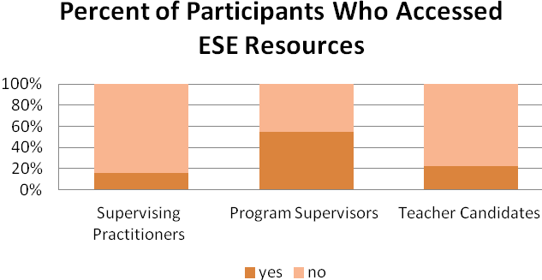
In response to questions about additional resources that could support implementation, survey respondents suggested:
- Exemplars/samples of completed forms.
- Further clarification of the concepts of Quality, Scope, and Consistency.
- Guidance on use of student feedback surveys.
CAP content
In response to survey questions about different components of CAP, including the Six Essential Elements and the concepts of rating candidates in Quality, Scope and Consistency:
- 87 percent of Program Supervisors and 90 percent of Supervising Practitioners agree or somewhat agree that the Six Essential Elements encompassed the Professional Standards for Teachers, and are most essential to measure a candidate’s readiness.
“Being consistently aware of the six elements will help mold the college student into an educator, one who not only presents information, but checks to ensure student success.”
-A Supervising Practitioner
- 59 percent of Program Supervisors and 76 percent of Supervising Practitioners agree or somewhat agree that separating ratings into Quality, Scope, and Consistency was an effective way to measure the readiness of a candidate.

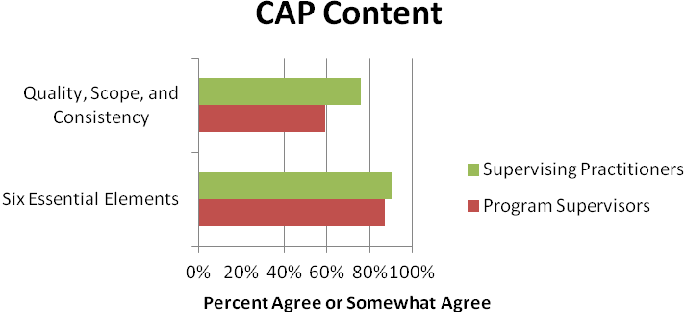
Supporting candidate readiness
We asked focus group and survey participants about which components of CAP best support a candidate’s readiness to be impactful in the classroom:
- Out of 198 total written responses, one-third of respondents identified observations as the feature of CAP that best supports candidate readiness (N=64). Teacher candidates and assessors indicated that providing immediate feedback after an observed lesson was a well-received modification to the initial implementation.
“The CAP standards helped me focus on certain areas in teaching. I will refer to this document throughout my entire teaching career to assess myself!”
-A teacher candidate
- Another attribute that participants felt best supports candidate readiness is the alignment of CAP to the Educator Evaluation system. All five focus groups discussed the value of CAP mirroring the Educator Evaluation system in both content and process.
- Out of 198 total written responses, 40 respondents (half of whom were teacher candidates) indicated CAP’s focus on reflection is an essential contributor to candidate readiness.

In a focus group, teacher candidates stated that CAP has helped them feel confident in their teaching, because they know the standards and the evaluation process that they will encounter when they are employed. In survey responses, 81 percent of teacher candidates (N=93) agreed that they are ready to be effective with students:
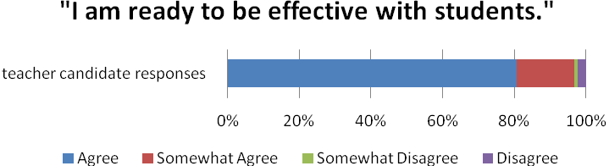
When asked to respond to the question, “I feel confident in my teacher candidate’s readiness to be effective with students day one:”
- Approximately 75 percent of Program Supervisors agreed and 22 percent somewhat agreed to feeling confident in their candidate’s readiness at the completion of CAP.
- 69 percent of Supervising Practitioners agreed and about 20 percent somewhat agreed to feeling assured in their candidate’s readiness to be effective.

When asked about receiving feedback, 87 percent of surveyed teacher candidates (N=96) agreed or somewhat agreed that the feedback they received was meaningful and assisted in improving their practice. In a focus group, one Supervising Practitioner commented on the required feedback to candidates in CAP, stating that it “held us more accountable for directive feedback; [it] forced you to think about what feedback you were giving them.”
When asked about their interest in serving in a supervisory role after the pilot, 89 percent of surveyed Supervising Practitioners (N=87) agreed or somewhat agreed to being interested in supervising a teacher candidate in the future:
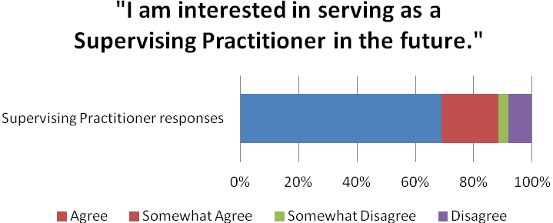
In a closing comment, a teacher candidate wrote: “I do think the CAP is a good stepping stone to the teacher evaluation system in place in many schools, because they are assessing some of the same standards, and I will be at an advantage next year in gathering evidence and clearly defining professional goals for the year.”

Looking Forward
ESE recognizes that due to the timeline for release of the CAP Guidelines in late June, the depth of training provided to all parties may have been somewhat limited. Our take away from this data is that as organizations prepare for full implementation and now have access to resources to support training candidates and supervisors, it will be critically important for Sponsoring Organizations to invest in communication, training, and support to ensure effective implementation of CAP. In addition, this feedback shows that many teacher candidates and Supervising Practitioners are experiencing a process that is in alignment with the Core Principles set forth by ESE, and therefore is an indication that these chosen attributes are vital to the integrity of the assessment.
In response to feedback regarding the reduction of paperwork and an increase in time needed for communication, ESE intends to support the ongoing development and implementation of the CAP online platform, which is currently being piloted. The online platform significantly reduces paperwork and makes the process of exchanging information and communicating among the triad of teacher candidate, Supervising Practitioner and Program Supervisor much more dynamic.
In May, ESE will administer another feedback survey and conduct additional focus groups for spring and full-year pilot participants. The feedback gathered in the spring, together with the feedback summarized in this report, will assist the Department in highlighting areas for revisions to the CAP Guidelines. The revised Guidelines will be made available in late June 2016. We are grateful to the Supervising Practitioners, Program Supervisors, and teacher candidates who took the time to complete the survey and/or participate in a focus group. The feedback is immensely useful as ESE continues to support CAP implementation.
Please note: We have developed additional resources, FAQs and completed modifications to existing resources. You can access CAP resources can be accessed here: http://www.doe.mass.edu/edprep/cap/resources.html.

